Computer Networking

Assignment 11

# Homework 11

## Problems of Chapter 5:

P12 - Describe how loops in paths can be detected in BGP.

P16- Consider the following network. ISP B provides national backbone service

to regional ISP A. ISP C provides national backbone service to regional

ISP D. Each ISP consists of one AS. B and C peer with each other in two

places using BGP. Consider traffic going from A to D. B would prefer

to hand that traffic over to C on the West Coast (so that C would have

to absorb the cost of carrying the traffic cross-country), while C would

prefer to get the traffic via its East Coast peering point with B (so that B

would have carried the traffic across the country). What BGP mechanism

might C use, so that B would hand over A-to-D traffic at its East Coast

peering point? To answer this question, you will need to dig into the BGP

specification.

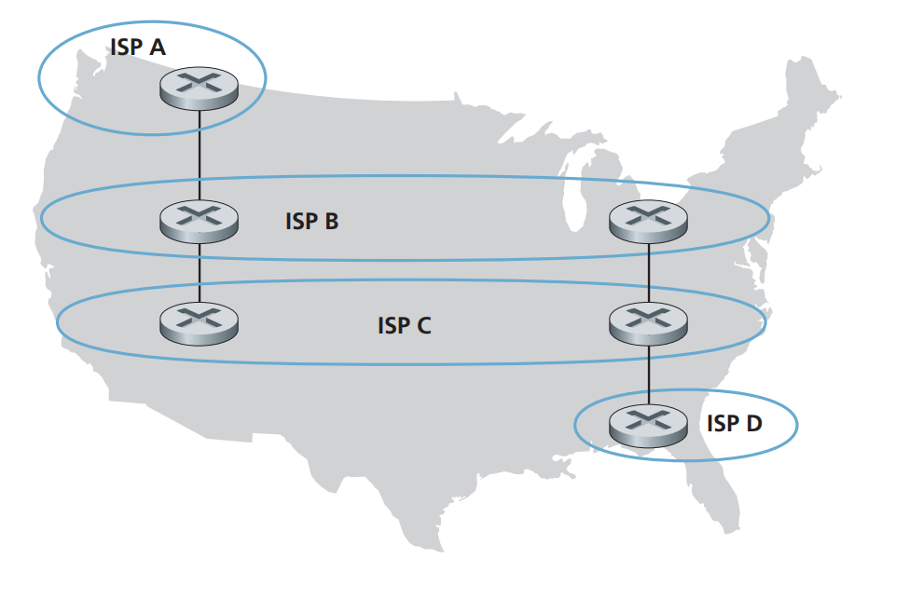

P20- Suppose ASs X and Z are not directly connected but instead are connected

by AS Y. Further suppose that X has a peering agreement with Y, and that Y

has a peering agreement with Z. Finally, suppose that Z wants to transit all

of Y’s traffic but does not want to transit X’s traffic. Does BGP allow Z to

implement this policy?

P22- In Section 5.7, we saw that it was preferable to transport SNMP messages in

unreliable UDP datagrams. Why do you think the designers of SNMP chose

UDP rather than TCP as the transport protocol of choice for SNMP?

## Lab

https://www.github.com/network-whu/lab/

3.Wireshark_ICMP.docx