Computer Networking

Assignment 8

**## Problems of Chapter 3:**

P40. Consider Figure 3.61. Assuming TCP Reno is the protocol experiencing the behavior shown above, answer the following questions. In all cases, you should provide a short discussion justifying your answer.

a. Identify the intervals of time when TCP slow start is operating.

b. Identify the intervals of time when TCP congestion avoidance is operating.

c. After the 16th transmission round, is segment loss detected by a triple duplicate ACK or by a timeout?

d. After the 22nd transmission round, is segment loss detected by a triple duplicate ACK or by a timeout?

e. What is the initial value of ssthresh at the first transmission round?

f. What is the value of ssthresh at the 18th transmission round?

g. What is the value of ssthresh at the 24th transmission round?

h. During what transmission round is the 70th segment sent?

i. Assuming a packet loss is detected after the 26th round by the receipt of a triple duplicate ACK, what will be the values of the congestion window

size and of ssthresh?

j. Suppose TCP Tahoe is used (instead of TCP Reno), and assume that triple duplicate ACKs are received at the 16th round. What are the ssthresh and the congestion window size at the 19th round?

k. Again suppose TCP Tahoe is used, and there is a timeout event at 22nd round. How many packets have been sent out from 17th round till 22nd round, inclusive?

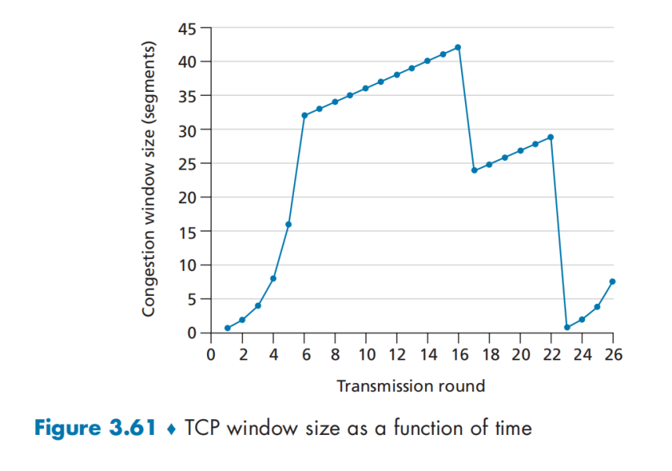

P44. Consider sending a large file from a host to another over a TCP connection that has no loss.

a. Suppose TCP uses AIMD for its congestion control without slow start. Assuming cwnd increases by 1 MSS every time a batch of ACKs is received and assuming approximately constant round-trip times, how long does it take for cwnd increase from 6 MSS to 12 MSS (assuming no loss events)?

b. What is the average throughput (in terms of MSS and RTT) for this connection up through time = 6 RTT?

**## Problems of Chapter 4:**

**P1. Consider the network below.**

a. Show the forwarding table in router A, such that all traffic destined to host H3 is forwarded through interface 3.

b. Can you write down a forwarding table in router A, such that all traffic from H1 destined to host H3 is forwarded through interface 3, while all traffic from H2 destined to host H3 is forwarded through interface 4? (*Hint:* This is a trick question.)

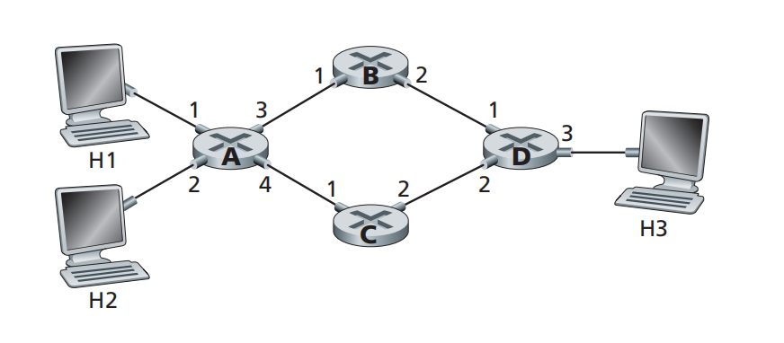

**P4. Consider the switch shown below.**

Suppose that all datagrams have the same fixed length, that the switch operates in a slotted, synchronous manner, and that in one time slot a datagram can be transferred from an input port to an output port. The switch fabric is a crossbar so that at most one datagram can be transferred to a given output port in a time slot, but different output ports can receive datagrams from different input ports in a single time slot. What is the minimal number of time slots needed to transfer the packets shown from input ports to their output ports, assuming any input queue scheduling order you want (i.e., it need not have HOL blocking)? What is the largest number of slots needed, assuming the worst-case scheduling order you can devise,

assuming that a non-empty input queue is never idle?

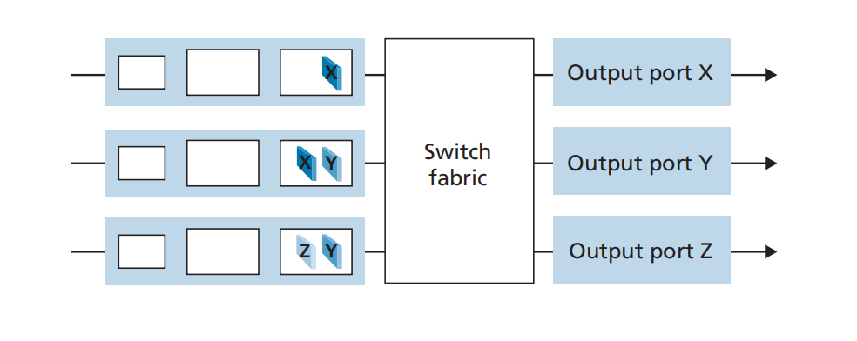

**P6. Consider the figure below. Answer the following questions:**

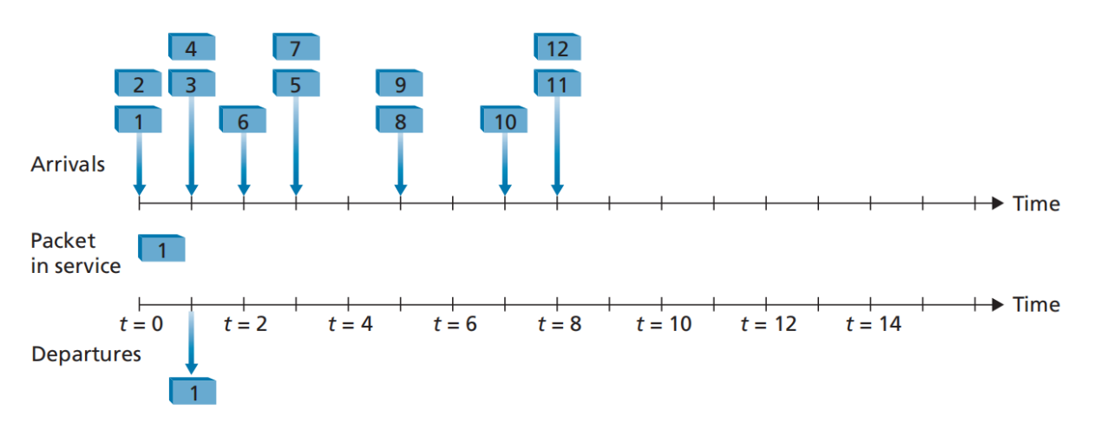

a. Assuming FIFO service, indicate the time at which packets 2 through 12 each leave the queue. For each packet, what is the delay between its arrival and the beginning of the slot in which it is transmitted? What is the average of this delay over all 12 packets?

b. Now assume a priority service, and assume that odd-numbered packets are high priority, and even-numbered packets are low priority. Indicate the time at which packets 2 through 12 each leave the queue. For each packet, what is the delay between its arrival and the beginning of the slot in which it is transmitted? What is the average of this delay over all 12 packets?

c. Now assume round robin service. Assume that packets 1, 2, 3, 6, 11, and 12 are from class 1, and packets 4, 5, 7, 8, 9, and 10 are from class 2. Indicate the time at which packets 2 through 12 each leave the queue. For each packet, what is the delay between its arrival and its departure? What is the average delay over all 12 packets?

d. Now assume weighted fair queueing (WFQ) service. Assume that oddnumbered packets are from class 1, and even-numbered packets are from class 2. Class 1 has a WFQ weight of 2, while class 2 has a WFQ weight of 1. Note that it may not be possible to achieve an idealized WFQ schedule as described in the text, so indicate why you have chosen the particular packet to go into service at each time slot. For each packet what is the delay between its arrival and its departure? What is the average delay over all 12 packets?

e. What do you notice about the average delay in all four cases (FIFO, RR, priority, and WFQ)?

**P9. Consider a datagram network using 8-bit host addresses. Suppose a router**

**uses longest prefix matching and has the following forwarding table:**

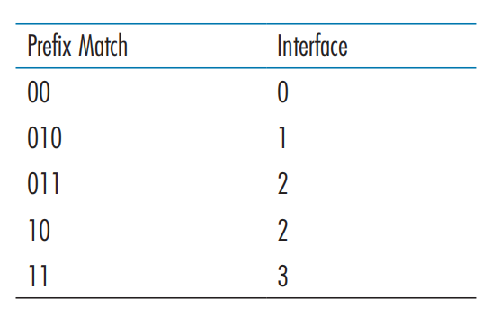

For each of the four interfaces, give the associated range of destination host addresses and the number of addresses in the range.

**## Lab**

`https://www.github.com/network-whu/lab/`

- 6.Wireshark_TCP.docx