STATISTICAL INFERENCE - Peer Assignment

Version: V00

Date: 21-dec-2014

GitHub Repository: <https://github.com/A6111E/datasciencecoursera/tree/master/Statistical_Inference/Assignment_Part1>

#### Introduction:

**Exponential Distribution:** is the probability distribution that describes the time between events in a Poisson process, i.e. a process in which events occur continuously and independently at a constant average rate.

The exponential distribution occurs naturally when describing the lengths of the inter-arrival times in a homogeneous Poisson process. Describes the time for a continuous process to change state.

In real scenarios, the assumption of a constant rate (or probability per unit time) is rarely satisfied.

For example, the rate of incoming phone calls differs according to the time of day. But if we focus on a time interval during which the rate is roughly constant, such as from 2 to 4 p.m. during work days, the exponential distribution can be used as a good approximate model for the time until the next phone call arrives.

Examples which yield approximately exponentially distributed variables:

* Time until a radioactive particle decays, or the time between clicks of a geiger counter.
* Time it takes before your next telephone call

Exponential variables can also be used to model situations where certain events occur with a constant probability per unit length, such as the distance between mutations on a DNA strand, or between roadkills on a given road.

**Expected Value:** the mean or expected value of an exponentially distributed random variable $X$ with rate parameter $lambda$ is given by:

$$E[X]=1/lambda=beta$$

**Variance: $Var[X]=1/lambda^{2}$**

**Standard Deviation (is equal to the mean): $sd[X]=1/lambda=beta$**

**Mean Standard Error: $se[X]=sd/sqrt(1/n)$**

**Sample Mean: $Sample_{M}ean[X]=1/sample.size(sum(xi))$**

**t Confidence Interval: $tConfidenceInterval=E[X]+/-t(n-1)×sd/sqrt(n)$**

*Partial Source:* <http://en.wikipedia.org/wiki/Exponential_distribution>

### Data Processing:

#### Data Set

#### Table: Summary Simulation Random Exponential Distribution

##### Simulations = 1000 - Sample Size = 40 - lambda = 0.2

colNames <- c("Trial_1", "Trial_100", "Trial_500", "Trial_750", "Trial_1000")  
pr1 <- DT[ , colNames, with = FALSE]  
  
xt <- xtable(summary(pr1))  
print(xt, type = "html", floating = FALSE)

|  |  |  |  |  |
| --- | --- | --- | --- | --- |
| **Trial_1** | **Trial_100** | **Trial_500** | **Trial_750** | **Trial_1000** |
| Min. : 0 | Min. : 0 | Min. : 0.2 | Min. : 0.1 | Min. : 0.0 |
| 1st Qu.: 2 | 1st Qu.: 2 | 1st Qu.: 1.0 | 1st Qu.: 0.4 | 1st Qu.: 1.5 |
| Median : 4 | Median : 3 | Median : 2.3 | Median : 1.7 | Median : 3.7 |
| Mean : 6 | Mean : 5 | Mean : 4.0 | Mean : 2.7 | Mean : 4.9 |
| 3rd Qu.: 6 | 3rd Qu.: 6 | 3rd Qu.: 5.5 | 3rd Qu.: 3.3 | 3rd Qu.: 7.2 |
| Max. :32 | Max. :37 | Max. :16.9 | Max. :16.1 | Max. :21.0 |

#### Table: Mean Value for each Simulation

xt <- xtable(DT1[1:10, ], digits = 2)  
print(xt, type = "html", include.rownames = FALSE, hline.after=c(1), floating = FALSE)

|  |  |
| --- | --- |
| **Trial** | **Sample_Mean** |
| 1 | 5.55 |
| 2 | 4.67 |
| 3 | 4.26 |
| 4 | 4.61 |
| 5 | 5.30 |
| 6 | 3.63 |
| 7 | 6.23 |
| 8 | 3.68 |
| 9 | 4.84 |
| 10 | 4.98 |

#### Graphic: Random Exponential Distribution

theo_center <- mu # distribution theoretical center  
cal_center <- mean(p) # distribution calculated center  
  
p1 <- ggplot(DT1, aes(x = Sample_Mean))  
 p1 <- p1 + geom_histogram(fill = "blue",  
 binwidth = 0.25, aes(y = ..density..), colour = "black")  
 p1 <- p1 + geom_vline(xintercept = theo_center, size = 0.75, colour = "red")  
 p1 <- p1 + geom_vline(xintercept = cal_center, size = 0.75, colour = "green")  
 mse <- round(cal_center, 3)  
 p1 <- p1 + labs(title = paste('theo_center = ', theo_center, ' cal_center = ', mse))  
grid.arrange(p1, ncol = 1)

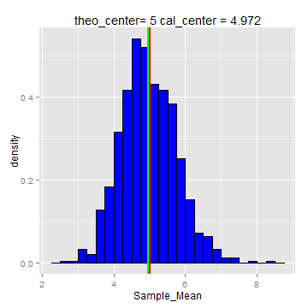

Remarks: Red Vertical Line: distribution theoretical center / Green Vertical Line: distribution calculated center

##### Q1 - Results:

The calculated center from 1000 simulations for $40$ exponential distributions with $lambda=0.2$, is approximately $5$, which corresponds to theoretical center of distribution ($E[X]=1/lambda=5$).

Increasing the simulations, the calculated gets closer to theoretical center.

**A. Theoretical Center: $5$**

**B. Calculated Center: $4.97$**

##### Q2 - Results:

The calculated variance from $1000$ simulations for $40$ exponential distributions samples with $lambda=0.2$ and theoretical variance $Var[X]=1/lambda^{2}$ are:

**A. Theoretical Variance: $25$**

**B. Calculated Variance: $24.57$**

Increasing the simulations, the calculated gets near to theoretical variance, and the exponential distributions trend to be a standard normal distribution.

For example:

A. The calculated variance from $1$ simulation for $40$ exponential distributions random variables is $41.9$ (for this simulation).

B. The theoretical variance $Var[X]=1/lambda^{2}$, is $25$

Decreasing the simulations, the calculated variance gets far away to theoretical variance, and the exponential distributions trend NOT to be a standard normal distribution.

##### Q3 - Results:

#### Graphic: Random Exponential Distribution ~ Standard Normal Distribution

p3 <- ggplot(DT1, aes(x = Sample_Mean))  
 p3 <- p3 + geom_histogram(fill = "blue",  
 binwidth = 0.25, aes(y = ..density..), colour = "black")  
 p3 <- p3 + geom_density(size = 1.25, colour = "red")  
 mse <- round(cal_center, 3)  
 p3 <- p3 + labs(title = paste('theo_center = ', mu, ' cal_center = ', mse))  
grid.arrange(p3, ncol = 1)

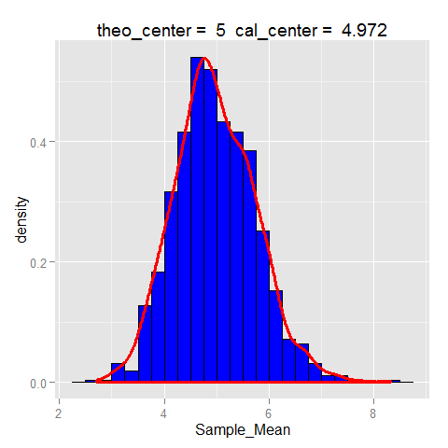

For a standard normal distribution, $68$, $95$ and $99$ of the normal density, lies within $1$, $2$ and $3$ standard deviations from the mean, respectively

The calculted percentage from the sample means of the exponential distribution ($lambda=0.2$) are:

**A. Percentage of Values between +/-1 Standard Deviation: $69.6$**

**B. Percentage of Values between +/-2 Standard Deviation: $95.4$**

**C. Percentage of Values between +/-3 Standard Deviation: $99.6$**

Both, the graphic "Random Exponential Distribution ~ Standard Normal Distribution", and the calculated percentage values, indicates that if the sample trend to be infinite, the random exponential distribution will convert to a standard normal distribution.

The confidence interval for the quantification of uncertainty in the exponential dsitribution is:

**A. Confidence Interval 95% - Up: $5.01$**

**B. Confidence Interval 95% - Down: $4.93$**

### Session Information

## R version 3.1.2 (2014-10-31)  
## Platform: x86_64-w64-mingw32/x64 (64-bit)  
##   
## locale:  
## [1] LC_COLLATE=Spanish_Colombia.1252 LC_CTYPE=Spanish_Colombia.1252   
## [3] LC_MONETARY=Spanish_Colombia.1252 LC_NUMERIC=C   
## [5] LC_TIME=Spanish_Colombia.1252   
##   
## attached base packages:  
## [1] grid stats graphics grDevices utils datasets methods   
## [8] base   
##   
## other attached packages:  
## [1] gridExtra_0.9.1 knitr_1.8 xtable_1.7-4 ggplot2_1.0.0   
## [5] data.table_1.9.4  
##   
## loaded via a namespace (and not attached):  
## [1] chron_2.3-45 colorspace_1.2-4 digest_0.6.4 evaluate_0.5.5   
## [5] formatR_1.0 gtable_0.1.2 htmltools_0.2.6 labeling_0.3   
## [9] MASS_7.3-35 munsell_0.4.2 plyr_1.8.1 proto_0.3-10   
## [13] Rcpp_0.11.3 reshape2_1.4 rmarkdown_0.3.3 scales_0.2.4   
## [17] stringr_0.6.2 tools_3.1.2 yaml_2.1.13