THE EFFECT OF VITAMIN C ON TOOTH GROWTH IN GUINEA PIGS

Version: V00

Date: 21-dec-2014

GitHub Repository: <https://github.com/A6111E/datasciencecoursera/tree/master/Statistical_Inference/Assignment_Part2>

Data Source: R Datasets Package (<http://svitsrv25.epfl.ch/R-doc/library/datasets/html/00Index.html>)

#### Synopsis:

During the 2nd World War, the Canadian Government was concern, because the difficulty of providing natural sources of $VitaminC$ to the armed forces. In as much as chemical procedures gave different results, as to the potency of food in which the armed forces were interested, the Department of Nutrition of the McGill University in Quebec, was requested in 1942 to establish a Vitamin C bio-assay, which might be used as a check against chemical procedures (<http://jn.nutrition.org/content/33/5/491.full.pdf>)

**DataSet Description:** data with the response the tooth growth the length of odontoblasts (teeth) in each of $10$ guinea pigs at each of $3$ dose levels of Vitamin C ($0.5$, $1$, and $2$ mg), with each of two delivery methods ( $OJ:orangejuice$ or $VC:ascorbicacid$).

**- Data Frame: $60$** observations - $3$ variables

**- Variable [len]:** numeric - tooth length

**- Variable [supp]:** factor - supplement type (VC or OJ)

**- Variable [dose]:** numeric - dose in milligrams (mg)

### Exploratory Analysis:

#### Table: Data Summary - Guinea Pig Tooth Growth per Supplement / Dose

|  |  |  |  |  |  |  |  |
| --- | --- | --- | --- | --- | --- | --- | --- |
| ***Supplement*** | ***Dose*** | ***Average*** | ***Std_Deviation*** | ***Variance*** | ***Median*** | ***Max*** | ***Min*** |
| OJ | 0.50 | 13.23 | 4.46 | 19.89 | 12.25 | 21.50 | 8.20 |
| OJ | 1.00 | 22.70 | 3.91 | 15.30 | 23.45 | 27.30 | 14.50 |
| OJ | 2.00 | 26.06 | 2.66 | 7.05 | 25.95 | 30.90 | 22.40 |
| VC | 0.50 | 7.98 | 2.75 | 7.54 | 7.15 | 11.50 | 4.20 |
| VC | 1.00 | 16.77 | 2.52 | 6.33 | 16.50 | 22.50 | 13.60 |
| VC | 2.00 | 26.14 | 4.80 | 23.02 | 25.95 | 33.90 | 18.50 |

Remarks:

* Supplement: OJ (Orange Juice) - VC (Vitamin C - ascorbic acid)
* Average / Std_Deviation / Variance: statistic data for the tooth growth length
* GitHub Repository: /reports

#### Table: Data Summary - Supplement Orange Juice

|  |  |  |
| --- | --- | --- |
| ***OJ_dos0.5*** | ***OJ_dos1.0*** | ***OJ_dos2.0*** |
| 15.2 | 20 | 26 |
| 21.5 | 23 | 26 |
| 17.6 | 24 | 22 |
| 9.7 | 26 | 24 |
| 14.5 | 20 | 25 |
| 10.0 | 25 | 31 |
| 8.2 | 26 | 26 |
| 9.4 | 21 | 27 |
| 16.5 | 14 | 29 |
| 9.7 | 27 | 23 |

#### Table: Data Summary - Supplement Vitamin C

|  |  |  |
| --- | --- | --- |
| ***VC_dos0.5*** | ***VC_dos1.0*** | ***VC_dos2.0*** |
| 4.2 | 16 | 24 |
| 11.5 | 16 | 18 |
| 7.3 | 15 | 34 |
| 5.8 | 17 | 26 |
| 6.4 | 22 | 26 |
| 10.0 | 17 | 32 |
| 11.2 | 14 | 27 |
| 11.2 | 14 | 22 |
| 5.2 | 19 | 23 |
| 7.0 | 16 | 30 |

#### Graphic: Guinea Pig Tooth Growth Length ~ Supplement ~ Dose

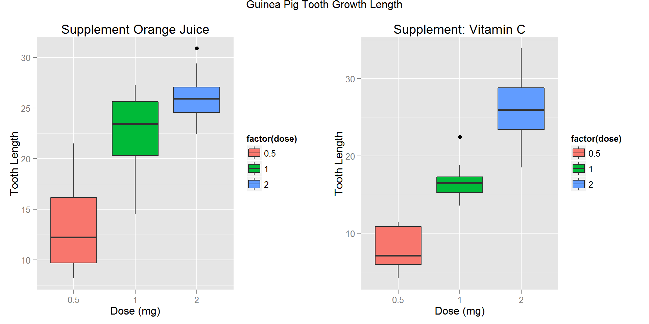

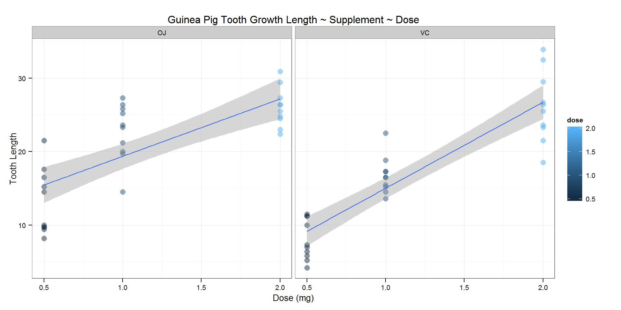

Remarks:

* OJ: supplement Orange Juice
* VC: supplement Vitamin C

### Basic Summary

The summary table "Data Summary - Guinea Pig Tooth Growth per Supplement / Dose" included above, shows statistical data like the mean, standard deviation, variance, median, maximal and minimal values, for each type of supplement and dose.

* For both supplement groups, Orange Juice and Vitamin C, as the doses increases, the tooth growth increases.
* For doses of $0.5$ and $1.0mg$, the maximal value of tooth growth corresponds to the supplement **Orange Juice**.
* For doses of $2.0mg$, the maximal value of tooth growth corresponds to the supplement **Vitamin C**.
* For doses of $0.5$ and $1.0mg$, the mean of tooth growth for Orange Juice is higher than for **Vitamin C**.
* For doses of $2.0mg$, there is no difference in the mean of tooth growth for both **supplements**.

**Initial Conclusions:**

* **Orange Juice** could have more impact on tooth growth for $0.5$ and $1.0mg$ doses, with maximal values of $21.50$ and $27.30$, although the variance is widely spread, standard deviation is higher than for Vitamin C.
* **Vitamin C** could have more impact on tooth growth for $2.0mg$ doses, with maximal values of $33.90$, although the variance is widely spread.
* There is **not evidence** of a dependence of tooth growth with the supplement, Orange Juice or Vitamin C.
* In both cases, there is **clear evidence** of a dependence of tooth growth on dose.

### Analysis - Gosset's t Test:

**Hypothesis**:

* Null hypothesis ($H_{0}$): is that the mean tooth growth for $OrangeJuice$ (OJ) is equal to the mean tooth growth for $VitaminC$ (VC), for the same dose.
* Alternative Hypothesis ($H_{a}$): not equal.

$$H_{0}:μ_{VC}=μ_{OJ}$$

$$H_{a}:μ_{VC}≠μ_{OJ}$$

**Assumptions**:

* The test was done on $10$ pigs chosen randomly, for each supplement ($OrangeJuice-VitaminC$) and each dose ($0.5,1,2mg$).
* Independent Groups: (not paired).
* Unequal variance.

For the **Gosset's t Test**, the dataset have the following groups:

* Group 1: Dose: $0.5mg$ ~ both Supplements
* Group 2: Dose: $1.0mg$ ~ both Supplements
* Group 3: Dose: $2.0mg$ ~ both Supplements

**Total t test Groups: $3$**

#### Confidence Interval Analysis

# t Test Outputs  
# t: $statistic / df: $parameter / p: $p.value / Confidence Interval: $conf  
# Mean of Differences: $estimate  
# Alternative: $alternative / Method: $method / Data Name: $data.name  
  
sta_data <- matrix(data = NA, nrow = 0, ncol = 8)  
  
# Group 1 - Per Dose: 0.5 mg ~ both Supplements  
group05_OJ_VC <- ToothGrowth[ToothGrowth$dose == "0.5",]  
  
groupOJ <- group05_OJ_VC[group05_OJ_VC$supp == "OJ"]  
groupOJ[ , c("supp", "dose") := NULL]  
groupOJ <- groupOJ$len  
  
groupVC <- group05_OJ_VC[group05_OJ_VC$supp == "VC"]  
groupVC[ , c("supp", "dose") := NULL]  
groupVC <- groupVC$len  
  
diff <- groupOJ - groupVC  
  
# t Confidence  
# Calculation - Option 1   
mn <- mean(diff)  
s <- sd(diff)  
n <- length(groupOJ)  
  
t.test1 <- mn + c(-1, 1) * qt(.95, n-1) * s / sqrt(n)  
  
t.true <- t.test(groupOJ, groupVC, paired = TRUE, var.equal = TRUE, conf.level = 0.95)  
  
t.false <- t.test(groupOJ, groupVC, paired = TRUE, var.equal = FALSE, conf.level = 0.95)  
  
sta_data <- rbind(c(t.true$data.name, round(t.true$statistic, 5),   
 round(t.true$parameter, 5), round(t.true$estimate, 5),   
 round(t.true$p.value, 5) , round(t.true$conf, 5), "TRUE"))  
  
sta_data <- rbind(sta_data, c(t.true$data.name, round(t.true$statistic, 5),   
 round(t.true$parameter, 5), round(t.true$estimate, 5),   
 round(t.true$p.value, 5) , round(t.true$conf, 5), "FALSE"))

#### Table: Statistical Data Summary - Gosset's t Test

|  |  |  |  |  |  |  |  |
| --- | --- | --- | --- | --- | --- | --- | --- |
| ***Data*** | ***t*** | ***df*** | ***Mean Difference*** | ***p_value*** | ***Confidence Interval*** | | ***Equal***  ***Variances*** |
| groupOJ and groupVC | 2.9791 | 9 | 5.25 | 0.01547 | 1.26346 | 9.23654 | FALSE |
| groupOJ and groupVC | 3.37212 | 9 | 5.93 | 0.00823 | 1.95191 | 9.90809 | FALSE |
| groupOJ and groupVC | -0.04259 | 9 | -0.08 | 0.96696 | -4.32898 | 4.16898 | FALSE |

Remarks: - t-test Statistical Summaries on GitHub Repository: /reports

### Conclusions:

**(1) Orange Juice and Vitamin C effectiveness - Dose 0.5 mg:** - Confidence Interval: $95$

* Mean Difference: $5.25$
* p-value: $0.01547$**< $0.05$**
* Null hypothesis: *would be rejected* (mean difference is not $0$)
* The supplement *Orange Juice is more effective for this dose*.

**(2) Orange Juice and Vitamin C effectiveness - Dose 1 mg:** - Confidence Interval: $95$

* Mean Difference: $5.93$
* p-value: $0.00823$**< $0.05$**
* Null hypothesis: *would be rejected* (mean difference is not $0$)
* The supplement *Orange Juice is more effective for this dose*.

**(3) Orange Juice and Vitamin C effectiveness - Dose 2 mg:** - Confidence Interval: $95$

* Mean Difference: $-0.08$
* p-value: $0.96696$**> $0.05$**
* Null hypothesis: *could not be rejected* (mean difference is almost $0$)
* It 's not possible to conclude which supplement *Orange Juice* or *Vitamin C* is more effective for this dose.

**(4) Supplement / Doses:** Higher doses, the more effective it is on the teeth growth without influence on the supplement.

### Session Information

## R version 3.1.2 (2014-10-31)  
## Platform: x86_64-w64-mingw32/x64 (64-bit)  
##   
## locale:  
## [1] LC_COLLATE=Spanish_Colombia.1252 LC_CTYPE=Spanish_Colombia.1252   
## [3] LC_MONETARY=Spanish_Colombia.1252 LC_NUMERIC=C   
## [5] LC_TIME=Spanish_Colombia.1252   
##   
## attached base packages:  
## [1] grid stats graphics grDevices utils datasets methods   
## [8] base   
##   
## other attached packages:  
## [1] plyr_1.8.1 gridExtra_0.9.1 knitr_1.8 xtable_1.7-4   
## [5] ggplot2_1.0.0 data.table_1.9.4  
##   
## loaded via a namespace (and not attached):  
## [1] chron_2.3-45 colorspace_1.2-4 digest_0.6.4 evaluate_0.5.5   
## [5] formatR_1.0 gtable_0.1.2 htmltools_0.2.6 labeling_0.3   
## [9] MASS_7.3-35 munsell_0.4.2 proto_0.3-10 Rcpp_0.11.3   
## [13] reshape2_1.4 rmarkdown_0.3.3 scales_0.2.4 stringr_0.6.2   
## [17] tools_3.1.2 yaml_2.1.13