

|  |  |
| --- | --- |
| **SCHOOL** | SCIENCE AND TECHNOLOGY |
| **DEPARTMENT** | COMPUTER SCIENCE AND INFORMATION SYSTEMS |
| **LECTURER** | G. NYIRENDA |
| **MODULE TITLE** | DATABASE MANAGEMENT SYSTEMS |
| **MODULE CODE** | 221 |
| **DUE DATE** | 31st JULY, 2025 |
| **ASSIGNMENT TITTLE** | DEVELOPMENT OF AN EER MODEL FOR MANAGING DATA OF THE MALAWI’S TRIPARTITE ELECTIONS |
| **REG NUMBER** | LAURYN MWASE **BIS/23/SS/026** |

DEVELOPMENT OF AN ER MODEL FOR MANAGING DATA OF THE MALAWI’S TRIPARTITE ELECTIONS

The Malawi’s tripartite elections consist of several operations that comprises of different identities. Each operation consists of various ID numbers which are used to specifically identify them. A person in this election can either be a candidate which belongs to a political party and also a person can be a voter in the elections. The elections consist of a number of positions categorized in several election types. Wards belong to a single constituency as well as a constituency belonging to a single ward. Voters is allowed to vote for a single candidate in each position which are categorized of president, counsellor and member of parliament (MP).

1. **IDENTIFICATION OF ENTITIES**

Using the top-down approach, the key entities and concepts involved are:

* Voter
* Person (Superclass)
* Candidate(subclass)
* Political Party
* Ward
* Vote
* Position
* Constituency
* Election type
* District
* Winner
* Ballot paper
* Ballot box
* Registration
* Member of MEC
* Monitor
* Presiding Officer
* Election

1. **IDENTIFICATION OF ATTRIBUTES**

Attributes for the entities found are:

|  |  |
| --- | --- |
| **Entity** | **Attributes** |
| Person [Super class] | FirstName, LastName, NRC, DOB, Gender |
| Voter [Subclass of Person] | Voter-ID, FirstName, LastName, NRC, Gender, District-ID |
| Vote | Voter-ID, Vote-ID, Candidate-ID |
| Candidate [Subclass of Person] | Candidate-ID, FirstName, LastName, Age, Party-ID, Position-ID, Ward-ID/Constituency-ID |
| Political Party | Party-ID, Name,Abbreviation,Leader Fname,Leader Lname,Founder year,Location, Contact info |
| Ballot Paper | Ballot\_Paper-ID, Ward-ID, Constituency-ID, Election\_ID, Issue\_date,Position-ID, Time-Stamp, Candidate-ID,Time stamp |
| Ballot box | Ballot\_Box-ID, Ward-ID, Constituency-ID, Election\_ID, Issue\_date, Presiding\_Officer-ID, Polling station\_ID, Polling station\_ID, Serial\_no, Opened date,Total ballots |
| District | District-ID, Name |
| Constituency | Constituency-ID, Name, District-ID |
| Ward | Ward-ID, Name, Constituency-ID |
| Position | Position-ID, Name (MP, President, Councilor) |
| Polling Station | Polling Station\_ID, Name, Constituency-ID, Location, Number of stations |
| Winner | Winner\_ID, Constituency\_ID, Candidate\_ID, Ward\_ID, Election\_ID, Position\_ID |
| Registration | Regstration\_ID, Person\_ID, Regration date, Constituency\_ID, Ward\_ID,Status |
| Member of MEC | Member\_ID, Person\_ID, First Name, Last name, Appointment date, Position, Contact information |
| Monitor | Monitor\_ID, Person\_ID, Nationality, Role, Assigned area, Nationality, Contact information |
| Presiding Officer | Officer\_ID, Person\_ID, Polling station\_ID, FName, Lname, Status, Contact information |
| Election | Election\_ID, Election type, Name, Date, Start time, End time, Status, Level, Total registered voters, Total votes cast, Voter percentage, Organized by, Managed by, Declaration date |

1. **IDENTIFICATION OF ERELATIONSHIP AND CARDINALITY**

* Person can be a voter or candidate or both
* Avoter can cast multiple Votes
* A candidate can receive many votes
* A candidate belongs to one party
* A candidate runs for one position
* A candidate contests in a ward or constituency
* Each ballot paper is linked to one candidate for specific position in a ward or constituency
* Each ballot box contains multiple ballot papers
* Each ballot box is assigned to one polling station and presiding officer
* District contains constituencies and constituency contains wards
* Each polling station is in one constituency
* Winner stores the winning candidate
* Registration contains voters that have registered
* Each member of MEC is a person
* Each monitor is a person assigned to an area
* Each presiding officer is a person assigned to a polling station
* Each election has multiple ballot papers, boxes and winners

1. **SPECILIZATION/ GENERALIZATION**

* **Superclass:** Person
* **Subclass:** Candidate, Voter, Member of MEC, Monitor, Presiding Officer

**SPECILIZATION TYPE:** *OVERLAPPING OPTIONAL*

This is because in election system, a person can vote and can also be a candidate at the same time a person can be chosen as a monitor or presiding officer. Therefore, a person can play multiple roles in the elections..

1. **EER DIAGRAM**

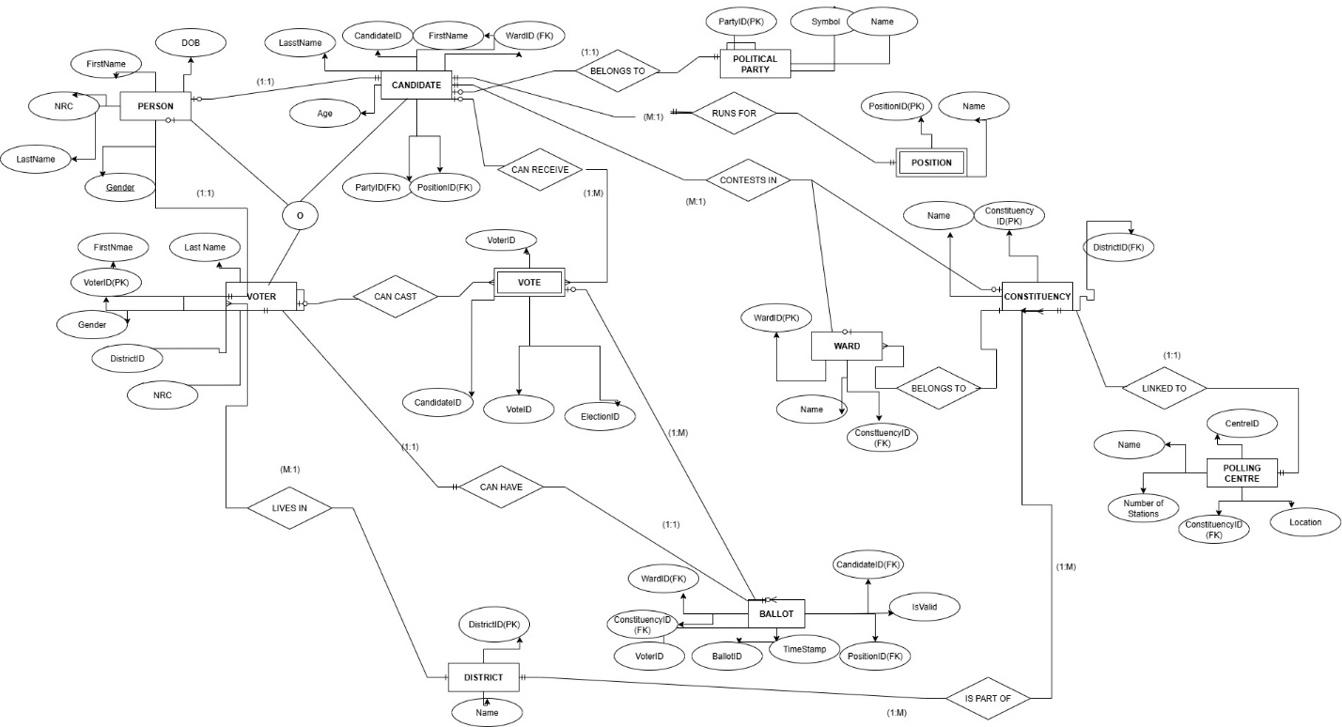

1. **TESTING DATA IN *BLANTYRE DISTRICT***

**PERSON**

|  |  |  |  |
| --- | --- | --- | --- |
| **FirstName** | **LastName** | **GENDER** | **DOB** |
| Madalitso | Banda | Male | 23/5/1999 |
| Alice | Mwale | Female | 20/3/1995 |

**VOTER**

|  |  |  |  |  |
| --- | --- | --- | --- | --- |
| **Voter-ID** | **FirstName** | **LastName** | **District-ID** | **Gender** |
| VID-12 | Laura | Mwamitawa | DID-12-C | Female |
| VID-13 | Steve | kosolo | DID-13-S | Male |

**VOTE**

|  |  |  |  |
| --- | --- | --- | --- |
| **Voter-ID** | **Vote-ID** | **Candidate-ID** | **Election-ID** |
| VID-16 | V-00 | C-2025-1 | E-120 |
| VID-20 | V-012 | C-2025-4 | E-70 |

**CANDIDATE**

|  |  |  |  |  |  |  |
| --- | --- | --- | --- | --- | --- | --- |
| **Candidate-ID** | **FirstName** | **LastName** | **Age** | **Party-ID** | **Position-ID** | **Ward-ID** |
| C-2025-1 | Micheal | Banda | 35 | pa-23-ss | PID-40 | W-30-S |
| C-2025-4 | Zawezi | Mtosa | 40 | pa-25-ss | PID-55 | W-40-S |

**POLITICAL PARTY(PARTY)**

|  |  |  |
| --- | --- | --- |
| **Party-id** | **Name** | **Symbol** |
| pa-23-ss | MCP | chicken |
| pa-25-ss | DPP | Maize Corn |

**BALLOT**

|  |  |  |  |
| --- | --- | --- | --- |
| **Ballot-ID** | **Ward-ID** | **Constituency-ID** | **Position-ID** |
| BA-20 | W-30-S | C-23-SS | PID-40 |
| BA-21 | W-40-S | C-24-SS | PID-55 |

**DISTRICT**

|  |  |
| --- | --- |
| **District-ID** | **Name** |
| DID-12-C | Blantyre |
| DID-13-S | Blantyre |

**CONSTITUENCY**

|  |  |  |
| --- | --- | --- |
| **Constituency-ID** | **Name** | **District-ID** |
| C-23-SS | Blantyre Rural East | DID-12-C |
| C-24-SS | Blantyre West | DID-13-S |

**WARD**

|  |  |  |
| --- | --- | --- |
| **Ward-ID** | **Name** | **Constituency-ID** |
| W-30-S | [Chilaweni](https://www.google.com/search?sca_esv=5c648e3aec9ca029&cs=1&sxsrf=AE3TifMo4BdsXW3TVv6tOZJRhYYYsXIxDQ%3A1754016125764&q=Chichiri-Misesa&sa=X&ved=2ahUKEwiRnOSgy-iOAxU9T0EAHZnyF-0QxccNegQIBRAE&mstk=AUtExfBDZBR9kve2nWZCfiy6URgC4x4BqDbYWe_N2GVqc02f0O2fsaDqhIyeFR0PCDSADR4oH55tv2o6Q90I8X6FcRDvk7UxLZcb-kf9Jl7_zgN6poOJgyY04MsAsx-pcES1Sz1tmJrBkafHLrPcDMXmYGLYT1vANfEK_PJ8oMsuoSeKLN3Wml3fY-hhoZK4fUNU9eHaITM_wEIWpIYDZQOPMyfkoLNPAGs6BS4Cw5xwtpBCGQ54nbmaA-NPSOpsQIdTtJBIdhalEQgQvyj2Hp-dSk3D&csui=3" \t "_blank) | C-23-SS |
| W-40-S | Chitukuko | C-24-SS |

**POSITION**

|  |  |
| --- | --- |
| **Position-ID** | **Name** |
| PID-40 | President |
| PID-55 | MP |

**POLLING CENTRE**

|  |  |  |  |  |
| --- | --- | --- | --- | --- |
| **Name** | **Constituency-ID** | **Location** | **Station Numbers** | **Centre-ID** |
| Chichiri Secondary Hall | C-30-SS | **Chichiri** | **2-l** | **C-78-B** |
| Chitawira Primary school | C-41-SS | **Chitawira** | **3-l** | **C-72-B** |

1. **MAPPING CONCEPTUAL SCHEMA TO RELATION/LOGICAL SCHEMA**

The mapping involved the following steps:

1. *Mapping of regular entity types*

* Person
* Candidate
* Voter
* Ballot
* Political Party
* Ward
* Position
* Constituency
* Polling Centre
* District

1. *Mapping of weak entities*

* Vote

1. *Mapping of Specialization/Generalization*

* Person (Super class)
* Option 2(Mapping)
* Candidate and Voter has person-ID as PK and FK

1. *Mapping of binary 1:1 relationship*

Person (1): Candidate (1)

Person (1): Voter (1)

Voter (1): Ballot (1)

Constituency (1): Polling Centre (1)

1. *Mapping of binary 1:M relationships*

District (1): Constituency (M)

Constituency (1): Wards (M)

Constituency (1): Polling Centre (M)

District (1): Voter (M)

Political Party (1): Candidates (M)

Position (1): Candidates (M)

Candidate (1): Vote (M)

Position (1): Candidate (M)

1. *Mapping of binary M:N relationships*

No many to many relationships

1. *Mapping Multivalued*

No multi valued attributes

1. THE LOGICAL/RELATIONAL SCHEMA DIAGRAM

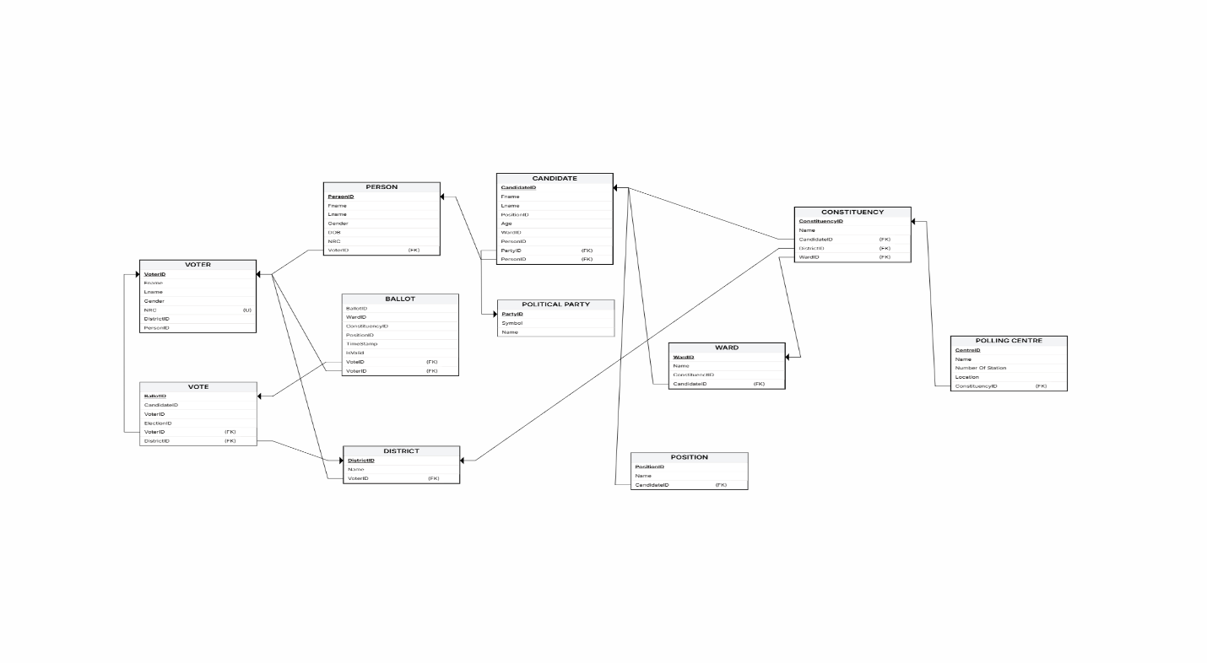

1. **THE PHYSICAL MODEL**
2. Translate logical data model for target DBMS
3. Design base relations

**PERSON**

|  |  |  |  |  |
| --- | --- | --- | --- | --- |
| **Attribute** | **Domain** | **Datatype** | **Length** | **Constraints** |
| PersonID | Unique person identifier | INT |  | PK, **AUTO\_INCREMENT** ,NOT NULL |
| FName | First name | VARCHAR | 50 | NOT NULL |
| LName | Last name | VARCHAR | 50 | NOT NULL |
| Gender | Gender type | ENUM |  | CHECK (“MALE”, ”FEMALE”)  NOT NULL |
| NRC | National registration card | VARCHAR | 15 | UNIQUE, NOT NULL |
| Date Of Birth | Birth date | DATE |  | NOT NULL |
| Address | Residential address | VAR CHAR | 150 | NULL ALLOWED |

**CANDIDATE**

|  |  |  |  |  |
| --- | --- | --- | --- | --- |
| **Attribute** | **Domain** | **Datatype** | **Length** | **Constraints** |
| CandidateID | Unique candidate identifier | INT |  | PK, **AUTO\_INCREMENT** ,NOT NULL |
| FName | Candidate first name | VARCHAR | 50 | NOT NULL |
| LName | Candidate Last name | VARCHAR | 50 | NOT NULL |
| Age | Candidate Age | INT |  | CHECK (Age >=18) |
| Gender | Candidate gender | ENUM |  | CHECK (“Female”, “Male”, “Other”) NOT NULL |
| PartyID | Related Party | INT |  | FK (Political Party) NOT NULL |
| PersonID | Related person | INT |  | FK Person (PersonID), UNIQUE |
| PositionID | Related position | INT |  | FK=>Position (PositionID), UNIQUE |
| WardID | Related ward | INT |  | FK=>Ward (WardID), UNIQUE |

**VOTER**

|  |  |  |  |  |
| --- | --- | --- | --- | --- |
| **Attribute** | **Domain** | **Datatype** | **Length** | **Constraints** |
| VoterID | Unique Voter Identifier | INT |  | PK, AUTO\_INCREMENT, NOT NULL |
| FName | Voter first name | VARCHAR | 50 | NOT NULL |
| LName | Voter Last name | VARCHAR | 50 | NOT NULL |
| NRC | National registration card | VARCHAR | 15 | UNIQUE, NOT NULL |
| DistrictID | Related District | INT |  | FK=>District(DistrictID), NOT NULL |
| PersonID | Related person | INT |  | FK=>Person (PersonID), UNIQUE |
| Gender | Gender | ENUM |  | CHECK(“Male”, “Female”,Other)NOT NULL |

**VOTE**

|  |  |  |  |  |
| --- | --- | --- | --- | --- |
| **Attribute** | **Domain** | **Datatype** | **Length** | **Constraints** |
| VoteID | Unique vote identifier | INT |  | PK, AUTO\_INCREMENT, NOT NULL |
| BallotID | Related ballot | INT |  | FK=>Ballot(BallotID),NOT NULL |
| VoterID | Related Voter | INT |  | FK=>Voter(VoterID),NOT NULL |
| CandidateID | Related candidate | INT |  | FK=>Candidate(CandidateID), NOT NULL |

**POSITION**

|  |  |  |  |  |
| --- | --- | --- | --- | --- |
| **Attribute** | **Domain** | **Datatype** | **Length** | **Constraints** |
| PositionID | Unique position identifier | INT |  | PK,AUTO\_INCREMENTT, NOT NULL |
| Name | Position name | VARCHAR | 50 | NOT NULL |
| CandidateID | Related constituency | INT |  | FK=>Candidate(CandiateID), NOT NULL |

**POLITICAL PARTY**

|  |  |  |  |  |
| --- | --- | --- | --- | --- |
| **Attribute** | **Domain** | **Datatype** | **Length** | **Constraints** |
| PartyID | Unique party identifier | INT |  | PK, AUTO\_INCREMENT, NOT NULL |
| Symbol | Party symbol | VARCHAR | 10 | UNIQUE |
| Name | Party Name | VARCHAR | 80 | UNIQUE, NOT NULL |

**BALLOT**

|  |  |  |  |  |
| --- | --- | --- | --- | --- |
| **Attribute** | **Domain** | **Datatype** | **Length** | **Constraints** |
| BallotID | Unique ballot identifier | INT |  | PK, AUTO\_INCREMENT, NOT NULL |
| WardID | Related ward | INT |  | FK Ward(WardID),NOT NULL |
| ConstituencyID | Related constituency | INT |  | FK Constituency(ConstituencyID),NOT NULL |
| PositionID | Related position | INT |  | FK Position(PositionID),NOT NULL |
| TimeStamp |  |  |  |  |
| isValid |  |  |  |  |
| VoterID | Related Voter | INT |  | FK Voter(VoterID),NOT NULL |
| VoteID | Related Vote | INT |  | FK Vote(VoteID),NOT NULL |

**CONSTITUENCY**

|  |  |  |  |  |
| --- | --- | --- | --- | --- |
| **Attribute** | **Domain** | **Datatype** | **Length** | **Constraints** |
| ConstituencyID | Unique constituency identifier | INT |  | PK, AUTO\_INCREMENT\_NOT NULL |
| CandidateID | Related constituency | INT |  | FK=>Candidate(CandiateID), NOT NULL |
| DistrictID | Related District | INT |  | FK=>District(DistrictID), NOT NULL |
| WardID | Related ward | INT |  | FK Ward(WardID),NOT NULL |
| Name | Constituency name | VARCHAR | 100 | NOT NULL |

**WARD**

|  |  |  |  |  |
| --- | --- | --- | --- | --- |
| **Attribute** | **Domain** | **Datatype** | **Length** | **Constraints** |
| WardID | Unique ward identifier | INT |  | PK,AUTO\_INCREMENT, NOT NULL |
| ConstituencyID | Related constituency | INT |  | FK Constituency(ConstituencyID),NOT NULL |
| CandidateID | Related constituency | INT |  | FK=>Candidate(CandiateID), NOT NULL |
| Name | Ward name | VARCHAR | 100 | NOT NULL |

**POLLING CENTRE**

|  |  |  |  |  |
| --- | --- | --- | --- | --- |
| **Attribute** | **Domain** | **Datatype** | **Length** | **Constraints** |
| CenterID | Unique center identifier | INT |  | PK,AUTO\_INCTREMENT, NOT NULL |
| Name | Polling center name | VARCHAR | 100 | NOT NULL |
| Number of station | Number of stations | INT |  | NOT NULL |
| Location | Center location | VARCHAR | 100 | NOT NULL |
| ConsituencyID | Related constituency | INT |  | FK Constituency(ConstituencyID),NOT NULL |

**DISTRICT**

|  |  |  |  |  |
| --- | --- | --- | --- | --- |
| **Attribute** | **Domain** | **Datatype** | **Length** | **Constraints** |
| DistrictID | Unique district identifier | INT |  | PK, AUTO\_INCREMENT, NOT NULL |
| Name | District name | VARCHAR | 100 | NOT NULL |
| VoterID | Related Voter | INT |  | FK Voter(VoterID),NOT NULL |

1. Design representation of derived data

Age = Year-Year of birth

1. Design general constraints

* Voter canot vote if not registered
* Candidate cannot be in the system without registering
* Voter is allowed to vote only once
* Candidate is supposed to have a single candidate id
* Candidate is supposed to run for a single position

1. **DESIGN FILE ORGANIZATIONS AND INDEXES**
2. Analyze transactions

* Voter registration
* Candidate Registration
* Vote casting

Attributes that are updated:

Number of votes in a candidate

Number of voters

Number of candidates

CROSS MATRIX

|  |  |  |  |  |
| --- | --- | --- | --- | --- |
| ENTITY | CREATE | READ | UPDATE | DELETE |
| Person | C | R | U | - |
| Voter | C(Register Voter) | R | U | - |
| Candidate | C(Nomination) | R | U(Update profile history) | - |
| Political Party | C | R | U(Update symbols,leadership) | D |
| Ward | C | R | U(boundary adjustments) | - |
| Position | C | R | U | - |
| Constituency | C | R | U | - |
| District | C | R | U | - |
| Ballot | C(generated for election) | R | - | - |
| Vote | C(when cast) | R(counting) | - | - |