Requirements Specification

for

KU Bookstore

Version 1.0 approved

Christopher Herdoiza

Laura Slocum

Niklas Meissner

KU Edwards_IT 811

3/10/22

Table of Contents

Table of Contents ii

Revision History ii

1. Introduction 1

1.1 Purpose 1

1.2 Document Conventions 1

1.3 Intended Audience and Reading Suggestions 1

1.4 Product Scope 1

1.5 References 1

2. Overall Description 2

2.1 Product Perspective 2

2.2 Product Functions 2

2.3 User Classes and Characteristics 2

2.4 Operating Environment 2

2.5 Design and Implementation Constraints 2

2.6 User Documentation 2

2.7 Assumptions and Dependencies 3

3. External Interface Requirements 3

3.1 User Interfaces 3

3.2 Hardware Interfaces 3

3.3 Software Interfaces 3

3.4 Communications Interfaces 3

4. System Features 4

4.1 System Features by Weight 4

4.2 Software Quality Attributes 5

5. Additional Requirements 4

5.1 Business Rules 5

Revision History

|  |  |  |  |
| --- | --- | --- | --- |
| **Name** | **Date** | **Reason For Changes** | **Version** |
| Christopher Herdoiza | 3/5/22 | Initial Draft | .05 |
| Christopher, Laura & Niklas | 3/10/22 | Final Draft | 1.0 |

# Introduction

## Purpose

Release .05

The scope of this work is to re-build the KU Bookstore website as a modern and student-oriented hub. The new bookstore website will focus on flexibility for students as well as administrators.

## Document Conventions

This document will dictate high-level requirements. Low-level requirements will be assumed. Arial font is utilized as standard font. Bold within the body of content will be considered priority content.

## Intended Audience and Reading Suggestions

This document is intended for the core development team and will dictate high-level requirements. The suggested sequence to be read is numerical in nature. Certain requirements may focus more on different members.

## Product Scope

Shape the KU Bookstore website into a pro-student offering. If the KU Bookstore operated pro-student, then local third-party stores would not exist. The KU Bookstore needs to match and exceed what is provided by third-party venues. Retention of KU Bookstore as a profit center is a priority, with the inclusion of a student focused business model.

## References

[KU Bookstore](https://www.kubookstore.com/)

[UMKC Bookstore](https://www.umkcbookstore.com/)

[K-State Bookstore](https://www.bkstr.com/kansasstatestore/home)

[Chiefs Website](https://www.chiefs.com/)

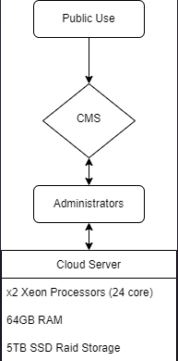

# Overall Description

## Product Perspective

The KU Bookstore website will be a complete rebuild (top-to-bottom) of the current KU bookstore website. The CMS (content management system), base code and host servers will be replaced.

## Product Functions

|  |  |
| --- | --- |
| **Requirements** | **Description** |
| **Ease of Use** | **Responsiveness**  The site should be responsive to the screen size. The following sizes should be utilized:   * Desktop -1920×1080 * Tablet - 1366×768 * Mobile - 640×360   **Browser Compatibility**  The site should be compatible with the following browsers:   * Chrome * Edge * Firefox * Safari |
| **Latency** | Maximum of 2 second response time from 10mbps connection over ethernet on a modern machine. |
| **Multiple Payment Methods** | The site should be able to accept the following payment methods   * Visa   + Debit & Credit * Mastercard   + Debit & Credit * American Express   + Debit & Credit * Discover   + Debit & Credit * Paypal * Cryptocurrency * Android Pay * Apple pay * Beak’em Bucks   The site should integrate with the Stripe API to provide secure payments. |
| **Simulated Merchandise Preview** | The user should be able to upload an image. The site should be able to place that photo on specified merchandise and show a rendering to the user.   * The merchandise picture should have a static place for the uploaded picture. * The user will not be able to move the picture on merchandise. * The user should crop the picture before uploading to the site. |
| **Ticket Sales** | * Provide an event calendar for all KU Athletics * Clicking an event on the calendar will deep link into KU Athletics website to purchase tickets. |
| **Automatic Price Matching** | The site should automatically price match merchandise & equipment with the following websites:   * Amazon - Books, Apparel, Equipment * Rally House - Apparel * Chegg - Books * Apple - Equipment * Best Buy – Equipment |
| **Community Hub** | The site should offer a forum to be utilized by students and staff for any academic purpose. The user will use their existing KU login.  The following are user roles for the forum:  **Administrator -** Director of KU Bookstore   * User Management   **Staff -** KU Bookstore Staff   * Moderation * User Management   **Faculty**   * Moderation   **Student**   * Community Hub Access |
| **Discount Hub** | The site should offer a list of establishments that offer discounts to students for the following:   * Restaurants * Electronics * Clothes * Events * Books * Travel * KU Clearance |
| **In-text Book Search** | The site should offer the ability to search for category-based keywords in textbooks. The site should return the results by searching the text of all books for the specified key words.   * The user will specify the category of books to search. For example, economics majors should only search in economic books. * The user should have the ability to further refine the search by   + Date   + Author   + Publisher   + Type of publication (book, magazine, journal, etc) |
| **Outdoor Pick-up/Drop-Off** | The site should allow the user to schedule:   * Book return & pickup * Repair drop off & Pickup * Merchandise pickup |
| **Online Course Signup** | The site should offer the ability to enroll in courses.   * Link to the course selection page of Enroll & Pay. * The user can enroll and pay for classes on the Enroll & Pay site. |
| **Feedback Functionality** | **Support Functionality**   * Chat * Phone * Email * The user should have the ability to review merchandise.   + The user must be logged into their KU account to create a review. |

## User Classes and Characteristics

**Administrator**

* + Total CMS functionality
  + User Management

**Staff**

* + Inventory & Sales Management
  + Community Hub Management
  + Chat Support

**Faculty**

* + Access to all front-end functionality
  + Community Hub Access & Moderation

**Student**

* + Access to all front-end functionality
  + Community Hub Access

**General Use**

* + Access to all front-end functionality

## Operating Environment

* Off-Site Hosting
  + Azure – Upscaling and load balancing
* CMS
  + Custom CMS designed for KU Bookstore
    - Angular
* Community Hub Access
  + Tribe
* Payment Processing
  + Stripe
* Security
  + HTTPS

## Design and Implementation Constraints

* **Development Limitations**
  + Develop within the parameters of the CMS (Custom CMS)
    - API Limitations
      * Price Matching
  + SQL Database
  + SSO – KU AD ID Login
* **Payment Processors**
  + The site should integrate with the Stripe API to provide secure payments.
  + All Major Debit & Credit Cards: Visa, Mastercard, American Express and Discover
  + Debit Cards
  + Paypal
  + Cryptocurrency
  + Android Pay
  + Apple Pay
  + Beak’em Bucks
  + Cash (In Store only)

## User Documentation

* CMS Guide
* Azure Administration Guide
* Tribe Moderation Guide

## Assumptions and Dependencies

* Integration with KU SSO login
* Payment API access
* Price Match API access
* Publisher API access
* IT department to setup mailbox for feedback

# External Interface Requirements

## User Interfaces

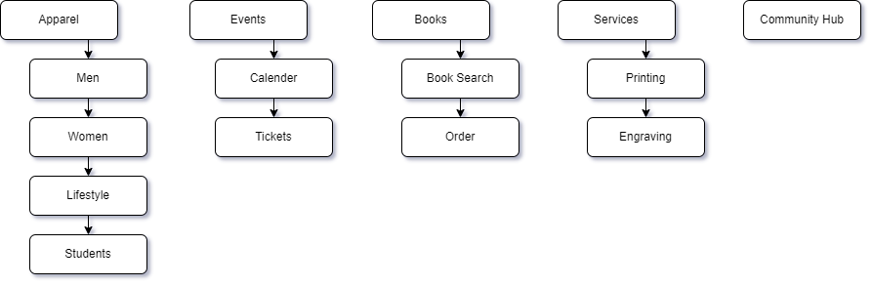

**Navigation**

The menu should provide categories of pages. Links to individual pages should be listed in the sub-menu. The menu layout should be:

* Apparel
  + Men
  + Women
  + Lifestyle
  + Students
* Events
  + Calendar
  + Tickets
* Books
  + Book Search
  + Order
* Services
  + Printing
  + Engraving
* Community Hub
* Header
  + Search
  + Cart
* Account Login

**Remainder to be design by UX team**

## Hardware Interfaces

Azure with upscaling with load balancing. Registers will utilize Microsoft Surface Tablets for payment processing. In-store payments will occur directly on the website, with a cash option available to Staff only. Offline-in-store orders will be possible if an outage occurs.

## Software Interfaces

* KU’s ADID system
* Feedback email inbox
* Chatbot for AI chat support
* Community Hub
  + Tribe
  + Pull user type from AD account
* SQL Database
* Azure App Services

## Communications Interfaces

* **Browser Support:** Edge, Firefox, Chrome, and Safari will be supported
* **Mobile Device Support:** Windows, iOS & Android

# System Features

## System Features by Weight

|  |  |  |  |  |
| --- | --- | --- | --- | --- |
| **Criteria** | **WT** | **K-State Bookstore** | **UMKC Bookstore** | **Chiefs.com** |
| Ease of Use | .2 | 4 | 3 | 5 |
| Latency/Performance | .15 | 2 | 3 | 5 |
| Multiple Payment Methods | .05 | 1 | 1 | 5 |
| Simulated Merchandise Previews | .05 | 1 | 1 | 1 |
| Ticket Sales | .15 | 0 | 0 | 5 |
| Auto Price Match | .1 | 0 | 0 | 0 |
| Community Hub | .1 | 0 | 0 | 0 |
| Discount Hub | .05 | 3 | 3 | 0 |
| In-Text Book Search | .025 | 0 | 0 | 0 |
| Outdoor Pick-up/Drop-off | .025 | 1 | 1 | 1 |
| Online Course Signup | .05 | 0 | 0 | 1 |
| Feedback Functionality | .05 | 3 | 3 | 5 |
| Analysis Score | 1.0 | **=1.525** | **=1.475** | **=3.124** |

## Software Quality Attributes

Adaptability (Responsiveness), availability (Accessibility), correctness, flexibility (Upgradeability), maintainability (Maintenance Free, Azure based), portability (Ease of Migration), reliability (99% uptime), testability (Unit and Integration Testing), and usability (UI/Cart Ease of Use).

# Business Rules

Web development will be completed solely by administrators/developers and reviewed by the staff prior to moving into production. This includes modification of the community hub. Staff will handle inventory, sales management, and customer services. Administrators require written approval to access customer data and or sales data.