**CSE 224 - Homework**

**Question**

The Lucas sequence has the same recursive relationship as the [Fibonacci sequence](https://en.wikipedia.org/wiki/Fibonacci_sequence), where each term is the sum of the two previous terms, but with different starting values.

The first few Lucas numbers are

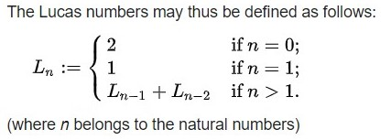2, 1, 3, 4, 7, 11, 18, 29, 47, 76, 123, ....

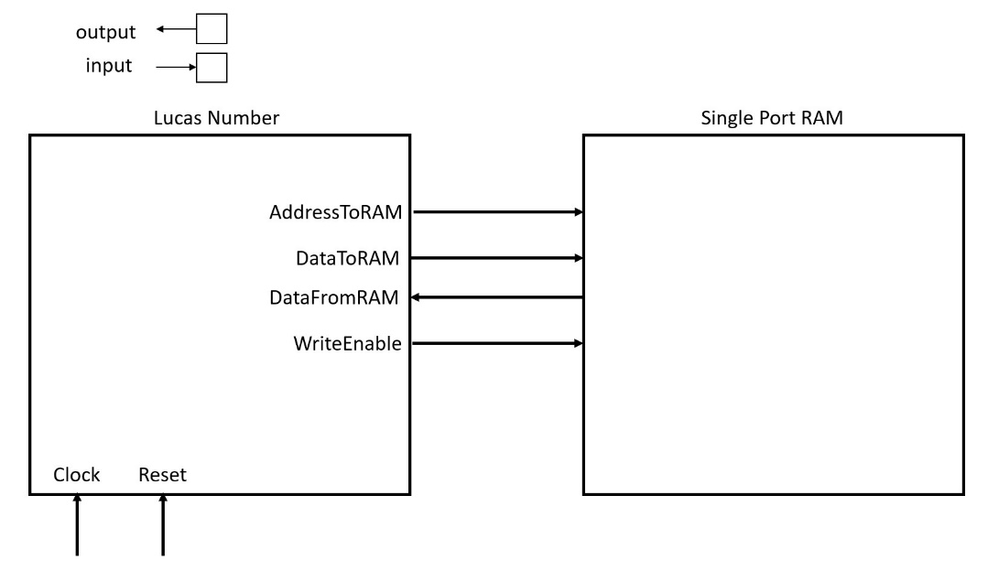From given information design a model which calculates each Lucas number. Your model must use a single port RAM and needs to read Ln-1 and Ln-2 from you RAM and write back the newly found Lucas number. Example block design is given below. Assume your RAM is empty. (HINT: Due to this you need to write initial conditions into RAM first). You do not need to design a RAM only design Lucas Number block.

1. Explain for how many states you need and what are you going to implement in that given each state (20 points)
2. Create inputs, outputs and necessary registers and sequential block for this design (10 points)
3. Rest of the design (70 points)
4. BONUS: create a testbench for your design. In your testbench you can call single port ram as singlePortRAM (10 points)

ONLY UPLOAD YOUR DESİGN! NOT THE WHOLE PROJECT!

UPLOAD EXAMPLE FİLE: NAME_SURNAME.zip