
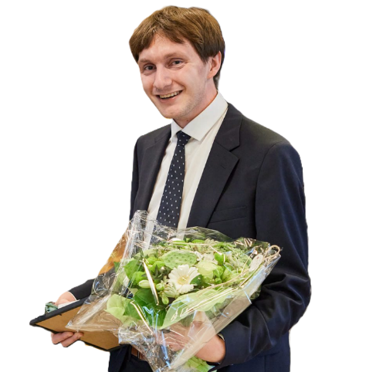
Education

Laust Rask
27 years old
M.Sc. Nanoscience 2025
+45 22 90 71 49
laustrask@live.dk

Nanoscience graduate with research experience in computational chemistry, QM/MM, and high-performance computing. Strong background in scientific analysis and writing, complemented by leadership experience as chairman of the Nanoscience Study Council.
University of Copenhagen 2020-2025
M.Sc. & B.Sc. Nanoscience


Projects
Master Thesis: The project involved simulation of electron transfer through a molecular junction utilising quantum master equations. Grade: 10 (B)
Bachelor Thesis: Implementation of core excitations in Cluster Perturbation Theory this was done using the core-valence separation approximation. Grade: 12 (A)


Work Experience
Nanoscience Study Council // Chairman 2021-2024
Led the council for two years, representing student interests, coordinating meetings, and facilitating communication between students and faculty.
Ankerpladsen Agersø // Bistro Manager 2020
Responsible for coordinating a small team, handling customer service and maintaining high operational standards.
Moment // Substitute worker 2019-2020
Took on a variety of temporary roles, quickly adapting to new tasks and workplaces as needed.

Languages

Fluent in Danish and English, communication level in German and learning French.

Achievements

Nanoscience Student of the Year 2022 & 2024

Skills

Computational & Programming
- Quantum Chemistry software: Dalton, Orca, VeloxChem, Penguin, VMD, etc.
- Programming, data processing and visualisation: Mainly in Python due to its flexibility
Scientific & Analytical
- Scientific writing and documentation: LaTeX, Word
- Presentation and communication skills. Especially due to my education in the Danish
- Critical analysis of both experimental and theoretical data

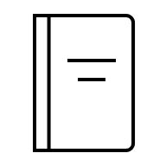
Publication List
Accepted:
A. E. Hillers-Bendtsen, M. B. Johansen, T. J. v. Buchwald, P. G. I. L. Dünweber, L. H. Olsen, L. Rask, G. I. Junker, R. M. H. Knudsen, K. V. Mikkelsen “Penguin: A Python-based Program for Electronic Structure Calculations based on Coupled Cluster Theory” The Journal of Physical Chemistry A (Accepted 2025)
In Progress:
L. Rask, K. V. Mikkelsen ”Conductance of a SubPc Molecular Junction using Redfield Theory” TBD (2025)

For more information please visit:
laustrask.github.io

