FlowPilot User Guide
From client request to accountable delivery
A brief client message can lose its meaning as it moves between people. FlowPilot keeps the request beside a proposed task, asks a person to confirm scope and ownership, then gives the team a visible path to delivery and review.
Request | Human review | Team delivery | Client sign-off
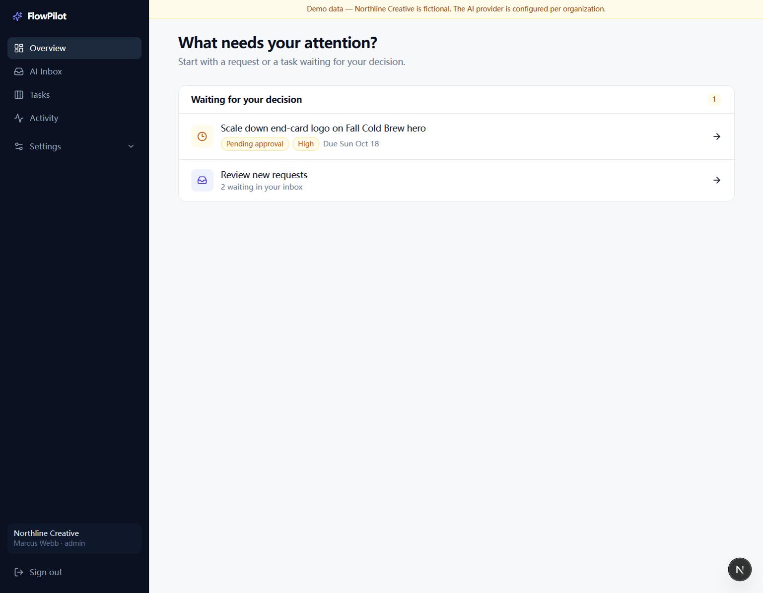
Overview: decisions and new requests are collected in one focused queue.
The value: AI can prepare the handoff; a person remains accountable for approval and completion.

01 Review the incoming request
Use the inbox to compare the original message with the proposed interpretation before any work is released.
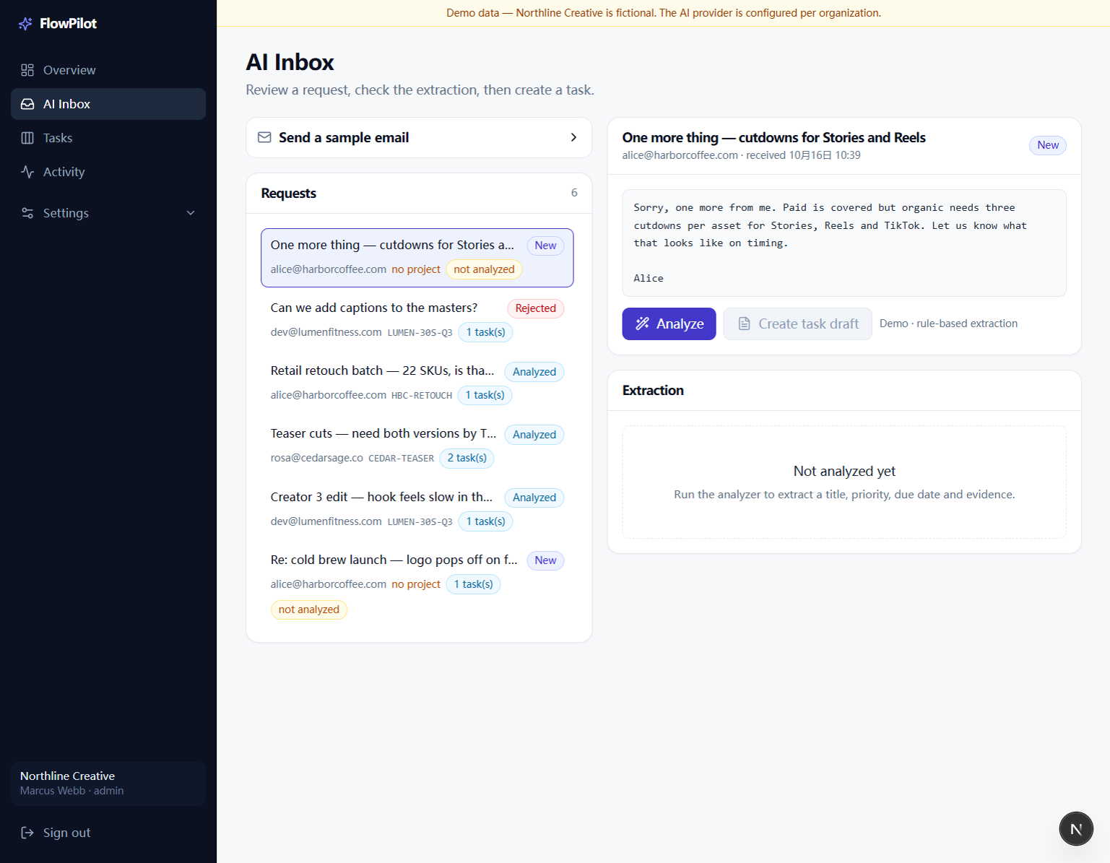
AI Inbox: source message, request list, and extraction review.
1. Select a request. Read the original message and confirm who sent it and which client or project it concerns.
2. Choose Analyze. Check the suggested title, evidence, priority, due date, and project. Correct uncertain or missing details.
3. Create a task draft. The draft moves to Tasks for a human review; analysis alone never approves work.
Demo scope: The sample email action simulates intake. It does not read a live mailbox in this build.

02 See work across the team
The board makes ownership and progress visible. Use filters to focus on one project or teammate.
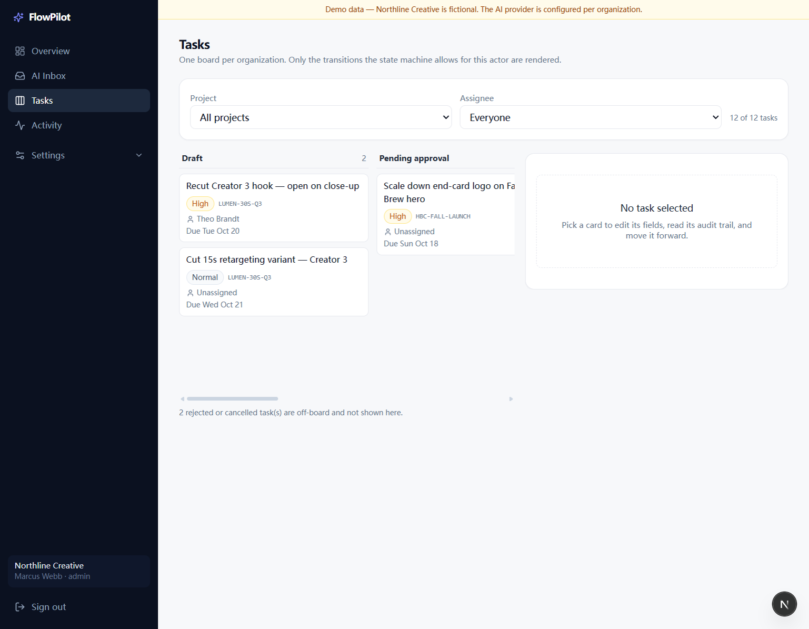
Tasks: active work is grouped by its current state.
1. Filter the board. Choose a project and, when useful, an assignee.
2. Open a card. Review its priority, due date, project, and owner in the detail panel.
3. Scroll horizontally. The remaining workflow columns continue off-screen. Only transitions allowed for your role and the task state are offered.
Board states: Draft, Pending approval, Ready, In progress, In review, and Completed. Rejected or cancelled work leaves the active board.

03 Coordinate the task
Keep the assignment, checkpoints, discussion, and delivery reference with the work itself.
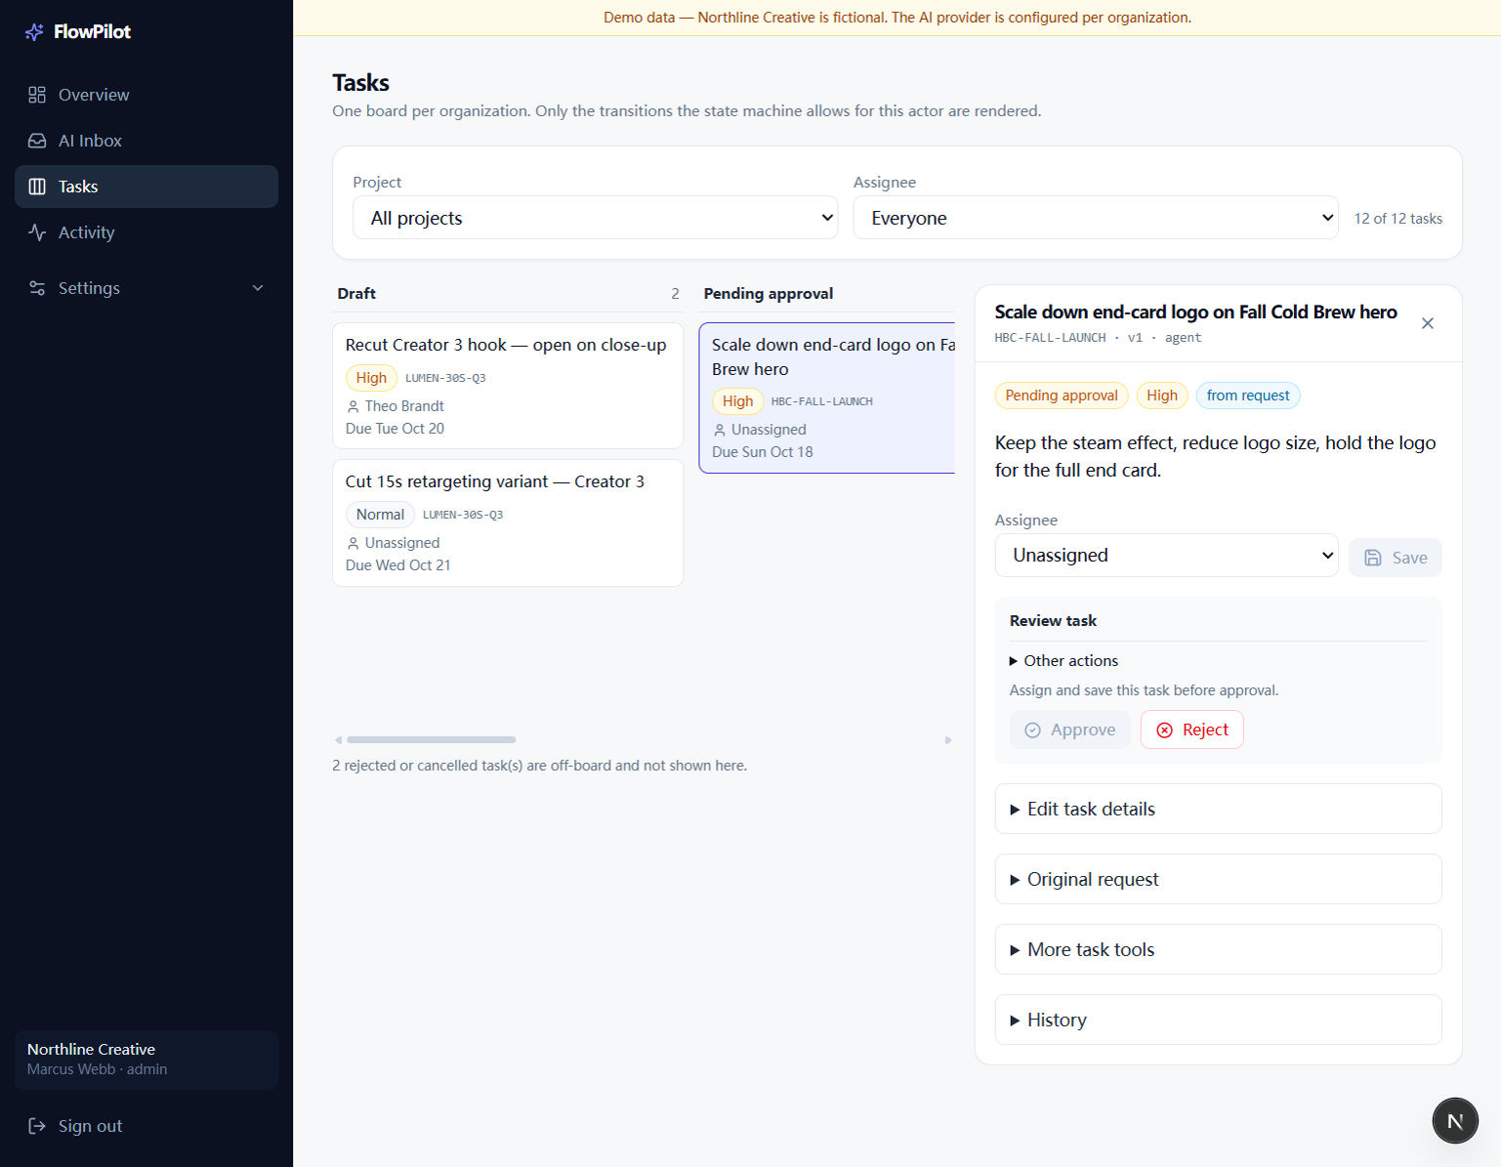
Task detail: assignment, review decision, original request, and task history.
1. Assign and save. A pending task must have an owner before a manager approves it; a manager may reject it without assigning it.
2. Respect the work gates. Prerequisites must be complete before work starts; checklist items must be complete before the task enters review.
3. Keep a useful record. Add comments, checklist updates, effort estimates, delivery or reference links, and manually logged time as the work changes.
Files: Links point to external files. FlowPilot does not upload or version those files.

04 Close the loop and review the record
Activity gives a manager one place to review events, workflow runs, approvals, and agent activity.
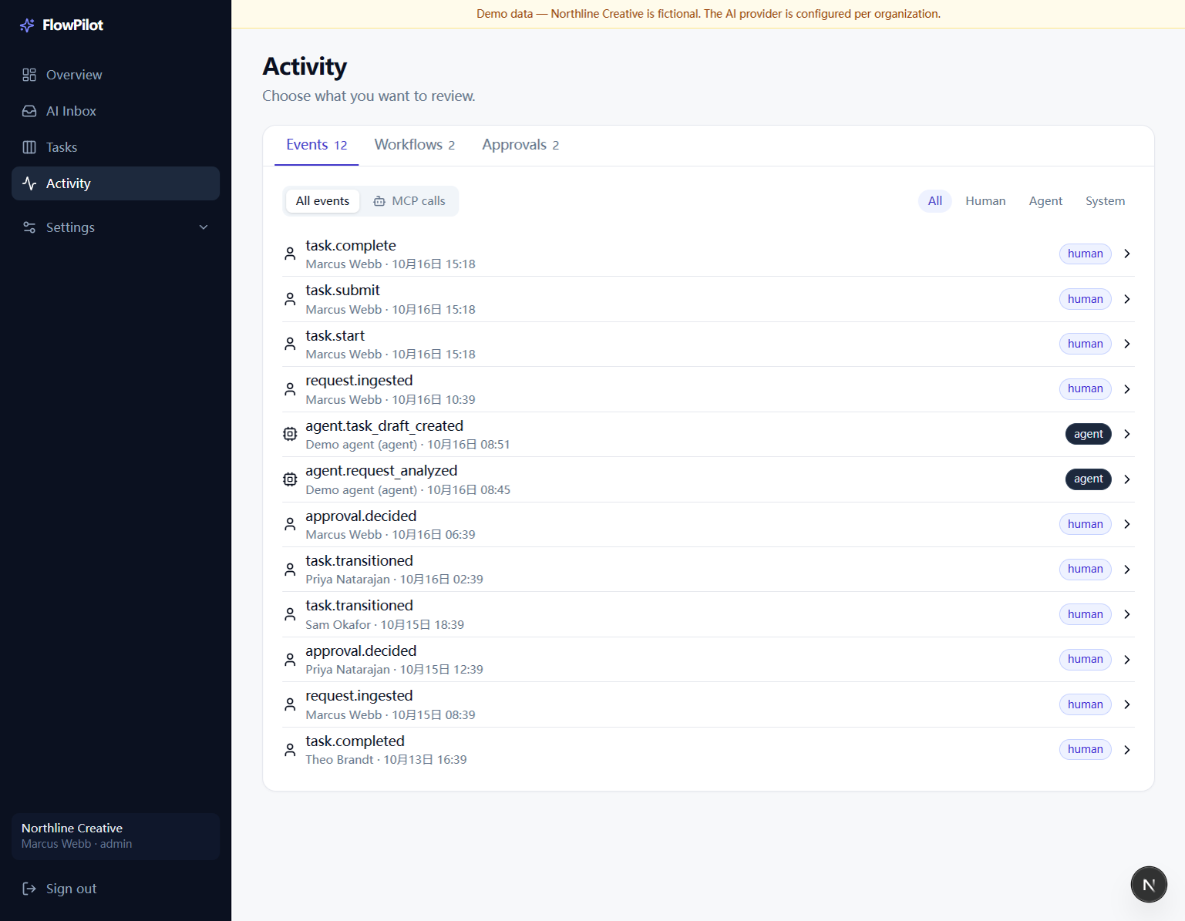
Activity: filter the audit trail by event type and by Human, Agent, or System.
1. Choose a view. Use Events, Workflows, or Approvals, then filter the list by actor or MCP calls.
2. Open a record. Confirm who acted, what changed, and whether an agent call created a draft or a person made the decision.
3. Request client sign-off. When the task is in review and has delivery links, a manager can create and manually send a separate review link. It expires after 14 days.
Client view: The client can approve or request changes. The page shows task and delivery details, not internal comments, estimates, or the source email. The team completes the task after sign-off.

05 Check your external connections
Settings separates a working sample workflow from integrations that are not connected yet.
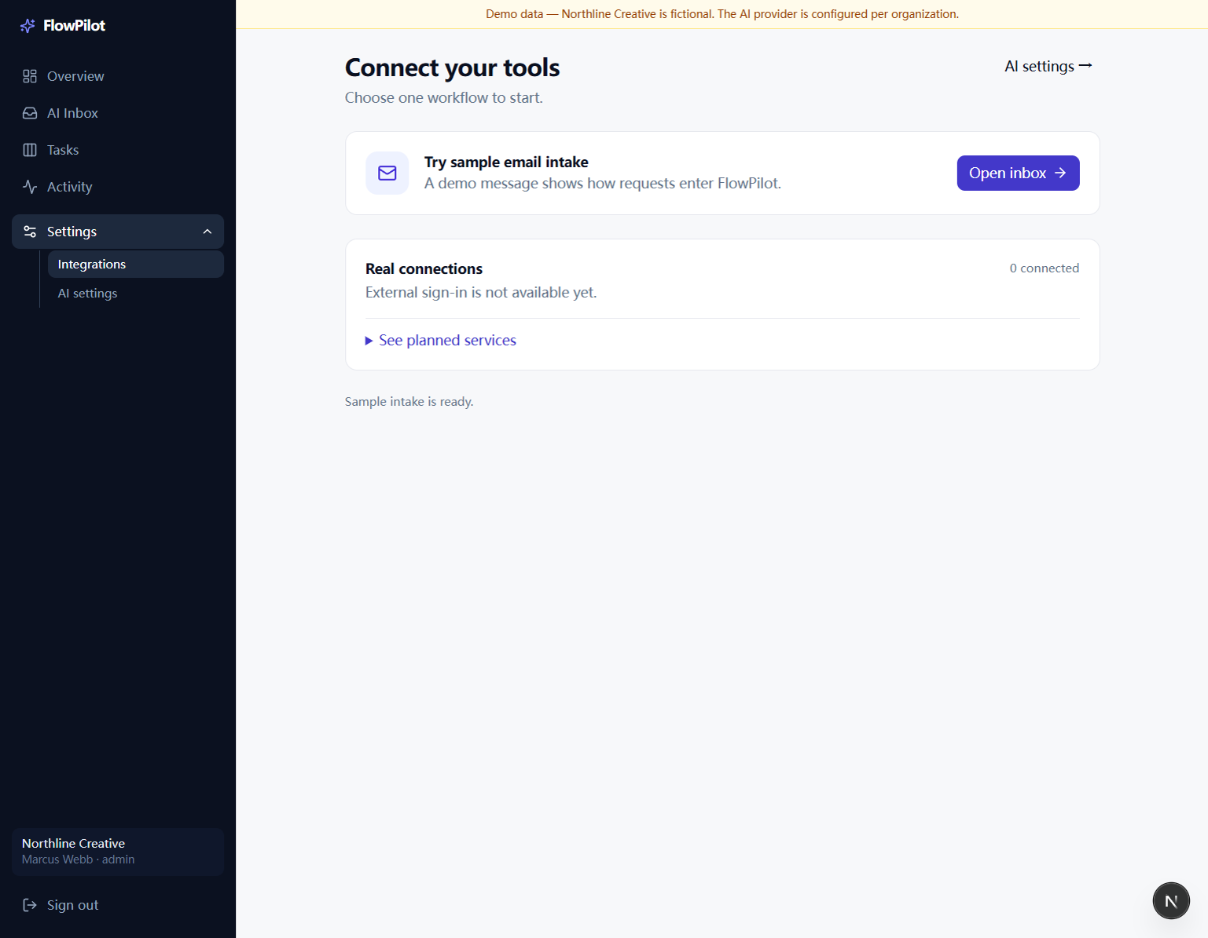
Settings > Integrations: sample intake is available; live connections are reported separately.
1. Open Integrations. Review the connected count and expand planned services to see the connector roadmap.
2. Use the sample intake. Open the inbox to demonstrate the request-to-draft workflow without connecting an external mailbox.
Current boundary: Live Gmail, Slack, and ClickUp sign-in or synchronization are not enabled in this build. Do not treat the sample email as a real connector.

06 Configure request analysis
An organization owner or admin can keep analysis offline or configure an OpenAI-compatible provider.
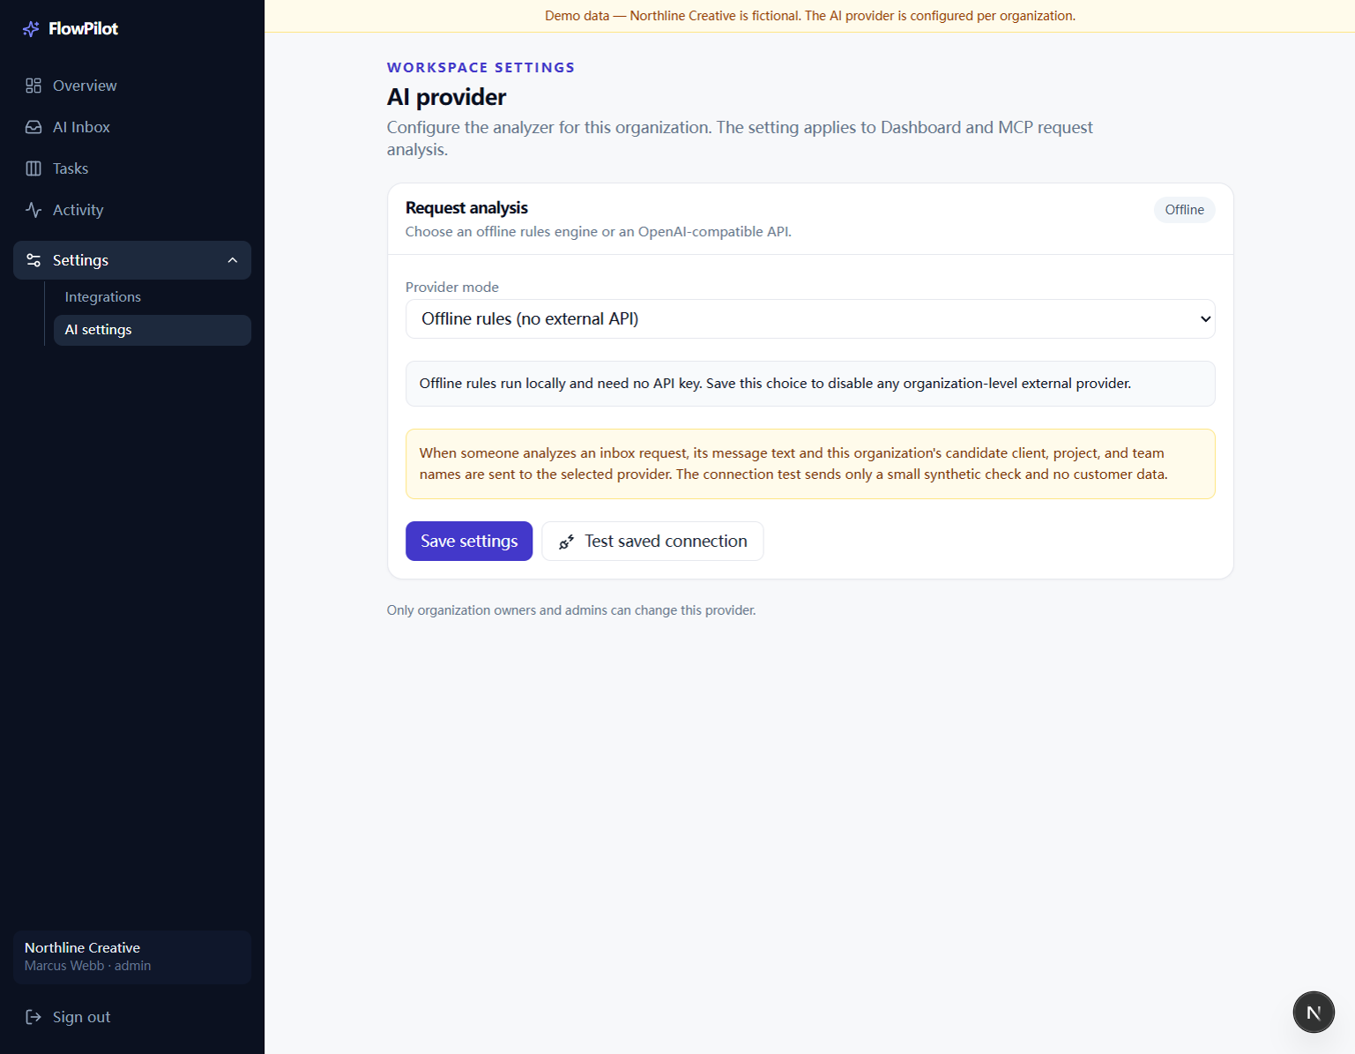
AI settings: select the analysis mode, save it, and test the saved connection.
1. Choose a mode. Offline rules need no external API. For an external model, enter its compatible base URL, model, and API key, then save.
2. Test the saved connection. The test sends synthetic content only. Real request analysis sends the message text and candidate client, project, and team names to the selected provider.
Credential handling: The API key is stored server-side and is not returned to the browser. Review your provider's data terms before analyzing client material.
Optional agent access: A scoped MCP token can let an agent find requests, analyze them, and create drafts. Agents cannot approve drafts; a person must make that decision.

