User Manual

1. Personal Information Update :

The program firstly ask you to enter your ID



You will see your current information after you enter currect ID

and then you can choose to update it

If you want, enter "y" (without ")

You can update name or city here, just enter which field you want to change



Then, you will enter new content of the selected field

The changes you made will be shown on the screen

To continue, enter y again. Move next, enter n

Next Page will show an example particular to this section

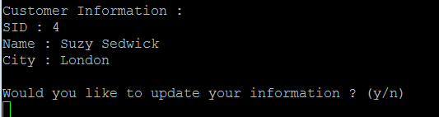

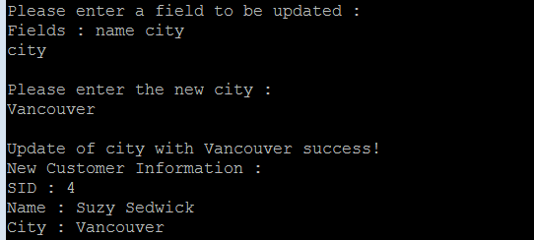

2. Purcahse:

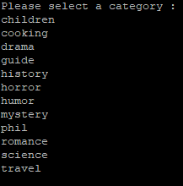

Next, the system requiers a book title

After entering title, there will be a confirm of your choice

Notice: If you type category or book title wrong,

An error message will occur.

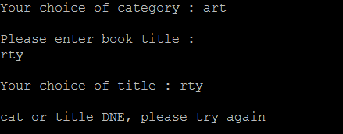

Customer choose right category and right title will pop up all the book related information

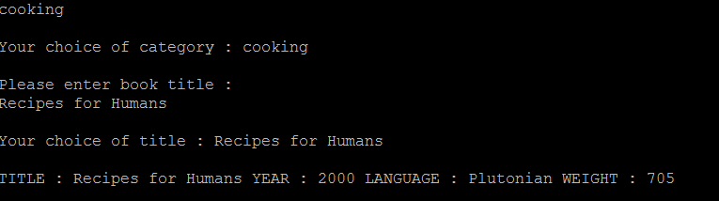

If customer not purchase the book it will say goodbye to the person

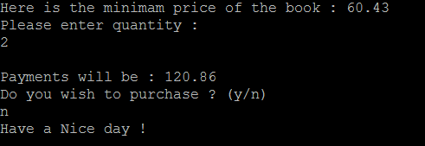

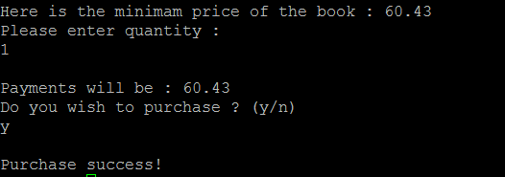

If the purchase success, my database will add this transection

Environment set up command(compile the java code)

0. Prepare: APPs.java

1. Open terminal in Linux

2. Type "source ~db2leduc/cshrc.runtime" (after %)

3. Type "db2 connect to c3421a"

4. Make sure APPs.java is in current directory

and type "javac APPs.java"

5. If step 4 success without any error,

type "java APPs"

Source Code

**import** java.sql.Connection;

**import** java.sql.DriverManager;

**import** java.sql.PreparedStatement;

**import** java.sql.ResultSet;

**import** java.sql.SQLException;

**import** java.sql.Timestamp;

**import** java.text.SimpleDateFormat;

**import** java.util.ArrayList;

**import** java.util.Date;

**import** java.util.Scanner;

**public** **class** APPs {

**private** Connection conDB;

**private** String url;

**private** **int** custID;

**private** String custName;

**private** String city;

**private** String cat;

**private** String title;

**private** **int** year;

**private** String club;

**private** **double** total;

**public** **void** APPS() {

}

**public** **boolean** findCust() {

String queryText = ""; // The SQL text.

PreparedStatement querySt = **null**; // The query handle.

ResultSet answers = **null**; // A cursor.

**boolean** result = **false**; // Return.

queryText = "SELECT * " + "FROM yrb_customer " + "WHERE cid = " + custID;

**try** {

querySt = conDB.prepareStatement(queryText);

} **catch** (SQLException e) {

System.***out***.println("SQL#1 failed in prepare");

System.***out***.println(e.toString());

System.*exit*(0);

}

**try** {6

answers = querySt.executeQuery();

} **catch** (SQLException e) {

System.***out***.println("SQL#1 failed in execute");

System.***out***.println(e.toString());

System.*exit*(0);

}

**try** {

**if** (answers.next()) {

result = **true**;

custName = answers.getString("name");

city = answers.getString("city");

} **else** {

custName = **null**;

city = **null**;

result = **false**;

}

} **catch** (SQLException e) {

System.***out***.println("SQL#1 failed in cursor.");

System.***out***.println(e.toString());

System.*exit*(0);

}

// Close the cursor.

**try** {

answers.close();

} **catch** (SQLException e) {

System.***out***.print("SQL#1 failed closing cursor.\n");

System.***out***.println(e.toString());

System.*exit*(0);

}

// We're done with the handle.

**try** {

querySt.close();

} **catch** (SQLException e) {

System.***out***.print("SQL#1 failed closing the handle.\n");

System.***out***.println(e.toString());

System.*exit*(0);

}

**return** result;

}

**public** **boolean** update(String field, String value) {

String queryText = ""; // The SQL text.

PreparedStatement querySt = **null**; // The query handle.

queryText = "UPDATE yrb_customer" + " SET " + field + " = " + "'" + value + "'" + " WHERE cid = " + custID;

**try** {

querySt = conDB.prepareStatement(queryText);

} **catch** (SQLException e) {

System.***out***.println("SQL#1 failed in prepare");

System.***out***.println(e.toString());

System.*exit*(0);

}

**try** {

**int** a = querySt.executeUpdate();

} **catch** (SQLException e) {

System.***out***.println("SQL#1 failed in execute");

System.***out***.println(e.toString());

System.*exit*(0);

}

**try** {

querySt.close();

} **catch** (SQLException e) {

System.***out***.print("SQL#1 failed closing the handle.\n");

System.***out***.println(e.toString());

System.*exit*(0);

}

**return** **true**;

}

**public** **boolean** showCat() {

String queryText = ""; // The SQL text.

PreparedStatement querySt = **null**; // The query handle.

ResultSet answers = **null**; // A cursor.

**boolean** result = **false**;

queryText = "SELECT * " + "FROM yrb_category ";

**try** {

querySt = conDB.prepareStatement(queryText);

} **catch** (SQLException e) {

System.***out***.println("SQL#1 failed in prepare");

System.***out***.println(e.toString());

System.*exit*(0);

}

**try** {

answers = querySt.executeQuery();

} **catch** (SQLException e) {

System.***out***.println("SQL#1 failed in execute");

System.***out***.println(e.toString());

System.*exit*(0);

}

**try** {

**while** (answers.next()) {

System.***out***.println(answers.getString("cat"));

}

result = **true**;

} **catch** (SQLException e) {

System.***out***.println("SQL#1 failed in cursor.");

System.***out***.println(e.toString());

System.*exit*(0);

}

**return** result;

}

**public** **boolean** chooseBook() {

String queryText = ""; // The SQL text.

PreparedStatement querySt = **null**; // The query handle.

ResultSet answers = **null**; // A cursor.

**boolean** result = **false**;

queryText = "SELECT title, year, language, weight FROM yrb_book WHERE " + "title = " + "'" + title + "'"

+ " and cat = " + "'" + cat + "'";

**try** {

querySt = conDB.prepareStatement(queryText);

} **catch** (SQLException e) {

System.***out***.println("SQL#1 failed in prepare");

System.***out***.println(e.toString());

System.*exit*(0);

}

**try** {

answers = querySt.executeQuery();

} **catch** (SQLException e) {

System.***out***.println("cat or title DNE, please try again");

System.***out***.println();

answers = **null**;

result = **false**;

}

**try** {

**while** (answers.next()) {

title = answers.getString("title");

year = answers.getInt("year");

String language = answers.getString("language");

**int** weight = answers.getInt("weight");

System.***out***.println(

"TITLE : " + title + " YEAR : " + year + " LANGUAGE : " + language + " WEIGHT : " + weight);

result = **true**;

}

} **catch** (SQLException e) {

System.***out***.println("SQL#1 failed in cursor.");

System.***out***.println(e.toString());

System.*exit*(0);

}

**return** result;

}

**public** **double** getMin() {

String queryText = ""; // The SQL text.

PreparedStatement querySt = **null**; // The query handle.

ResultSet answers = **null**; // A cursor.

**double** result = 0.0;

queryText = "select * from yrb_offer where price = (" + "select min(T.price) as min_price from "

+ "(select o.club, o.title, o.year, o.price " + "from yrb_member m, yrb_offer o "

+ "where o.club = m.club and m.cid = " + custID + " and o.title = " + "'" + title + "'"

+ " and o.year = " + year + ") T)";

**try** {

querySt = conDB.prepareStatement(queryText);

} **catch** (SQLException e) {

System.***out***.println("SQL#1 failed in prepare");

System.***out***.println(e.toString());

System.*exit*(0);

}

**try** {

answers = querySt.executeQuery();

} **catch** (SQLException e) {

System.***out***.println("SQL#1 failed in execute");

System.***out***.println(e.toString());

System.*exit*(0);

}

**try** {

**if** (answers.next()) {

result = answers.getDouble("price");

club = answers.getString("club");

}

} **catch** (SQLException e) {

System.***out***.println("SQL#1 failed in cursor.");

System.***out***.println(e.toString());

System.*exit*(0);

}

**return** result;

}

**public** **boolean** setPurchase(String time, **int** q) {

String queryText = ""; // The SQL text.

PreparedStatement querySt = **null**; // The query handle.

queryText = "insert into yrb_purchase values " + "(" + custID + ", " + "'" + club + "'" + ", " + "'" + title

+ "'" + ", " + year + ", " + "'" + time + "'" + ", " + q + ")";

**try** {

querySt = conDB.prepareStatement(queryText);

} **catch** (SQLException e) {

System.***out***.println("SQL#1 failed in prepare");

System.***out***.println(e.toString());

System.*exit*(0);

}

**try** {

**int** a = querySt.executeUpdate();

} **catch** (SQLException e) {

System.***out***.println("SQL#1 failed in execute");

System.***out***.println(e.toString());

System.*exit*(0);

}

**try** {

querySt.close();

} **catch** (SQLException e) {

System.***out***.print("SQL#1 failed closing the handle.\n");

System.***out***.println(e.toString());

System.*exit*(0);

}

**return** **true**;

}

**public** **static** **void** main(String[] args) {

APPs app = **new** APPs();

**try** {

Class.*forName*("com.ibm.db2.jcc.DB2Driver").newInstance();

} **catch** (ClassNotFoundException e) {

e.printStackTrace();

System.*exit*(0);

} **catch** (InstantiationException e) {

e.printStackTrace();

System.*exit*(0);

} **catch** (IllegalAccessException e) {

e.printStackTrace();

System.*exit*(0);

}

app.url = "jdbc:db2:c3421a";

**try** {

app.conDB = DriverManager.*getConnection*(app.url);

} **catch** (SQLException e) {

System.***out***.print("\nSQL: database connection error.\n");

System.***out***.println(e.toString());

System.*exit*(0);

}

// main program

**boolean** check = **false**;

// find the customer

**while** (!check) {

System.***out***.println("Please enter customer ID (an integer) :");

Scanner sc = **new** Scanner(System.***in***);

String input = sc.nextLine();

app.custID = Integer.*parseInt*(input);

**if** (!app.findCust()) {

System.***out***.println();

System.***out***.println("Customer DNE, please try again.");

System.***out***.println();

} **else** {

check = **true**;

System.***out***.println();

System.***out***.println("Customer Information :");

System.***out***.println("SID : " + app.custID);

System.***out***.println("Name : " + app.custName);

System.***out***.println("City : " + app.city);

System.***out***.println();

}

}

// choose updates

check = **false**;

**while** (!check) {

System.***out***.println("Would you like to update your information ? (y/n)");

Scanner sc = **new** Scanner(System.***in***);

String input = sc.nextLine();

**if** (input.equals("n")) {

check = **true**;

System.***out***.println();

System.***out***.println("No changes made, lets move on.");

System.***out***.println();

} **else** **if** (input.equals("y")) {

System.***out***.println("Please enter a field to be updated :");

System.***out***.println("Fields : name city");

Scanner sc2 = **new** Scanner(System.***in***);

String input2 = sc2.nextLine();

System.***out***.println();

System.***out***.println("Please enter the new " + input2 + " :");

Scanner sc3 = **new** Scanner(System.***in***);

String input3 = sc3.nextLine();

System.***out***.println();

app.update(input2, input3);

System.***out***.println("Update of " + input2 + " with " + input3 + " success!");

**if** (input2.equals("name")) {

app.custName = input3;

} **else** {

app.city = input3;

}

System.***out***.println("New Customer Information :");

System.***out***.println("SID : " + app.custID);

System.***out***.println("Name : " + app.custName);

System.***out***.println("City : " + app.city);

}

}

// show all cats, select a cat

check = **false**;

**while** (!check) {

System.***out***.println();

System.***out***.println("Please select a category :");

app.showCat();

System.***out***.println();

Scanner sc = **new** Scanner(System.***in***);

String input = sc.nextLine();

app.cat = input;

System.***out***.println();

System.***out***.println("Your choice of category : " + app.cat);

// choose title

System.***out***.println();

System.***out***.println("Please enter book title :");

Scanner sc2 = **new** Scanner(System.***in***);

String input2 = sc.nextLine();

app.title = input2;

System.***out***.println();

System.***out***.println("Your choice of title : " + app.title);

System.***out***.println();

**if** (app.chooseBook()) {

check = **true**;

} **else** {

System.***out***.println("cat or title DNE, please try again");

check = **false**;

}

}

// choose book, give price

check = **false**;

**while** (!check) {

System.***out***.println();

System.***out***.println("Please enter the year of the book which you want to choose : ");

Scanner sc = **new** Scanner(System.***in***);

String input = sc.nextLine();

app.year = Integer.*parseInt*(input);

System.***out***.println();

System.***out***.println("Your final choice is : ");

System.***out***.println("" + app.title + " " + app.year);

System.***out***.println();

**double** minPrice = app.getMin();

System.***out***.println("Here is the minimam price of the book : " + minPrice);

System.***out***.println("Please enter quantity : ");

Scanner sc2 = **new** Scanner(System.***in***);

String input2 = sc2.nextLine();

**int** quantity = Integer.*parseInt*(input2);

app.total = minPrice * quantity;

System.***out***.println();

System.***out***.println("Payment will be : " + app.total);

System.***out***.println("Do you wish to purchase ? (y/n)");

Scanner sc3 = **new** Scanner(System.***in***);

String input3 = sc3.nextLine();

**if** (input3.equals("n")) {

check = **false**;

System.***out***.println("Have a Nice day !");

} **else** {

Date date = **new** Date();

SimpleDateFormat ft = **new** SimpleDateFormat("yyyy-MM-dd hh:mm:ss");

String t = ft.format(date);

app.setPurchase(t, quantity);

check = **true**;

System.***out***.println();

System.***out***.println("Purchase success!");

}

}

}

}