

### QQI

### HIGHER DIPLOMA IN SCIENCE IN COMPUTING

### FINAL EXAMINATIONS 2018

**SEPTEMBER INTAKE**

*Module Code:* **B8IT119**

*Module Description:* **Advanced Programming**

*Examiner:* **Mr Darren Redmond**

*Internal Moderator:* **Mr Harnaik Dhoot**

*External Examiner:* **Dr Faheem Bukhatwa**

*Date:* ***Wednesday 14th March***

*Time:* ***18:30 – 20:30***

**INSTRUCTIONS TO CANDIDATES**

**Time allowed is 2 hours.**

**Section A is mandatory – 50 marks**

**Section B - Answer any TWO (2) questions (25 marks each).**

### Section A

### Question 1

1. Dublin Gas & Electricity Services have hired you to develop an application that will be used as part of their electric & gas billing system. Your first step towards building this system is to write a very basic prototype system using Windows Forms that **emulates** accessing a database system.

You are concerned with 2 main entities:

* a list storing a number of gas & electricity meter records
* a list storing customer account records.

These lists will hold the following data:

**Gas Meter Records**

|  |  |  |  |
| --- | --- | --- | --- |
| MeterID | VolumeUsed | HasBeenServiced | OwnerAccountID |
| 100 | 6805 | True | 50001 |
| 101 | 13609 | True | 50002 |
| 102 | 28115 | False | 50003 |
| 103 | 32191 | False | 50004 |
| 104 | 19100 | False | 50005 |

**Account Records**

|  |  |  |  |
| --- | --- | --- | --- |
| AccountID | EirCode | PaymentPeriod | ArrearsCount |
| 50001 | DV4R102 | 2 | 2 |
| 50002 | DV4R103 | 1 | 2 |
| 50003 | DV4R104 | 4 | 1 |
| 50004 | DV4S101 | 3 | 0 |
| 50005 | DV4S102 | 1 | 0 |
| 50006 | DV4S103 | 2 | 0 |

The PaymentPeriod can be interpreted as follows:

|  |  |
| --- | --- |
| 1 | Annual |
| 2 | Bi-annual |
| 3 | Quarterly |
| 4 | Monthly |

Non-zero ArrearsCount values represent accounts that are in debt to Dublin Gas & Electricity Services, e.g., AccountID = 50002 is 12 months (2 arrears x Bi-Annual) in arrears.

NOTE: This question **does not** require you to make use of SQL Server.

1. Create classes to represent the two entities identified, i.e., gas meters and accounts.

**(2 * 2 = 4 marks)**

1. Make appropriate use of 2 data structures to store the above sample data records. Ensure you use object initialisation syntax to create the above sample data records.

**(2 * 3 = 6 marks)**

1. In your Windows Form application produce a master-detail view of the above two “tables” by making use of 2 data grid views. Ensure the top data grid displays the details of the gas meters, while the bottom one reflects the account associated with a given meter.

**(5 + 5 = 10 marks)**

1. Provide a number of LINQ queries that allow Dublin Gas & Electricity Services staff to satisfy the following requirements:
   1. Sort the data in the gas meter grid by either MeterID or by VolumeUsed.

**(5 marks)**

* 1. A Customer Arrears Report that is invoked via a button click. This shows the customer accounts that are in arrears. Your report needs to be “normalised” by displaying arrears in months; in other words, you will need to convert non-monthly periods into their month equivalents.

**(15 marks)**

* 1. A Summary Report that is invoked via another button click. This report shows the total volume of gas used as well as the total number of accounts that are in arrears.

**(10 marks)**

**(Total: 50 marks)**

### Section B

### Question 2

1. What software patterns are in use when using the stream architecture and implementation in .NET? What are the benefits from using these techniques?

**(2 + 3 = 5 marks)**

1. Write a Windows Forms application that consists of one main form.

This form should have a title of “ABC College Registration”.

The main body of the form should provide labelled edit boxes to enable the capture of first name, surname, organization and conference ID. Ensure your form also has a Register button.

**(2 marks)**

1. The registration ID must match a regular expression pattern with the form ^CONF_(ARTS|BUSINESS|LAW)$. This regular expression should be stored in the app.config file—do not hard code the expression in your code.

When the Register button is clicked, if the user has entered a badly formatted registration faculty your code should notify the user of this fact and place the focus back on the registration faculty edit box.

**(5 marks)**

1. Your code also needs to validate the first name and surname fields to ensure they have a minimum length of 2 characters.

If this validation fails notification to the user should be done.

Focus should be placed on appropriate incorrect field UNLESS the faculty type field is also in error.

If both surname and first name fields are in error, then the surname field takes precedence for focus.

**(5 marks)**

1. Finally, if all fields are valid, save the details entered to a binary file.

**(8 marks)**

Please submit a file named CollegeRegistration.cs and app.config to contain your app configuration.

**(Total: 25 Marks)**

### Question 3

1. Ireland Creche Limited requires an application to handle the records of the babies attending the creche. In order to prepare for this, you have decided to write a list class that will hold baby records in it. You have also added methods to this class to add and remove baby records. The baby class should have fields to hold information such as id, first-name, surname, start date and end date, address, contact number, parents.

The business rules for the baby class are as follows:

|  |  |  |
| --- | --- | --- |
| Rule | Parameters | Requirement |
| End Date | EndDate (DateTime) | This cannot be a future date. This cannot be before the start date. |
| Contact Number | ContactNumber (string) | This must start with either 0, 00, or + and cannot be more than 16 characters long. |

* 1. Write code for the baby class and the baby list class. Note: you are **not** expected to derive your list class from ICollection<T>

**(5 marks)**

* 1. Create a Test project that will test your baby list class and your baby records. Write at least 2 test methods for the list class and 2 for your baby class.

**(15 marks)**

1. Test Driven Development has been described as Snake Oil – causing more problems than benefits that it delivers. To what extent do you agree/disagree with this statement? Please provide reasoning for your view.

**(5 marks)**

**(Total: 25 Marks)**

### Question 4

The following url has a list of famous quotations. The url returns the list of quotations in json format.

https://raw.githubusercontent.com/btford/philosobot/master/quotes/cats.json

Implement an application that will invoke on the endpoint, and can receive the json response.

**(10 Marks)**

Then parse the json response into an appropriate list object.

**(10 Marks)**

Design an appropriate windows form layout that can show the quotations in a list

view on the screen

**(5 Marks)**

Please submit a zipped C Sharp project for your application.

**(Total: 25 Marks)**

### Question 5

1. Write a Python program which accepts a row of delimited data and the delimiter used and writes out the individual data fields to the screen as per Figure 3 below.

***Figure 1***

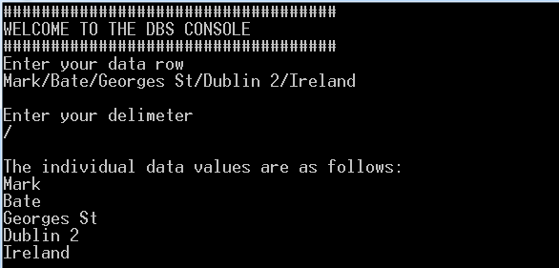

**(10 Marks)**

1. Write a program in Python to accept a grade and using a conditional statement declare the equivalent description as per Figure 2 below.

Use the following table for the possible grades and descriptions:

|  |  |
| --- | --- |
| **Grade** | **Description** |
| E | Excellent |
| V | Very Good |
| G | Good |
| A | Average |
| F | Fail |

***Figure 2***

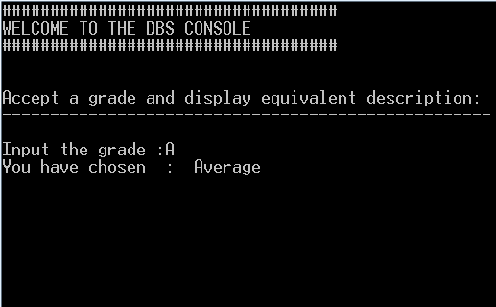

**(15 Marks)**

**(Total: 25 Marks)**

**END OF EXAMINATION**