STEP 1: Load the Dataset
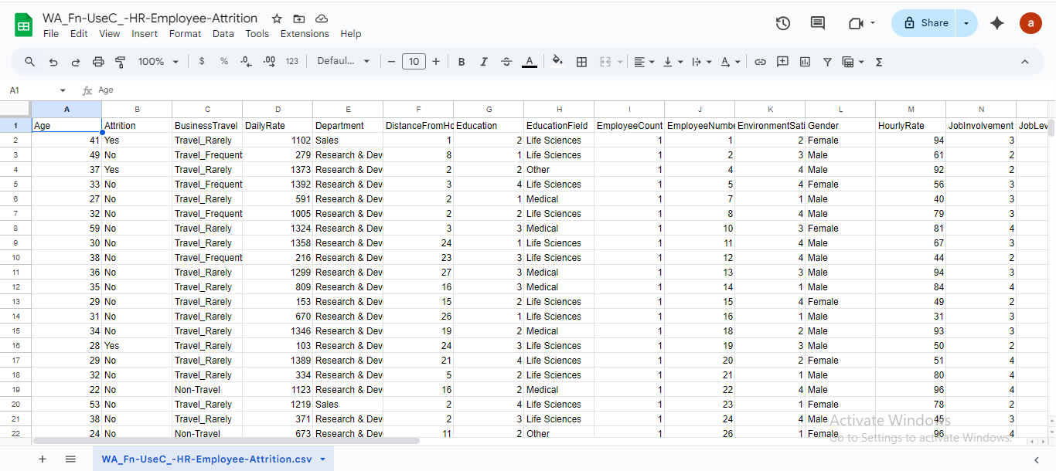

STEP 2: Clean & Prepare the Dataset
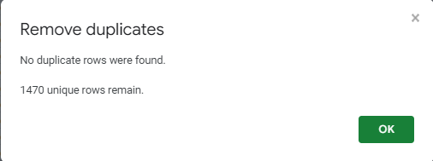
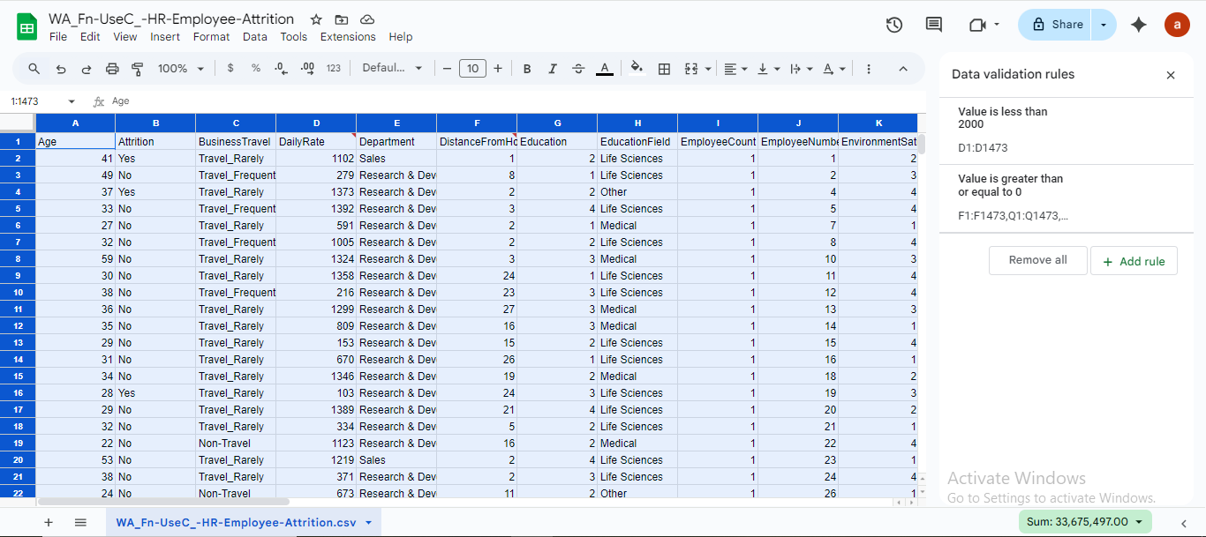
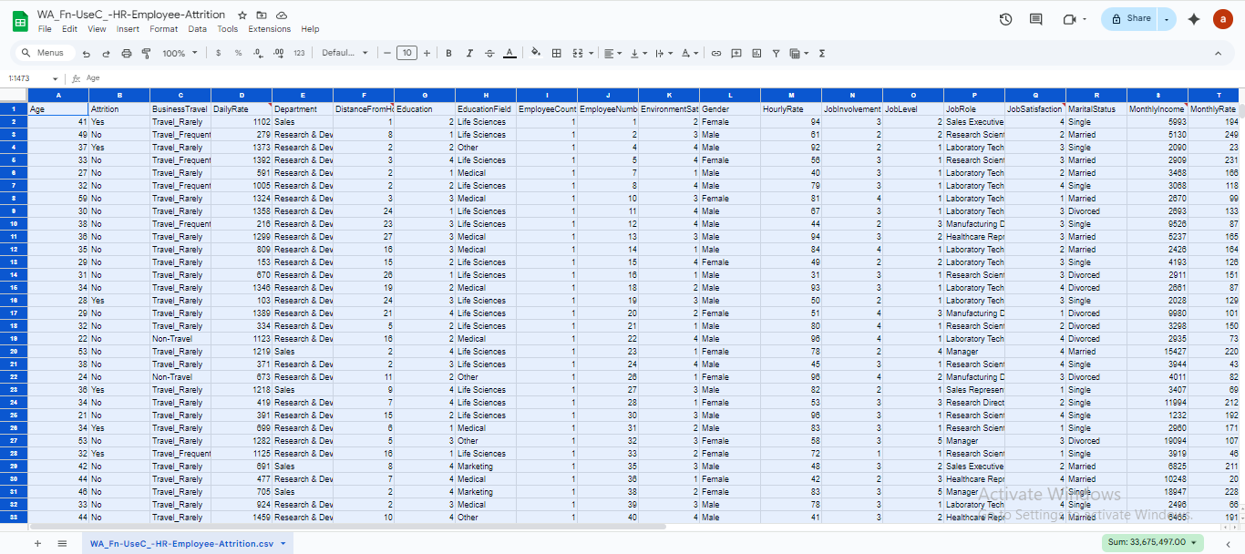

STEP 3: Convert CSV to ARFF
( actually not needed )

STEP 4: Load Dataset in Weka Explorer
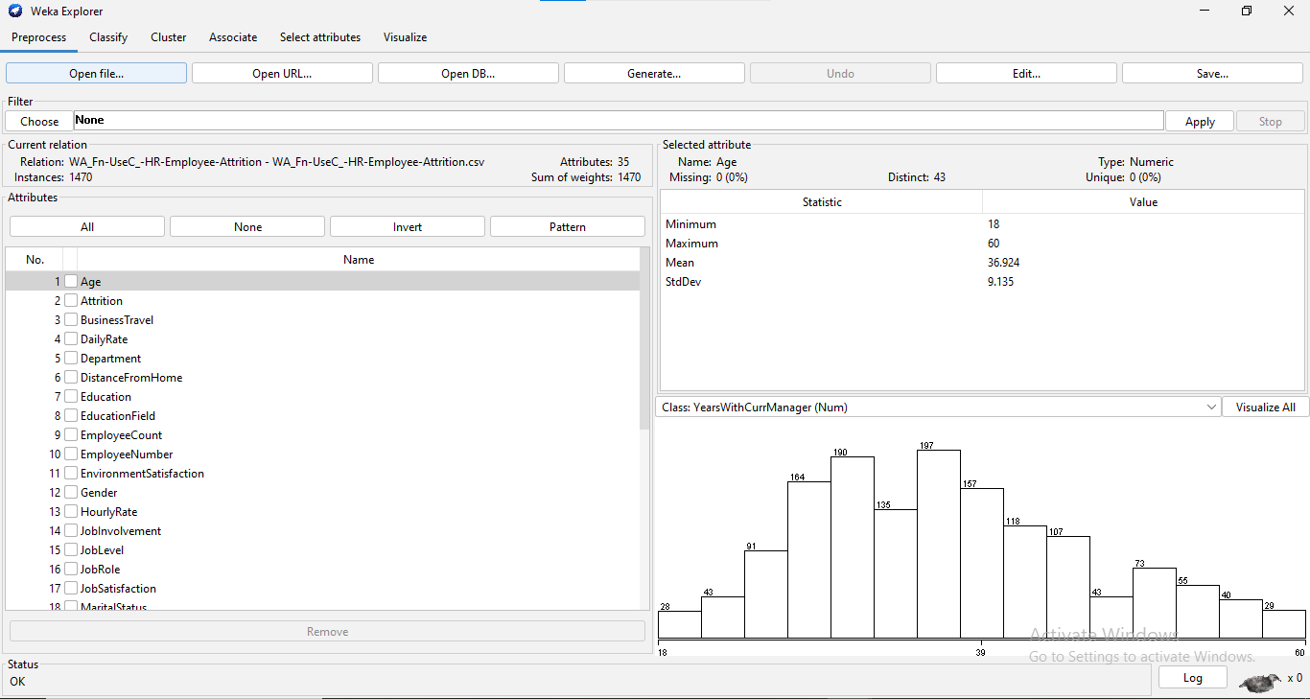

STEP 5: Explore Attributes & Visualize Patterns
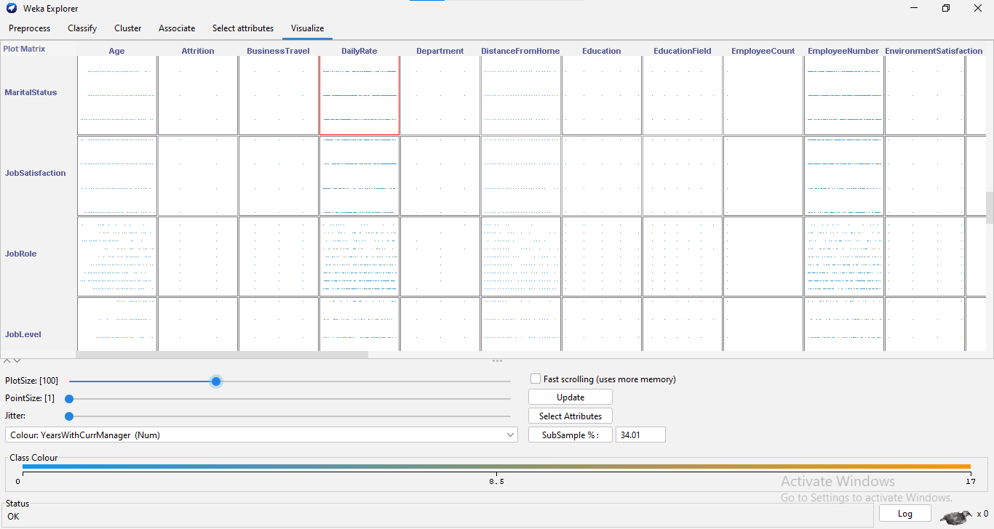
○ Attrition vs Job Satisfaction
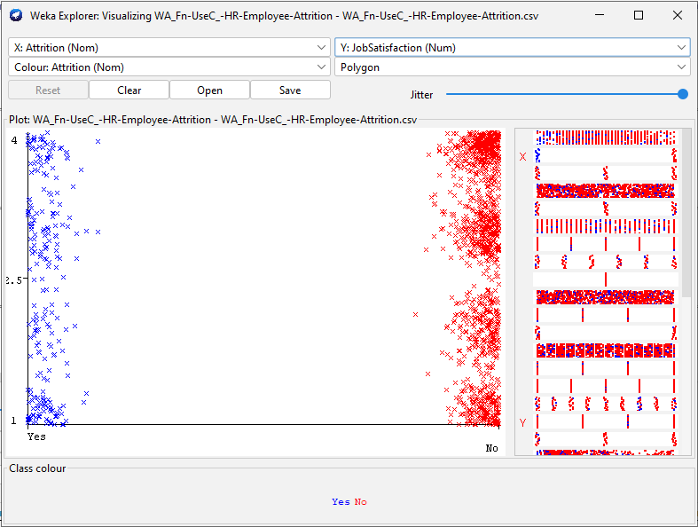
○ Attrition vs OverTime
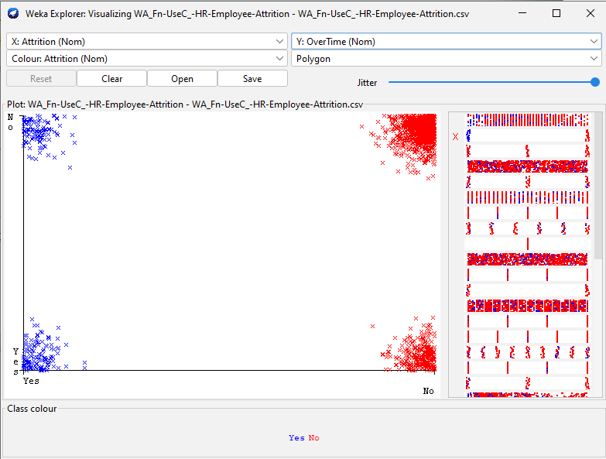
○ Histograms
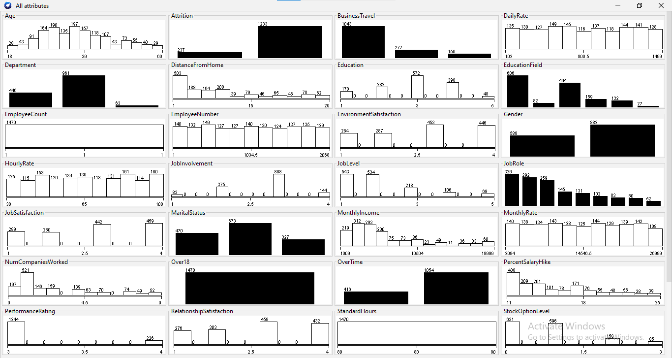

STEP 6: Create Visual Narratives in Flourish
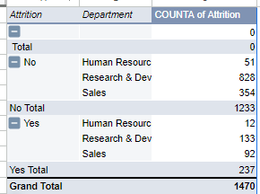
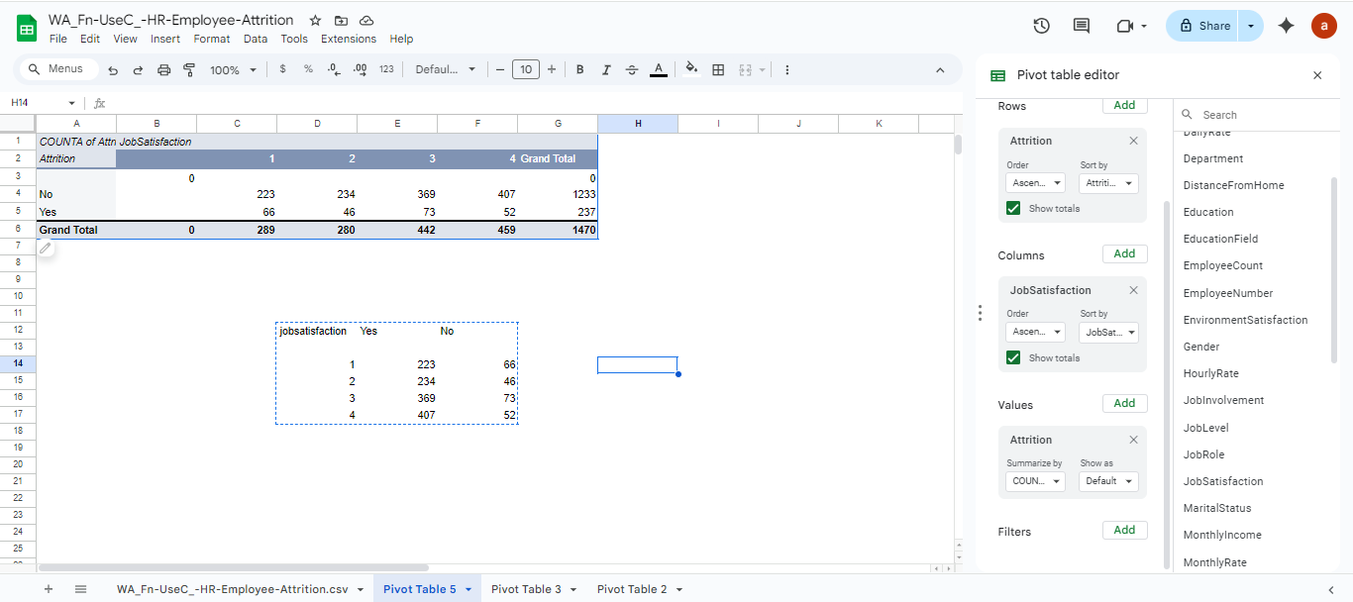

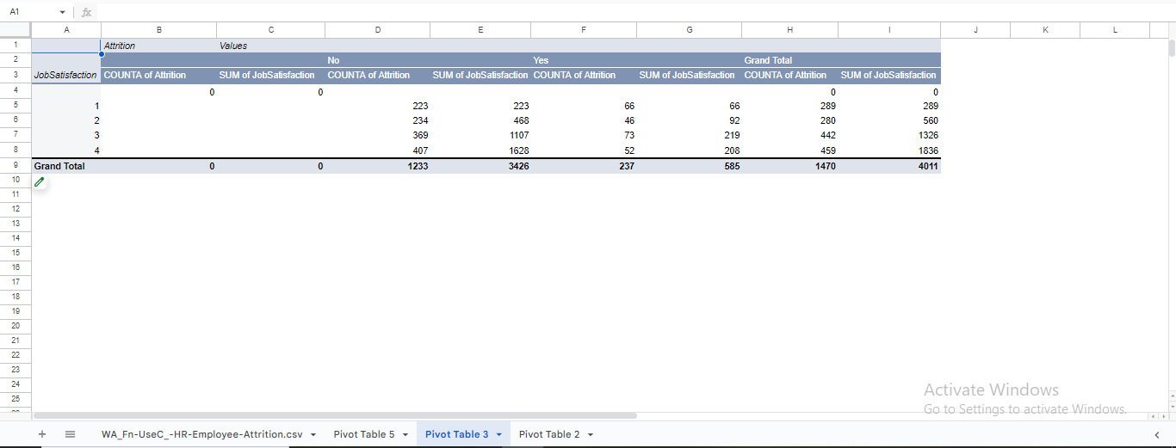

Click for the story : https://public.flourish.studio/story/3459871/
Screen shots :
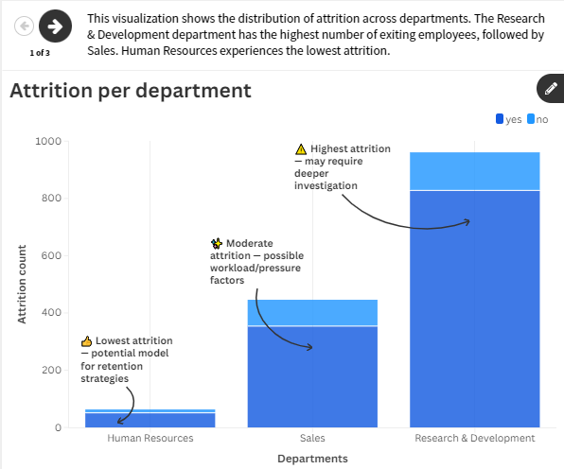

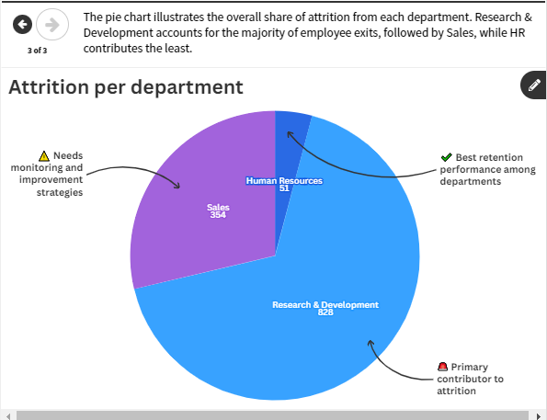
Step 7: Train Baseline Model
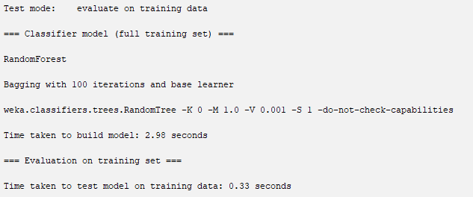
=== Summary ===
Correlation coefficient 0.97981
Mean absolute error 0.6278
Root mean squared error 0.8194
Relative absolute error 30.4805 %
Root relative squared error 32.8113 %
Total Number of Instances 1470
Number of Leaves : 2225
Size of the tree : 2247
Time taken to build model: 0.05 seconds
=== Evaluation on training set ===
Time taken to test model on training data: 0.07 seconds
=== Summary ===
Correctly Classified Instances 1075 72.9308 %
Incorrectly Classified Instances 399 27.0692 %
Kappa statistic 0.6861
Mean absolute error 0.0377
Root mean squared error 0.1373
Relative absolute error 39.0965 %
Root relative squared error 62.5605 %
Total Number of Instances 1474
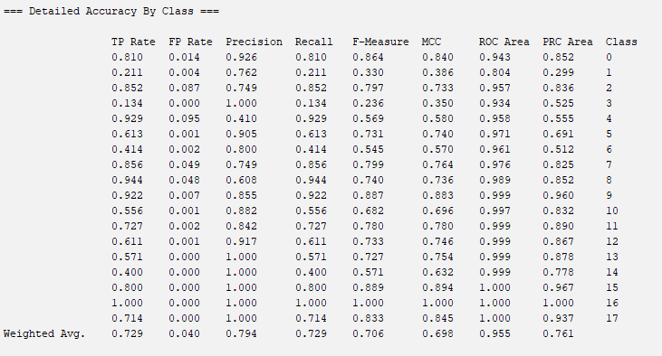
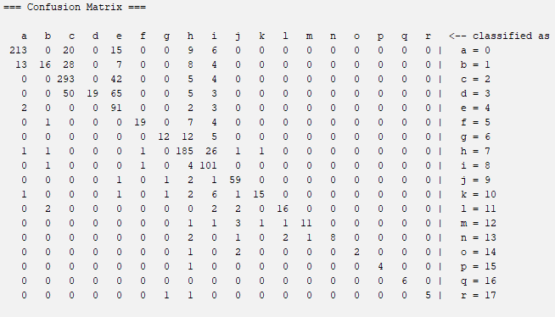

Number of Leaves : 2225
Size of the tree : 2247
Time taken to build model: 0.12 seconds
=== Stratified cross-validation ===
=== Summary ===
Correctly Classified Instances 749 50.8141 %
Incorrectly Classified Instances 725 49.1859 %
Kappa statistic 0.4318
Mean absolute error 0.0609
Root mean squared error 0.1874
Relative absolute error 63.1553 %
Root relative squared error 85.3806 %
Total Number of Instances 1474
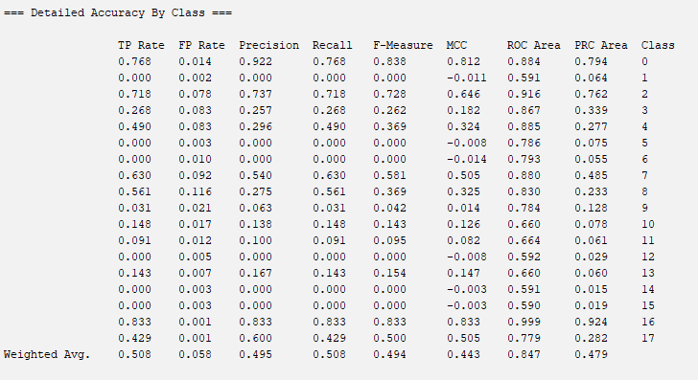
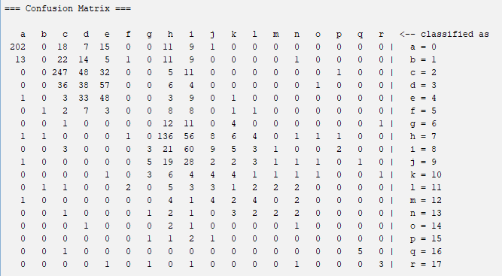

Overfitting
Using naïve bayes as training results
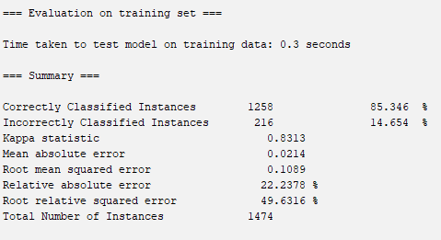
Using naïve bayes for cross validation
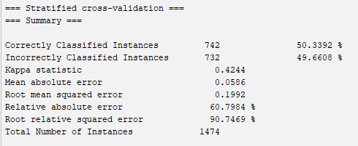
By using random forest without converting all data to nominal and removing unrelated rows
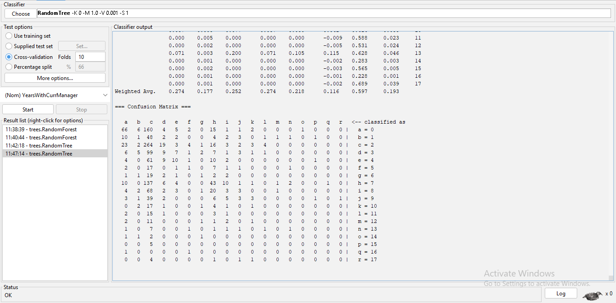
=== Detailed Accuracy By Class ===
TP Rate FP Rate Precision Recall F-Measure MCC ROC Area PRC Area Class
0.251 0.058 0.485 0.251 0.331 0.255 0.629 0.299 0
0.013 0.014 0.048 0.013 0.021 -0.002 0.449 0.048 1
0.767 0.630 0.271 0.767 0.401 0.123 0.614 0.310 2
0.063 0.036 0.158 0.063 0.090 0.042 0.572 0.132 3
0.102 0.019 0.278 0.102 0.149 0.134 0.595 0.109 4
0.032 0.007 0.091 0.032 0.048 0.042 0.544 0.027 5
0.034 0.005 0.125 0.034 0.054 0.056 0.579 0.030 6
0.199 0.077 0.307 0.199 0.242 0.147 0.622 0.215 7
0.028 0.023 0.086 0.028 0.042 0.008 0.571 0.085 8
0.047 0.011 0.158 0.047 0.072 0.064 0.629 0.077 9
0.037 0.008 0.077 0.037 0.050 0.041 0.616 0.053 10
0.000 0.005 0.000 0.000 0.000 -0.009 0.588 0.023 11
0.000 0.002 0.000 0.000 0.000 -0.005 0.531 0.024 12
0.071 0.003 0.200 0.071 0.105 0.115 0.628 0.046 13
0.000 0.001 0.000 0.000 0.000 -0.002 0.283 0.003 14
0.000 0.002 0.000 0.000 0.000 -0.003 0.565 0.005 15
0.000 0.001 0.000 0.000 0.000 -0.001 0.228 0.001 16
0.000 0.001 0.000 0.000 0.000 -0.002 0.689 0.039 17
Weighted Avg. 0.274 0.177 0.252 0.274 0.218 0.116 0.597 0.193

=== Summary ===

Correctly Classified Instances 403 27.415 %
Incorrectly Classified Instances 1067 72.585 %
Kappa statistic 0.099
Mean absolute error 0.089
Root mean squared error 0.231
Relative absolute error 92.3523 %
Root relative squared error 105.2777 %
Total Number of Instances 1470

Underfitting
Using zeroR classifiervto test results
As a training set
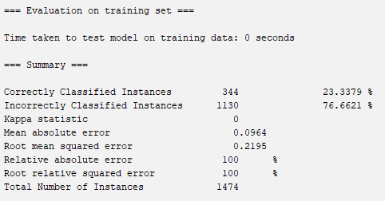
Cross validating
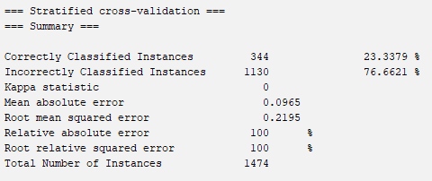

Step 10: Summarize Insights : using napkin
Napkin ai summary link :
https://app.napkin.ai/page/CgoiCHByb2Qtb25lEiwKBFBhZ2UaJDc5ZDE5MDc3LWMxMjUtNGEyMi1hNWZhLWY3NDQ2ODEyMmVhNA?s=1
summary main points
- The evaluation of models (J48, Naive Bayes, Random Forest, ZeroR) showed mixed performance, with J48 suffering from overfitting and Random Forest and ZeroR showing underfitting, indicating improper learning of meaningful patterns.
- A major challenge identified across models was class imbalance, where "no attrition" cases dominate the dataset, causing models to bias predictions toward the majority class and reduce detection accuracy of actual attrition cases.
- The inclusion of irrelevant features like EmployeeNumber negatively impacted learning by creating meaningless model splits; removing such non-predictive features is essential to improve model interpretability and accuracy.
- The summary highlighted the need for techniques like resampling, cost-sensitive learning, proper feature selection, and hyperparameter tuning to improve prediction performance and handle imbalanced data effectively.
- Potential key drivers of attrition include factors such as job satisfaction, salary, work-life balance, tenure, promotion history, and workload (overtime), although further feature importance analysis is needed once the model is improved.
- Based on insights, HR can leverage refined predictive models to identify high-risk employees and implement targeted retention strategies (e.g., salary review, career development programs, flexible working policies, and department-specific interventions).

Reflection Questions
Answer any 3:
- Which factors contributed most to attrition?
- Did your model overfit or underfit? Why?
- How can dataset quality be improved?
- How should HR teams use this model?
Ans 1 - From the patterns observed, employees with low job satisfaction, poor work-life balance, lower salaries, and limited growth opportunities seemed more likely to leave. Tenure and overtime also appeared to influence the likelihood of attrition.
Ans2 - Yes — one model overfitted and another underfitted. The J48 model overfitted because it learned the training data too perfectly, including noise. Meanwhile, Random Forest and ZeroR underfitted due to class imbalance and irrelevant features affecting learning.
Ans3 - The dataset can be improved by removing non-useful columns like EmployeeNumber, balancing the classes, and cleaning or encoding categorical values properly. Doing this will help the model learn real patterns instead of random or misleading ones.
Overall, the mini-project demonstrated how different machine learning models behave when applied to HR attrition data. The experiment helped me understand how data imbalance, irrelevant features, and model settings affect prediction accuracy. After improving feature selection and handling imbalance, the model can become more useful for HR teams to identify employees at risk and take preventive actions.
Final dataset :
https://docs.google.com/spreadsheets/d/1FvJYP03OPrZUGc3dTIgn6uXQWM7MtOs21azyTC5QoO0/edit?usp=sharing

Submitted by Abduttaiyeb Huseni Matcheswala (b24bs1015)

