Lab 3: Corner Escpae Contest

Team 6

Alex Woods and Taylor Mansfield

# Hardware and Software Design

T

the objective of a corner escape contest as is found in Lab 3 is to navigate safely down a cooridor until reaching a dead end, then turn around and navigate back to the starting position as shown in Fig. 1.

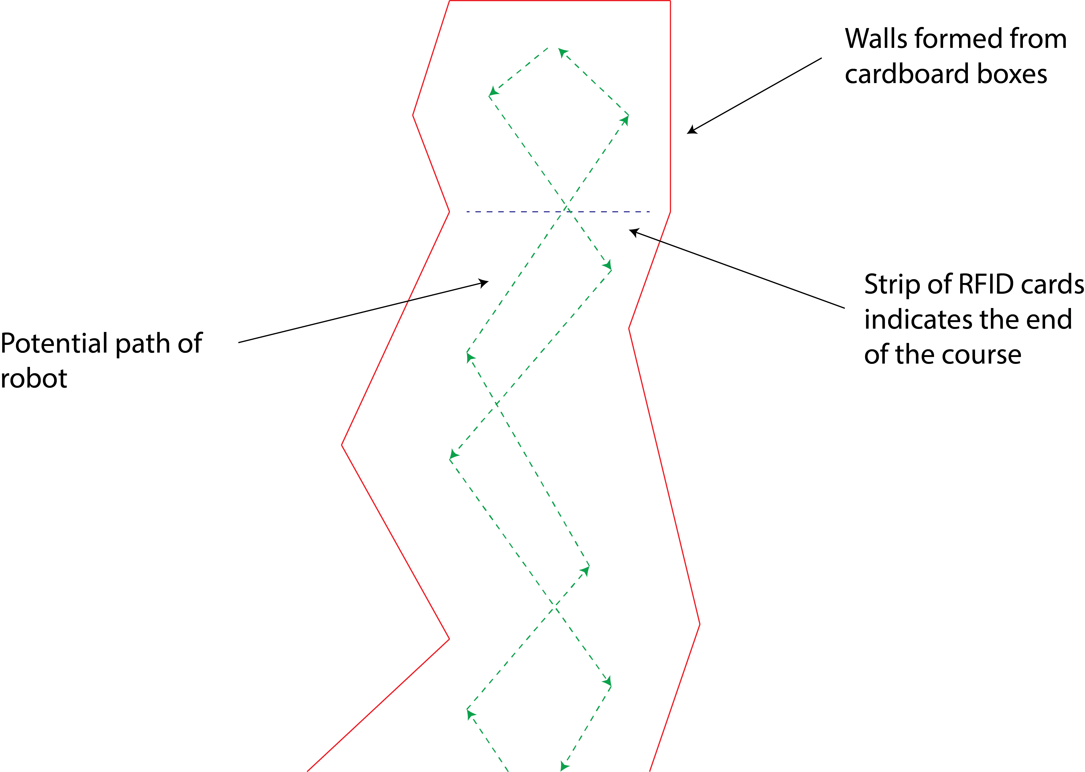

Fig. 1: In a corner escape contest, the robot navigates to the end of a cooridor then returns to the start.

In our design, sound navigation and randing (sonar) sensors are used to detect the presence of walls, and an RFID sensor detects a strip of RFID cards, which signal the end of the course. The two sonar sensors equipped have a field of view of approximately 30° and are each oriented at approximately 30° to the sides from the front of the robot as shown in Fig. 2.

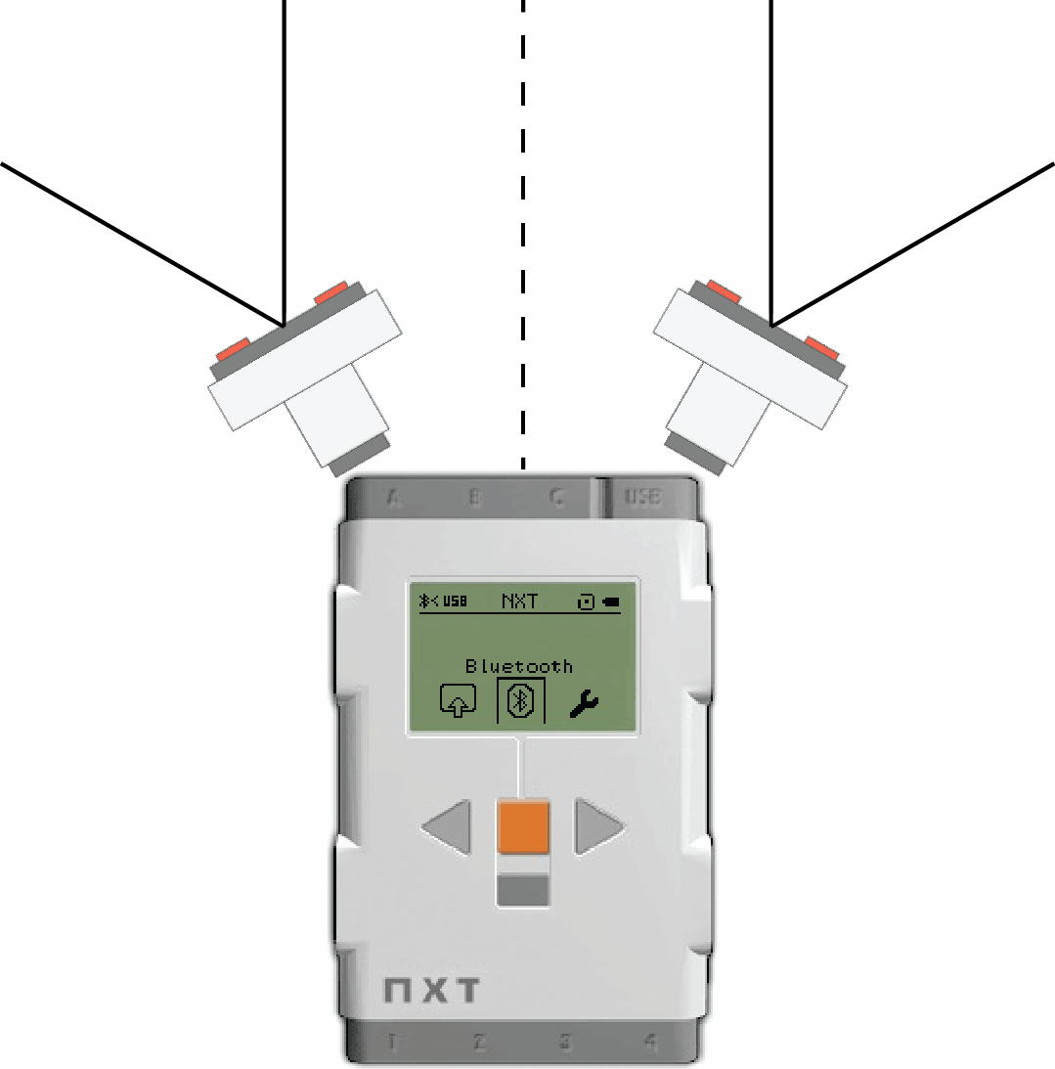

Fig. 2: Each sonar sensor is oriented at approximately a 30° angle from the centerline of the robot and has a 30° field of view.

This orientation allows the robot to sense walls as they approach from the sides, as well as walls that it runs into head on. The RFID sensor is oriented at the ground in such a way that it reads the strip of cards when passed.

The software design for a corner escape contest must include two main tasks. First, the robot should have reliable wandering behavior. This means that the robot should be able to wander down the cooridor without getting stuck, no matter

how the cooridor is formed. Second, the robot should be able to sense the end of the course.

We created a wandering behavior, which is not only reliable, but also fast. Our robot has two methods of avoiding walls, depending on how close they are. First, if the sonar senses a wall within the first threshold, 40 cm, then it simply veers away from the wall while maintining forward movement. This is accomplished by reducing the speed of the wheel opposite the wall. So, if the robot senses a wall on the left it will veer right by reducing the speed in the right wheel and maintaining speed in the left wheel. The second method of wall avoidance is when the robot encounters a wall within a second, closer threshold of 20 cm. When this happens, the robot will back up a small amount, and then rotate in a direction opposite the wall a small amount. It will do this until the sonar sensor detects that the wall is far enough away, at which point it continues forward. So, if the robot encountered a wall on the right 15 cm away, it would continuously back up and rotate left until it was clear to move forward. The combination of these two methods allows the robot to quickly navigate down relatively straight sections of the cooridor with ease, but also allow it to work its way out of tight corners such as the end of the course.

The second main task, finding the RFID strip, is accomplished through constant monitoring of the sensor while also navigating through the course. It is important to note that because these two tasks must run simultaneously, the robot must use multitasking to run them in parallel. Finding RFID tags with the sensor is a relatively easy task. When the card passes near the sensor, it can read the identifying numbers associated with it. So, to indicate that the robot had indeed found the end of the course, we were instructed to sound a tone when the RFID strip passed under the robot. Because the sensor reads zero when no card is present, we continuously played a tone, whose frequency was dependent on the RFID value read by the sensor. Thus, when no card was present, the frequency was zero and when a card was encountered, the tone would be audible with a frequency dependet on the particular card.

# Problems Encountered

During the development of this lab, we encountered several problems. These included: 1) the RFID sensor had trouble picking up the cards under certain normal conditions, 2) certain sonar sensor orientations and distance thresholds caused undesireable behavior, 3) the sonar sensors sometimes were unreliable and would not sense walls as expected, and 4) when attempting to drive straight, the robot would veer to one side dramatically.

The specific problem encountered with the RFID sensor was that when the robot passed over the strip too fast, or if the sensor happened to pass over the seam of two cards, it would not register a reading.

The undesireable behavior regarding sensor orientations and thresholds was that if the sensors were not oriented in such a way that they could see towards the front (e.g., facing too far to the side) then the robot could run headfirst into a wall and not know it. Regarding the thresholds, if they were too low then then robot would not have time to react to the wall before running into it, but if they were too large, the robot could potentially sense both walls on either side at the same time which resulted in rather unpredicatable behavior.

Another problem encountered with the sonar sensors is that sometimes they would not sense the walls as expected. It was not uncommon for the robot to completely run into a wall, with the sensor pointed right at it before it realized that there was a problem.

Finally, when using the standard OnFwd function to turn on both motors at the same power level, the robot would generally drift badly. It was noted that the drift was always to the side of whichever motor was plugged into port A.

# Solutions

To solve the problem with the RFID sensor not getting a reading, two important steps were taken. First, the sensor was moved as close to the ground as possible without dragging when it passed over the row of cards. Second, the tape on the top side of the RFID strip holding all of the cards together was removed, leaving only tape on the bottom. The combination of being closer, and not having tape in between the sensor and card resulted in the RFID sensor getting a reading nearly every time it passed ove the strip.

The behavior resulting from various orientations and distance thresholds was made predictable and reliable simply through iterations and trial and error. It was found that the most effective method for mounting the sonar sensors was as close to the centerline of the robot as possible, and at the angles described in the hardware design. The distance thresholds were also experimentally determined. Because the sonar sensors do not always accurately report the distance (e.g., reading 50 cm when the actual distance is 45 cm), the thresholds were set based on the actual distance and then adjusted based on performance.

Finally, the drift encountered when attempting to drive straight was solved using a combination of two methods. It was noted that the drift always manifested towards the motor plugged into port A of the NXT. Thus, motors were changed to ports B and C rather than A and B. This alone helped the problem significantly, but the function OnFwdSync was also used which is intended to synchronize the rotation of the motors resulting in straight movement. Using these two solutions, relatively straight motion was achieved, but a very slight drift is still in place, attributed to differences in the motors themselves.

# Unsolved Problems

The problem regarding reliability of sonar sensors remains unsolved. Attempts to diagnose and solve this problem included swapping the sensor out with another, using various input ports, changing the angles at which it pointed, and creating unique thresholds for each sensor. None of these solutions was successful in fixing the problem, but it was determined that the issue lay with a single sensor, so the conclusion is that the sensor is somehow faulty and cannot be fixed by the user.