A Bootstrapped SOFR Curve with Rating-Based Corporate Spreads
Model note
Illustrative figures as at 2026-07-20

1. Purpose
The model produces a term structure of US dollar interest rates in two layers. The first is a risk-free curve derived from the Secured Overnight Financing Rate (SOFR); the second is a set of credit spreads by rating that sit on top of it. Together they yield a discount curve and a forward-rate view out to ten years, and an all-in fixed rate for a loan of a given maturity and credit quality.
The immediate application is pricing fixed-rate, fixed-maturity loans. Where the lender's funding cost floats with SOFR, the fixed rate that leaves the lender indifferent over the life of the loan is read off the risk-free curve; the credit spread is the additional compensation for the borrower's default risk. Keeping the two layers separate makes the pricing auditable — the risk-free part is pinned to observable market instruments, and the credit part is stated explicitly rather than absorbed into a single figure.

2. The SOFR risk-free curve
The curve is built by bootstrapping. Instead of fitting a smooth functional form, bootstrapping solves for the discount factors that reprice a chosen set of market instruments exactly, one maturity at a time from the short end outward. Each instrument adds a single node and is priced using only the nodes already fixed, so the calibration reduces to a sequence of one-dimensional root solves.
Three families of instruments are used, each liquid over its own part of the curve. The published overnight SOFR fixing, with the realised fixings of the current month, anchors the front. One- and three-month SOFR futures cover the range to roughly two and a half years, fixing the expected compounded overnight rate over each contract period. SOFR overnight-indexed swaps (OIS) carry the term structure from three to ten years through their par rates. The public swap source publishes tenors only to ten years, so the curve is capped there; longer maturities are not produced rather than extrapolated.
Between nodes the curve interpolates log-linearly on discount factors, which holds the instantaneous forward rate constant across each interval. This keeps forward rates well behaved where instruments are sparse, at the cost of a forward curve that is piecewise flat rather than smooth. The finished curve reprices every input to within about two tenths of a basis point.
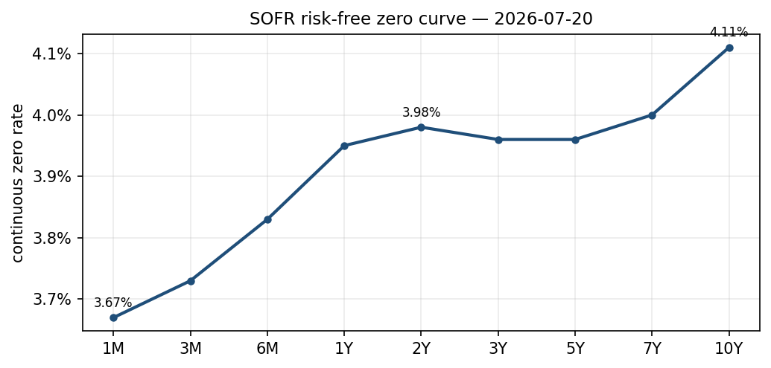
SOFR risk-free zero curve, continuous compounding.
The curve as at 2026-07-20 is mildly humped. It rises through the first year to about 3.95 percent, is broadly flat across the two-to-five-year segment near 3.96 percent, and rises to about 4.11 percent at ten years. The belly sitting close to the front is consistent with expectations of modest policy easing over the medium term.
Tenor | SOFR zero rate
1M | 3.67%
3M | 3.73%
6M | 3.83%
1Y | 3.95%
2Y | 3.98%
3Y | 3.96%
5Y | 3.96%
7Y | 4.00%
10Y | 4.11%
Table 1. SOFR continuous-compounded zero rates.

3. Corporate credit spreads
Credit risk is added as a spread over the SOFR curve, differentiated by rating. The market does not quote a full spread curve for each rating; it quotes, for each rating, a single option-adjusted spread (OAS) blended across maturities. The model turns that single number into a term structure from three inputs.
The first input is the level. Each rating's OAS is taken from the ICE BofA US corporate and high-yield indices, and is a spread over Treasuries.
Rating | OAS over Treasuries (bp)
AAA | 41
AA | 56
A | 66
BBB | 97
BB | 163
B | 291
CCC | 975
Table 2. Blended index OAS by rating.
The second is the slope. The investment-grade index is also published split into maturity buckets. Dividing each bucket's spread by the index average gives a dimensionless shape that rises with maturity — short-dated credit trades tighter than long-dated. Each rating's level is scaled by this shape to obtain a spread that varies by tenor.
The third is the basis between Treasuries and SOFR. Because the OAS is measured against Treasuries while discounting is done on SOFR, the model adds the Treasury–SOFR basis at each tenor. That basis is slightly negative at the front, where Treasury bills trade rich to secured funding, and positive further out, where Treasury yields sit above the swap curve. Adding it restates the spread as a genuine pickup over SOFR.
Tenor | AAA | AA | A | BBB | BB | B | CCC
1M | 23 | 33 | 39 | 58 | 99 | 178 | 603
3M | 29 | 38 | 44 | 64 | 104 | 184 | 608
6M | 29 | 38 | 45 | 64 | 105 | 184 | 608
1Y | 22 | 31 | 37 | 57 | 98 | 177 | 601
2Y | 35 | 45 | 51 | 70 | 111 | 190 | 615
3Y | 45 | 56 | 64 | 87 | 135 | 229 | 731
5Y | 61 | 75 | 84 | 113 | 174 | 293 | 930
7Y | 74 | 91 | 101 | 135 | 207 | 346 | 1091
10Y | 83 | 101 | 113 | 150 | 229 | 383 | 1202
Table 3. Credit spread over SOFR by rating and tenor (basis points).
One assumption carries most of the weight. Every rating is given the same maturity shape, borrowed from the investment-grade index; the rating levels are observed, but the slope is not observed rating by rating. This is a fair approximation for investment grade and a rougher one for high yield, whose spread curves are flatter and, for distressed names, can invert. Below two years, where no maturity bucket exists, the shape is held flat.

4. All-in rates
Adding the credit spread to the SOFR curve gives an all-in rate for each rating and maturity. The investment-grade rungs sit within about a percentage point of the risk-free curve; the high-yield rungs open up sharply, with the CCC bucket reaching double digits at the longer maturities.
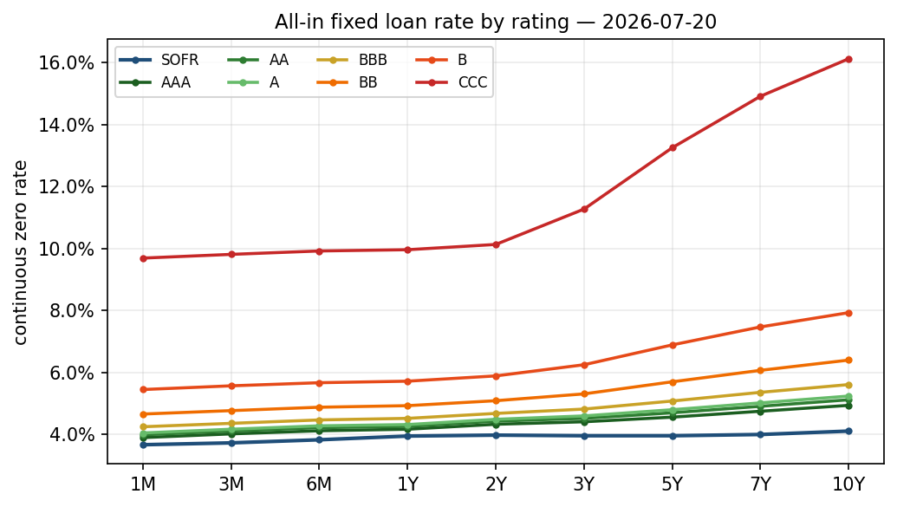
All-in fixed loan rate by rating; SOFR shown for reference.
Tenor | SOFR | AAA | AA | A | BBB | BB | B | CCC
1M | 3.67 | 3.90 | 3.99 | 4.05 | 4.25 | 4.66 | 5.45 | 9.69
3M | 3.73 | 4.02 | 4.11 | 4.17 | 4.36 | 4.77 | 5.57 | 9.81
6M | 3.83 | 4.12 | 4.22 | 4.28 | 4.47 | 4.88 | 5.67 | 9.92
1Y | 3.95 | 4.17 | 4.26 | 4.32 | 4.52 | 4.93 | 5.72 | 9.96
2Y | 3.98 | 4.33 | 4.43 | 4.49 | 4.68 | 5.09 | 5.89 | 10.13
3Y | 3.96 | 4.41 | 4.52 | 4.60 | 4.82 | 5.31 | 6.25 | 11.27
5Y | 3.96 | 4.56 | 4.70 | 4.80 | 5.08 | 5.70 | 6.89 | 13.25
7Y | 4.00 | 4.75 | 4.91 | 5.02 | 5.36 | 6.07 | 7.47 | 14.91
10Y | 4.11 | 4.94 | 5.12 | 5.24 | 5.61 | 6.40 | 7.93 | 16.12
Table 4. All-in fixed rate by rating and tenor (per cent, continuous compounding).
For the intended application — an unrated borrower such as a crypto fund — the relevant reference is the high-yield band rather than investment grade. The published spreads should be read as a market floor, not the spread the borrower would actually pay, which is set by underwriting against collateral.
The all-in rate can be restated in whatever day-count and payment convention the loan uses — Actual/360, Actual/Actual, or 30/360, with monthly, quarterly or annual coupons. The discount factors are invariant to the convention; only the quoted rate changes. Across conventions the same six-month rate moves by roughly ten to fifteen basis points, which is not negligible in a contract.

5. Data and validation
The overnight rate and its history come from the Federal Reserve Bank of New York; the futures from the CME, through a delayed public source; the SOFR swap rates from Pensford's public rates feed; and the corporate spreads and Treasury yields from the St. Louis Fed's FRED. All are free, end-of-day, and not perfectly synchronised in time, which suits a reference calculation rather than execution. Before each build the inputs pass range and consistency checks, and after the build the curve is confirmed to reprice its inputs. If the swap feed is unreachable the build falls back to last-known values rather than failing.

6. Assumptions and limitations
- The corporate spreads are index-level references, not a specific borrower's spread; for an unrated borrower they are a floor rather than the executable rate.
- The same maturity shape is applied to every rating; the high-yield long end is the least reliable region.
- The curve is pinned by market swaps only to ten years — the public swap source does not extend further — so the model does not produce rates beyond that point.
- SOFR futures carry a small convexity bias that is left uncorrected — below a basis point in the first year, a few basis points by two and a half years.
- Data is end-of-day, indicative, and drawn from several sources at slightly different times.
- Predictable turn-of-year and quarter-end effects in overnight rates are not modelled.
The model is intended for analysis and pricing reference. It is not a default or recovery model, and its output is not an executable quote.

