Customer Shopping Behavior Analysis
1. Project Overview
This project focuses on analysing customer shopping behavior using transactional data from 3,900 customer purchases across multiple product categories.
The primary objective is to transform raw customer shopping data into meaningful business insights related to:
- Customer spending behavior
- Customer segmentation and loyalty
- Product and category performance
- Discount usage
- Subscription behavior
- Shipping preferences
- Customer demographics
- Product ratings
The analysis follows an end-to-end data analytics workflow using Python, MySQL, and Power BI.
The project begins with data preparation and transformation in Python, followed by structured business analysis using MySQL queries. The resulting insights are then presented through an interactive Power BI dashboard to support data-driven decision-making.

2. Business Problem
The business needs to develop a deeper understanding of its customers’ shopping behavior in order to identify the factors that influence purchasing decisions, customer spending, and repeat purchasing behavior.
With customer data spanning demographics, purchase history, product categories, discounts, subscriptions, shipping preferences, and product ratings, there is an opportunity to uncover meaningful patterns that can support better business decisions.
The objective of this project is to identify high-value and loyal customer segments, understand purchasing and product trends across demographics and categories, and evaluate how factors such as discounts, subscriptions, shipping preferences, and product ratings relate to customer spending and purchasing behavior.
The analysis aims to help the business:
- Understand customer purchasing patterns
- Identify valuable and loyal customer segments
- Identify high-performing products and categories
- Evaluate the relationship between discounts and spending
- Understand subscriber and non-subscriber behavior
- Identify opportunities for improving customer retention
- Support targeted marketing and promotional strategies
- Improve product positioning and revenue generation

3. Dataset Overview
The dataset contains customer-level shopping transaction information.
Dataset Summary
Attribute | Details
Total Records | 3,900
Total Columns | 18
Data Type | Customer Shopping / Transactional Data
Primary Focus | Customer Purchasing Behavior

Key Data Attributes
The dataset contains information covering:
Customer Demographics
- Age
- Gender
- Location
- Subscription Status
Purchase Details
- Item Purchased
- Category
- Purchase Amount
- Season
- Size
- Color
Shopping Behavior
- Discount Applied
- Promo Code Used
- Previous Purchases
- Frequency of Purchases
- Review Rating
- Shipping Type
The original dataset contained 37 missing values in the Review Rating column.

4. Data Preparation & Transformation Using Python
Python was used as the first stage of the analytical workflow to inspect, clean, transform, and prepare the raw dataset for further analysis.
4.1 Data Loading & Initial Exploration
The dataset was imported using Pandas and initially explored to understand its structure, data types, and statistical characteristics.
The following techniques were used:
- df.info() to inspect data types and structure
- df.describe() to understand numerical distributions
- Null-value checks to identify missing data
- Inspection of categorical variables and data consistency

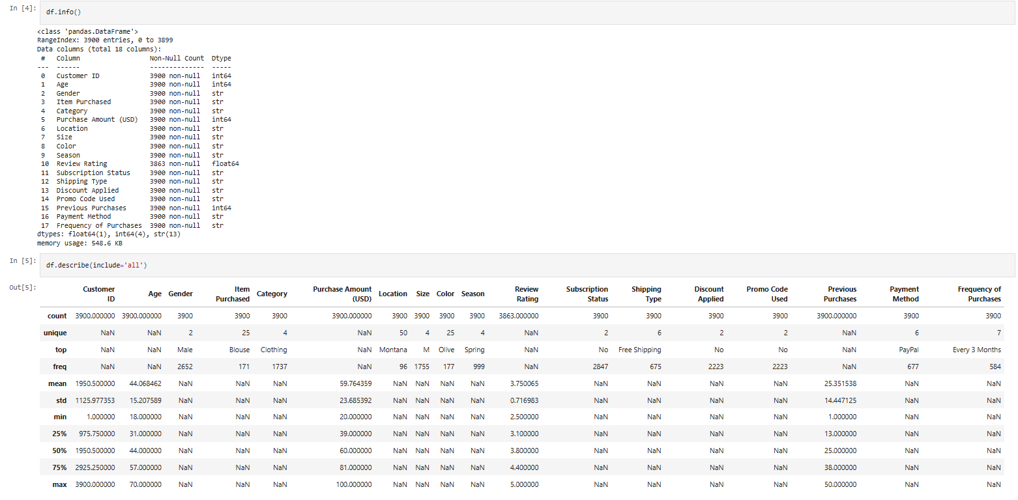Figure 1: Initial dataset structure and exploratory analysis using Python.

4.2 Missing Value Treatment
The dataset contained 37 missing values in the Review Rating column.
Instead of removing these records, missing ratings were imputed using the median review rating of the corresponding product category.
This approach preserves the available customer records while maintaining a reasonable representation of ratings within each category.

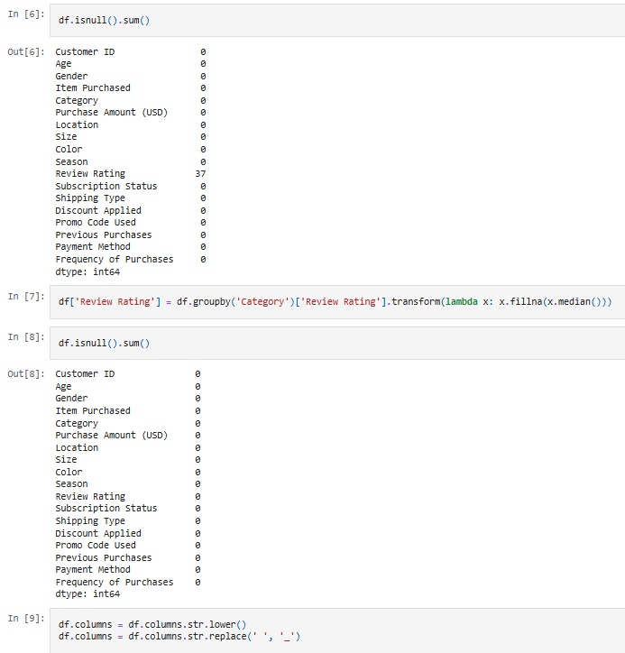
Figure 2: Identification and treatment of missing Review Rating values.

4.3 Column Standardization
Column names were standardized into snake_case format to improve readability, consistency, and usability during SQL analysis.
For example:
Purchase Amount → purchase_amount
Review Rating → review_rating
Subscription Status → subscription_status

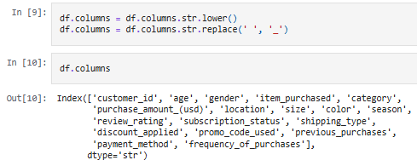
Figure 3: Standardized dataset column names.

4.4 Feature Engineering
Two additional analytical features were created:
Age Group
Customer ages were grouped into meaningful age categories to enable demographic-level analysis.
Purchase Frequency in Days
A numerical representation of purchase frequency was created to support behavioral analysis.

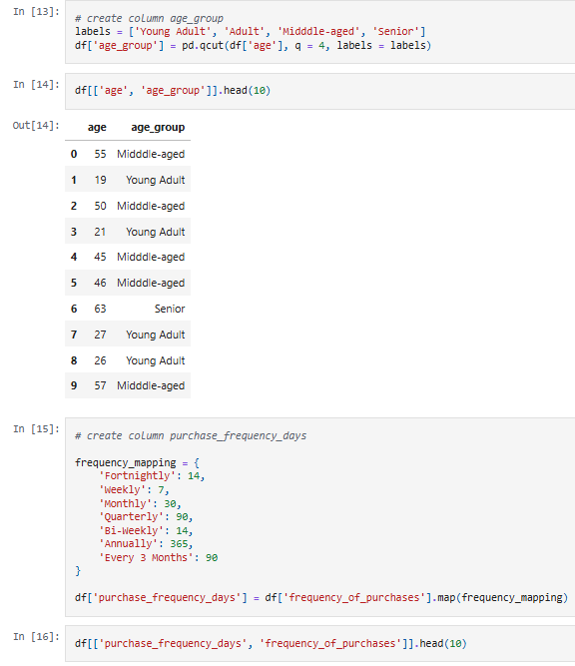
Figure 4: Creation of Age Group and Purchase Frequency features.

4.5 Data Consistency Check
The relationship between discount_applied and promo_code_used was examined to identify redundancy.
Since both variables represented overlapping discount information, promo_code_used was removed from the final analytical dataset.
The cleaned dataset was then prepared for database analysis using MySQL.

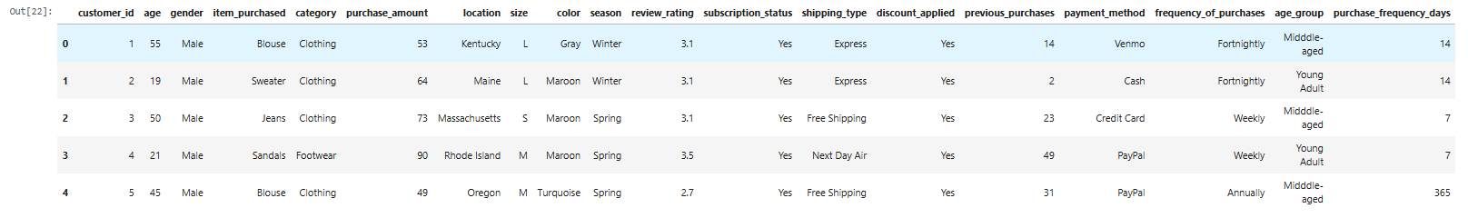
Figure 5: Final cleaned and transformed dataset prepared for SQL analysis.

5. SQL Business Analysis Using MySQL
After data preparation, the cleaned dataset was analyzed using MySQL.
The SQL analysis was designed around 10 business questions covering revenue, customer spending, product performance, discounts, subscriptions, loyalty, and demographics.

5.1 Revenue by Gender
Business Question
What is the total revenue generated by male vs. female customers?
This analysis compares the total purchase revenue generated by customers across gender groups.
SQL Approach
The analysis uses:
- SUM(purchase_amount)
- GROUP BY gender
This allows management to understand revenue contribution across customer genders.

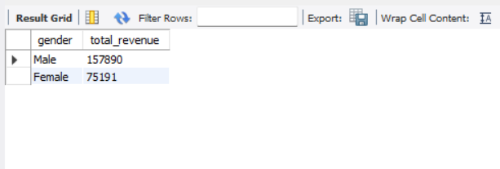
Figure 6: Revenue comparison between male and female customers.

5.2 High-Spending Discount Users
Business Question
Which customers used a discount but still spent more than the average purchase amount?
This analysis identifies customers who received discounts while making purchases at or above the overall average purchase value.
This helps evaluate whether discounts are being used only to drive low-value purchases or can also be associated with higher-value transactions.
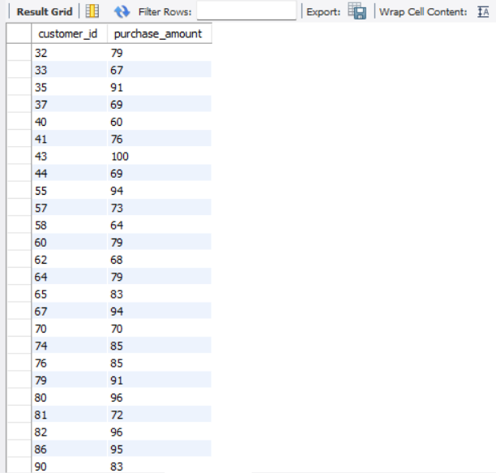
Figure 7: Customers using discounts while spending above the average purchase amount.

5.3 Top 5 Products by Review Rating
Business Question
Which five products have the highest average review ratings?
Average review ratings were calculated at the product level and ranked using a SQL window function.
This analysis helps identify products associated with stronger customer satisfaction.
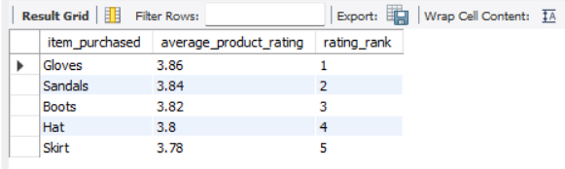
Figure 8: Top five products based on average review rating.

5.4 Shipping Type Comparison
Business Question
How does average purchase amount differ between Standard and Express shipping?
Average purchase values were compared across the two shipping types.
This analysis provides insight into whether customers choosing different delivery options exhibit different purchasing values.
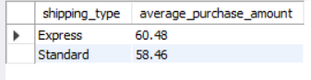
Figure 9: Average purchase amount by shipping type.

5.5 Subscribers vs. Non-Subscribers
Business Question
Do subscribed customers spend more than non-subscribers?
The analysis compares:
- Number of customers
- Average purchase amount
- Total revenue
across subscription statuses.
This helps evaluate the potential business value of the subscription program.
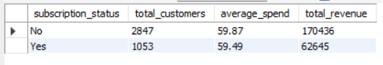
Figure 10: Spending and revenue comparison between subscribers and non-subscribers.

5.6 Products with the Highest Discount Usage
Business Question
Which five products have the highest percentage of purchases with discounts applied?
The discount rate for each product was calculated as the percentage of purchases where a discount was applied.
This helps identify products that may be particularly dependent on promotional pricing.
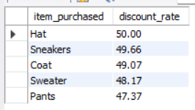
Figure 11: Top five products based on discount usage rate.

5.7 Customer Segmentation
Business Question
How can customers be classified based on their previous purchase behavior?
Customers were segmented into three groups:
Segment | Previous Purchases
New | 0–1
Returning | 2–10
Loyal | More than 10
This segmentation helps the business understand the composition of its customer base and identify opportunities for retention and loyalty initiatives.
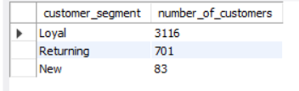
Figure 12: Customer distribution across New, Returning, and Loyal segments.

5.8 Top 3 Products Within Each Category
Business Question
What are the three most purchased products within each product category?
A ranking-based SQL analysis was performed to identify the highest-demand products within each category.
This provides category-level insights that can support product assortment, inventory planning, and promotional decisions.
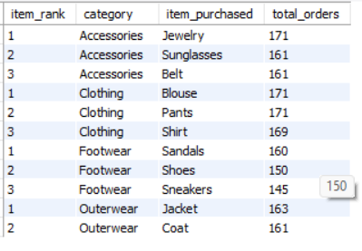
Figure 13: Top three most purchased products within each category.

5.9 Repeat Buyers & Subscription Behavior
Business Question
Are customers with more than five previous purchases also more likely to subscribe?
Customers with more than five previous purchases were analyzed based on their subscription status.
The purpose of this analysis is to understand whether repeat purchasing behavior is associated with subscription adoption.
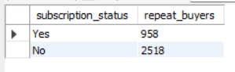
Figure 14: Subscription status among repeat buyers.

5.10 Revenue by Age Group
Business Question
Which age groups contribute the most revenue?
Total purchase revenue was calculated for each age group.
This analysis helps identify demographic groups that contribute significantly to overall business revenue and can therefore be considered for targeted marketing strategies.
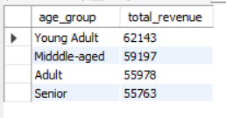
Figure 15: Revenue contribution by age group.

6. Power BI Dashboard
The results of the analysis were presented through an interactive Power BI dashboard.
The dashboard provides a consolidated view of customer shopping behavior and enables stakeholders to explore important metrics and trends.
Key Performance Indicators
The dashboard includes:
- Total Number of Customers
- Average Purchase Amount
- Average Review Rating
Dashboard Analysis Areas
The dashboard provides insights into:
- Revenue and sales by age group
- Revenue and sales by product category
- Customer distribution by subscription status
- Customer demographics
- Shipping preferences
- Category-level performance
Interactive filters allow users to explore the data by:
- Shipping Type
- Subscription Status
- Gender
- Category

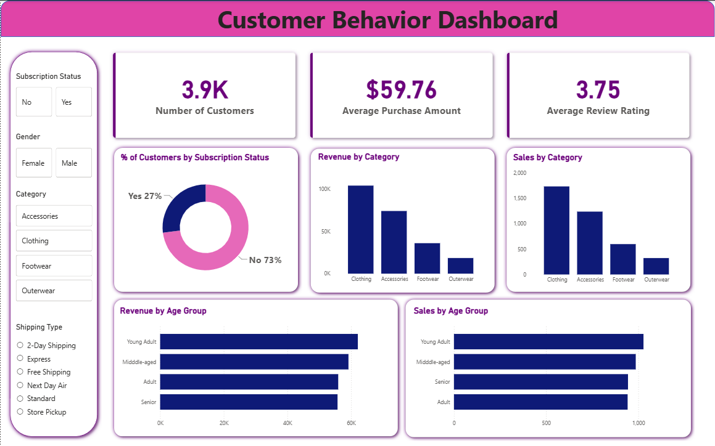Figure 16: Interactive Power BI dashboard for customer shopping behavior analysis.

7. Key Business Insights
The combined Python, MySQL, and Power BI analysis provides several areas of business insight.
Customer Segmentation
The New, Returning, and Loyal segmentation provides a structured way to understand customer maturity and identify opportunities for retention.
Subscription Behavior
Comparing subscribers and non-subscribers helps evaluate differences in customer spending and revenue contribution and provides a basis for improving subscription strategies.
Product Performance
Identifying highly rated and frequently purchased products helps distinguish products that perform well in terms of both customer demand and customer feedback.
Discount Behavior
The analysis of discount usage highlights products where promotions are frequently used and identifies customers who continue to make relatively high-value purchases despite receiving discounts.
Demographic Contribution
Revenue analysis by gender and age group provides a foundation for more targeted marketing and customer acquisition strategies.
Shipping Preferences
The comparison between Standard and Express shipping provides insight into purchasing behavior associated with different delivery preferences.

8. Business Recommendations
Based on the analysis, the following recommendations can be considered.
8.1 Strengthen Customer Loyalty Programs
Develop targeted loyalty initiatives for Returning customers to encourage progression toward the Loyal segment.
8.2 Promote Subscription Benefits
Use exclusive benefits, offers, or convenience-focused features to encourage repeat customers to adopt subscription plans.
8.3 Optimize Discount Strategies
Review discount-heavy products and evaluate whether promotions are generating incremental value while maintaining healthy margins.
8.4 Promote High-Performing Products
Use highly rated and frequently purchased products in marketing campaigns and product recommendations.
8.5 Target High-Revenue Customer Groups
Use age-group and demographic revenue insights to develop more targeted marketing campaigns.
8.6 Improve Product & Category Strategy
Use category-level purchase patterns to support product assortment, inventory planning, and promotional decisions.

9. Technology Stack
Technology | Role
Python | Data cleaning and transformation
Pandas | Data manipulation
MySQL | SQL-based business analysis
Power BI | Interactive dashboard and visualization
Jupyter Notebook | Python development and analysis

10. Project Workflow
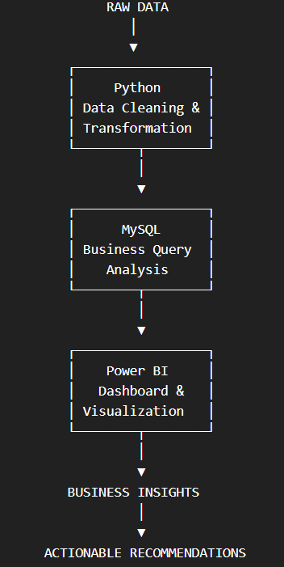

11. Conclusion
This project demonstrates an end-to-end approach to analysing customer shopping behavior and converting raw transactional data into actionable business insights.
Python was used to prepare and transform the dataset, while MySQL was used to answer business-focused analytical questions around revenue, customer segmentation, product performance, discounts, subscriptions, shipping, and demographics.
The final Power BI dashboard brings these findings together into an interactive reporting environment, allowing stakeholders to explore customer behavior and identify areas for business improvement.
Overall, the analysis provides a data-driven foundation for improving customer retention, targeted marketing, promotional strategies, product positioning, and revenue growth.

12. Project Files
The complete project includes:
customer-shopping-behavior-analysis/
|
|── data/
| └── customer_shopping_behavior.csv
|── python/
│ └── customer_shopping_behavior_analysis.ipynb
|── sql/
│ └── customer_behavior_analysis.sql
|── powerbi/
│ └── customer_behavior_dashboard.pbix
|── README.md
|── LICENSE

