DDATA DESCRIPTION

I HAVE CHANGE THE DATASET LINK:

<https://us1.ca.analytics.ibm.com/bi/?perspective=ca-modeller&pathRef=.my_folders%2Fdataset2>

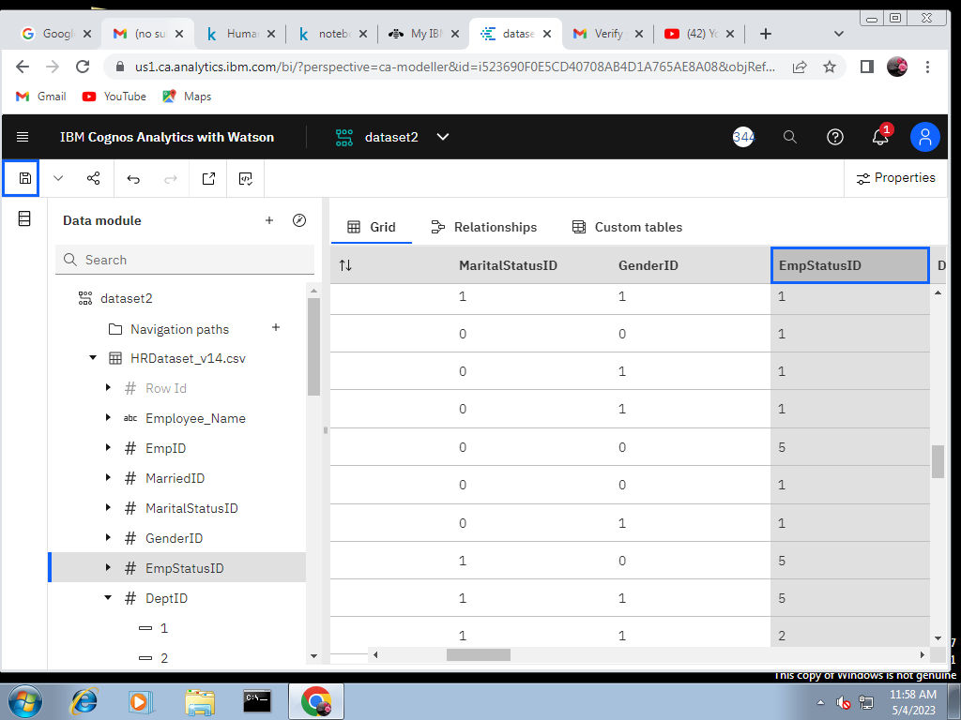

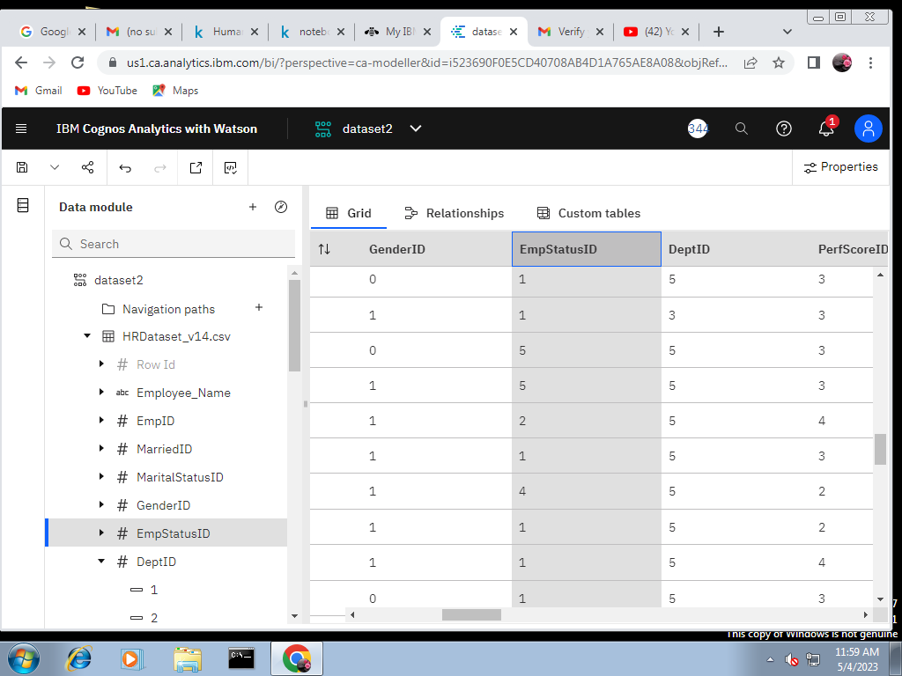

DATA VISULIZATION

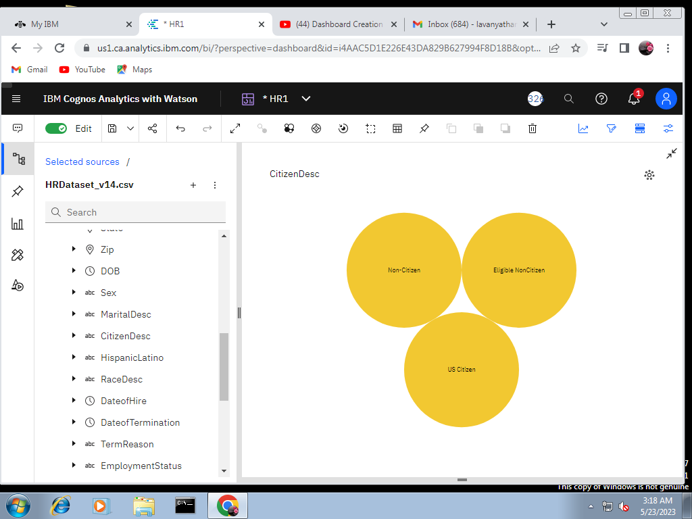

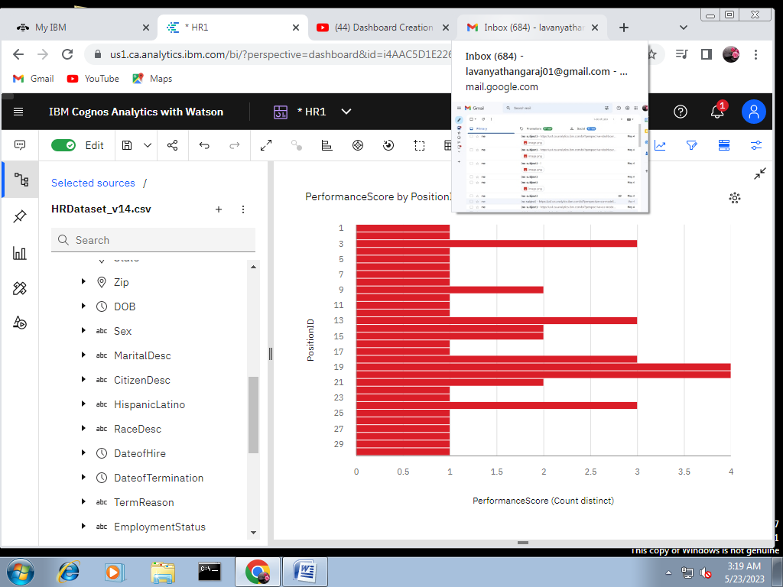

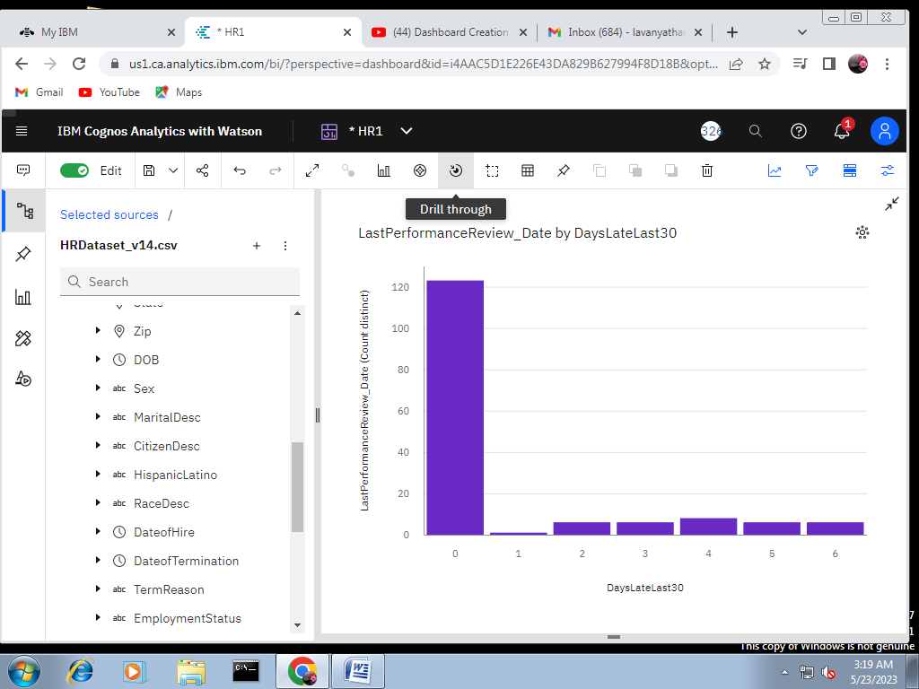

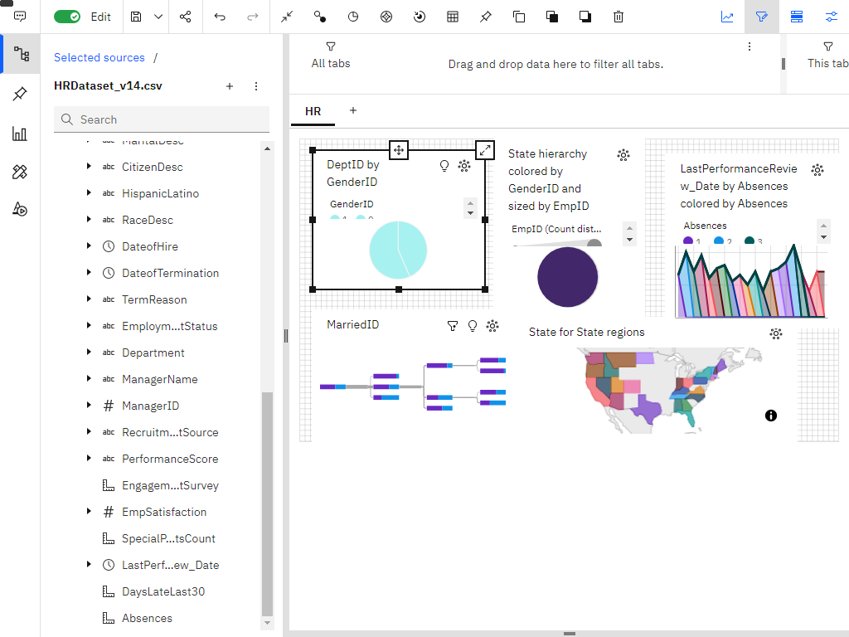

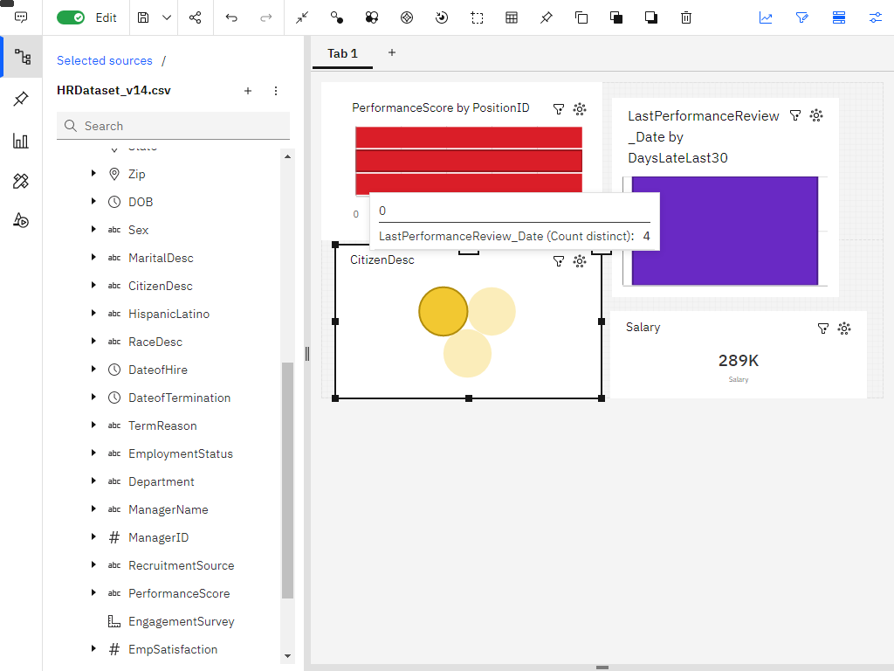

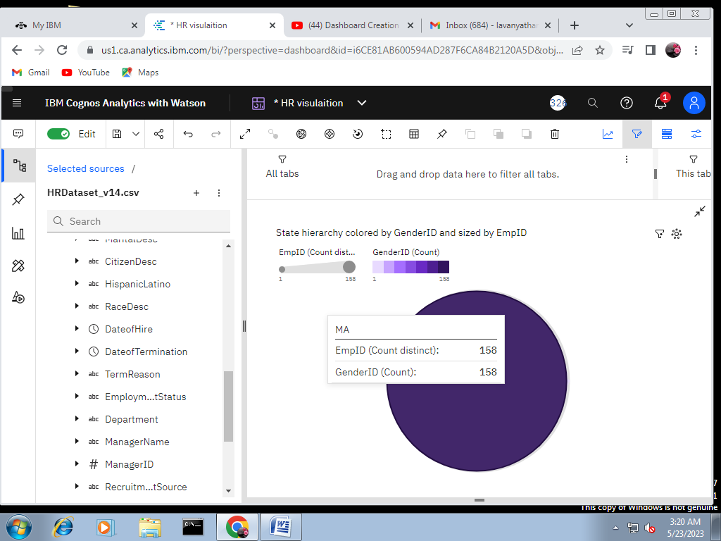

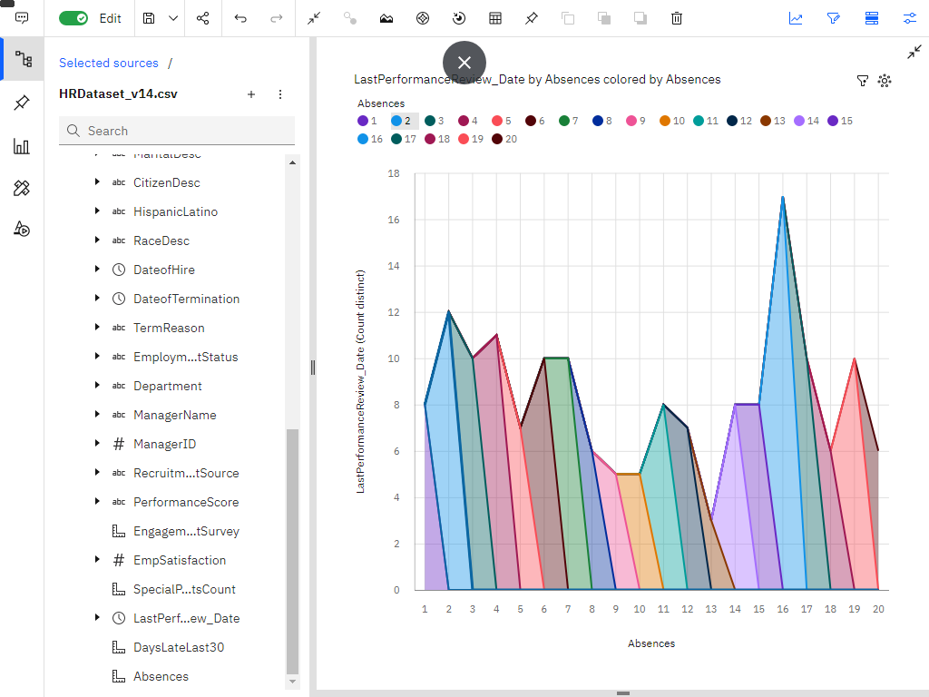

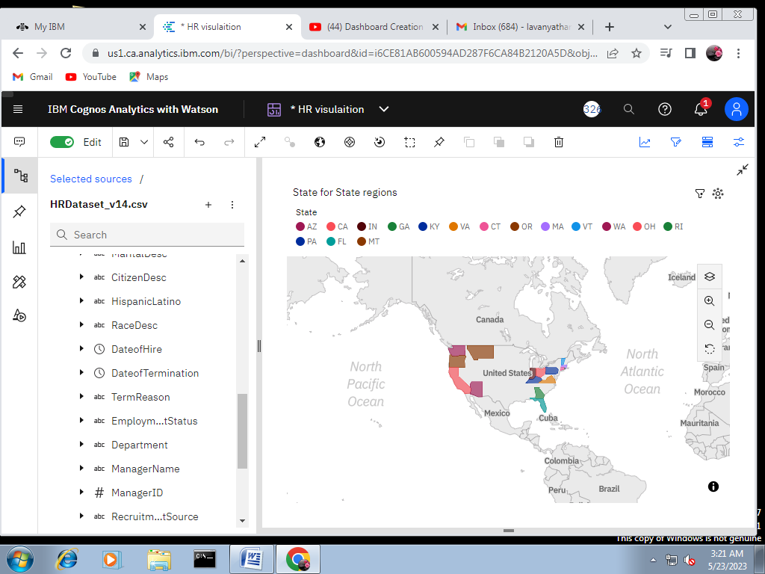

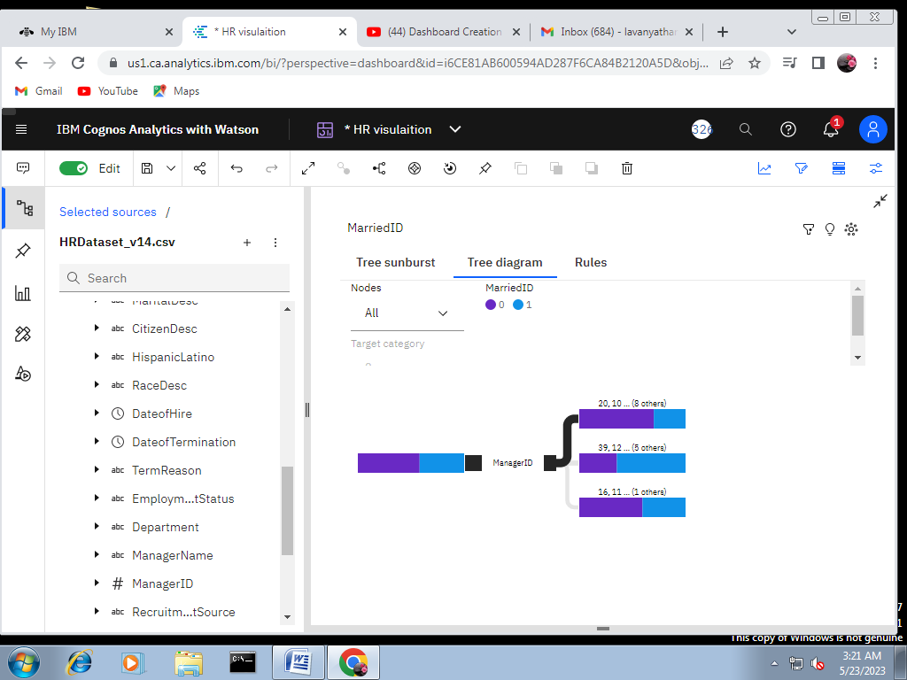

Link: <https://us1.ca.analytics.ibm.com/bi/?perspective=dashboard&pathRef=.my_folders%2FHR%2Bvisulaition&action=view&mode=dashboard&subView=model0000018845383f8a_00000000>

Link: <https://us1.ca.analytics.ibm.com/bi/?perspective=dashboard&pathRef=.my_folders%2FHR1&action=view&mode=dashboard&subView=model0000018845647a36_00000002>

DATA REPORT

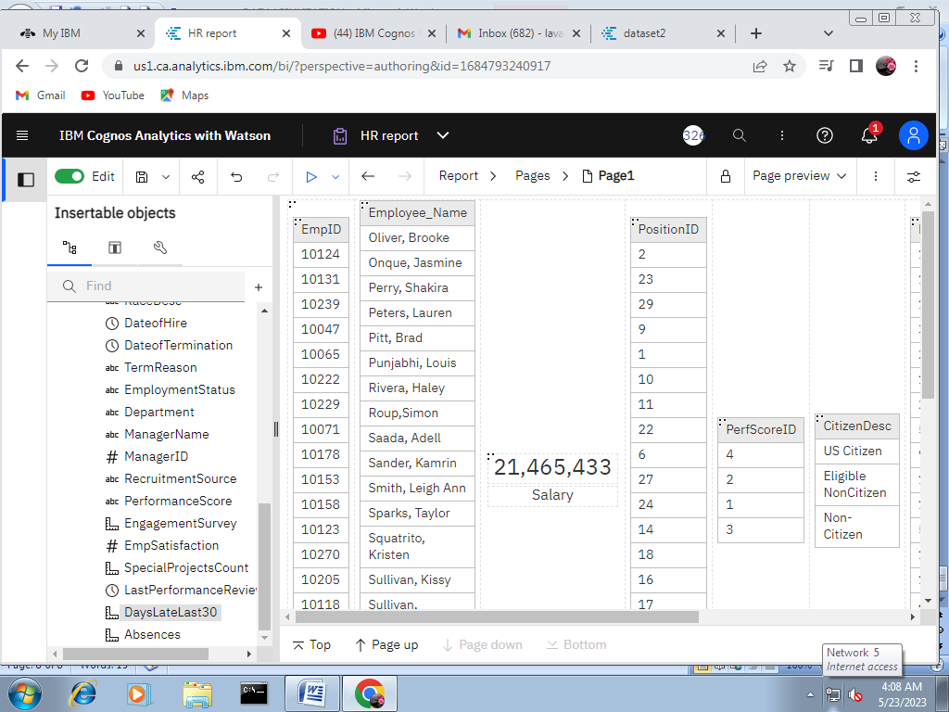

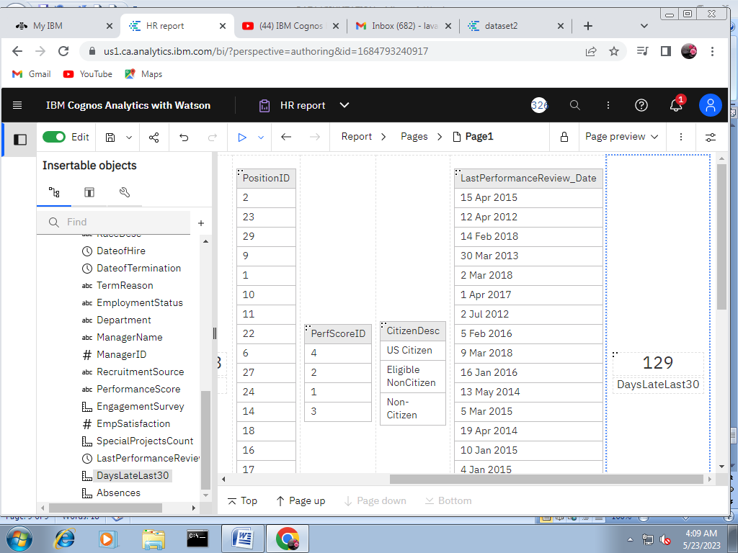

LINK: <https://us1.ca.analytics.ibm.com/bi/?pathRef=.my_folders%2FHR%2Breport&action=edit>

DATA REPORT

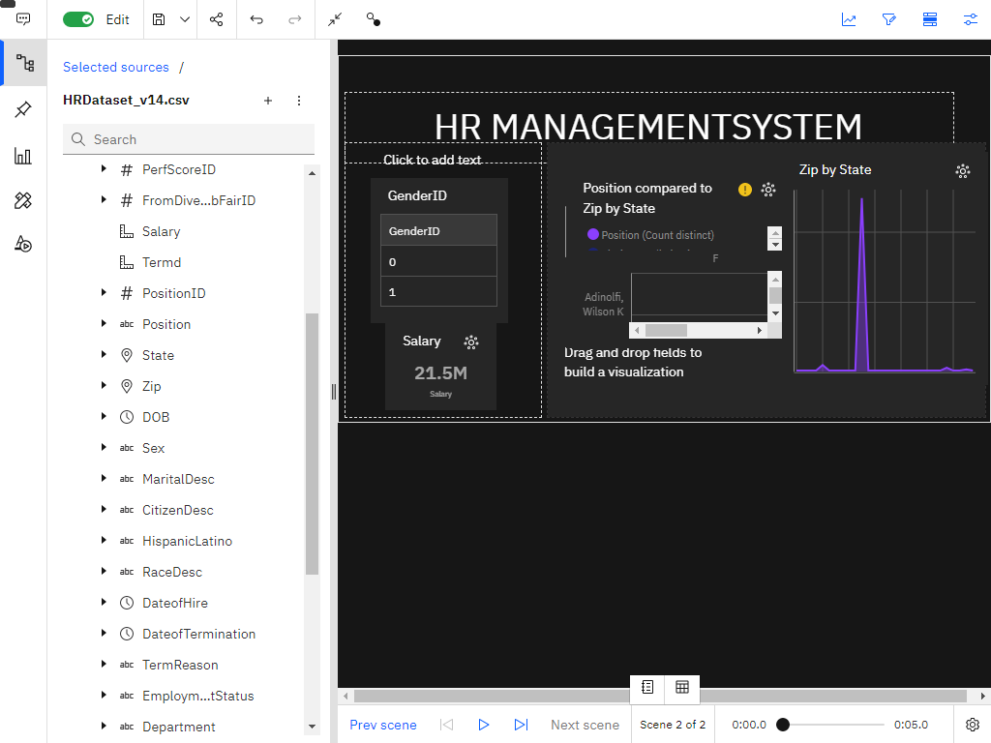

LINK: <https://us1.ca.analytics.ibm.com/bi/?perspective=story&pathRef=.my_folders%2FSTORY%2B1&action=view&sceneId=model00000188549bc0e7_00000000&sceneTime=0>

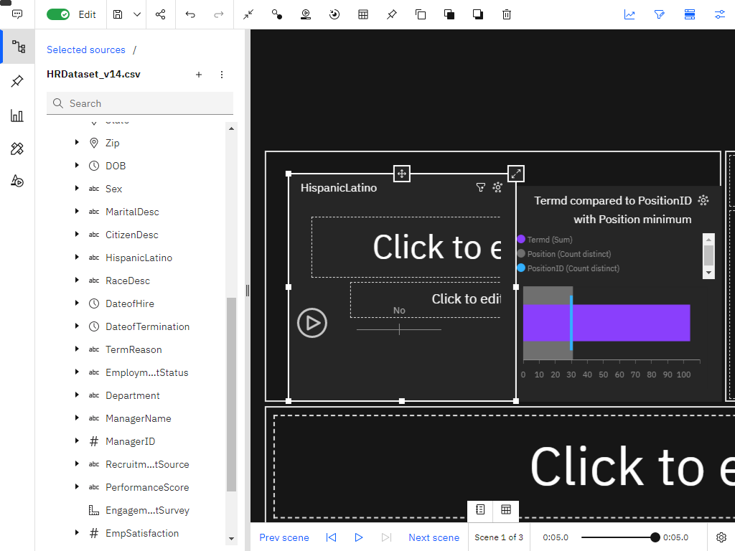

LINK: <https://us1.ca.analytics.ibm.com/bi/?perspective=story&pathRef=.my_folders%2FSTORY1&action=view&sceneId=model0000018854ddc621_00000000&sceneTime=0>

