**Online Shopping Application**

**SYNOPSOIS:**

The Online shopping Application is a web-based application, which helps user to find and shop latest varieties of products easily with different styles that are available in the market through online. It is a user-friendly website where user can shop through mobile or laptops with reasonable prices so that user can save their time as well as money.

1. Home Page
2. Product Search Facility
3. Product Detail Page
4. Add to Cart
5. Place Order

**Preliminary Design:**

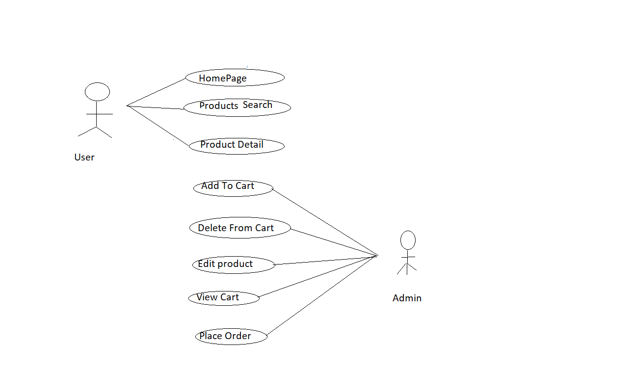

**Specifications of Use Cases:**

**1.Use Case Name:** Home Page

|  |  |
| --- | --- |
| Home Page | |
| **Element** | **Details** |
| Actor | User |
| Trigger | User view the home page. |
| Pre conditions | Run the application. |
| Post conditions | User successfully runs the application and is able to view the home page. |
| Normal course | 1.Home page will be displayed.  2.User search the products on the search bar. |

2.**Use Case Name**: Product Search Facility

|  |  |
| --- | --- |
| Product Search Facility | |
| **Element** | **Details** |
| Actor | User |
| Trigger | User wants to search the details using name or category of product. |
| Pre conditions | A text box Provided for searching the products. |
| Post conditions | It displays the Products that are present in database. |
| Normal course | Home page will be displayed with all the products based on category. |

**3.Use Case Name**: Product Detail s

|  |  |
| --- | --- |
| Product Details | |
| **Element** | **Details** |
| Actor | User |
| Trigger | User wants to select one product from all the displayed products. |
| Pre conditions | Runs the application and view the product details. |
| Post conditions | It displays all the product details based on selection. |
| Normal course | 1.Product detail page will be displayed.  2.Based on product selection all the details of the product will be displayed in this page. |

**4.Use Case Name:** Add to Cart

|  |  |
| --- | --- |
| Add Cart Details | |
| **Element** | **Details** |
| Actor | Admin. |
| Trigger | New cart details added. |
| Pre conditions | Cart details was not present in data base. |
| Post conditions | New cart details will add into database. |
| Normal course | 1.Admin click the add to cart button.  2.Then all the details of product stored in the database. |

**5.Use Case Name:** Delete Product from Cart

|  |  |
| --- | --- |
| **Delete Product from Cart** | |
| **Elements** | **Details** |
| Actor | Admin |
| Trigger | User wants to delete the product from cart. |
| Pre conditions | Product details already existing in database |
| Post conditions | Existing product details will get deleted into database |
| Normal course | 1. Delete button will be displayed.  2.Admin delete all the product details.  3.Details has to be deleted from server. |

**7.Use Case Name:** Place Order

|  |  |
| --- | --- |
| **Place Order** | |
| **Elements** | **Details** |
| Actor | Admin |
| Trigger | Admin wants to order the product |
| Pre conditions | Order details was not in database |
| Post conditions | Order details will be added into database |
| Normal course | 1.Admin click the place order button.  2.the order is then placed. |

**Database Table Diagram:**

Product Category:

|  |  |  |
| --- | --- | --- |
| Field Name | Data Type | Remark |
| CategoryId | Int | PK |
| CategoryName | Varchar (50) |  |

Products:

|  |  |  |
| --- | --- | --- |
| Field Name | Data Type | Remark |
| Productid | int | PK |
| Category id | int | FK |
| Product name | Varchar (50) |  |
| picture | Varchar (50) |  |
| price | decimal |  |
| content | Nvarchar (Max) |  |

Cart Item:

|  |  |  |
| --- | --- | --- |
| Fieldname | Datatype | Remark |
| productid | int | FK |
| Productname | Varchar (50) |  |
| picture | Varchar (50) |  |
| price | decimal |  |

APPENDICES:

**1.Home Page**

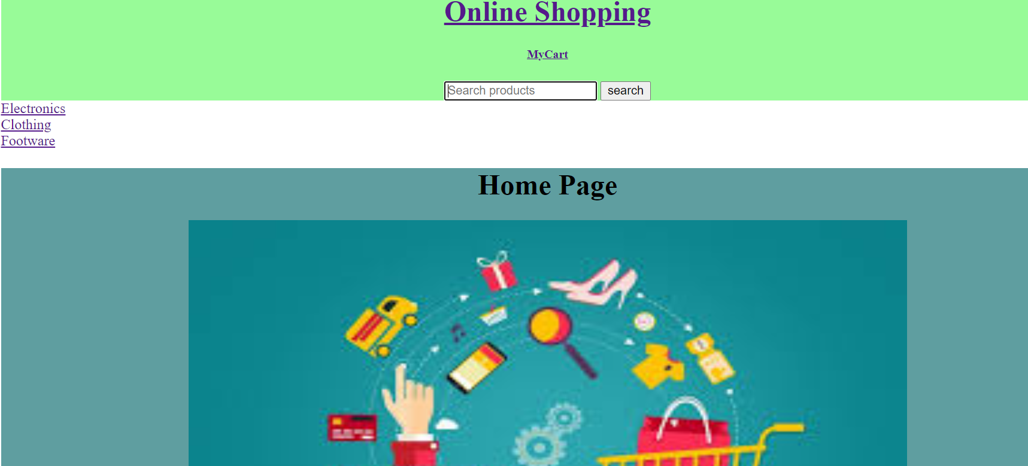**2.Search by Product Name:**

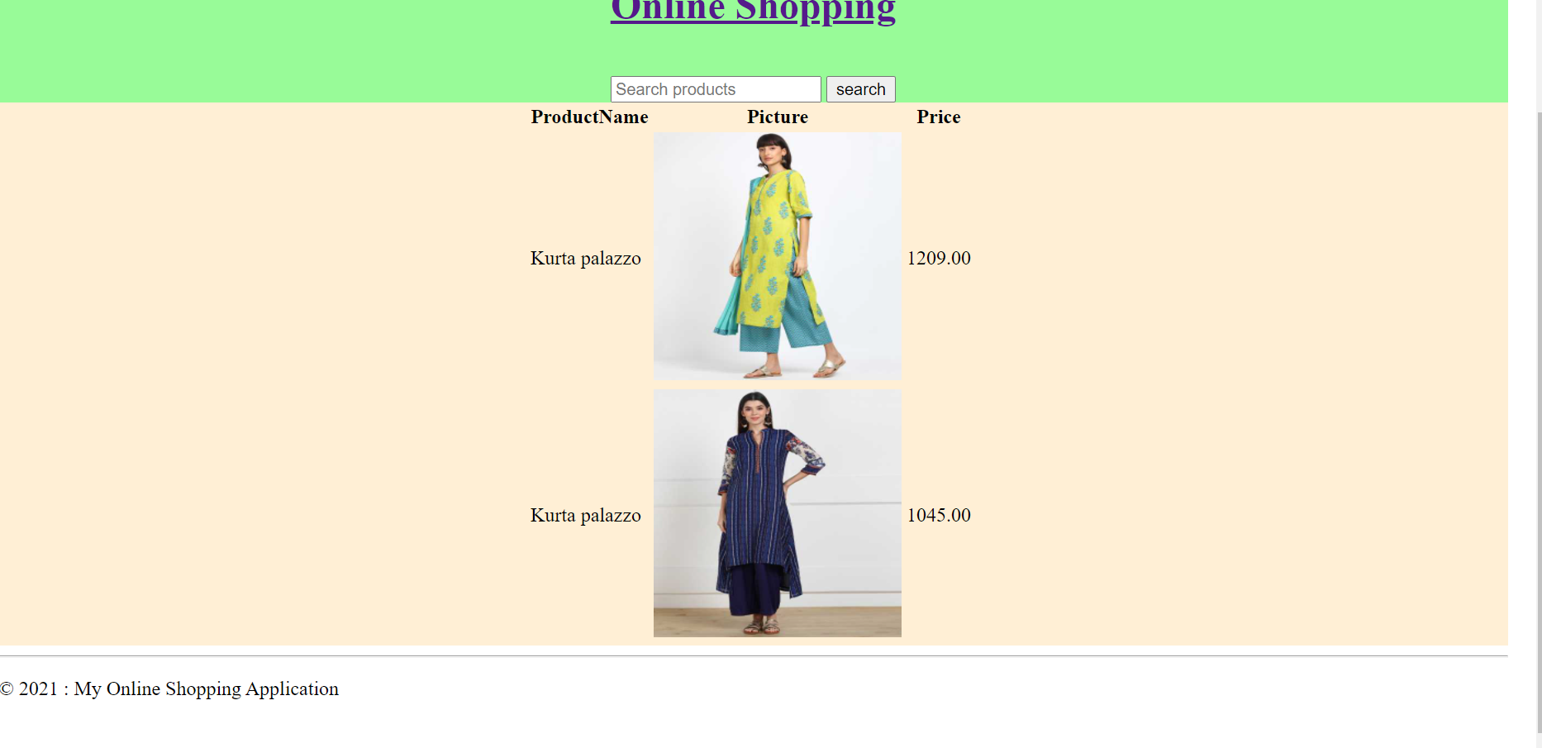**3.Search by category Name:**

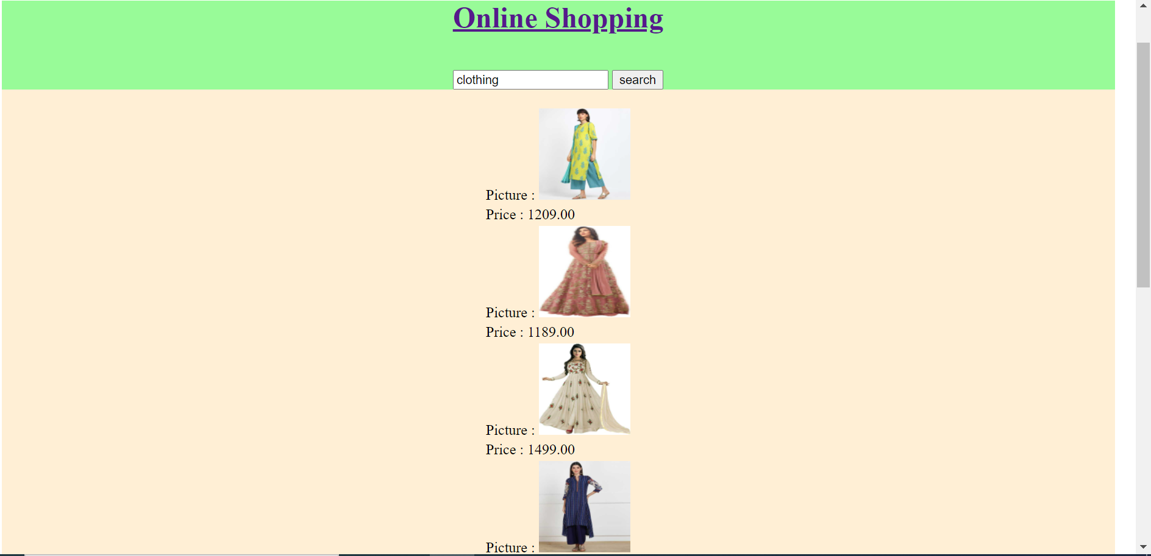

**4.Product Details:**

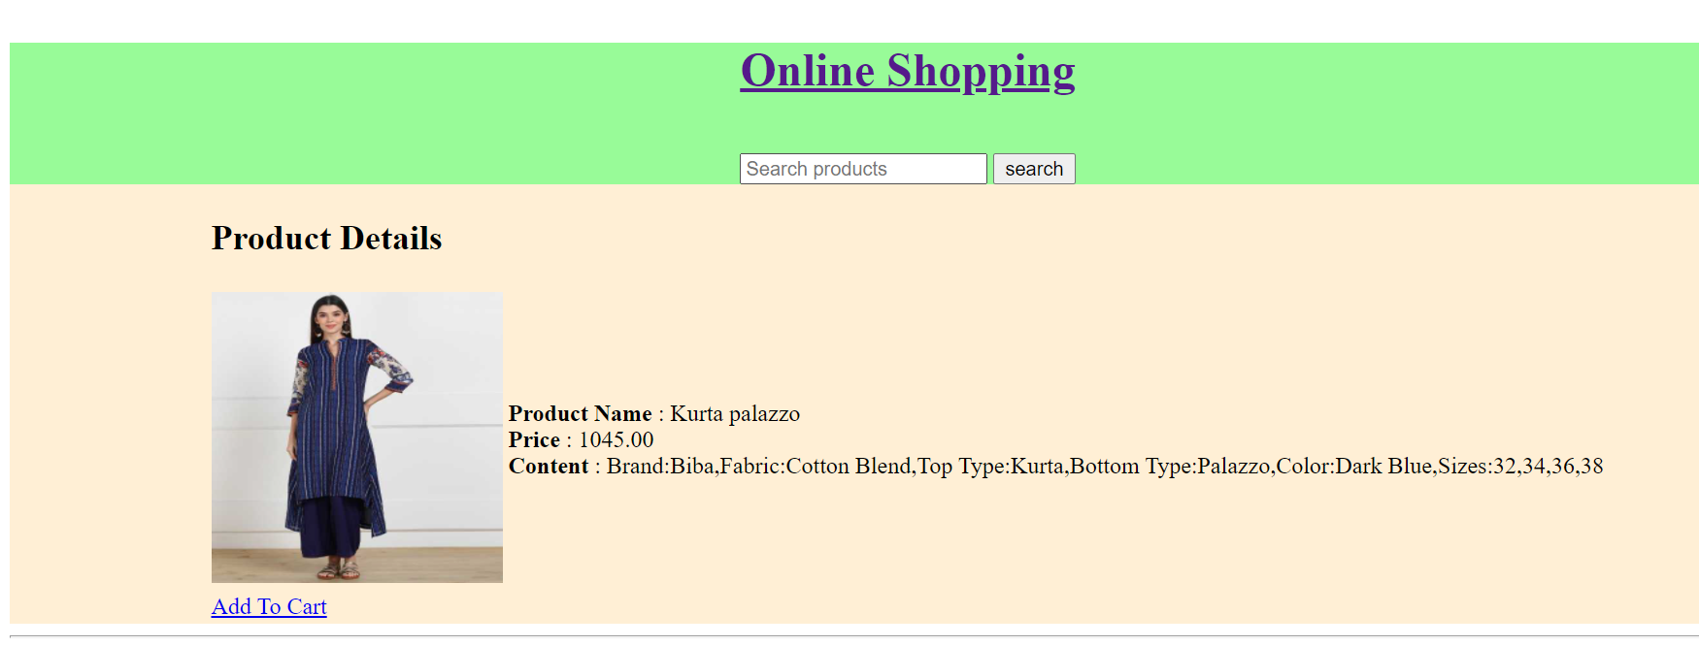

**5.Add to Cart:**

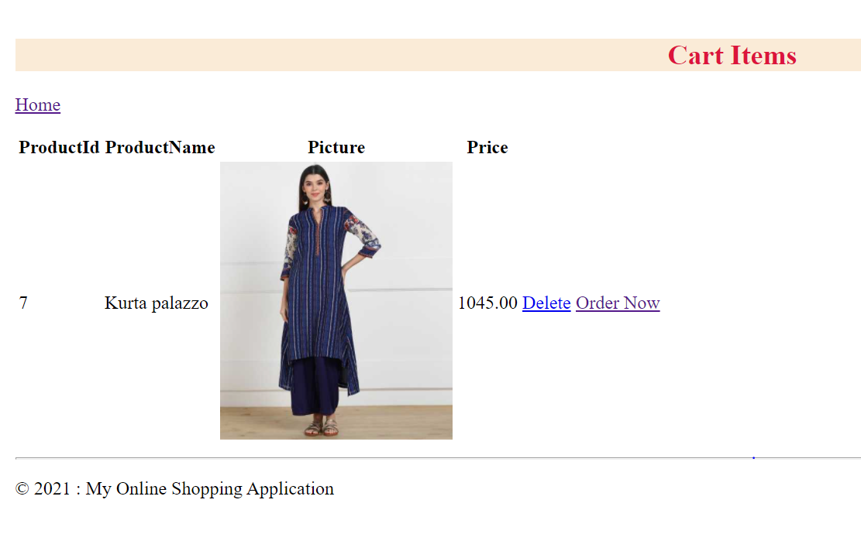**6.View Cart:**

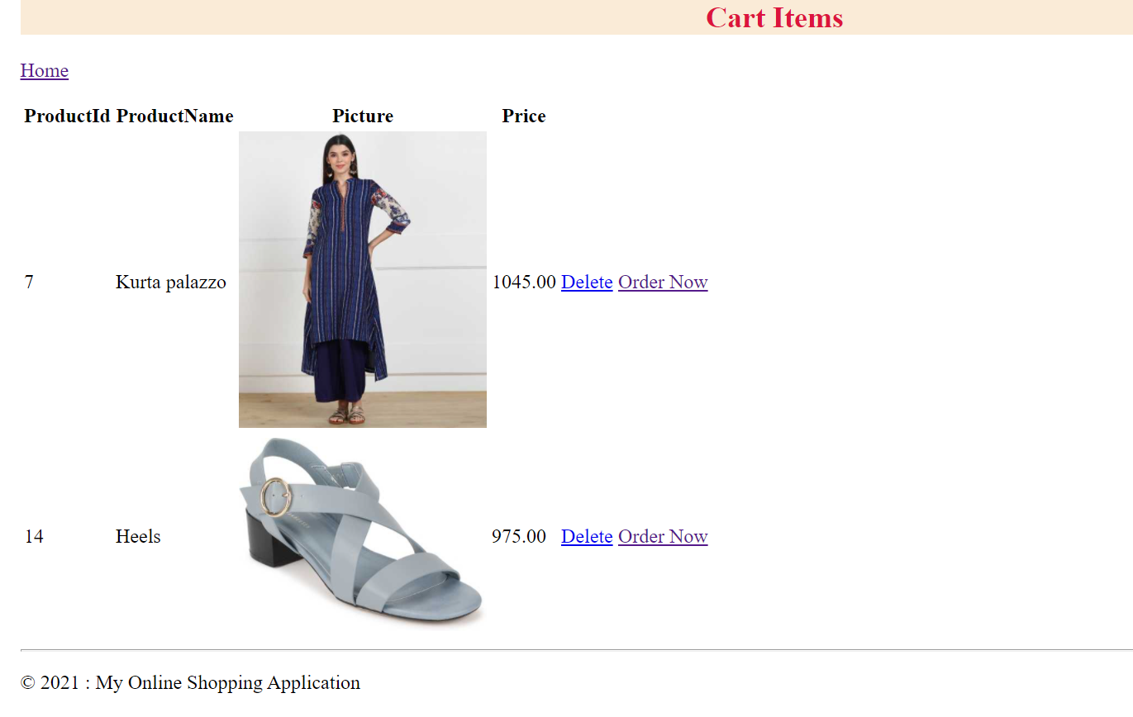**7.Delete Cart Items:**

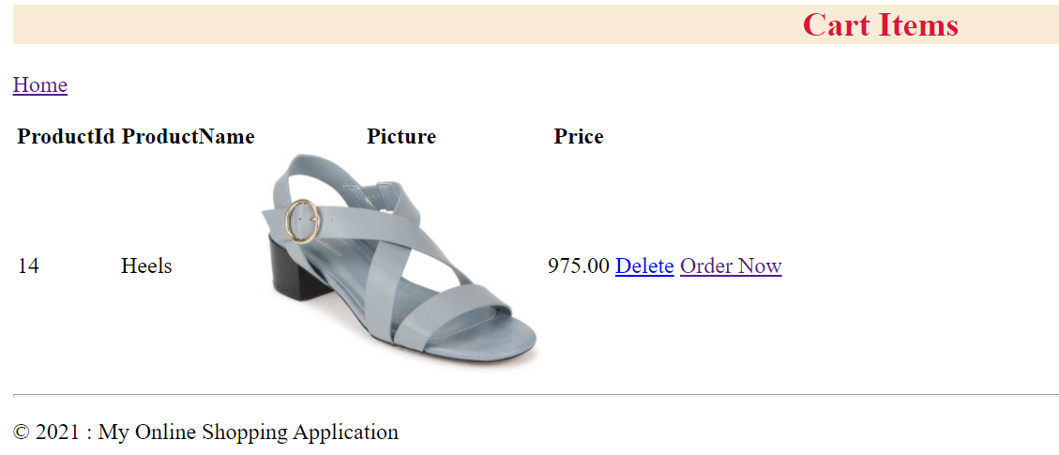**8.Place Order:**

