Install Docker Desktop for Windows
Run the below commands to check docker version
docker –version
docker compose version
Verify Docker is Working
Run this command: docker run hello-world
If you see a success message, Docker is working correctly.
Clone the Project
git clone https://github.com/lavanya-nagarro/sample-docker-assignment.git
Project Structure
sample-docker-assignment/
│
├── user-service/
│ ├── src/ # Spring Boot backend source code
│ ├── pom.xml # Maven configuration
│ └── Dockerfile # Backend Dockerfile
│
├── frontend/
│ ├── index.html # Simple HTML + JS frontend
│ └── Dockerfile # Frontend Dockerfile
│
├── docker-compose.yml # Multi-container configuration
├── README.md
└── .gitignore

Navigate to the sample-docker-assignment directory in the Docker CLI.
Start the application by running the command below, which will build and launch the frontend, backend, and database services:
docker compose up --build
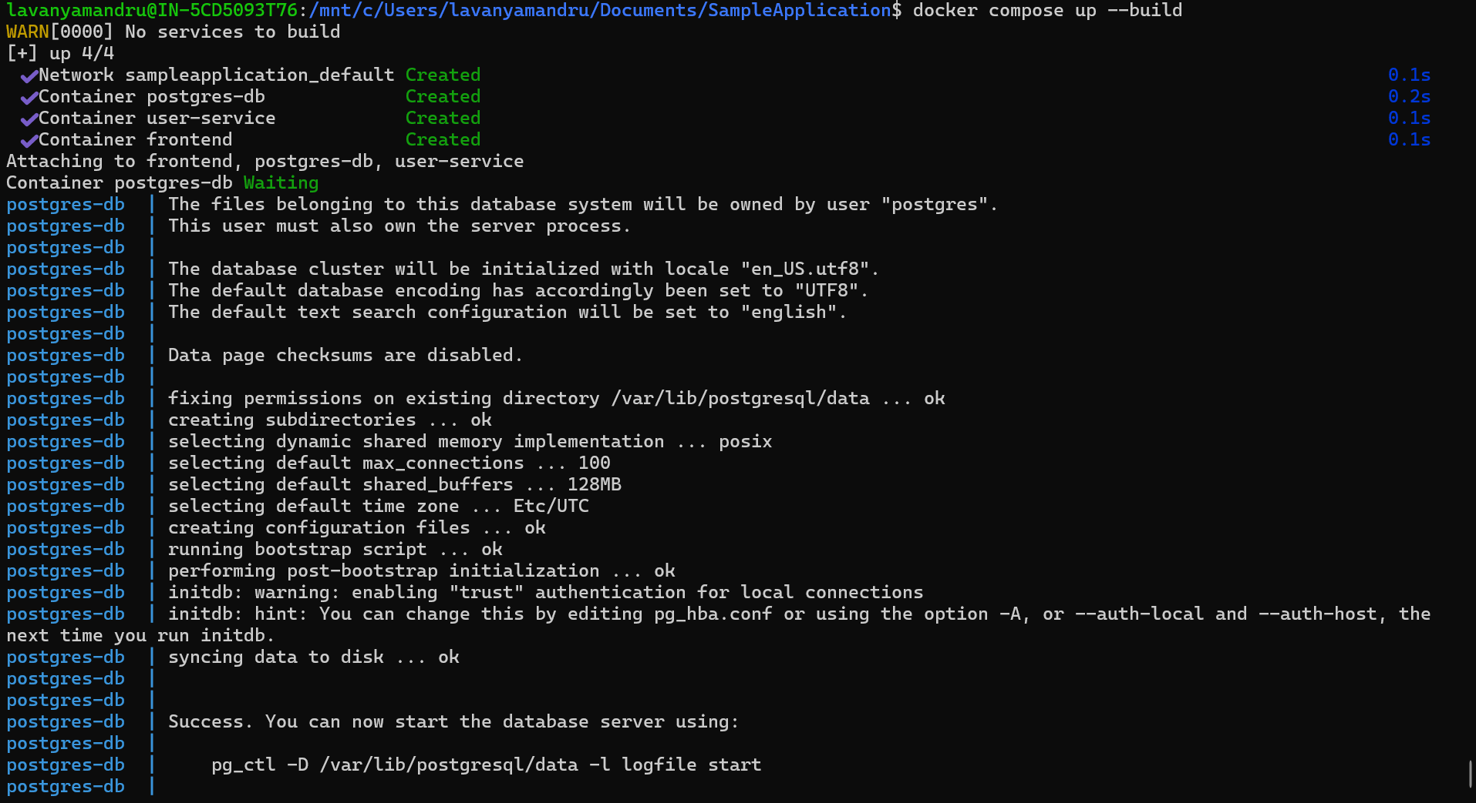
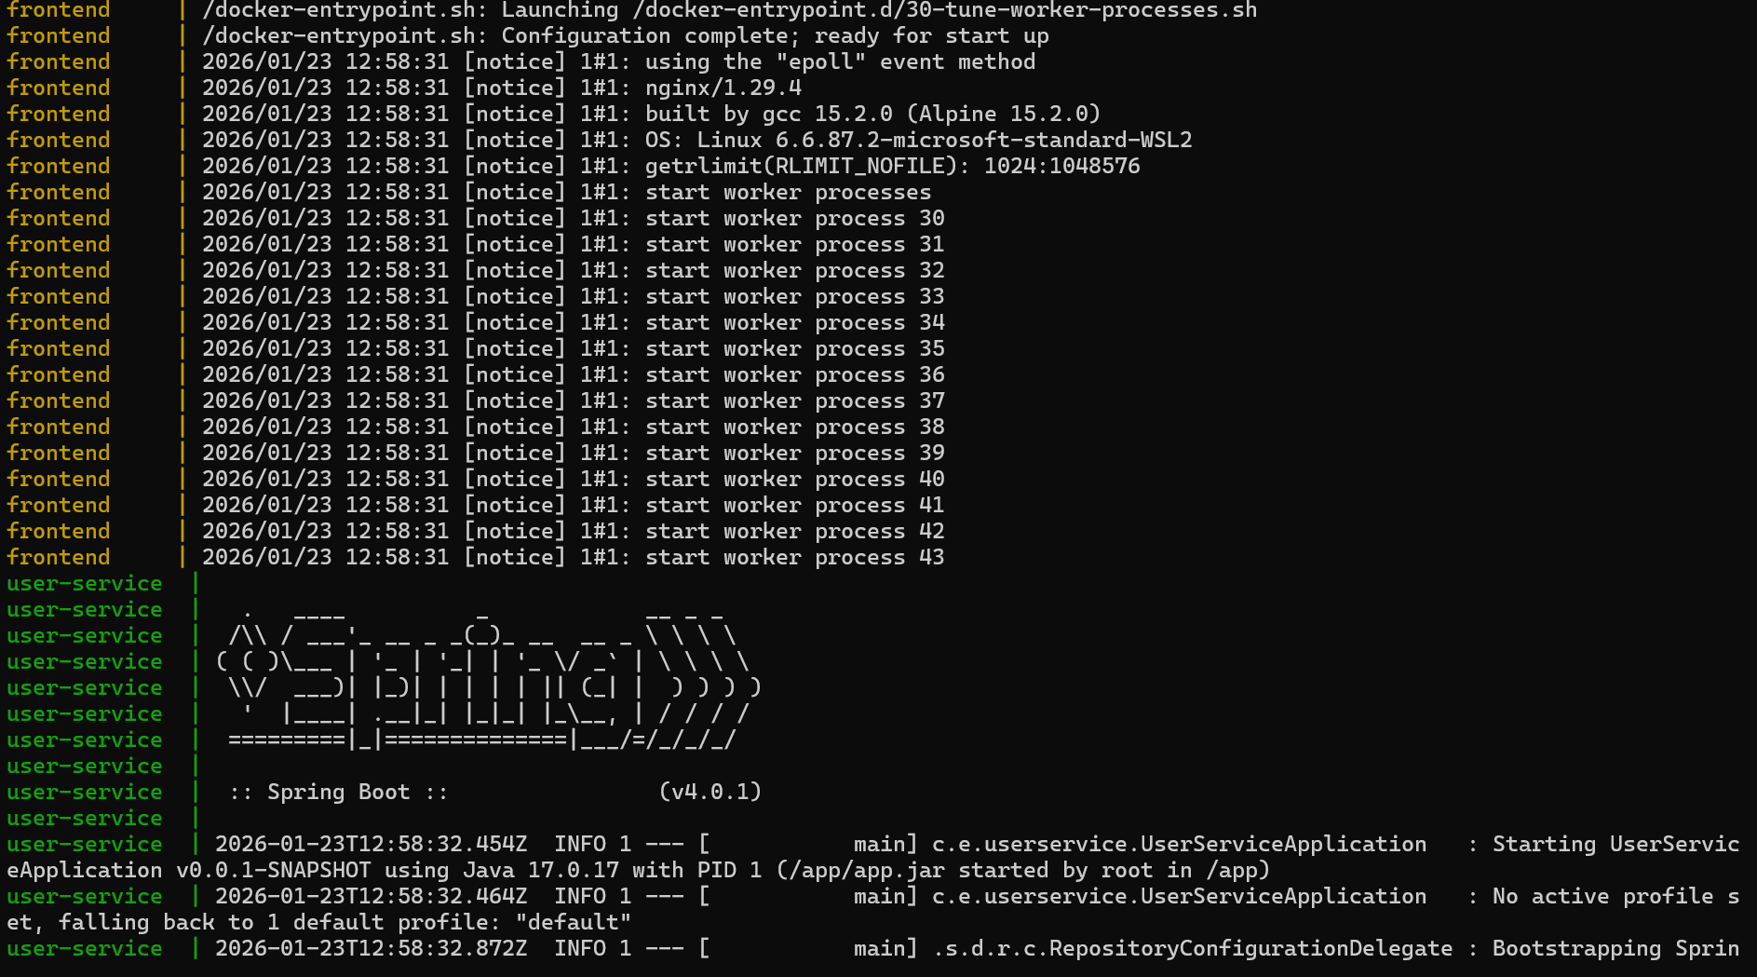
To open the Application user the url http://localhost:3000/
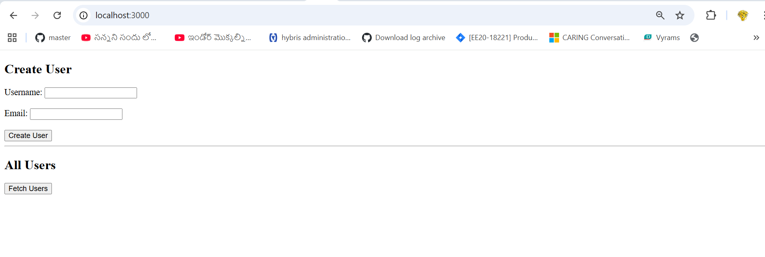
Action: Enter Username/Email → Click: Create User → Verification: Click Find User.
Docker Commands
docker ps : It displays only list of running containers
docker ps -a : Displays list of all containers
docker images : Displays Docker Images
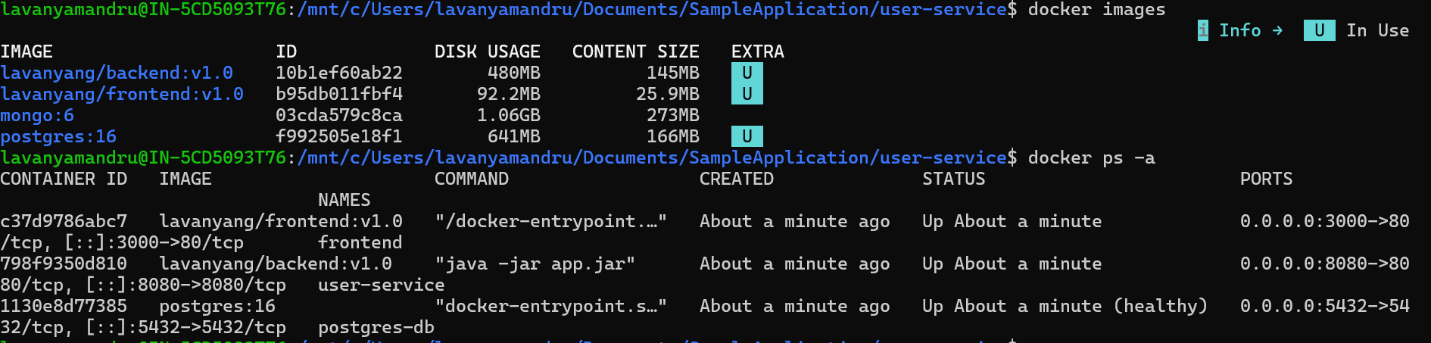
docker start<container Id/Name> : Start the container
docker stop <container Id/Name> : Stop container
docker rm <container Id/Name> : Remove Container
docker rmi <image Id>: Removes the image
docker logs <Conatainer Id>
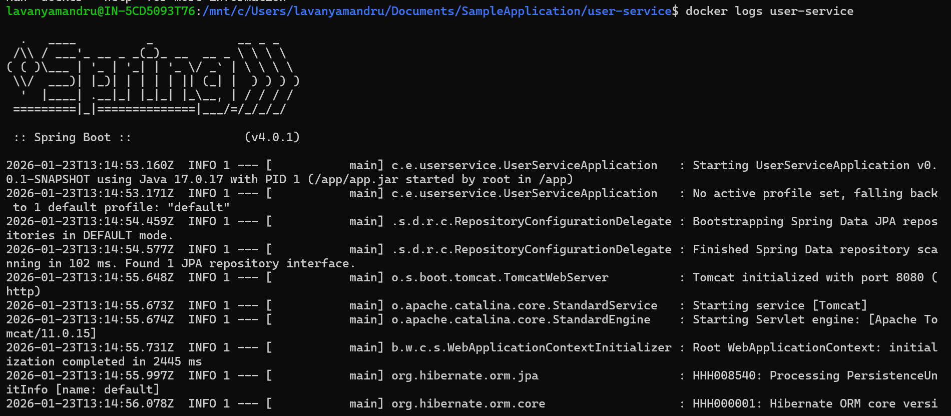

Docker Hub (Image Registry)
Login
docker login
Push Image
docker tag <imagename> <dockerhub-username>/<repositoty name>:tag
docker push <dockerhub-username>/< repositoty name>:tag
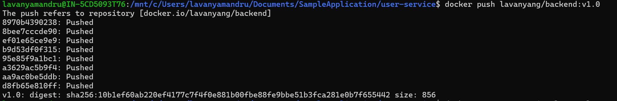
Pull Image
docker pull lavanyang/backend:v1.0

