Docker Advance Assignment instructions
Took an existing Dockerfile and optimize it for build speed and image size.
To reduce the image size and improve build speed, a multi-stage build approach and lightweight base images were used in the Dockerfile from the below path
sample-docker-assignment\user-service.
After build the optimized docker file, we can see layer wise size based on below command
Clone the Project
git clone https://github.com/lavanya-nagarro/sample-docker-assignment.gitNavigate to the sample-docker-assignment directory in the Docker CLI.
start the application by using docker compose up –build command
docker history backend:latest
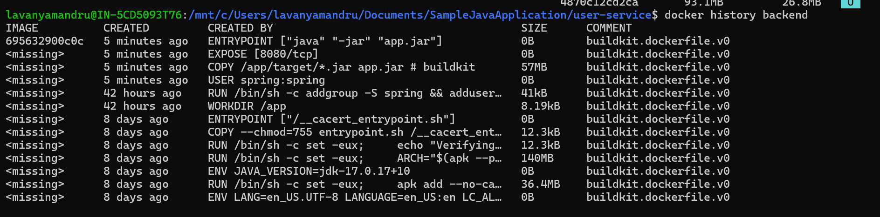
pull the old docker image by using the below command to compare the size
docker pull lavanyang/backend:v1.0
We can check docker size by using docker images command
Custom Docker network and connect multiple containers to it.
Created custom network by the below command or we can do through docker compose file docker network create backend(NetworkName)
To check both containers listed under Containers by this command docker network inspect backend
Test Communication Between Containers:
from one container we can ping another container by following this command
docker exec -it user-service /bin/sh
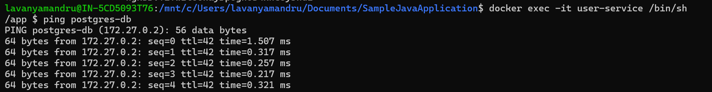
Connect Existing Containers to Network by using command docker network connect backend user-service
Docker volumes to persist data of containers
Create Volume by using docker volume create sample-docker-assignment_db_data.Check volumes by the below command docker volume ls.Inspect by using docker volume inspect sample-docker-assignment_db_data command.
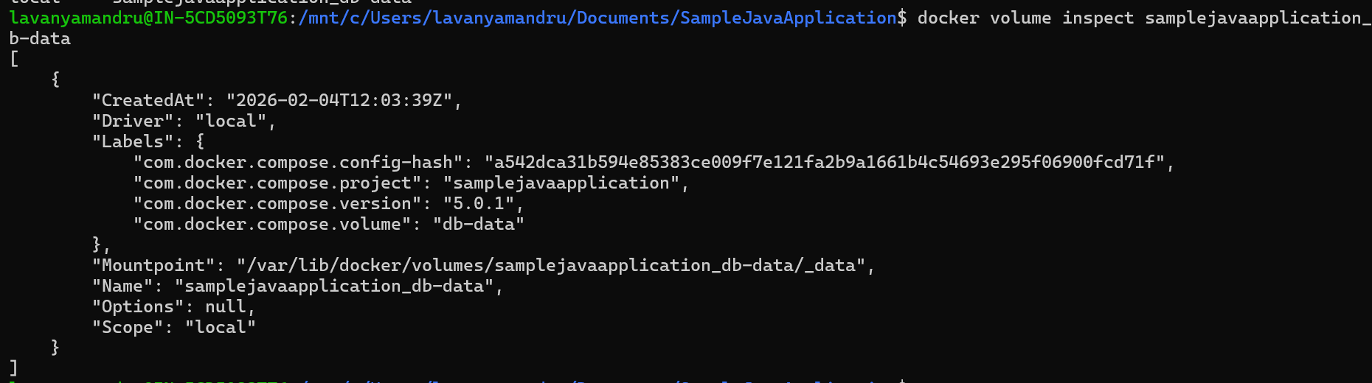
Created named volumes for database container and bind mount for user-service container
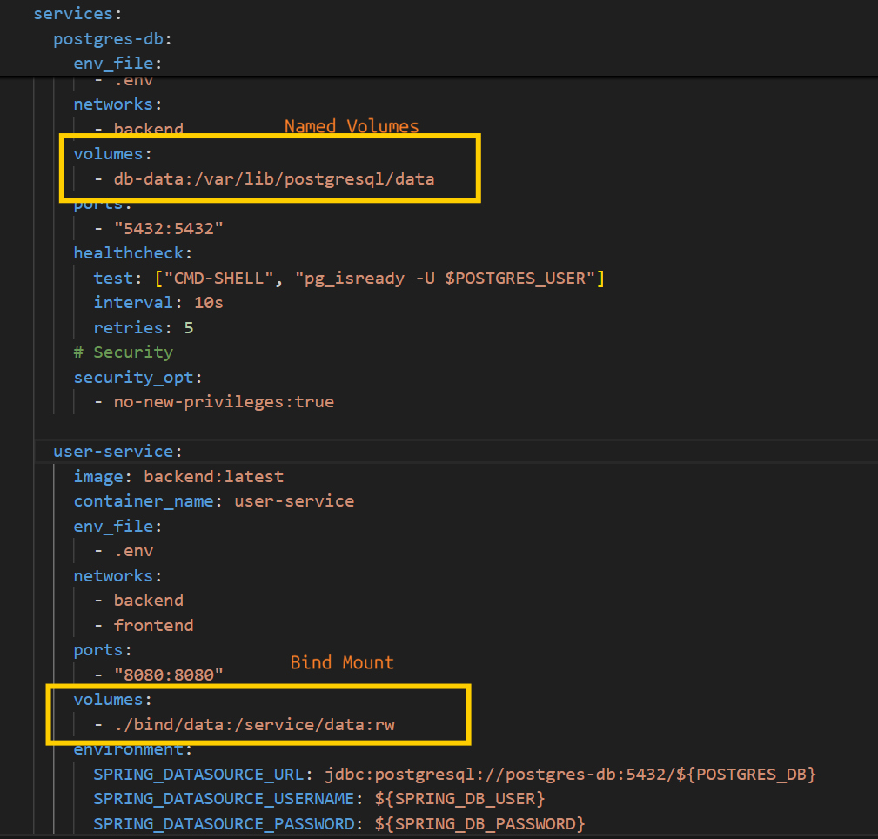
You can remove a container and create a new one without losing database data because the data is stored in Docker volumes.
When a volume is attached to a container, the data is saved outside the container.
So, even if the container is deleted, the data in the volume remains safe.
If you create a new container and attach the same volume, the existing database data will be automatically available in the new container. Or we can it manually also by below method
Backup and restore data from Docker volumes
To take backup from we can the below command, it will take backup in userdb_backup.sql
docker exec postgres-db pg_dump -U postgres userdb > userdb_backup.sql
to restore data into container level
docker exec -i postgres-db psql -U postgres userdb < userdb_backup.sql
security, user permissions, image vulnerability scanning, and secret management
By default, Docker containers run with root privileges, which can pose security risks. To improve security, non-root users are created and minimal, trusted base images are used. Image vulnerabilities are scanned using the open-source Trivy tool, and sensitive information such as secret keys and passwords is managed securely through environment variables.
Non root user permission on Dockerfile
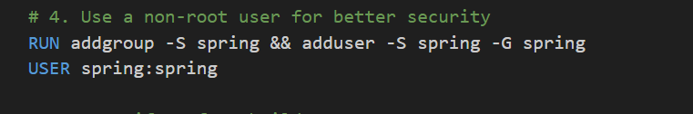
secret management: sensitive information such as secret keys and passwords is managed securely through environment variables(separate file)
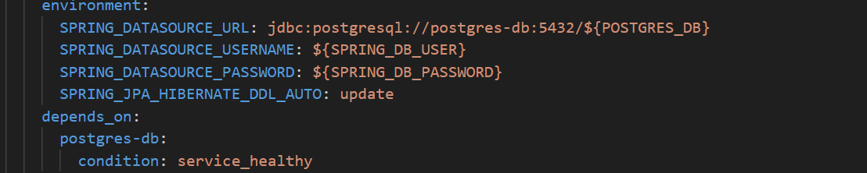
Security:
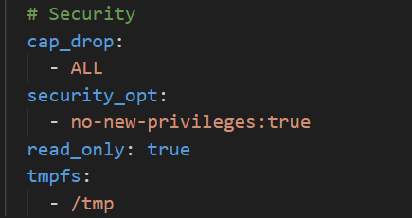
image vulnerability scanning : by using trivy we can scan the vulnerabilities
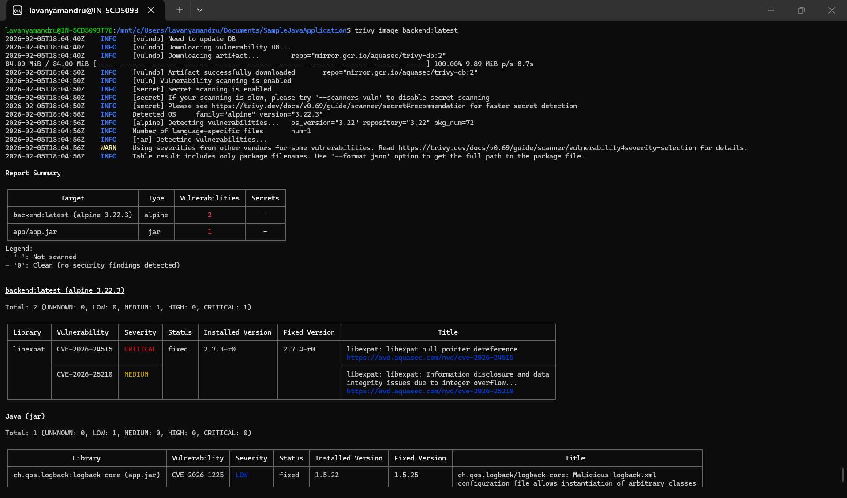
Secure Container: For Secure Container Run Command the below command
docker run -d \
--name secure_app \
--user 1001:1001 \
--cap-drop ALL \
--cap-add NET_BIND_SERVICE \
--read-only \
--tmpfs /tmp \
--memory=512m \
--cpus=1 \
--security-opt no-new-privileges \
--network secure_net \
User-service

Docker Bench for Security to audit for Docker environment: Docker Bench for Security is not supported in our WSL environment where Docker is installed. Therefore, we are currently using Trivy to scan for security vulnerabilities.

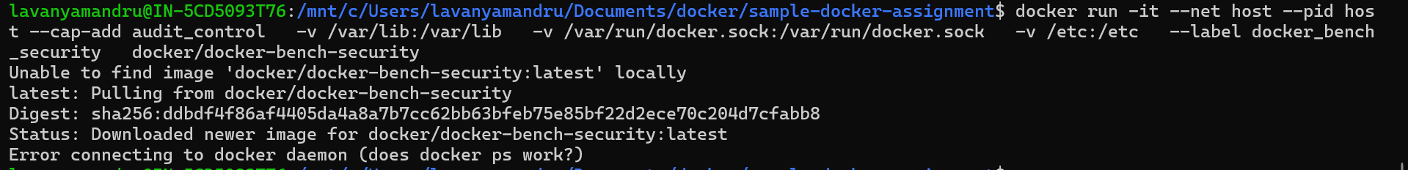

Continues integration and push the images to docker hub
Created ci.yaml file for continues integration configuration https://github.com/lavanya-nagarro/sample-docker-assignment/blob/master/.github/workflows/ci.yml
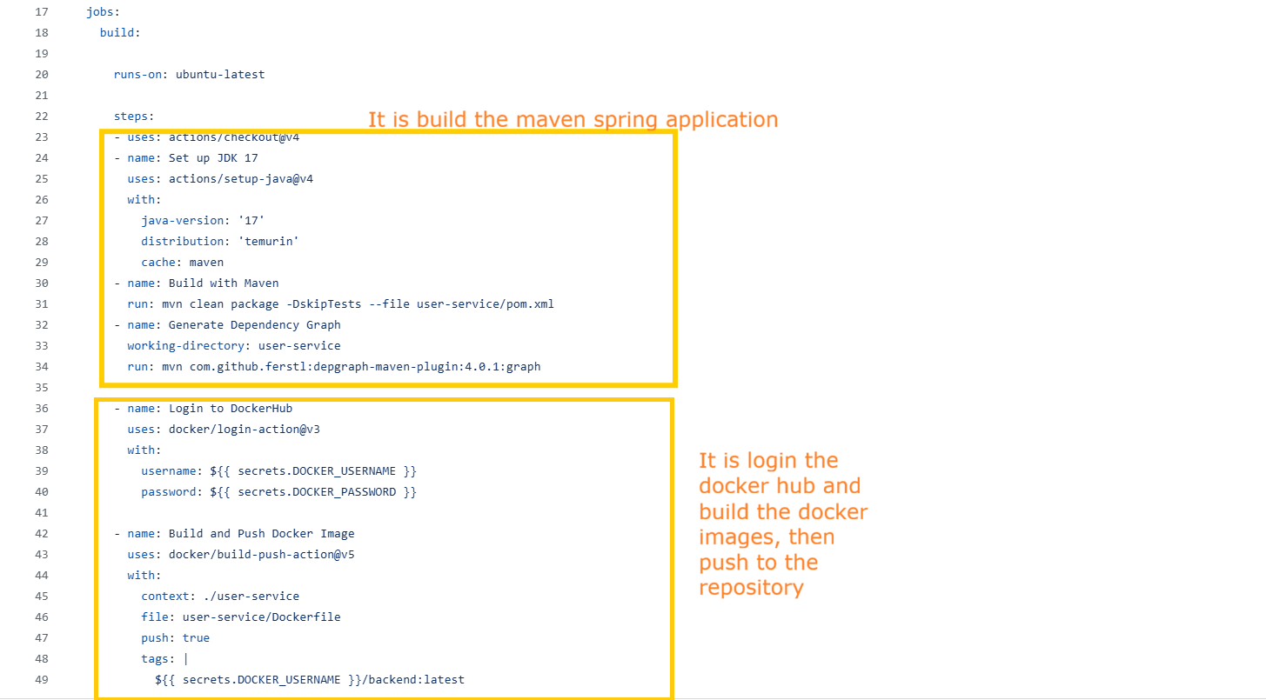
Docker username and password are stored under secrets of git hub repository
