LogBook

# Date: 24th August 2018, 12pm-2pm

Summary of decisions:

* Discussed the assessment specs - difference in goals and roles of healthcare provides/centres
* Further broke down specification and asked each other about doubts to clarify what the main aim to achieve is and how to break the process into steps
* We made a scaffold of the basic user case stories we wanted to dwell on which included :
  + For health care provider: US1: Access current appointment history
    - US2: Access past appointment history
    - US3: See details about patient history
    - US4: Record notes after patient visits
    - US5: Record any prescribed medication
  + For health care users: US6: Search for available health care centres
    - US7: View profile of healthcare centres/providers
    - US8: Book appointment
    - US9: View appointment history
    - US10: Rate healthcare provider/centre
* Finalised responsibilities to be achieved by next meeting (lab on Tuesday)

Progress:

* Discussed classes to include in the UML diagram
* Roughly discussed the relationships between classes
* Evenly allocated the user stories and acceptance criteria to be written for next week:
  + Lavanya – US1-US3
  + Sheril – US4- US5
  + Felix – US6 – US7
  + Sophia – US8 – US10

Responsibilities:

* To expand on the user cases, we have been allocated
* Rough scaffold/ idea of attributes to be individually brainstormed so that we can recombine during our next meeting

Velocity Chart:

* Expectation for next lab - x/10

# Date: 28th August 2018, 1pm - 2:30pm

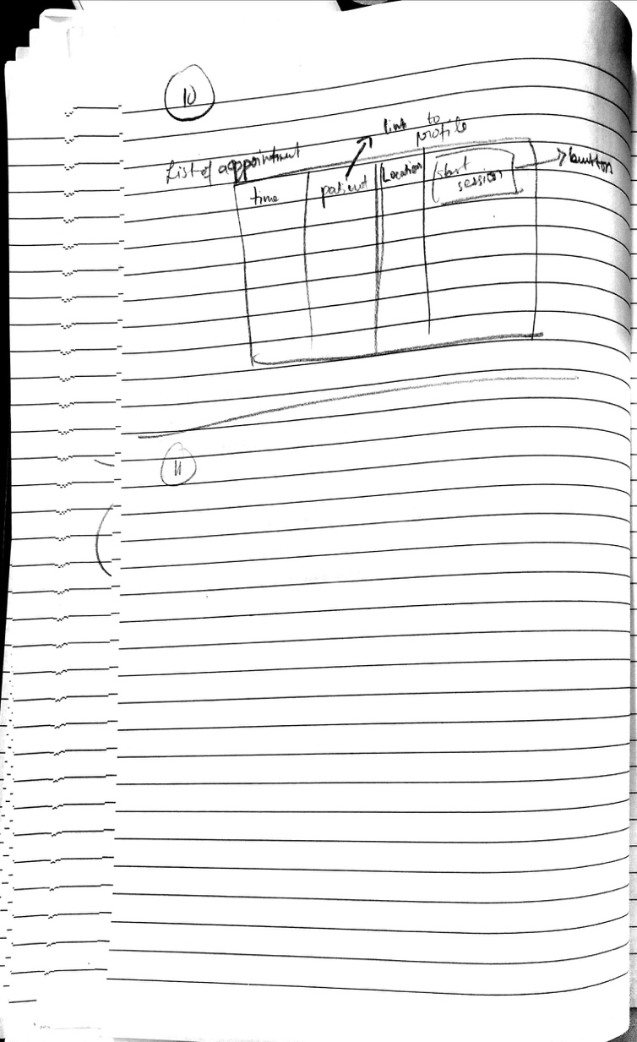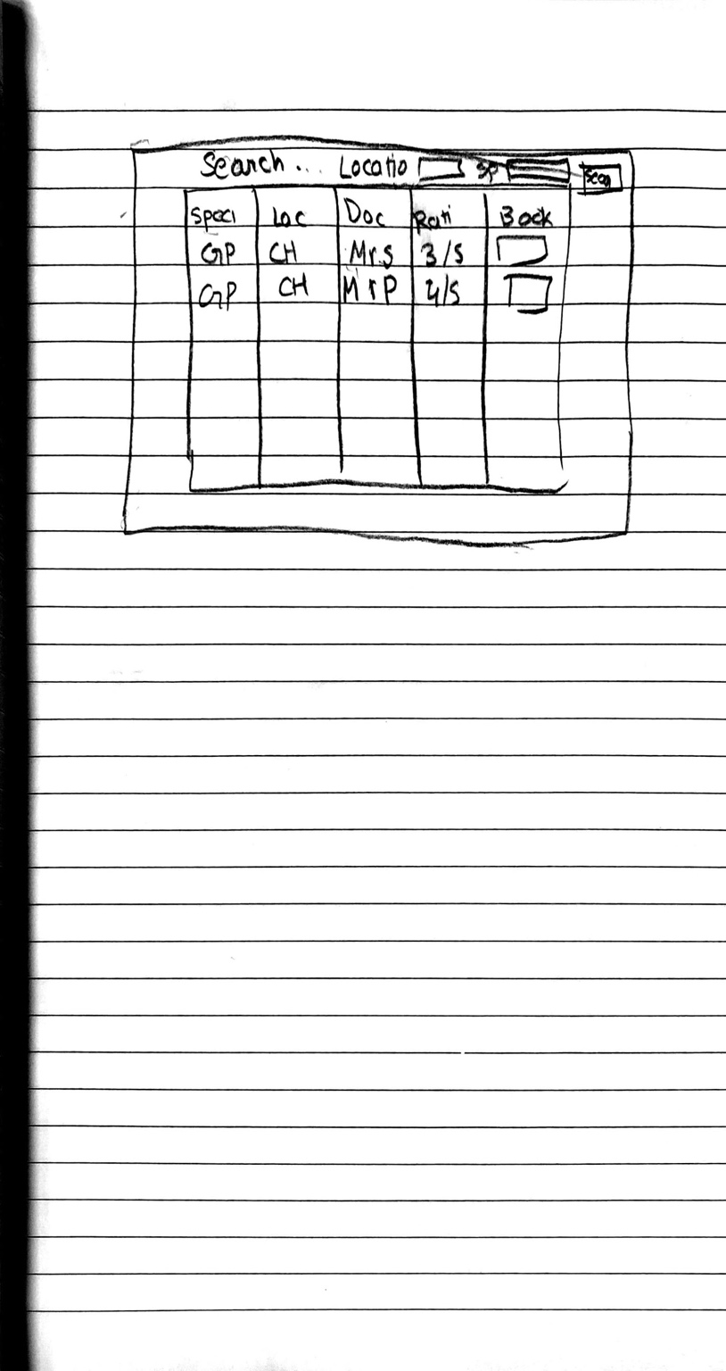

Summary of decisions:

* Given the written-up user-cases and acceptance criteria – we had to give each case a priority
* Additionally, we had to allocated story points as to plan how much time will be spent on which tasks based on priority
* We also designed a basic layout of how we expect to layout the webpages and its functionality

Progress:

* We clarified the user-cases and the acceptance criteria
* We asked for feedback and took the suggestions on board to further perfect our documentation
* As a team, we recognised a few major classes which the UML diagram must encapsulate

Responsibilities:

* Each member has the responsibility of revising their part of the User-story and criteria
* Additionally, all members are to further brainstorm possible methods to classes
* Solidify our documentations and ideas for Milestone #1

Velocity Chart:

# Date: 6th September 2018, 1pm - 2:30pm

Summary of decisions:

* Decide which requirements to be prioritised and which ones most time needs to be spent on – prioritising searching and booking and then login
* Clarified login page layout
* Designed the layout of search engine page and considered the functionality of how classes can link the data
* Designated python/flash/html tasks to be completed

Progress:

* Refined user stories
* Delegated flask and python implementation task to be completed before the next milestone
  + Lavanya – Search/ Booking page(s)
  + Felix – UML (Classes and methods included)
  + Sophia – Search/ Booking page(s)
  + Sheril – Login page

Responsibilities:

* Understanding how csv files are to be read and stored by python/flask implementation
* Utilising the flask_login application to authenticate logging into the system
* Completing the delegated tasks for implementation before next meeting

Velocity Chart:

Date: 11th September 2018 12pm – 2pm

🡪 maybe include what the base and other html pages are

how we are organising the

# Date: 15th September 2018 12pm – 3pm

Summary of decisions:

* Defined the various implementation processes
* Laid out how the user will be directed through our user interface

Progress:

* Refined user stories
* Delegated flask and python implementation task to be completed before

Responsibilities: