**NOISE POLLUTION MONITORING**

**Phase – 3**

**PROBLEM**

In this project, we will create an noise pollution monitoring system to detect sound in decibels and display sound and level of the sound in decibel on an OLED. Additionally, we will link our sound pollution monitor with Blynk application and users can monitor the sound decibels on the Blynk app.

**DEPLOYED IOT DEVICES:**

1. **ESP32 Microcontroller:** The ESP32 is a powerful microcontroller widely used for IoT applications due to its built-in Wi-Fi and Bluetooth capabilities.
2. **Sound Sensor (Microphone):** The code implies the use of a sound sensor to measure ambient noise levels. It likely provides analog voltage readings (connected to pin A0) that are then converted into decibel levels.
3. **Buzzer:** A simple buzzer or piezo element is employed to produce sound alerts when the noise levels exceed a certain threshold. The buzzer is connected to pin 19.
4. **OLED Display (Adafruit SSD1306):** The Adafruit SSD1306 is an OLED display module used for visual output. It's connected via I2C communication (using the Wire library), and the code displays the calculated decibel values and descriptors on this display.

**SOURCE CODE**

This code is used for monitoring sound levels and displaying the dB value on the OLED screen, accompanied by different displays based on the sound level and generating a sound alarm when it exceeds a certain threshold.

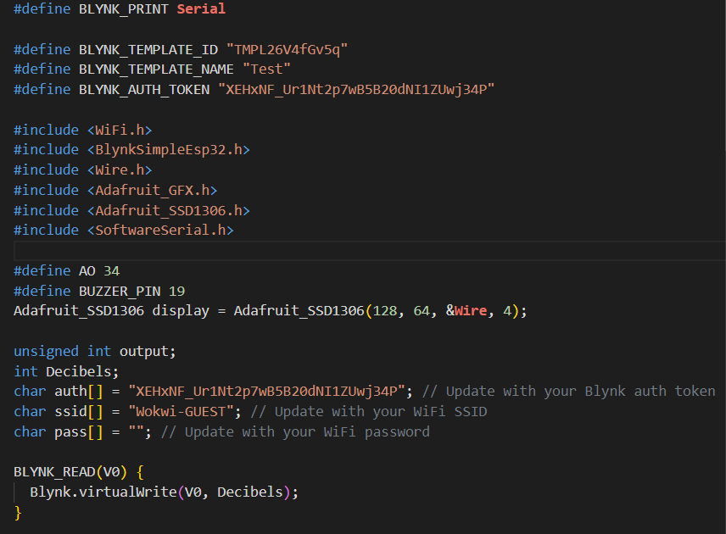

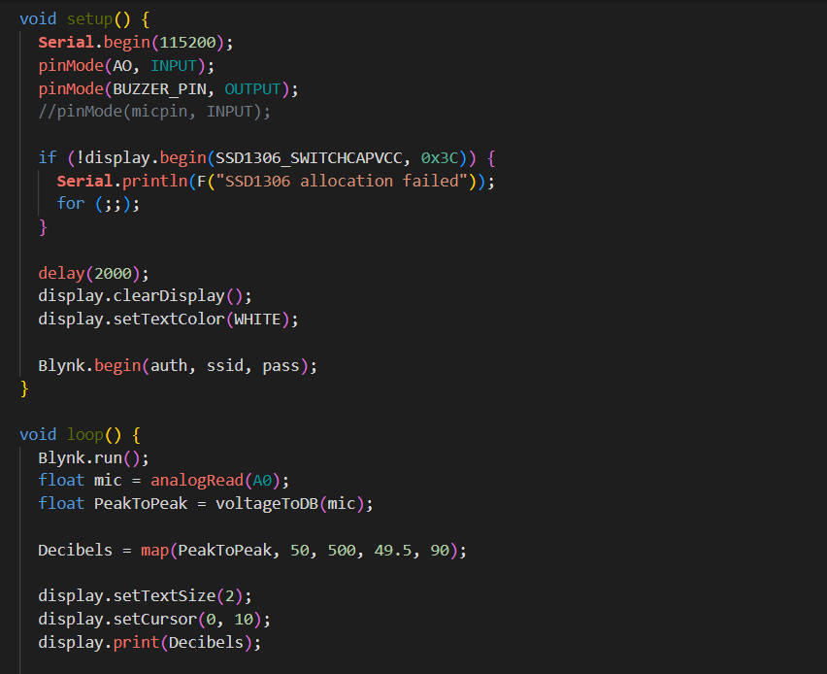

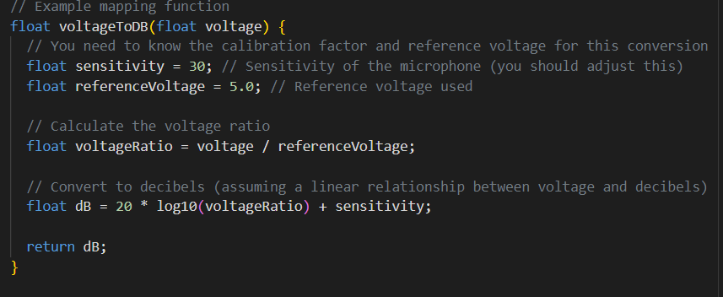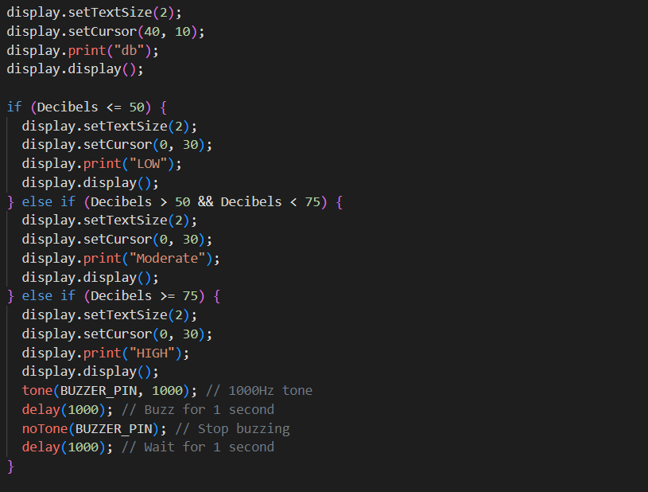

**SIMULATION AND OUTPUT**

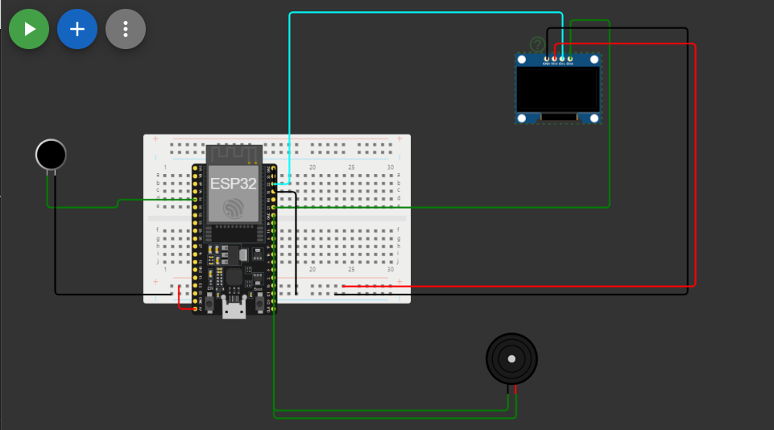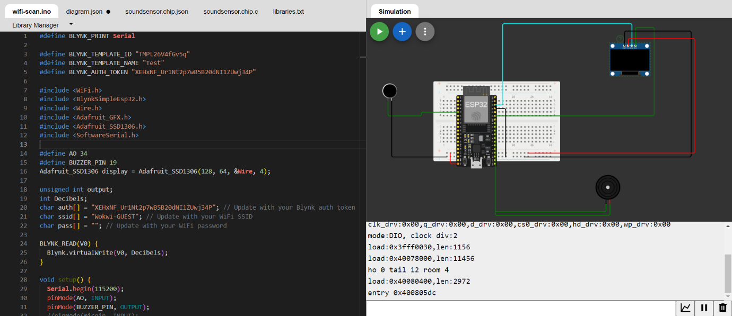

Loudness : 40dB

**Python Script Structure**

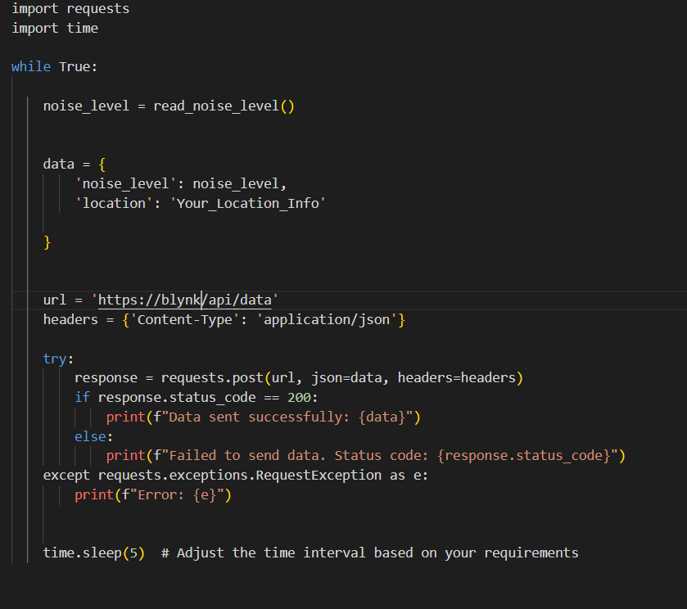

TEAM MEMBERS:

1. Jayanth N - (2021504523)

2. Lavanya V - (2021504525)

3. Mathana K - (2021504528)

4. Sudhanthira P - (2021504548)

5. Vidhya SS - (2021504557)