EXCEL ASSIGNMENT

Question 1: What is the difference between 'Paste' and 'Paste Special' in Excel? Briefly explain with examples

Answer: The main difference is that Paste applies all copied content and formatting as-is, while Paste Special allows you to choose specific parts of the copied content, like only values, formulas, or formats

Question 2: Describe the functions and usefulness of 'Freeze Panes' and 'Split Panes' in Excel.

Answer: Freeze Panes locks specific rows and columns so they remain visible while you scroll, allowing you to keep headers or key data in view.

Split Panes creates two or four independent, scrollable panes of the same worksheet, enabling you to compare different parts of a lengthy sheet side-by-side using separate scroll bars.

Question 3: Explain the difference between inserting a new row and inserting a new column in Excel. Can you insert multiple rows or columns at once?

Answer: Inserting a row adds a horizontal blank space that shifts existing data down, while inserting a column adds a vertical blank space that shifts existing data to the right.

You can insert multiple rows or columns at once by selecting the same number of rows or columns as you want to add.

Question 4: What are logical functions in Excel? Provide examples of at least two logical functions and their applications.

Answer: Logical functions in Excel perform tests on data to return either TRUE or FALSE, enabling decision-making and conditional actions within a spreadsheet.

The IF function returns one value if a condition is true and another if it's false,

while the AND function returns TRUE only if all specified conditions are met.

Question 5: Discuss the purpose of 'XLOOKUP' and how it differs from the traditional 'VLOOKUP' function.

Answer: Both the XLOOKUP and VLOOKUP functions in Microsoft Excel are used to find a value within a range of data and return result.

While VLOOKUP was a long-standing standard, XLOOKUP was introduced as a more flexible and powerful

Question 6: Create a worksheet titled 'Employee Data' with columns: Name, Age, Department. Add 5 rows of data. Format as follows:

● Bold and center-align the header row ● Apply a fill color ● Auto-fit column width

Answer:

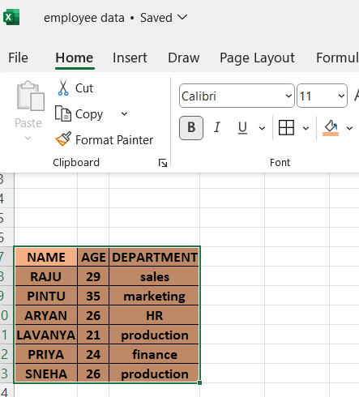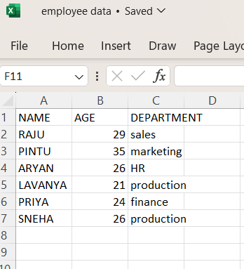

Question 7: Demonstrate how to insert and delete multiple rows and columns in Excel.

Answer:

You can insert and delete multiple rows and columns in excel using short cut key.

For inserting use (ctrl+) and for deleting use (ctrl-)

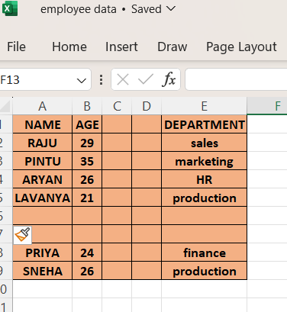

Question 8: Use Excel's 'Find and Replace' feature to update department names in a sample table.

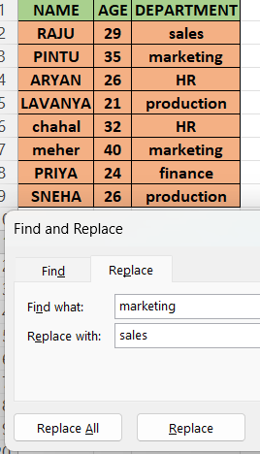Answer:

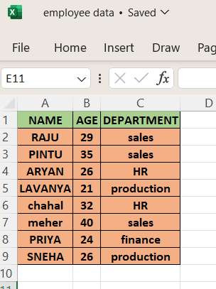

Question 9: Create a small numerical dataset and apply the following functions:

● AVERAGE ● MAX ● MIN

Answer:

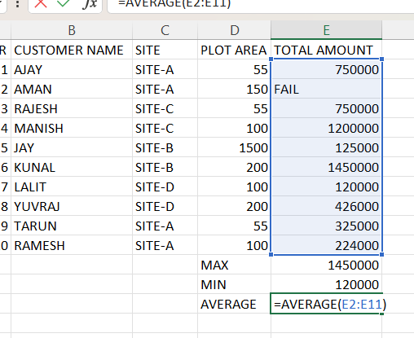

Question 10: You're working with a dataset that contains missing values. As a Data Scientist, explain how you'd detect and handle missing data using Excel. Mention tools like: ● Go To Special ● ISBLANK ● COUNTBLANK

Answer: