Change Log: Data Cleaning & Preparation
Project: DecodeLabs Data Analytics Project 1: Data Cleaning & Preparation
Dataset: Dataset_for_Data_Analytics_1.xlsx (1,200 rows, 14 columns)
Tools: Excel Power Query and Python (pandas)
Prepared by: Lavanya Galagali
Date: 22 October 2026

Change ID | Description | Impact | Status
CR001 | Filled blank CouponCode values with "No Coupon". A blank meant no coupon was used, so it was labelled instead of deleted or guessed. | 309 records preserved (25.75% of 1,200 rows). 0 blanks remain. | Resolved
CR002 | Checked for duplicate OrderIDs and removed duplicates by OrderID. | 0 duplicates found. 1,200 rows before and after. | Verified
CR003 | Trimmed leading and trailing spaces in text columns. Checked Product, PaymentMethod, OrderStatus and ReferralSource for mixed-case duplicates. | 0 values needed trimming. No case inconsistencies (7, 5, 5 and 5 distinct values, identical when case is ignored). No change made. | Verified
CR004 | Rounded UnitPrice and TotalPrice to 2 decimals. | 29 TotalPrice values had floating-point noise (for example 635.9000000000001) and were standardised. 0 UnitPrice values changed. No real price changed. | Resolved
CR005 | Validated the Date column and set the display format to YYYY-MM-DD (ISO 8601). Values remain true dates. | 0 invalid dates. 1,200 dates, range 2023-01-01 to 2025-06-30. | Resolved
CR006 | Final verification on the saved cleaned file. | 0 duplicate OrderIDs, 0 invalid dates, 0 empty cells. 1,200 rows x 14 columns. | Verified

Proof of Verification
Requirement: zero duplicate IDs and zero incorrectly formatted dates before the data moves on.
Check | Excel Power Query | Python (pandas)
Duplicate OrderIDs | 0 | 0
Invalid or wrongly formatted dates | 0 | 0
Empty cells | 0 | 0
Rows x columns | 1,200 x 14 | 1,200 x 14

Screenshot 1: Excel verification sheet  Shows the check formulas with results of 0 (duplicate IDs, bad dates, empty cells).  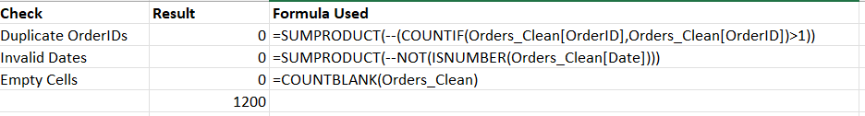 | Screenshot 2: Python final check  Terminal output from "FINAL CHECK (read back from saved file)" to "ALL CHECKS PASSED".  