**A Report on**

**Healthcare Website**

**Submitted By:**

**Nandini Modgil (N006)**

**Lavanya Mujumdar (N028)**

**Gagandeep Singh (N049)**



**Shri Vile Parle Kelvani Mandal’s**

**Mukesh Patel School of Technology and Management Engineering**

**Department of Computer Engineering**

**Vile Parle (W), Mumbai- 400056**

**Index**

* **Detailed Project Overview**
* **Objectives**
* **Software Requirements**
* **Web Pages Overview**
* **Database and Diagrams**

**Detailed Project Overview**

The Hospital Management website is designed to provide a seamless experience for patients and healthcare professionals. The primary goal is to streamline hospital interactions such as booking appointments, accessing medical history, and viewing doctor profiles. The website caters to both registered and non-registered users, ensuring that all patients can easily access healthcare services.

**Key Features**

**Patient Registration & Login System**

New Patient Sign-Up:

A new patient can create an account by entering basic information such as name, email, and password. This information will be stored securely in the system.

The patient will then receive a confirmation and will be able to log in using their credentials.

Patient Login:

Registered patients can log in using their email and password. After login, they will be redirected to the homepage where they can access additional features like medical history and appointments.

Homepage Access Post-Login:

Once logged in, patients will have access to all registered-user functionalities, such as viewing their medical history and doctor profiles.

**Appointment Booking System**

For Registered Patients:

Patients can book appointments by entering basic details. The exact appointment date and time will be confirmed by the hospital via phone, ensuring personal communication with the patient.

For Non-Registered Patients:

Non-registered patients can also book appointments by providing their basic details without having to create an account.

Like registered patients, they will receive appointment confirmation through a phone call.

**Medical History and Appointment Management**

Medical Record Overview:

Patients can view their medical history, including treatments, test results, and diagnoses from past appointments, allowing them to monitor their health progress over time.

**Doctor Profiles:**

The website will feature detailed profiles of doctors working in the hospital. Each profile will include:

Doctor’s Name and Specialization: What field they specialise in (e.g., cardiology, dermatology).

Education Background: Their educational qualifications.

Experience: Information about their years of experience and previous positions.

**Appointment Confirmation Process:**

After an appointment is booked (whether by a registered or non-registered patient), the hospital administration will call the patient to finalise the appointment date and time.

This manual confirmation ensures that appointments are effectively scheduled based on both patient and doctor availability.

**Objectives**

**Ease of Use for Patients**

By providing both registered and non-registered appointment booking options, the system offers flexibility to all types of users, catering to those who may not wish to create an account but still want to book an appointment.

Patients can easily access their medical history and appointment details, improving transparency and communication with healthcare providers.

**Improved Hospital Management**

Manual confirmation of appointments ensures a human touch and minimises booking errors.

**Enhanced Patient-Doctor Interaction**

The ability to view doctor profiles, including their qualifications and experience, empowers patients to choose their healthcare provider based on comprehensive information.

This system promotes trust and transparency between the hospital and its patients.

**Data Security and Confidentiality**

Patient information, including medical history and personal data, will be securely stored and only accessible to authorised users, ensuring compliance with data protection regulations.

**Software Requirements**

**Express.js**: A web framework for building server-side applications.  
Supports routing, middleware, and rendering dynamic HTML.

**MySQL2**: A MySQL client to connect the Node.js app to a MySQL database.  
Provides promise-based queries for cleaner asynchronous code.

**Body-parser**: Middleware to parse form data submitted via HTTP requests.  
Handles JSON, raw, text, and URL-encoded form data.

**Bcrypt**: A library for hashing and comparing passwords securely.  
Automatically generates salt to protect against rainbow table attacks.

**HTML**: For structuring the content of the website.  
Used to create semantically meaningful layouts and elements.

**CSS**: For styling and designing the website layout.  
Supports media queries for responsive design across different devices.

**JavaScript**: For adding interactive functionality to the website.  
Enables DOM manipulation, event handling, and AJAX requests.

**Angular**: A framework for building dynamic, single-page applications (SPAs).  
Uses two-way data binding and dependency injection to streamline development.

**MySQL**: For managing and storing data in a relational database.  
Ensures ACID compliance for reliable transactions and data integrity.

**Visual Studio**: As the integrated development environment (IDE) for coding and debugging.  
Includes IntelliSense, debugging tools, and Git integration for seamless workflows.

**Web Pages Overview**

**Home Page**:

* **Purpose**: Serves as the landing page of the hospital website, providing an introduction and an overview of the hospital’s services.
* **Key Features**:
  + Brief description of the hospital.
  + Navigation to other sections like Login, Doctor Profiles, About Us, etc.
  + Highlights of key services or departments.
  + Contains Book appointment form for patients.

**Login Page**:

* **Purpose**: Allows existing patients to log into their accounts.
* **Key Features**:
  + Secure user authentication.
  + Password encryption using bcrypt.
  + Error handling for invalid credentials.

**Sign-In Page**:

* **Purpose**: Registration page for new users to create an account.
* **Key Features**:
  + Collects basic user information such as name, email, and password.
  + Password hashing for security.
  + Successful registration confirmation.

**About Us Page**:

* **Purpose**: Provides detailed information about the hospital, including its mission, history, and team.
* **Key Features**:
  + Introduction to the hospital's services and achievements.
  + Information on hospital staff, specialties, and facilities.

**Doctor Profile Page**:

* **Purpose**: Displays detailed profiles of doctors available at the hospital.
* **Key Features**:
  + Information about each doctor (name, specialisation, experience).

**Dashboard**:

* **Purpose**: Acts as a control panel for users after login, providing personalised information.
* **Key Features**:
  + Upcoming appointments, medical history, and prescriptions.

**Database and Diagrams**

Number of tables featured in our project: 8

1. **GuestPatient**: Stores information about patients who have not logged in but are making an appointment as guests.  
   Attributes: GuestPatientID, Name, Illness, PreferredDate, PreferredTimeSlot, Age, Gender, Phone.
2. **LoggedInPatient**: Stores information for registered patients who log into the system.  
   Attributes: PatientID, Name, Email, Password, Age, DoctorName, Illness, AppointmentDate, AppointmentTime, Phone, Gender.
3. **Doctor**: Holds information about doctors in the hospital.  
   Attributes: DoctorID, Name, Specialization, Contact.
4. **Department**: Stores details of hospital departments.  
   Attributes: DepartmentID, Name, Location.
5. **Bill**: Contains billing information related to patients' treatments.

Attributes: BillID, PatientID, Amount, BillingDate.

1. **Appointment**: Manages patient appointments with doctors.  
   Attributes: AppointmentID, AppointmentDate, DoctorID, PatientID.
2. **Prescription**: Keeps records of prescriptions provided to patients.  
   Attributes: PrescriptionID, DoctorID, PatientID, MedicationDetails, Date.
3. **Room**: Information about hospital rooms assigned to patients.  
   Attributes: RoomID, RoomNumber, DepartmentID.

**ER Diagram**

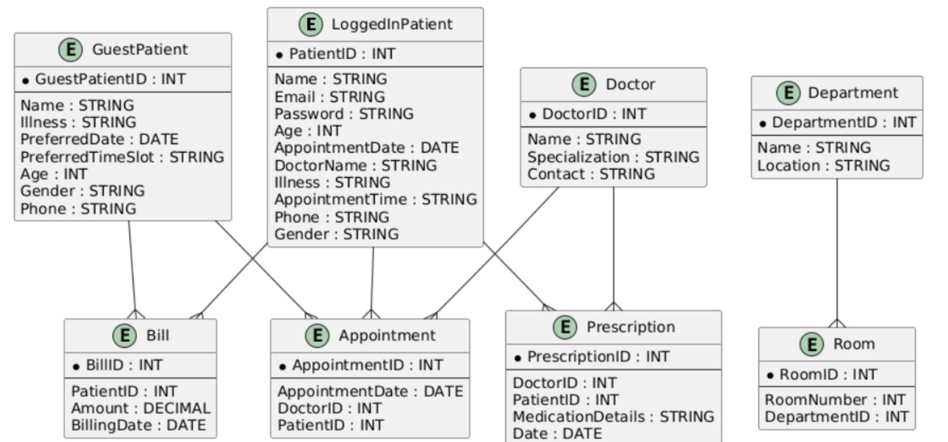

**Use-case Diagram**

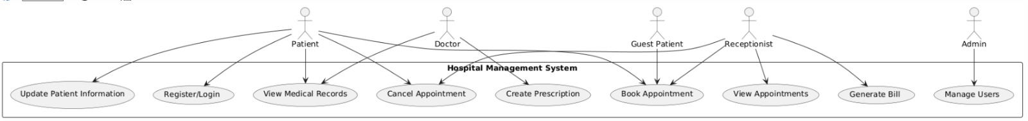

**Sequence Diagram**

