**REXIT-REPORT-CREATION:**

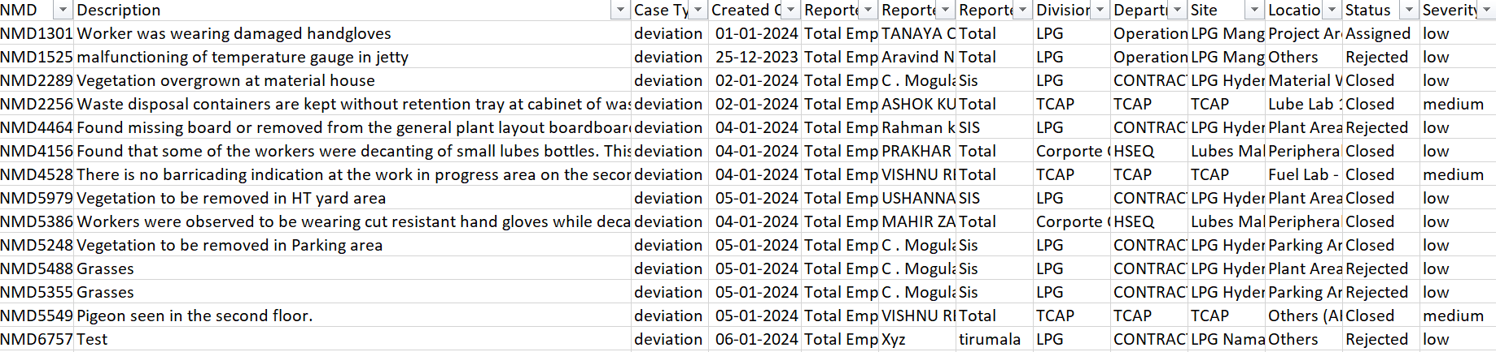The data simply looks like:

the columns include:

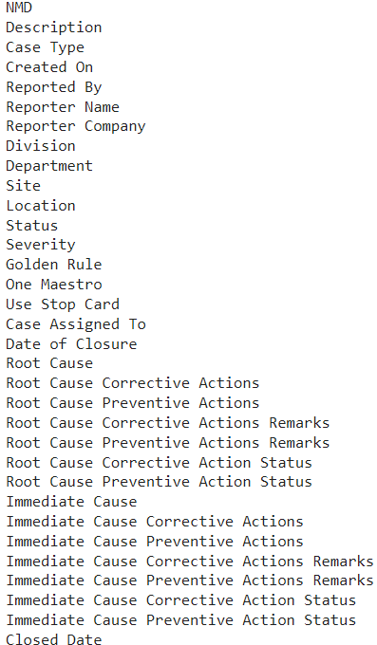

Objective:

To create reports based on

1. The Equipments Used.[which Equipment have more issues…..]
2. Identifying the maintenance and training areas among the complaints.
3. After Identifying, Assigning the sub categories.
4. Areas of Improvement:

Training Required

Maintenance Required.

1. Sub Categories.

Training:

Equipment Handling Training.

Fire Safety Training

Personal Safety Training

Traffic Safety Training

Maintenance:

Equipment Maintenance

Waste Management

Structural Maintenance

Electrical Maintenance

Housekeeping Maintenance

1. Finding Equipment names

Chatgpt: Giving the the list of descriptions and Asking chatgpt to give the equipment names included in the description

Manual: checking Manually and listing only the important Equipment names

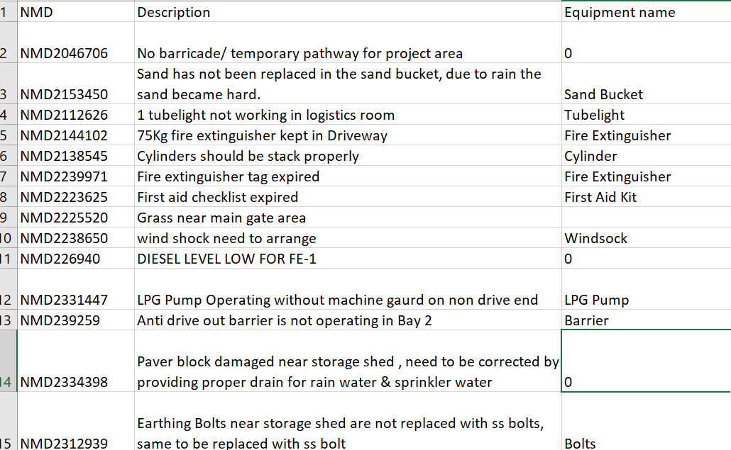This is how the total Equipment names listed in a column.

1. Identifying areas of improvement and their subcategories.

**CHATGPT PROMPT:**

Here are the rules:

**Rule1**:Give The Data Serially, Don't Miss Any Column

**Rule 2**:I Want The Following Format

Description Area Training Maintenance

Area Column Have (Training Needed/Maintenance Needed) If The Description is Related To Maintenance Give Maintenance Needed, If Training Is Related Give Training Needed, If It Is Related To Both Give Training Needed, Maintenance Needed

**Rule 3**: The Training Column Should Contain These Category Names Only

Training Categories

Equipment Handling Training

Personal Safety Training

Fire Safety Training

Traffic Safety Training

And The Maintenance Column Should Contain These Names Only Maintenance Categories

Structural Maintenance

Electrical Maintenance

Equipment Maintenance

Housekeeping Maintenance

Waste Management

And now proceed giving your data in a small chunks it will format the table like this: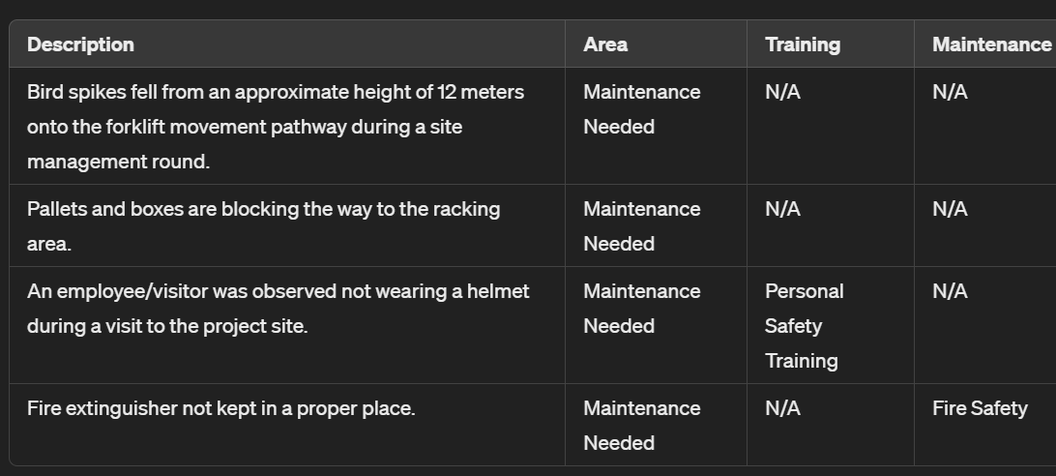

Checked every line whether all the columns are proper or not.

Now the data is ready with the necessary columns.

After this add the EquipmentNames, Area of Improvement, Training, Maintenance column to the original table.

Now used this data to create visualisations in PowerBi report.

**TASK 2: Automating the above process using Machine Learning Algorithms.**

Step1:To fetch the Equipment Names from the complaints

Not Completely developed,but just tried….

Not completely accurate, the algorithm I have used is just giving all the words in the complaint_description instead of getting the important equipmentName from the description.

Refer to “EQuipmentNAMES_Rexit_complaints” collab file…………………..

Step2:After fetching the key equipmentNames ,next thing is to get the Classification of Training and Equipment.

Not Completely Accurate,…..

Used Supervised Learning methods for training and Testing the data.

Refer to “MAIN&TRAINING” collab notebook……….

Step-3: After getting the training or maintenance label, then we have to get their further classifications[Type of trainings and type of Maintenance issues’].