

**Final Project.**

**Subject : CSE307 (INTERNETWORKING ESSENTIALS)**

Name: Lavanya Puppala

Section: K23UP-(G-2)

Roll No.: 50

Reg.No.: 12300764

Submitted To:

**Simarjeet singh malhi**

1. **Physical scenario:**

**Floor 1,2(MESH TOPOLOGY)**

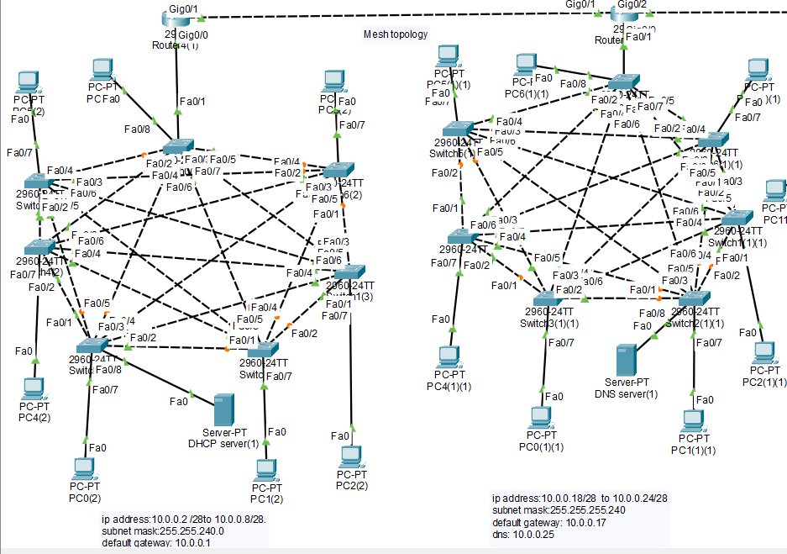

**FLOOR 3-5(STAR TOPOLOGY)**

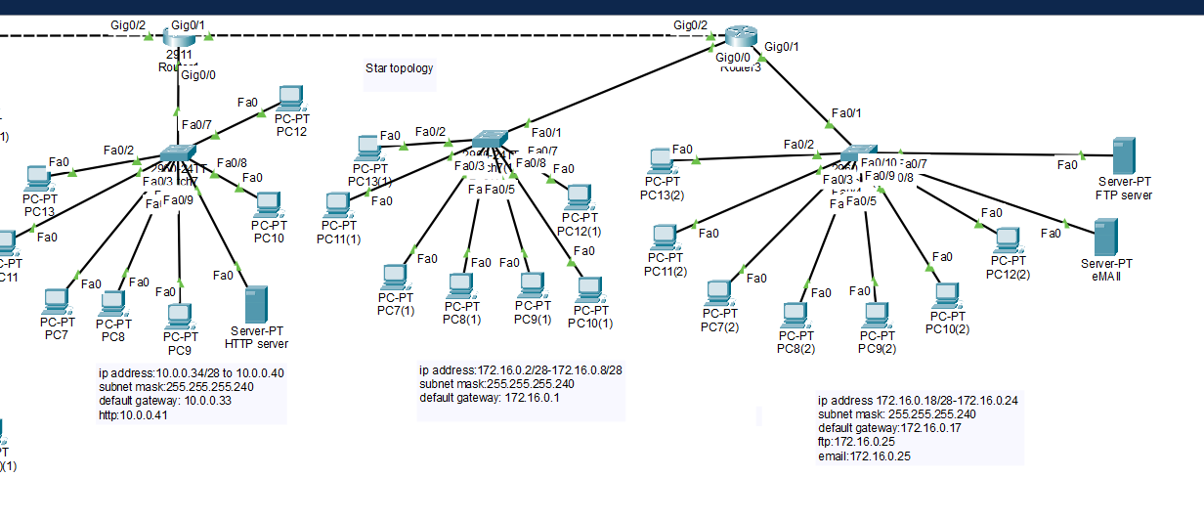

**FULL SCENARIO:**

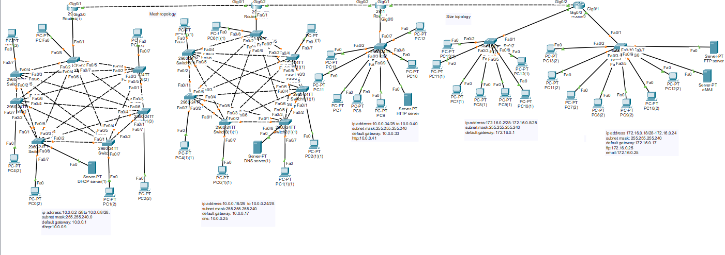

I have created 5-floor building consisting of different:

* Floors 1–2 have 7 computers each. **(use of mesh Topology with switch )**
* Floors 3-5 have 7computers each. **(use of star Topology with switch)**

**2. IP VALUES and Servers:**

**FLOOR-1**

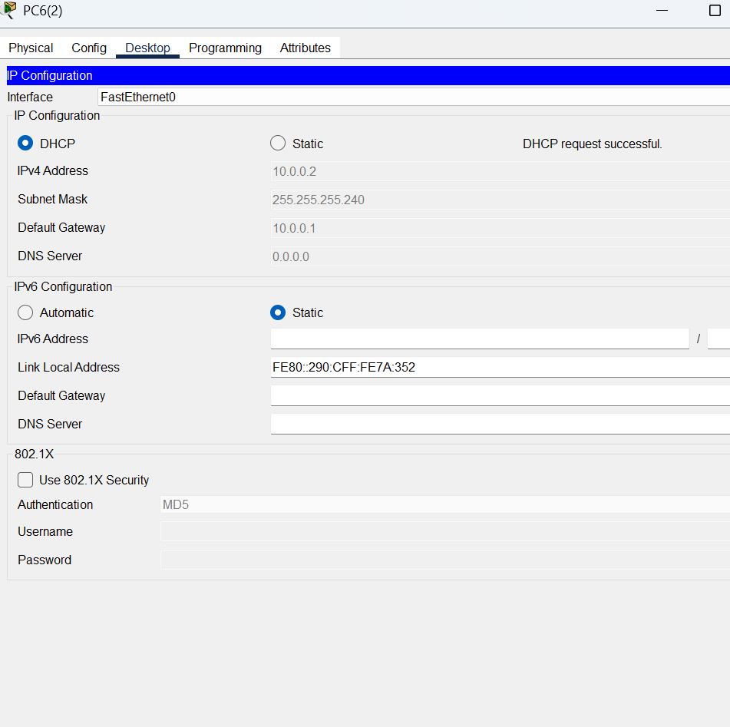

Here I have used VLSM(Variable length subnet masking)so subnet is different its not what basically it is for class A i.e, 255.0.0.0 but here its different due to classless addressing VLSM  
floor 1 has :

ip address:10.0.0.2 /28 to 10.0.0.8/28.

subnet mask:255.255.240.0

default gateway: 10.0.0.1

dhcp:10.0.0.9

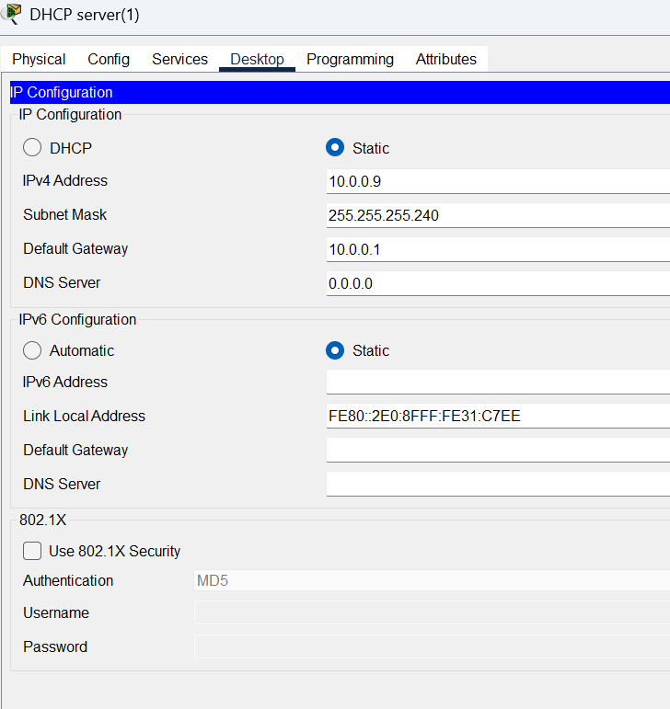

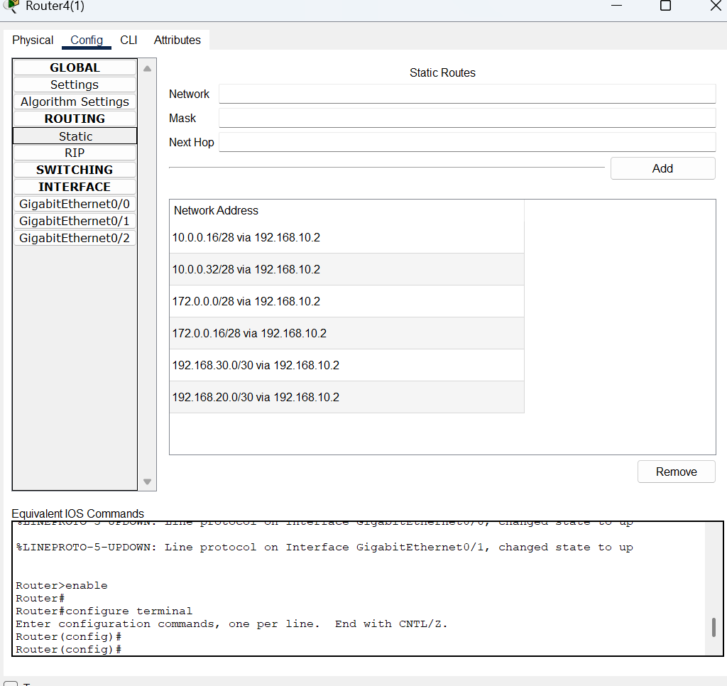

**Router-1**

**I have done static routing for all the routers which is doing routing manually**

**Static routing: ip route [destination network] [subnet-mask] [next-hope ip address]**

**Floor-2** PC ip address(example)

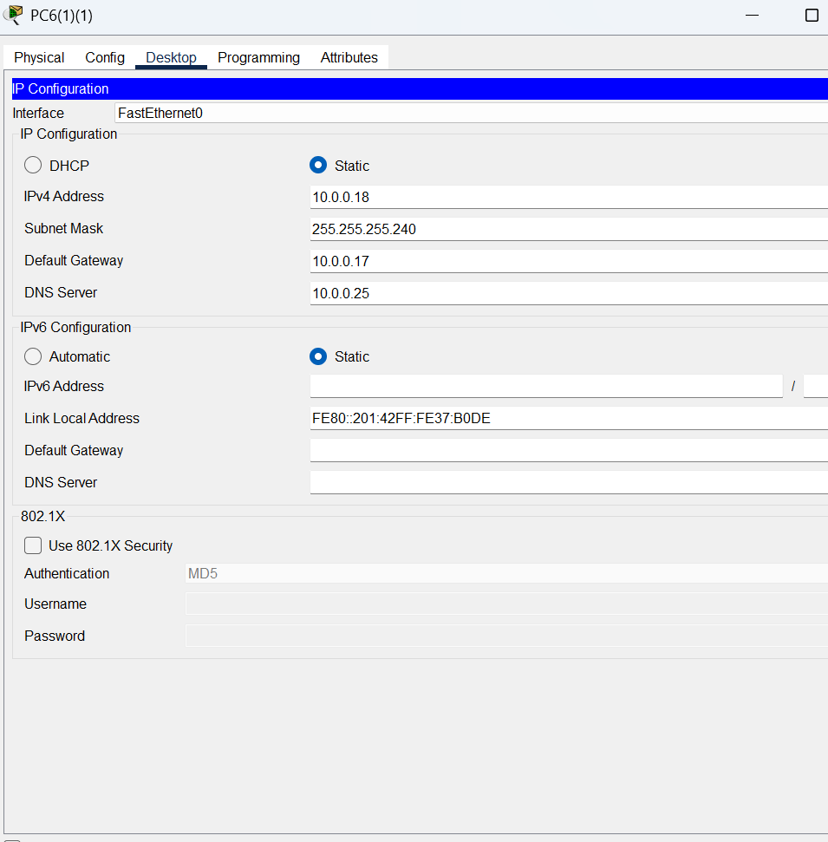

**DNS server**

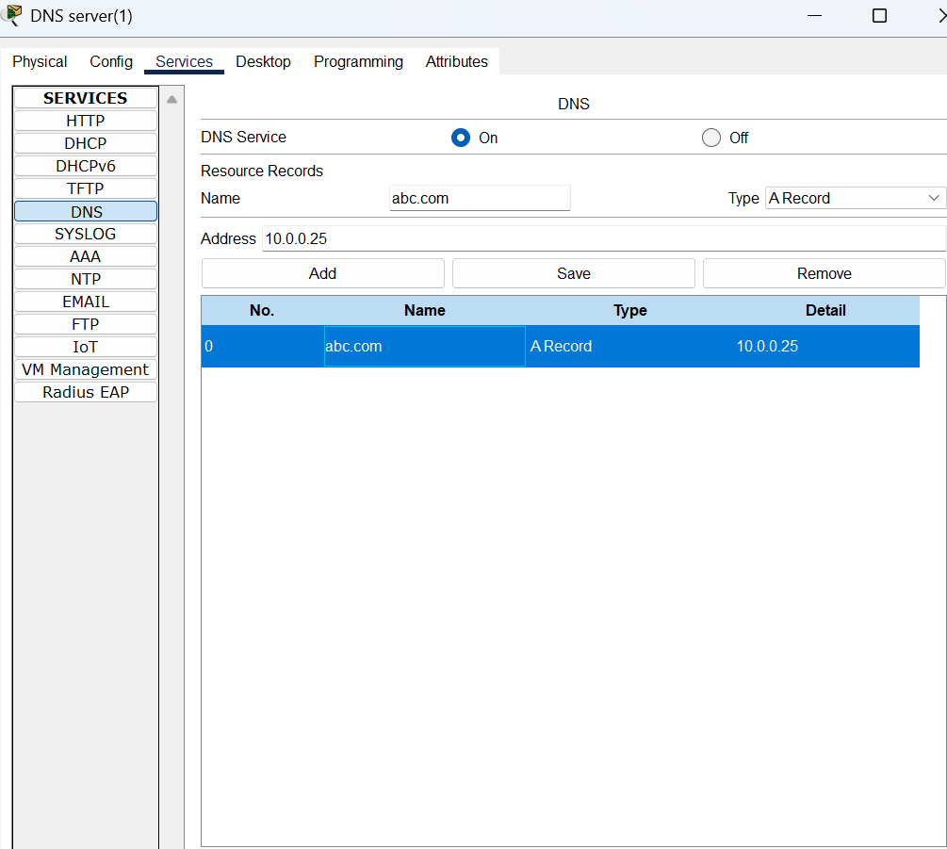

Router-2

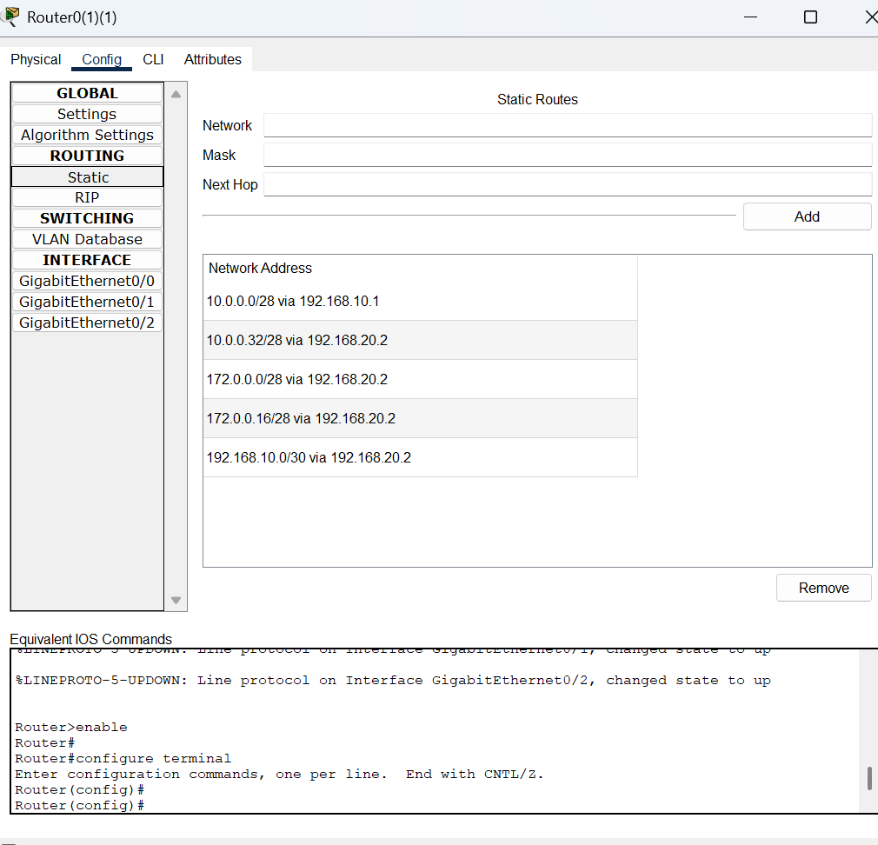

Floor-2 ip address:10.0.0.18/28 to 10.0.0.24/28

subnet mask:255.255.255.240

default gateway: 10.0.0.17

dns: 10.0.0.25

**Floor-3**

One PC example

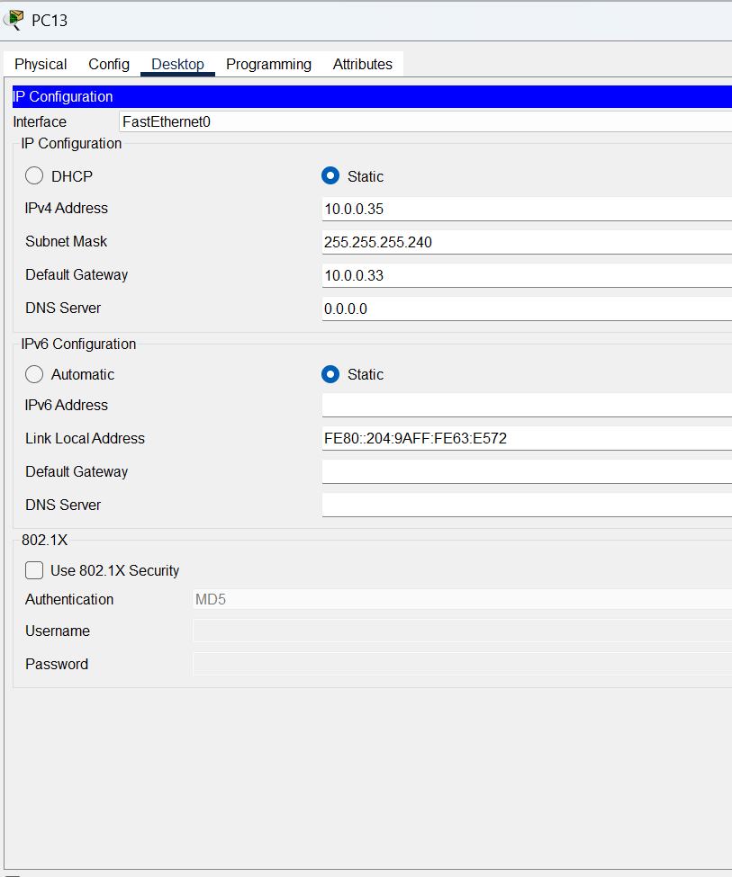

Router-3

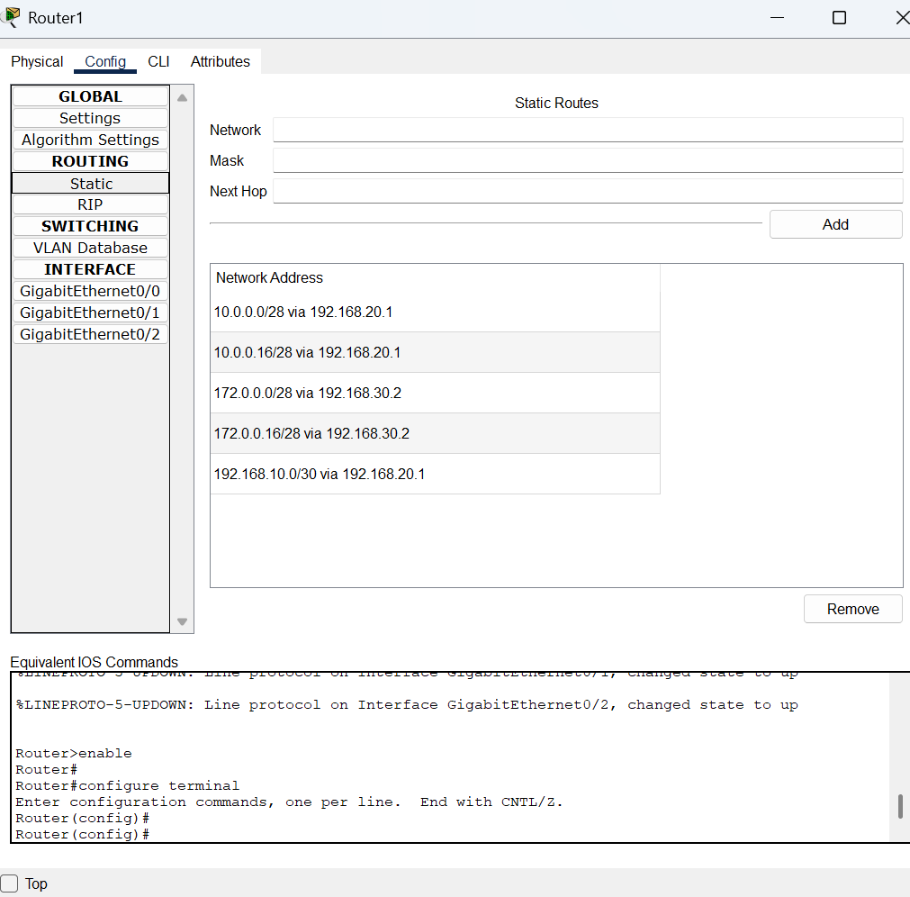

HTTP server

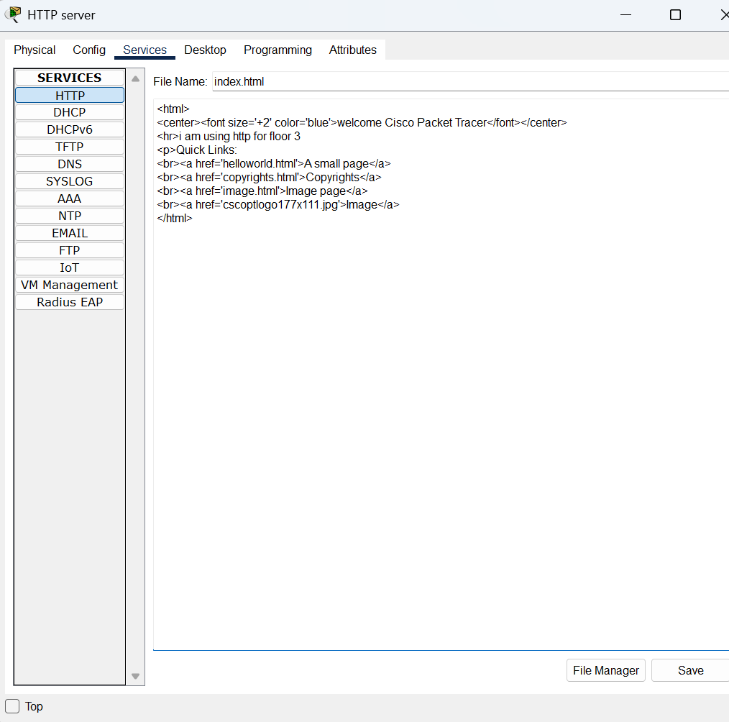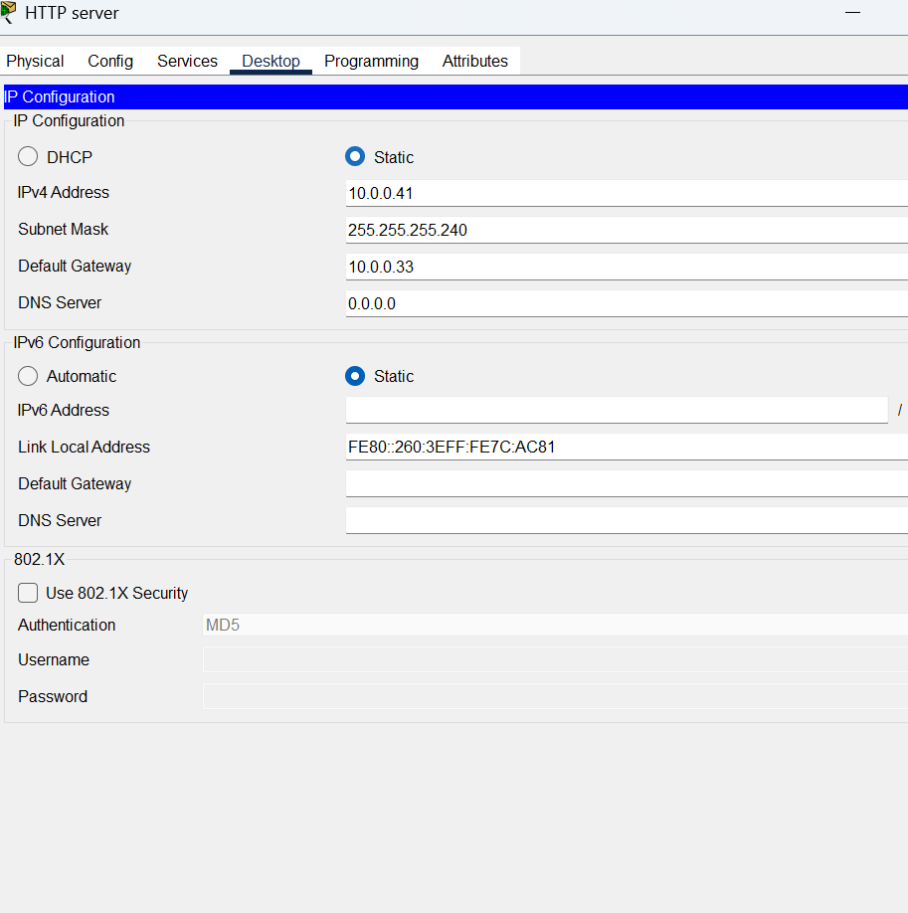

Floor-3 ip address:10.0.0.34/28 to 10.0.0.40

subnet mask:255.255.255.240

default gateway: 10.0.0.33

http:10.0.0.41

Floor-4

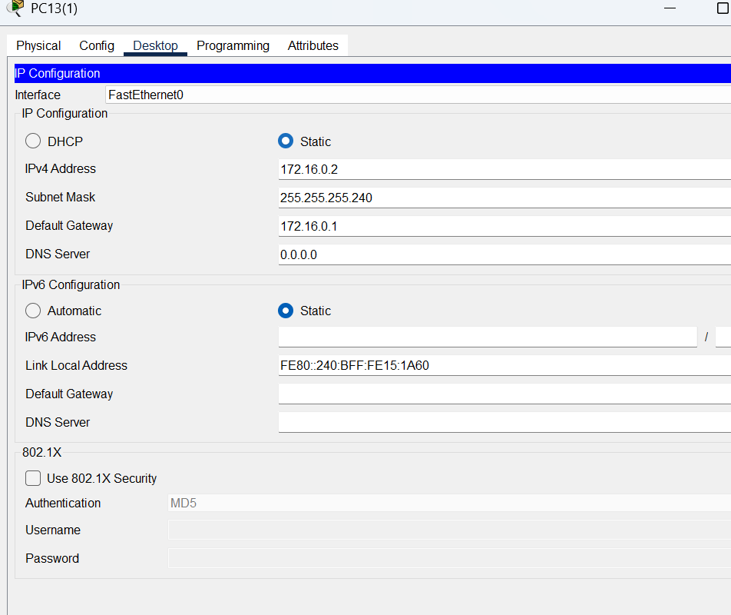

Floor 4-ip address:172.16.0.2/28-172.16.0.8/28

subnet mask:255.255.255.240

default gateway: 172.16.0.1

common router for floor 4 and floor 5

no server in floor 4

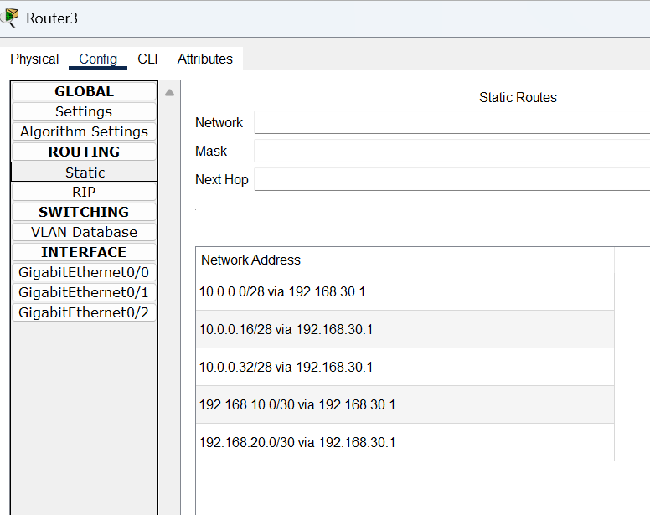

Floor-5

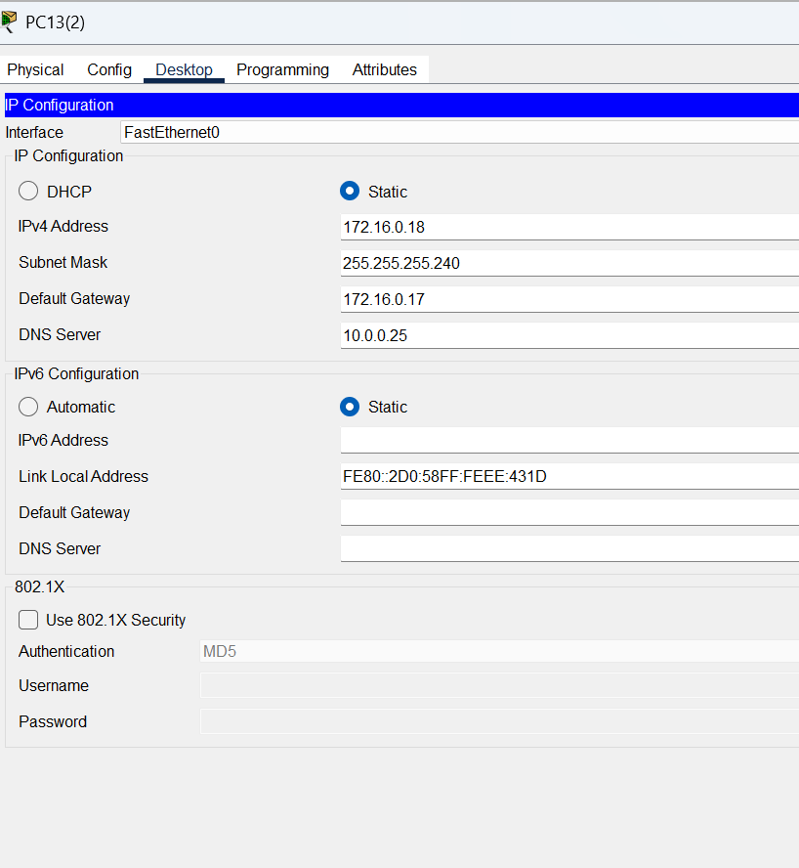

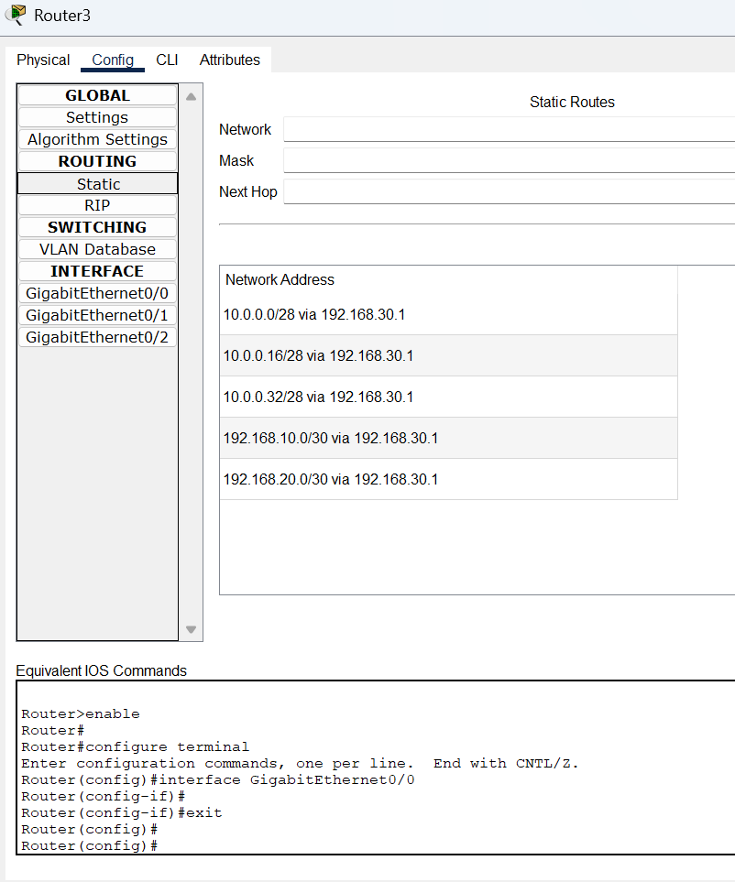

**EMAIL**

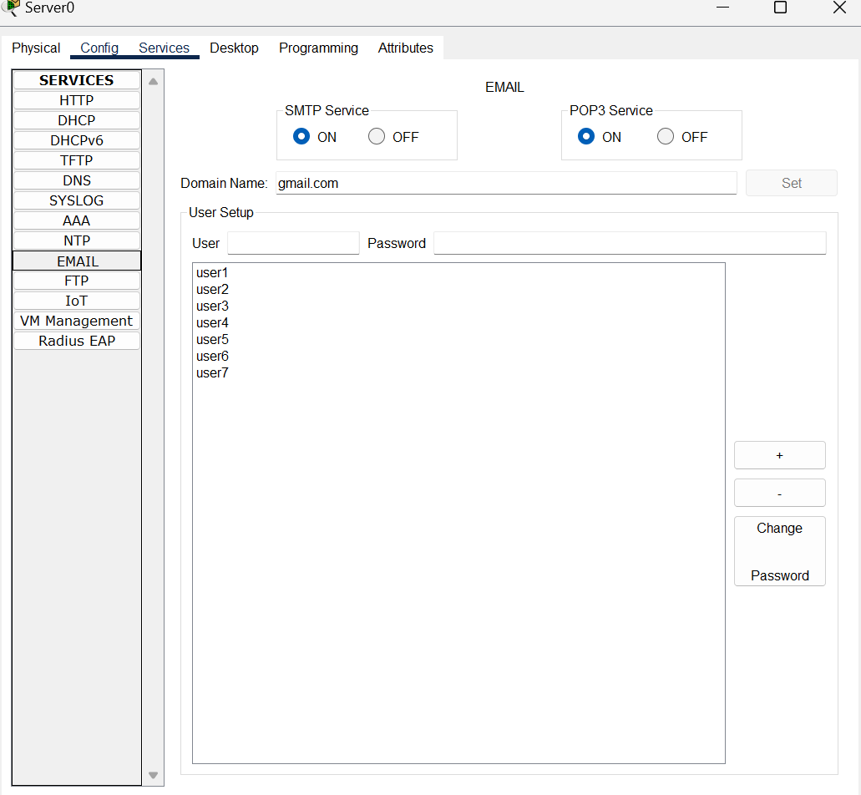

**FTP:**

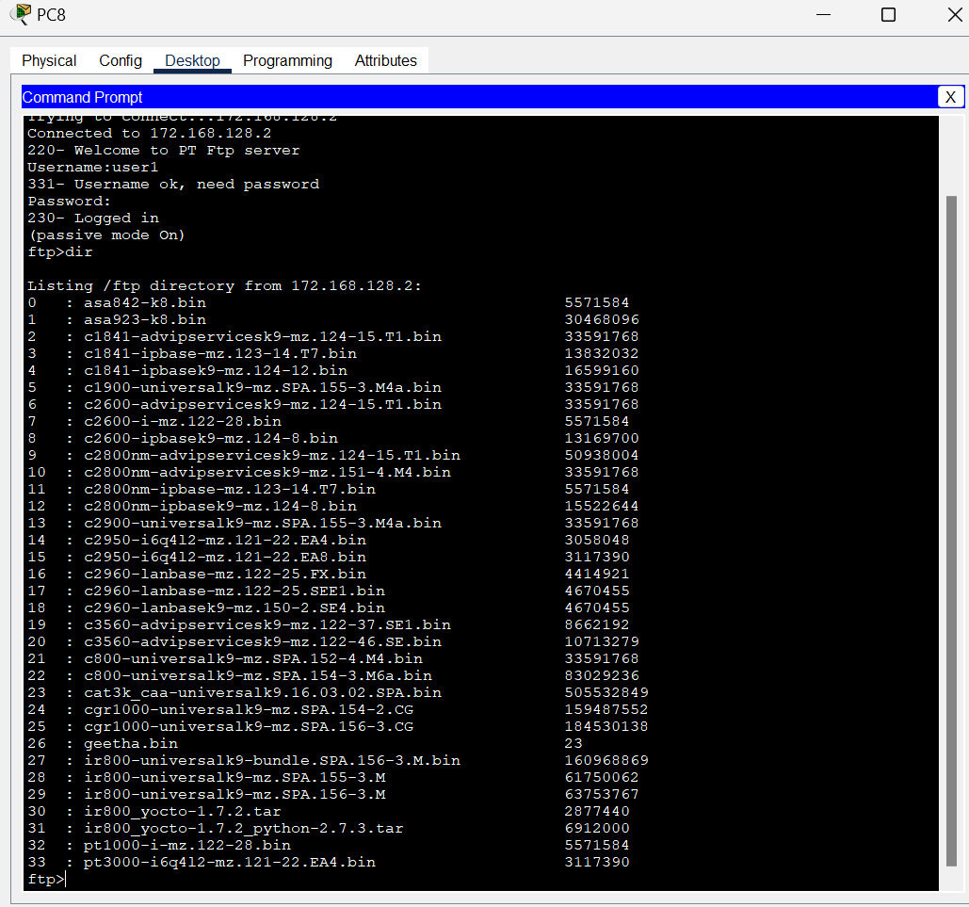

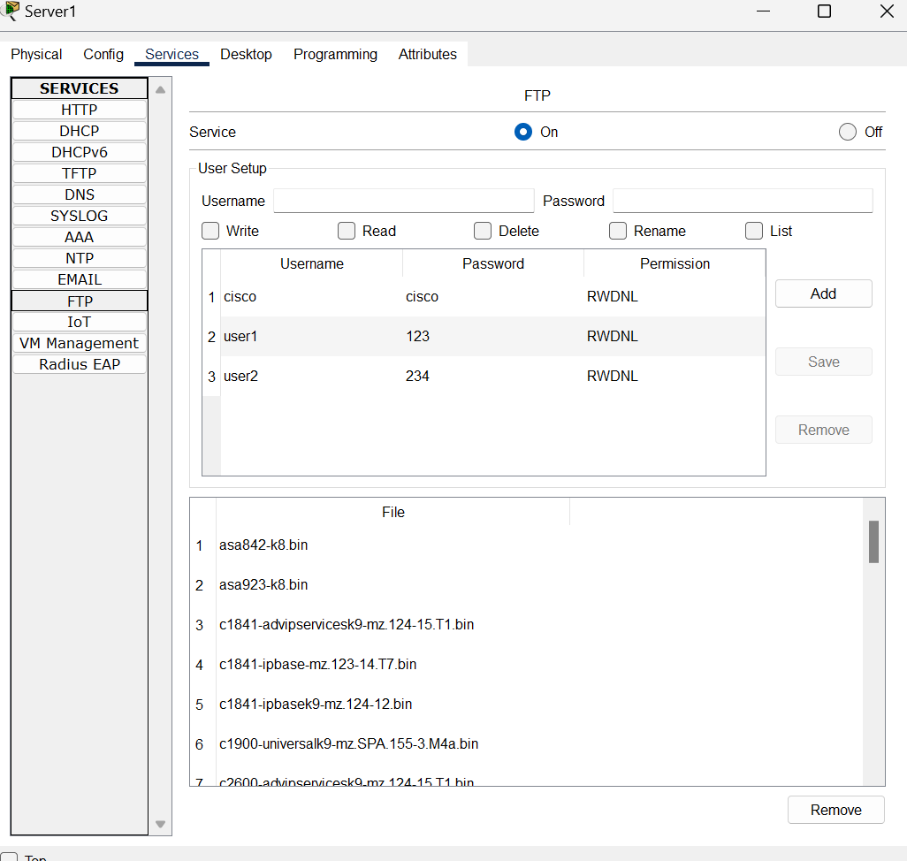

Floor-5:

ip address 172.16.0.18/28-172.16.0.24

subnet mask: 255.255.255.240

default gateway:172.16.0.17

ftp:172.16.0.25

email:172.16.0.25

**\*Communication between pc:** 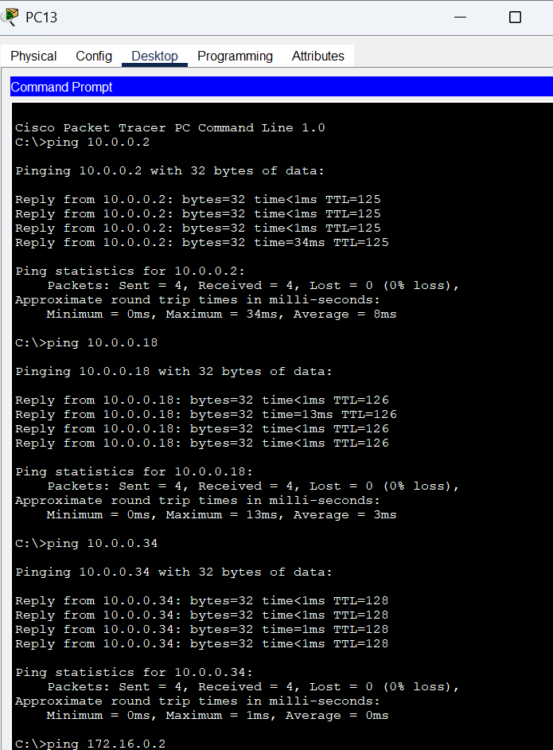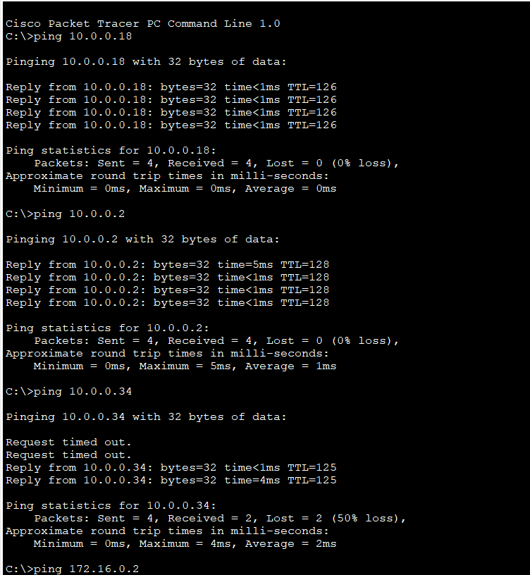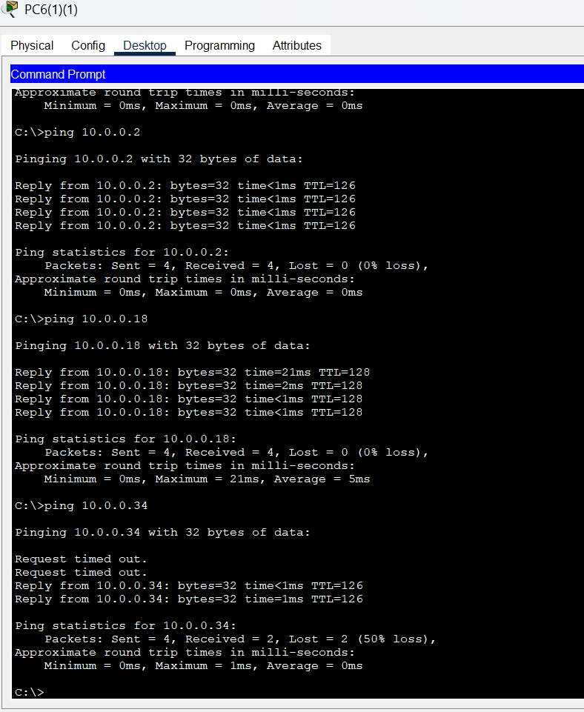

**\*THANK YOU\***