AIRFOIL SELECTION & AERODYNAMIC ANALYSIS
Project X 3.0 | Payload Aircraft and Aerobatic Aircraft

Aircraft A — Payload and stability
• Generate enough lift to carry the required load.
• Fly steadily and predictably; consider low-speed handling and stall behaviour.
Aircraft B — Manoeuvrability and aerobatics
• Perform turns, rolls, loops and inverted flight.
• Produce both positive and negative lift.

1. Candidate airfoils
Aircraft A — Payload
• NACA 4412: 4% camber at 40% chord from the leading edge; 12% thickness. Cambered useful-lift candidate.
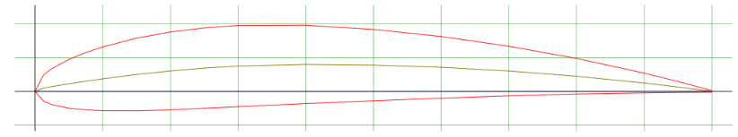
Stall Angle: Typically occurs around 15° to 17° at higher Reynolds numbers, and roughly 11° at lower Reynolds numbers (≈ 150,000).
Lift-to-Drag (L/D) Performance: Provides high lift-to-drag efficiency at moderate angles of attack due to its cambered design, making it effective for low-speed and high-lift applications.

• NACA 2412: 2% camber at 40% chord from the leading edge; 12% thickness. Moderately cambered, general-purpose baseline.
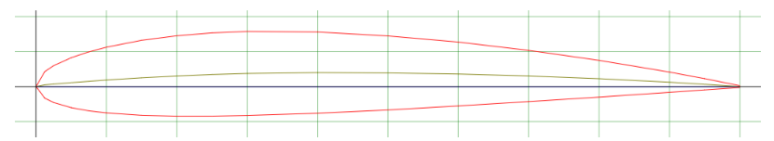
Stall Angle: It features a highly forgiving and gentle post-stall curve, typically stalling at an angle of attack around 15° to 16° under high Reynolds numbers.
Lift-to-Drag (L/D) Performance: The airfoil is optimized for clean efficiency at low-to-medium cruise speeds. Depending on the specific Reynolds number, its maximum lift-to-drag ratio typically peaks at an angle of attack between 5.5° and 8°

• Selig S1223: strongly cambered (about 8.1% at 49% chord); about 12% thickness. High-lift, low-Reynolds-number candidate; check drag and stall.
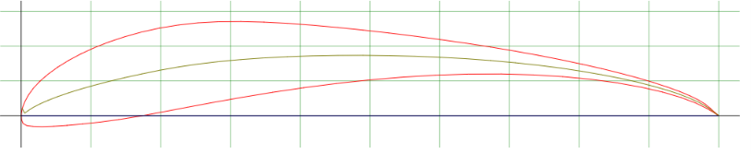
Stall Angle: It features an aggressive and sharp stall curve. Due to the rapid boundary layer separation over its extreme camber, it typically stalls early, before or near 12° to 14° depending on the specific low-velocity airflow parameters
lower overall lift-to-drag (L/D) efficiency ratio compared to cleaner, subtler airfoils. Its optimal L/D performance occurs in a very tight window, typically between 0° and 4° angle of attack

Aircraft B — Aerobatics
• NACA 0010: 0% camber; 10% thickness. Thinner option; may reduce drag in some conditions, but this is not guaranteed.
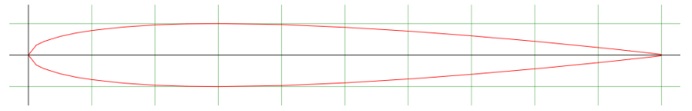
- Stall Behavior: Stall occurs when airflow separates from the surface; the stall angle depends on Reynolds number and flow conditions.
- Drag Profile: The thinner profile may reduce drag under some conditions. Drag generally increases at higher AOA, especially when airflow separates.

• NACA 0012: 0% camber; 12% thickness. Intermediate-thickness option.
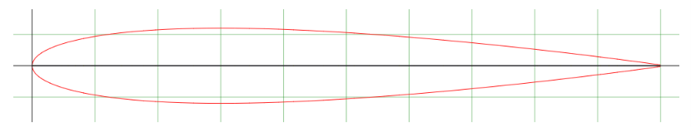
Stall Behavior: Stall typically occurs between 12° and 14° depending on the Reynolds number. It acts as a boundary case between trailing-edge stall and combined leading/trailing-edge stall.
Drag Profile: Minimum drag occurs at a 0° angle of attack and increases with higher angles. At moderate angles (e.g., around 3°), skin friction drag tends to outweigh pressure drag, whereas higher angles shift the balance toward pressure/form drag as wake separation begins.

• NACA 0015: 0% camber; 15% thickness. Thicker section provides more depth for structure, but may add drag in some conditions.
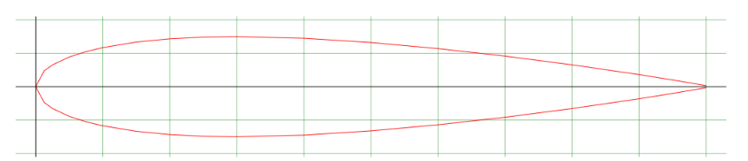
- Stall Behavior: Stall occurs when airflow separates from the surface; the stall angle depends on Reynolds number and flow conditions.
- Drag Profile: The thicker profile may produce greater drag under some conditions. Drag generally increases at higher AOA, particularly when separation develops.

• For NACA 00xx sections, “00” means symmetrical/zero camber; the final two digits indicate maximum thickness as a percentage of chord.

2.Best ones for each mission
For Aircraft A-NACA 4412
• 4% camber: Its curved shape can generate lift even at \(0^\circ\) geometric angle of attack.
• 12% thickness: Provides some depth for the wing structure, such as spars.
• Payload support: Its camber makes it a reasonable candidate for generating the lift needed to carry a payload.
• Balanced starting point: It is worth testing for a combination of lift and practical wing construction.
For Aircraft B-NACA 0012
• Symmetrical shape: The upper and lower surfaces have the same shape, supporting similar aerodynamic behaviour during positive and negative angles of attack.
• Inverted flight: It can generate lift when the aircraft flies upside down by adjusting its angle of attack.
• Balanced thickness: Its thickness is 12% of the chord, providing a reasonable balance between structural depth and aerodynamic performance.
• Suitable starting point: It is a middle option compared with NACA 0010 (thinner) and NACA 0015 (thicker).

3. Compare aerodynamic characteristics
• Lift coefficient (CL): describes lift for a given condition. Higher CL can help carry payload at lower speed; compare candidates at the same AOA and Reynolds number.
• Drag coefficient (CD): describes aerodynamic resistance. Lower CD means less drag at the compared condition; CD depends on AOA and Reynolds number.
• Lift-to-drag ratio (CL/CD): calculate CL ÷ CD from the same polar and condition. A higher ratio often benefits efficient cruise or glide.
• Stall characteristics: Stall characteristics describe how an airfoil behaves when it reaches the point where it can no longer generate more lift normally.
Note: CL, CD, CL/CD and stall behaviour depend on angle of attack, Reynolds number and test conditions. Use matched aerodynamic polars for a fair comparison.
Airfoil | Camber / thickness | Lift coefficient (CL) | Drag coefficient (CD) / CL/CD | Stall / pitching moment
NACA 2412 | 2% camber at 40% chord; 12% thick | Cambered; typically positive lift at 0° angle of attack. | Drag depends on flight condition. Efficiency should be compared with NACA 4412 using (L/D) | Moderate camber; stall and pitching moment depend on Reynolds number and angle of attack.
NACA 4412 | 4% camber at 40% chord; 12% thick | Often more lift than NACA 2412 at the same angle before stall. | Higher lift may come with added drag; compare at matched conditions. | Typically stronger nose-down pitching moment than NACA 2412; verify with data.
Selig S1223 | About 8.1% camber at 49% chord; about 12.1% thick | Designed for high lift at low Reynolds numbers; published CL,max around 2.2 in specific tests. | High lift does not guarantee high efficiency; inspect drag polar and CL/CD. | Highly cambered; pitching moment and stall behaviour need careful checking.
NACA 0010 | 0% camber; 10% thick | Symmetric; CL is approximately zero at 0° and changes sign with angle. | Thinner profile may reduce profile drag in some conditions; not guaranteed. | Symmetric response suits positive/negative lift; less depth for internal structure.
NACA 0012 | 0% camber; 12% thick | Symmetric; CL is approximately zero at 0° and changes sign with angle. | CL/CD depends on angle of attack and Reynolds number. | Symmetric response supports inverted flight; moderate structural depth.
NACA 0015 | 0% camber; 15% thick | Symmetric; CL is approximately zero at 0° and changes sign with angle. | Greater thickness may increase profile drag; result is condition-dependent. | More depth for a spar, but thickness alone does not guarantee strength or better stall behaviour.

4. How geometry affects performance
• Camber: the curvature of the airfoil. Positive camber can generate lift at 0° geometric AOA; too much camber may increase drag or change stall behaviour.
• Thickness: affects structural depth, internal space, pressure distribution and drag. Thickness alone does not determine whether an airfoil is better or stronger.
• Leading/trailing edges: affect airflow acceleration and recovery, pressure drag, separation and stall. Small shape differences can matter at low Reynolds numbers.
• These are reasoned starting choices, not proven winners until tested at matched operating conditions.

5. Can one airfoil serve both missions?
• Possible as a compromise: one moderately cambered airfoil may carry payload and still provide acceptable manoeuvrability, while simplifying design and manufacturing.
• Limitation: built-in camber makes positive- and negative-lift behaviour less symmetric.
• Separate choices better match the missions: NACA 4412 for payload and NACA 0012 for aerobatics.

6. Airfoil vs whole-aircraft factors
• Airfoil: affects section lift/drag behaviour and stall tendencies.
• Wing loading (weight ÷ wing area): affects the speed needed to support the aircraft and handling; higher wing loading generally requires higher speed.
• Controls: control-surface size and authority affect pitch, roll and yaw response.
• Structure: must withstand loads without excessive flex or failure.
• Thrust/power: affects acceleration, climb and energy recovery; a good airfoil cannot compensate for insufficient thrust.

7. Conclusion
• Aircraft A: use NACA 4412 as the balanced starting point; compare S1223 if maximum lift is essential.
• Aircraft B: use NACA 0012 as the symmetrical starting point.
• No airfoil is best under every condition. Final choices should be supported by matched Reynolds-number data and whole-aircraft design considerations.

8. Bonus Task
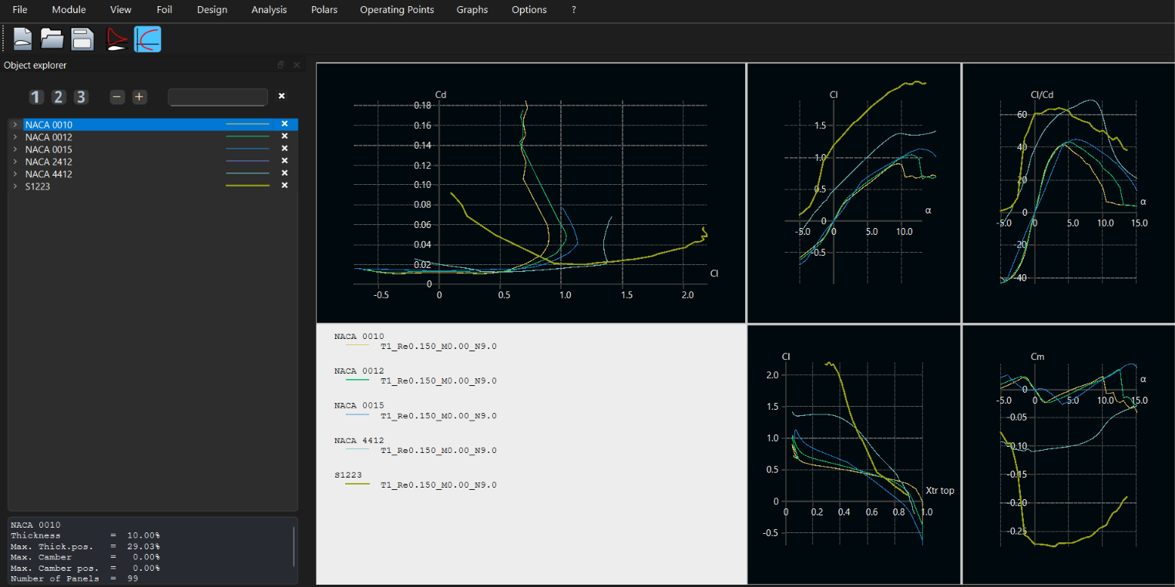

References
Airfoil Tools — NACA 2412: https://airfoiltools.com/airfoil/details?airfoil=naca2412-il
Airfoil Tools — NACA 0010: https://airfoiltools.com/airfoil/details?airfoil=n0010-il
Airfoil Tools — NACA 0015: https://airfoiltools.com/airfoil/details?airfoil=n0015-il
XFOIL/XFLR5 documentation for airfoil polar analysis.

