1. Create a blank file named "myfile":

Command used :

**> myfile.txt**

2. Open "myfile" in vi editor:

Command used:

**vi myfile.txt**

3.Write your name, address, email id, phone number and blood group in 5 different lines

Command used :

**i (to insert the data)**

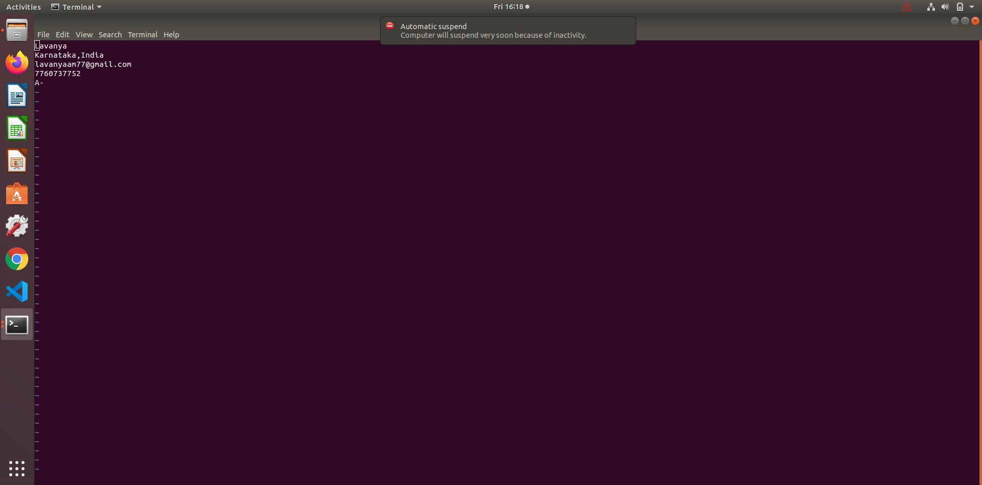

**:wq (to save the file)**

4. Build one single expression to see the line with your name and blood group in myfile

Command used:

**sed -n ‘1p’ myfile.txt & sed -n ‘5p’ myfile.txt**

