ME F211 Mechanics of Solids
Exam Study Guide — Chapters 1 to 6 (Crandall, Dahl & Lardner)
Built from the lecture slides, Crandall, and previous-year papers 2014–2024
Contents

How to use this guide
Built from the uploaded lecture slides (Ch 1–6), Crandall, Dahl & Lardner An Introduction to the Mechanics of Solids (2nd ed., SI), and six previous-year papers (2014-15 Test-1/Test-2/Compre, 2019-20, 2021-22, 2023-24 and 2024-25 Compre).
Each chapter file follows the same layout for every concept: Part A (intuition → why it matters → formal treatment and conventions → derivations → picture → special cases → traps → summary box), then Part B (solved questions: slides → Crandall → PYQs, easy → hard, with given/asked, approach, solution, boxed answer, sanity check and exam takeaway).
⚠ Scope warning. The compre papers cover the whole course. About 40% of PYQ marks come from chapters after Ch 6 (bending stress σ = My/I, beam deflection and indeterminate beams, curved beams, Euler buckling). Those slides weren’t uploaded, so those questions are listed below but not solved here.
What’s new in this Word edition: every solved question now shows the original problem figure (cropped from the lecture slides or the question paper) directly under its heading, and most solutions end with a worked diagram drawn from the solution itself: free-body diagrams, truss member-force maps (blue = tension, red = compression), shear-force and bending-moment diagrams (Crandall sign convention), axial-force and torque diagrams, Mohr’s circles (+τ plotted down at X) and rotated stress elements.

Chapter 1 — Fundamental Principles of Mechanics
Equilibrium, free-body diagrams, friction, trusses
Sources used: Slides “chapter 1 slides” (Dr. Sharad Shrivastava), Crandall Ch. 1 (Probs 1.13, 1.37, 1.45), PYQ 2014-15 Test-1.

Concept 1.1 — What “mechanics of solids” is and the general procedure

A. Concept explanation
1. Intuition. Picture a bookshelf with four books on it. Statics tells you how hard each bracket has to push up. Mechanics of solids goes further and asks what happens inside the shelf: how much it sags, how hard the wood fibres are pulled, and whether it will snap. The slide shows this with a beam carrying four loads of $w/4$: we use equilibrium to get the support reactions, but while those forces travel through the material from the loads to the supports, the material “develops resisting forces, generates stresses and undergoes deformation”. That internal story is the subject.
2. Why it matters. Every later chapter depends on getting the external forces right first. If an FBD is wrong, the stress, deflection and buckling answers are all wrong too. In the compre papers, roughly the first 20–30% of the marks on most long questions go to “draw the FBD and find the reactions”.
3. Formal treatment — the 5-step procedure (slides, Crandall §1.1):
- Select the system of interest.
- Idealize it (simplify: rigid bars, point loads, frictionless pins…).
- Apply the principles of mechanics to make predictions.
- Compare the predictions with the real system (tests).
- If they don’t agree, build a better idealized model and repeat.
The slides note that in research, steps 1 and 2 are the hardest.
Rigid body: the distance between any two points never changes. No real structure is perfectly rigid. A lever bends slightly, but if we only want its equilibrium, the distance from each weight to the fulcrum is still $L/2$, so we can treat it as rigid. If we want its strength, we must include the small deformation.
Principle of transmissibility: you can slide a force along its line of action without changing its effect on a rigid body. The slide’s example: pushing a truck at the front bumper or pulling it at the rear bumper has the same effect. ⚠ This applies only to the external equilibrium of rigid bodies. It is not valid for internal forces or deformation. Pulling a rubber band at its end is not the same as pushing at the other end.
4–5. Derivations / geometry: none needed here. This concept is about method.
6. Limiting cases. Treating a body as rigid is a limiting case of “stiffness → ∞”. It always gives correct reactions for statically determinate systems. It fails for indeterminate ones (Ch. 2), where you need deformations to find the forces.
7. Common traps.
- Using transmissibility to move a load along a beam when computing bending moment. Never do this.
- Replacing a distributed load by its resultant before computing internal forces. This is fine for reactions only (Ch. 3).
8. Summary box
Idea | When valid
Rigid-body idealization | Reactions of determinate structures
Transmissibility | External equilibrium only
Deformable-body analysis | Internal forces, stresses, indeterminate problems

Concept 1.2 — Supports, free-body diagrams and equilibrium

A. Concept explanation
1. Intuition. An FBD is like cutting the object out of a photograph with scissors. Everything that was touching it (the floor, a pin, a rope, gravity) is replaced by an arrow showing the force it applied. If the object is not accelerating, those arrows must cancel exactly, both as pushes and as twists.
2. Why it matters. FBDs are step 1 of every problem in this course: trusses, beams (Ch. 3), shafts (Ch. 6) and columns.
3. Formal treatment.
Constraint: a restriction on free motion in some direction. Each prevented motion produces one reaction component.
Support (slides) | Prevents | Reaction components (2-D)
Roller | motion ⟂ to surface | 1 force ⟂ surface
Hinge / pin | both translations | 2 forces ($R_{x},R_{y}$)
Built-in / fixed / clamped | both translations + rotation | $R_{x},R_{y}$ and a moment $M$
Cable / rope | stretching | 1 tensile force along the cable
Smooth contact | penetration | 1 normal force
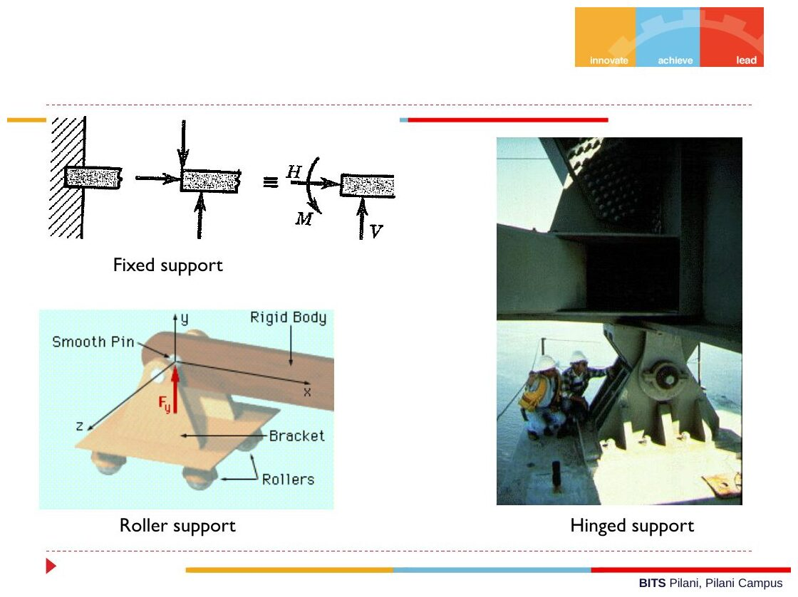
Original: Slides Ch 1, slide 8
Equations of equilibrium (2-D):
$$∑F_{x}=0, ∑F_{y}=0, ∑M_{O}=0$$
$∑M_{O}$ includes the moments of all forces and any applied couples. Point $O$ can be anywhere, so pick it where the most unknowns pass through.
In 3-D: $∑F=0$ and $∑M_{O}=0$, which gives 6 scalar equations.
Two-force member: a body loaded at only two points, with no couples, is in equilibrium only if the two forces are equal, opposite and collinear, acting along the line joining the two points.
Three-force member: if three non-parallel forces act on a body in equilibrium, their lines of action meet at one point (concurrency).
4. Derivation — why a two-force member’s forces are collinear. Let forces $F_{A}$ at $A$ and $F_{B}$ at $B$ act on the body.
- $∑F=0⇒F_{B}=−F_{A}$, so they are equal and opposite.
- Take moments about $A$: $r_{AB}×F_{B}=0$. A cross product is zero only if $F_{B}∥r_{AB}$, so the force lies along line $AB$. ∎
Three-force concurrency: take moments about the point where two of the lines of action cross. Those two forces have zero moment there, so the third force’s moment must also be zero, which means it passes through that point. ∎
5. Graphical interpretation. For a three-force body, draw the two known lines of action. Where they cross, the third force must also pass. This is the quickest check on a roller-over-step problem (see Problem 1.13 below).
6. Special cases.
- If all forces are parallel, $∑F_{x}$ is trivially zero, so only 2 equations are useful.
- If all forces are concurrent, the moment equation is automatically satisfied, so only 2 force equations are useful.
- A 2-D rigid body has 3 independent equations. More than 3 unknown reactions means the problem is statically indeterminate (Ch. 2).
7. Common mistakes.
- Forgetting self-weight. It acts at the centroid ($mg$, with $g=9.81$ m/s²).
- Giving a fixed support only forces and forgetting its moment.
- Assuming a reaction’s direction and then “correcting” its sign halfway through. Assume a direction, keep it, and interpret a negative answer at the end.
- Units: kg is not N. Multiply by 9.81.
8. Summary box
$$\boxed{ ∑F_{x}=0, ∑F_{y}=0, ∑M_{\text{any pt}}=0 }$$
- Two-force member → force along the line joining the two pins.
- Three-force member → lines of action are concurrent.
- Pin = 2 unknowns, roller = 1, fixed = 3.

B. Solved questions

Q1 (Slides Ch1, “Problem 3”) — Simply supported beam, central load (easy)
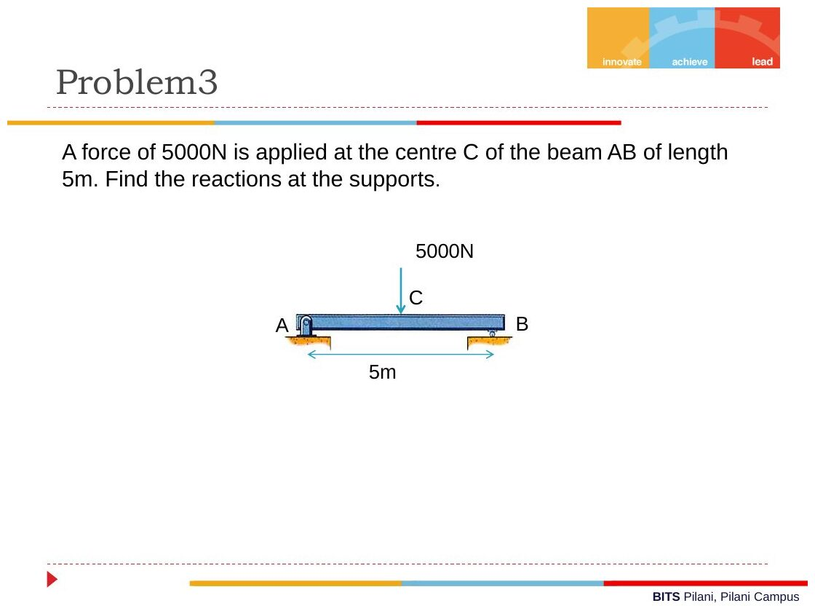
Original: Slides Ch 1, slide 12
Given: beam AB, $L=5$ m, $P=5000$ N at midpoint C. A is a pin, B is a roller. Find: reactions.
Approach: 3 unknowns ($A_{x},A_{y},B_{y}$) and 3 equations, so it is determinate.
Solution:
- $∑F_{x}=0⇒A_{x}=0$
- $∑M_{A}=0: B_{y}\left(5\right)−5000\left(2.5\right)=0⇒B_{y}=2500$ N
- $∑F_{y}=0: A_{y}=5000−2500=2500$ N
$$\boxed{A_{x}=0, A_{y}=B_{y}=2500 \text{N} \left(↑\right)}$$
Check: the load is symmetric, so the reactions should be equal. ✓ Takeaway: a variation could put $P$ at distance $a$ from A. Then $A_{y}=Pb/L$ and $B_{y}=Pa/L$. You will reuse this result constantly in Ch. 3.

Q2 (Slides Ch1, “Problem 2”) — Cantilever with self-weight (easy)
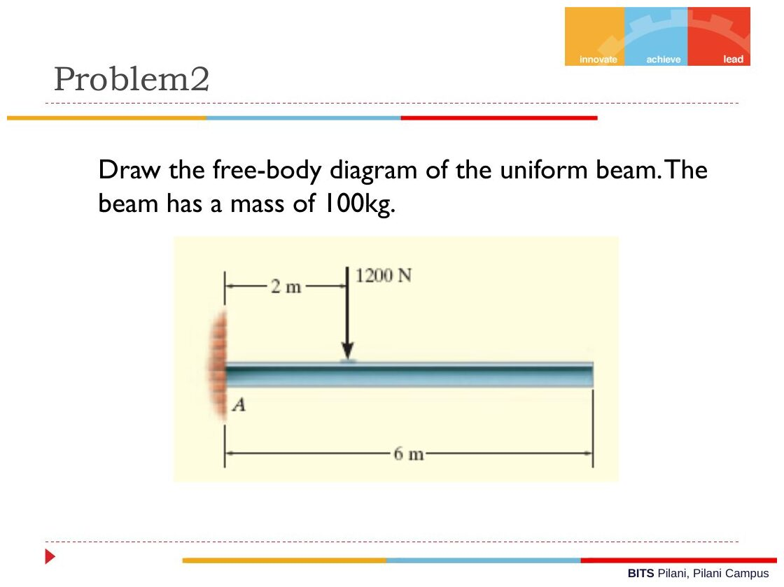
Original: Slides Ch 1, slide 10
Given: uniform beam, mass 100 kg, length 6 m, fixed at A. Load 1200 N at 2 m from A. Find: FBD and reactions.
FBD in words: at A draw $A_{x}$, $A_{y}$ and a moment $M_{A}$ (counter-clockwise assumed). Draw 1200 N down at $x=2$ m and the weight $W=100\left(9.81\right)=981$ N down at the centroid $x=3$ m.
Solution:
- $∑F_{x}=0⇒A_{x}=0$
- $∑F_{y}=0⇒A_{y}=1200+981=2181$ N
- $∑M_{A}=0: M_{A}−1200\left(2\right)−981\left(3\right)=0⇒M_{A}=2400+2943=5343$ N·m
$$\boxed{A_{y}=2181 \text{N} ↑, M_{A}=5.34 \text{kN·m (counter-clockwise on the beam)}}$$
Takeaway: the common slip is forgetting the 981 N self-weight or putting it at the wrong point. The weight acts at $L/2$, not at the load point.

Q3 (Slides Ch1) — Diving board (easy–medium)
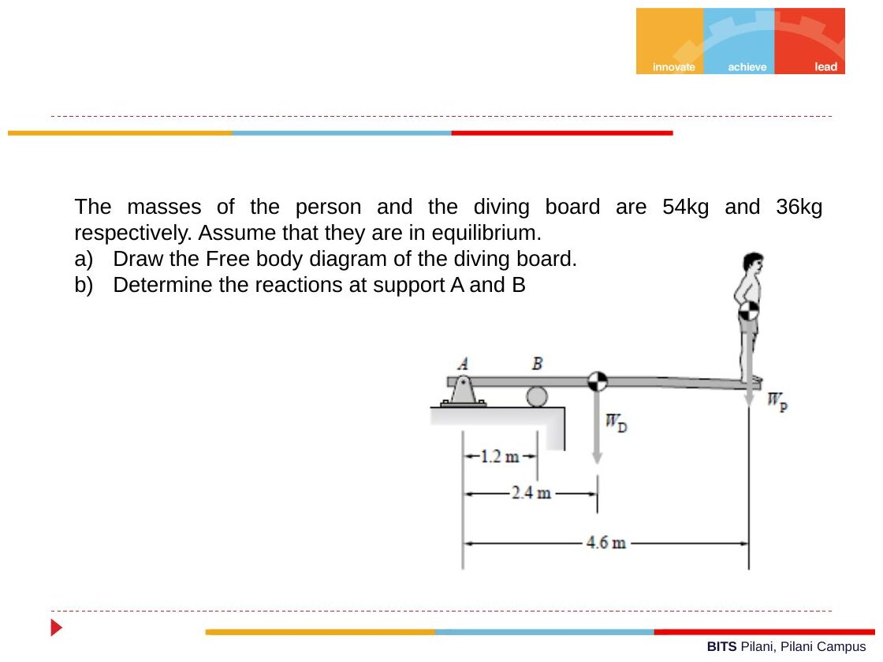
Original: Slides Ch 1, slide 15
Given: board mass 36 kg (centroid at 2.4 m from A), person 54 kg at 4.6 m. Pin at A ($x=0$), roller at B ($x=1.2$ m). Find: reactions at A and B.
Solution: $W_{D}=36\left(9.81\right)=353.2$ N and $W_{P}=54\left(9.81\right)=529.7$ N.
- $∑M_{A}=0: B\left(1.2\right)−353.2\left(2.4\right)−529.7\left(4.6\right)=0⇒B=\frac{847.6+2436.8}{1.2}=2737$ N
- $∑F_{y}=0: A+B−353.2−529.7=0⇒A=882.9−2737=−1854$ N
$$\boxed{B=2737 \text{N} \left(↑\right), A=1854 \text{N} \left(↓\right)}$$
Check: the board is a lever over the roller B, so the pin at A must hold the end down. A negative $A$ means “opposite to the direction assumed”. ✓ Takeaway: examiners like supports that pull the wrong way. Don’t flip the sign without saying so in words.

Q4 (Slides Ch1) — Two cylinders in a box (medium)
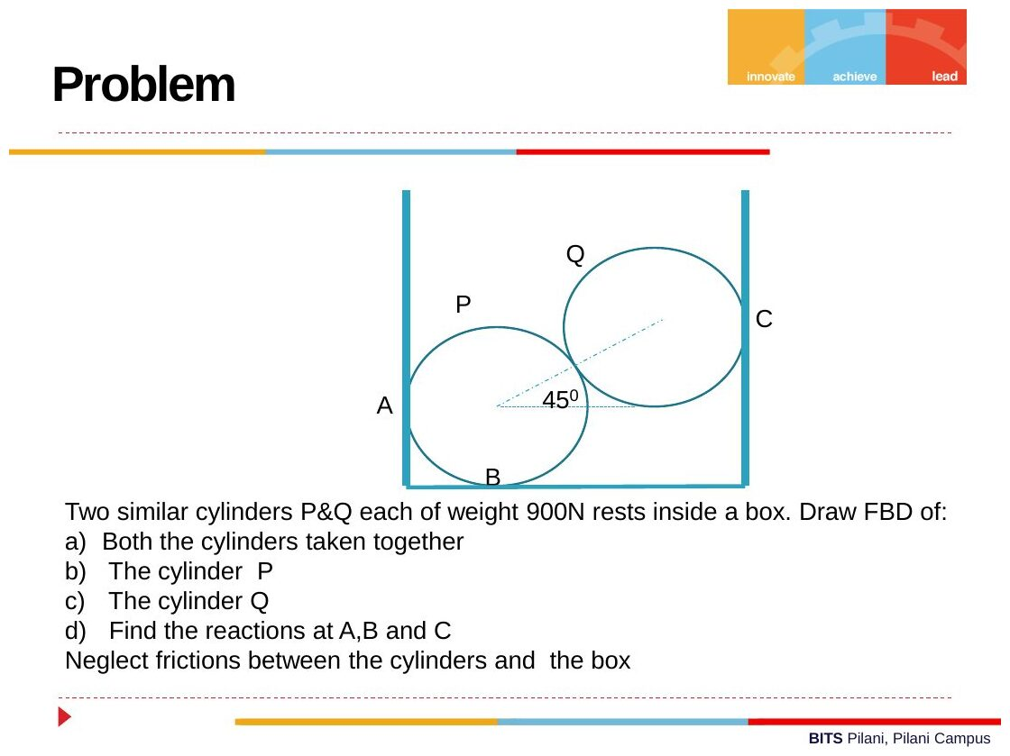
Original: Slides Ch 1, slide 13
Given: cylinders P and Q, each weighing 900 N. P rests on the floor (B) and against the left wall (A). Q rests on P and against the right wall (C). The line of centres is at 45°. All surfaces smooth. Find: FBDs and reactions at A, B, C.
FBD of Q: weight 900 N ↓, wall reaction $R_{C}$ ← (horizontal), and contact force $N$ from P along the line of centres, pointing up and to the right at 45°.
- $∑F_{y}: Nsin{45}^{∘}=900⇒N=1272.8$ N
- $∑F_{x}: R_{C}=Ncos{45}^{∘}=900$ N
FBD of P: weight 900 N ↓, $R_{A}$ → (wall), $R_{B}$ ↑ (floor), and $N=1272.8$ N from Q pointing down and to the left at 45° (Newton’s 3rd law).
- $∑F_{x}: R_{A}=Ncos{45}^{∘}=900$ N
- $∑F_{y}: R_{B}=900+Nsin{45}^{∘}=1800$ N
Both cylinders together: the internal force $N$ cancels. $R_{B}=1800$ N (total weight) and $R_{A}=R_{C}$ ✓.
$$\boxed{R_{A}=900 \text{N}, R_{B}=1800 \text{N}, R_{C}=900 \text{N}}$$
Takeaway: the combined FBD checks the individual ones. Variation: if the angle is $θ$, then $R_{A}=R_{C}=Wcotθ$.
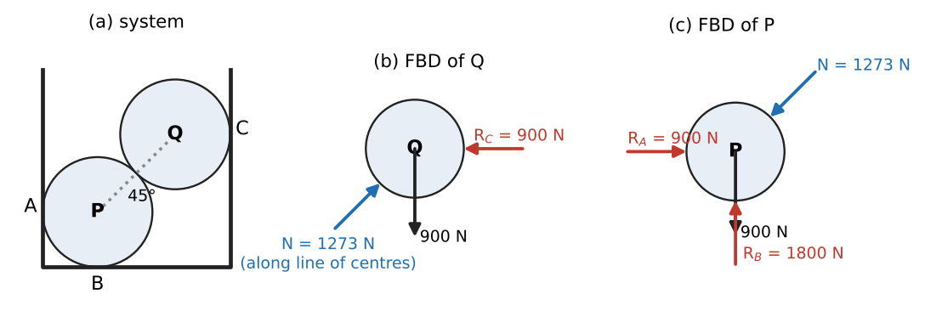
Worked FBDs: system, cylinder Q, cylinder P

Q5 (Crandall Prob 1.13, Slides) — Lawn roller over a step (medium)
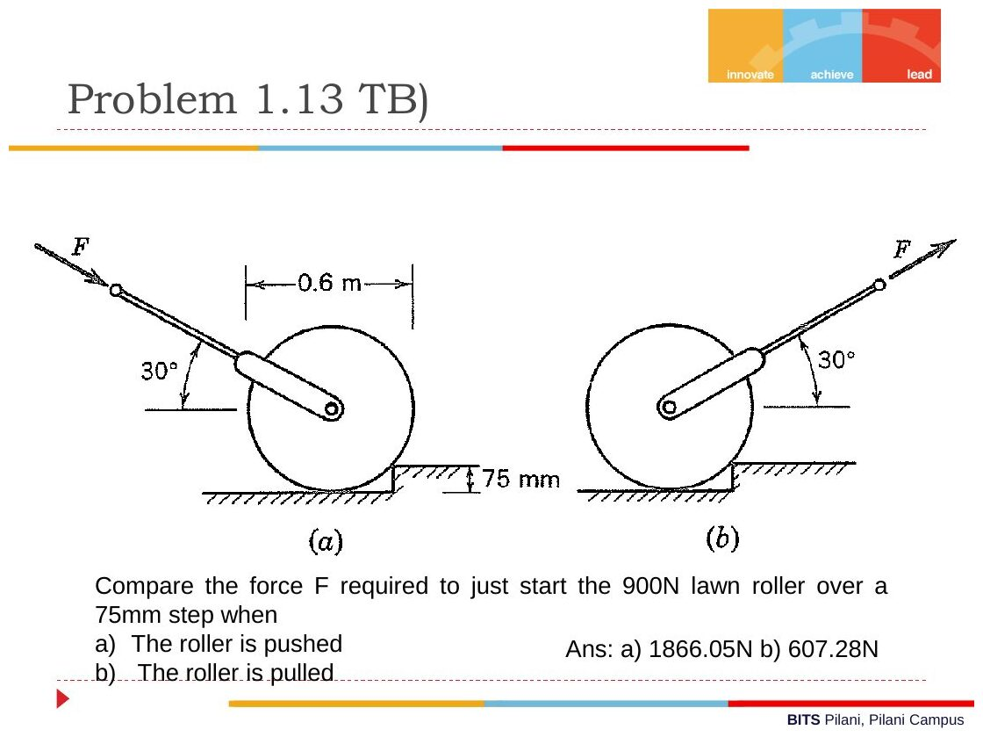
Original: Slides Ch 1, slide 14
Given: roller weight $W=900$ N, diameter 0.6 m (so $r=300$ mm). Step height $h=75$ mm. Handle at 30° to the horizontal, with the force $F$ acting through the axle. Find: $F$ to just start the roller over the step when (a) pushed (F points down at 30°) and (b) pulled (F points up at 30°).
Key idea: at the instant of “just starting”, the roller leaves the ground, so the ground reaction is zero. Only three forces act: $W$, $F$, and the step-corner reaction $R$. Take moments about the corner so that $R$ drops out.
Geometry: the corner is at vertical distance $r−h=225$ mm below the axle. Its horizontal offset is
$$a=\sqrt{r^{2}−{\left(r−h\right)}^{2}}=\sqrt{{300}^{2}−{225}^{2}}=198.4 \text{mm}$$
(a) Pushed: $F$ has components $Fcos{30}^{∘}$ toward the step and $Fsin{30}^{∘}$ downward. About the corner:
$$Fcos{30}^{∘} \left(225\right)=W\left(198.4\right)+Fsin{30}^{∘}\left(198.4\right)$$
$$F=\frac{900\left(198.4\right)}{225cos{30}^{∘}−198.4sin{30}^{∘}}=\frac{178,600}{194.9−99.2} ⇒ \boxed{F_{push}≈1867 \text{N}}$$
(b) Pulled: now the vertical component helps lift the roller:
$$Fcos{30}^{∘}\left(225\right)+Fsin{30}^{∘}\left(198.4\right)=W\left(198.4\right) ⇒ \boxed{F_{pull}≈607.3 \text{N}}$$
(The slides give 1866.05 N and 607.28 N. The difference is rounding.)
Check by geometry: $R$ must pass through the axle (three-force member, since all three forces are concurrent at the centre). ✓ Pulling is about 3× easier because pulling lifts the roller, while pushing presses it into the ground. Takeaway: “just starts to move over” means the ground reaction is zero. Variation: find the minimum force and its direction. It is perpendicular to the line from the corner to the centre, giving $F_{min}=Wsinϕ$ where $cosϕ=\left(r−h\right)/r$, so $F_{min}=900\left(198.4/300\right)=595$ N.
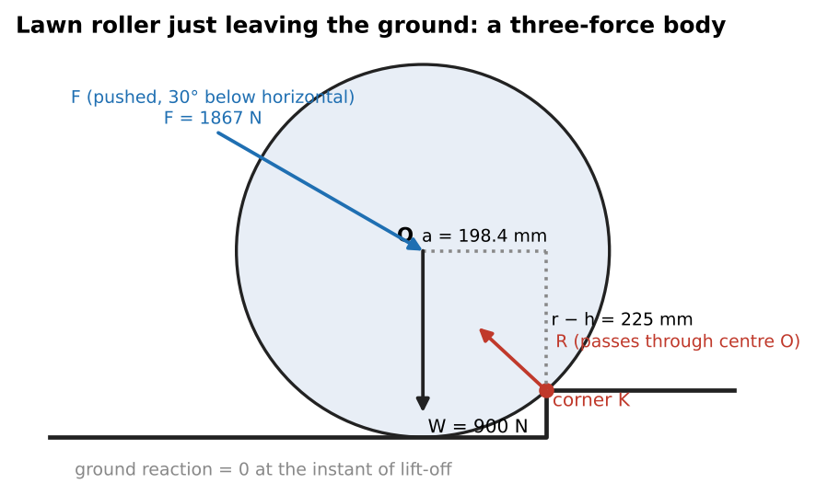
Geometry and three-force FBD at lift-off (pushed case)

Q6 (Slides Ch1) — Pliers (medium)
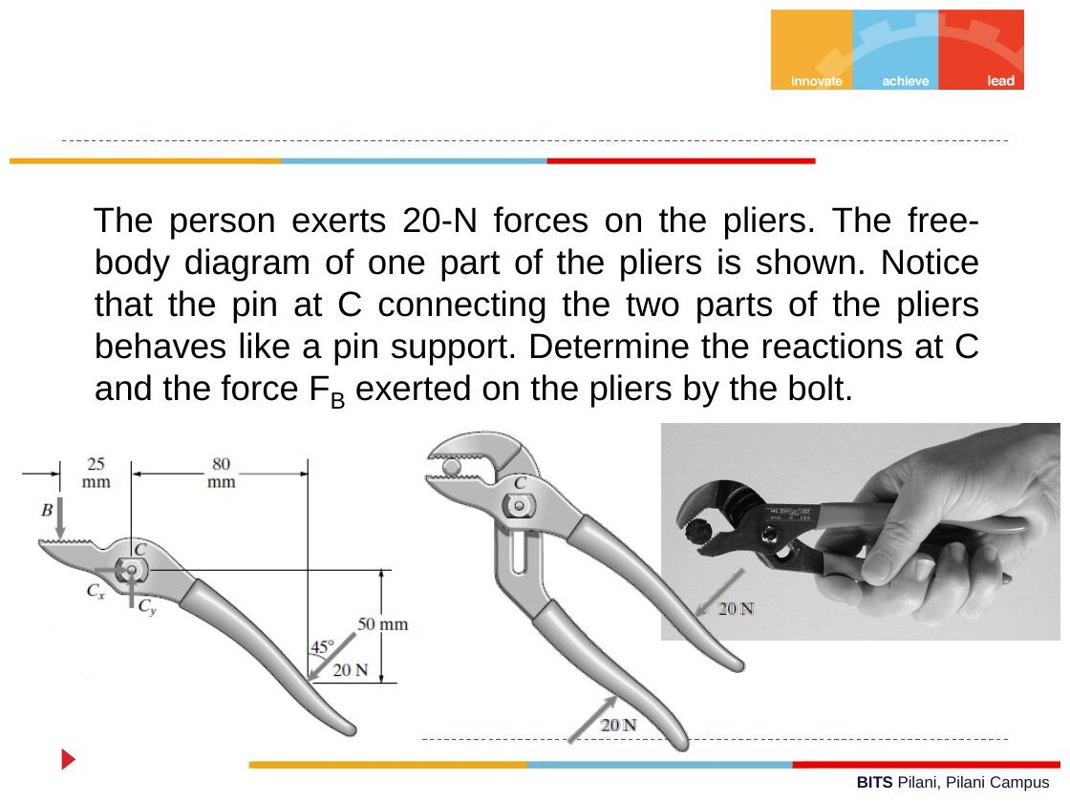
Original: Slides Ch 1, slide 16
Given: in the FBD of one handle, the bolt force $F_{B}$ acts downward at B, 25 mm left of pin C. The hand force of 20 N acts at 45° (down and to the left) at a point 80 mm right of and 50 mm below C. Find: $C_{x}$, $C_{y}$, $F_{B}$.
Solution (C at the origin, x to the right, y up): the 20 N force is $\left(−14.14,−14.14\right)$ N at $\left(80,−50\right)$ mm.
$$M_{C}^{\left(20N\right)}=xF_{y}−yF_{x}=80\left(−14.14\right)−\left(−50\right)\left(−14.14\right)=−1838.5 \text{N·mm (clockwise)}$$
$$∑M_{C}=0: F_{B}\left(25\right)−1838.5=0⇒\boxed{F_{B}=73.5 \text{N}}$$
- $∑F_{x}: C_{x}−14.14=0⇒\boxed{C_{x}=14.1 \text{N}}$
- $∑F_{y}: C_{y}−73.5−14.14=0⇒\boxed{C_{y}=87.7 \text{N}}$
Check: a 20 N squeeze gives a 73.5 N bite, a mechanical advantage of about 3.7. That is reasonable for pliers. ✓

Q7 (Slides Ch1) — Bicycle hand brake (easy)
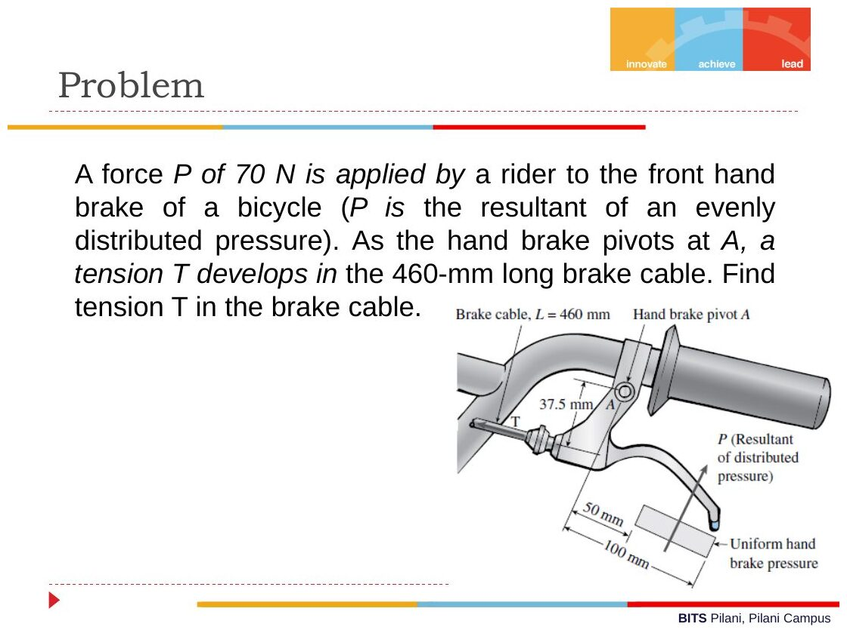
Original: Slides Ch 1, slide 17
Given: $P=70$ N, the resultant of a uniform hand pressure acting between 50 mm and 100 mm from pivot A (so $P$ acts at 75 mm). Cable arm = 37.5 mm. Cable length 460 mm. Find: $T$.
$$∑M_{A}=0: T\left(37.5\right)=70\left(75\right) ⇒ \boxed{T=140 \text{N}}$$
Takeaway: the 460 mm cable length is a distractor. It would only matter for a cable-stretch question (Ch. 2: $δ=TL/AE$).

Concept 1.3 — Dry (Coulomb) friction

A. Concept explanation
1. Intuition. Push a heavy box lightly and it doesn’t move. The floor pushes back sideways exactly as hard as you push, up to a limit. Past that limit it slides. The limit grows if the box is heavier (bigger normal force) but does not depend on how big its base is.
2. Why it matters. Wedges, belts, brakes, bolts, the trunk on a ramp, and (in a PYQ) a rope over a drum.
3. Formal treatment (slides).
- No relative motion → static friction $f_{s}$. It can take any value from 0 up to $f_{s,max}$, whatever equilibrium needs.
- Limiting (impending motion): $f_{s,max}=μ_{s}N$.
- Sliding → kinetic friction $f_{k}=μ_{k}N$, roughly constant and slightly less than $f_{s,max}$.
- Friction is independent of contact area (slides). If the area doubles at the same $N$, the force per unit area halves.
- Friction always acts opposite to the impending relative motion.
Slide example: $f_{s,max}=10$ N. With an 8 N push, $f=8$ N and there is no motion. With a 12 N push, the block moves. With no push, $f=0$, not $μN$.
4. Derivations.
(a) Block on an incline, angle $α$, pulled up the slope by tension $T$:
- Impending motion up: friction acts down the slope. $T=W\left(sinα+μcosα\right)$
- Impending motion down: friction acts up the slope. $T=W\left(sinα−μcosα\right)$
Equilibrium holds for any $T$ between these two values.
(b) Angle of repose: with no applied force, the block is about to slide when $Wsinα=μWcosα$, so $tanα=μ$.
(c) Belt/rope friction (needed for PYQ 2014 Q3). Take a small rope element subtending $dθ$ on a drum. Tension is $T$ on one side and $T+dT$ on the other. Normal force is $dN$ and friction is $μ dN$.
- Radial: $dN=T dθ$ (since $sin\left(dθ/2\right)≈dθ/2$, and both tensions contribute).
- Tangential, at impending slip: $dT=μ dN=μT dθ$.
- Integrate: $\int_{T_{1}}^{T_{2}}{\frac{dT}{T}}=μ\int_{0}^{β}{d}θ$, so
$$\boxed{\frac{T_{2}}{T_{1}}=e^{μβ}}$$
- Here $T_{2}$ is the tight side and $β$ is the wrap angle in radians. Tension along the contact varies as $T\left(θ\right)=T_{1}e^{μθ}$.
5. Graphical picture. The total reaction $R$ (combining $N$ and $f$) leans away from the normal by at most the friction angle $ϕ$, where $tanϕ=μ$. Equilibrium is possible as long as the resultant of the applied forces falls inside this “friction cone”.
6. Special cases. $μ=0$ gives a smooth surface, where the reaction is purely normal. $β=π$ (half wrap) gives $T_{2}/T_{1}=e^{μπ}$.
7. Common traps.
- Writing $f=μN$ when the problem does not say motion is impending.
- Getting the friction direction wrong. Decide which way the body would slide.
- Forgetting that $N$ changes when the applied force has a component normal to the surface.
- Using degrees in $e^{μβ}$.
8. Summary box
Situation | Equation
Not slipping | $f≤μ_{s}N$ (find $f$ from equilibrium)
Impending | $f=μ_{s}N$, opposing impending motion
Incline, impending up/down | $T=W\left(sinα±μcosα\right)$
Rope on drum | $T_{2}/T_{1}=e^{μβ}$

B. Solved questions

Q8 (Slides Ch1) — Range of $W$ for a block on an incline (easy)
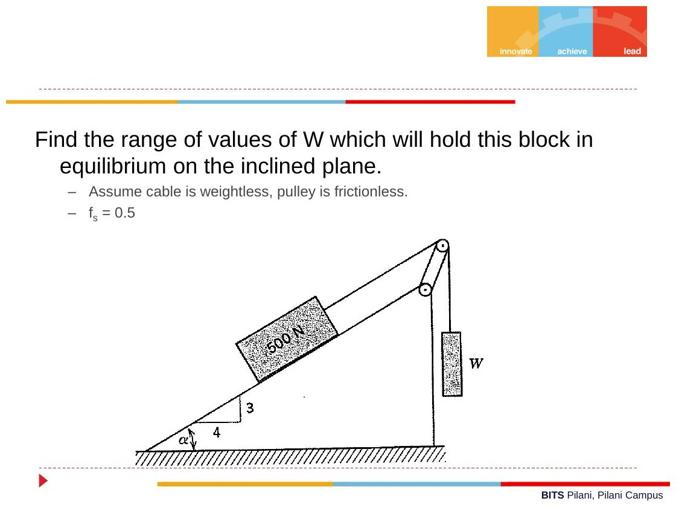
Original: Slides Ch 1, slide 24
Given: a 500 N block on a 3-4-5 incline ($sinα=0.6$, $cosα=0.8$). The cable runs parallel to the incline over a frictionless pulley to a hanging weight $W$. $μ_{s}=0.5$. Find: the range of $W$ for equilibrium.
Cable tension $T=W$.
- Impending down (smallest $W$): $W_{min}=500\left(0.6−0.5×0.8\right)=100$ N
- Impending up (largest $W$): $W_{max}=500\left(0.6+0.5×0.8\right)=500$ N
$$\boxed{100 \text{N}≤W≤500 \text{N}}$$
Check: $tanα=0.75>μ=0.5$, so the block would slide down on its own. That is why $W_{min}>0$. ✓
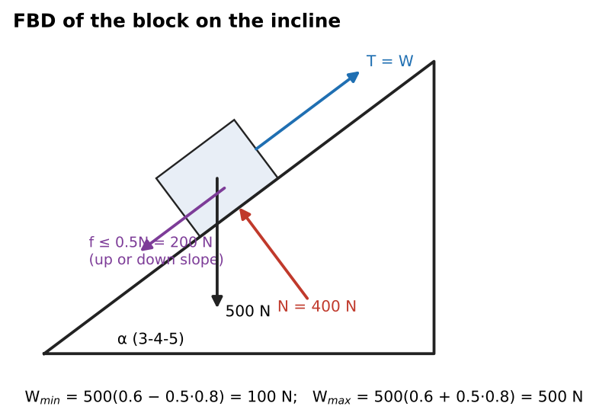
Worked FBD of the block

Q9 (Crandall Prob 1.45, Slides) — Trunk on a ramp (medium)
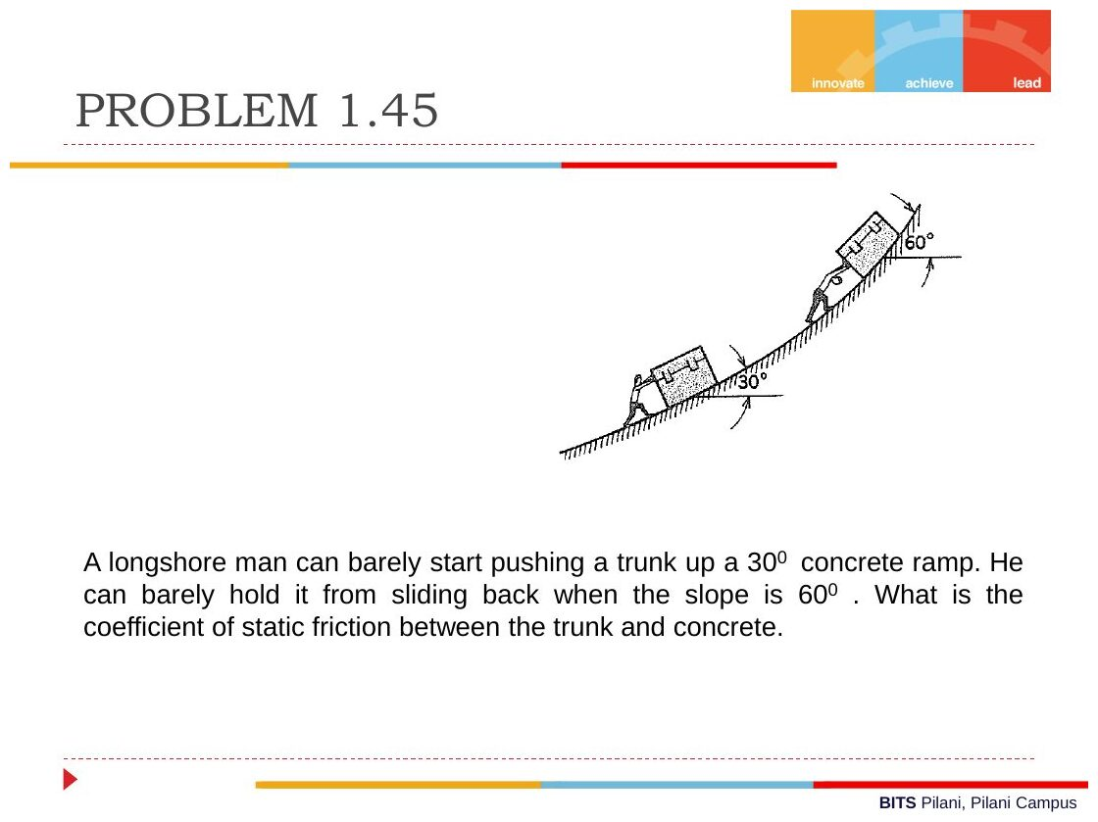
Original: Slides Ch 1, slide 25
Given: a man can just start pushing a trunk up a 30° ramp. With the same push (parallel to the ramp) he can just hold it from sliding back on a 60° ramp. Find: $μ_{s}$.
- 30°, impending up: $P=W\left(sin{30}^{∘}+μcos{30}^{∘}\right)$
- 60°, impending down: $P=W\left(sin{60}^{∘}−μcos{60}^{∘}\right)$
Set them equal: $0.5+0.866μ=0.866−0.5μ⇒1.366μ=0.366$
$$\boxed{μ_{s}=0.268 \left(=tan{15}^{∘}=2−\sqrt{3}\right)}$$
Check: $μ<tan{30}^{∘}$, so the trunk would slide down the 30° ramp unaided. That is consistent with him needing to push. ✓ Takeaway: “barely start pushing up” and “barely hold from sliding” are the two impending-motion directions. Friction flips between them.

Q10 (Crandall Prob 1.37, Slides) — Cylinder on two half-cylinders (hard)
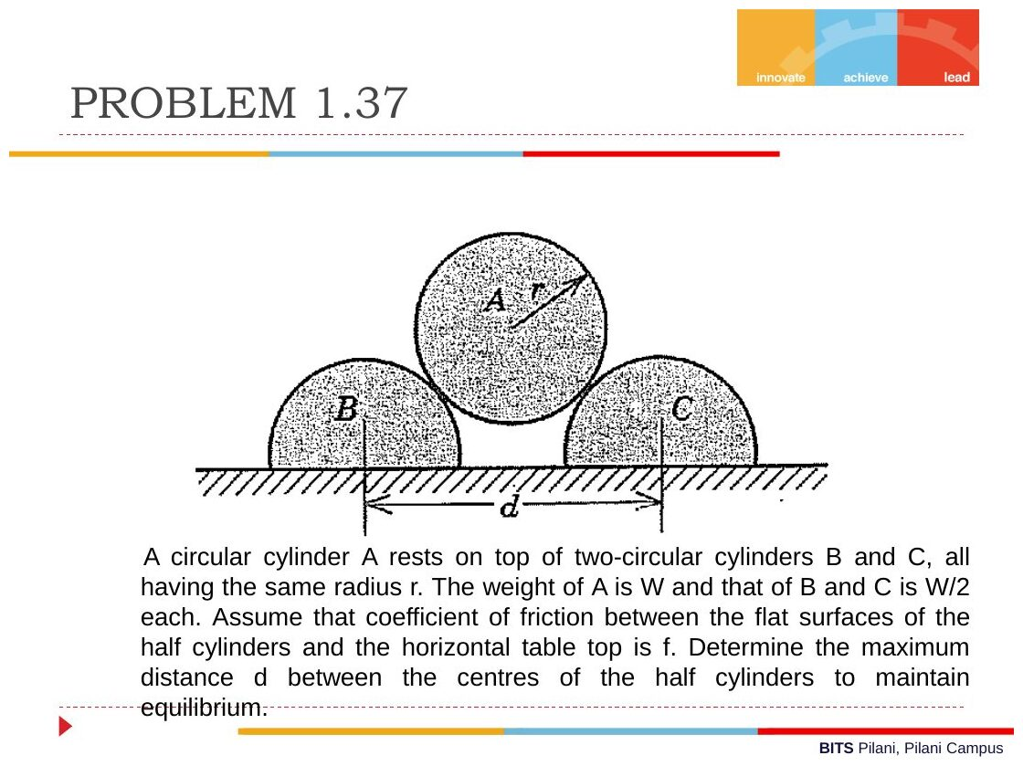
Original: Slides Ch 1, slide 26
Given: cylinder A (weight $W$, radius $r$) rests on half-cylinders B and C (each $W/2$, radius $r$). Their flat faces sit on a table with friction coefficient $f$. The cylinder-to-cylinder contacts are smooth. Find: the maximum distance $d$ between the centres of B and C.
Geometry: the centres of A and B are $2r$ apart. The horizontal offset is $d/2$. Let $θ$ be the angle of line AB from the vertical, so $sinθ=\frac{d}{4r}$.
FBD of A: by symmetry, the contact forces $N$ from B and C act along the lines of centres. $2Ncosθ=W⇒N=\frac{W}{2cosθ}$.
FBD of B: $N$ pushes B down and outward. Its horizontal component is $Nsinθ=W/2tanθ$. The table gives normal force $W/2+W/2=W$ and friction $F≤fW$.
$$W/2tanθ≤fW⇒tanθ≤2f$$
With $tanθ=2f$, $sinθ=\frac{2f}{\sqrt{1+4f^{2}}}$, so
$$\boxed{d_{max}=4rsinθ=\frac{8rf}{\sqrt{1+4f^{2}}}}$$
Check: $f→0$ gives $d→0$ (no friction, so they must touch). $f→∞$ gives $d→4r$, which is the geometric limit where A falls through. ✓ Takeaway: the normal from table to B is $W$, not $W/2$. It carries half of A’s weight as well as B’s own weight.

Q11 (PYQ 2014-15 Test-1 Q3) — Rope over a fixed drum (medium, combines Ch 1 and Ch 2)
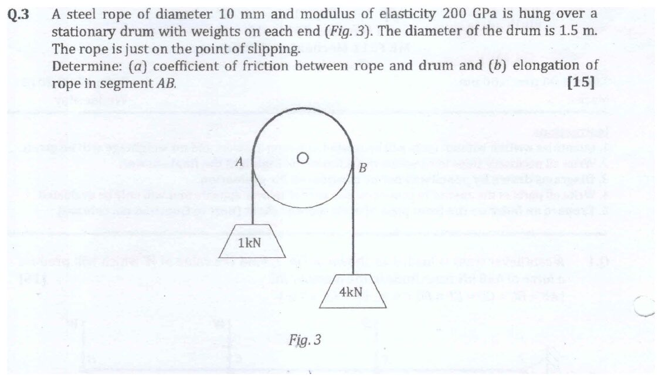
Original question: PYQ 2014-15 Test-1 Q3
Given: steel rope $d=10$ mm, $E=200$ GPa, over a fixed drum of diameter 1.5 m. Hanging weights are 1 kN (at A) and 4 kN (at B), with 180° of contact. The rope is just about to slip. Find: (a) $μ$, (b) the elongation of the rope segment AB (the part in contact with the drum).
(a) $T_{2}/T_{1}=e^{μπ}⇒4=e^{μπ}$
$$\boxed{μ=\frac{ln4}{π}=0.441}$$
(b) The tension varies along the contact: $T\left(θ\right)=T_{1}e^{μθ}$, with $ds=r dθ$. The elongation of a segment with varying force is $δ=∫\frac{T ds}{AE}$ (Ch. 2):
$$δ=\frac{r}{AE}\int_{0}^{π}{T_{1}}e^{μθ}dθ=\frac{rT_{1}}{AEμ}\left(e^{μπ}−1\right)=\frac{r\left(T_{2}−T_{1}\right)}{AEμ}$$
Here $A=π/4{\left(10\right)}^{2}=78.54$ mm², $AE=78.54×200,000=1.571×{10}^{7}$ N, and $r=750$ mm.
$$δ=\frac{750\left(3000\right)}{1.571×{10}^{7}×0.441}⇒\boxed{δ_{AB}≈0.325 \text{mm}}$$
Check: if the whole arc carried the average tension, $\overset{‾}{T}=\left(1+4\right)/2=2.5$ kN, then $δ=2500\left(π×750\right)/1.571×{10}^{7}=0.375$ mm. The exact value is a bit lower because the true tension curve is exponential, not linear. Same order of magnitude. ✓ Takeaway: this “friction plus axial deformation” combination shows exactly how Test-1 mixes Ch. 1 and Ch. 2.
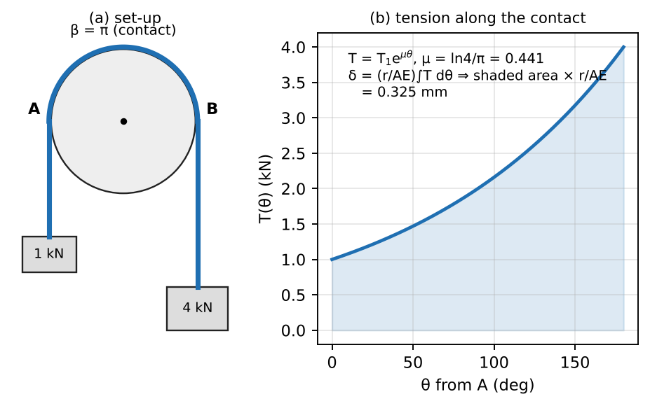
Rope tension varies exponentially along the drum

Concept 1.4 — Plane trusses

A. Concept explanation
1. Intuition. A truss is a skeleton of straight sticks pinned at the ends, like a Meccano bridge. If loads are applied only at the joints, each stick is either pulled (tension) or squashed (compression) along its length. There is no bending. Solving a truss means finding that one number for every stick.
2. Why it matters. Bridges, roof trusses, cranes, towers. Every member is a two-force member (Concept 1.2), and in Ch. 2 we use the member forces to get deflections with $δ=FL/AE$ and Castigliano’s theorem.
3. Formal treatment — ideal truss assumptions (slides):
- Members are connected only at their ends.
- Connections are frictionless pins.
- Loads are applied only at the joints.
- Member weights are neglected.
Each member is therefore a two-force member, in tension or compression.
Stability / determinacy (slides): with $m$ members, $j$ joints and 3 support reactions:
- $m=2j−3$: rigid and statically determinate (“perfect”)
- $m<2j−3$: unstable, collapsible
- $m>2j−3$: over-rigid, statically indeterminate
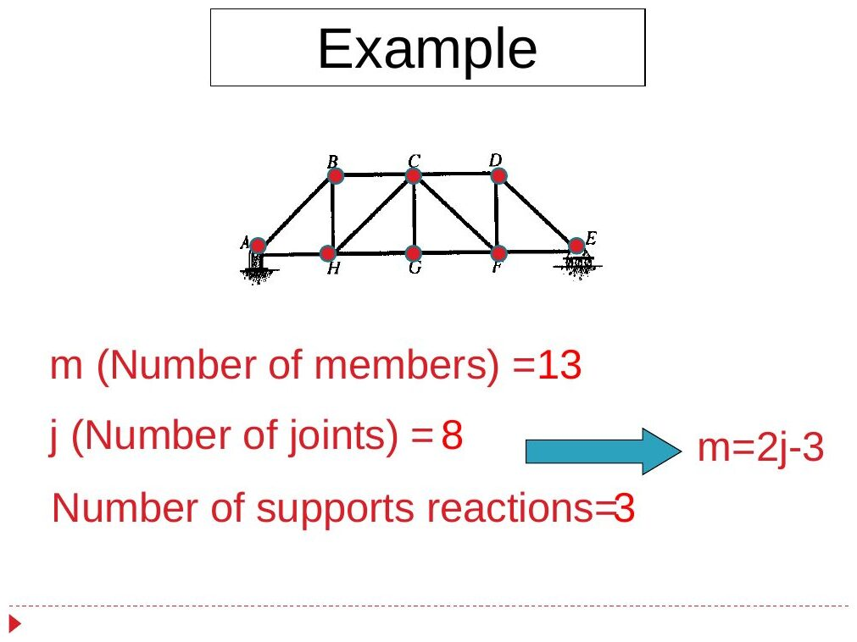
Original: Slides Ch 1, slide 33
Why: each joint gives 2 equations ($∑F_{x}$, $∑F_{y}$), so there are $2j$ equations. The unknowns are $m$ member forces plus 3 reactions. Determinate when $m+3=2j$. (Slide example: $m=13$, $j=8$, $13=2\left(8\right)−3$ ✓.)
Zero-force members (slides):
- Two non-collinear members meet at an unloaded, unsupported joint → both are zero.
- Three members meet at an unloaded joint and two are collinear → the third is zero.
Why rule 2: sum forces perpendicular to the collinear pair. Only the third member has a component in that direction, so it must be zero.
Method of joints (slides):
- Find the support reactions from the whole truss. (Not needed for a cantilever truss if you start at the free end.)
- Pick a joint with at most 2 unknowns. Assume every unknown member force is tensile (arrow pointing away from the joint).
- Apply $∑F_{x}=∑F_{y}=0$ and move from joint to joint.
- Tabulate: member, force, T/C. A negative answer means compression.
Method of sections (slides): use it when only a few members are wanted.
- Find reactions if needed.
- Cut through at most 3 members (including the wanted ones). The cut must split the truss into two separate parts and pass through members, not joints.
- Keep the part with fewer forces.
- Use the 3 equilibrium equations. Take moments about the point where two of the unknown forces intersect, so you get one equation in one unknown.
4. Derivation — moment trick. If the cut members are a top chord (force $F_{1}$), a bottom chord ($F_{2}$) and a diagonal ($F_{3}$), then $F_{2}$ and $F_{3}$ meet at a bottom joint. Taking moments about that joint gives $F_{1}h=M_{\text{external}}$, so $F_{1}=M/h$. A truss chord behaves like the flange of a beam: chord force = bending moment / depth. This links forward to Ch. 3.
5. Geometric check. In a cantilever truss under downward loads, the top chord is in tension and the bottom chord in compression (the truss “hogs”). In a simply supported truss it is the opposite.
6. Special cases. A diagonal’s vertical component equals the shear in that panel: $F_{diag}sinθ=V$.
7. Common mistakes.
- Mixing up “T assumed” and “C answer”. Keep the sign convention fixed.
- Passing a section through a joint.
- Cutting 4 unknown members and expecting 3 equations to solve them.
- Getting angles wrong. Always compute $tanθ$ from the dimensions.
8. Summary box
Tool | Use when
$m=2j−3$ | Check determinacy first
Zero-force rules | Spot them before starting; they save time
Joints | All member forces wanted
Sections | 1–3 specific members wanted; take moments about the intersection of the other two

B. Solved questions

Q12 (Slides Ch1) — A-frame truss (easy–medium)
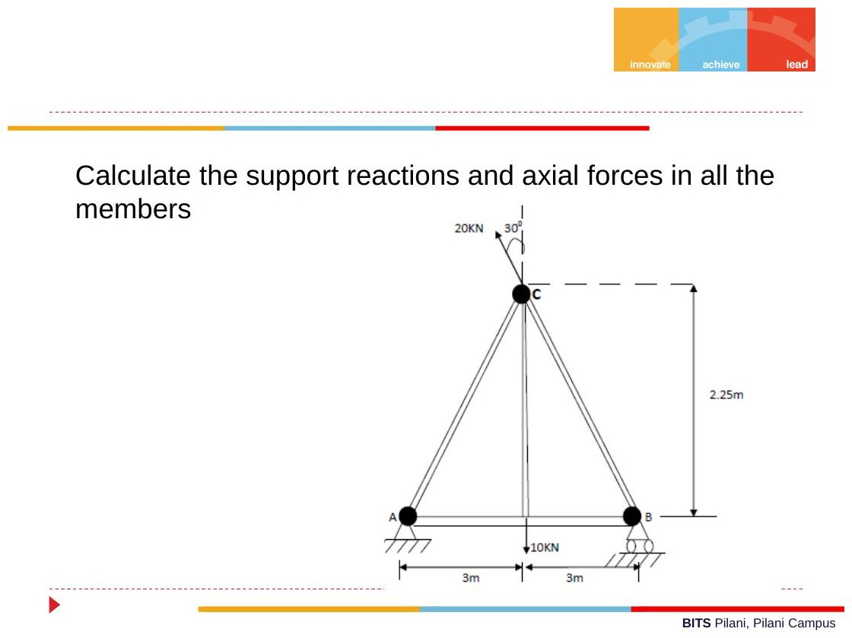
Original: Slides Ch 1, slide 41
Given: A (pin) and B (roller) are 6 m apart. Apex C is 2.25 m above midpoint D. Members AC, BC, CD, AD, BD. Loads: 10 kN down at D, and 20 kN at C acting down and to the right, 30° from the vertical. Find: reactions and all member forces.
Geometry: $AC=BC=\sqrt{3^{2}+{2.25}^{2}}=3.75$ m, so $sinθ=0.6$ and $cosθ=0.8$. Load at C: $\left(+20sin{30}^{∘},−20cos{30}^{∘}\right)=\left(10,−17.32\right)$ kN.
Reactions:
- $∑F_{x}$: $A_{x}=−10$ kN (10 kN to the left)
- $∑M_{A}$: $B_{y}\left(6\right)−10\left(3\right)−\left[17.32\left(3\right)+10\left(2.25\right)\right]=0⇒B_{y}=17.41$ kN
- $A_{y}=27.32−17.41=9.91$ kN
Joints:
- D: CD is the only vertical member, so $F_{CD}=10$ kN (T). The horizontal members give $F_{AD}=F_{BD}$.
- A: $0.6F_{AC}+9.91=0⇒F_{AC}=−16.52$ kN (C). Then $0.8\left(−16.52\right)+F_{AD}−10=0⇒F_{AD}=23.21$ kN (T).
- B: $0.6F_{BC}+17.41=0⇒F_{BC}=−29.02$ kN (C). $F_{BD}=23.21$ kN (T) ✓.
Member | Force (kN) | Nature
AC | 16.52 | C
BC | 29.02 | C
CD | 10.00 | T
AD | 23.21 | T
BD | 23.21 | T
(The slide table labels the first row “AB”. It means AC, since there is no member AB.)
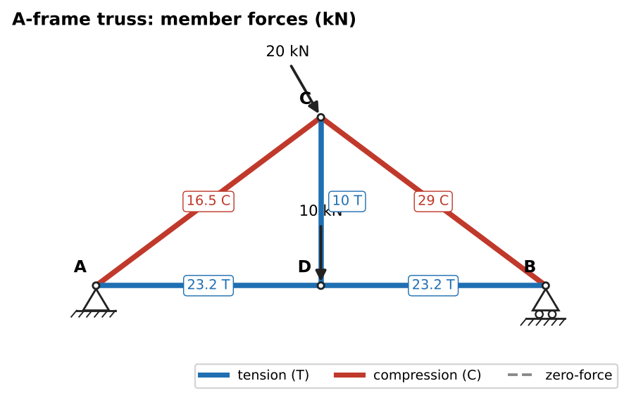
Solution: member forces (blue = tension, red = compression)

Q13 (Slides Ch1) — Warren truss, 2000 N and 4000 N (medium)
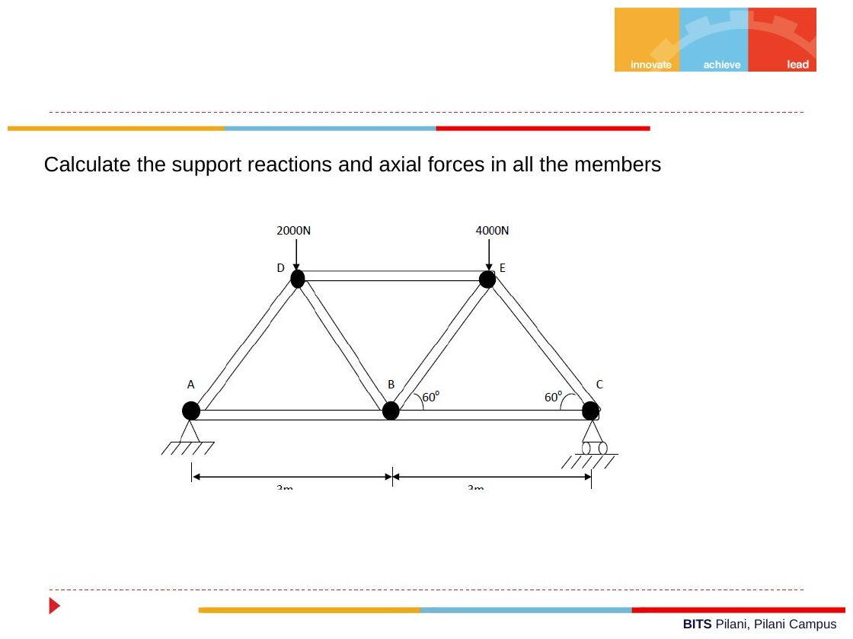
Original: Slides Ch 1, slide 39
Given: equilateral panels of 3 m. Bottom A (pin), B, C (roller). Top D (above $x=1.5$), E (above $x=4.5$). 2000 N at D and 4000 N at E. Find: all member forces.
$h=1.5tan{60}^{∘}=2.598$ m. Reactions: $C_{y}=\left(2000×1.5+4000×4.5\right)/6=3500$ N and $A_{y}=2500$ N.
- Joint A: $F_{AD}sin{60}^{∘}+2500=0⇒F_{AD}=−2886.8$ (C). $F_{AB}=−F_{AD}cos{60}^{∘}=1443.4$ (T).
- Joint C: $F_{CE}=−3500/sin{60}^{∘}=−4041.5$ (C). $F_{BC}=2020.7$ (T).
- Joint D: $y$: $−0.866F_{DA}−0.866F_{DB}−2000=0⇒F_{DB}=\frac{−2000+0.866\left(2886.8\right)}{0.866}=577.4$ (T). $x$: $−0.5F_{DA}+0.5F_{DB}+F_{DE}=0⇒F_{DE}=−1443.4−288.7=−1732.1$ (C).
- Joint E: $y$: $−0.866F_{EB}−0.866F_{EC}−4000=0⇒F_{EB}=\frac{−4000+3500}{0.866}=−577.4$ (C).
Member | AB | BC | AD | BD | BE | CE | DE
Force (N) | 1443.4 T | 2020.7 T | 2886.8 C | 577.4 T | 577.4 C | 4041.5 C | 1732.1 C
⚠ The slide table lists BE = 500 N (C). That is a slip: $500$ is the vertical component. The member force is $500/sin{60}^{∘}=577.4$ N. A computer solve of the whole truss confirms this. Check: BD and BE carry the panel shear (2500 − 2000 = 500 N) in opposite senses ✓.
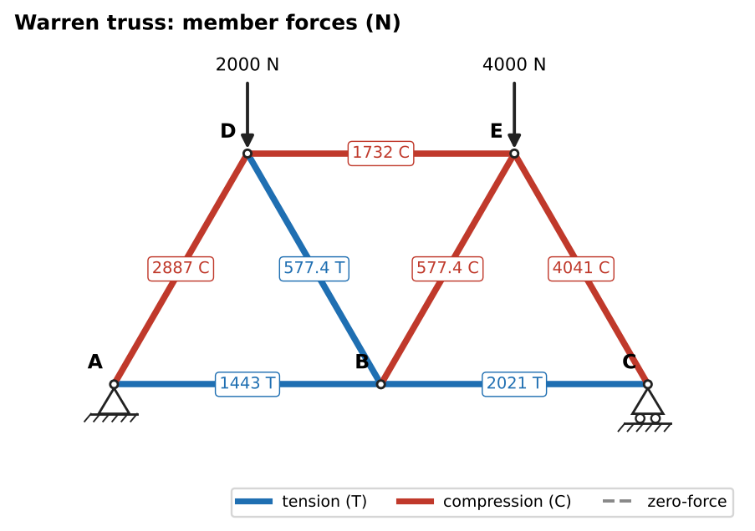
Solution: member forces; note BE = 577 N (C), not 500 N

Q14 (Slides Ch1) — Cantilever truss (medium)
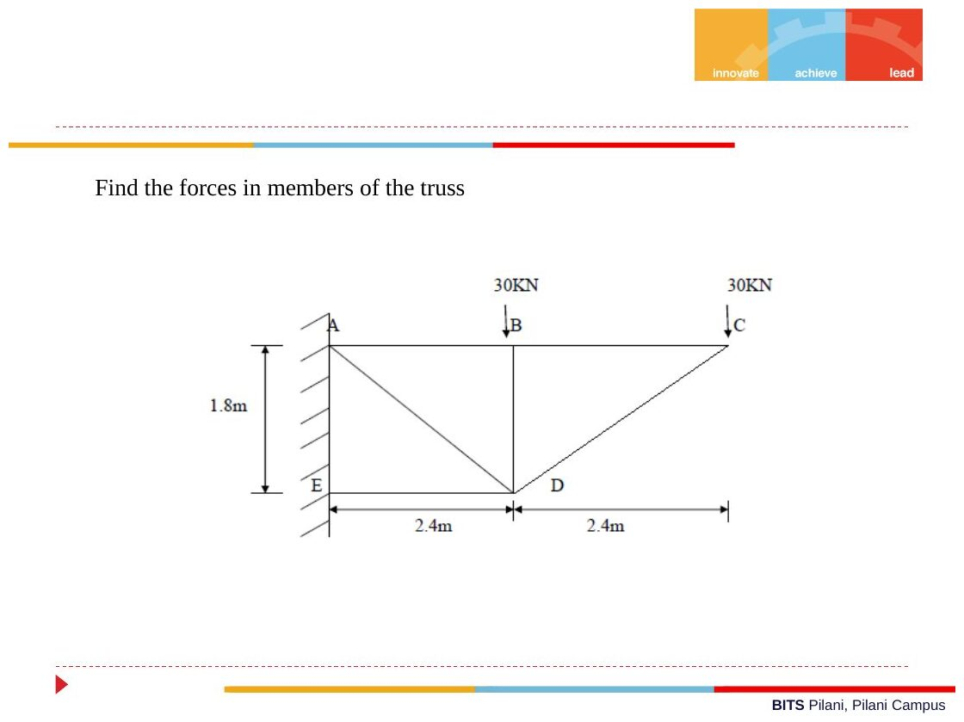
Original: Slides Ch 1, slide 43
Given: wall joints A (top, $y=1.8$ m) and E (bottom). Top chord A–B–C with panels of 2.4 m. Bottom joint D below B. Members AB, BC, AD, BD, CD, ED. 30 kN down at B and at C. Find: all forces (no reactions needed if you start at the free end C).
$tanθ=1.8/2.4⇒θ={36.87}^{∘}$.
- Joint C: $30+F_{CD}sinθ=0⇒F_{CD}=−50$ kN (C). $F_{BC}=−F_{CD}cosθ=40$ kN (T).
- Joint B: $F_{BA}=40$ kN (T). $F_{BD}=−30$ kN (C).
- Joint D: $y$: $F_{DA}sinθ=30+50sinθ⇒F_{DA}=100$ kN (T). $x$: $F_{DE}=−120$ kN (C).
$$\boxed{BC=40 T, CD=50 C, BD=30 C, AB=40 T, AD=100 T, DE=120 C \left(\text{kN}\right)}$$
(The slides show 40.01, 50.01 and so on because they rounded θ to 36.86°.)
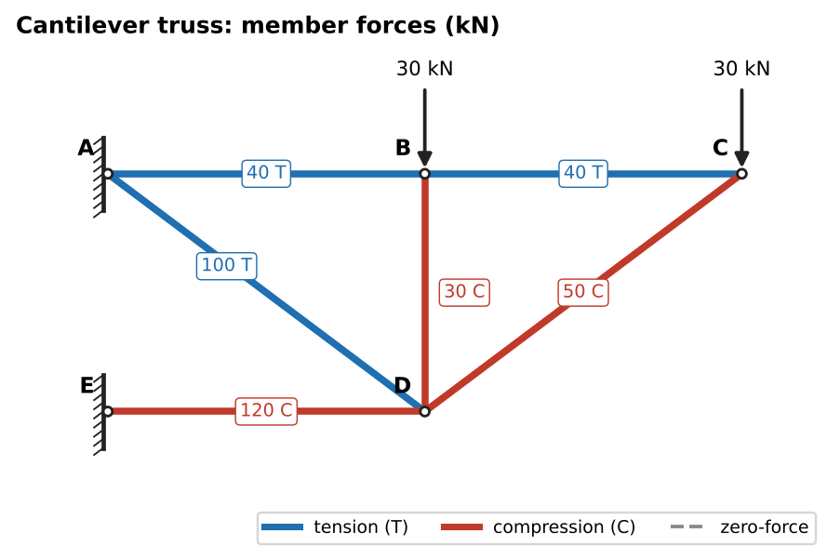
Solution: member forces

Q15 (Slides Ch1, “Question 2”) — Find P from a member force (medium, sections)
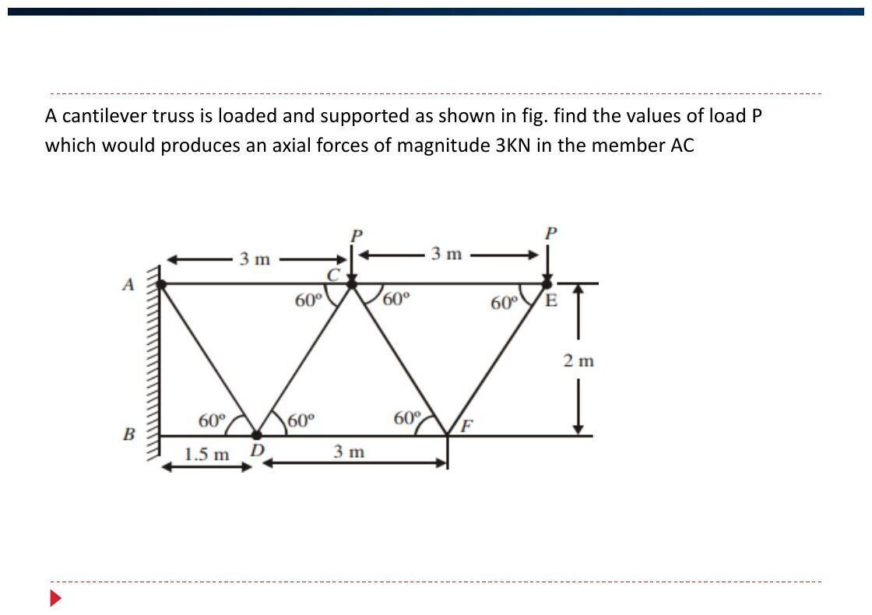
Original: Slides Ch 1, slide 53
Given: cantilever truss (60° triangles, height 2 m) with loads $P$ at C and E. The force in AC must be 3 kN. Find: $P$.
Cut through AC, CD and the bottom member at D. Take moments about D, where CD and the bottom chord meet. The slide’s result is $F_{AC}\left(2\right)−P\left(1.5\right)−P\left(4.5\right)=0$, so $F_{AC}=3P$.
$$3P=3 \text{kN}⇒\boxed{P=1 \text{kN}}$$

Q16 (Slides Ch1, Hibbeler-type) — Sections: GE, GC, BC (medium)
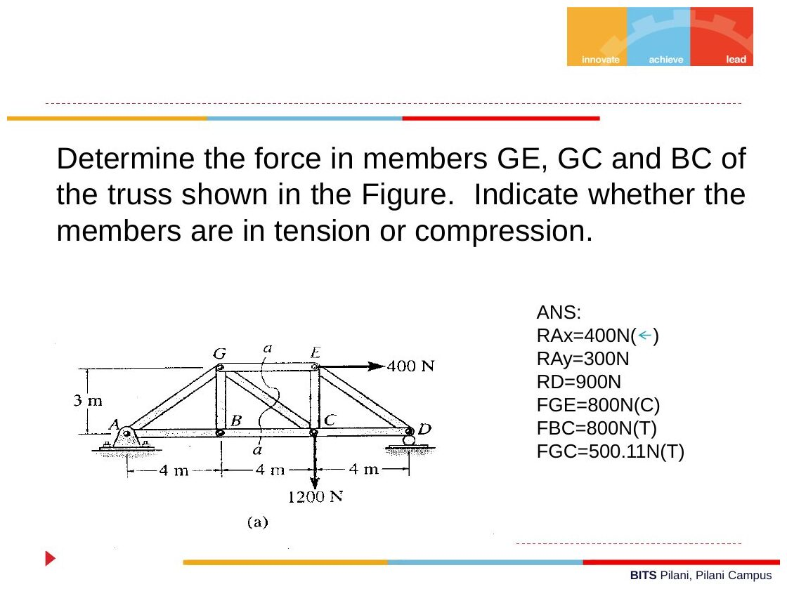
Original: Slides Ch 1, slide 52
Given: pin A, roller D. Panels of 4 m, height 3 m. 400 N horizontal at E and 1200 N down at C. Find: $F_{GE},F_{GC},F_{BC}$.
Reactions: $A_{x}=400$ N ←. $∑M_{A}$: $D_{y}\left(12\right)−1200\left(8\right)−400\left(3\right)=0⇒D_{y}=900$ N. $A_{y}=300$ N. Section a–a cuts GE, GC and BC. Take the left part (A, B, G).
- $∑M_{G}$ (G at $x=4$, $y=3$). $A_{y}=300$ ↑ at 4 m to the left gives −1200 N·m. $A_{x}=400$ ← at 3 m below gives −1200 N·m. $F_{BC}$ (tension, →) at 3 m below gives $+3F_{BC}$. So $−2400+3F_{BC}=0⇒F_{BC}=800$ N (T)
- $∑M_{C}$ (C at $x=8$, $y=0$). $A_{y}$ gives $−300\left(8\right)=−2400$. $A_{x}$ is on the line through C, so 0. $F_{GE}$ (→) at 3 m above gives $−3F_{GE}$. So $F_{GE}=−800$ N (C)
- $∑F_{y}$: $300−F_{GC}\left(3/5\right)=0⇒F_{GC}=500$ N (T)
$$\boxed{F_{GE}=800 \text{N (C)}, F_{GC}=500 \text{N (T)}, F_{BC}=800 \text{N (T)}}$$
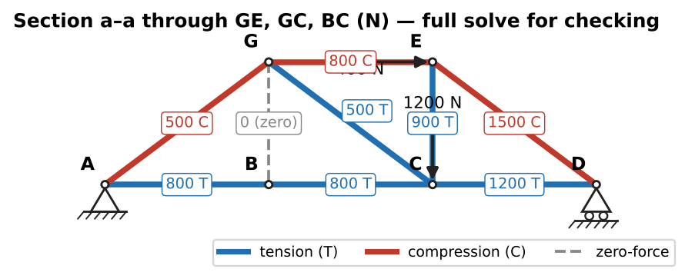
Full joint-by-joint solution, used to check the section answers

Q17 (Slides Ch1) — Sections with a 20 kN horizontal load (medium)
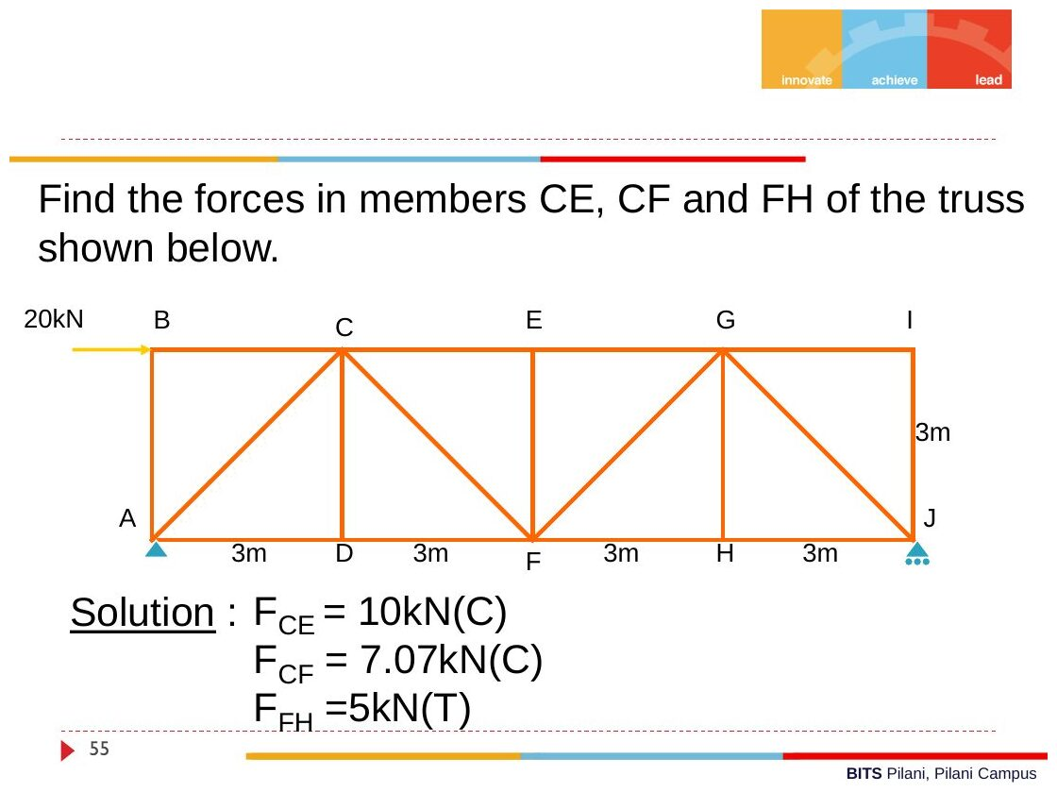
Original: Slides Ch 1, slide 55
Given: top B–C–E–G–I and bottom A–D–F–H–J, all panels 3 m, height 3 m. Diagonals AC, CF, FG, GJ. A is a pin, J a roller. 20 kN horizontal (→) at B. Find: $F_{CE},F_{CF},F_{FH}$.
Reactions: $A_{x}=20$ ←. $∑M_{A}$: $J_{y}\left(12\right)=20\left(3\right)⇒J_{y}=5$ kN ↑, so $A_{y}=5$ kN ↓.
- Cut CE, CF, DF. Left part. Moments about F$\left(6,0\right)$: $−20\left(3\right)+5\left(6\right)−3F_{CE}=0⇒F_{CE}=−10$ kN (C)
- Same cut, $∑F_{y}$: $−5−F_{CF}/\sqrt{2}=0⇒F_{CF}=−7.07$ kN (C)
- Cut EG, FG, FH. Right part. Moments about G$\left(9,3\right)$: $5\left(3\right)−3F_{FH}=0⇒F_{FH}=5$ kN (T)
$$\boxed{F_{CE}=10 \text{kN C}, F_{CF}=7.07 \text{kN C}, F_{FH}=5 \text{kN T}}$$
✓ matches the slide.
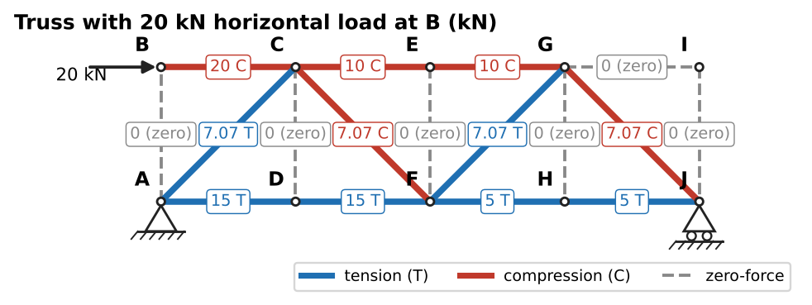
Full solution (zero-force members dashed)

Q18 (Slides Ch1) — Zero-force members + one cut (medium)
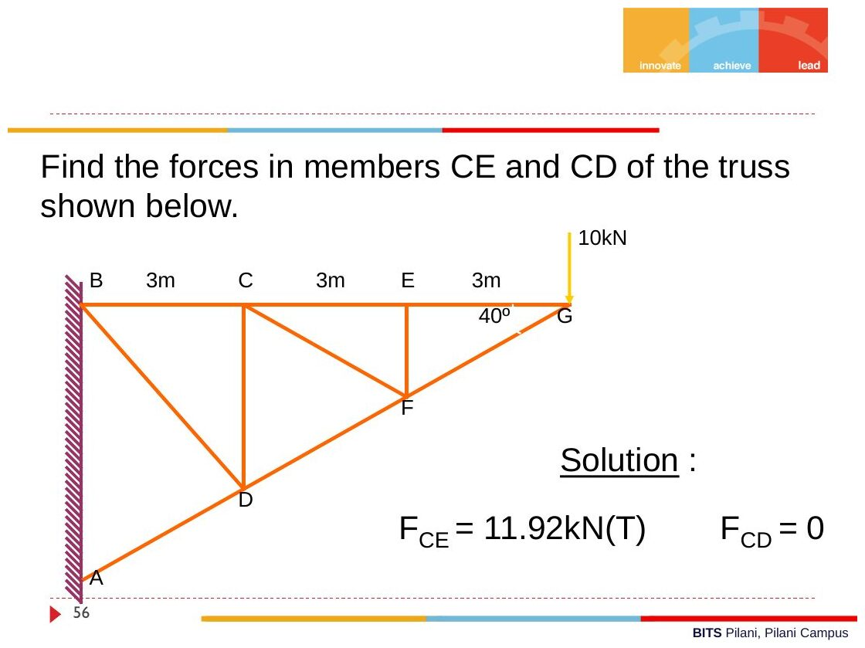
Original: Slides Ch 1, slide 56
Given: cantilever truss. Top B–C–E–G (3 m spacings). Bottom chord A–D–F–G sloping at 40° at G. Verticals CD and EF. Diagonal CF. 10 kN at G. Find: $F_{CE}$, $F_{CD}$.
- Joint G: $F_{GF}sin{40}^{∘}=−10⇒F_{GF}=−15.56$ kN (C). $F_{GE}=−F_{GF}cos{40}^{∘}=11.92$ kN (T).
- Joint E: CE and EG are collinear and EF is the third member, with no load → $F_{EF}=0$ (zero-force rule 2). So $F_{CE}=F_{EG}=11.92$ kN (T).
- Joint F: DF and FG are collinear, EF = 0, so CF is the odd one out → $F_{CF}=0$.
- Joint C: BC and CE are collinear, CF = 0, so the vertical CD is the odd one out → $F_{CD}=0$.
$$\boxed{F_{CE}=11.92 \text{kN (T)}, F_{CD}=0}$$

Q19 (Slides Ch1) — Identify zero-force members (easy)
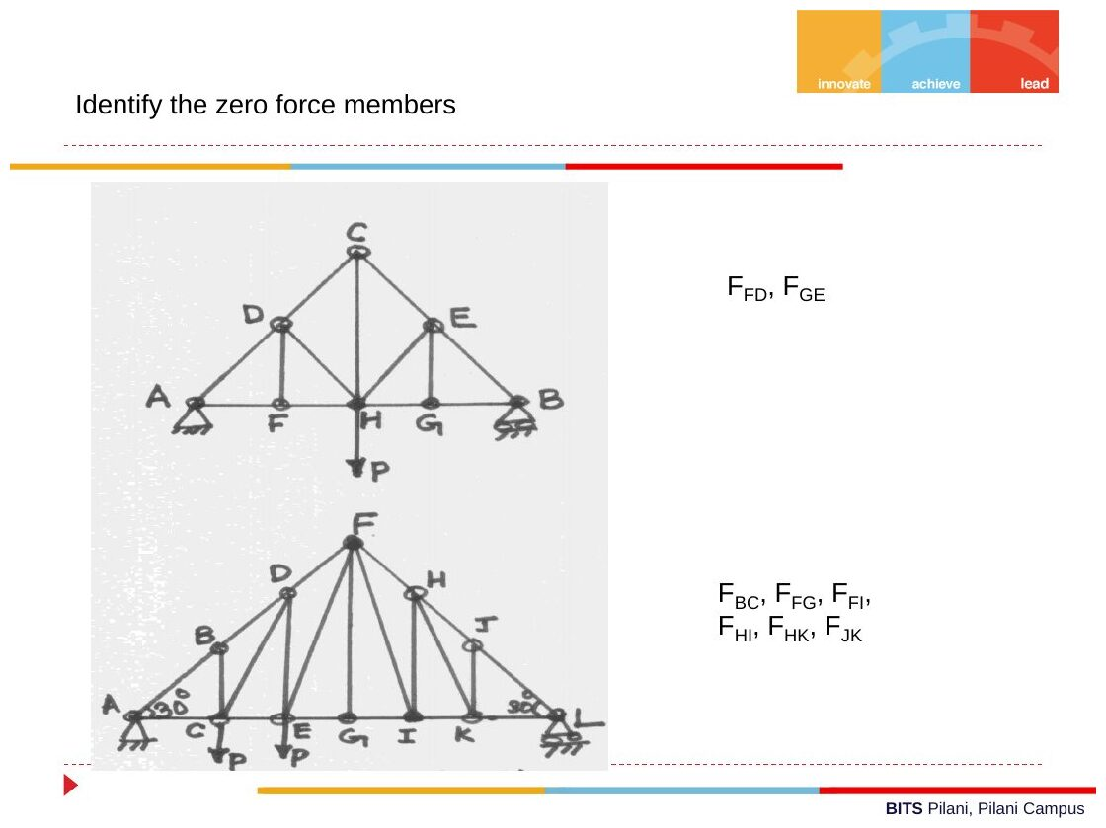
Original: Slides Ch 1, slide 38
Upper truss: $F_{FD}$ and $F_{GE}$ (the verticals at unloaded bottom joints F and G, where the bottom chord is collinear). Lower truss: $F_{BC},F_{FG},F_{FI},F_{HI},F_{HK},F_{JK}$. Apply rule 2 repeatedly, working inward from the unloaded joints. Takeaway: after finding one zero member, remove it and check the neighbouring joint again. The rules cascade.

Q20 (PYQ 2014-15 Test-1 Q1) — Cantilever truss, find $W$ (medium)
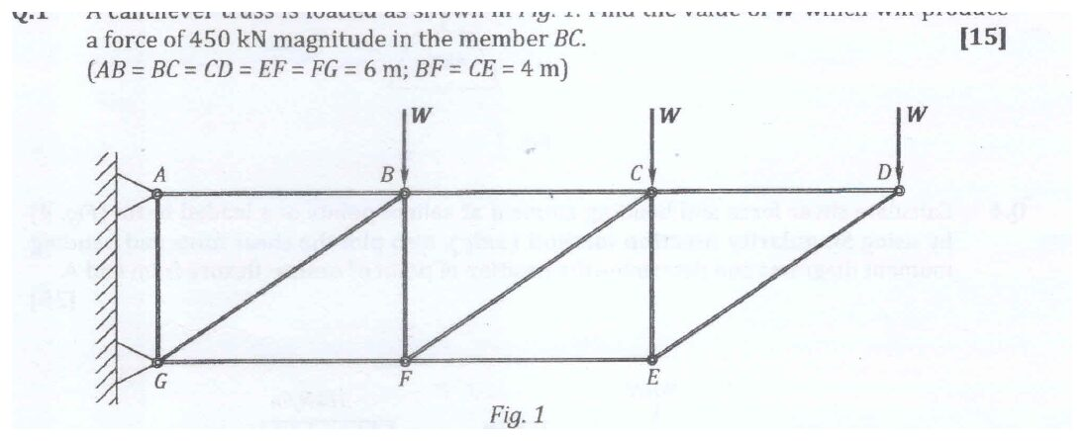
Original question: PYQ 2014-15 Test-1 Q1
Given: top A–B–C–D and bottom G–F–E. $AB=BC=CD=EF=FG=6$ m and $BF=CE=4$ m. Diagonals GB, FC, ED. Wall supports at A and G. Loads $W$ at B, C, D. $\left|F_{BC}\right|=450$ kN. Find: $W$.
Cut BC, FC and FE. Keep the right part (C, D, E). Take moments about F, where FC and FE meet:
$$F_{BC}\left(4\right)−W\left(6\right)−W\left(12\right)=0⇒F_{BC}=4.5W$$
$$4.5W=450⇒\boxed{W=100 \text{kN}} \left(BC \text{in tension}\right)$$
Check: a full joint-by-joint solve with W = 100 gives BC = 450.0 kN T, AB = 900 kN T and GF = 450 kN C. The top chord is in tension, as expected for a cantilever. ✓ Takeaway: “find the load that gives force X in member Y” means method of sections with moments about a cleverly chosen point. It is a 15-mark question that takes 3 lines once you see the right point.
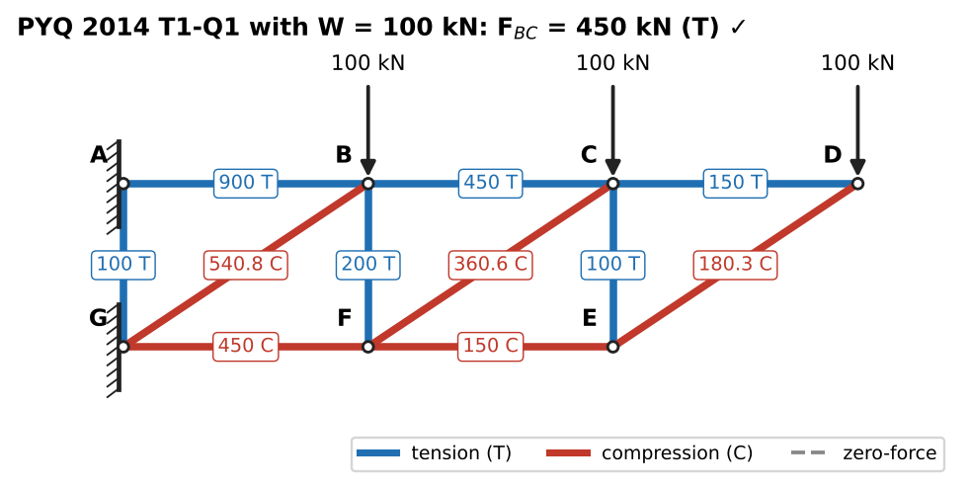
Check: full solve with W = 100 kN

Chapter 1 — Formula and convention sheet
Topic | Key relation
Equilibrium (2-D) | $∑F_{x}=∑F_{y}=∑M_{O}=0$
Two-force member | Forces equal, opposite, along the line of the pins
Three-force member | Lines of action concurrent (or all parallel)
Static friction | $f≤μ_{s}N$; at impending motion $f=μ_{s}N$
Incline, impending | $T=W\left(sinα±μcosα\right)$; angle of repose $tanα=μ$
Belt friction | $T_{2}/T_{1}=e^{μβ}$ ($β$ in rad)
Truss determinacy | $m=2j−3$
Zero-force rules | 2 non-collinear unloaded → both 0; 3 with 2 collinear unloaded → third 0
Sections | Cut ≤ 3 members; moments about the intersection of 2 unknowns
Sign | Assume tension; negative answer = compression
Other Crandall Ch. 1 problems worth practising (same patterns): FBD drills (Probs 1.1–1.10), friction (Probs 1.38–1.46), trusses in the problem set.

Chapter 2 — Introduction to Mechanics of Deformable Bodies
Axial deformation, statically indeterminate bars, displacement diagrams, strain energy, Castigliano
Sources used: Slides “Chapter 2” (Dr. Sharad Shrivastava), Crandall Ch. 2 (§2.2–2.6; Probs 2.1, 2.6, 2.7, 2.19, 2.24), PYQs 2014-15 (Test-1 Q2; Compre A Q8, Q11) and 2019-20 Compre A Q3(b).

Concept 2.1 — The three-step method for deformable bodies

A. Concept explanation
1. Intuition. Push down on a mattress that has two different springs side by side. You can’t say how much each spring carries just by balancing forces, because one equation can’t fix two unknowns. What settles it is that both springs squash by the same amount, and the stiffer one pushes back harder. Every deformable-body problem combines three facts in this way: forces balance, pieces fit together, and force relates to stretch.
2. Why it matters. This is the backbone of the whole course. Ch. 4 (stress/strain), Ch. 5 (Hooke’s law) and Ch. 6 (torsion) all re-run these three steps with more refined ingredients.
3. Formal treatment (Crandall eq. 2.1, slides):
- Study of forces and equilibrium requirements
- Study of deformation and conditions of geometric fit (compatibility)
- Force–deformation relation (material law)
For a statically determinate problem, step 1 alone gives the forces, and steps 2 and 3 are needed only for displacements. For an indeterminate problem you need all three at the same time.
4. Derivation — two coaxial springs (Crandall Example 2.1, slides). A piston carries $F$ and sits on two coaxial springs $k_{A}$ and $k_{B}$.
- Step 1, equilibrium of the piston: $F=F_{A}+F_{B}$ … (1)
- Step 2, geometric fit: the piston moves both springs equally, $δ_{A}=δ_{B}=δ$ … (2)
- Step 3, force–deflection: $F_{A}=k_{A}δ_{A}$, $F_{B}=k_{B}δ_{B}$ … (3)
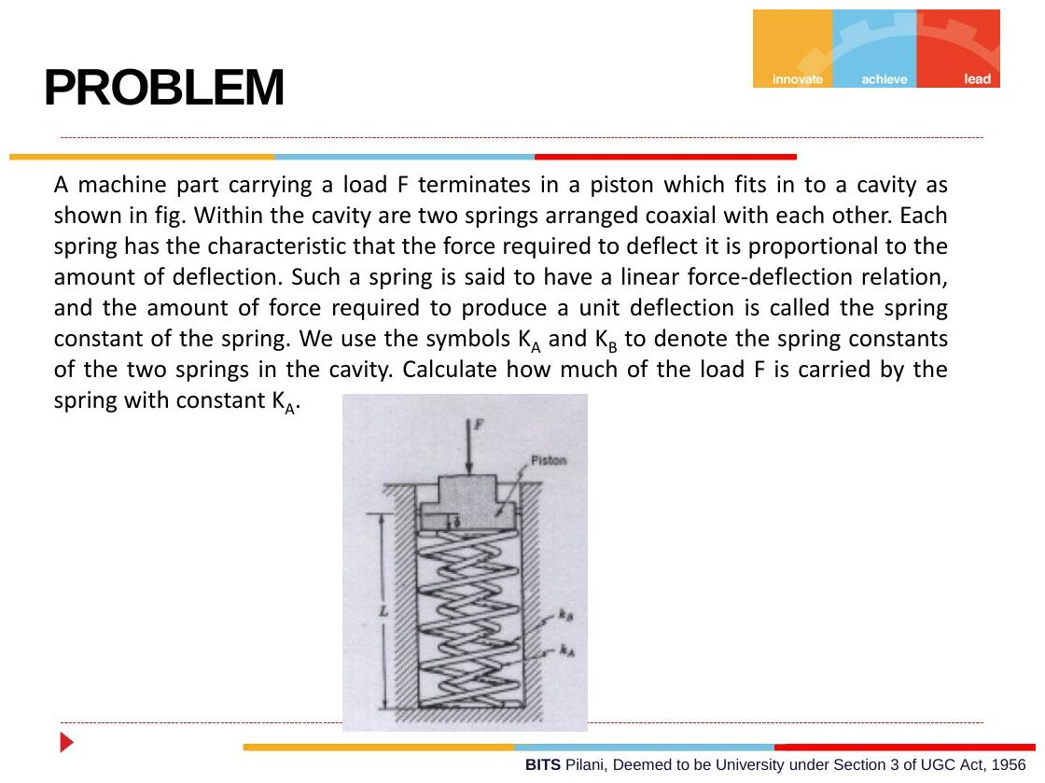
Original: Slides Ch 2, slide 3
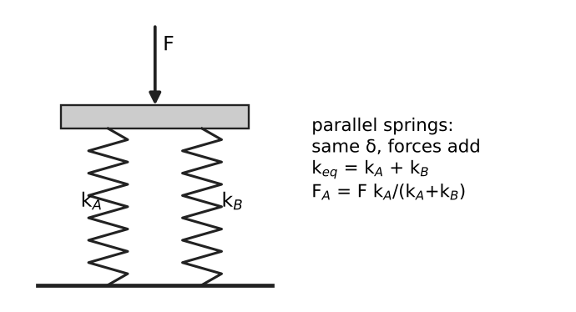
Parallel springs share the deflection
Substitute (2) and (3) into (1): $F=\left(k_{A}+k_{B}\right)δ$. Dividing by $F_{A}=k_{A}δ$ gives
$$\boxed{F_{A}=\frac{k_{A}}{k_{A}+k_{B}}F, δ=\frac{F}{k_{A}+k_{B}}}$$
5. Picture. Springs in parallel share the deflection, so their stiffnesses add: $k_{eq}=k_{A}+k_{B}$. Springs in series share the force, so their flexibilities add: $1/k_{eq}=1/k_{A}+1/k_{B}$.
6. Limiting cases. $k_{B}→0$ gives $F_{A}→F$. $k_{A}=k_{B}$ gives $F_{A}=F/2$. The stiffer member attracts the load. This rule of thumb reappears in composite bars, bolt-and-sleeve problems and indeterminate shafts.
7. Common traps. Writing compatibility as “forces equal” instead of “deflections equal”. Mixing up the series and parallel formulas.
8. Summary. Equilibrium + compatibility + constitutive law. Count unknowns versus equilibrium equations to decide whether you need compatibility.

Concept 2.2 — Uniaxial loading: $δ=PL/AE$ and bars with several segments

A. Concept explanation
1. Intuition. Pull a rubber band. Doubling the force doubles the stretch. Doubling the length also doubles the stretch, because each piece stretches the same amount and there are twice as many pieces. Doubling the thickness halves the stretch, because twice as much material shares the load.
2. Why it matters. Truss deflections, bolts, cables, columns, thermal stresses (Ch. 5). It also introduces the material constant $E$.
3. Formal treatment (slides, Crandall §2.3). Test bars with different $L$ and $A$ (bars 1, 2, 3 in the slide) give different $P$–$δ$ curves. When re-plotted as $P/A$ versus $δ/L$, they collapse onto a single curve, a property of the material alone. For a linear material its slope is the modulus of elasticity $E$:
$$E=\frac{P/A}{δ/L} ⇒ \boxed{δ=\frac{PL}{AE}}$$
$E$ measures the stiffness of the material. $AE/L$ is the axial stiffness $k$ of the bar.
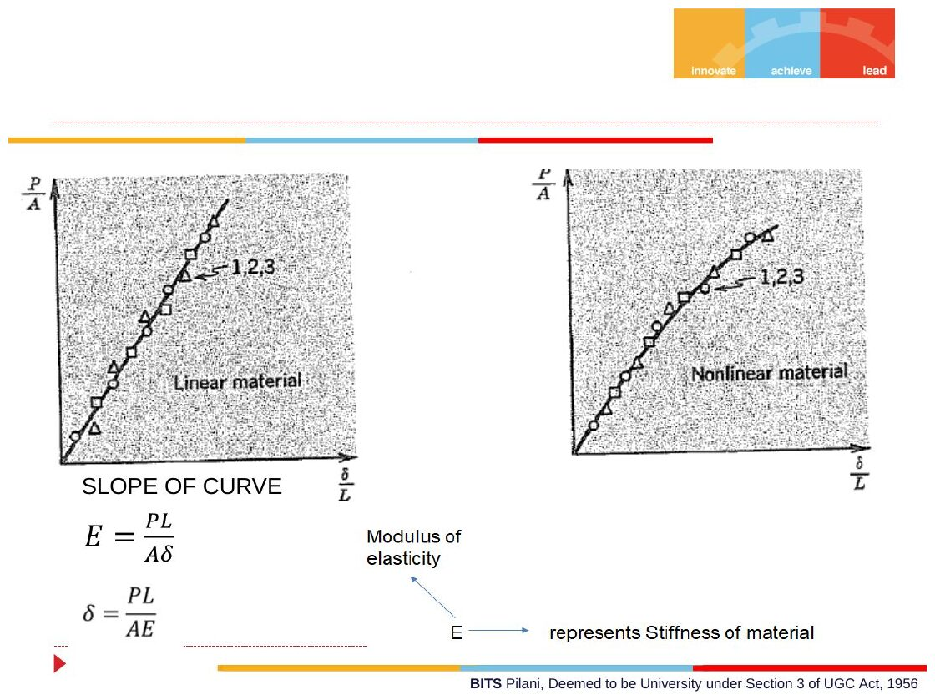
Original: Slides Ch 2, slide 10
Several segments / non-uniform:
δ=i​PiLiAiEi or δ=0LPx dxAxE
Here $P_{i}$ is the internal force in segment $i$, found from an FBD of a cut. Sign: tension positive (elongation), compression negative.
4. Derivation of the internal force in a segment. Cut through segment $i$ and keep the left part. $∑F_{x}=0$ gives $P_{i}$ = (sum of external forces to the left of the cut that point left). Equivalently, $P_{i}$ = the force needed on the cut face to hold the left part in equilibrium. Draw $P_{i}$ as tension (pointing away from the cut face) and let the sign tell you the answer.
5. Picture. Draw an axial force diagram (AFD): a step plot of $P\left(x\right)$. The total elongation is $\frac{1}{E}∑\left(\text{AFD area}\right)/A$.
6. Special cases.
- Bar hanging under its own weight: $P\left(x\right)=γAx$, which gives $δ=γL^{2}/\left(2E\right)=WL/\left(2AE\right)$, half of what you’d get with the whole weight at the end.
- Tapered bar: integrate with $A\left(x\right)$.
7. Common traps.
- Using the external load at a point instead of the internal force in the segment.
- Unit slips: N, mm and N/mm² (MPa) form a consistent set. So do N, m and Pa. Never mix kN with mm² without converting.
- Forgetting that compression gives a negative $δ$.
8. Summary box
$$δ=∑\frac{P_{i}L_{i}}{A_{i}E_{i}}, k_{bar}=\frac{AE}{L}, 1 \text{MPa}=1 {\text{N/mm}}^{2}, 1 \text{GPa}={10}^{3} {\text{N/mm}}^{2}$$

B. Solved questions

Q1 (Slides Ch2) — Brass bar with four axial forces (easy)
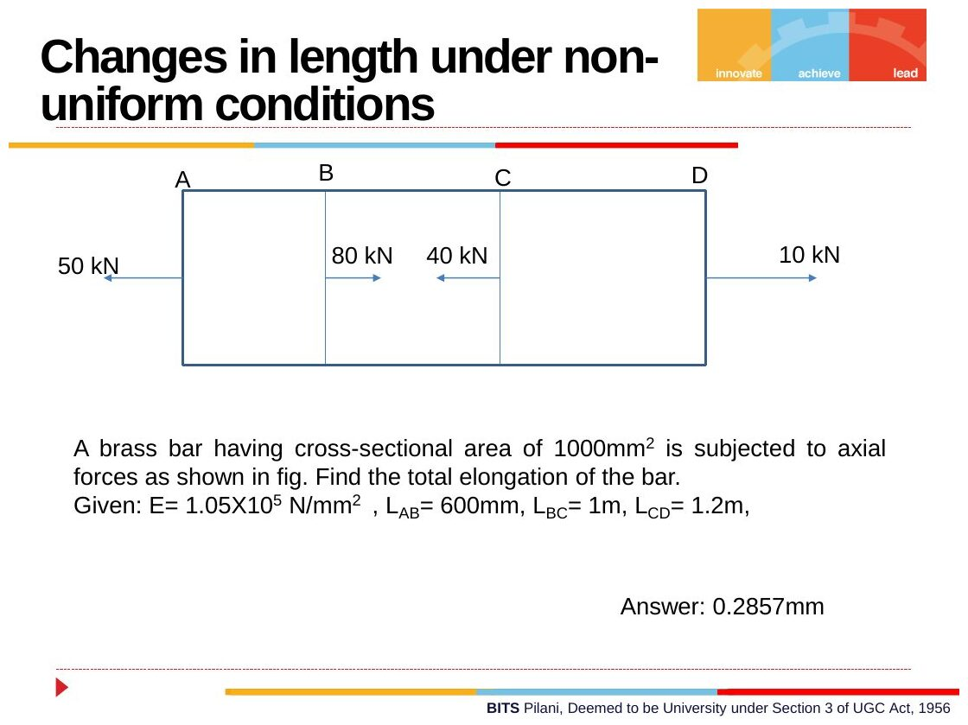
Original: Slides Ch 2, slide 11
Given: $A=1000$ mm², $E=1.05×{10}^{5}$ N/mm². Lengths $L_{AB}=600$ mm, $L_{BC}=1000$ mm, $L_{CD}=1200$ mm. Loads: 50 kN ← at A, 80 kN → at B, 40 kN ← at C, 10 kN → at D. Find: the total elongation.
Check equilibrium: $−50+80−40+10=0$ ✓. Internal forces (cut each segment, look left):
- AB: the left part has 50 kN ←, so the cut face needs 50 kN →, which is tension. $P_{AB}=+50$ kN
- BC: $−50+80=+30$ kN → to the left of the cut, so the cut face needs 30 kN ←, which is compression. $P_{BC}=−30$ kN
- CD: $−50+80−40=−10$ ←, so $P_{CD}=+10$ kN (T). Check: this equals the 10 kN pulling at D ✓
$$δ=\frac{1}{AE}\left[50\left(600\right)−30\left(1000\right)+10\left(1200\right)\right]×{10}^{3}=\frac{12×{10}^{6}}{1000×1.05×{10}^{5}}$$
$$\boxed{δ=0.114 \text{mm (extension)}}$$
⚠ The slide states 0.2857 mm. That equals the AB contribution alone ($30×{10}^{6}/1.05×{10}^{8}$). With the loads as drawn, the BC shortening cancels it and only CD’s 12 kN·m remains. Ask your instructor if your copy of the figure differs. Otherwise trust 0.114 mm. Takeaway: examiners award most of the marks for the AFD. Draw it.
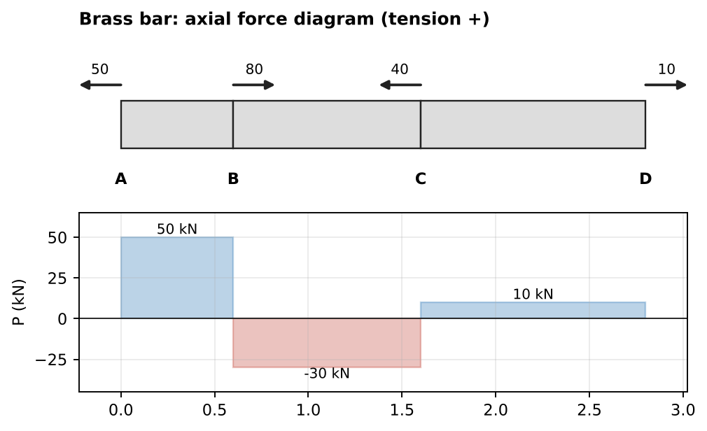
Axial force diagram (tension +)

Q2 (Slides Ch2) — Stepped member ABCD, find $P_{2}$ (easy)
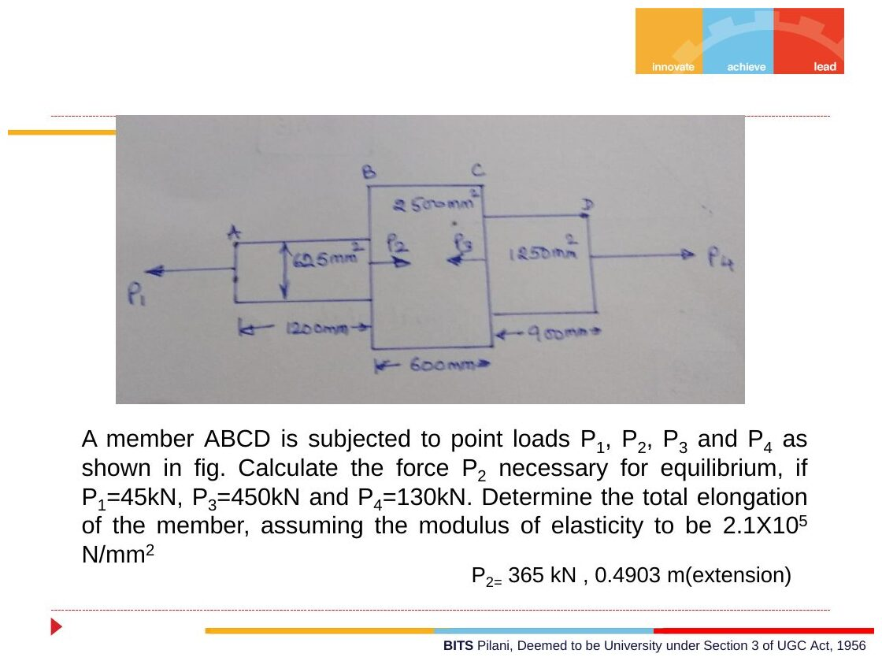
Original: Slides Ch 2, slide 12
Given: $P_{1}=45$ kN ← at A, $P_{2}$ → at B, $P_{3}=450$ kN ← at C, $P_{4}=130$ kN → at D. $A_{AB}=625$ mm² ($L=1200$ mm), $A_{BC}=2500$ mm² ($L=600$ mm), $A_{CD}=1250$ mm² ($L=900$ mm). $E=2.1×{10}^{5}$ MPa.
- Equilibrium: $−45+P_{2}−450+130=0⇒\boxed{P_{2}=365 \text{kN}}$
- Internal forces: $P_{AB}=+45$ (T), $P_{BC}=45−365=−320$ (C), $P_{CD}=+130$ (T)
$$δ=\frac{1}{2.1×{10}^{5}}\left[\frac{45000\left(1200\right)}{625}−\frac{320000\left(600\right)}{2500}+\frac{130000\left(900\right)}{1250}\right]=\frac{86400−76800+93600}{2.1×{10}^{5}}$$
$$\boxed{δ=0.491 \text{mm (extension)}}$$
(The slide writes “0.4903 m”. That is a units typo for mm, and a rounding difference.)
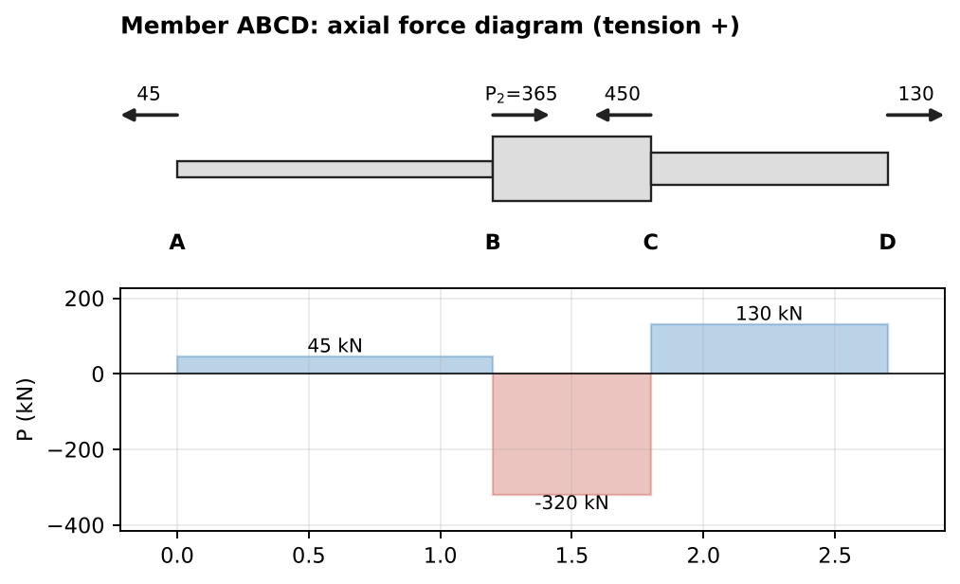
Axial force diagram (bar width shows the area)

Q3 (Slides Ch2, Gere example) — Vertical bar with a side arm (medium)
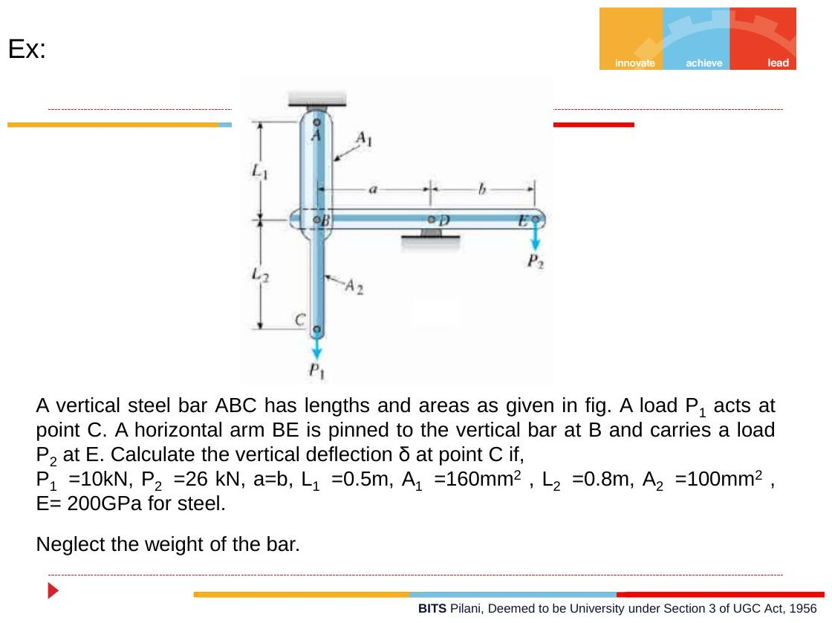
Original: Slides Ch 2, slide 15
Given: vertical bar ABC hanging from A. AB: $L_{1}=0.5$ m, $A_{1}=160$ mm². BC: $L_{2}=0.8$ m, $A_{2}=100$ mm². $P_{1}=10$ kN ↓ at C. Horizontal arm BDE is pinned to the bar at B, supported on a pin at D, with $a=b$, and $P_{2}=26$ kN ↓ at E. $E=200$ GPa. Find: $δ_{C}$.
FBD of arm BDE: take moments about D. $P_{2}\left(b\right)=F_{B}\left(a\right)$, so $F_{B}=26$ kN. The arm is pushed down at B, so it pushes up on the bar with 26 kN. Internal forces in bar: BC: $+10$ kN (T). AB: $10−26=−16$ kN (C).
$$δ_{C}=\frac{10000\left(800\right)}{100\left(200,000\right)}+\frac{−16000\left(500\right)}{160\left(200,000\right)}=0.400−0.250⇒\boxed{δ_{C}=0.150 \text{mm} ↓}$$
Takeaway: a lever arm can turn a downward load into an upward push on the main bar. Always draw the arm’s FBD separately.

Q4 (Slides Ch2, Beer) — Rigid bar on two links: deflections of B, D, E (medium)
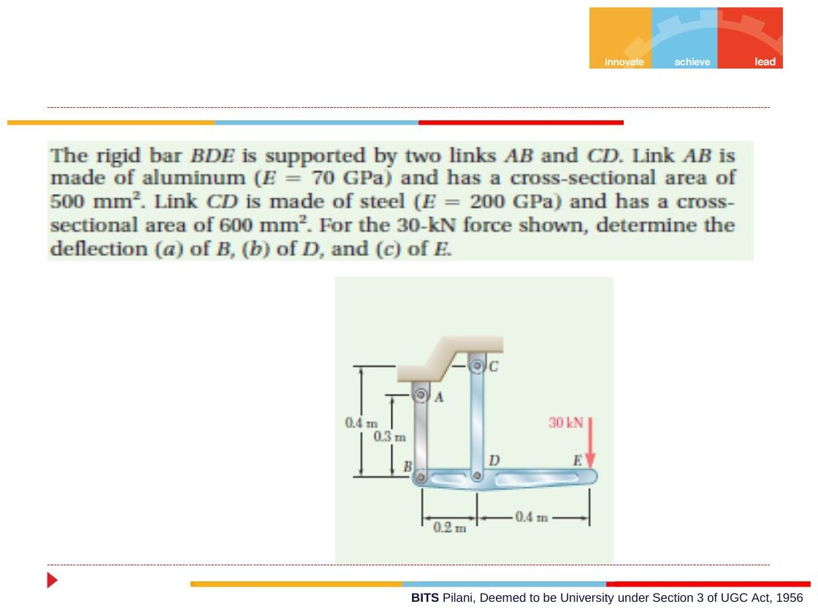
Original: Slides Ch 2, slide 30
Given: rigid bar BDE, with B at 0, D at 0.2 m, E at 0.6 m. 30 kN ↓ at E. Link AB is aluminium ($E=70$ GPa, $A=500$ mm², $L=0.3$ m). Link CD is steel ($E=200$ GPa, $A=600$ mm², $L=0.4$ m). Both links are vertical, attached above the bar.
Statics: $∑M_{D}$: $F_{B}\left(0.2\right)=30\left(0.4\right)⇒F_{AB}=60$ kN. The bar needs a downward force at B, so link AB pushes it: compression. $∑F_{y}$: $F_{CD}=90$ kN (tension).
Deformations:
$$δ_{AB}=\frac{60000\left(300\right)}{500\left(70000\right)}=0.514 \text{mm (shortens}⇒B \text{moves up)}$$
$$δ_{CD}=\frac{90000\left(400\right)}{600\left(200000\right)}=0.300 \text{mm (lengthens}⇒D \text{moves down)}$$
Geometry (similar triangles): B goes up 0.514 and D goes down 0.300. The bar pivots about point H between B and D, at $x_{H}=200⋅\frac{0.514}{0.514+0.300}=126.3$ mm from B.
$$δ_{E}=0.300⋅\frac{600−126.3}{200−126.3}⇒\boxed{δ_{B}=0.514↑, δ_{D}=0.300↓, δ_{E}=1.93 \text{mm}↓}$$

PYQs on this concept
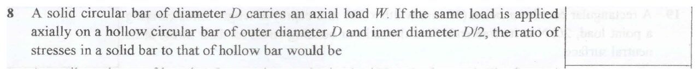
Original question: PYQ 2014-15 Compre A Q8
PYQ 2014-15 Compre A Q8 — A solid bar of diameter $D$ and a hollow bar ($D_{o}=D$, $D_{i}=D/2$) carry the same load $W$. Ratio of stresses (solid : hollow)? $A_{solid}=π/4D^{2}$ and $A_{hollow}=π/4\left(D^{2}−D^{2}/4\right)=3/4⋅π/4D^{2}$.
$$\frac{σ_{s}}{σ_{h}}=\frac{A_{h}}{A_{s}}⇒\boxed{0.75}$$

Concept 2.3 — Statically indeterminate bars (superposition)

A. Concept explanation
1. Intuition. A bar wedged tightly between two walls with a load in the middle. Both walls push, but statics gives one equation for two reactions. The extra fact is that the bar’s total length can’t change. The walls don’t move.
2. Why it matters. Most real structures are indeterminate: bolted joints, composite columns, fixed–fixed shafts (Ch. 6), thermal stresses (Ch. 5).
3. Formal treatment (slides). Indeterminate: reactions or internal forces can’t be found from statics alone. Method of superposition / redundant force:
- Pick a redundant reaction (say $R_{B}$) and release that support.
- Find the displacement at B due to the applied loads alone, $δ_{L}$.
- Find the displacement at B due to $R_{B}$ alone, $δ_{R}$.
- Compatibility: $δ=δ_{L}+δ_{R}=0$ (the support doesn’t move).
- Solve for $R_{B}$, then get the other reactions from statics.
This works because of linearity: the effects of loads add.
4. Derivation (general bar fixed at both ends, load $P$ at distance $a$ from A, total $L$, uniform $AE$):
- Release B. Under $P$, segment $a$ stretches and $b=L−a$ carries nothing. So $δ_{L}=Pa/AE$ (B moves down).
- $R_{B}$ alone (upward) stretches the whole bar upward by $δ_{R}=−R_{B}L/AE$.
- Compatibility: $Pa−R_{B}L=0$, so $R_{B}=Pa/L$ and $R_{A}=Pb/L$.
This is the same split as for a simply supported beam: the support nearer the load carries more. Since $R_{A}=Pb/L$, a small $a$ makes $R_{A}$ close to $P$.
5. Picture. A “release diagram” with three sketches, as on the slide: (a) the actual bar = (b) the bar with B released under the loads + (c) the bar under $R_{B}$ only.
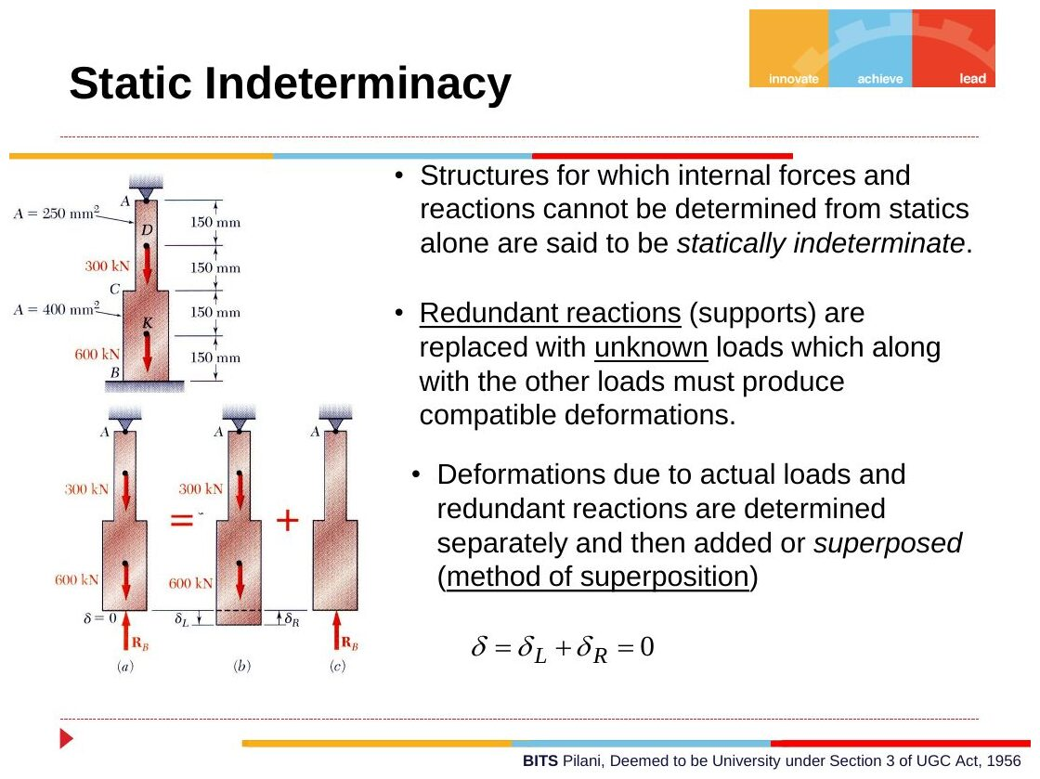
Original: Slides Ch 2, slide 13
6. Special case. With different areas in different segments, use $δ=∑PL/AE$ in each step.
7. Traps. Sign of $δ_{R}$ (it acts against $δ_{L}$). Forgetting that segments beyond the last load carry zero force in the released structure.
8. Summary. $δ_{L}+δ_{R}=0$. Redundant first, then statics.

B. Solved questions

Q5 (Slides Ch2, Beer Ex. 2.04) — Steel bar fixed at both ends (medium)
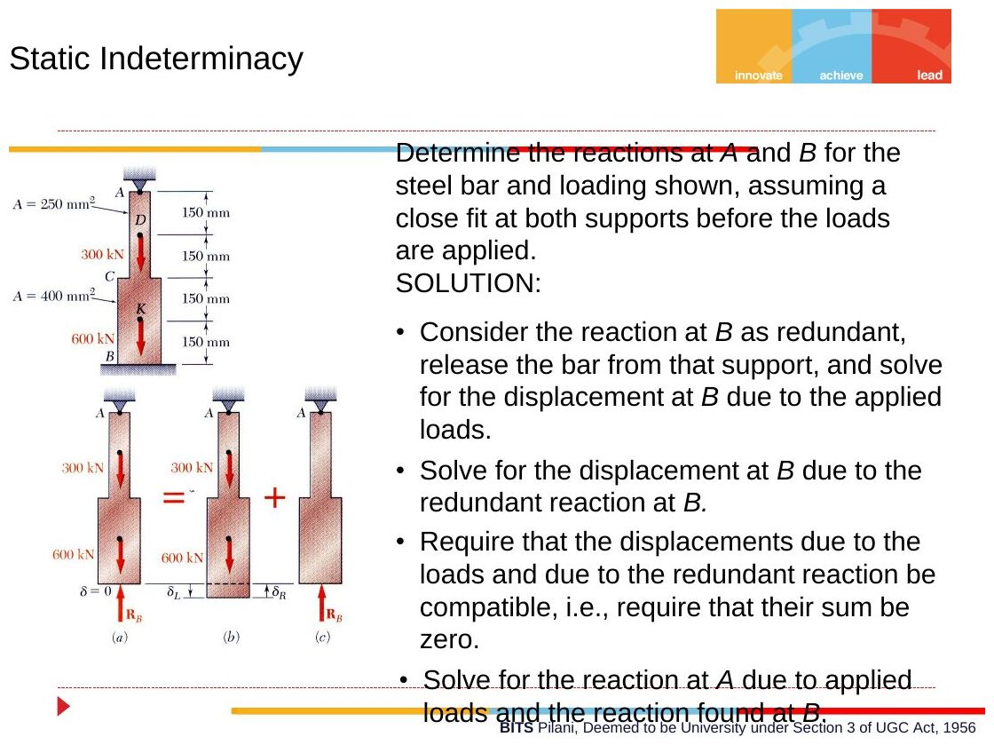
Original: Slides Ch 2, slide 14
Given: vertical bar, A on top, B at the bottom, both fixed. Segments from the top, each 150 mm: AD and DC with $A=250$ mm², CK and KB with $A=400$ mm². Loads: 300 kN ↓ at D, 600 kN ↓ at K. $E=200$ GPa. Find: $R_{A}$, $R_{B}$.
Release B. Internal forces from the loads only: AD = 900 kN, DC = 600, CK = 600, KB = 0 (all tension).
$$δ_{L}=\frac{1}{E}\left[\frac{900e3\left(150\right)}{250}+\frac{600e3\left(150\right)}{250}+\frac{600e3\left(150\right)}{400}+0\right]=\frac{1.125×{10}^{6}}{E} \text{(B moves down)}$$
$R_{B}$ alone (upward): compresses the whole bar.
$$δ_{R}=−\frac{R_{B}}{E}\left[\frac{300}{250}+\frac{300}{400}\right]=−\frac{1.95R_{B}}{E}$$
Compatibility: $1.125×{10}^{6}−1.95R_{B}=0$
$$\boxed{R_{B}=577 \text{kN}↑, R_{A}=900−577=323 \text{kN}↑}$$
Check: the lower half is stiffer (larger area) and closer to the big load, so $R_{B}>R_{A}$ ✓.
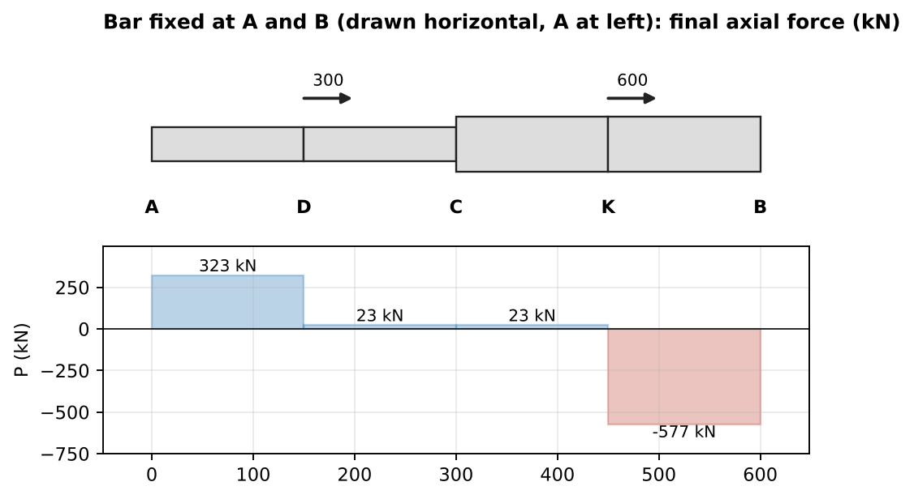
Final axial forces: upper part in tension, lower part in compression

Q6 (Crandall Prob 2.24, Slides) — Bolt and sleeve, quarter turn (medium)
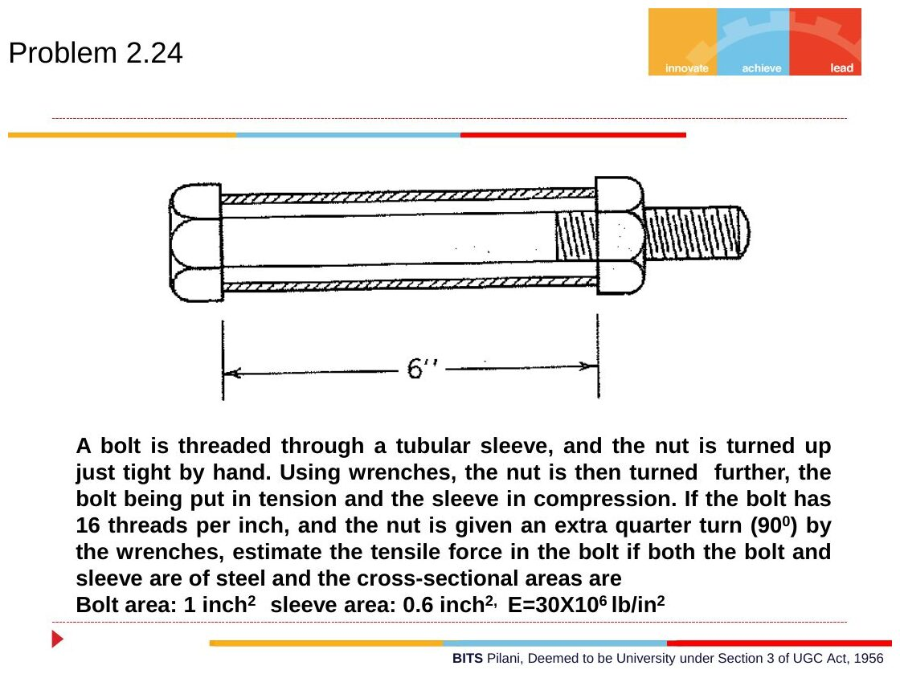
Original: Slides Ch 2, slide 31
Given: bolt area 1 in², sleeve area 0.6 in², both steel ($E=30×{10}^{6}$ psi). Length 6 in. 16 threads/in. The nut is turned an extra 90° after snug. Find: the bolt tension.
- Equilibrium: bolt tension $F$ = sleeve compression $F$.
- Geometric fit: the nut advances $Δ=\frac{1}{4}⋅\frac{1}{16}=\frac{1}{64}$ in. That gap is taken up by the bolt stretching plus the sleeve shortening: $δ_{b}+δ_{s}=Δ$.
- Force–deformation: $\frac{FL}{A_{b}E}+\frac{FL}{A_{s}E}=Δ$
$$F=\frac{ΔE}{L\left(\frac{1}{A_{b}}+\frac{1}{A_{s}}\right)}=\frac{\left(1/64\right)\left(30×{10}^{6}\right)}{6\left(1+1.667\right)}⇒\boxed{F≈29,300 \text{lb}}$$
Check: bolt stress 29.3 ksi and sleeve stress 48.8 ksi. These are high but plausible for steel. The thinner sleeve is more highly stressed. Takeaway: this is the series spring case. Same force, deformations add.

Concept 2.4 — Displacement diagrams for pin-jointed structures

A. Concept explanation
1. Intuition. Take two bars pinned together at B, with their other ends fixed to a wall. Load B and each bar changes length a little. B must end up where both bars, with their new lengths, can still reach it. For small deformations, each circle arc of possible positions can be replaced by a straight line perpendicular to the bar.
2. Why it matters. Gives joint deflections for trusses and links. These are often checked against Castigliano answers (Concept 2.5) and used in PYQs.
3. Formal treatment (Williot diagram, small displacements). A joint displacement $u=\left(u,v\right)$ changes the length of a bar with unit vector $e$ (pointing from the fixed end to the joint) by
$$\boxed{δ_{bar}=u⋅e}$$
That is, only the displacement component along the bar changes its length. Write one equation per bar, then solve for $u$ and $v$.
4. Derivation. The new length is $\left|L+u\right|=\sqrt{L^{2}+2L⋅u+u^{2}}≈L+e⋅u$, dropping $u^{2}$ (small). ∎
5. Graphical construction. From the fixed end, lay off each bar’s $δ$ along the bar. At the tip, draw a line perpendicular to the bar. The two perpendiculars intersect at the displaced joint.
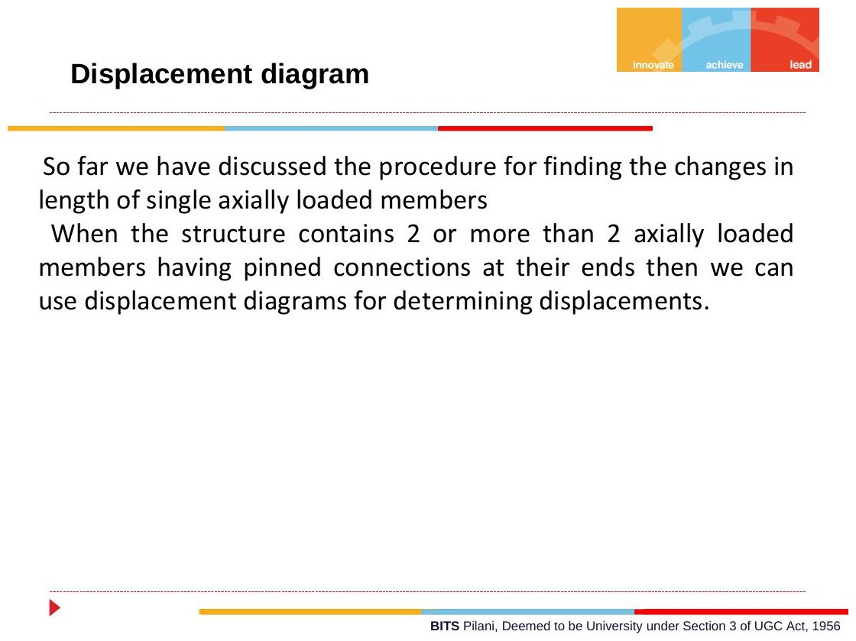
Original: Slides Ch 2, slide 16
6. Special cases.
- Two-bar bracket (AB horizontal, BC inclined at θ to AB, load $P$ down at B): $F_{AB}=Pcotθ$ (T) and $F_{BC}=Pcscθ$ (C). Then $u=δ_{AB}$ (to the right) and $v=\left(δ_{BC}+ucosθ\right)/sinθ$ (downward), where $δ_{BC}$ is the shortening.
- Symmetric V (two equal bars at ±β from the vertical, load $P$ down): $F=\frac{P}{2cosβ}$ and $\boxed{δ_{B}=\frac{PL}{2AE\cos^{2}β}}$.
7. Traps. Forgetting that a shortening bar pulls the joint toward its support. Adding bar elongations as if they were displacements.

B. Solved questions

Q7 (Slides Ch2) — Displacement of D: rod + beam bracket (medium)
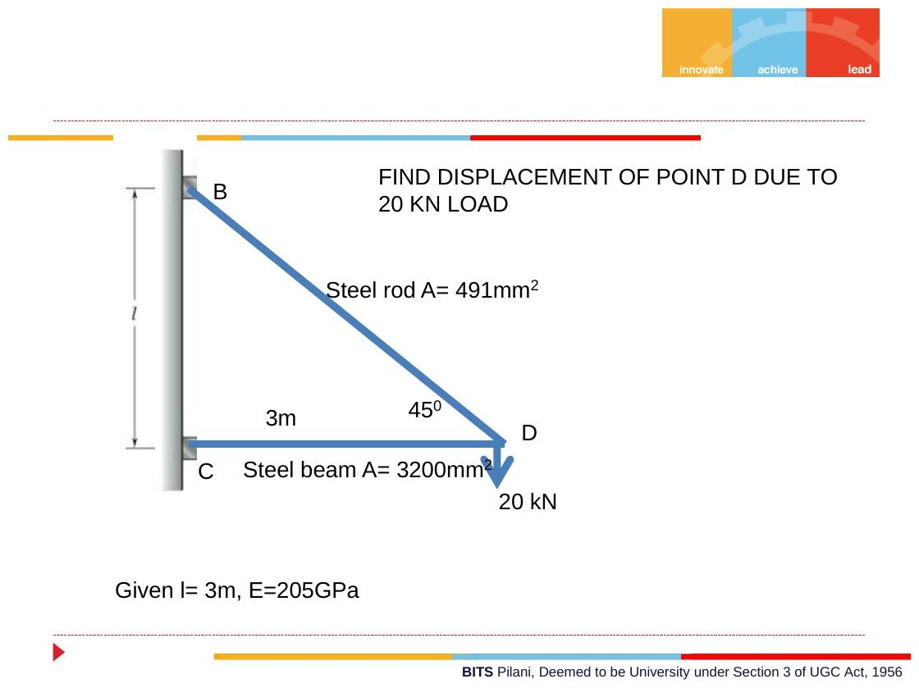
Original: Slides Ch 2, slide 19
Given: wall. Horizontal steel beam CD, $L=3$ m, $A=3200$ mm². Steel rod BD at 45°, $A=491$ mm², with B 3 m above C. $E=205$ GPa. 20 kN ↓ at D. Find: the displacement of D.
Forces (joint D): $F_{BD}sin{45}^{∘}=20⇒F_{BD}=28.28$ kN (T) and $F_{CD}=20$ kN (C). Changes in length:
$$δ_{BD}=\frac{28284\left(4243\right)}{491\left(205000\right)}=1.192 \text{mm (lengthens)}, δ_{CD}=\frac{20000\left(3000\right)}{3200\left(205000\right)}=0.0915 \text{mm (shortens)}$$
Compatibility (u to the right, away from the wall, and v downward):
- CD: $u=−0.0915$ mm, so D moves 0.0915 mm toward the wall.
- BD, with unit vector $\left(0.707,−0.707\right)$ from B to D: $0.707u+0.707v=1.192⇒v=1.686+0.0915$
$$\boxed{v_{D}=1.78 \text{mm}↓, u_{D}=0.092 \text{mm toward wall}}$$
Check with Castigliano: see Q10 below, which gives the same 1.777 mm ✓.
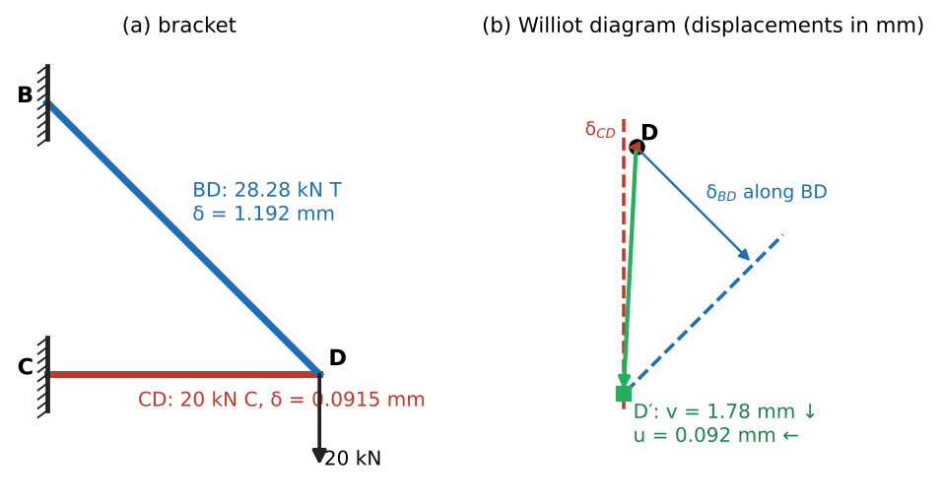
Williot (displacement) diagram for joint D

Q8 (Crandall Prob 2.6, Slides) — Stiff member on three bars (hard)
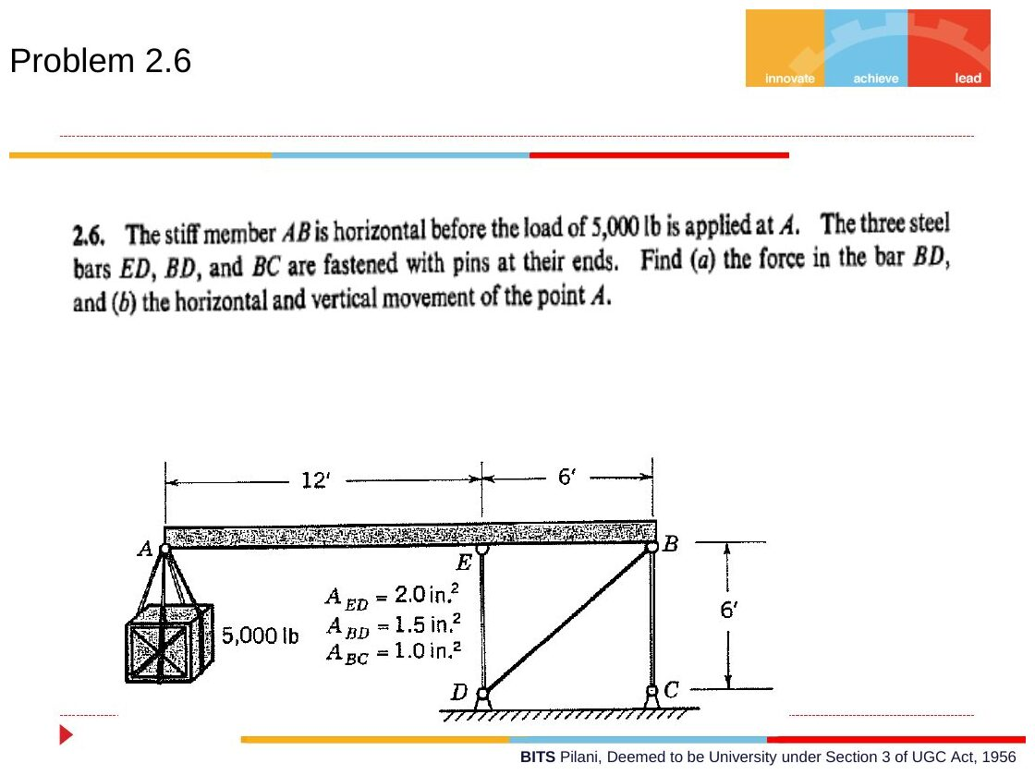
Original: Slides Ch 2, slide 27
Given: stiff horizontal member AB. A at $x=0$, E at $x=12$ ft, B at $x=18$ ft. 5000 lb at A. Vertical bar ED (6 ft, 2 in²) down to D. Vertical bar BC (6 ft, 1 in²) down to C. Diagonal bar BD (from D up to B, at 45°, 1.5 in²). $E=30×{10}^{6}$ psi. Find: (a) the force in BD, (b) the horizontal and vertical movement of A.
(a) Statics of AB. ED and BC are vertical and the load is vertical. Only BD has a horizontal component, so $∑F_{x}=0$ gives
$$\boxed{F_{BD}=0}$$
$∑M_{B}$: $5000\left(18\right)=F_{ED}\left(6\right)⇒F_{ED}=15,000$ lb. ED pushes up on AB, so it is in compression. $∑F_{y}$: BC pulls B down with 10,000 lb, so it is in tension.
Deformations: $δ_{ED}=\frac{15000\left(72\right)}{2\left(30×{10}^{6}\right)}=0.018$ in (shortens, so E moves down 0.018 in). $δ_{BC}=\frac{10000\left(72\right)}{1\left(30×{10}^{6}\right)}=0.024$ in (lengthens, so B moves up 0.024 in). $δ_{BD}=0$.
Fit at B. BD has zero length change, with unit vector $\left(0.707,0.707\right)$ from D to B: $0.707u_{B}+0.707\left(0.024\right)=0⇒u_{B}=−0.024$ in (to the left). Rigid AB. Every point has the same horizontal displacement, and the vertical displacement varies linearly: slope $=\frac{0.024−\left(−0.018\right)}{72}=5.83×{10}^{−4}$. $v_{A}=−0.018−144\left(5.83×{10}^{−4}\right)=−0.102$ in.
$$\boxed{A \text{moves} 0.024 \text{in to the left and} 0.102 \text{in down}}$$
Takeaway: a zero-force member can still constrain displacement. That is why Crandall asks for both parts.

Concept 2.5 — Strain energy and Castigliano’s theorem

A. Concept explanation
1. Intuition. Stretching a spring takes work. That work is stored like charge in a battery. If you know how the stored energy depends on each load, the derivative tells you how far that load’s point moves. A large derivative means a small increase in load stores a lot of energy, which means a big movement.
2. Why it matters. It is the fastest route to deflections of trusses, curved members and frames, and it works even where no load is applied (using a fictitious load). PYQs: 2014 Test-1 Q2 (truss) and 2019-20 Q3(b) (curved beam).
3. Formal treatment (slides, Crandall §2.6). Work done by a slowly applied load: $dU=P dx$, so $U=\int_{0}^{x_{1}}{P} dx$, the area under the $P$–$x$ curve. Linear elastic: $P=kx$, so $U=1/2kx_{1}^{2}=1/2P_{1}x_{1}$. Axial bar: $x_{1}=P_{1}L/AE$, so
$$\boxed{U=\frac{P^{2}L}{2AE}} \text{(for a structure, }U=∑\frac{F_{i}^{2}L_{i}}{2A_{i}E_{i}}\text{)}$$
Castigliano’s theorem: for a linear elastic system with small displacements, the displacement at load $F_{i}$, in the direction of $F_{i}$, is
$$\boxed{δ_{i}=\frac{∂U}{∂F_{i}}}$$
Fictitious load (slides): to find a deflection where no load acts, add a dummy load $Q$ there in the desired direction, compute $∂U/∂Q$, then set $Q=0$.
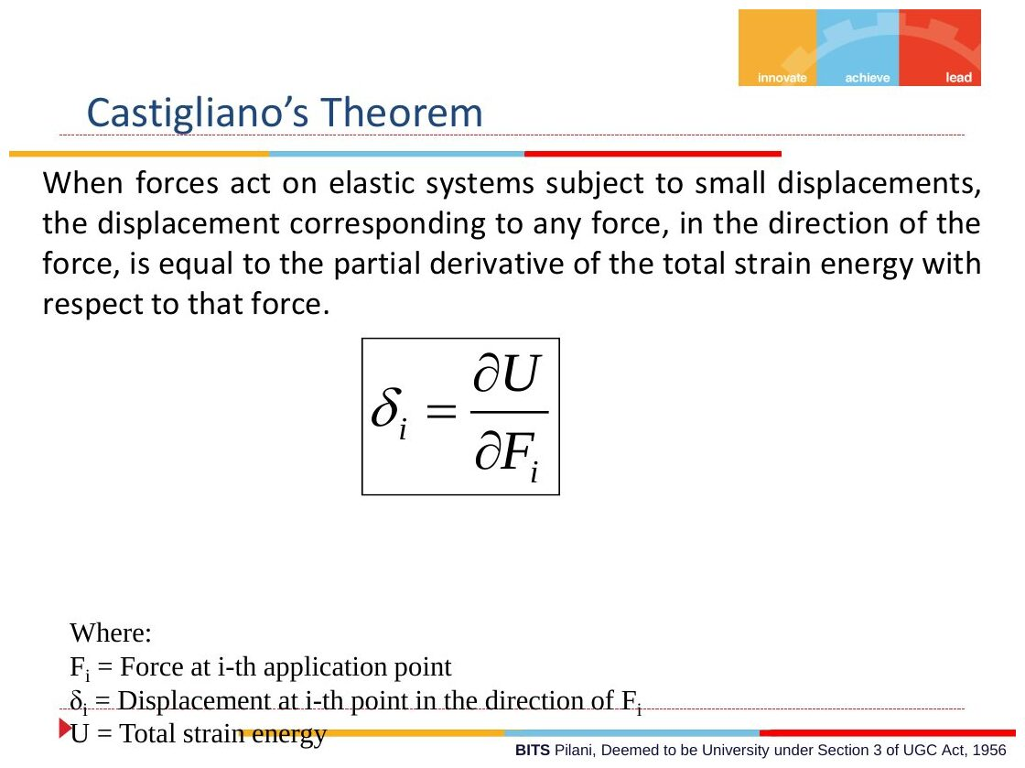
Original: Slides Ch 2, slide 22
4. Derivation (sketch). For a linear system, $U=1/2∑P_{j}δ_{j}$ and each δj=k​cjkPk, so $U$ is a quadratic form $1/2∑∑c_{jk}P_{j}P_{k}$, with $c_{jk}=c_{kj}$ (Maxwell reciprocity). Then ∂U/∂Pi=k​cikPk=δi. ∎
Working formula for trusses (differentiate before squaring, which saves algebra):
δi=members​Fj ∂Fj∂Pi LjAjEj
For beams and curved members (bending energy; the bending formula comes in Ch. 7):
$$U=∫\frac{M^{2}}{2EI}ds+∫\frac{N^{2}}{2AE}ds ⇒ δ_{i}=∫\frac{M}{EI}\frac{∂M}{∂P_{i}}ds+∫\frac{N}{AE}\frac{∂N}{∂P_{i}}ds$$
5. Picture. $U$ is the triangle under the linear $P$–δ line. The “complementary” triangle above the line is equal for linear materials, and that equality is why the theorem holds.
6. Special cases.
- A member whose force doesn’t depend on $Q$ ($∂F/∂Q=0$) contributes nothing to that deflection.
- To get a rotation, use a dummy couple: $θ=∂U/∂C$.
7. Common traps.
- Using $∂U/∂P$ when $P$ is applied to two points. The result is then the sum of those displacements. Give each load its own symbol.
- Forgetting the sign: a negative result means the displacement is opposite to the assumed load direction.
- Setting $Q=0$ before differentiating.
8. Summary box
Item | Formula
Bar energy | $U=P^{2}L/2AE$
Castigliano | $δ_{i}=∂U/∂F_{i}$
Truss form | $δ=∑F \left(∂F/∂P\right) L/AE$
Beam form | $δ=∫M\left(∂M/∂P\right) ds/EI$

B. Solved questions

Q9 (Slides Ch2) — Truss, find P to move roller C by 0.2 mm (medium)
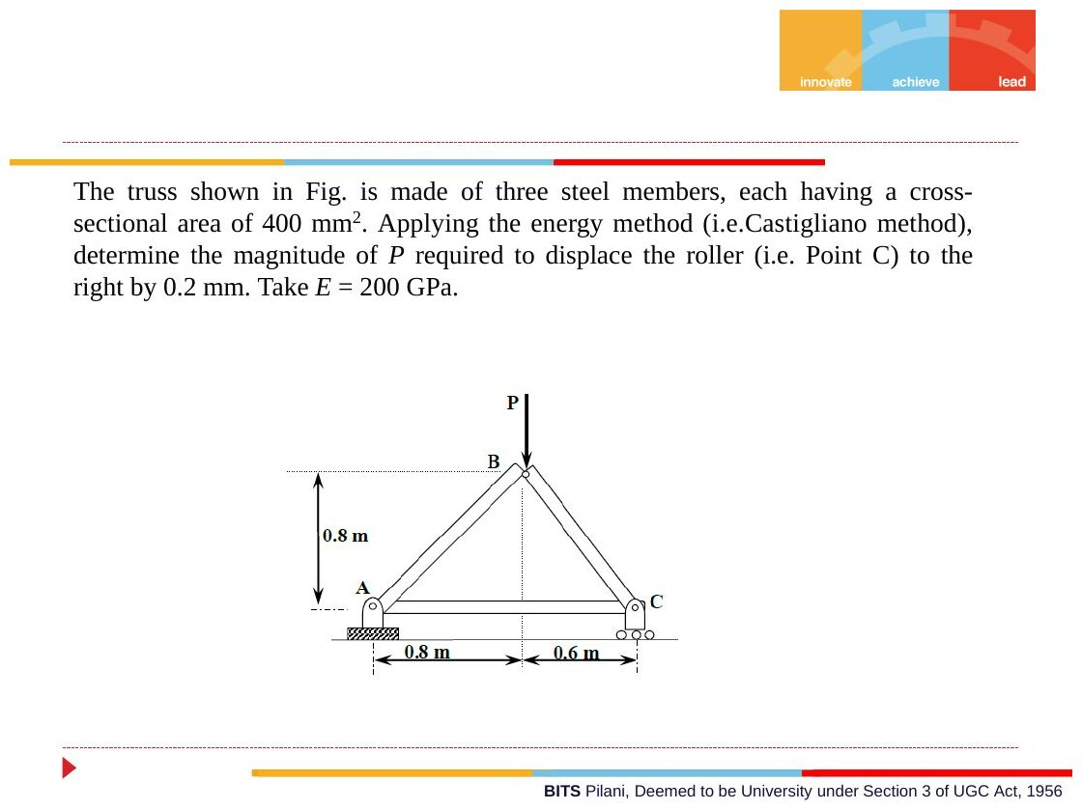
Original: Slides Ch 2, slide 26
Given: A pin, C roller, $AC=1.4$ m. Apex B is 0.8 m above, at 0.8 m from A, so $AB=1.131$ m and $BC=1.0$ m. Each $A=400$ mm², $E=200$ GPa. $P$ ↓ at B. Roller C must move right by 0.2 mm.
Add a fictitious Q (→) at C. Joint C: $∑F_{y}$ gives $F_{BC}=−0.714P$, with no Q. $∑F_{x}$ gives $F_{AC}=0.429P+Q$. Joint A: $F_{AB}=−0.606P$, with no Q. Only AC depends on Q, with $∂F_{AC}/∂Q=1$:
$$δ_{C}=\frac{F_{AC}\left(1\right)L_{AC}}{AE}|_{Q=0}=\frac{0.4286P\left(1400\right)}{400\left(200000\right)}=0.2⇒\boxed{P=26.7 \text{kN}}$$
Check: C slides along AC (A is pinned), so its motion is the elongation of AC. ✓

Q10 (Slides Ch2) — Rod–beam bracket by Castigliano (easy, check of Q7)
Original: Slides Ch 2, slide 24
$F_{BD}=\sqrt{2}P$ (T) and $F_{CD}=−P$ (C):
$$δ_{v}=\frac{\sqrt{2}P⋅\sqrt{2}⋅4243}{491\left(205000\right)}+\frac{\left(−P\right)\left(−1\right)⋅3000}{3200\left(205000\right)}=1.686+0.0915⇒\boxed{1.78 \text{mm} ↓} ✓$$

Q11 (PYQ 2014-15 Test-1 Q2) — Two-bar bracket, H and V deflection by Castigliano only (medium, 20 marks)
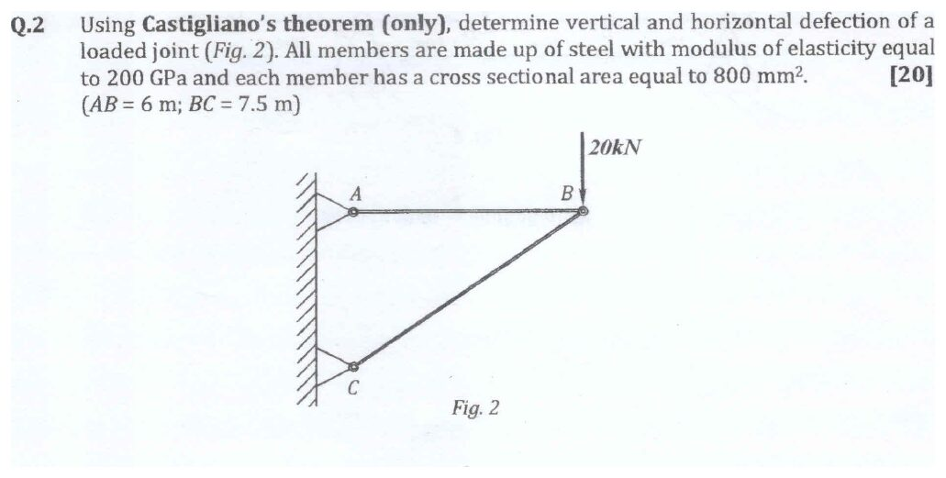
Original question: PYQ 2014-15 Test-1 Q2
Given: AB horizontal, 6 m. BC from C (on the wall below A) to B, 7.5 m, so $AC=4.5$ m. 20 kN ↓ at B. $E=200$ GPa, $A=800$ mm² each.
Forces (let the vertical load be $P$ and add a fictitious horizontal $Q$ → at B). $sinθ=4.5/7.5=0.6$ and $cosθ=0.8$.
- $∑F_{y}$ at B: $F_{BC}=−\frac{P}{0.6}=−1.667P$ (C). Independent of Q.
- $∑F_{x}$ at B: $F_{AB}=Q+0.8\left(1.667P\right)=Q+1.333P$ (T).
Vertical deflection:
$$δ_{v}=\frac{1}{AE}\left[F_{AB}\frac{∂F_{AB}}{∂P}L_{AB}+F_{BC}\frac{∂F_{BC}}{∂P}L_{BC}\right]=\frac{26667\left(1.333\right)\left(6000\right)+33333\left(1.667\right)\left(7500\right)}{800\left(200000\right)}$$
$$\boxed{δ_{v}=\frac{6.30×{10}^{8}}{1.6×{10}^{8}}=3.94 \text{mm} ↓}$$
Horizontal deflection ($Q→0$):
$$δ_{h}=\frac{F_{AB}\left(1\right)L_{AB}}{AE}=\frac{26667\left(6000\right)}{1.6×{10}^{8}}⇒\boxed{δ_{h}=1.00 \text{mm} →}$$
Check by displacement diagram: $u=δ_{AB}=1.00$ mm. BC shortens by $33333\left(7500\right)/1.6×{10}^{8}=1.5625$ mm. $v=\left(1.5625+1.00\left(0.8\right)\right)/0.6=3.94$ mm ✓. Takeaway: the paper said “Castigliano only”, so a displacement diagram gets no marks there even though it gives the right number. Use it only as your private check.
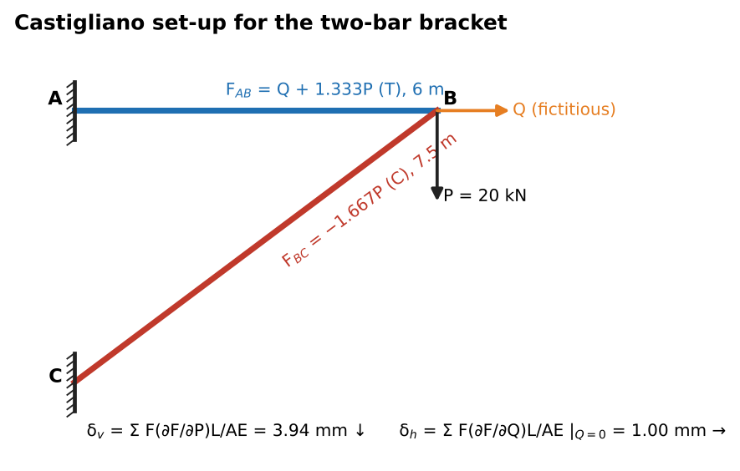
Castigliano set-up with fictitious load Q

Q12 (PYQ 2019-20 Compre A Q3(b)) — Curved cantilever, vertical deflection by Castigliano (hard)
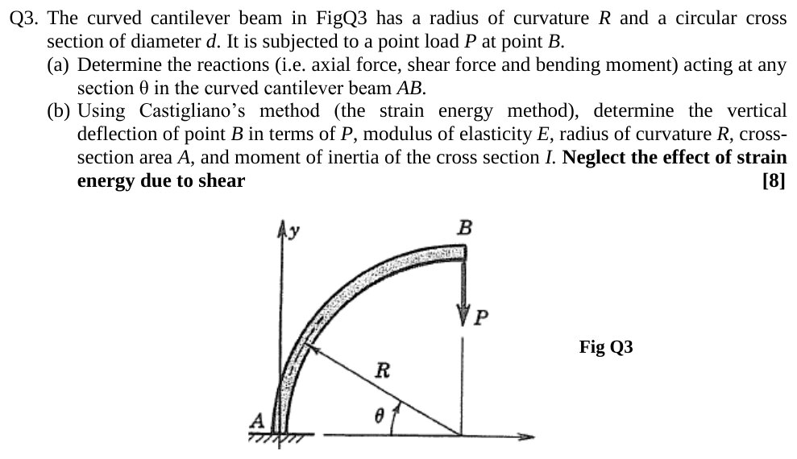
Original question: PYQ 2019-20 Compre A Q3
Given: quarter-circle cantilever of radius $R$, fixed at A ($θ=0$, at the base), free at B ($θ={90}^{∘}$, at the top). Vertical load $P$ ↓ at B. Neglect shear energy. Find: $δ_{B,v}$.
Internal forces at angle θ (from Ch. 3; see Ch. 3 Q12): $M=PRcosθ$, $N=Pcosθ$ (compression), $V=Psinθ$. Also $ds=R dθ$.
$$δ_{B}=\int_{0}^{π/2}{\frac{M}{EI}}\frac{∂M}{∂P}R dθ+\int_{0}^{π/2}{\frac{N}{AE}}\frac{∂N}{∂P}R dθ=\frac{PR^{3}}{EI}\int_{0}^{π/2}{\cos^{2}}θ dθ+\frac{PR}{AE}\int_{0}^{π/2}{\cos^{2}}θ dθ$$
Since $\int_{0}^{π/2}{\cos^{2}}θ dθ=π/4$:
$$\boxed{δ_{B,v}=\frac{πPR^{3}}{4EI}+\frac{πPR}{4AE}}$$
Check: the ratio of axial to bending term is $I/\left(AR^{2}\right)={\left(d/4R\right)}^{2}$, which is tiny for a slender member. That is why the axial term is often dropped too, but the question asked for it in terms of $A$ and $I$, so keep both.

Q13 (Crandall Prob 2.7, Slides) — Railroad bridge truss: how far does roller R move? (hard)
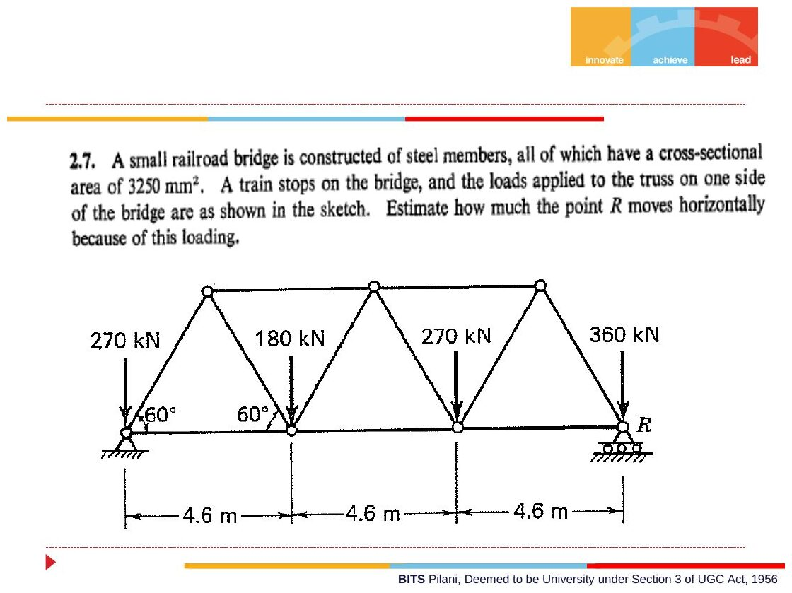
Original: Slides Ch 2, slide 25
Given: Warren truss with 60° triangles and bottom panels of 4.6 m (span 13.8 m). All members have $A=3250$ mm² and $E=200$ GPa (steel). Bottom-joint loads: 270 kN at A (on the pin), 180 kN, 270 kN, 360 kN at R (on the roller).
Idea: A is pinned and R rolls horizontally, so R’s movement equals the total elongation of the bottom chord. Loads sitting directly on supports go straight into the reactions. Only 180 and 270 kN create member forces. Net reactions from those two loads: $R_{R}′=\left(180×4.6+270×9.2\right)/13.8=240$ kN and $R_{A}′=210$ kN. Height $h=2.3tan{60}^{∘}=3.984$ m.
Bottom chord forces (method of sections, moments about the top joints):
- $F_{1}=210\left(2.3\right)/3.984=121.2$ kN (T)
- $F_{2}=\left[210\left(6.9\right)−180\left(2.3\right)\right]/3.984=259.8$ kN (T)
- $F_{3}=240\left(2.3\right)/3.984=138.6$ kN (T)
$$δ_{R}=\frac{\left(121.2+259.8+138.6\right)×{10}^{3}\left(4.6\right)}{3250×{10}^{−6}\left(200×{10}^{9}\right)}⇒\boxed{δ_{R}≈3.68 \text{mm (to the right)}}$$
Check: a full truss solve gives the same bottom-chord forces ✓. Takeaway: “how far does the roller move” is a sum of member elongations along one line. No energy method is needed.
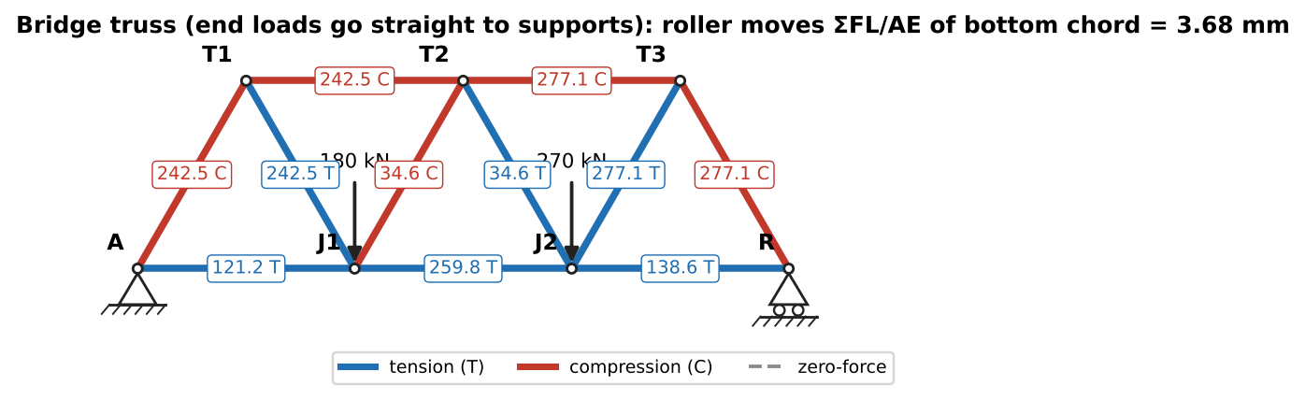
Member forces from the 180 kN and 270 kN loads

Concept 2.6 — Beams/levers on springs and thin rings (extra slide problems)

Q14 (Crandall Prob 2.1, Slides) — Diving board on a spring (easy)
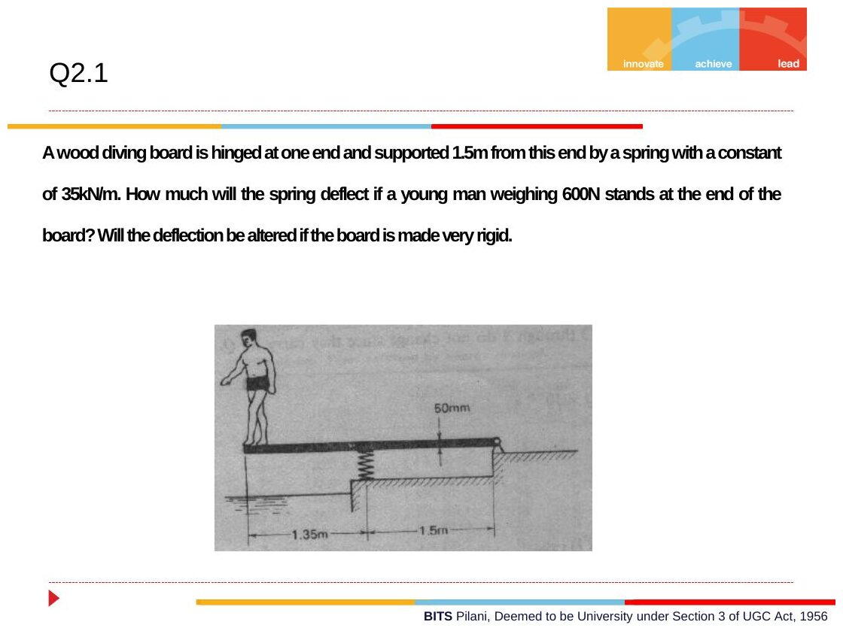
Original: Slides Ch 2, slide 29
Given: board hinged at one end, spring ($k=35$ kN/m) 1.5 m from the hinge, person (600 N) at the far end, 1.35 m beyond the spring (2.85 m from the hinge). Find: spring deflection. Does it change if the board is made very rigid?
$$∑M_{hinge}:F_{s}\left(1.5\right)=600\left(2.85\right)⇒F_{s}=1140 \text{N}, \boxed{δ_{s}=\frac{1140}{35000}=32.6 \text{mm}}$$
No, the spring deflection is set by statics alone (the problem is determinate), so board stiffness doesn’t matter. The tip deflection does change: it is $32.6\left(2.85/1.5\right)=61.9$ mm for a rigid board, plus extra bending for a flexible one.

Q15 (Crandall Prob 2.19, Slides) — Where to put P for system stiffness $\frac{20}{9}k$ (medium)
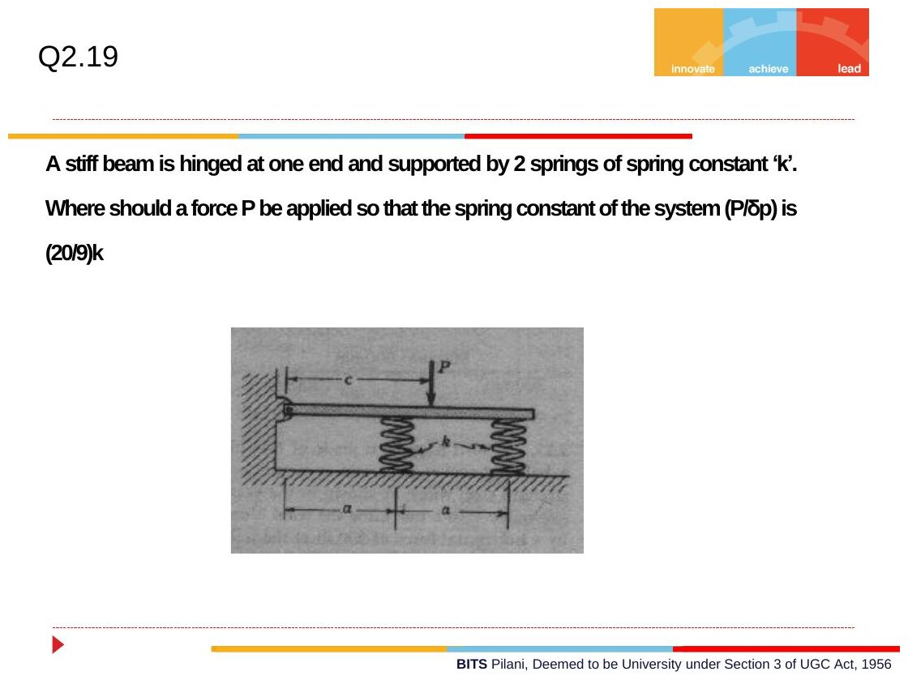
Original: Slides Ch 2, slide 28
Given: stiff beam hinged at its left end, springs $k$ at $a$ and $2a$, force $P$ at distance $c$. Rigid rotation θ: spring deflections are $aθ$ and $2aθ$.
- Equilibrium about the hinge: $Pc=k\left(aθ\right)a+k\left(2aθ\right)\left(2a\right)=5ka^{2}θ$
- Deflection under P: $δ_{P}=cθ$
$$\frac{P}{δ_{P}}=\frac{5ka^{2}}{c^{2}}=\frac{20}{9}k⇒\boxed{c=3/2a}$$
Check: at $c=2a$, stiffness $=5k/4$. Moving the load inward makes the system stiffer ✓.

Q16 (Slides Ch2, Crandall Ex.) — Thin ring under internal pressure (easy; PYQ-type)
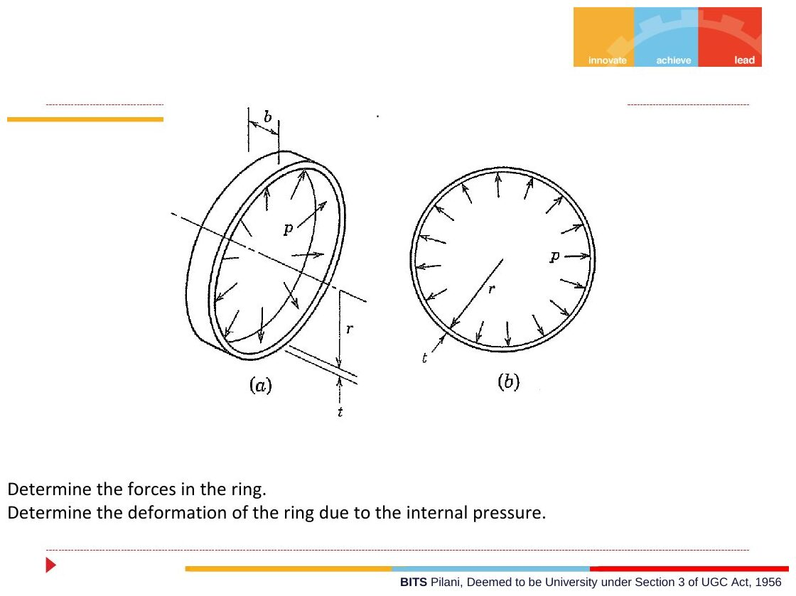
Original: Slides Ch 2, slide 32
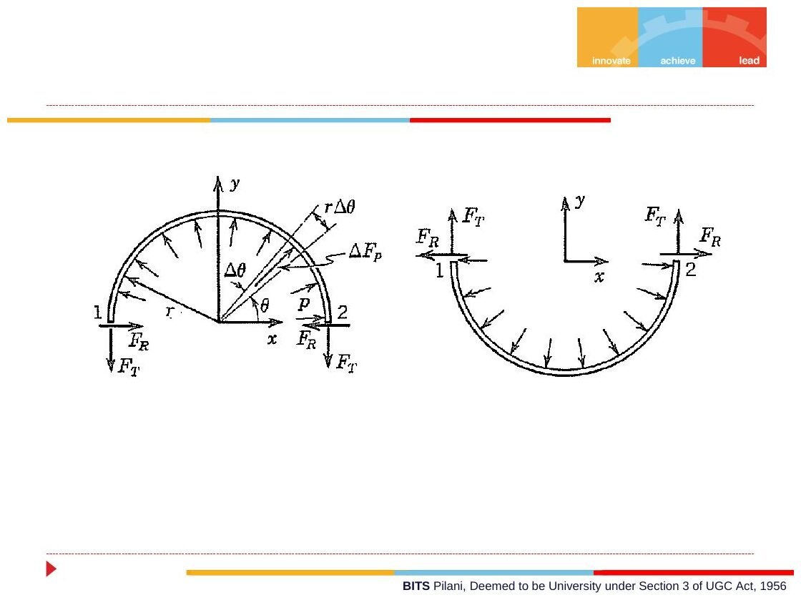
Original: Slides Ch 2, slide 33
Given: ring of mean radius $r$, width $b$, thickness $t≪r$, internal pressure $p$. FBD of half the ring: the pressure on element $r dθ$ (width $b$) gives a vertical component $p b rsinθ dθ$.
$$2F_{T}=\int_{0}^{π}{p}brsinθ dθ=2pbr⇒\boxed{F_{T}=pbr, σ_{θ}=\frac{F_{T}}{bt}=\frac{pr}{t}}$$
Deformation: the hoop strain $ϵ=σ/E$ stretches the circumference $2πr$ by $2πrϵ$. The radius grows by
$$\boxed{δ_{R}=rϵ=\frac{pr^{2}}{Et}}$$
PYQ 2014-15 Compre A Q11: inner diameter 500 mm, width 10 mm, $t=5$ mm, $p=1.5$ MPa.
Original question: PYQ 2014-15 Compre A Q11
$σ=pr/t=1.5\left(250\right)/5=\boxed{75 \text{MPa}}$. Using the mean radius 252.5 mm gives 75.75 MPa. Either is accepted at this level.

Chapter 2 — Formula and convention sheet
Topic | Formula / rule
Three steps | Equilibrium → geometric fit → force–deformation
Axial deformation | $δ=∑P_{i}L_{i}/\left(A_{i}E_{i}\right)$, with $P_{i}$ = internal force (T +)
Bar stiffness | $k=AE/L$; parallel springs add $k$, series add $1/k$
Load sharing | $F_{A}=Fk_{A}/\left(k_{A}+k_{B}\right)$, so the stiffer member carries more
Indeterminate (superposition) | Release redundant: $δ_{L}+δ_{R}=0$
Displacement diagram | $δ_{bar}=u⋅e_{bar}$ (small displacements)
Two-bar bracket | $F_{AB}=Pcotθ$, $F_{BC}=Pcscθ$
Symmetric V | $δ=PL/\left(2AE\cos^{2}β\right)$
Strain energy | $U=P^{2}L/2AE$; beams $∫M^{2}ds/2EI$
Castigliano | $δ_{i}=∂U/∂F_{i}$; truss: $∑F\left(∂F/∂P\right)L/AE$; dummy load → set 0 after differentiating
Thin ring | $σ=pr/t$, $δ_{R}=pr^{2}/\left(Et\right)$
Units | N, mm, MPa (N/mm²) is a consistent set; GPa = ${10}^{3}$ MPa
Other Crandall Ch. 2 problems worth practising: 2.2–2.5 (determinate links), 2.8–2.15 (indeterminate bars, composite members), 2.25+ (energy).

Chapter 3 — Forces and Moments Transmitted by Slender Members
Internal forces, shear-force and bending-moment diagrams, distributed loads, differential relations, singularity functions, 3-D/curved members
Sources used: Slides “Chapter 3” (Dr. Kushagra Tiwari), Crandall Ch. 3 (§3.1–3.8, Examples 3.1 and 3.11, Probs 3.7, 3.8, 3.17), PYQs 2014-15 (Test-1 Q4; Compre A Q6, Q7, Q14, Q17, Q18) and 2019-20 (Compre A Q1, Q3a).

⚠ Read first: the sign convention for shear force in this course
The slides follow Crandall’s convention, which is opposite to Gere/Hibbeler/Beer for shear force V.
Quantity | Crandall (slides, this guide) | Gere / Hibbeler
Axial $F$ | + tension | + tension
Bending $M_{b}$ | + sagging (concave up, “smile”) | + sagging (same)
Shear $V$ | + when it acts on the positive (+x) face in the +y direction, i.e. the right face of the left segment pushes up | + when the left face is pushed up (element rotates clockwise)
$dV/dx$ | $=−q$ | $=−w$ (w is downward load)
$dM/dx$ | $=−V$ | $=+V$
So $V_{Crandall}=−V_{Gere}$ everywhere, while $M$ is the same. In the slides’ picture of “Positive Shear”, the arrow is ↓ on the left face and ↑ on the right face. In every solution below, V is given in Crandall’s convention, the one the slides and examiners use. If you learned from Gere, flip the sign of V.
Quick rule: with Crandall’s convention, $V\left(x\right)=−\left(\text{sum of upward forces to the left of the cut}\right)$ and $M\left(x\right)$ = sum of moments, about the cut, of the forces to the left, clockwise positive.
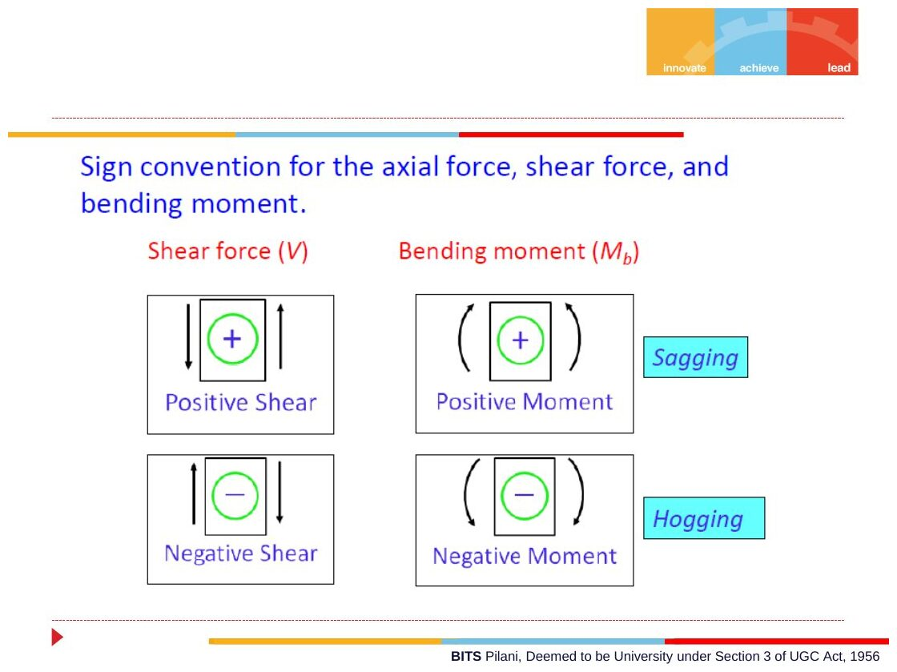
Original: Slides Ch 3, slide 9
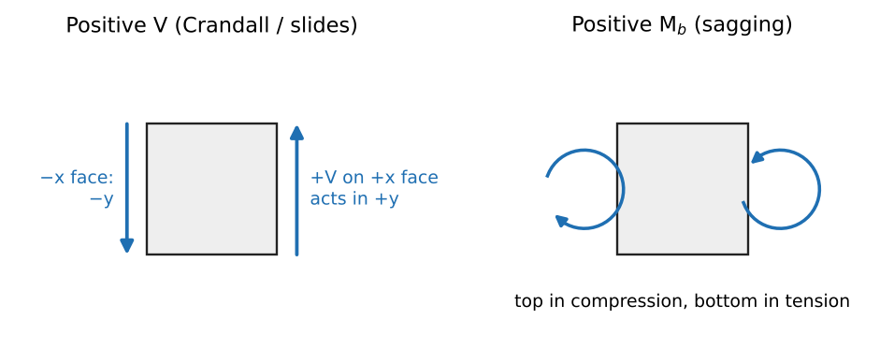
Positive shear and positive bending moment (Crandall)

Concept 3.1 — Internal forces at a section: the method of sections

A. Concept explanation
1. Intuition. Cut a loaded beam with an imaginary saw. Each half would fly off unless something at the cut held it in place. Whatever the other half was supplying (a push or pull along the axis, a sideways shear, a twist, a bend) we now draw at the cut. Equilibrium of either half tells us their values.
2. Why it matters. These internal forces are the input for everything that follows: $σ=F/A$ (Ch. 4), $τ=Tr/J$ (Ch. 6), and later $σ=My/I$ for bending and $v″=M/EI$ for deflection. Every “combined loading” PYQ starts by finding $F$, $V$, $M_{b}$ and $T$ at a section.
3. Formal treatment (slides, Crandall §3.2). Slender member: length at least about 5 times the lateral dimensions. Examples: beams, columns, shafts, rods, struts, links. x-section: a cut whose normal is the x-axis (the member’s axis). In 3-D the resultant on it has 6 components:
Component | Name | Symbol | Effect
$F_{xx}$ | axial force | $F$ | stretches/compresses
$F_{xy},F_{xz}$ | shear forces | $V_{y},V_{z}$ | slides one part past the other
$M_{xx}$ | twisting moment | $M_{t}$, $T$ | twists about the axis
$M_{xy},M_{xz}$ | bending moments | $M_{by},M_{bz}$ | bends
(First subscript = face normal, second = direction of the component.)
Positive face: outward normal along +x. Negative face: outward normal along −x. Sign rule (slides): a component is positive if it acts on a positive face in a positive direction or on a negative face in a negative direction. Otherwise it is negative. By this rule, tension is positive and compression negative.
For loading in the x–y plane, only three components survive: $F=F_{xx}$, $V=F_{xy}$ and $M_{b}=M_{xz}$.
Procedure (slides):
- Idealize and isolate the structure; draw all external forces.
- Find the reactions from $∑F=0$ and $∑M=0$.
- Cut at the point of interest, keep one segment, draw $F,V,M_{b}$ in their positive senses, and apply equilibrium.
4. Derivation — Example 3.1 (simply supported beam, load W at a from A, b from B). Reactions: $R_{A}=Wb/L$ and $R_{B}=Wa/L$. Cut at $x<a$ and keep the left part. On its right (positive) face draw $V$ ↑, $M_{b}$ counter-clockwise and $F$ →.
- $∑F_{x}$: $F=0$
- $∑F_{y}$: $R_{A}+V=0⇒V=−\frac{Wb}{L}$
- $∑M_{cut}$: $M_{b}−R_{A}x=0⇒M_{b}=\frac{Wb}{L}x$
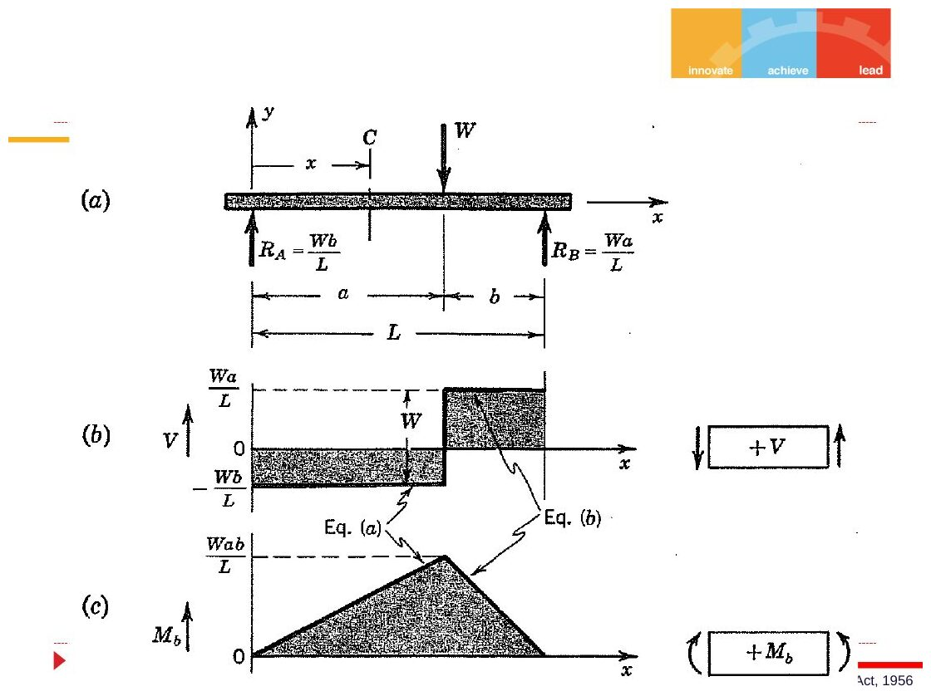
Original: Slides Ch 3, slide 15
For $x>a$: $V=\frac{Wa}{L}$ and $M_{b}=\frac{Wa}{L}\left(L−x\right)$. The peak is $M_{max}=\frac{Wab}{L}$ under the load.
5. Picture. For a positive $M_{b}$ on the right face of the left segment the arrow is counter-clockwise; on the left face of the right segment it is clockwise. The pair “opens upward” like a smile, which is sagging.
6. Special cases. $a=b=L/2$ gives $M_{max}=WL/4$. Load at a support gives zero internal moment.
7. Common traps.
- Drawing $V$ and $M$ in assumed physical directions instead of the positive convention. Always draw them positive and let algebra give the sign.
- Mixing up the Crandall and Gere sign for V (see the box above).
- Using a distributed load’s resultant for the whole beam when the cut is inside the load. Only the part of the load on your segment counts.
8. Summary box. Cut → draw $F,V,M$ positive → equilibrium → read the signs. $V=−\left(Σ \text{up-forces to the left}\right)$ and $M=Σ \left(\text{moments to the left about the cut, clockwise}+\right)$.

B. Solved questions

Q1 (Slides Ch3, Ex 3.1 numerical version) — Two 10 kN loads on a 3 m span (easy)
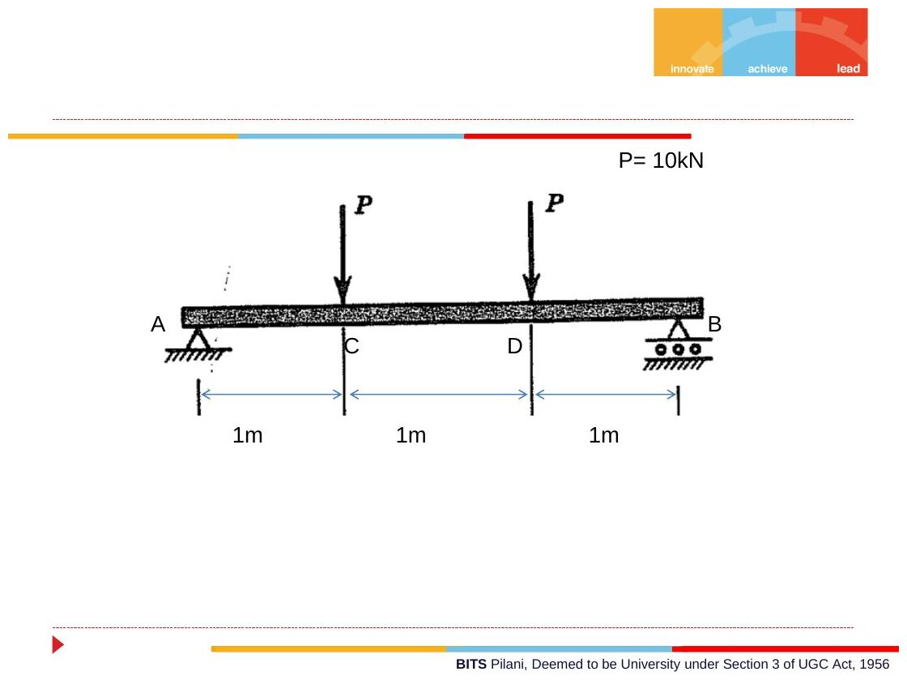
Original: Slides Ch 3, slide 16
Given: simply supported AB, 3 m. $P=10$ kN at C (1 m) and at D (2 m). Find: SFD and BMD.
$R_{A}=R_{B}=10$ kN.
Region | $V$ (Crandall) | $M_{b}$
A–C | $−10$ kN | $10x$ (0 → 10 kN·m)
C–D | $0$ | $10$ kN·m (constant)
D–B | $+10$ kN | $10\left(3−x\right)$ (10 → 0)
Shape: the SFD has steps at the loads. The BMD is a trapezoid, with a flat top between C and D where there is pure bending ($V=0$). Takeaway: the four-point-bending test uses exactly this setup. Constant M with V = 0 is used to measure bending stiffness.
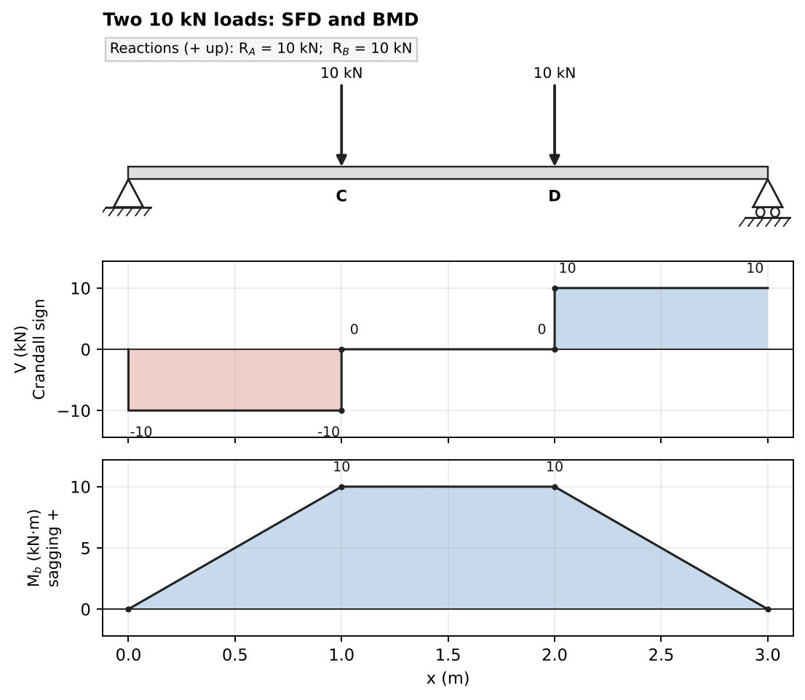
Solution: loading, SFD, BMD

Q2 (Slides Ch3, Gere) — Beam with a bracket (medium)
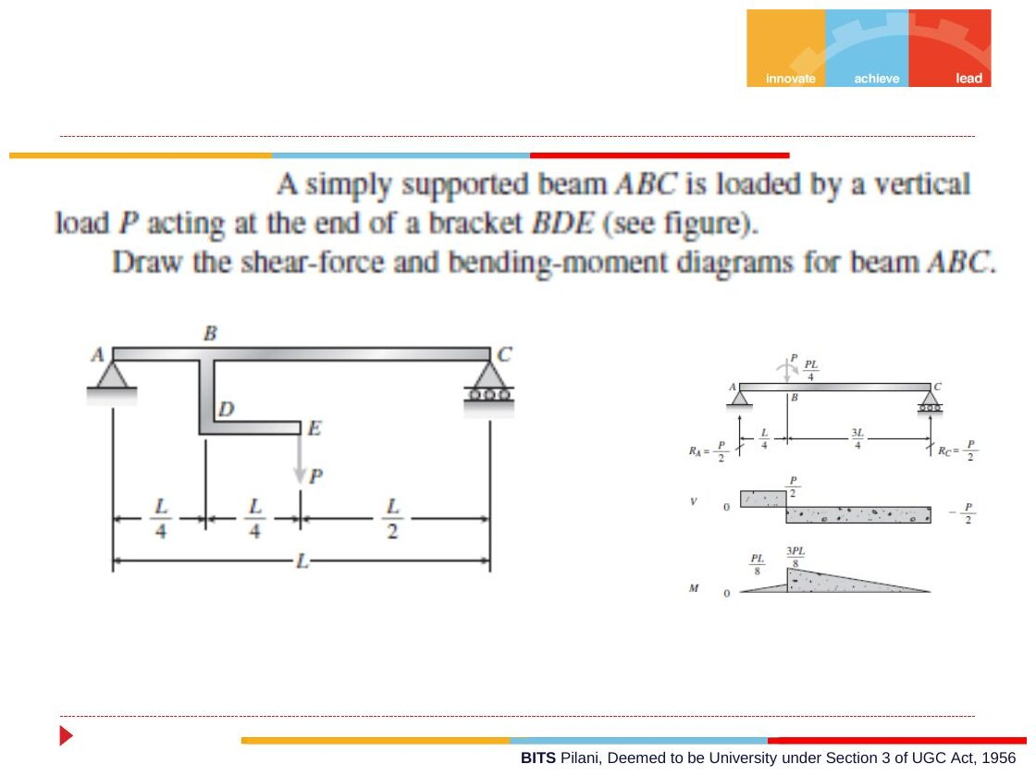
Original: Slides Ch 3, slide 17
Given: simply supported ABC, length $L$. A bracket BDE hangs from B (at $L/4$) and carries $P$ at E, which lies at $x=L/2$. Find: SFD and BMD of ABC.
Transfer the load to the beam at B: a force $P$ ↓ plus a couple $P⋅\frac{L}{4}$ clockwise. Reactions: $∑M_{C}$ gives $R_{A}=P/2$ (the line of action of P is at mid-span), so $R_{C}=P/2$.
Point | $V$ (Crandall) | $M_{b}$
A to B⁻ | $−P/2$ | $0→PL/8$
B⁺ to C | $+P/2$ | jumps by $+PL/4$ (clockwise couple) to $3PL/8$, then falls linearly to 0
$$\boxed{M_{max}={3PL}/8 \text{just right of B}}$$
Takeaway: an applied clockwise couple makes the BMD jump up by the couple’s magnitude (moving left to right). A counter-clockwise couple makes it jump down.
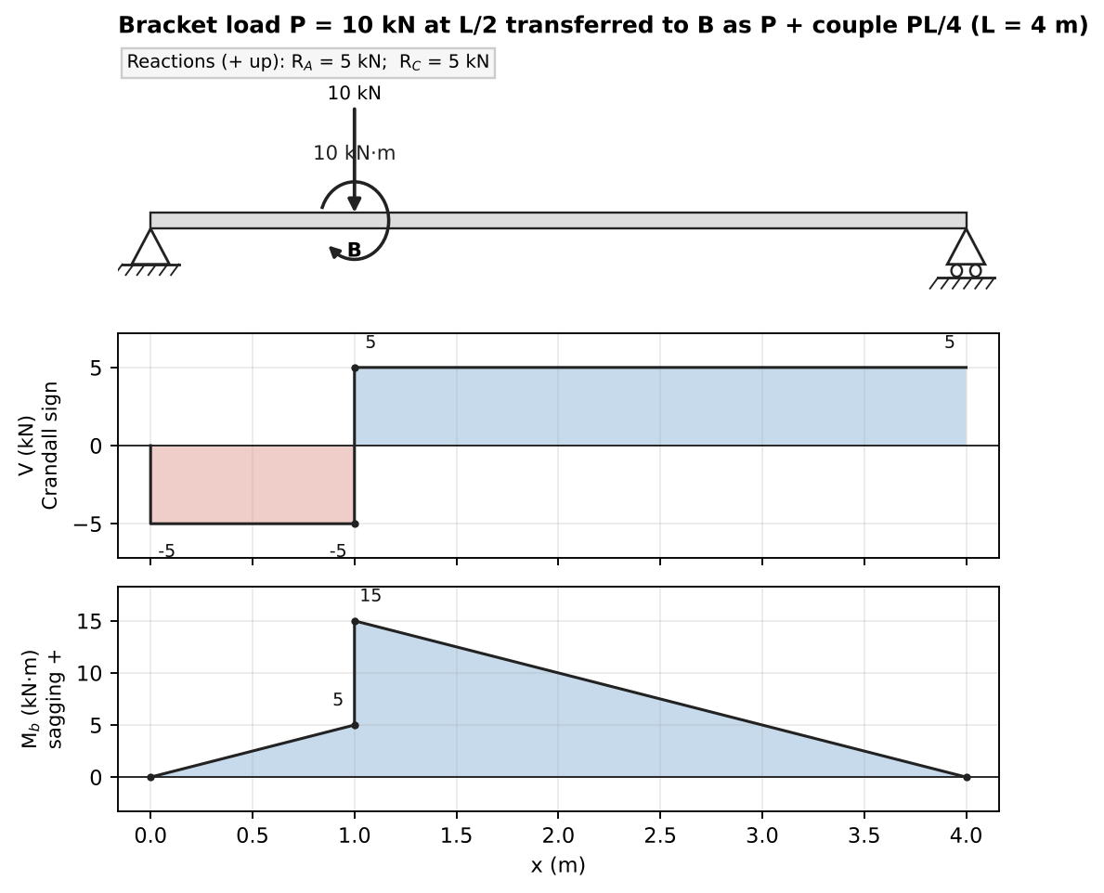
Solution with P = 10 kN, L = 4 m (M jumps up at B because of the clockwise couple)

Q3 (Slides Ch3, Gere) — Beam with pulley and cable: N, V, M at C (medium–hard)
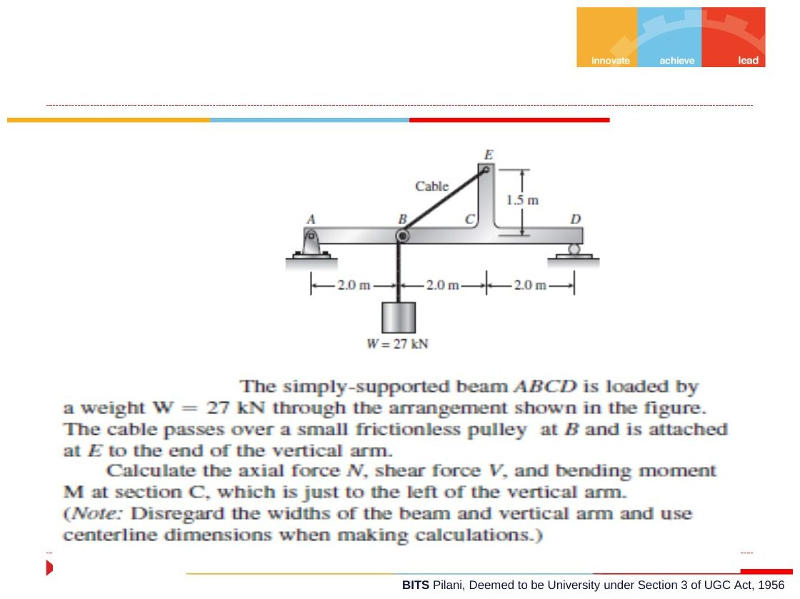
Original: Slides Ch 3, slide 28
Given: simply supported ABCD with A (pin) at 0, B at 2 m, C at 4 m and D (roller) at 6 m. A vertical arm at C goes up to E (1.5 m). The cable from the weight $W=27$ kN passes over a small pulley at B and is tied to E. Find: $N$, $V$, $M$ at section C, just left of the arm.
Reactions (whole system): the only external load is W, which hangs below B. $R_{D}\left(6\right)=27\left(2\right)⇒R_{D}=9$ kN and $R_{A}=18$ kN. Force of the pulley on the beam at B: the cable leaves B toward E with direction $\left(2,1.5\right)/2.5=\left(0.8,0.6\right)$ and $T=27$ kN. The two cable segments pull on the pulley with $\left(0,−27\right)+27\left(0.8,0.6\right)=\left(21.6,−10.8\right)$ kN. Cut just left of C, keep the left part:
- $∑F_{x}$: $21.6+N=0⇒N=−21.6$ kN (compression)
- $∑F_{y}$: $18−10.8+V=0⇒V=−7.2$ kN (Crandall). Gere would write +7.2 kN.
- $∑M_{C}$: $M=18\left(4\right)−10.8\left(2\right)=50.4$ kN·m
$$\boxed{N=−21.6 \text{kN}, V=−7.2 \text{kN (Crandall)}, M=50.4 \text{kN·m}}$$
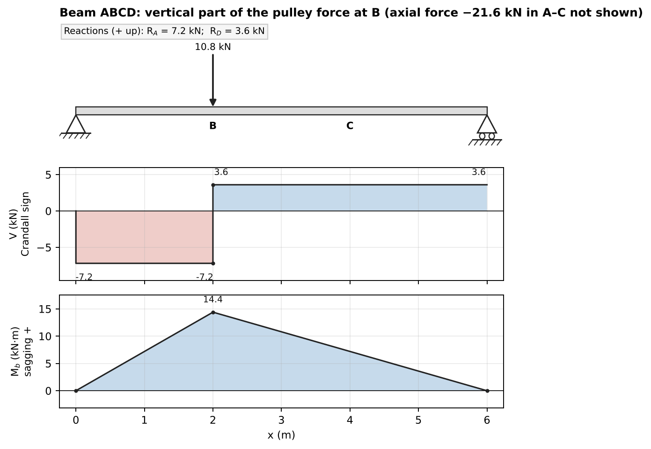
Vertical-load SFD/BMD for ABCD (M at C = 50.4 kN·m)

Q4 (PYQ 2014-15 Compre A Q14) — Couple on a hinged beam (easy)
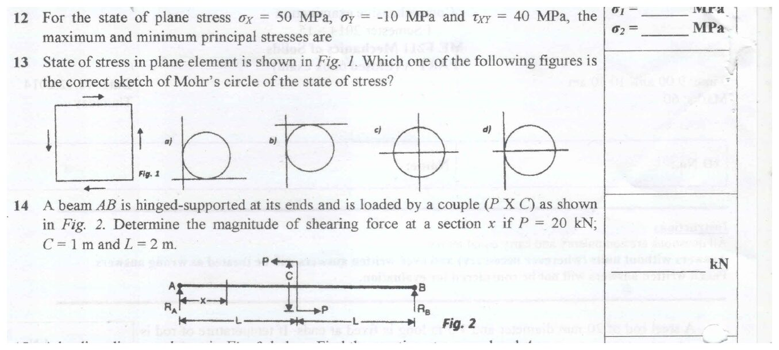
Original question: PYQ 2014-15 Compre A Q12–Q14
Given: beam AB hinged at both ends, span $2L$ with $L=2$ m. Midway, a couple is formed by two forces $P=20$ kN, $C=1$ m apart, so the couple is 20 kN·m. Find: shear force at section x.
A pure couple: $R_{A}=−R_{B}=\frac{20}{2L}=\frac{20}{4}=5$ kN, forming an equal and opposite couple.
$$\boxed{\left|V\right|=5 \text{kN, constant along the whole beam}}$$
Takeaway: a couple causes no jump in the SFD. It only jumps the BMD.

Concept 3.2 — Distributed loads, resultants and their limitations

A. Concept explanation
1. Intuition. Sand spread on a plank. Each little strip $Δx$ carries $q Δx$. For finding the support reactions you can pretend all the sand is piled at its centre of gravity. For the bending inside the plank you cannot, because a pile in the middle bends the plank differently from sand spread evenly.
2. Why it matters. Self-weight, snow, fluid pressure, the 2000 N/m triangular load and the trapezoidal load questions.
3. Formal treatment.
$$q=\lim_{Δx→0}\frac{ΔF}{Δx} \text{(force per unit length; positive in }+y\text{, i.e. upward)}$$
Common forms: uniform ($q$ = const) and linear ($q=Ax+B$). Resultant and its location:
$$R=\int_{0}^{L}{q} dx, \overset{‾}{x}=\frac{\int_{0}^{L}{x} q dx}{R}$$
Resultant = area of the load diagram, acting through its centroid.
Load shape | $R$ | $\overset{‾}{x}$ from the zero/left end
Uniform $w_{0}$ over $L$ | $w_{0}L$ | $L/2$
Triangle 0 → $w_{0}$ | $w_{0}L/2$ | $2L/3$ (from the zero end)
Trapezoid $w_{1}→w_{2}$ | $\left(w_{1}+w_{2}\right)L/2$ | $\frac{L\left(w_{1}+2w_{2}\right)}{3\left(w_{1}+w_{2}\right)}$ from the $w_{1}$ end
Limitations (slides):
- Allowed when you only want external reactions.
- Not allowed for internal forces and moments.
Slide illustration: beam (a) has loads $P$ at the two overhang tips, each a distance $a$ outside supports $2b$ apart. Beam (b) has $2P$ at the centre. The resultant is the same and so are the reactions ($R_{A}=R_{B}=P$). But (a) has hogging $M=−Pa$ between the supports, while (b) has sagging $M_{max}=+Pb$. The beams even bend in opposite directions.
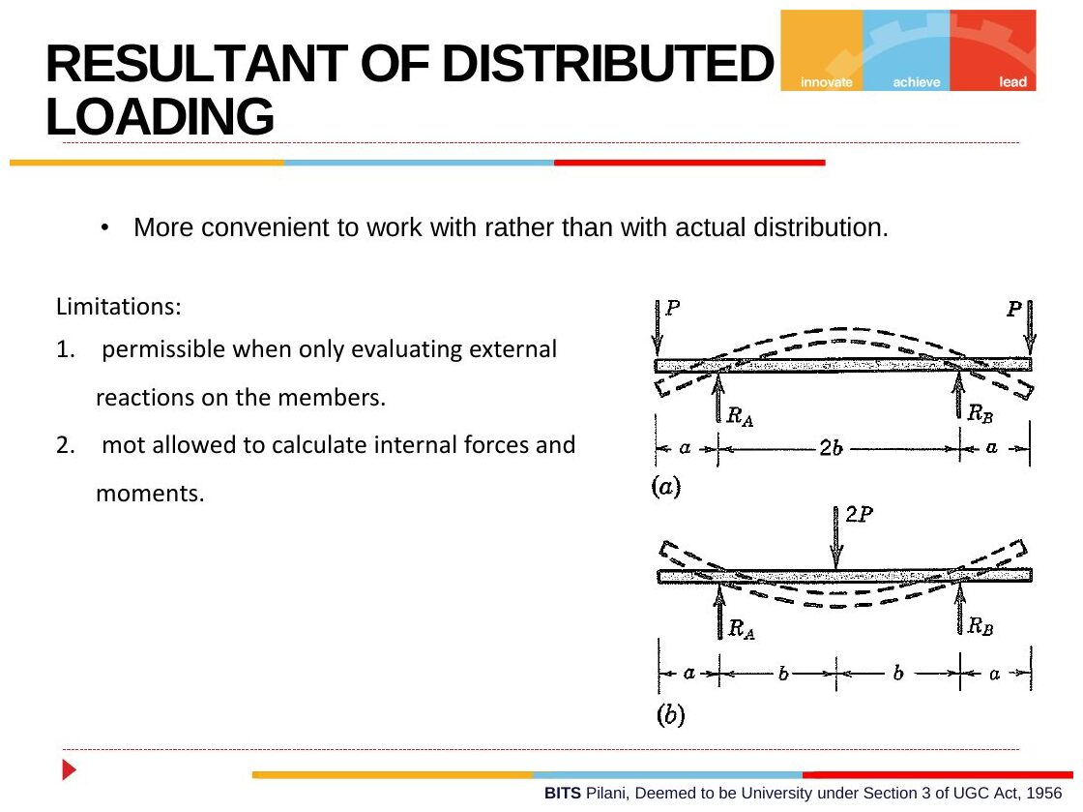
Original: Slides Ch 3, slide 22
4. Derivation — cantilever with triangular load (slides). Load $w=w_{0}x/L$ downward, free end A at $x=0$, wall at B. Cut at $x$ and keep the left part. The load on it is $\int_{0}^{x}{w_{0}}ξ/L dξ=w_{0}x^{2}/2L$, acting at $2x/3$ from A, i.e. $x/3$ from the cut.
- $∑F_{y}$: $−\frac{w_{0}x^{2}}{2L}+V=0⇒V=\frac{w_{0}x^{2}}{2L}$
- $∑M$: $M_{b}+\frac{w_{0}x^{2}}{2L}⋅\frac{x}{3}=0⇒M_{b}=−\frac{w_{0}x^{3}}{6L}$
At the wall: $V=w_{0}L/2$ and $M_{b}=−w_{0}L^{2}/6$ (hogging).
5. Shape. UDL gives a linear V and a parabolic M. Triangular load gives a parabolic V and a cubic M.
6. Special cases. Simply supported, full UDL: $V=−\frac{w_{0}L}{2}+w_{0}x$ and $M=\frac{w_{0}x\left(L−x\right)}{2}$, with $M_{max}=\frac{w_{0}L^{2}}{8}$ at mid-span where $V=0$.
7. Common traps. Using the resultant of the whole distributed load when cutting inside it. Putting a triangle’s resultant at $L/2$.
8. Summary. For reactions, replace by the resultant. For V and M, only the portion on your free body counts, placed at its own centroid.

B. Solved questions

Q5 (PYQ 2014-15 Compre A Q6, Q7) — Simply supported, UDL (easy)
Shear at mid-span: $\boxed{V\left(L/2\right)=0}$. Moment at mid-span: $\boxed{M=wL^{2}/8}$.

Q6 (Slides Ch3, Gere) — Trapezoidal load: V and M at mid-span (medium)
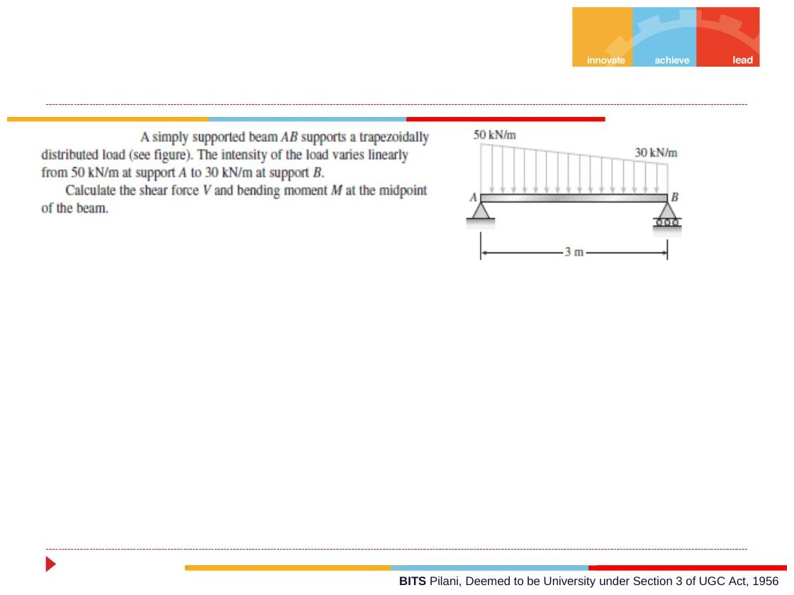
Original: Slides Ch 3, slide 29
Given: simply supported, $L=3$ m. Load decreases linearly from 50 kN/m at A to 30 kN/m at B. Find: $V$ and $M$ at $x=1.5$ m.
Total load $=\frac{50+30}{2}\left(3\right)=120$ kN at $\overset{‾}{x}=\frac{3\left(50+60\right)}{3\left(80\right)}=1.375$ m. So $R_{B}=120\left(1.375\right)/3=55$ kN and $R_{A}=65$ kN. Load on $0≤x≤1.5$: intensity at 1.5 m is 40 kN/m. Resultant $=\frac{50+40}{2}\left(1.5\right)=67.5$ kN at $\overset{‾}{x}=\frac{1.5\left(50+80\right)}{3\left(90\right)}=0.722$ m from A, i.e. 0.778 m from the cut.
- $V=−\left(65−67.5\right)=+2.5$ kN (Crandall). Gere gives −2.5 kN.
- $M=65\left(1.5\right)−67.5\left(0.778\right)=97.5−52.5=45.0$ kN·m
$$\boxed{V=2.5 \text{kN (Crandall)}, M=45 \text{kN·m}}$$
(The true maximum, 45.08 kN·m, is at $x=1.44$ m where $V=0$, just left of mid-span. That makes sense because the load is heavier on the left.)
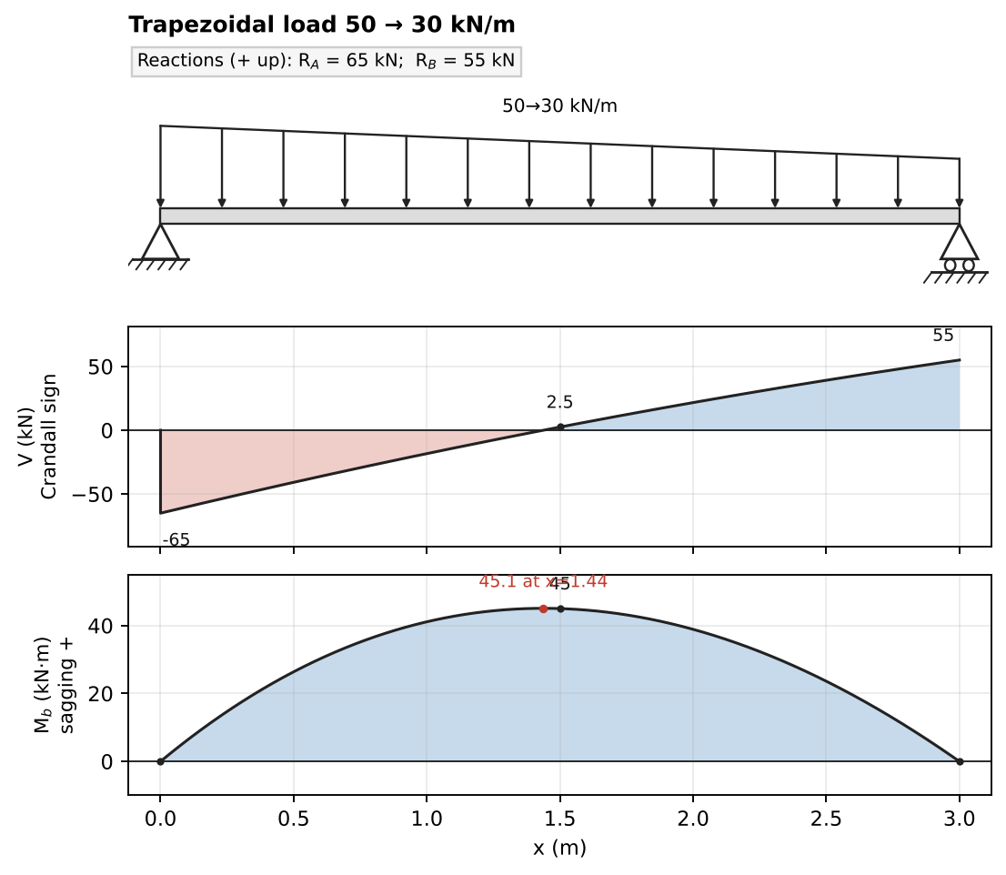
Solution

Q7 (Slides Ch3) — Symmetric triangular load, total W (easy)
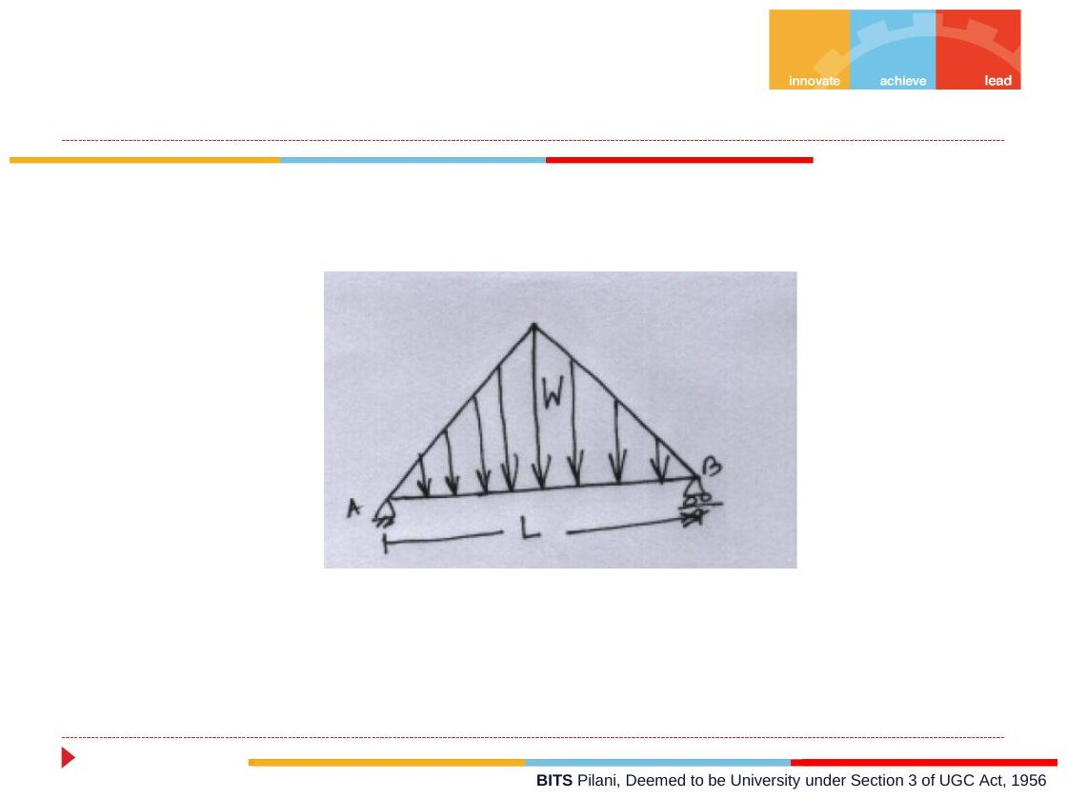
Original: Slides Ch 3, slide 26
Peak at mid-span, simply supported. $R_{A}=R_{B}=W/2$. For $x≤L/2$: $q=4Wx/L^{2}$. $M\left(x\right)=\frac{W}{2}x−\frac{2W}{3L^{2}}x^{3}$. At $x=L/2$:
$$\boxed{M_{max}=\frac{WL}{4}−\frac{WL}{12}=\frac{WL}{6}}$$
Check: a concentrated W at the centre gives $WL/4$. Spreading the load must give less ✓.
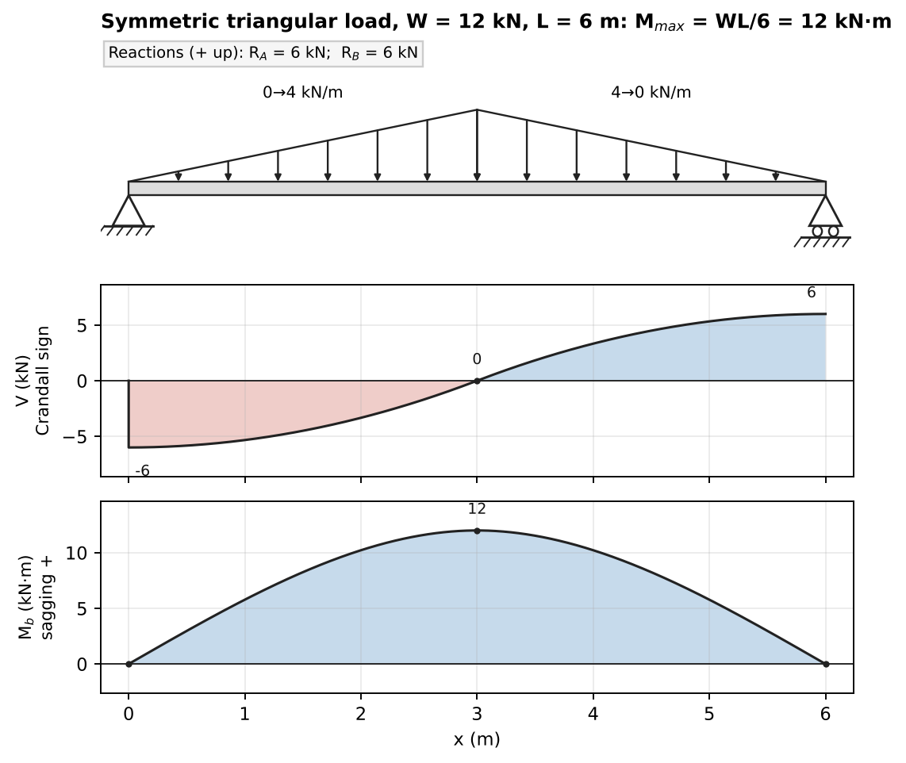
Solution with W = 12 kN, L = 6 m

Q8 (Slides Ch3) — Partial UDL $q=−w_{0}$ over length a from A, simply supported span L (medium)
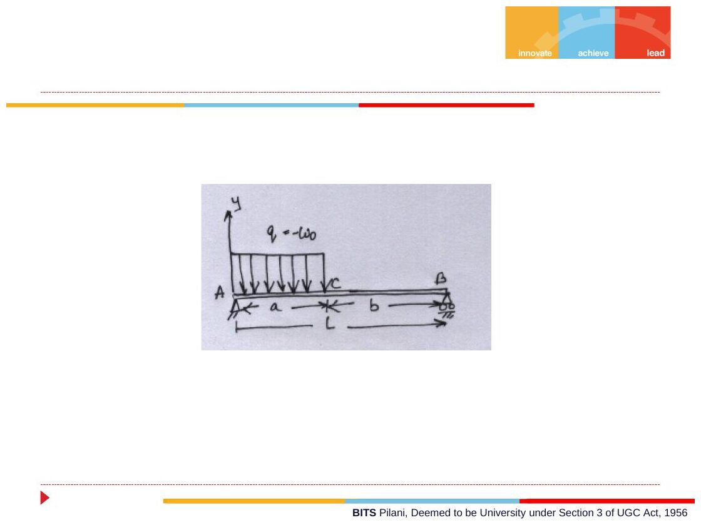
Original: Slides Ch 3, slide 27
$R_{A}=\frac{w_{0}a\left(2L−a\right)}{2L}$ and $R_{B}=\frac{w_{0}a^{2}}{2L}$. $V=0$ at $x_{0}=R_{A}/w_{0}=\frac{a\left(2L−a\right)}{2L}$ (always ≤ a ✓).
$$\boxed{M_{max}=\frac{R_{A}^{2}}{2w_{0}}=\frac{w_{0}a^{2}{\left(2L−a\right)}^{2}}{8L^{2}}}$$
Check: $a=L$ gives $w_{0}L^{2}/8$ ✓.
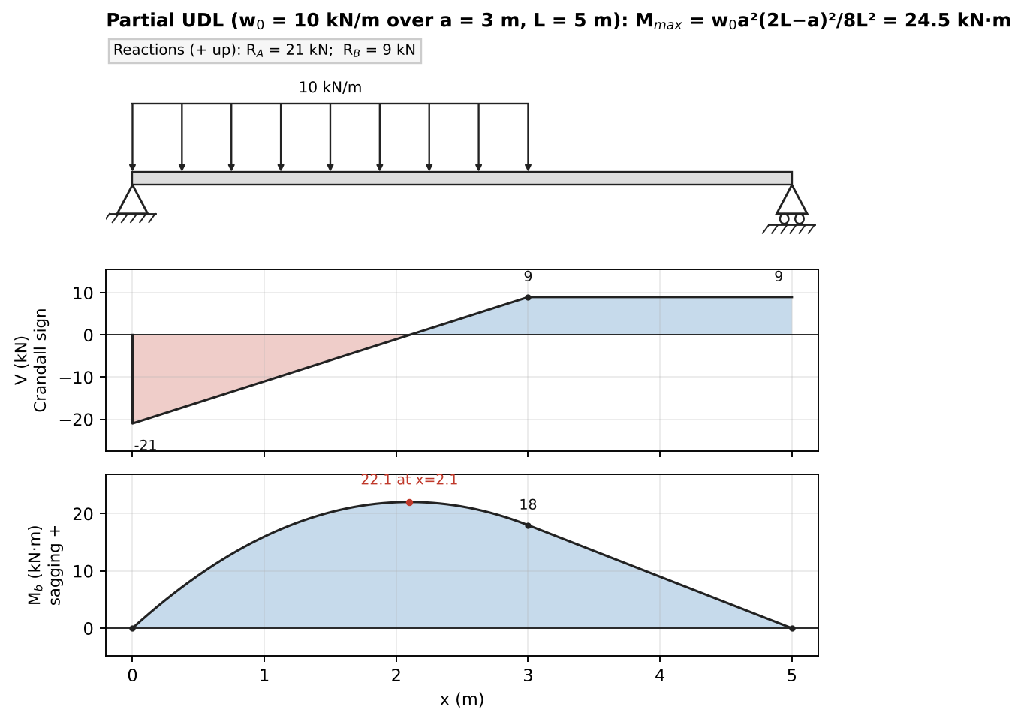
Solution with w₀ = 10 kN/m, a = 3 m, L = 5 m

Q9 (Slides Ch3) — Triangular load 0 → 2000 N/m over 9 m, then 2000 → 0 over 3 m (medium)
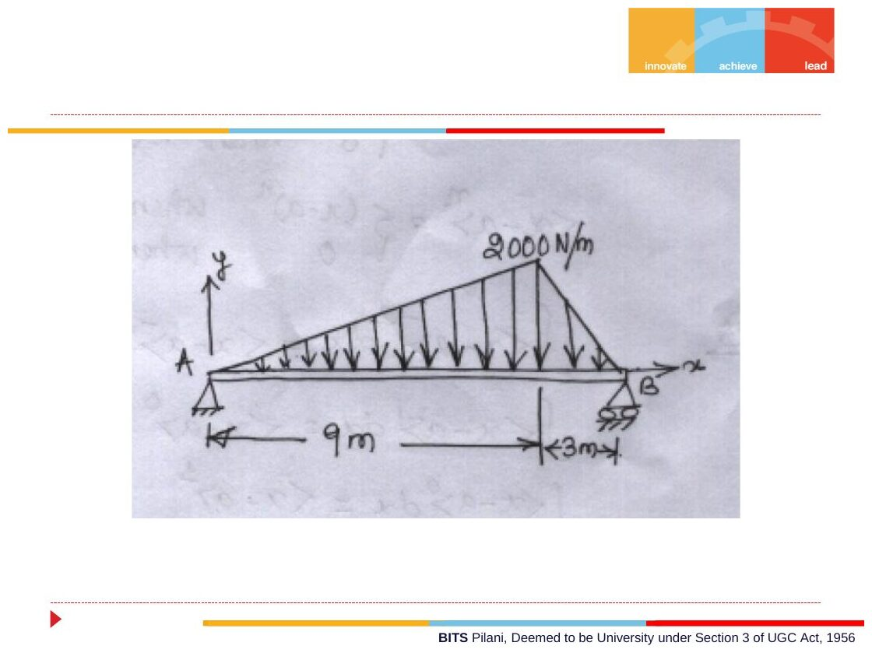
Original: Slides Ch 3, slide 42
Given: simply supported, span 12 m. Find: reactions and maximum M.
$R_{total}=1/2\left(2000\right)\left(12\right)=12,000$ N acting at the triangle’s centroid $\overset{‾}{x}=\left(0+9+12\right)/3=7$ m. So $R_{B}=12000\left(7\right)/12=7000$ N and $R_{A}=5000$ N. For $x≤9$: the load to the left is $\int_{0}^{x}{\frac{2000}{9}}ξ dξ=\frac{1000x^{2}}{9}$. $V=0$: $5000=1000x^{2}/9⇒x=\sqrt{45}=6.708$ m.
$$M=5000x−\frac{1000x^{2}}{9}⋅\frac{x}{3}|_{6.708}⇒\boxed{M_{max}=22.36 \text{kN·m at} x=6.71 \text{m}}$$
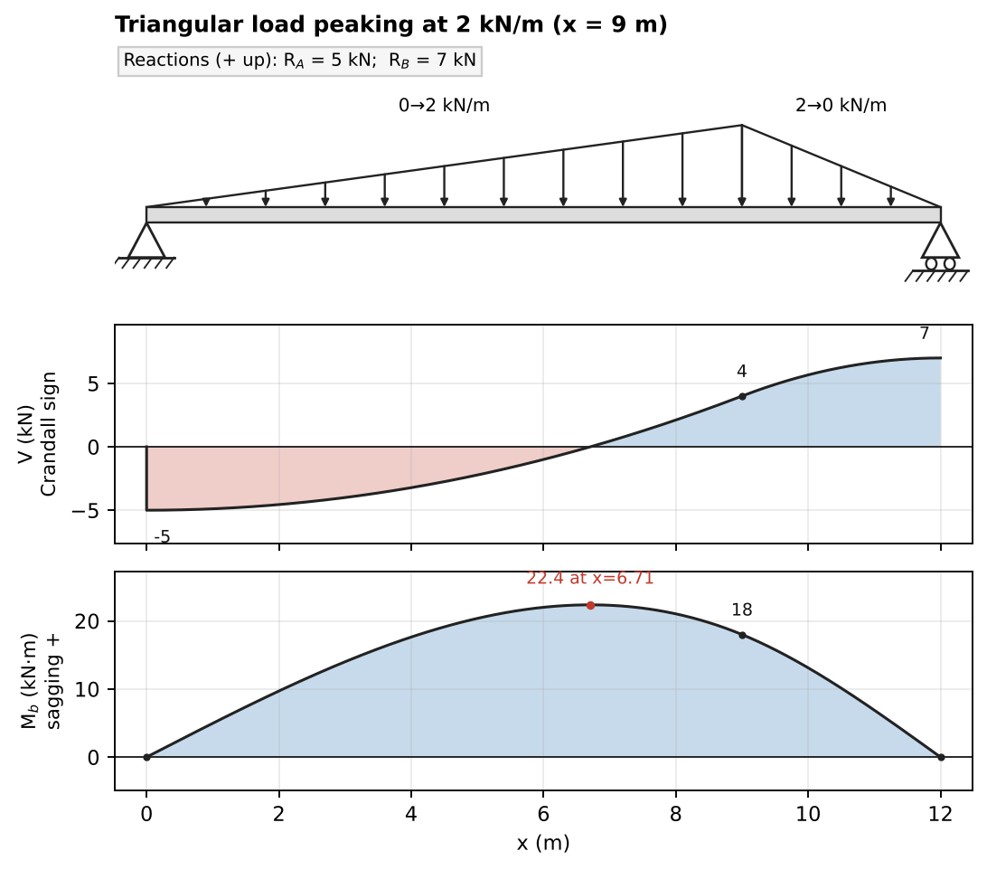
Solution

Concept 3.3 — Differential relations between q, V and M

A. Concept explanation
1. Intuition. The load intensity is the “slope-maker” for the shear diagram, and the shear is the “slope-maker” for the moment diagram. So you can sketch SFDs and BMDs almost without algebra: the load tells you the V slope, and the V tells you the M slope.
2. Why it matters. Fast and reliable diagrams, finding $M_{max}$ (where $V=0$), and the starting point of the beam-deflection chapter ($EIv⁗=q$).
3. Formal treatment / 4. Derivation (slides, Crandall §3.5). Take an element $Δx$ with $q\left(x\right)$ upward. On the left face are $V$ and $M_{b}$ (negative face, so drawn ↓ and clockwise). On the right face are $V+ΔV$ and $M_{b}+ΔM_{b}$ (positive face, ↑ and counter-clockwise).
- $∑F_{y}$: $\left(V+ΔV\right)−V+qΔx=0⇒\frac{ΔV}{Δx}=−q$
- $∑M_{O}$ (about the centre of the element): $\left(M_{b}+ΔM_{b}\right)−M_{b}+\left(V+ΔV\right)\frac{Δx}{2}+V\frac{Δx}{2}=0$
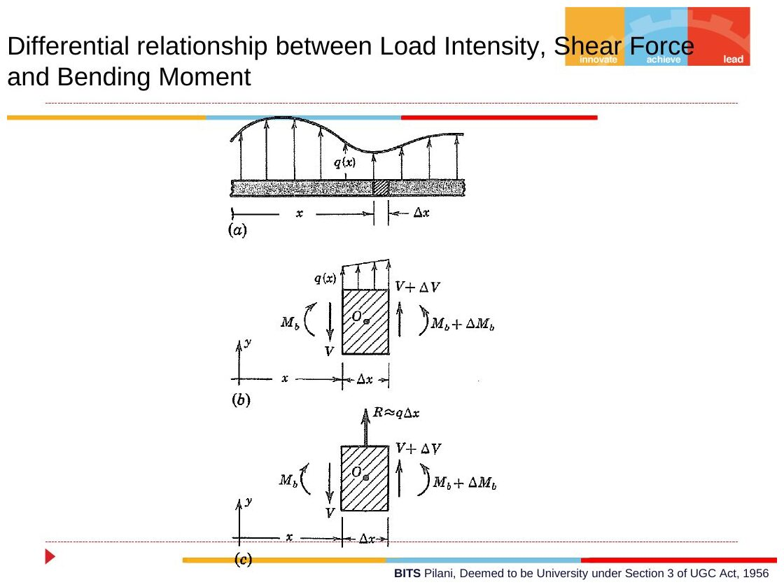
Original: Slides Ch 3, slide 31
Let $Δx→0$:
$$\boxed{\frac{dV}{dx}+q=0, \frac{dM_{b}}{dx}+V=0} ⇒ \frac{d^{2}M_{b}}{dx^{2}}=q$$
Integral forms: $V_{2}−V_{1}=−\int_{1}^{2}{q} dx$ and $M_{2}−M_{1}=−\int_{1}^{2}{V} dx$.
5. Reading diagrams (Crandall signs; q upward positive, so a downward load means $q<0$):
Load on segment | SFD | BMD
None | constant | linear
UDL downward | linear, rising (slope $=−q>0$) | parabola, concave down (∩)
Linear load | parabola | cubic
Concentrated downward $P$ | jumps up by $P$ | kink (slope change)
Clockwise couple $C$ | no change | jumps up by $C$
$M$ is extreme where $V=0$ (or where V jumps through zero at a concentrated load).
6. Special cases. At a free end or a pinned end with no applied couple, $M=0$. At a free end with no load, $V=0$.
7. Common traps.
- With Gere’s formulas ($dM/dx=+V$) and Crandall’s signs for V you get the BMD upside down. Pick one convention and stay with it.
- Missing a maximum inside a distributed load: always solve $V=0$ there.
- A point of contraflexure is where M changes sign (passes through zero), not where V = 0.
8. Summary. $V′=−q$, $M′=−V$ (Crandall). Area of the load diagram gives the change in V. Area of the SFD gives minus the change in M.

B. Solved questions

Q10 (Slides Ch3) — 4 kN, 2 kN/m, 8 kN on a 10 m span (medium)
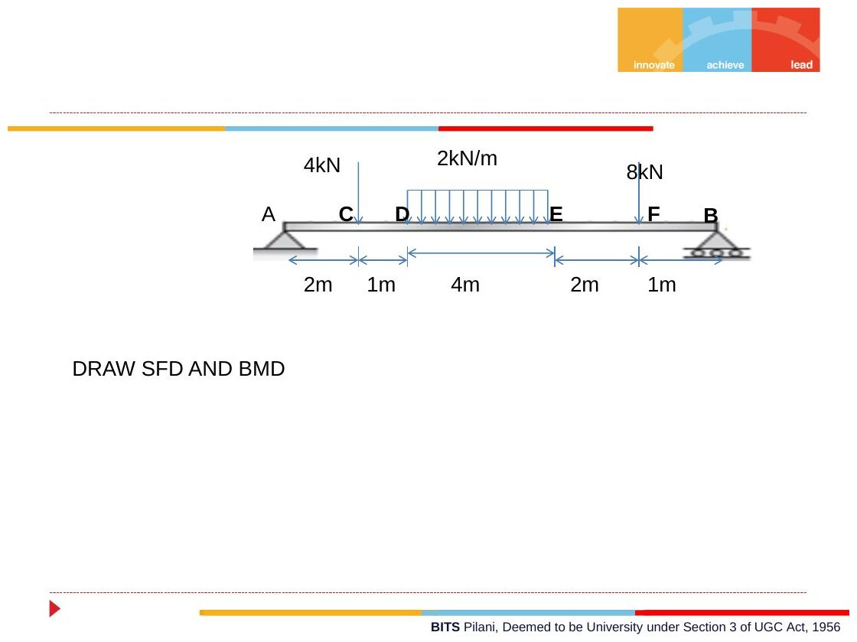
Original: Slides Ch 3, slide 30
Given: simply supported, A at 0, B at 10. 4 kN at C (2 m). UDL 2 kN/m from D (3 m) to E (7 m). 8 kN at F (9 m). Reactions: $∑M_{A}$: $R_{B}\left(10\right)=4\left(2\right)+8\left(5\right)+8\left(9\right)=120⇒R_{B}=12$ kN and $R_{A}=8$ kN.
Point | A | C⁻ | C⁺ | D | $x=5$ | E | F⁻ | F⁺ | B
$V$ (kN, Crandall) | −8 | −8 | −4 | −4 | 0 | +4 | +4 | +12 | +12
$M$ (kN·m) | 0 | 16 | 16 | 20 | 24 | 20 | 12 | 12 | 0
$M$ in DE: $M=8x−4\left(x−2\right)−{\left(x−3\right)}^{2}$, which peaks at $x=5$:
$$\boxed{M_{max}=24 \text{kN·m at mid-span}}$$
No point of contraflexure: M ≥ 0 everywhere.
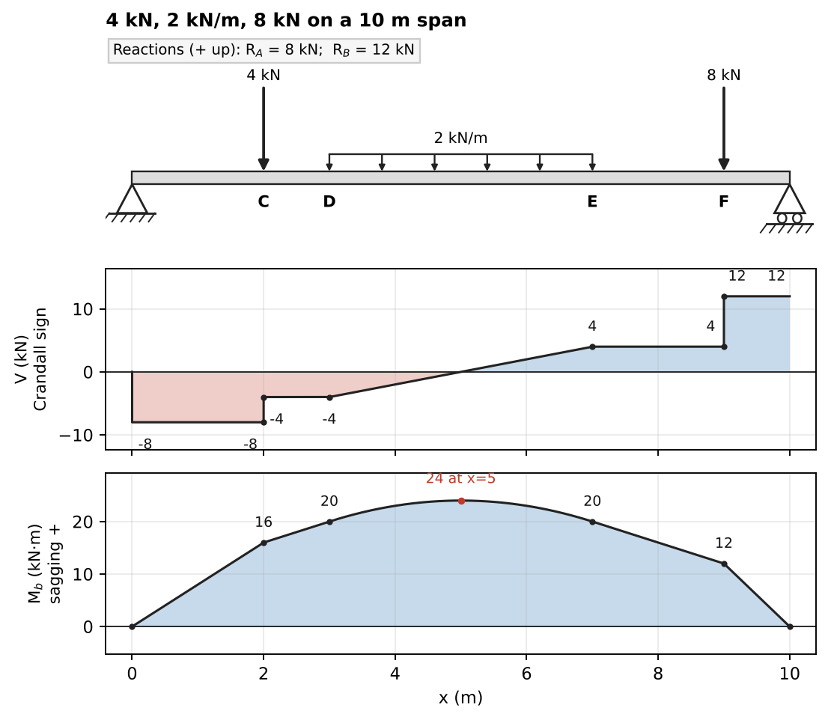
Solution

Q11 (Slides Ch3) — 3 kN + UDL + 2 kN: position and value of maximum BM (medium)
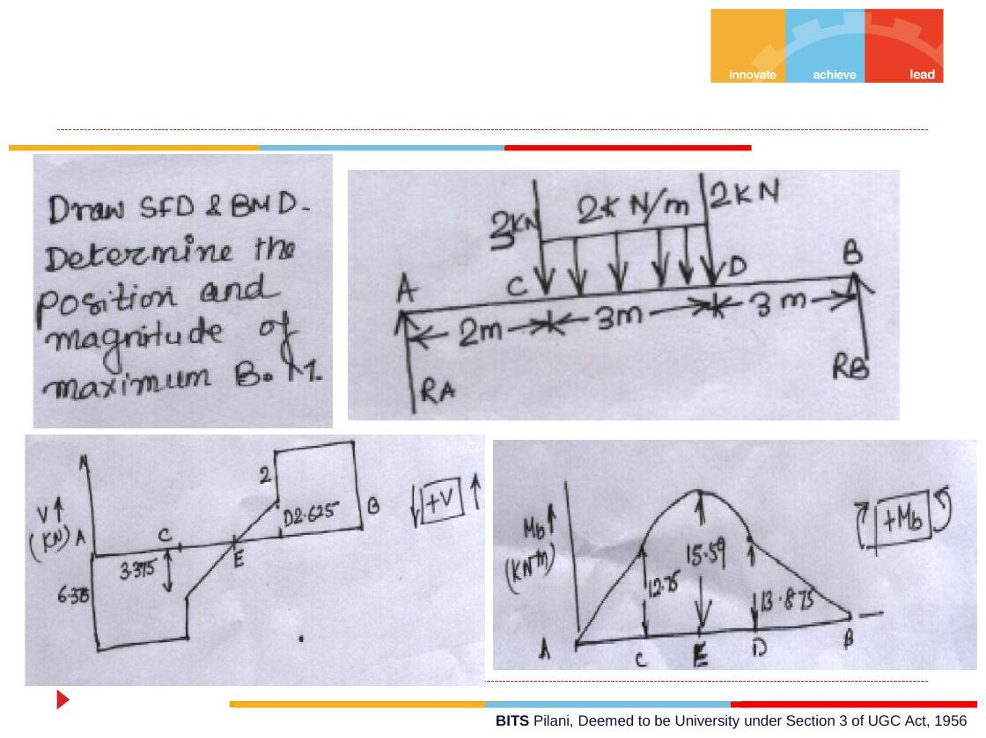
Original: Slides Ch 3, slide 41
Given: simply supported, 8 m. 3 kN at C (2 m). 2 kN/m from C to D (2 to 5 m). 2 kN at D (5 m). Reactions: $∑M_{A}$: $R_{B}\left(8\right)=3\left(2\right)+6\left(3.5\right)+2\left(5\right)=37⇒R_{B}=4.625$ kN and $R_{A}=6.375$ kN. $V=0$ in CD: $6.375−3−2\left(x−2\right)=0⇒x=3.6875$ m (point E).
Point | A | C⁺ | E | D⁻ | D⁺ | B
$V$ (Crandall) | −6.375 | −3.375 | 0 | +2.625 | +4.625 | +4.625
$M$ (kN·m) | 0 | 12.75 | 15.60 | 13.875 | 13.875 | 0
$$\boxed{M_{max}=15.6 \text{kN·m at} x=3.69 \text{m from A}}$$
✓ Matches the slide’s hand solution (6.38, 3.375, 2.625, 12.75, 15.59, 13.875).
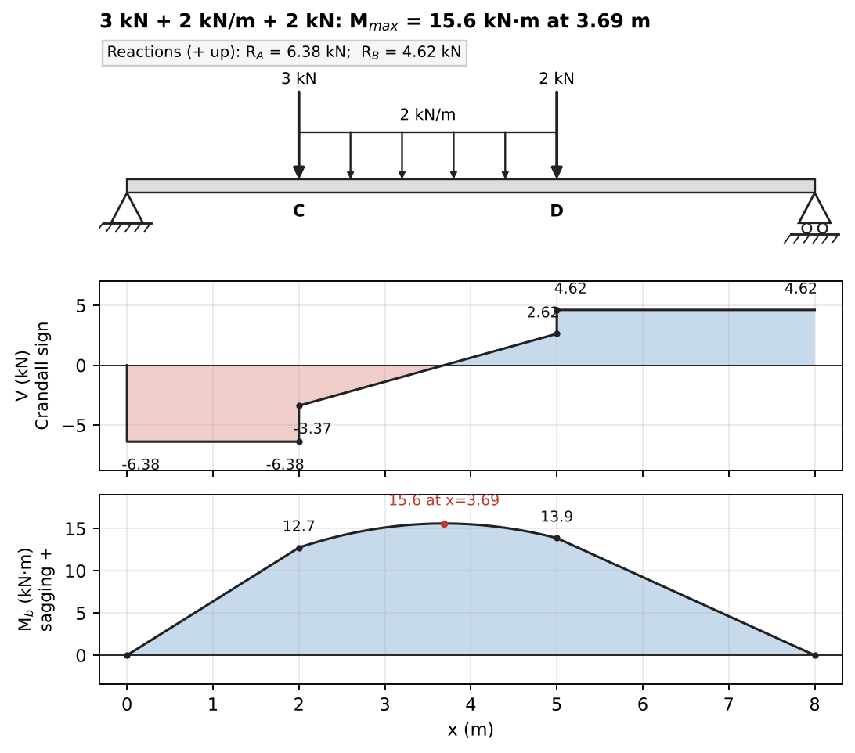
Solution

Q12 (Slides Ch3) — 5 kN/m segments plus an offset couple (medium–hard; fill-the-table type)
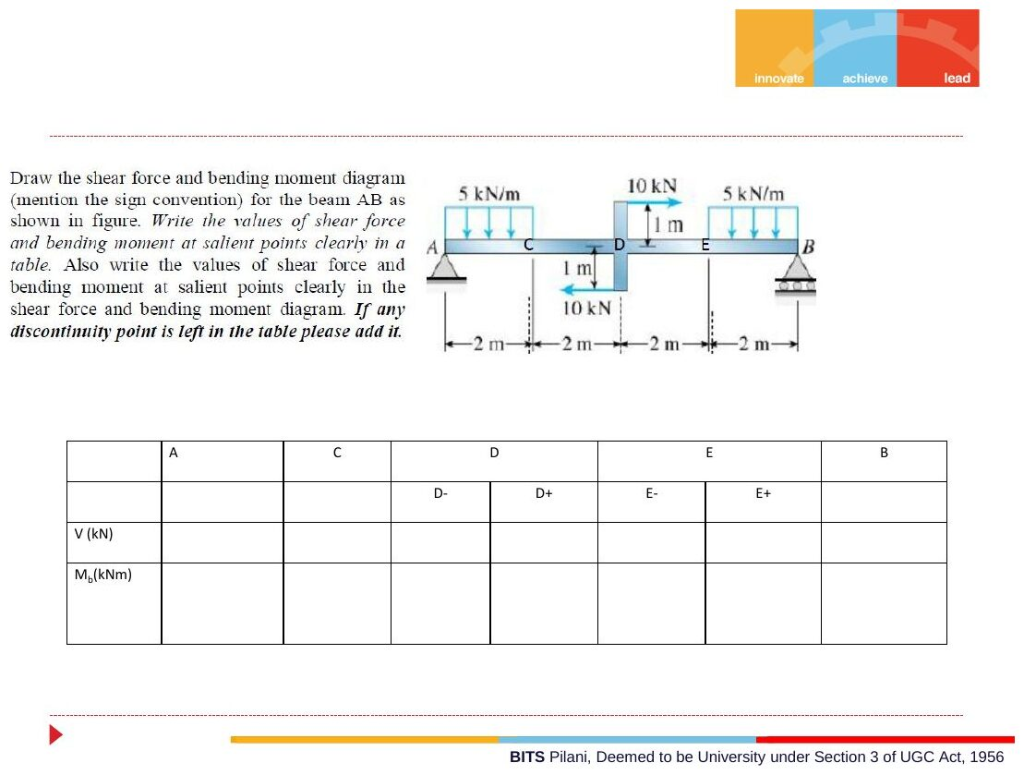
Original: Slides Ch 3, slide 25
Given: simply supported AB, 8 m (A pin, B roller). 5 kN/m on AC (0–2 m) and on EB (6–8 m). At D (4 m) a vertical arm carries 10 kN → at 1 m above the beam and 10 kN ← at 1 m below. Find: the V/M table at A, C, D⁻, D⁺, E, B.
Arm loads → a couple: the two forces cancel. Their moment is $10\left(1\right)+10\left(1\right)=20$ kN·m clockwise, applied at D. Reactions: $∑M_{A}$: $R_{B}\left(8\right)−10\left(1\right)−10\left(7\right)−20=0⇒R_{B}=12.5$ kN and $R_{A}=7.5$ kN. M: AC: $7.5x−2.5x^{2}$. CD: $10−2.5x$. At D the moment jumps up by 20 (clockwise couple). DE: $30−2.5x$. EB: $30−2.5x−2.5{\left(x−6\right)}^{2}$.
 | A | C | D⁻ | D⁺ | E | B
$V$ (kN, Crandall) | −7.5 | +2.5 | +2.5 | +2.5 | +2.5 | +12.5
$M_{b}$ (kN·m) | 0 | 5 | 0 | 20 | 15 | 0
There is a local max of 5.625 kN·m at $x=1.5$ m in AC.
$$\boxed{M_{max}=20 {\text{kN·m at D}}^{+}}$$
Takeaway: horizontal forces on an offset arm add no vertical shear, but they do add a couple. The slide’s “if any discontinuity point is left in the table please add it” is a hint about the jump at D.
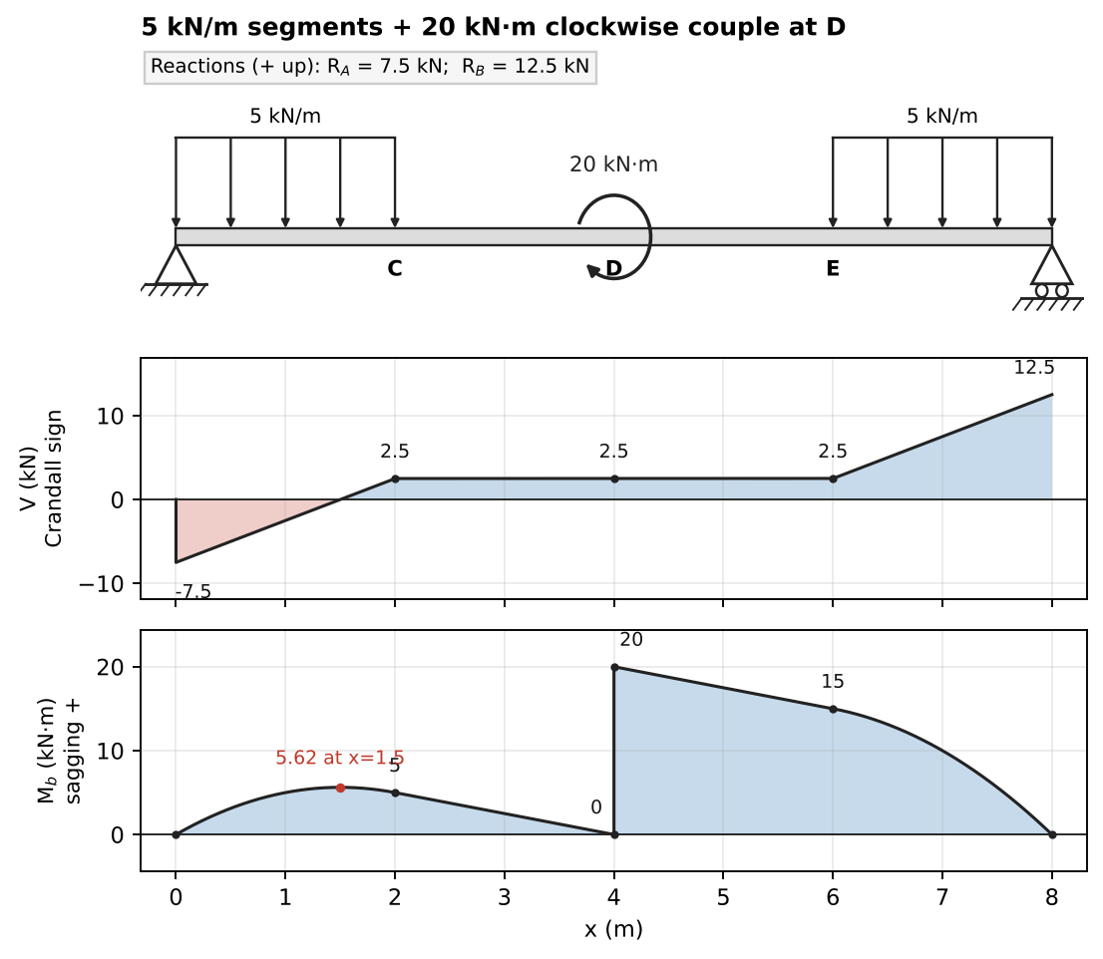
Solution: the arm forces become a 20 kN·m clockwise couple at D

Q13 (Crandall Prob 3.7) — Uniform load over a beam with an overhang (medium)
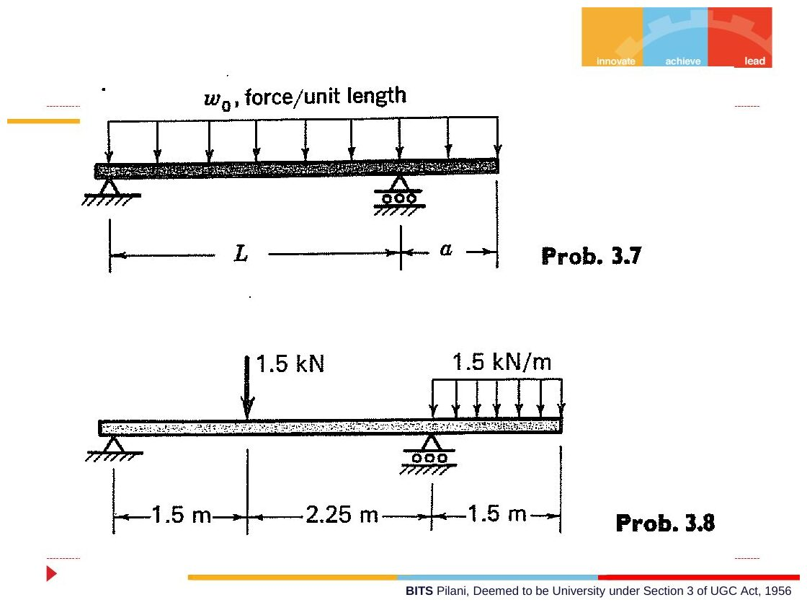
Original: Slides Ch 3, slide 40
Given: load $w_{0}$ over the whole length $L+a$. Supports at $x=0$ and $x=L$, overhang $a$. $R_{A}=\frac{w_{0}\left(L^{2}−a^{2}\right)}{2L}$ and $R_{B}=\frac{w_{0}{\left(L+a\right)}^{2}}{2L}$.
Point | $V$ (Crandall) | $M$
A | $−R_{A}$ | 0
inside span, $V=0$ at $x_{0}=\left(L^{2}−a^{2}\right)/2L$ | 0 | $+\frac{w_{0}{\left(L^{2}−a^{2}\right)}^{2}}{8L^{2}}$
B⁻ | $+\frac{w_{0}\left(L^{2}+a^{2}\right)}{2L}$ | $−\frac{w_{0}a^{2}}{2}$
B⁺ | $−w_{0}a$ | $−\frac{w_{0}a^{2}}{2}$
tip | 0 | 0
Variation (Crandall 3.18-type): choose $a$ so that $\left|M_{max}^{+}\right|=\left|M_{B}\right|$. This gives $a≈0.414L$ for this layout, the best support position for a plank.
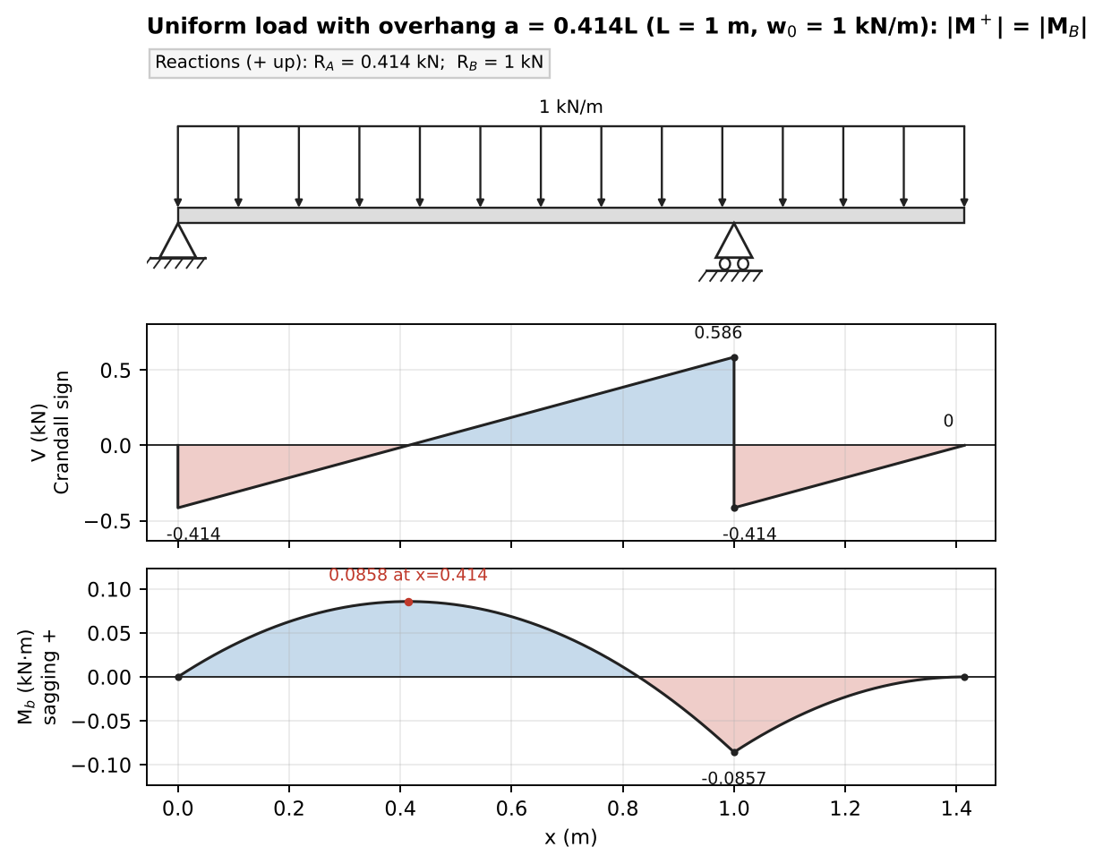
Solution for the optimum overhang a = 0.414L

Q14 (Crandall Prob 3.8) — Overhanging beam, 1.5 kN and 1.5 kN/m (medium)
Original: Slides Ch 3, slide 40
Given: pin A at 0, roller B at 3.75 m. 1.5 kN at 1.5 m. 1.5 kN/m over the 1.5 m overhang (3.75–5.25 m). Reactions: $R_{B}\left(3.75\right)=1.5\left(1.5\right)+2.25\left(4.5\right)⇒R_{B}=3.30$ kN and $R_{A}=0.45$ kN.
 | A | load⁻ | load⁺ | B⁻ | B⁺ | tip
$V$ (kN, Crandall) | −0.45 | −0.45 | +1.05 | +1.05 | −2.25 | 0
$M$ (kN·m) | 0 | 0.675 | 0.675 | −1.69 | −1.69 | 0
Contraflexure: $0.45x−1.5\left(x−1.5\right)=0⇒\boxed{x=2.14 \text{m from A}}$. ${\left|M\right|}_{max}=1.69$ kN·m (hogging) at B.
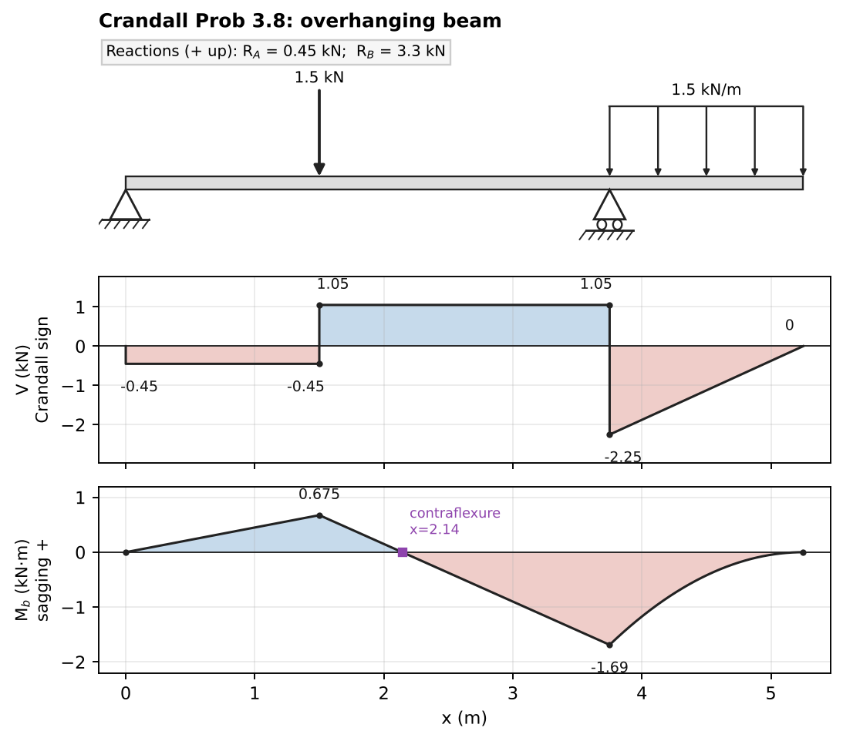
Solution

Q15 (Crandall Prob 3.17) — The carpenter and the sawhorses (medium, a classic)
Given: 6 m plank, uniform $w_{0}$. One sawhorse at end A. Where should the second go so that $M=0$ at 1.8 m from the other end ($x=4.2$ m)? Let the second sawhorse be at $s$, with $4.2<s<6$. $R_{s}=\frac{w_{0}\left(6\right)\left(3\right)}{s}=\frac{18w_{0}}{s}$. $M\left(4.2\right)$ from the right: $R_{s}\left(s−4.2\right)−w_{0}\left(1.8\right)\left(0.9\right)=0⇒18−\frac{75.6}{s}=1.62$
$$\boxed{s=4.62 \text{m from A} \left(\text{i.e. 1.38 m from the far end}\right)}$$
Check: if $s<4.2$, the cut would be in the overhang where $M=−w_{0}{\left(1.8\right)}^{2}/2≠0$, so no solution there ✓.
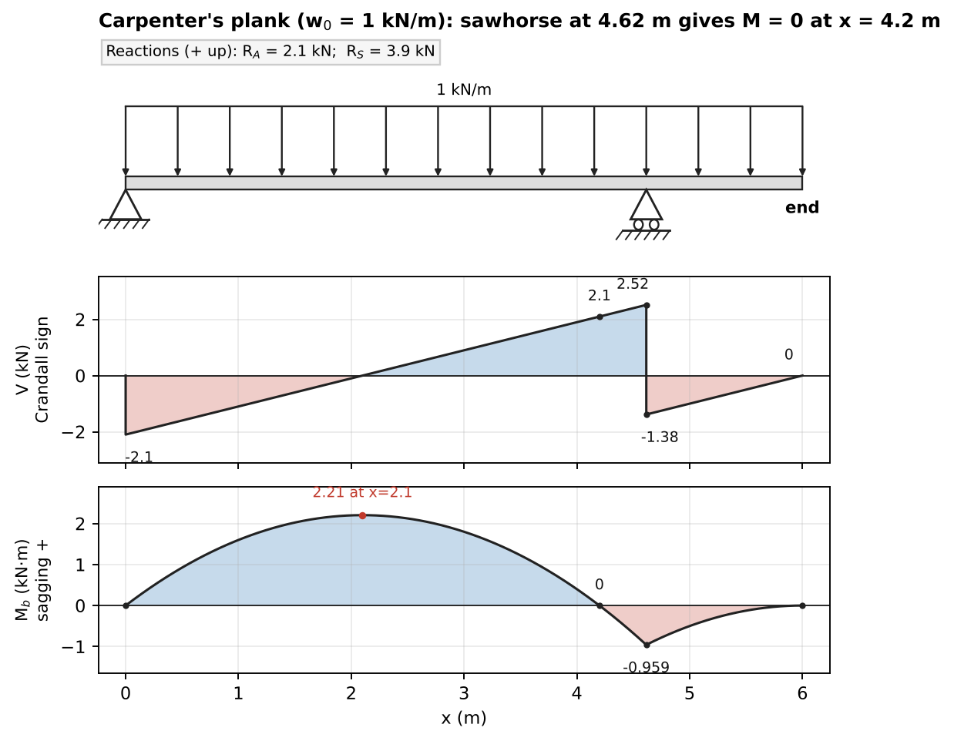
Solution: sawhorse at 4.62 m, M = 0 at the cut (x = 4.2 m)

Concept 3.4 — Singularity (Macaulay) functions

A. Concept explanation
1. Intuition. Instead of writing a new $M\left(x\right)$ for every segment, use “switches” $⟨x−a⟩$ that are off ($0$) before $x=a$ and on afterwards. One formula then covers the whole beam. This is very useful in the deflection chapter, where you integrate twice.
2. Why it matters. PYQ 2014-15 Test-1 Q4 (25 marks!) demanded this method only, and 2023-24 Part B Q3 uses it for deflection.
3. Formal treatment (slides).
$$⟨x−a⟩^{n}=\left\{\begin{matrix}{\left(x−a\right)}^{n} & x≥a \\ 0 & x<a\end{matrix}\right. \left(n≥0\right), ⟨x−a⟩^{0}=\text{unit step}$$
$⟨x−a⟩_{−1}$ is a concentrated (Dirac) load and $⟨x−a⟩_{−2}$ a concentrated couple (doublet). Integration rules: for $n≥0$, $\int_{−∞}^{x}{⟨}x−a⟩^{n}dx=\frac{⟨x−a⟩^{n+1}}{n+1}$. For $n<0$, $∫⟨x−a⟩_{n}dx=⟨x−a⟩_{n+1}$. So $∫⟨⟩_{−2}=⟨⟩_{−1}$ and $∫⟨⟩_{−1}=⟨⟩^{0}$. Loading representation (Rule 2):
- UDL $w_{0}$ starting at $a$: $w_{0}⟨x−a⟩^{0}$. To stop it at $b$, add $−w_{0}⟨x−b⟩^{0}$.
- Ramp: $\frac{w_{0}}{b−a}⟨x−a⟩^{1}$.
- Point load $P$ at $a$: $P⟨x−a⟩_{−1}$.
- Couple $M_{0}$ at $a$: $M_{0}⟨x−a⟩_{−2}$.
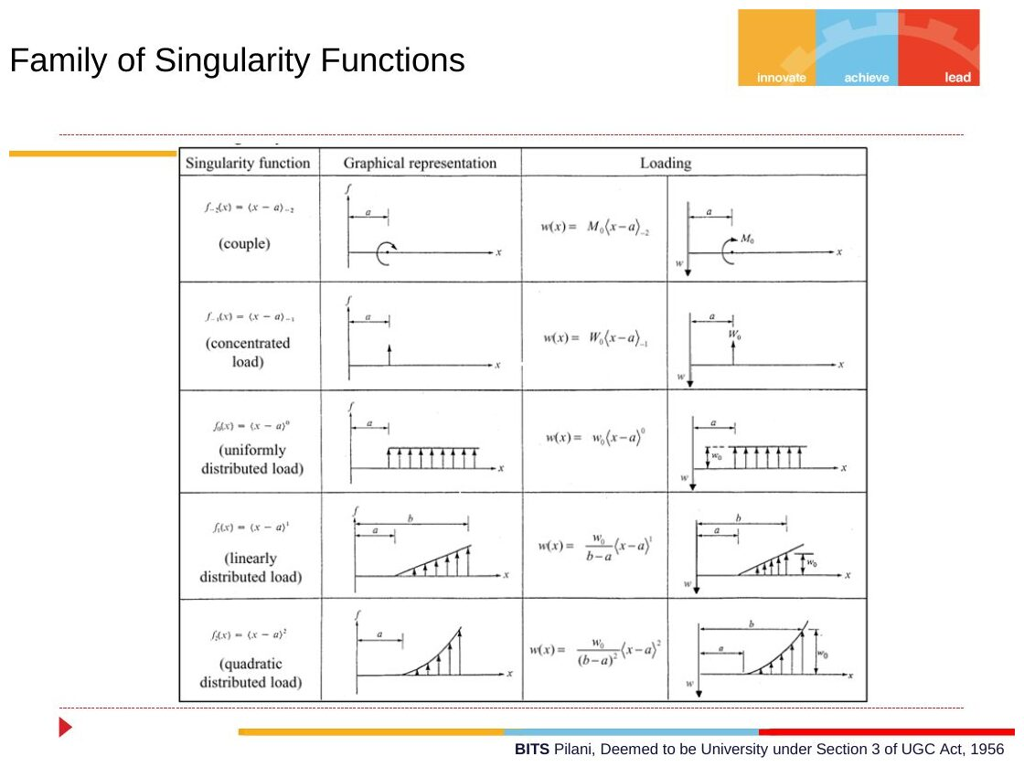
Original: Slides Ch 3, slide 35
Rule 4: write $q\left(x\right)$ including all forces (reactions too) from left to right. Integrate once to get $V$ and again to get $M$. No integration constants are needed, because the reactions are already inside the $⟨ ⟩_{−1}$ terms.
4. Derivation — why no constants. $V$ and $M$ are zero just left of the beam ($x<0$), and every term $⟨x−a⟩_{n}$ is zero there too. So the constants must be 0.
5. Working form you can use directly (sagging $M$ +, clockwise couples +, upward forces +):
Mx=up forces​Pi⟨x−ai⟩1−down​Pj⟨x−aj⟩1+cw couples​Ck⟨x−ak⟩0−UDL down​w2⟨x−a⟩2+…
and $V_{Crandall}=−dM/dx$.
6. Special cases. A UDL that runs to the end of the beam needs no “stop” term.
7. Traps.
- Evaluating $⟨x−a⟩$ as $\left(x−a\right)$ when $x<a$. It must be 0.
- Forgetting to end a UDL.
- Using $⟨x−a⟩^{1}$ for a couple: it must be $⟨x−a⟩^{0}$ in $M$.
8. Summary. One equation, switches on at each discontinuity, no constants (for V and M).

B. Solved questions

Q16 (PYQ 2014-15 Test-1 Q4) — Singularity functions: SFD, BMD and contraflexure (hard, 25 marks)
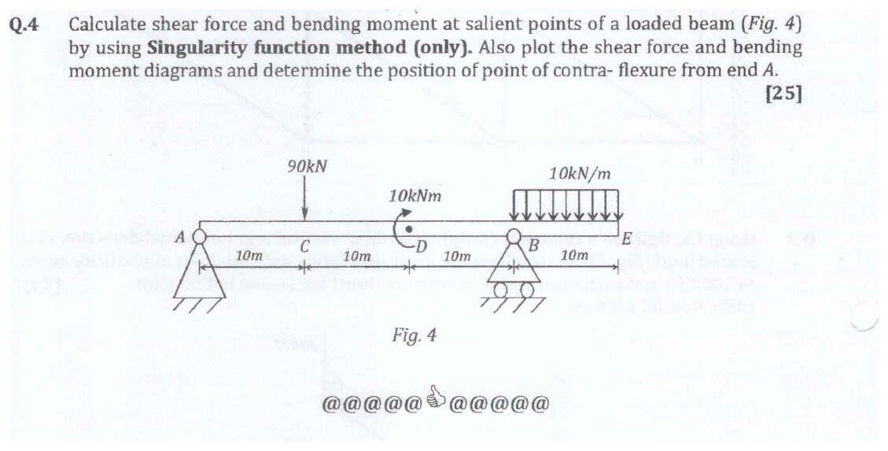
Original question: PYQ 2014-15 Test-1 Q4
Given: A (pin) at 0, C at 10 m (90 kN ↓), D at 20 m (10 kN·m couple, clockwise as drawn), B (roller) at 30 m, E (free end) at 40 m. UDL 10 kN/m over BE (30–40 m). Reactions: $∑M_{A}$: $R_{B}\left(30\right)−90\left(10\right)−10−100\left(35\right)=0⇒R_{B}=147$ kN and $R_{A}=190−147=43$ kN.
Singularity equation for M:
$$M\left(x\right)=43⟨x⟩^{1}−90⟨x−10⟩^{1}+10⟨x−20⟩^{0}+147⟨x−30⟩^{1}−5⟨x−30⟩^{2} \text{(kN·m)}$$
$$V\left(x\right)=−\frac{dM}{dx}=−43⟨x⟩^{0}+90⟨x−10⟩^{0}−147⟨x−30⟩^{0}+10⟨x−30⟩^{1} \text{(Crandall)}$$
(The couple’s term differentiates to $⟨⟩_{−1}$, which is zero except at $x=20$ exactly.)
 | A | C⁻ | C⁺ | D⁻ | D⁺ | B⁻ | B⁺ | E
$V$ (kN, Crandall) | −43 | −43 | +47 | +47 | +47 | +47 | −100 | 0
$M$ (kN·m) | 0 | 430 | 430 | −40 | −30 | −500 | −500 | 0
Contraflexure: in CD, $M=43x−90\left(x−10\right)=900−47x=0$, so
$$\boxed{x=19.15 \text{m from A}}$$
After D, $M$ stays negative (−30 to −500) and reaches 0 only at the free end E, so there is only one point of contraflexure. Max moments: $+430$ kN·m at C (sagging) and $−500$ kN·m at B (hogging). Check: $M\left(40\right)=43\left(40\right)−90\left(30\right)+10+147\left(10\right)−5\left(100\right)=0$ ✓.
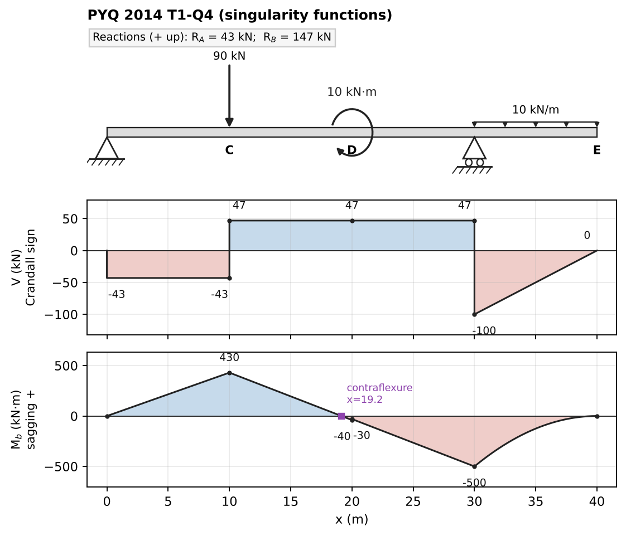
Solution: SFD and BMD from the singularity equations

Concept 3.5 — Cantilevers, frames, curved members and 3-D problems

A. Concept explanation
1. Intuition. The cut method works the same for bent or curved members. Just remember that “axial” and “shear” are now measured along and across the local direction of the member at the cut. In 3-D, use vectors: $F$ and $M=r×F$.
2. Why it matters. Brackets, crank shafts, pipes, curved hooks. These appear in every compre as the first part of a combined-stress question (see Ch. 4 Concept 4.6).
3. Formal treatment (Crandall §3.8, Example 3.11). For a cut segment with free-end loads $P$ at position $r_{CA}$ relative to the cut C:
$$V_{C}+P=0, M_{C}+r_{CA}×P=0$$
Resolve into components along the local axis (twist and axial force) and perpendicular to it (bending and shear). Crandall Ex. 3.11: for a quarter-circle pipe of radius $a$ with a transverse (out-of-plane) load $P$, $V=−P$, $M_{b}=Pasinθ$ and $M_{t}=−Pa\left(1−cosθ\right)$. An out-of-plane load on a curved member produces twist. Crandall’s observation: for straight members under point loads, the maximum bending moment always occurs at a load point, never between loads.
4. Derivation — in-plane moment in a bent bracket. For a free end D loaded by $\left(F_{x},F_{y}\right)$, the bending moment at any point $\left(x,y\right)$ of the frame is
$$M\left(x,y\right)=\left(x_{D}−x\right)F_{y}−\left(y_{D}−y\right)F_{x}$$
This one formula covers every straight segment, so there is no need to redo FBDs for each leg.
7. Traps. For curved members, the “axial” direction rotates with θ. Resolve the load into tangential and radial components at the cut.

B. Solved questions

Q17 (PYQ 2014-15 Compre A Q17–18) — Cantilever with three loads (easy–medium)
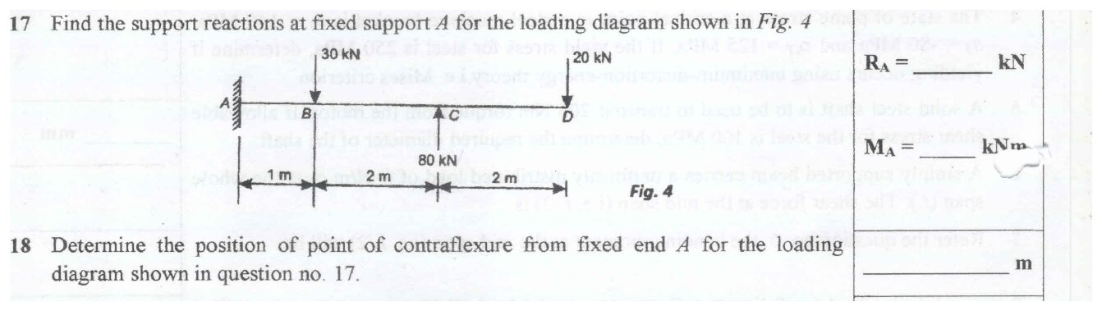
Original question: PYQ 2014-15 Compre A Q17–Q18
Given: fixed at A. 30 kN ↓ at B (1 m), 80 kN ↑ at C (3 m), 20 kN ↓ at D (5 m). Find: $R_{A}$, $M_{A}$ and the point of contraflexure.
- $∑F_{y}$: $R_{A}−30+80−20=0⇒R_{A}=−30$ kN, so $\boxed{30 \text{kN}↓}$
- $∑M_{A}$: $M_{A}−30\left(1\right)+80\left(3\right)−20\left(5\right)=0⇒M_{A}=−110$ kN·m, so $\boxed{110 \text{kN·m clockwise on the beam}}$
M along the beam (from the right): CD: $M=−20\left(5−x\right)$ (hogging). BC: $M=140−60x$. AB: $M=110−30x$. $M=0$ in BC at $\boxed{x=2.33 \text{m from A}}$.
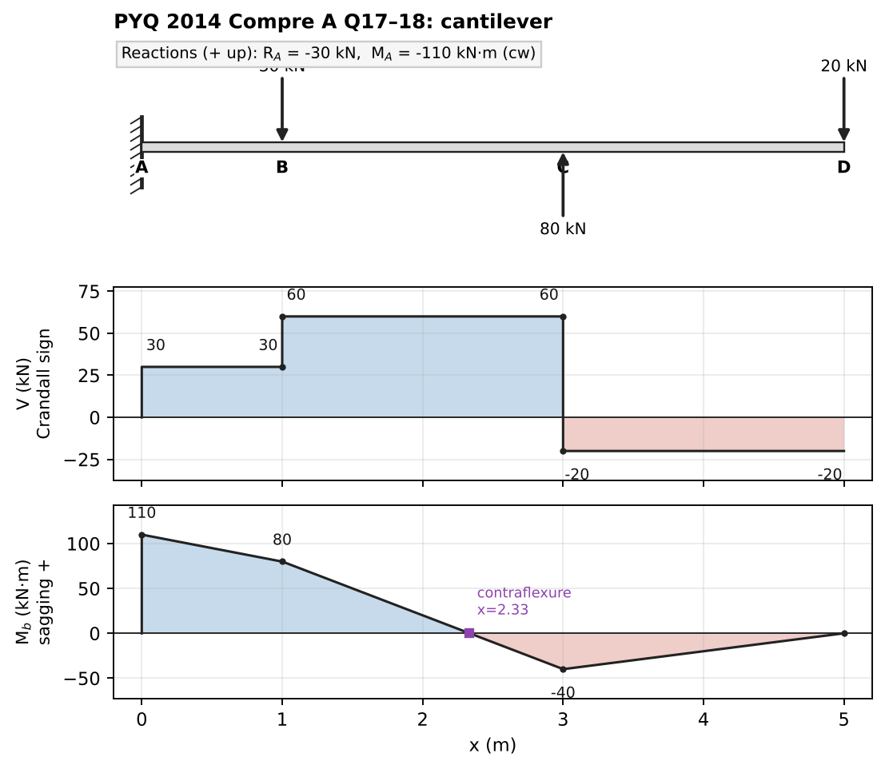
Solution

Q18 (PYQ 2019-20 Compre A Q1) — Bracket ABCD: BMD and minimum diameter (medium, 8 marks)
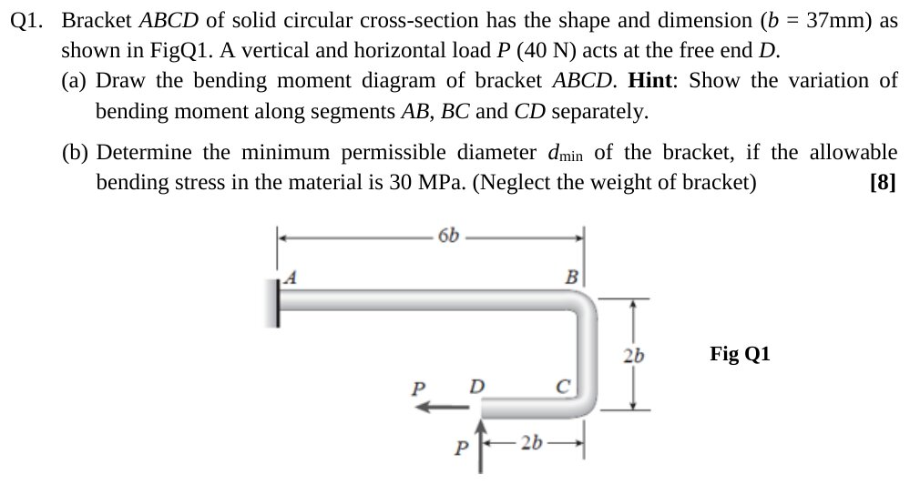
Original question: PYQ 2019-20 Compre A Q1
Given: fixed at A. AB horizontal, $6b$. BC vertical (down), $2b$. CD horizontal back toward A, $2b$. At free end D: $P=40$ N ← and $P=40$ N ↑. $b=37$ mm. Solid circular section, $σ_{allow}=30$ MPa. Find: (a) the BMD, (b) $d_{min}$.
Coordinates: A(0,0), B(6b, 0), C(6b, −2b), D(4b, −2b). Loads at D: $\left(F_{x},F_{y}\right)=\left(−P,+P\right)$. Using $M=\left(x_{D}−x\right)F_{y}−\left(y_{D}−y\right)F_{x}$:
$$M\left(x,y\right)=P\left(4b−x\right)−P\left(2b+y\right)=P\left(2b−x−y\right)$$
Segment | Expression | End values
CD ($y=−2b$, $x$: $4b→6b$) | $P\left(4b−x\right)$ | D: 0 → C: $−2Pb$ (linear)
BC ($x=6b$, $y$: $−2b→0$) | $P\left(−4b−y\right)$ | C: $−2Pb$ → B: $−4Pb$ (linear)
AB ($y=0$, $x$: $6b→0$) | $P\left(2b−x\right)$ | B: $−4Pb$ → A: $+2Pb$; zero at $x=2b$
The BMD is linear on every leg. The largest magnitude is ${\left|M\right|}_{max}=4Pb$ at B. The sign changes at $x=2b$ from A, a point of contraflexure.
$$M_{max}=4\left(40\right)\left(37\right)=5920 \text{N·mm}$$
(b) Bending stress in a solid circle (from the flexure formula, Ch. 7): $σ=\frac{32M}{πd^{3}}$.
$$d^{3}=\frac{32\left(5920\right)}{π\left(30\right)}=2010 {\text{mm}}^{3}⇒\boxed{d_{min}=12.6 \text{mm}}$$
Check: the axial force in AB is only $P=40$ N, giving $P/A≈0.3$ MPa, which is negligible next to 30 MPa ✓. Takeaway: the hint “show the variation along AB, BC, CD separately” is asking for exactly this table.
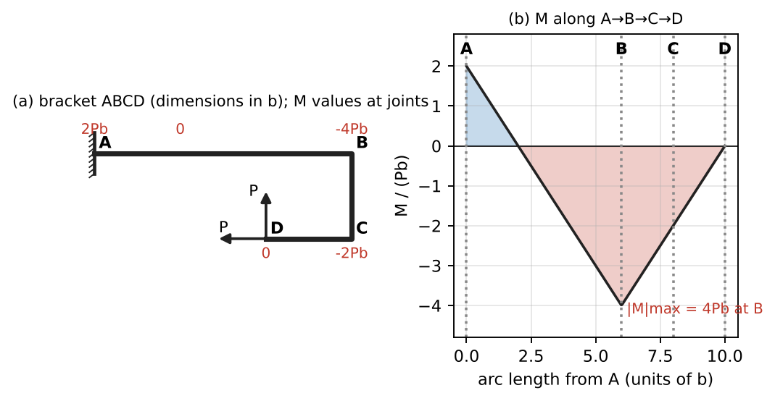
Bending moment along the bracket (units of Pb)

Q19 (PYQ 2019-20 Compre A Q3(a)) — Curved cantilever, forces at section θ (medium)
Original question: PYQ 2019-20 Compre A Q3
Given: quarter circle of radius $R$, fixed at A (θ = 0, at ground level), free at B (θ = 90°, top), with $P$ ↓ at B. θ is measured at the centre O from the horizontal. Position on the arc relative to O: $\left(−Rcosθ,Rsinθ\right)$. The tangent direction (toward B) is $t=\left(sinθ,cosθ\right)$ and the outward radial direction is $n=\left(−cosθ,sinθ\right)$. Segment from the cut to B: load $\left(0,−P\right)$ at B $\left(0,R\right)$.
- Axial (along $t$): $P⋅t=−Pcosθ$, so $\boxed{N=Pcosθ \text{(compression)}}$
- Shear (along $n$): $\boxed{V=Psinθ}$
- Moment: the horizontal lever arm from the cut to B is $Rcosθ$, so $\boxed{M=PRcosθ}$ (tension on the outer fibre)
Check: at B (θ = 90°): $N=M=0$ and $V=P$ (the load is purely transverse there) ✓. At A (θ = 0): $N=P$ and $M=PR$, the maximum ✓. These expressions feed Castigliano’s theorem in Ch. 2 Q12: $δ_{B}=πPR^{3}/4EI+πPR/4AE$.
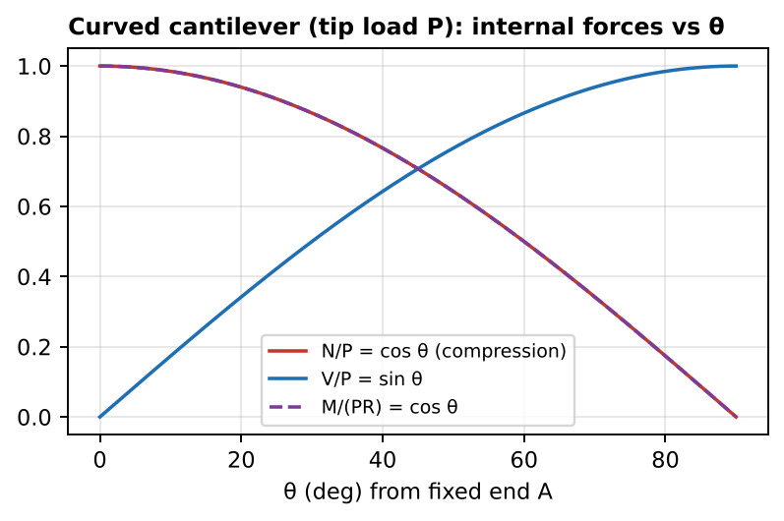
Internal forces vs θ

Chapter 3 — Formula and convention sheet
Item | Crandall / slides
Positive face | outward normal along +x
+ component | (+face, +dir) or (−face, −dir)
$V$ | $=−Σ\left(\text{upward forces left of cut}\right)$ — opposite sign to Gere
$M_{b}$ | sagging +; $=Σ$ moments of left-hand forces about the cut (clockwise +)
Differential relations | $dV/dx=−q$, $dM_{b}/dx=−V$, $d^{2}M_{b}/dx^{2}=q$ (q up +)
Max/min M | where $V=0$ or V changes sign
Contraflexure | where $M$ changes sign
Concentrated load P↓ | V jumps by $+P$ (Crandall), kink in M
Clockwise couple C | M jumps by $+C$, V unchanged
Resultant of distributed load | $R=∫q dx$ at the centroid — reactions only
Standard results | SS + central W: $WL/4$; SS + UDL: $wL^{2}/8$; SS + W at a: $Wab/L$; cantilever + tip P: $−PL$; cantilever + UDL: $−wL^{2}/2$
Singularity | $⟨x−a⟩^{n}$ (0 for $x<a$); point load $⟨⟩_{−1}$, couple $⟨⟩_{−2}$; no constants for V and M
Frame moment | $M=\left(x_{D}−x\right)F_{y}−\left(y_{D}−y\right)F_{x}$
Curved cantilever (tip load) | $N=Pcosθ$, $V=Psinθ$, $M=PRcosθ$
Other Crandall Ch. 3 problems worth practising: 3.1–3.6 (basic SFD/BMD), 3.9–3.11 (arcs and curved bars), 3.13–3.15 (sections in frames), 3.18 (scaffold plank optimisation).

Chapter 4 — Stress and Strain
Stress at a point, plane stress, stress transformation, Mohr’s circle, principal and maximum shear stresses, plane strain, strain transformation, Mohr’s circle of strain, strain rosettes
Sources used: Slides “Chapter 4 part 1” (stress) and “Ch 4 Part 2” (strain), Crandall Ch. 4 (§4.2–4.9, Example on sheet-metal strain, Prob 4.20), PYQs 2019-20 (A-Q2), 2021-22 (A-Q1, B-Q1), 2014-15 (Test-2 Q1, Q2; Compre A-Q12, Q13; Compre B-Q1).

⚠ Read first: sign conventions for this chapter
- Stress sign (Crandall, slides): a stress component is positive when it acts on a positive face in a positive direction, or on a negative face in a negative direction. Tension is +. $τ_{xy}>0$ means that on the right (+x) face the shear points up (+y).
- Angle θ: measured counter-clockwise from x to x′ (the normal of the inclined face).
- Mohr’s circle (Crandall and slides use the same rule): σ is plotted to the right. A positive $τ_{xy}$ is plotted downward at point x and upward at point y. With this rule, a rotation of 2θ counter-clockwise on the circle equals a rotation of θ counter-clockwise on the element. (Beer/Hibbeler say “positive shear (clockwise on element) plotted up”, which is the same circle.)
  - If you plot $τ_{xy}$ upward at x (the “math” convention), the circle is mirrored and 2θ rotations reverse direction. This is the most common Mohr’s-circle mistake in the exam.
- Strain Mohr’s circle: the vertical axis is γ/2, not γ. Same plotting rule: $+γ_{xy}/2$ is downward at x.
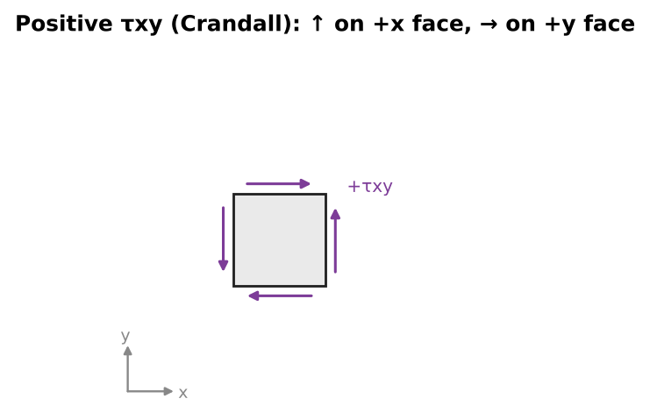
A positive τxy element

Concept 4.1 — Stress at a point and the stress tensor

A. Concept explanation
1. Intuition. Squeeze a sponge in your hand. Every tiny cube inside it is pushed and dragged by its neighbours. “Stress” is the intensity of that push or drag, force per unit area, on a particular imaginary cut. A single number isn’t enough, because the answer depends on which way you slice. Slice it one way and the material is pulled apart; slice at 45° and it may be sliding.
2. Why it matters (slides’ motivating example). A bracket ABC carries 30 kN at B. AC is 2 m horizontal and BC is a 20 mm rod rising 1.5 m. Statics gives $F_{BC}=50$ kN (T) and $F_{AB}=40$ kN (C), but that alone doesn’t tell you whether rod BC survives. That depends on (1) the internal force, (2) the cross-sectional area and (3) the material.
$$σ_{BC}=\frac{50 000}{π{\left(10\right)}^{2}}=159 \text{MPa}$$
Compare this with the allowable stress of the material (for example, 165 MPa for structural steel, which is safe). Stress is the bridge from forces (Ch. 1–3) to material failure (Ch. 5).
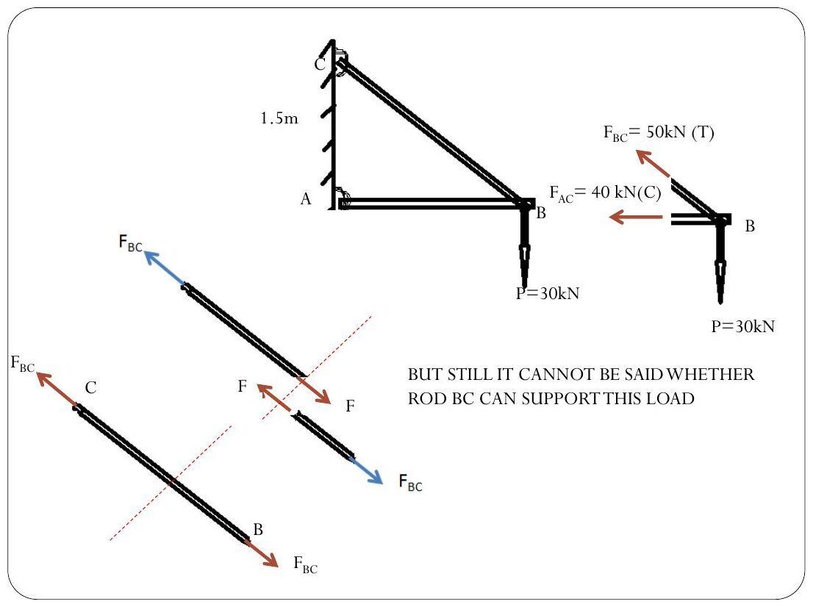
Original: Slides Ch 4 Part 1, slide 3
3. Formal treatment (Crandall §4.2–4.3, slide figures 4.1–4.8). Cut the body by a plane with normal $n$ through point O. On a small area $ΔA$ the internal force is $ΔF$. Resolve it into components on an x-face ($ΔA_{x}=ΔyΔz$):
$$σ_{x}=\lim_{ΔA_{x}→0}\frac{ΔF_{x}}{ΔA_{x}}, τ_{xy}=lim\frac{ΔF_{y}}{ΔA_{x}}, τ_{xz}=lim\frac{ΔF_{z}}{ΔA_{x}}$$
The first subscript is the face normal and the second is the direction. Doing this on all three faces gives the stress tensor:
$$\left[\begin{matrix}σ_{x} & τ_{xy} & τ_{xz} \\ τ_{yx} & σ_{y} & τ_{yz} \\ τ_{zx} & τ_{zy} & σ_{z}\end{matrix}\right]$$
Plane stress (slides): only the components in one plane are non-zero, $σ_{z}=τ_{zx}=τ_{zy}=0$. Two faces of the cube are stress-free. This is typical of thin plates loaded in their plane and of the free surface of any part (where all strain gauges sit).
4. Derivation — equilibrium of a differential element (Crandall Fig. 4.10, slides). On an element $Δx×Δy×Δz$ in plane stress, the stresses change from face to face, for example $σ_{x}$ on the left and $σ_{x}+\frac{∂σ_{x}}{∂x}Δx$ on the right.
- Moment about the z-axis through the centre: $\left(τ_{xy}ΔyΔz\right)Δx−\left(τ_{yx}ΔxΔz\right)Δy+\left(\text{higher-order terms}\right)=0$. Divide by $ΔxΔyΔz$ and let the element shrink:
$$\boxed{τ_{xy}=τ_{yx}} \text{(shear stresses on perpendicular faces are equal; they point toward or away from the same corner)}$$
- Force balance in x and y (no body force):
$$\boxed{\frac{∂σ_{x}}{∂x}+\frac{∂τ_{xy}}{∂y}=0, \frac{∂τ_{xy}}{∂x}+\frac{∂σ_{y}}{∂y}=0}$$
- So in 3-D only 6 of the 9 stress components are independent.
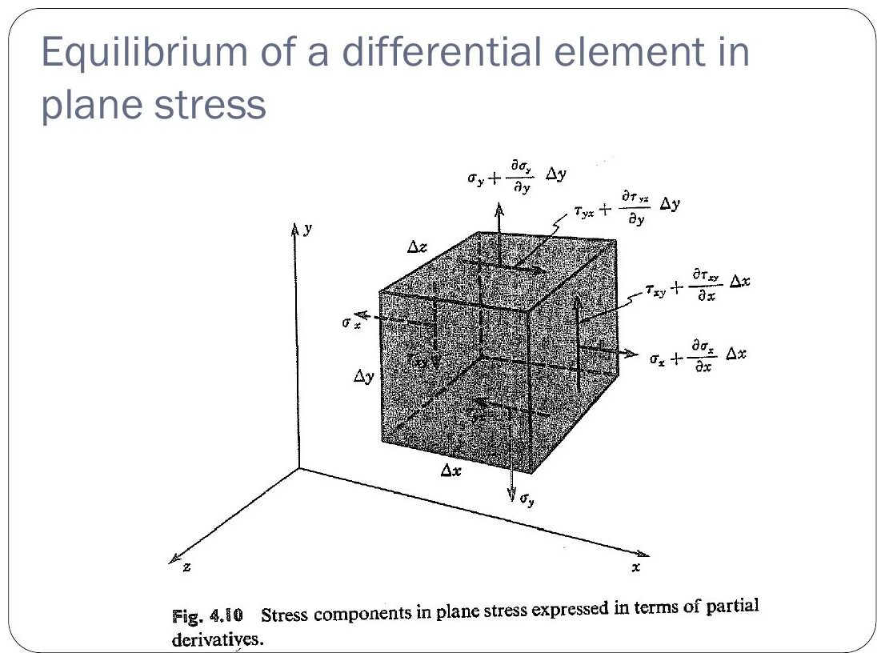
Original: Slides Ch 4 Part 1, slide 11
5. Picture. A positive $τ_{xy}$ element (Crandall Fig. 4.11): arrows ↑ on the right face, ↓ on the left face, → on the top face, ← on the bottom face. The element is pushed into a rhombus that is “stretched along the 45° diagonal” (the diagonal joining the first-quadrant corner to the third-quadrant corner).
6. Special cases. Uniaxial: only $σ_{x}$. Hydrostatic: $σ_{x}=σ_{y}=σ_{z}=−p$ with no shear on any plane. Pure shear: only $τ_{xy}$.
7. Traps. Drawing $τ_{yx}$ opposite to $τ_{xy}$ on adjacent faces. They must meet head-to-head or tail-to-tail at the corners. Forgetting that stress is force per area: you can’t add stresses on differently-oriented faces without multiplying by the areas (that is the next concept).
8. Summary. Stress = force/area on a specified face. Plane stress is described by $\left(σ_{x},σ_{y},τ_{xy}\right)$, with $τ_{xy}=τ_{yx}$.

Concept 4.2 — Stress transformation in plane stress

A. Concept explanation
1. Intuition. The material at a point is in one definite physical state. Rotating the imaginary cube is like walking around a statue: you see it differently but the statue doesn’t change. The transformation equations tell you what $σ$ and $τ$ a cut at angle θ “sees”.
2. Why it matters. Welded and glued joints at an angle, the grain of wood, failure planes (ductile metals fail on 45° shear planes, brittle ones on principal planes), and the starting point for principal stresses and Mohr’s circle.
3. Formal treatment. Given $σ_{x},σ_{y},τ_{xy}$, find $σ_{x′},τ_{x′y′}$ on the face whose outward normal $x′$ is at angle θ counter-clockwise from x.
4. Derivation (wedge equilibrium, slides). Cut a triangular wedge: the inclined face has area $ΔA$ and normal $x′$. The vertical (−x) face has area $ΔAcosθ$ and the horizontal (−y) face has area $ΔAsinθ$. Forces on the negative faces (multiply stress by area):
- −x face: $σ_{x}ΔAcosθ$ (←) and $τ_{xy}ΔAcosθ$ (↓)
- −y face: $σ_{y}ΔAsinθ$ (↓) and $τ_{xy}ΔAsinθ$ (←)
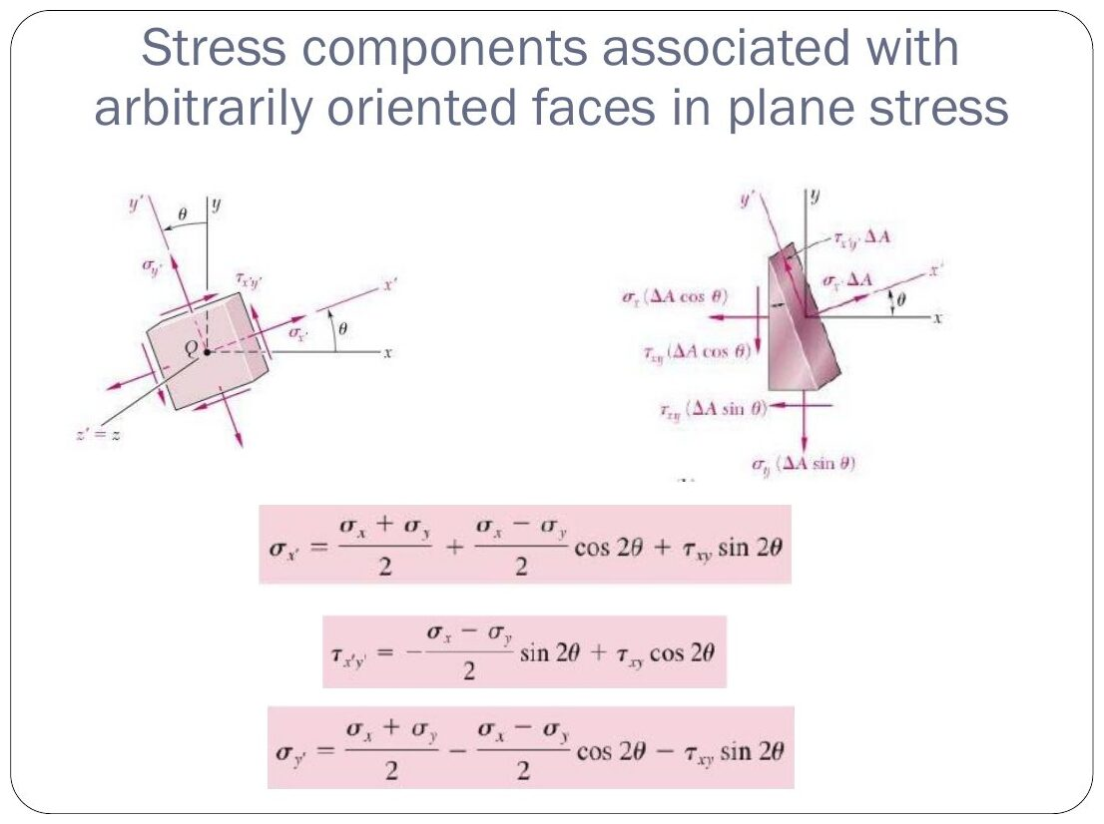
Original: Slides Ch 4 Part 1, slide 15
Sum forces along $x′$ (unit vector $\left(cosθ,sinθ\right)$):
$$σ_{x′}ΔA=σ_{x}ΔA\cos^{2}θ+σ_{y}ΔA\sin^{2}θ+2τ_{xy}ΔAsinθcosθ$$
Sum forces along $y′$ (unit vector $\left(−sinθ,cosθ\right)$):
$$τ_{x′y′}=−\left(σ_{x}−σ_{y}\right)sinθcosθ+τ_{xy}\left(\cos^{2}θ−\sin^{2}θ\right)$$
Use the double-angle identities $\cos^{2}θ=\frac{1+cos2θ}{2}$, $\sin^{2}θ=\frac{1−cos2θ}{2}$, $2sinθcosθ=sin2θ$:
$$\boxed{σ_{x′}=\frac{σ_{x}+σ_{y}}{2}+\frac{σ_{x}−σ_{y}}{2}cos2θ+τ_{xy}sin2θ}$$
$$\boxed{τ_{x′y′}=−\frac{σ_{x}−σ_{y}}{2}sin2θ+τ_{xy}cos2θ}$$
$$\boxed{σ_{y′}=\frac{σ_{x}+σ_{y}}{2}−\frac{σ_{x}−σ_{y}}{2}cos2θ−τ_{xy}sin2θ}$$
Invariant: $σ_{x′}+σ_{y′}=σ_{x}+σ_{y}$. Use it to check every answer.
5. Picture. All three equations depend on 2θ, so rotating the element by 180° gives the same state (as it must, since a face and its opposite are the same plane).
6. Special cases.
- Uniaxial $σ_{x}=σ$: $σ_{θ}=σ\cos^{2}θ$ and $τ=−\frac{σ}{2}sin2θ$, so ${\left|τ\right|}_{max}=σ/2$ at 45°. This is why ductile bars fail at 45°.
- Pure shear $τ$: $σ_{{45}^{∘}}=+τ$ and $σ_{{135}^{∘}}=−τ$, so the principal stresses are ±τ at 45°. This is the basis of torsion strain-gauge problems (Ch. 6).
7. Traps.
- Measuring θ from the plane instead of from its normal. If a weld line is at β to the cross-section, the weld’s normal is at β to the axis.
- Using θ instead of 2θ in the trig functions.
- Mixing up the sign of $τ_{xy}$ (check the right face: is the arrow up?).

B. Solved questions

Q1 (Slides Ch4) — Stresses on a 45° plane (easy)
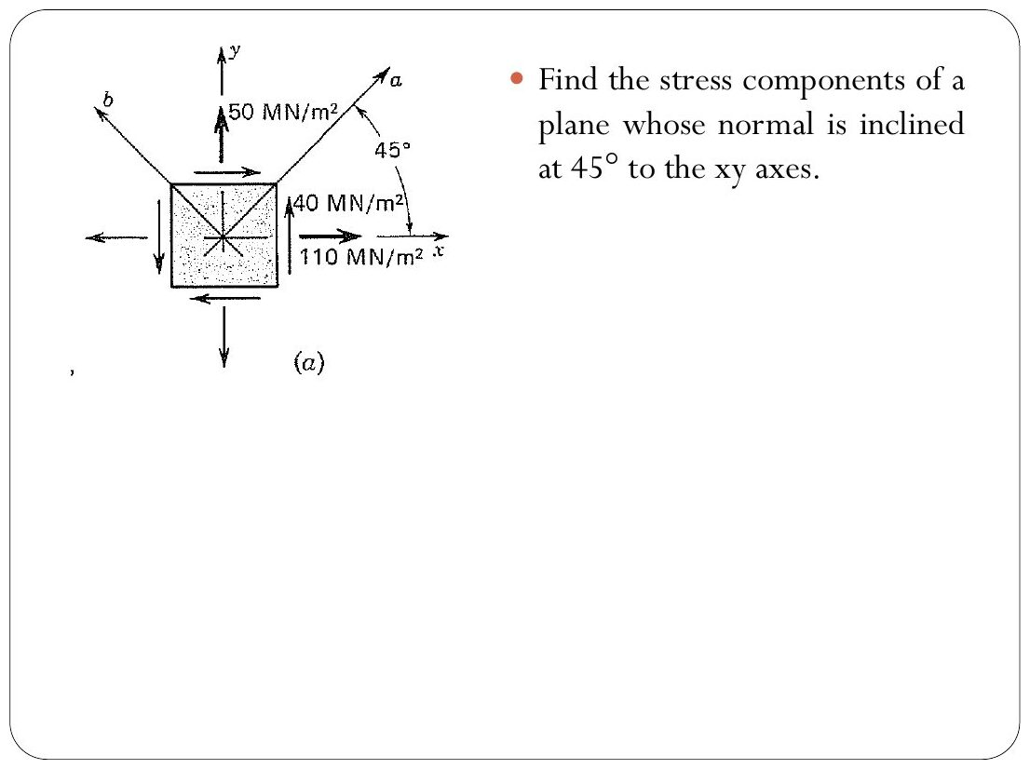
Original: Slides Ch 4 Part 1, slide 21
Given: $σ_{x}=110$, $σ_{y}=50$, $τ_{xy}=+40$ MN/m² (MPa). Find: the stresses on faces a (normal at 45°) and b (normal at 135°). $\frac{σ_{x}+σ_{y}}{2}=80$, $\frac{σ_{x}−σ_{y}}{2}=30$, and $2θ={90}^{∘}$ (cos = 0, sin = 1).
$$σ_{a}=80+0+40=\boxed{120 \text{MPa}}, τ_{ab}=−30+0=\boxed{−30 \text{MPa}}, σ_{b}=80−0−40=\boxed{40 \text{MPa}}$$
Check: $120+40=160=110+50$ ✓. On face a the shear acts toward −b, i.e. clockwise on the rotated element.
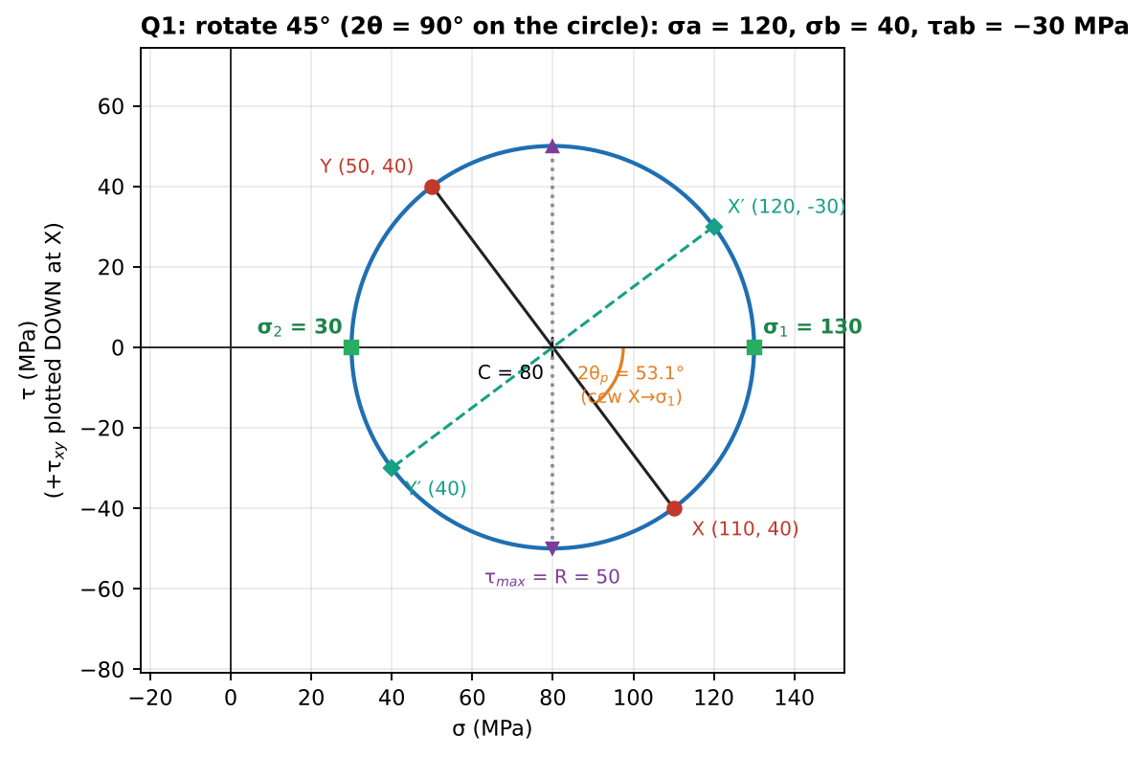
Mohr’s circle: diameter XY rotated 90° to X′Y′

Q2 (Slides Ch4, Beer Prob 7.x) — Oblique face by wedge equilibrium (medium)
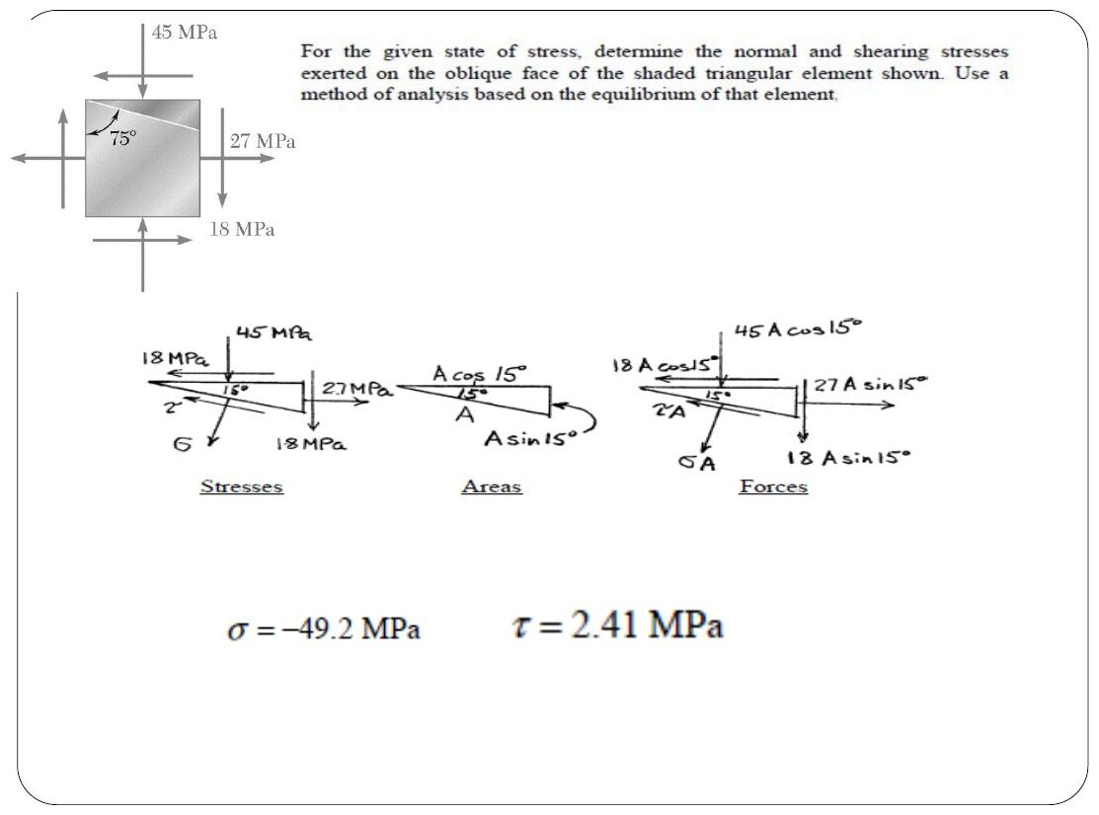
Original: Slides Ch 4 Part 1, slide 35
Given: $σ_{x}=27$ MPa, $σ_{y}=−45$ MPa, $τ_{xy}=18$ MPa. The shaded triangle’s oblique face is 15° from the horizontal, so its outward normal is at θ = 105° (= 90° + 15°). Find: σ and τ on the oblique face.
$$σ=−9+36cos{210}^{∘}+18sin{210}^{∘}=−9−31.18−9=\boxed{−49.2 \text{MPa}}$$
$$τ=−36sin{210}^{∘}+18cos{210}^{∘}=18−15.59=\boxed{2.41 \text{MPa}}$$
✓ Matches the slide answer. The slide sets up the force balance on the wedge with areas $Acos{15}^{∘}$ and $Asin{15}^{∘}$, which is exactly the derivation above with numbers.
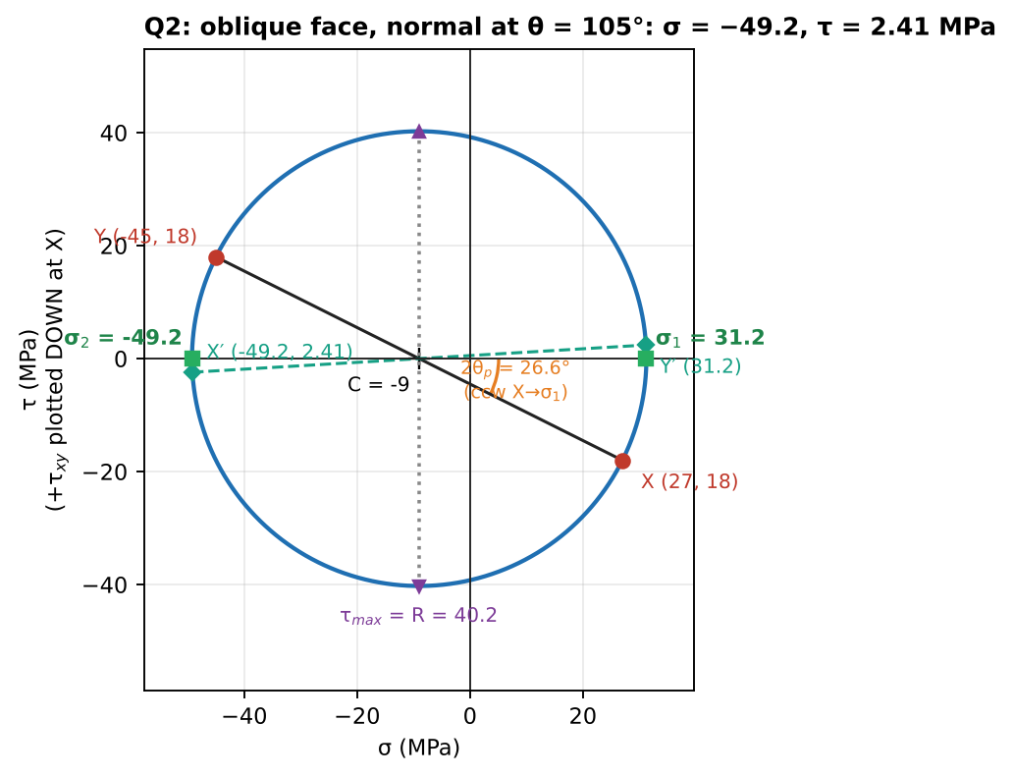
Mohr’s circle check

Q3 (Slides Ch4, Beer Prob 7.x) — Welded plates (medium)
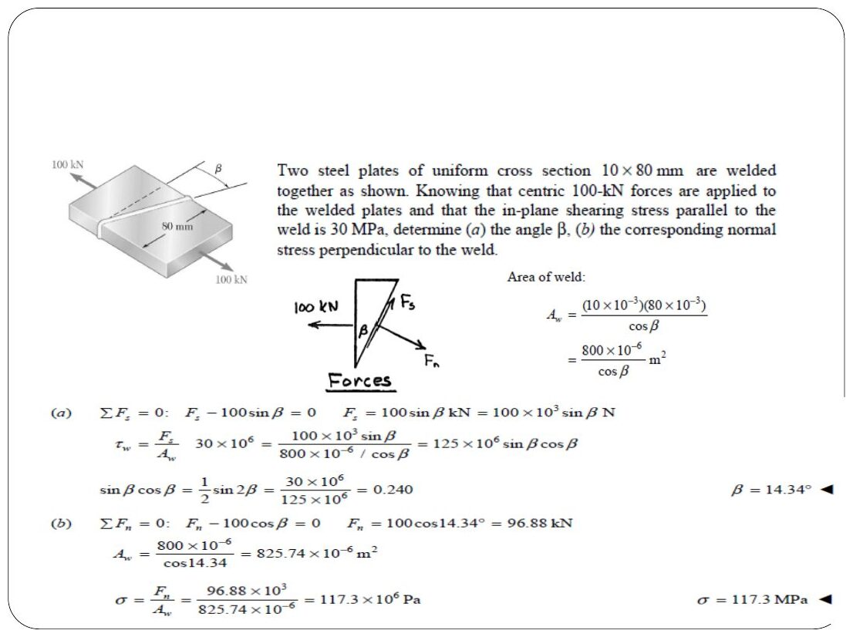
Original: Slides Ch 4 Part 1, slide 33
Given: two steel plates 10 × 80 mm, welded along a line at angle β to the cross-section, axial force 100 kN. In-plane shear stress parallel to the weld = 30 MPa. Find: (a) β, (b) the normal stress perpendicular to the weld. $σ_{x}=100 000/\left(10×80\right)=125$ MPa (uniaxial). The weld’s normal is at β to the axis.

  - $\left|τ\right|=\frac{σ_{x}}{2}sin2β=62.5sin2β=30⇒sin2β=0.48⇒\boxed{β={14.3}^{∘}}$

  - $σ=\frac{σ_{x}}{2}\left(1+cos2β\right)=62.5\left(1+0.8773\right)=\boxed{117.3 \text{MPa}}$
Check by direct force balance (slides): $F_{s}=100sinβ=24.77$ kN and $A_{w}=800/cosβ=825.7$ mm². $24770/825.7=30$ MPa ✓.
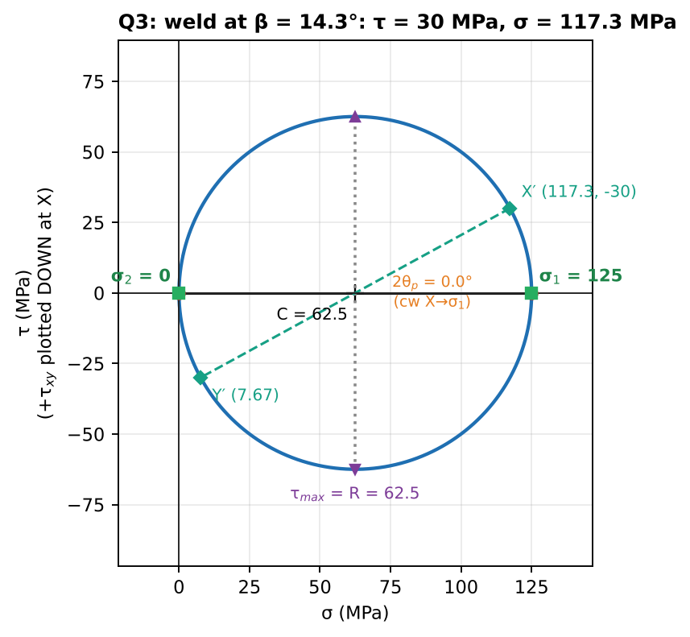
Uniaxial circle with the weld plane marked

Concept 4.3 — Mohr’s circle, principal stresses and maximum shear stress

A. Concept explanation
1. Intuition. As you spin the cut through 180°, the pair $\left(σ_{x′},τ_{x′y′}\right)$ traces out a circle. The rightmost point of the circle is the largest normal stress any cut can feel, the leftmost is the smallest, and the top and bottom are the largest shear. Mohr’s circle is a picture of every possible cut at once.
2. Why it matters. Failure criteria (Ch. 5) need principal stresses, and PYQs ask for “principal stresses and orientation” or “sketch the Mohr’s circle” every year.
3. Formal treatment / 4. Derivation (slides). Move the average to the left side and square both transformation equations:
$${\left(σ_{x′}−\frac{σ_{x}+σ_{y}}{2}\right)}^{2}={\left(\frac{σ_{x}−σ_{y}}{2}cos2θ+τ_{xy}sin2θ\right)}^{2}, τ_{x′y′}^{2}={\left(−\frac{σ_{x}−σ_{y}}{2}sin2θ+τ_{xy}cos2θ\right)}^{2}$$
Add them. The cross terms cancel and $\sin^{2}+\cos^{2}=1$:
$$\boxed{{\left(σ_{x′}−σ_{avg}\right)}^{2}+τ_{x′y′}^{2}=R^{2}}, σ_{avg}=\frac{σ_{x}+σ_{y}}{2}, R=\sqrt{{\left(\frac{σ_{x}−σ_{y}}{2}\right)}^{2}+τ_{xy}^{2}}$$
This is a circle with centre $\left(σ_{avg},0\right)$ and radius $R$.
Principal stresses (shear = 0): set $τ_{x′y′}=0$:
$$\boxed{tan2θ_{p}=\frac{2τ_{xy}}{σ_{x}−σ_{y}}}, \boxed{σ_{1,2}=σ_{avg}±R}$$
This gives two angles 90° apart. To tell which angle gives σ₁, substitute it back into the $σ_{x′}$ equation. Equivalently, $dσ_{x′}/dθ=0$ gives the same condition, so principal stresses are the extremes of normal stress.
Maximum in-plane shear:
$$\boxed{τ_{max}=R=\frac{σ_{1}−σ_{2}}{2}}, tan2θ_{s}=−\frac{σ_{x}−σ_{y}}{2τ_{xy}}, θ_{s}=θ_{p}±{45}^{∘}$$
On the max-shear planes the normal stress is not zero. It equals $σ′=σ_{avg}$.
Absolute maximum shear (3-D view of plane stress): the out-of-plane principal stress is $σ_{3}=0$. Order the three as $σ_{max}≥σ_{mid}≥σ_{min}$. Then
$$τ_{abs,max}=\frac{σ_{max}−σ_{min}}{2}$$
If $σ_{1},σ_{2}$ have the same sign, $τ_{abs}=\left|σ_{1}\right|/2$ (or $\left|σ_{2}\right|/2$), which is larger than the in-plane $R$. Examiners love this.
5. Graphical construction (Crandall §4.5, slides). You must be able to draw this.
- Axes: σ horizontal (+ right) and τ vertical. Following Crandall, positive τ plotted downward at x.
- Plot X $=(σ_{x}, τ_{xy}$ downward if positive$)$.
- Plot Y $=(σ_{y}, τ_{xy}$ upward if positive$)$.
- Join XY. It crosses the σ-axis at the centre C $=σ_{avg}$. Radius $R=CX$.
- Points A (rightmost) and B (leftmost) give $σ_{1}$ and $σ_{2}$. Points D and E (top and bottom) give $±τ_{max}$, both at $σ_{avg}$.
- To find the stresses on a face rotated θ counter-clockwise, rotate the diameter XY by 2θ in the same sense (counter-clockwise). The new ends are X′ and Y′.
- The angle from CX to CA, measured on the circle, is $2θ_{p}$. The element rotates by $θ_{p}$ in the same sense.
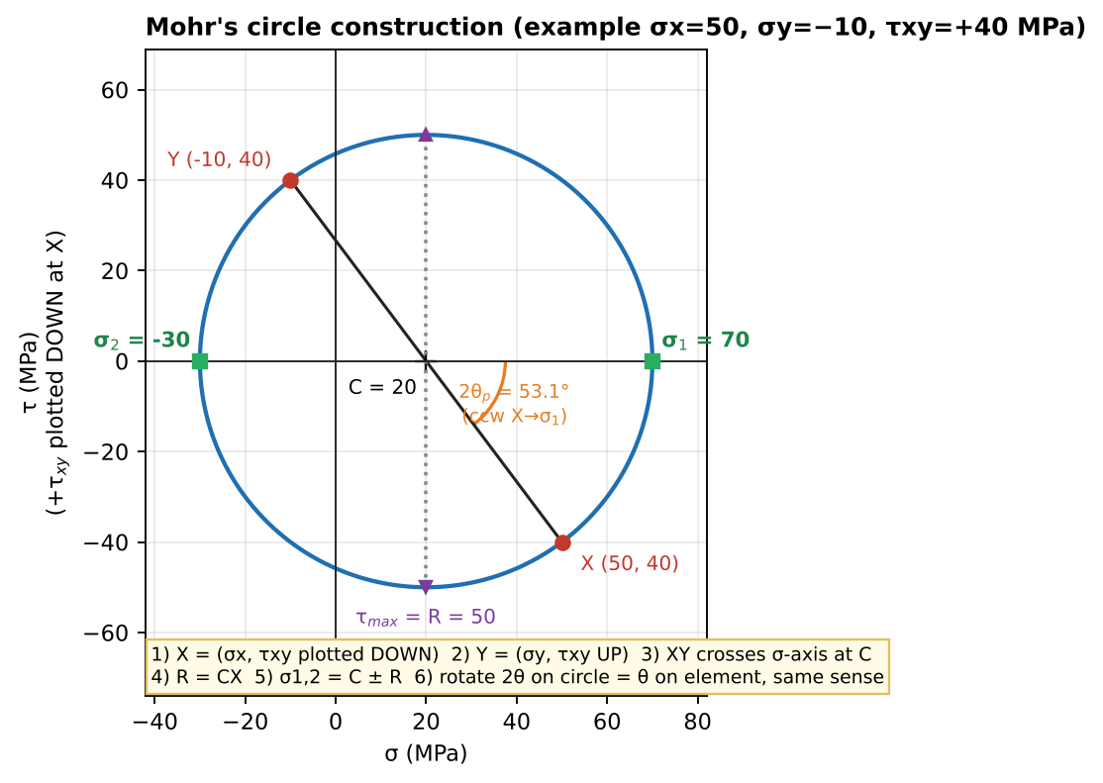
Mohr’s circle construction (Crandall convention)
6. Special cases.
State | Circle
Uniaxial σ | passes through the origin, $R=σ/2$
Pure shear τ | centred at the origin, $R=τ$, principal stresses ±τ at 45°
Equal biaxial $σ_{x}=σ_{y}$, $τ=0$ | shrinks to a point, every direction is principal
Hydrostatic | a point, no shear on any plane
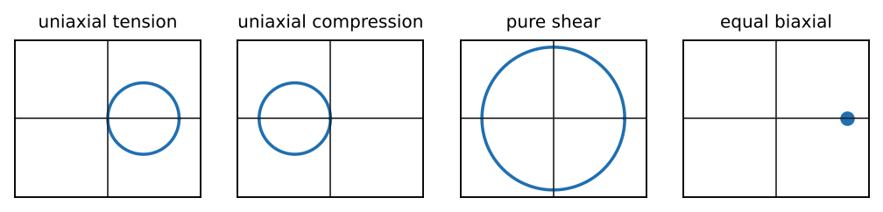
Signature circles: uniaxial tension, uniaxial compression, pure shear, equal biaxial
7. Common traps.
- θ vs 2θ: angles on the circle are double the element angles.
- Direction of rotation: consistent only if you plot +τ downward at X (Crandall convention).
- Using $arctan$ blindly: $tan2θ_{p}$ has two solutions 180° apart. Pick by checking the quadrant on the circle, or substitute back.
- Reporting $τ_{max}$ = R when both principal stresses have the same sign (the true maximum is out of plane).
- Forgetting $σ_{avg}$ on the max-shear planes when drawing the element.
8. Summary box
$$σ_{1,2}=\frac{σ_{x}+σ_{y}}{2}±\sqrt{{\left(\frac{σ_{x}−σ_{y}}{2}\right)}^{2}+τ_{xy}^{2}}, tan2θ_{p}=\frac{2τ_{xy}}{σ_{x}−σ_{y}}, τ_{max}=R, θ_{s}=θ_{p}±{45}^{∘}, σ′=σ_{avg}$$

B. Solved questions

Q4 (Slides Ch4, Beer Ex 7.1) — Principal planes, principal stresses, max shear (easy, classic)
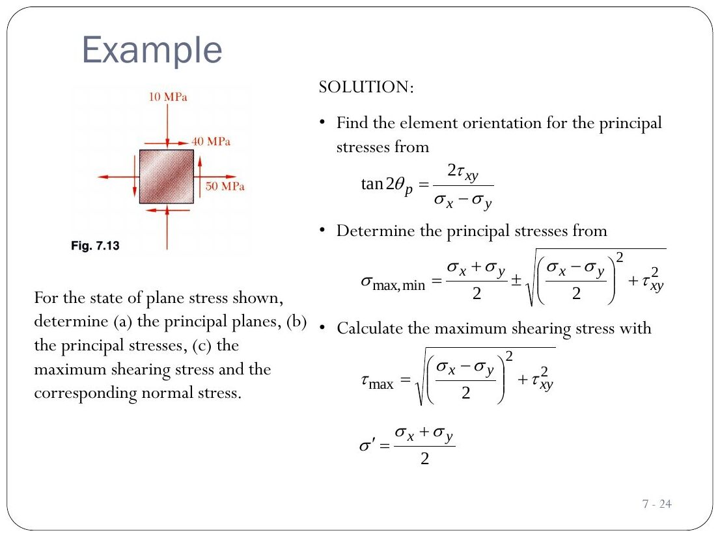
Original: Slides Ch 4 Part 1, slide 24
Given: $σ_{x}=50$, $σ_{y}=−10$, $τ_{xy}=+40$ MPa. Equations: $tan2θ_{p}=\frac{80}{60}=1.333⇒2θ_{p}={53.1}^{∘}$, so $θ_{p}={26.6}^{∘}$ and ${116.6}^{∘}$. Substitute θ = 26.6°: $σ_{x′}=20+30\left(0.6\right)+40\left(0.8\right)=70$, so this angle gives σ₁.
$$\boxed{σ_{1}=70 \text{MPa at} {26.6}^{∘}, σ_{2}=−30 \text{MPa at} {116.6}^{∘}}$$
$$\boxed{τ_{max}=50 \text{MPa at} θ_{s}=−{18.4}^{∘} \left(\text{and }{71.6}^{∘}\right), σ′=20 \text{MPa}}$$
Mohr’s circle: C = 20, R = $\sqrt{{30}^{2}+{40}^{2}}=50$. X = (50, 40 below), Y = (−10, 40 above). From X to A is 53.1° counter-clockwise, so the element rotates 26.6° counter-clockwise ✓. Absolute max shear: σ₁ = 70, σ₂ = −30, σ₃ = 0, so $τ_{abs}=\left(70−\left(−30\right)\right)/2=50$ MPa (same as in-plane, because the signs are opposite).
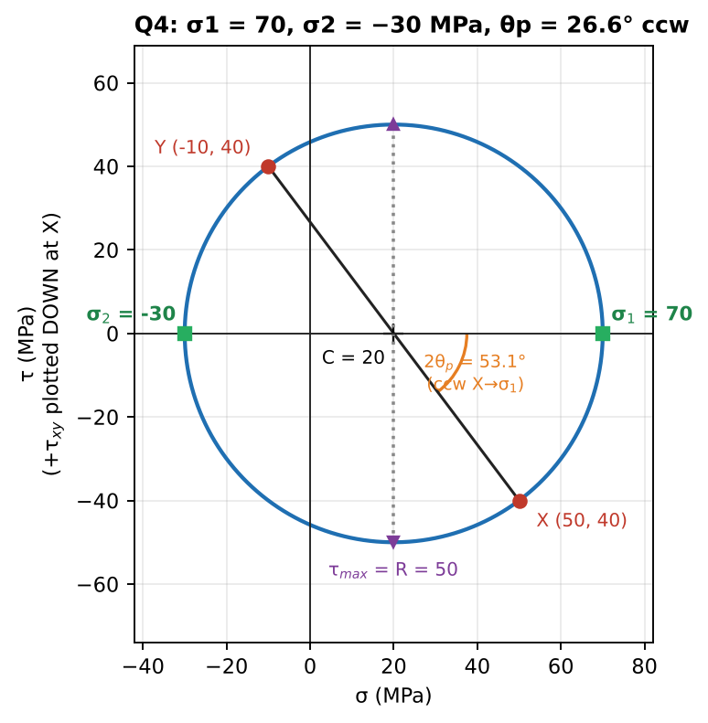
Mohr’s circle
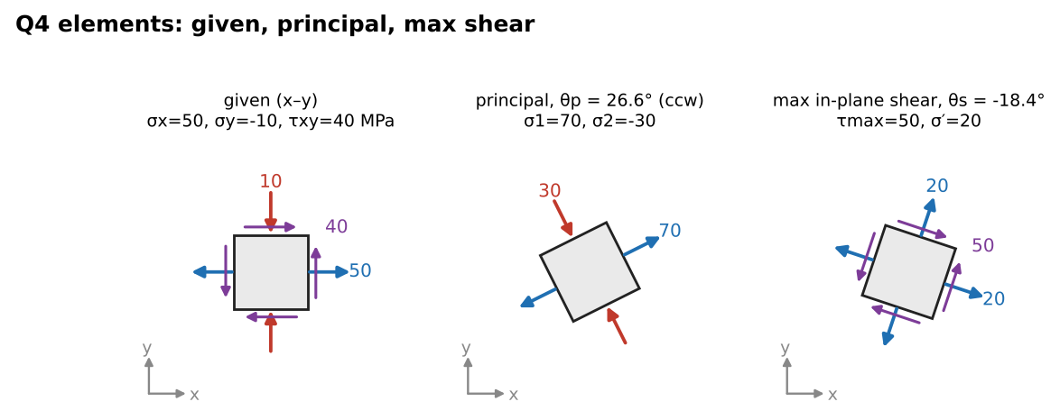
Stress elements: given, principal, maximum shear

Q5 (Slides Ch4, Beer Sample 7.2) — Principal stresses, then rotate the element 30° CCW (medium)
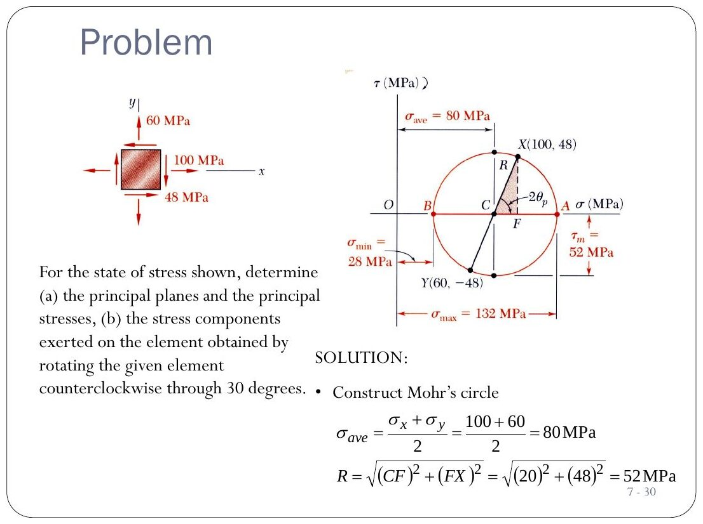
Original: Slides Ch 4 Part 1, slide 30
Given: $σ_{x}=100$, $σ_{y}=60$, $τ_{xy}=−48$ MPa (shear on the right face points down). C = 80, R = $\sqrt{{20}^{2}+{48}^{2}}=52$.
$$\boxed{σ_{1}=132 \text{MPa}, σ_{2}=28 \text{MPa}, θ_{p}={33.7}^{∘} \text{clockwise}}$$
($tan2θ_{p}=−96/40⇒2θ_{p}=−{67.4}^{∘}$.) Rotate the element 30° CCW (2θ = 60° on the circle):
$$σ_{x′}=80+20cos{60}^{∘}−48sin{60}^{∘}=\boxed{48.4 \text{MPa}}, σ_{y′}=\boxed{111.6 \text{MPa}}, τ_{x′y′}=−20sin{60}^{∘}−48cos{60}^{∘}=\boxed{−41.3 \text{MPa}}$$
Mohr’s circle check: X starts 67.4° clockwise from A (it is at 48 above, because τ is negative). Rotating 60° counter-clockwise puts X′ at φ = 180° − 60° − 67.4° = 52.6° from the negative σ-axis. So $σ_{x′}=80−52cos{52.6}^{∘}=48.4$ ✓ and $\left|τ\right|=52sin{52.6}^{∘}=41.3$ ✓ (slide method). Invariant: 48.4 + 111.6 = 160 ✓.
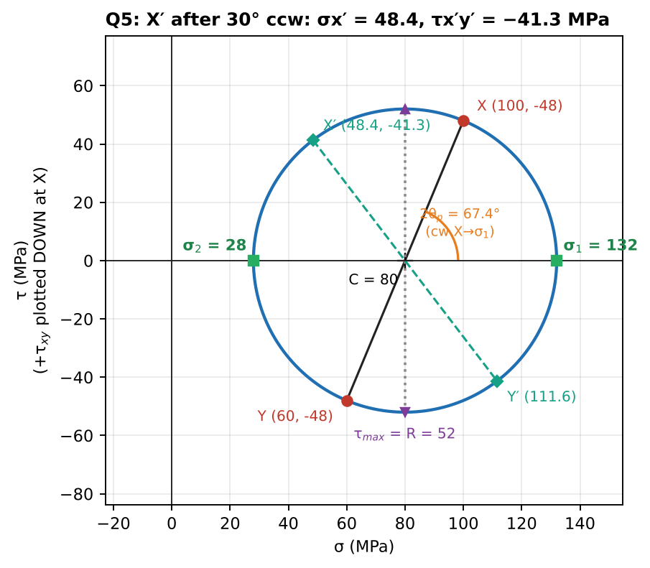
Mohr’s circle with the rotated diameter X′Y′
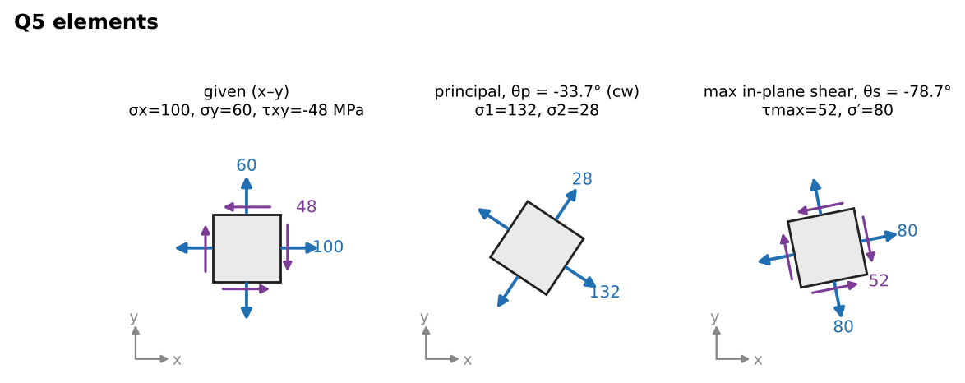
Stress elements

Q6 (PYQ 2014-15 Compre A Q12) — Principal stresses (easy, 1-line answer)
Original question: PYQ 2014-15 Compre A Q12–Q13
$σ_{x}=50$, $σ_{y}=−10$, $τ_{xy}=40$ MPa, the same as Q4.
$$\boxed{σ_{1}=70 \text{MPa}, σ_{2}=−30 \text{MPa}}$$

Q7 (PYQ 2014-15 Compre A Q13) — Which Mohr’s circle? (easy, conceptual)
The element in the figure has only shear (no normal arrows), so it is pure shear. Its Mohr’s circle is centred at the origin with radius τ. Choose the option whose circle is centred on the intersection of the axes (option c in the scanned paper, the circle centred on both axes). Takeaway: know the four “signature” circles (uniaxial tension, uniaxial compression, pure shear, equal biaxial).

Q8 (PYQ 2014-15 Test-2 Q1) — Axial force + torque on a 40 mm shaft: principal stresses and Mohr’s circle (medium, 20 marks)
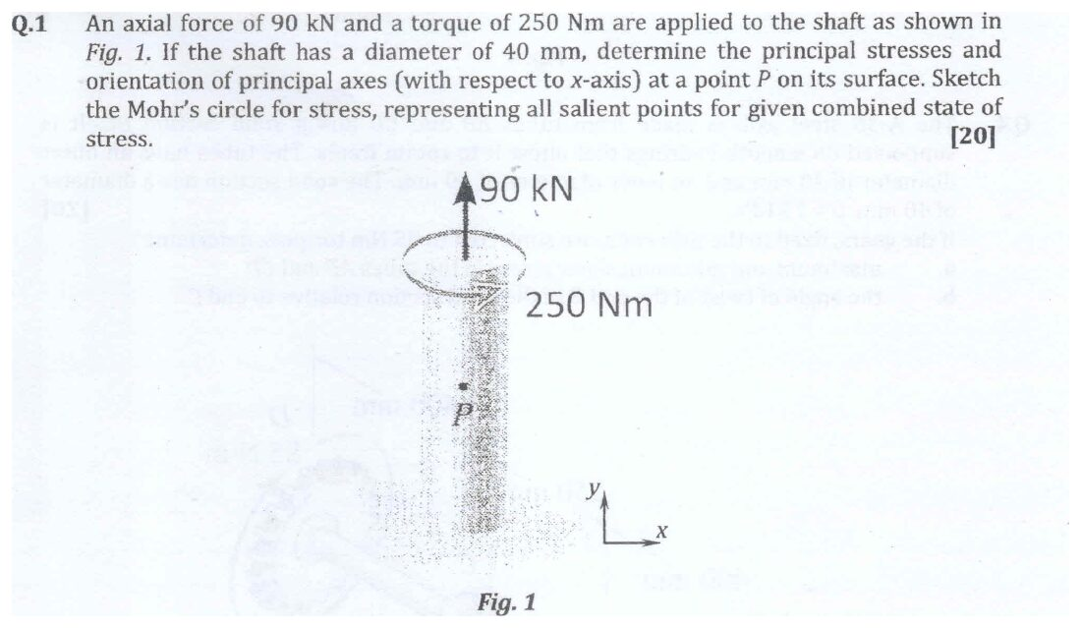
Original question: PYQ 2014-15 Test-2 Q1
Given: $P=90$ kN (tension), $T=250$ N·m, $d=40$ mm. Point P is on the surface. Find: principal stresses, orientation, Mohr’s circle.
- Axial: $σ=\frac{P}{A}=\frac{90 000}{π{\left(20\right)}^{2}}=71.6$ MPa
- Torsion (Ch. 6): $τ=\frac{16T}{πd^{3}}=\frac{16\left(250 000\right)}{π{\left(40\right)}^{3}}=19.9$ MPa
With the bar axis vertical (the y-axis in the figure): $σ_{y}=71.6$, $σ_{x}=0$, $\left|τ_{xy}\right|=19.9$. $σ_{avg}=35.8$, $R=\sqrt{{35.8}^{2}+{19.9}^{2}}=41.0$.
$$\boxed{σ_{1}=76.8 \text{MPa}, σ_{2}=−5.2 \text{MPa}, τ_{max}=41.0 \text{MPa}}$$
$tan2θ_{p}=\frac{2\left(19.9\right)}{71.6}⇒θ_{p}={14.5}^{∘}$, measured from the bar axis (the y-axis) to the σ₁ direction, i.e. 75.5° from the x-axis. The sense follows the direction of T. Mohr’s circle: centre 35.8, radius 41.0. It crosses the τ-axis because σ₂ < 0. Mark X(0, 19.9) and Y(71.6, 19.9) on opposite sides. Check: σ₁σ₂ = −398 = −τ² (since $σ_{x}=0$) ✓.
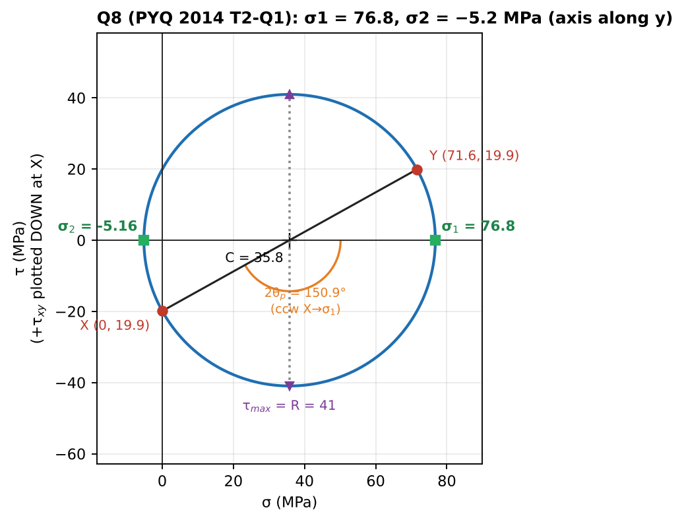
Mohr’s circle

Q9 (PYQ 2014-15 Compre B Q1) — Superposing two stress states (hard, 15 marks)
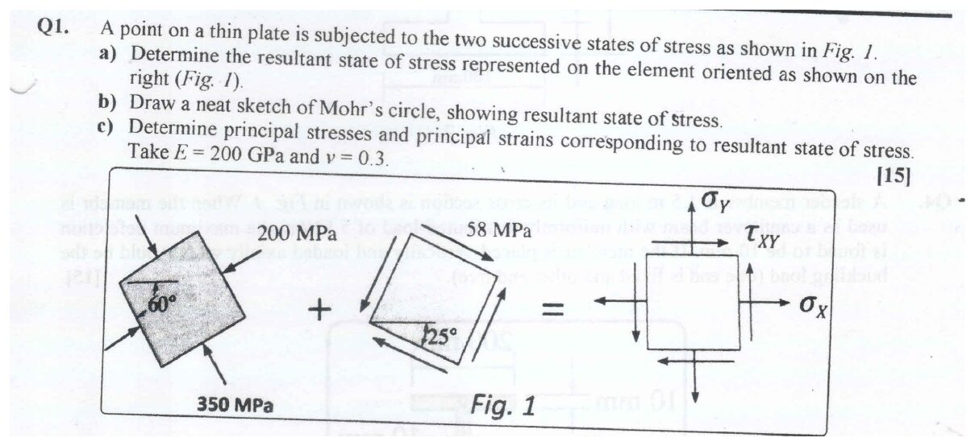
Original question: PYQ 2014-15 Compre B Q1
Given: state 1 is biaxial compression (−350 MPa and −200 MPa) on an element rotated 60°. State 2 is pure shear of 58 MPa on an element rotated 25°. Find: the resultant on the x–y element, the Mohr’s circle, principal stresses and strains ($E=200$ GPa, ν = 0.3).
Key idea: you cannot add stresses on differently oriented elements. First transform each state to the same x–y axes (using the transformation equations with $θ=−{60}^{∘}$ and $θ=−{25}^{∘}$), then add component by component.
State 1 (σ′ = −350 along x′ at 60°, σ″ = −200 along y′):
$$σ_{x}=−275+\left(−75\right)cos\left(−{120}^{∘}\right)=−237.5, σ_{y}=−312.5, τ_{xy}=−\left(−75\right)sin\left(−{120}^{∘}\right)=−65.0$$
State 2 (pure shear τ′ = −58 on an element at 25°; the sign follows the arrows):
$$σ_{x}=τ′sin\left(−{50}^{∘}\right)=44.4, σ_{y}=−44.4, τ_{xy}=τ′cos\left(−{50}^{∘}\right)=−37.3$$
Sum:
$$\boxed{σ_{x}≈−193 \text{MPa}, σ_{y}≈−357 \text{MPa}, \left|τ_{xy}\right|≈102 \text{MPa}}$$
(This matches the textbook answer to the Hibbeler problem this question is taken from. The sign of τ depends on how the arrows are read. The principal values below don’t depend on it.)
Principal stresses: $σ_{avg}=−275$ and $R=\sqrt{{81.9}^{2}+{102.2}^{2}}=131.0$:
$$\boxed{σ_{1}=−144 \text{MPa}, σ_{2}=−406 \text{MPa}} \left(σ_{3}=0\right)$$
Principal strains (Hooke’s law, plane stress; see Ch. 5):
$$ϵ_{1}=\frac{σ_{1}−νσ_{2}}{E}=\frac{−144+121.8}{200 000}=\boxed{−111×{10}^{−6}}, ϵ_{2}=\frac{−406+43.2}{200 000}=\boxed{−1814×{10}^{−6}}$$
$$ϵ_{3}=−\frac{ν}{E}\left(σ_{1}+σ_{2}\right)=\boxed{+825×{10}^{−6}} \text{(thickness grows)}$$
Checks: the invariant $σ_{x}+σ_{y}=−550=σ_{1}+σ_{2}$ ✓. Both principal stresses are compressive, so the circle lies entirely left of the τ-axis, and $τ_{abs,max}=406/2=203$ MPa > R.
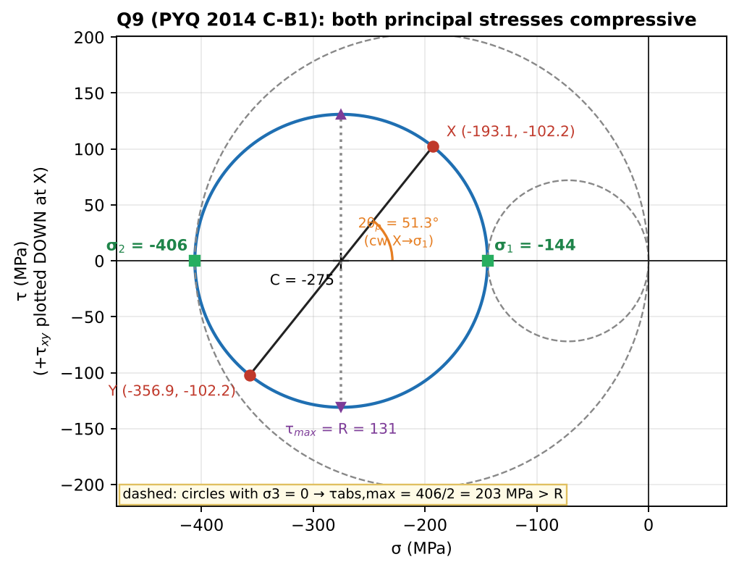
Mohr’s circle, with the σ3 = 0 circles dashed
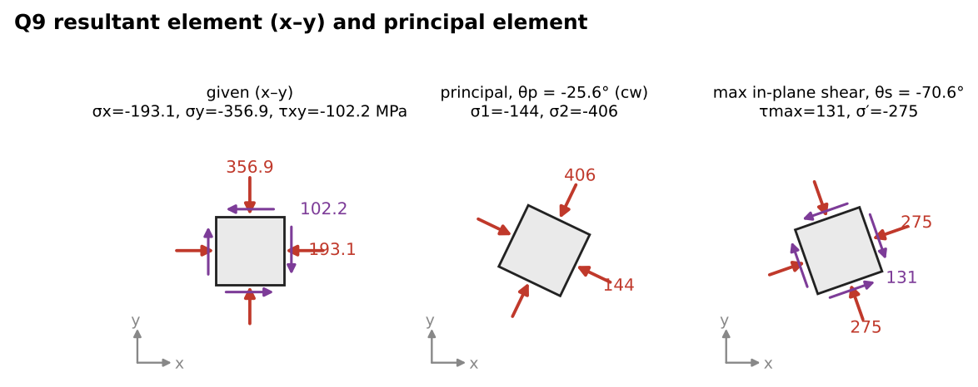
Resultant x–y element and principal element

Concept 4.4 — Strain and strain–displacement relations (plane strain)

A. Concept explanation
1. Intuition. Draw a circle on a rubber sheet and stretch it. The circle becomes an ellipse (slide picture of circle ABCD…). Some diameters get longer (normal strain) and right angles between lines change (shear strain). Strain is the geometry of deformation, just as stress is its statics.
2. Why it matters. Strain is what we actually measure (gauges, extensometers). Hooke’s law (Ch. 5) turns measured strains into stresses. The PYQs that ask about a circle becoming an ellipse (2021 B-Q1, 2024 A-Q2) are strain problems.
3. Formal treatment (Crandall §4.6–4.7, slides). Let $u\left(x,y\right)$ and $v\left(x,y\right)$ be the displacements in x and y. For a small rectangle OCDE, with O→C along x ($Δx$) and O→E along y ($Δy$):
- Normal strain = change in length / original length:
$$ϵ_{x}=lim\frac{O′C′−OC}{OC}=\frac{∂u}{∂x}, ϵ_{y}=\frac{∂v}{∂y}$$
- Shear strain = decrease of the originally right angle COE:
$$γ_{xy}=lim\left(\frac{π}{2}−∠C′O′E′\right)=\frac{∂v}{∂x}+\frac{∂u}{∂y}$$
- Plane strain: $ϵ_{z}=γ_{xz}=γ_{yz}=0$. ⚠ Plane strain ≠ plane stress. A thin plate in plane stress has $ϵ_{z}≠0$ (it thins). A long dam or a plate between rigid walls is in plane strain, with $σ_{z}≠0$.
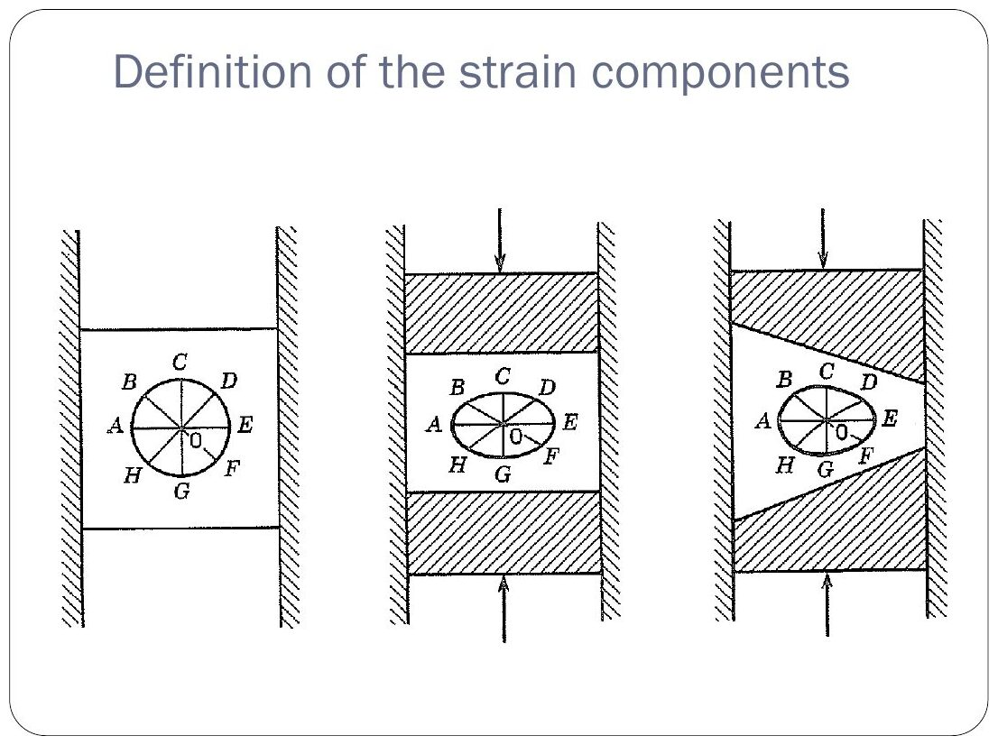
Original: Slides Ch 4 Part 2, slide 1
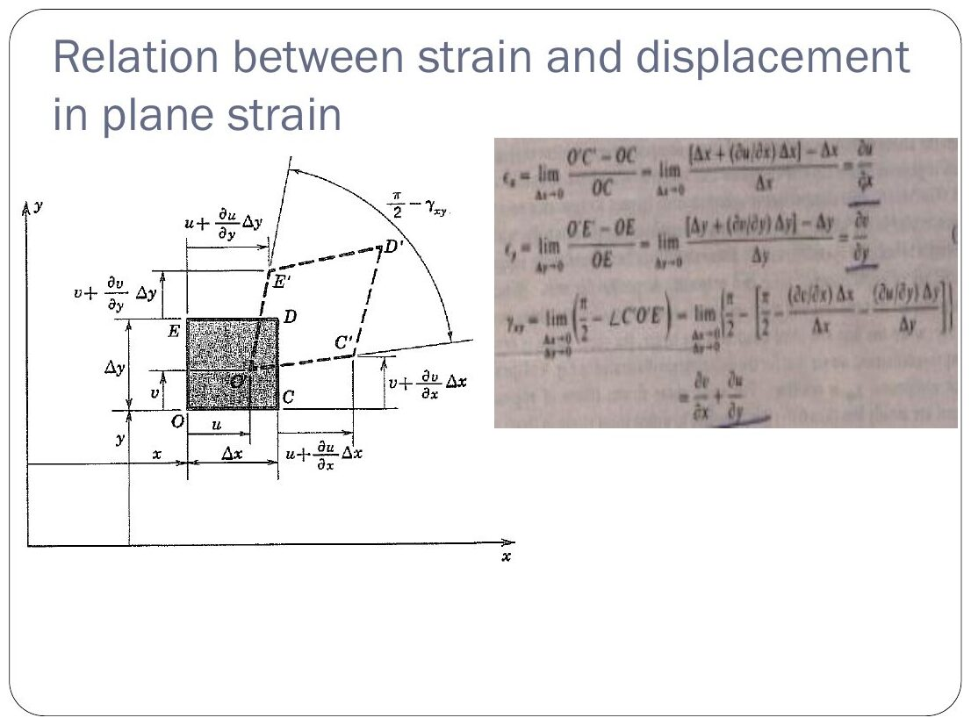
Original: Slides Ch 4 Part 2, slide 3
4. Derivation of $ϵ_{x}$ and $γ_{xy}$. Point C at $\left(x+Δx,y\right)$ moves by $u+\frac{∂u}{∂x}Δx$ in x and $v+\frac{∂v}{∂x}Δx$ in y. To first order, the new length of OC is $Δx\left(1+∂u/∂x\right)$, which gives $ϵ_{x}$. Line OC rotates counter-clockwise by $\frac{∂v}{∂x}$ and line OE rotates clockwise by $\frac{∂u}{∂y}$. The angle between them closes by the sum, which gives $γ_{xy}$. ∎ Sign: $γ_{xy}>0$ means the angle between +x and +y decreases.
7. Traps. Engineering shear strain γ is twice the tensor shear strain. Mohr’s circle uses γ/2.

Concept 4.5 — Strain transformation and Mohr’s circle of strain

A. Concept explanation
1. Intuition. Same idea as for stress. Rotate the measuring axes and the stretch along each direction changes, following exactly the same algebra with $σ→ϵ$ and $τ→γ/2$.
3–4. Derivation (slides, Crandall §4.8). With $x=x′cosθ−y′sinθ$, $y=x′sinθ+y′cosθ$, $u′=ucosθ+vsinθ$ and $v′=−usinθ+vcosθ$, the chain rule gives
$$ϵ_{x′}=\frac{∂u′}{∂x′}=\left(\frac{∂u}{∂x}cosθ+\frac{∂v}{∂x}sinθ\right)cosθ+\left(\frac{∂u}{∂y}cosθ+\frac{∂v}{∂y}sinθ\right)sinθ$$
$$⇒ ϵ_{x′}=ϵ_{x}\cos^{2}θ+ϵ_{y}\sin^{2}θ+γ_{xy}sinθcosθ$$
In double-angle form:
$$\boxed{ϵ_{x′}=\frac{ϵ_{x}+ϵ_{y}}{2}+\frac{ϵ_{x}−ϵ_{y}}{2}cos2θ+\frac{γ_{xy}}{2}sin2θ}$$
$$\boxed{\frac{γ_{x′y′}}{2}=−\frac{ϵ_{x}−ϵ_{y}}{2}sin2θ+\frac{γ_{xy}}{2}cos2θ}$$
$$ϵ_{1,2}=\frac{ϵ_{x}+ϵ_{y}}{2}±\sqrt{{\left(\frac{ϵ_{x}−ϵ_{y}}{2}\right)}^{2}+{\left(\frac{γ_{xy}}{2}\right)}^{2}}, tan2θ_{p}=\frac{γ_{xy}}{ϵ_{x}−ϵ_{y}}, \frac{γ_{max}}{2}=R$$
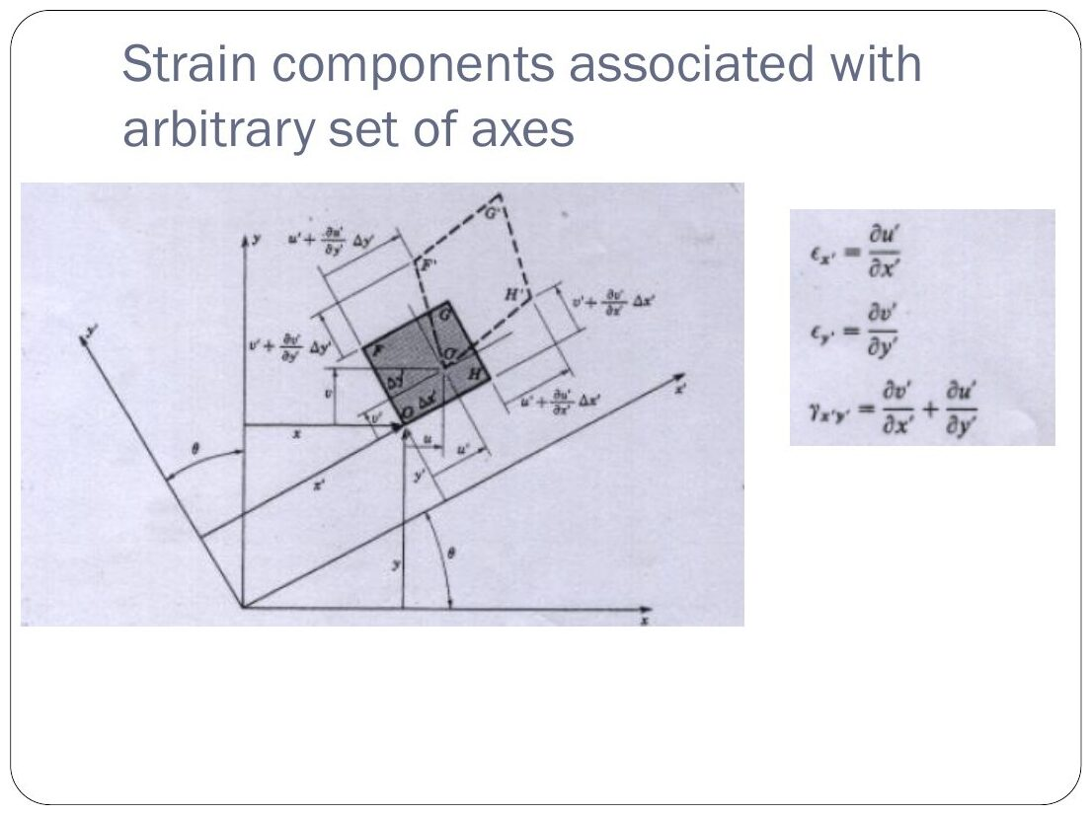
Original: Slides Ch 4 Part 2, slide 4
5. Mohr’s circle of strain: horizontal axis ε, vertical axis γ/2 (+γ/2 plotted downward at x, as for stress). Centre $\frac{ϵ_{x}+ϵ_{y}}{2}$, radius $R=\sqrt{{\left(\frac{ϵ_{x}−ϵ_{y}}{2}\right)}^{2}+{\left(\frac{γ_{xy}}{2}\right)}^{2}}$.
6. Isotropy link (Ch. 5): for an isotropic material, principal strain axes = principal stress axes, so you can use either circle to find directions.
7. Traps. Plotting γ instead of γ/2 doubles the radius. Remember $γ_{max}=2R=ϵ_{1}−ϵ_{2}$ (in-plane).

B. Solved questions

Q10 (Crandall Example, Slides Ch4 Part 2) — Sheet metal: strains on axes 30° clockwise, principal strains (medium)
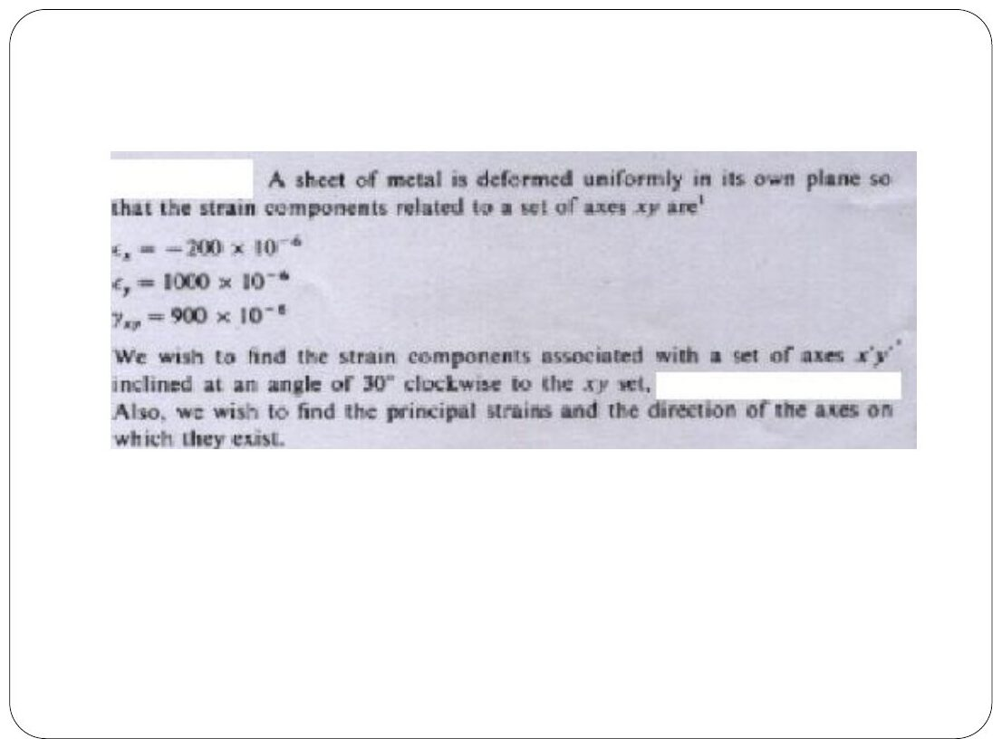
Original: Slides Ch 4 Part 2, slide 6
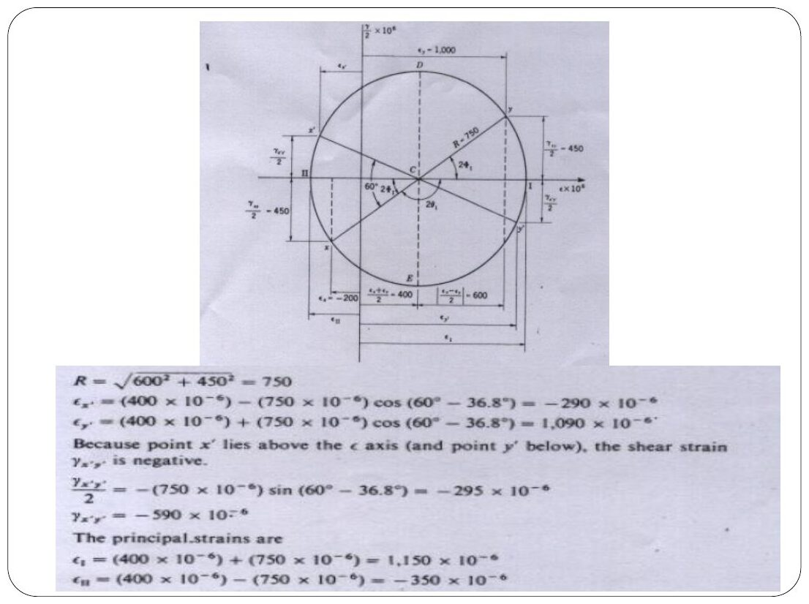
Original: Slides Ch 4 Part 2, slide 7
Given: $ϵ_{x}=−200μ$, $ϵ_{y}=1000μ$, $γ_{xy}=900μ$ ($μ={10}^{−6}$). Axes x′y′ at 30° clockwise (θ = −30°). Centre $=400μ$. $\left(ϵ_{x}−ϵ_{y}\right)/2=−600μ$ and $γ/2=450μ$, so $R=\sqrt{{600}^{2}+{450}^{2}}=750μ$. $cos\left(−{60}^{∘}\right)=0.5$ and $sin\left(−{60}^{∘}\right)=−0.866$:
$$ϵ_{x′}=400+\left(−600\right)\left(0.5\right)+450\left(−0.866\right)=\boxed{−290μ}$$
$$ϵ_{y′}=800−\left(−290\right)=\boxed{1090μ}$$
$$\frac{γ_{x′y′}}{2}=−\left(−600\right)\left(−0.866\right)+450\left(0.5\right)=−295μ ⇒ \boxed{γ_{x′y′}=−590μ}$$
Principal: $\boxed{ϵ_{1}=1150μ, ϵ_{2}=−350μ}$. Direction: $tan2θ_{p}=900/\left(−1200\right)$, so ε₁ is at θ = 71.6° from x (and ε₂ at −18.4°). Circle check (slides): the angle at the centre is ${60}^{∘}−{36.8}^{∘}$ ✓. Point x′ lies above the axis, so $γ_{x′y′}<0$ ✓.
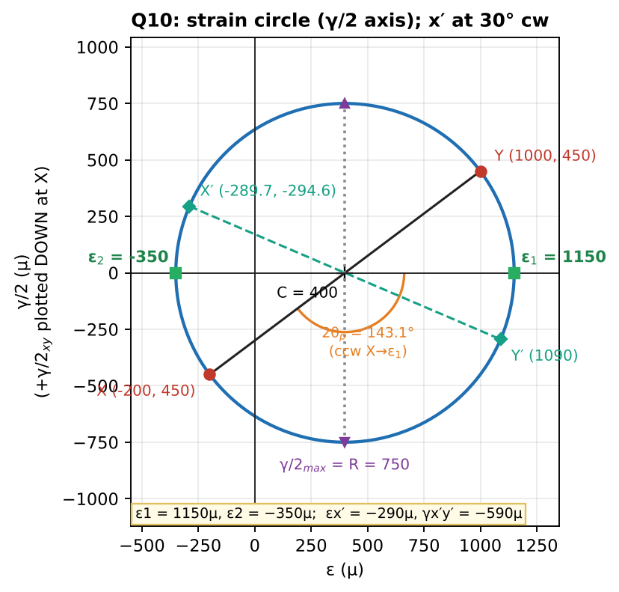
Strain Mohr’s circle (vertical axis γ/2)

Q11 (Crandall Prob 4.20, Slides) — Principal strains (easy)
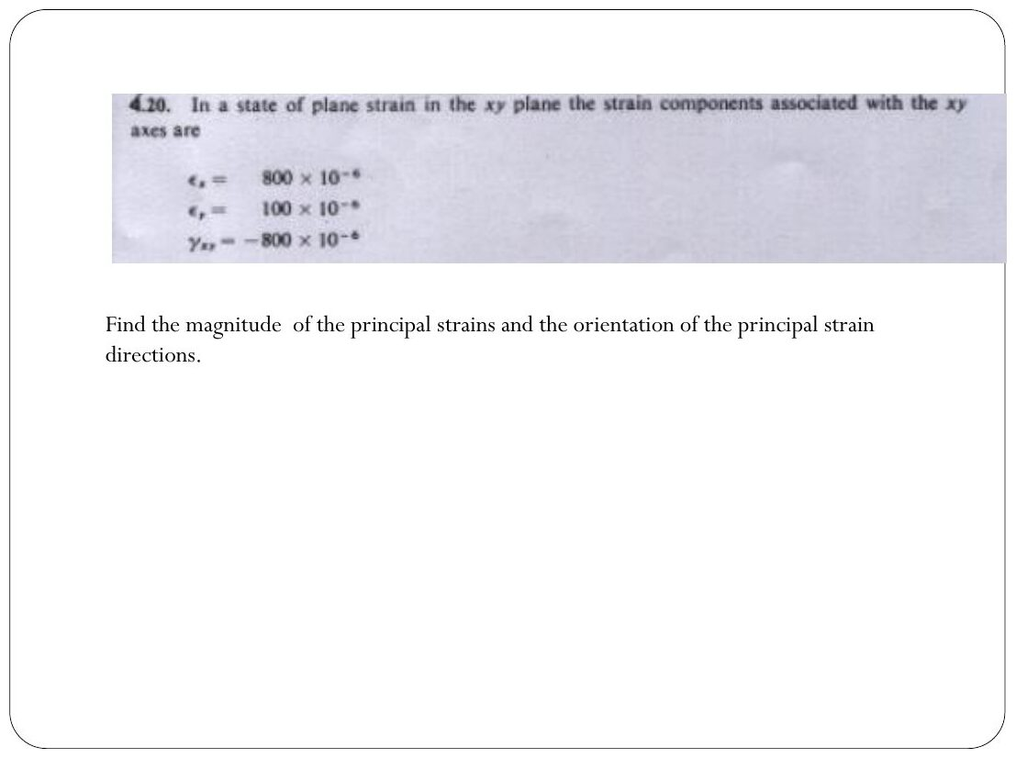
Original: Slides Ch 4 Part 2, slide 8
Given: $ϵ_{x}=800μ$, $ϵ_{y}=100μ$, $γ_{xy}=−800μ$. Centre $450μ$. $R=\sqrt{{350}^{2}+{400}^{2}}=531.5μ$.
$$\boxed{ϵ_{1}=981.5μ, ϵ_{2}=−81.5μ}, tan2θ_{p}=\frac{−800}{700}⇒\boxed{θ_{p1}=−{24.4}^{∘} \left(\text{24.4° clockwise from x}\right)}$$
Check: substitute θ = −24.4°: $450+350cos\left(−{48.8}^{∘}\right)−400sin\left(−{48.8}^{∘}\right)=450+230.5+301=981.5$ ✓. $γ_{max}=1063μ$.
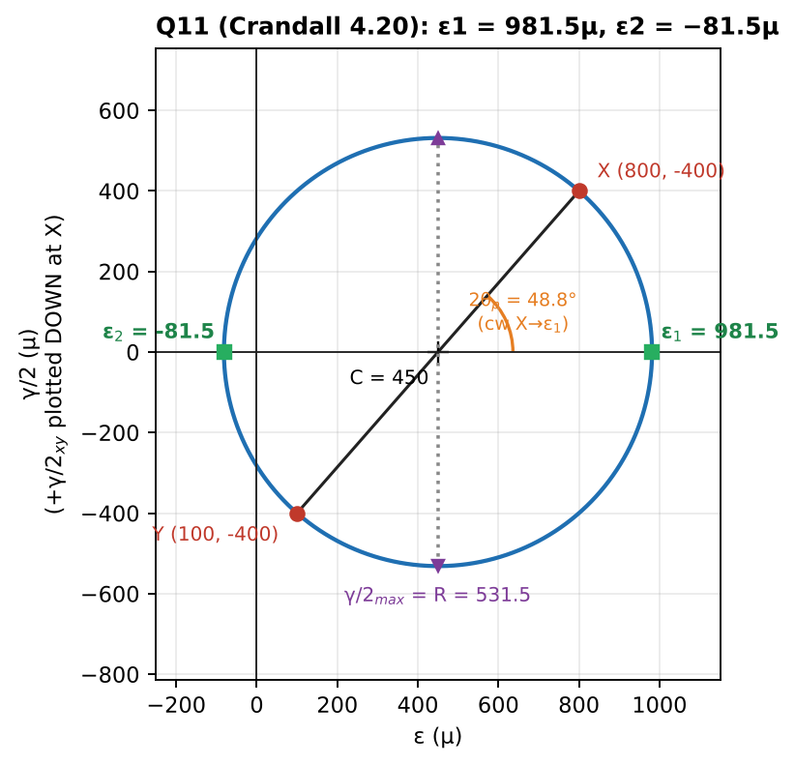
Strain Mohr’s circle

Concept 4.6 — Strain rosettes

A. Concept explanation
1. Intuition. One strain gauge measures stretch in only one direction. A point in plane strain has three unknowns $\left(ϵ_{x},ϵ_{y},γ_{xy}\right)$, so glue three gauges at different angles (a rosette) and solve three equations.
2. Why it matters. This is how real structures (bridges, aircraft, the bracket in the slide example) are monitored. Also PYQ 2021 A-Q1 (one gauge at 45° on a shaft).
3. Formal treatment. Each gauge at angle $θ_{i}$ reads
$$ϵ_{i}=ϵ_{x}\cos^{2}θ_{i}+ϵ_{y}\sin^{2}θ_{i}+γ_{xy}sinθ_{i}cosθ_{i}$$
45° rectangular rosette (0°, 45°, 90°): $ϵ_{x}=ϵ_{a}$, $ϵ_{y}=ϵ_{c}$, $\boxed{γ_{xy}=2ϵ_{b}−\left(ϵ_{a}+ϵ_{c}\right)}$. 60° delta rosette (0°, 60°, 120°): $ϵ_{x}=ϵ_{a}$, $ϵ_{y}=1/3\left(2ϵ_{b}+2ϵ_{c}−ϵ_{a}\right)$, $γ_{xy}=2/{\sqrt{3}}\left(ϵ_{b}−ϵ_{c}\right)$.
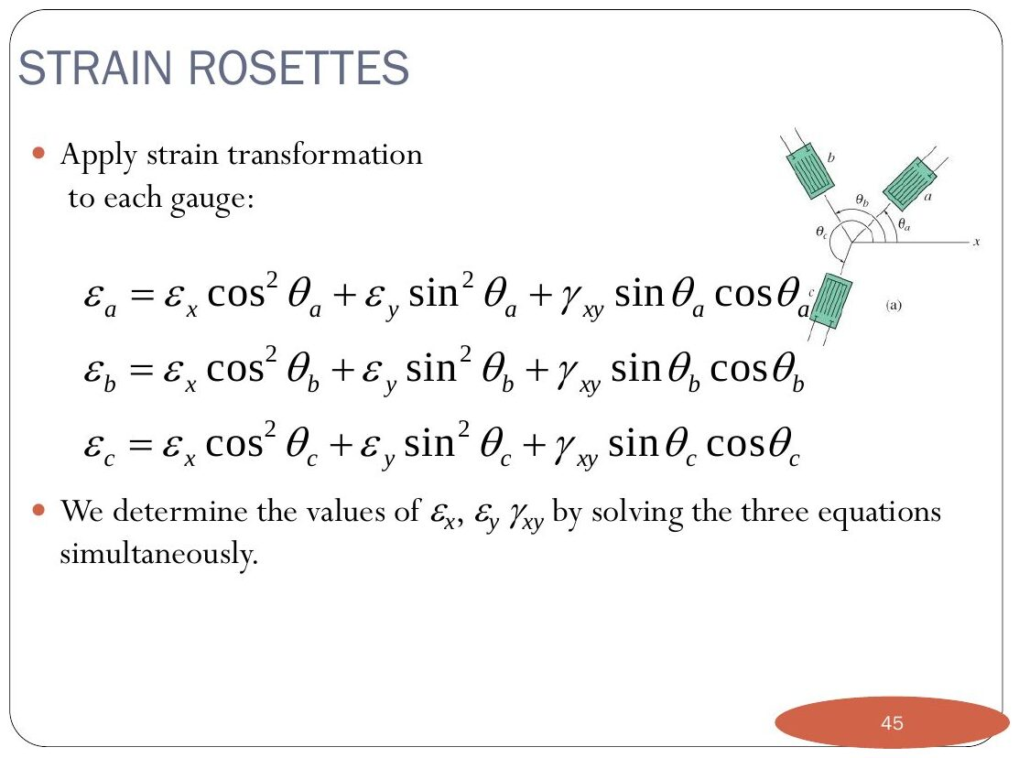
Original: Slides Ch 4 Part 2, slide 10
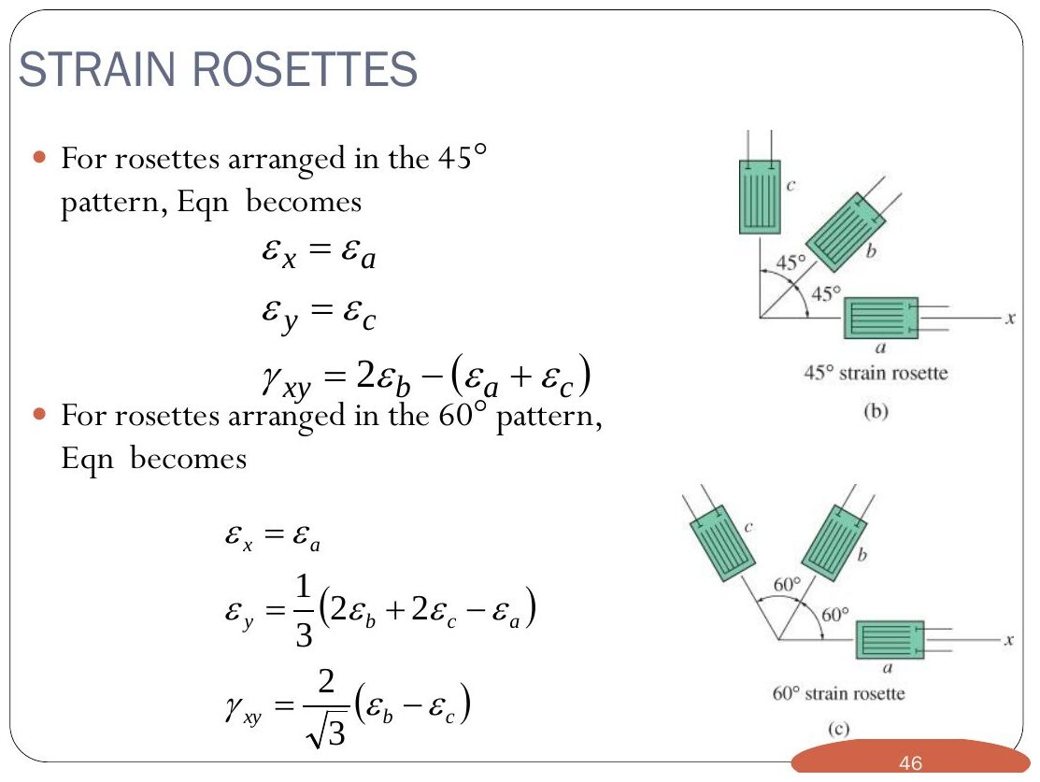
Original: Slides Ch 4 Part 2, slide 11
4. Derivation of the 45° case. With θ = 45°, $\cos^{2}=\sin^{2}=sincos=1/2$, so $ϵ_{b}=1/2\left(ϵ_{x}+ϵ_{y}+γ_{xy}\right)$, giving $γ_{xy}=2ϵ_{b}−ϵ_{a}−ϵ_{c}$. ∎
7. Traps. Angles must be measured counter-clockwise from your chosen x-axis (the gauge “a” direction). Mixing degrees and radians on calculators. Forgetting that the final principal stresses need Hooke’s law with plane stress (the surface is free).

B. Solved questions

Q12 (Slides Ch4 Part 2, Hibbeler Ex 10.8) — 60° rosette on a bracket (medium)
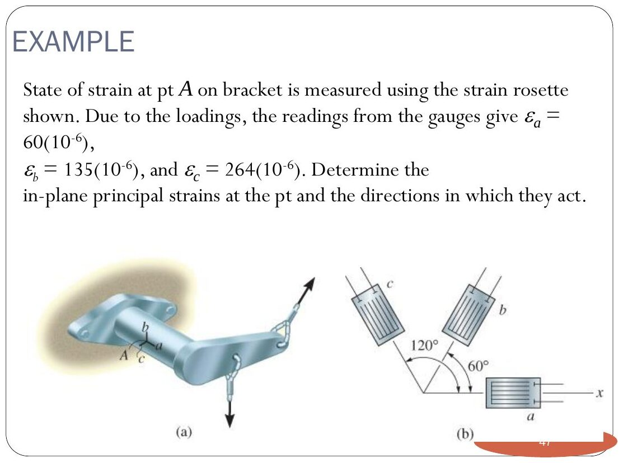
Original: Slides Ch 4 Part 2, slide 12
Given: $ϵ_{a}=60μ$ (0°), $ϵ_{b}=135μ$ (60°), $ϵ_{c}=264μ$ (120°). Equations: $60=ϵ_{x}$; $135=0.25ϵ_{x}+0.75ϵ_{y}+0.433γ$; $264=0.25ϵ_{x}+0.75ϵ_{y}−0.433γ$. Subtract the last two: $0.866γ=−129⇒γ_{xy}=−149μ$. Add them: $1.5ϵ_{y}=399−30⇒ϵ_{y}=246μ$. (Formula check: $ϵ_{y}=1/3\left(270+528−60\right)=246$ ✓ and $γ=2/{\sqrt{3}}\left(135−264\right)=−149$ ✓.) Centre $153μ$, $R=\sqrt{{93}^{2}+{74.5}^{2}}=119.2μ$.
$$\boxed{ϵ_{1}=272μ, ϵ_{2}=33.8μ}, \boxed{θ_{p2}={19.3}^{∘} \text{(counter-clockwise from x, direction of} ϵ_{2})}$$
⚠ The slide writes “ε₂ = 246(10⁻⁶) − 119.2(10⁻⁶) = 33.8”. The 246 is a typo for 153 (the centre). The result 33.8 is correct.
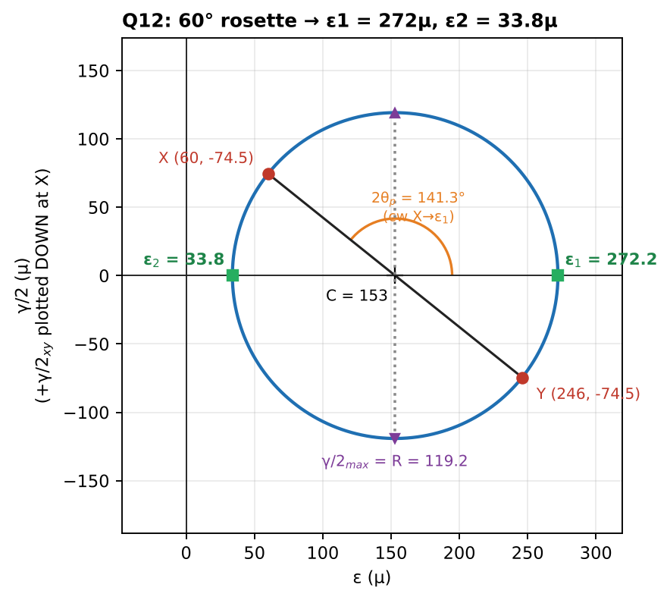
Strain Mohr’s circle

Q13 (PYQ 2021-22 A Q1) — Strain gauge at 45° on a twisted bar (easy, 10 marks)
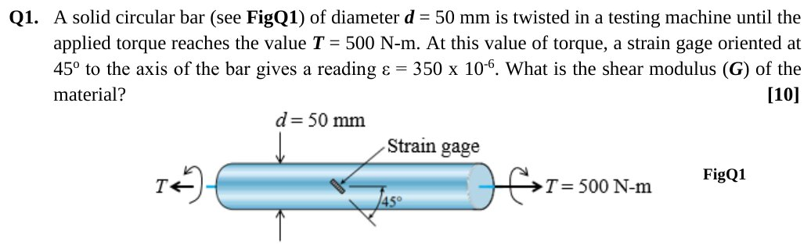
Original question: PYQ 2021-22 Compre A Q1
Given: $d=50$ mm, $T=500$ N·m, the gauge at 45° reads $ϵ=350μ$. Find: G. Surface shear (Ch. 6): $τ=\frac{16T}{πd^{3}}=\frac{16\left(500 000\right)}{π{\left(50\right)}^{3}}=20.37$ MPa. Pure shear: the 45° direction is principal, and $ϵ_{45}=γ/2$ (from the rosette formula with $ϵ_{x}=ϵ_{y}=0$). So $γ=700μ$.
$$G=\frac{τ}{γ}=\frac{20.37}{700×{10}^{−6}}=\boxed{29.1 \text{GPa}}$$
Alternative via Hooke: principal stresses ±τ give $ϵ_{45}=\frac{τ\left(1+ν\right)}{E}=\frac{τ}{2G}$, the same result ✓. Takeaway: a gauge at 45° on a shaft reads γ/2. It is a popular closed-book question.

Q14 (PYQ 2019-20 A Q2) — From principal strains to $σ_{x},σ_{y},τ_{xy}$ (medium, 7 marks)
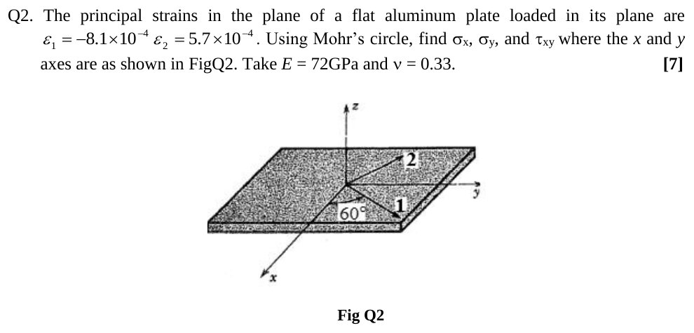
Original question: PYQ 2019-20 Compre A Q2
Given: aluminium plate, $ϵ_{1}=−8.1×{10}^{−4}$, $ϵ_{2}=5.7×{10}^{−4}$, $E=72$ GPa, ν = 0.33. Principal direction 1 is at 60° from x (rotating toward y). Step 1, principal stresses (plane stress Hooke, Ch. 5): $\frac{E}{1−ν^{2}}=80 799$ MPa.
$$σ_{1}=80 799\left(ϵ_{1}+νϵ_{2}\right)=80 799\left(−8.1+1.881\right)×{10}^{−4}=−50.2 \text{MPa}$$
$$σ_{2}=80 799\left(ϵ_{2}+νϵ_{1}\right)=80 799\left(5.7−2.673\right)×{10}^{−4}=24.5 \text{MPa}$$
Step 2, Mohr’s circle of stress: centre $=−12.9$, $R=37.4$. The x-axis is at θ = −60° from axis 1, so on the circle rotate 120° clockwise from point “1”.
$$σ_{x}=−12.9+\left(−37.35\right)cos\left(−{120}^{∘}\right)=\boxed{5.8 \text{MPa}}$$
$$σ_{y}=−12.9−18.7=\boxed{−31.6 \text{MPa}}$$
$$τ_{xy}=−\left(−37.35\right)sin\left(−{120}^{∘}\right)=\boxed{−32.3 \text{MPa}}$$
Checks: $σ_{x}+σ_{y}=−25.8=σ_{1}+σ_{2}$ ✓ and $\sqrt{{\left(18.7\right)}^{2}+{32.3}^{2}}=37.4=R$ ✓. Alternative: transform the strains to x–y first (strain circle) and then apply Hooke’s law. Same answer.
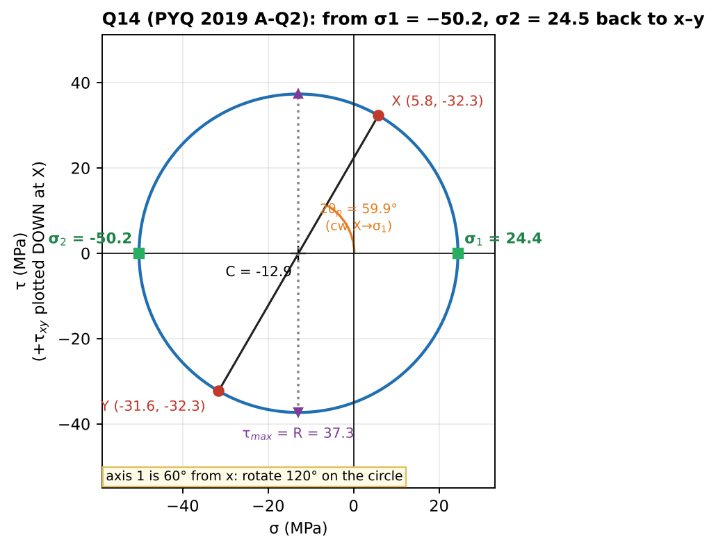
Stress Mohr’s circle used to return to x–y

Q15 (PYQ 2021-22 B Q1) — Circle → ellipse: lengths and orientation of the axes (medium–hard, 10 marks)
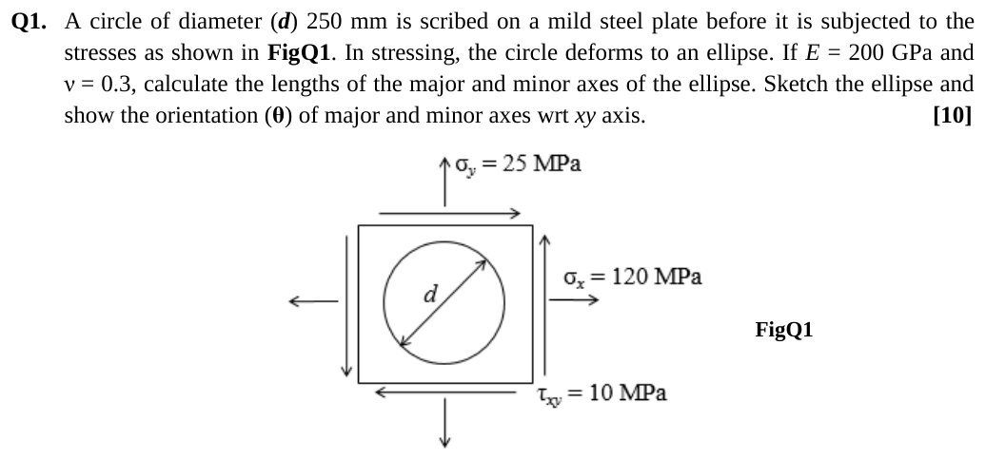
Original question: PYQ 2021-22 Compre B Q1
Given: $d=250$ mm circle on mild steel. $σ_{x}=120$, $σ_{y}=25$, $τ_{xy}=10$ MPa. $E=200$ GPa, ν = 0.3. Idea: the ellipse’s major and minor axes lie along the principal strain directions, which equal the principal stress directions for an isotropic material. Principal stresses: centre 72.5, $R=\sqrt{{47.5}^{2}+{10}^{2}}=48.54$, so σ₁ = 121.04 and σ₂ = 23.96 MPa. $θ_{p}=1/2\tan^{−1}\frac{20}{95}={5.94}^{∘}$ (counter-clockwise from x for σ₁). Principal strains (plane stress):
$$ϵ_{1}=\frac{121.04−0.3\left(23.96\right)}{200 000}=569.3μ, ϵ_{2}=\frac{23.96−0.3\left(121.04\right)}{200 000}=−61.8μ$$
$$\boxed{\text{Major axis}=250\left(1+ϵ_{1}\right)=250.142 \text{mm at} {5.94}^{∘} \text{from x}, \text{Minor axis}=249.985 \text{mm at} {95.94}^{∘}}$$
Sketch: the ellipse is very slightly elongated, tilted about 6° counter-clockwise from x. Trap: using $σ/E$ without the Poisson term would give minor axis = 250.030 mm (longer than d). That’s wrong, because the Poisson contraction from σ₁ wins.
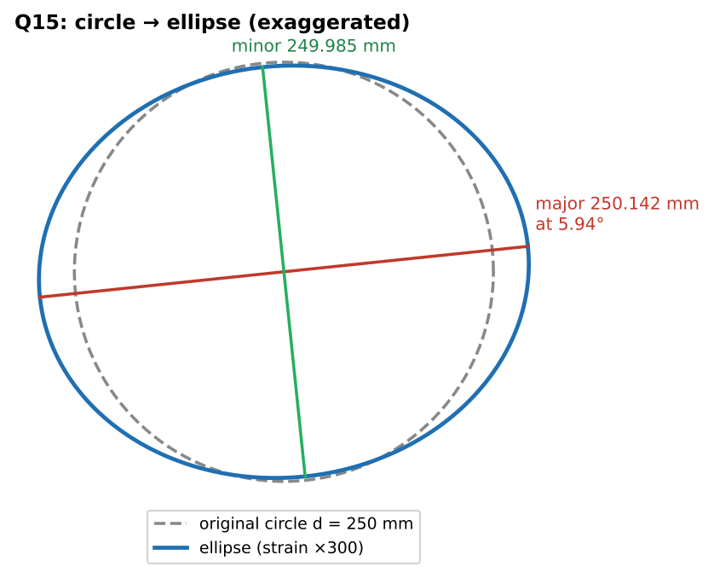
The deformed circle (strains exaggerated ×300)

Q16 (PYQ 2014-15 Test-2 Q2) — Absolute maximum shear strain in a bar (easy–medium, 15 marks)
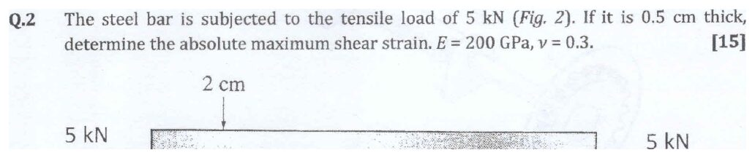
Original question: PYQ 2014-15 Test-2 Q2
Given: steel bar 2 cm × 0.5 cm, tension 5 kN. $E=200$ GPa, ν = 0.3. Find: the absolute maximum shear strain. $σ=5000/\left(20×5\right)=50$ MPa (uniaxial). Principal strains: $ϵ_{1}=σ/E=250μ$ and $ϵ_{2}=ϵ_{3}=−νσ/E=−75μ$.
$$γ_{abs,max}=ϵ_{max}−ϵ_{min}=250−\left(−75\right)=\boxed{325×{10}^{−6} \text{rad}}$$
Check: $τ_{max}=σ/2=25$ MPa and $G=E/2\left(1+ν\right)=76.9$ GPa give $γ=25/76,900=325μ$ ✓. Takeaway: “absolute” means include the out-of-plane direction. Here, in-plane and absolute are equal because $ϵ_{2}=ϵ_{3}$.
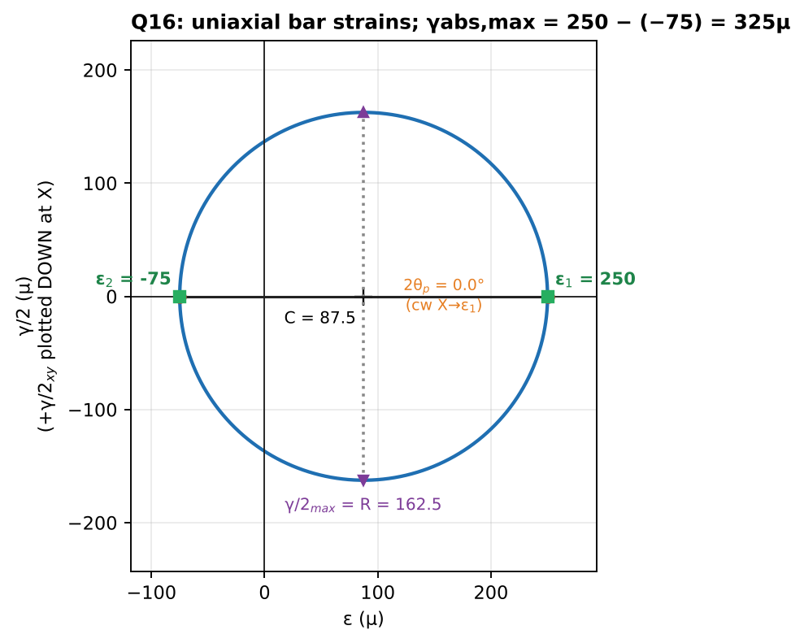
Strain circle for the uniaxial bar

Chapter 4 — Formula and convention sheet
Item | Formula / rule
Sign of stress | +face & +direction, or −face & −direction
Symmetry | $τ_{xy}=τ_{yx}$
Equilibrium | $∂σ_{x}/∂x+∂τ_{xy}/∂y=0$, $∂τ_{xy}/∂x+∂σ_{y}/∂y=0$
Transformation | $σ_{x′}=\overset{‾}{σ}+\frac{σ_{x}−σ_{y}}{2}cos2θ+τ_{xy}sin2θ$; $τ_{x′y′}=−\frac{σ_{x}−σ_{y}}{2}sin2θ+τ_{xy}cos2θ$
Invariant | $σ_{x′}+σ_{y′}=σ_{x}+σ_{y}$
Principal | $σ_{1,2}=\overset{‾}{σ}±R$, $R=\sqrt{{\left(\frac{σ_{x}−σ_{y}}{2}\right)}^{2}+τ_{xy}^{2}}$, $tan2θ_{p}=\frac{2τ_{xy}}{σ_{x}−σ_{y}}$ (verify which θ gives σ₁)
Max in-plane shear | $τ_{max}=R$ at $θ_{p}±{45}^{∘}$, normal stress $\overset{‾}{σ}$ there
Absolute max shear | $\left(σ_{max}−σ_{min}\right)/2$ including $σ_{3}=0$
Mohr’s circle | +τ plotted down at X, up at Y; 2θ on circle = θ on element, same sense
Strains | $ϵ_{x}=∂u/∂x$, $ϵ_{y}=∂v/∂y$, $γ_{xy}=∂u/∂y+∂v/∂x$
Strain transformation | replace σ → ε and τ → γ/2 in the stress equations
Strain circle | vertical axis γ/2; $γ_{max}=ϵ_{1}−ϵ_{2}$
45° rosette | $ϵ_{x}=ϵ_{a}$, $ϵ_{y}=ϵ_{c}$, $γ=2ϵ_{b}−ϵ_{a}−ϵ_{c}$
60° rosette | $ϵ_{y}=\frac{1}{3}\left(2ϵ_{b}+2ϵ_{c}−ϵ_{a}\right)$, $γ=\frac{2}{\sqrt{3}}\left(ϵ_{b}−ϵ_{c}\right)$
Gauge at 45° on shaft | $ϵ_{45}=γ/2=τ/2G$
Other Crandall Ch. 4 problems worth practising: 4.1–4.10 (transformation, Mohr), 4.12 (thin cylinder), 4.15–4.25 (strain and rosettes).

Chapter 5 — Stress–Strain–Temperature Relations
Tensile test, Hooke’s law, Poisson’s ratio, generalized Hooke’s law, E–G–ν, volume change, thermal strain and thermal stresses, strain energy, yield criteria (Tresca and von Mises)
Sources used: Slides “Chapter 5”, Crandall Ch. 5 (§5.2–5.8, 5.16), PYQs 2023-24 (A-Q3), 2024-25 (A-Q2), 2019-20 (A-Q4), 2021-22 (A-Q2c, B-Q1), 2014-15 (Compre A-Q1–Q4; Test-2 Q3).

Concept 5.1 — The tensile test and material behaviour

A. Concept explanation
1. Intuition. Pull a steel bar in a machine and plot force against stretch. At first it behaves like a stiff spring (straight line). Then it suddenly “gives” and stretches a lot for little extra force (yield). Then it hardens, necks down and breaks. Dividing force by area and stretch by length removes the size of the specimen, leaving a curve that belongs to the material.
2. Why it matters. Every design number ($E$, $σ_{Y}$, $σ_{u}$, ν) comes from this test. Yield strength is the limit in every factor-of-safety PYQ.
3. Formal treatment (slides).
- Engineering stress $σ=P/A_{0}$ and engineering strain $ϵ=δ/L_{0}$, both using the original dimensions.
- True stress and strain use the current area and length, which matters only after large deformation (necking).
- Proportional limit: end of the straight line. Elastic limit: the largest stress with no permanent set on unloading. Yield point: large strain increase with little stress increase. Ultimate strength: peak of the curve.
- Ductile materials (mild steel, aluminium, copper, brass) undergo large strain, absorb energy and give visible warning. They fail on 45° shear planes: the cup-and-cone fracture.
- Brittle materials (cast iron, concrete, glass, stone) fail at small strain on planes perpendicular to the maximum tensile stress.
- Elastic vs plastic: strain recovers or does not recover on unloading. Fatigue: failure under cyclic stress below $σ_{u}$. Creep: time-dependent strain under constant stress.
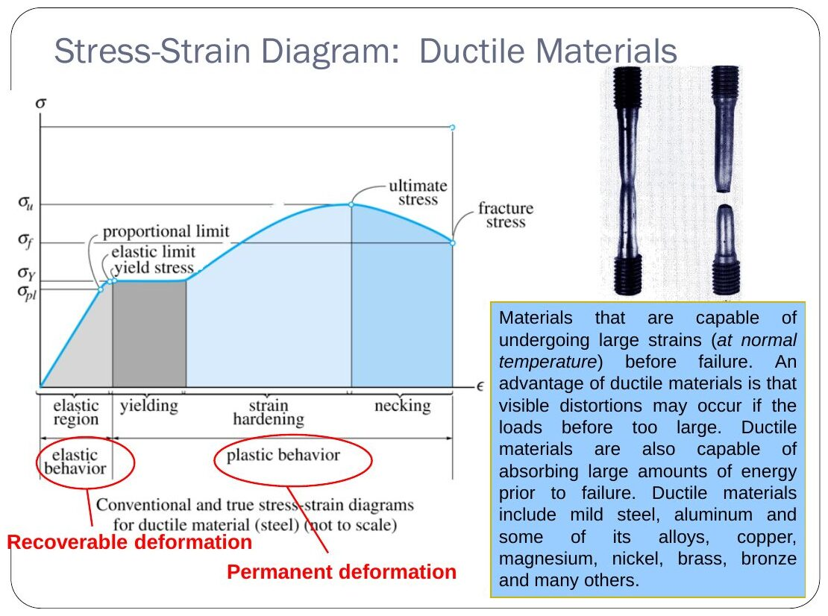
Original: Slides Ch 5, slide 5
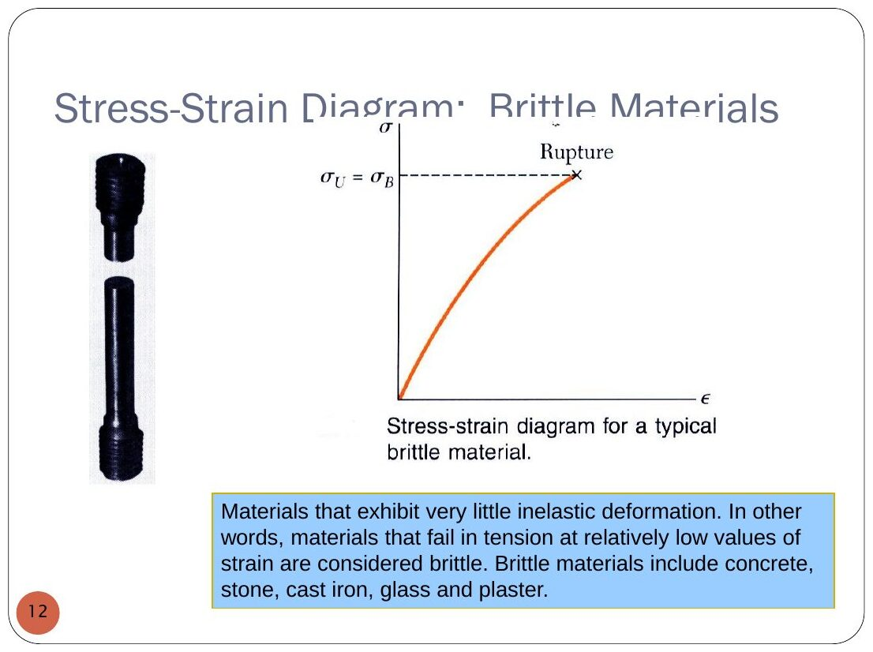
Original: Slides Ch 5, slide 9
Hooke’s law (uniaxial): $σ=Eϵ$, where $E$ is Young’s modulus, the slope of the linear part. Typical values from the slides (GPa): mild steel 210, aluminium 70, concrete 18.5, wood 12.5, nylon 2.8, rubber 0.004.
Idealized curves (Crandall §5.3): linear elastic; rigid–perfectly plastic; elastic–perfectly plastic; linear strain-hardening. Choose the one that captures what matters for the problem at hand.
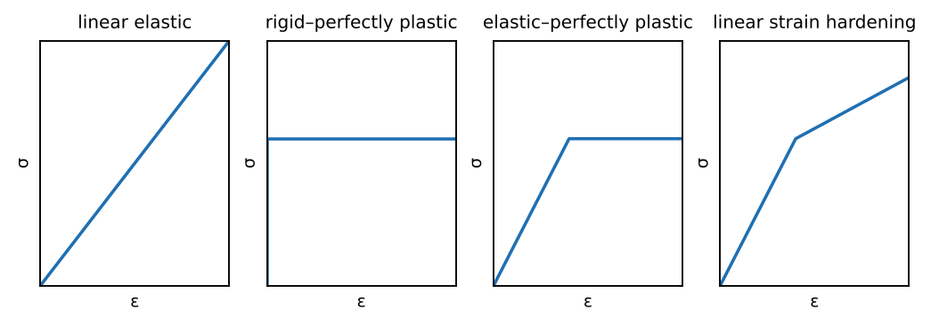
Idealized stress–strain curves
7. Traps. Using $σ_{u}$ where the question asks for yield. Using true stress where engineering stress is meant.

Concept 5.2 — Poisson’s ratio and generalized Hooke’s law

A. Concept explanation
1. Intuition. Stretch a rubber band and it gets thinner. The ratio of sideways shrinking to lengthwise stretching is Poisson’s ratio. Most metals are about 0.3, rubber about 0.5 (incompressible), and cork about 0.
2. Why it matters. It explains why a plate under biaxial stress changes thickness, and it appears in every “change in thickness/volume” PYQ (2023 A-Q3 and 2024 A-Q2 are the same question type two years running).
3. Formal treatment (slides). For uniaxial $σ_{x}$: $ϵ_{x}=σ_{x}/E$ and $ϵ_{y}=ϵ_{z}=−νϵ_{x}$, where
$$ν=−\frac{\text{lateral strain}}{\text{axial strain}}$$
Assumptions: linear elastic, small deformations, isotropic (same properties in all directions).
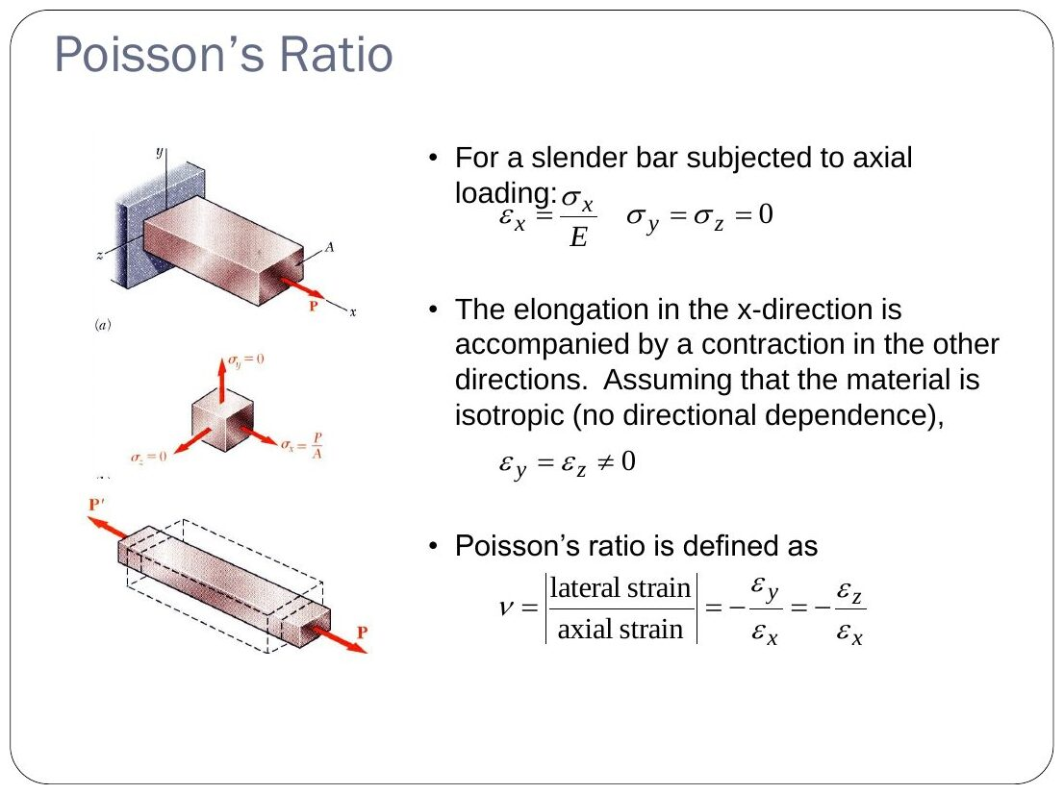
Original: Slides Ch 5, slide 16
Isotropy arguments (slides, Crandall §5.4):
- A normal stress produces no shear strain. With a hypothetical shear strain, rotating the element 180° about the loading axis would flip the sign of the shear strain but not the load, which contradicts isotropy.
- A shear stress produces no normal strain. Reversing τ would reverse the normal strain, but by symmetry the result must be the same, which contradicts linearity unless the strain is zero.
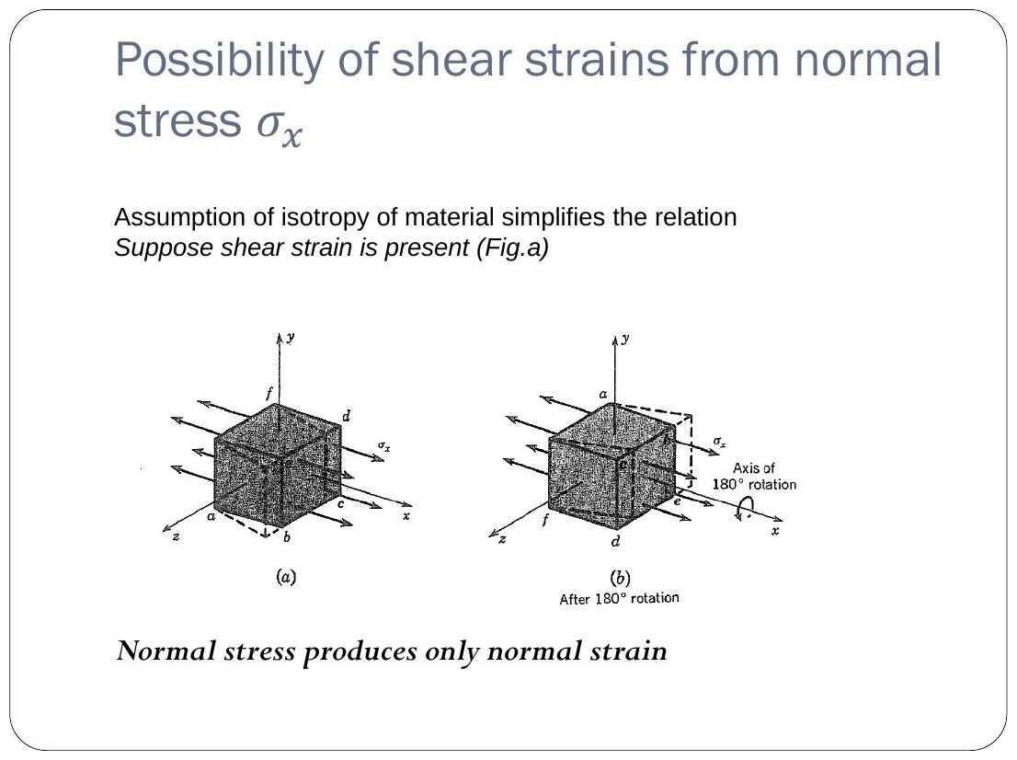
Original: Slides Ch 5, slide 19
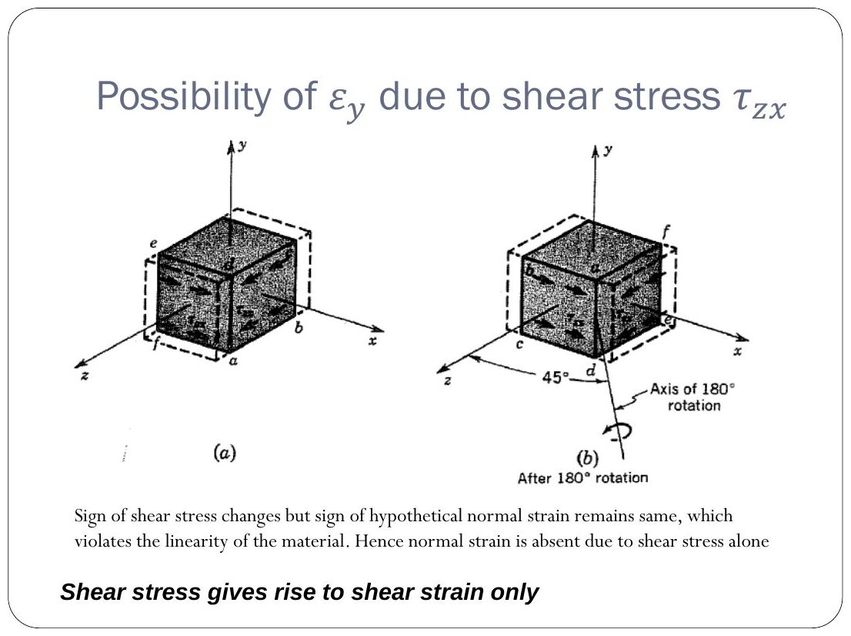
Original: Slides Ch 5, slide 21
So normal stresses cause only normal strains, and shear stresses cause only their own shear strain.
4. Derivation — superposition gives generalized Hooke’s law:
$$\boxed{ϵ_{x}=\frac{1}{E}\left[σ_{x}−ν\left(σ_{y}+σ_{z}\right)\right]+αΔT, ϵ_{y}=\frac{1}{E}\left[σ_{y}−ν\left(σ_{z}+σ_{x}\right)\right]+αΔT, ϵ_{z}=\frac{1}{E}\left[σ_{z}−ν\left(σ_{x}+σ_{y}\right)\right]+αΔT}$$
$$\boxed{γ_{xy}=\frac{τ_{xy}}{G}, γ_{yz}=\frac{τ_{yz}}{G}, γ_{zx}=\frac{τ_{zx}}{G}}$$
(The $αΔT$ term is the thermal strain, Concept 5.4.)
Plane stress ($σ_{z}=0$), inverted:
$$σ_{x}=\frac{E}{1−ν^{2}}\left(ϵ_{x}+νϵ_{y}\right), σ_{y}=\frac{E}{1−ν^{2}}\left(ϵ_{y}+νϵ_{x}\right), ϵ_{z}=−\frac{ν}{E}\left(σ_{x}+σ_{y}\right)=−\frac{ν}{1−ν}\left(ϵ_{x}+ϵ_{y}\right)$$
Isotropy ⇒ principal axes of strain = principal axes of stress (slides). Since shear stress gives only shear strain, zero shear stress means zero shear strain.
Volume change (dilatation). For small strains,
$$e=\frac{ΔV}{V}=ϵ_{x}+ϵ_{y}+ϵ_{z}=\frac{1−2ν}{E}\left(σ_{x}+σ_{y}+σ_{z}\right)$$
Under hydrostatic pressure $p$, this gives the bulk modulus $K=\frac{E}{3\left(1−2ν\right)}$. As ν → 0.5, $K→∞$ (incompressible).
5. Picture. A circle drawn on a plate becomes an ellipse whose axes follow the principal directions (Ch. 4 Q15).
6. Special cases.
- Uniaxial: $ϵ_{y}=−νσ/E$.
- Plate between rigid walls (slide problem): one strain is zero, so a stress appears in that direction (see Q3).
- ν = 0.5: $e=0$, the volume is constant.
7. Traps.
- Using the plane strain formula where plane stress applies, or the other way round.
- Forgetting the Poisson terms when finding a dimension change. For example, in the 2024 PYQ the y diameter actually shrinks even though $σ_{y}$ is tensile.
- Mixing E in GPa with σ in MPa. Convert so that both are in MPa.

B. Solved questions

Q1 (PYQ 2014-15 Compre A Q2) — Finding ν and E from a tension test (easy)
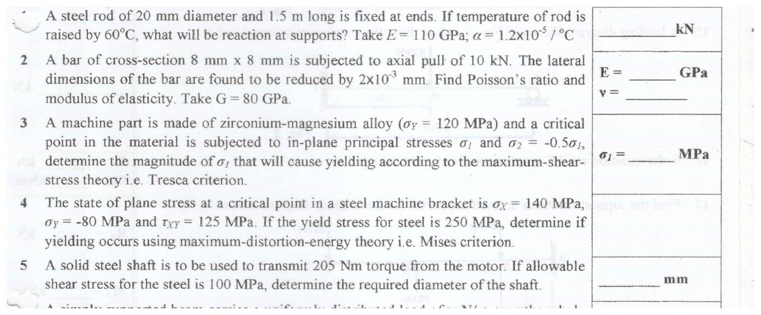
Original question: PYQ 2014-15 Compre A Q1–Q5
Given: bar 8 × 8 mm, pull 10 kN, lateral dimension reduced by $2×{10}^{−3}$ mm, G = 80 GPa. Find: ν and E. $σ=10 000/64=156.25$ MPa. Lateral strain $=−2×{10}^{−3}/8=−2.5×{10}^{−4}$. Since $ϵ_{lat}=−νσ/E$ and $E=2G\left(1+ν\right)$:
$$2.5×{10}^{−4}=\frac{ν\left(156.25\right)}{2\left(80 000\right)\left(1+ν\right)}⇒0.256\left(1+ν\right)=ν⇒\boxed{ν=0.344}, \boxed{E=215 \text{GPa}}$$
Check: axial strain $=156.25/215 000=7.27×{10}^{−4}$ and $ν=2.5/7.27=0.344$ ✓.

Q2 (PYQ 2023-24 A Q3) — Plate in biaxial stress: γ_max, Δt, ΔV (easy–medium, 10 marks)
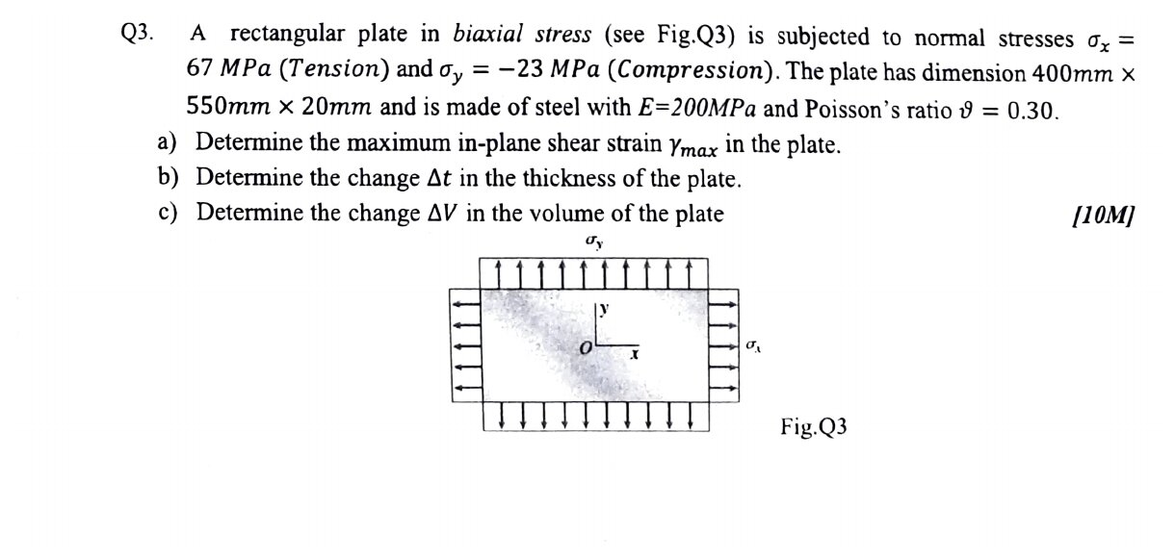
Original question: PYQ 2023-24 Compre A Q3
Given: $σ_{x}=67$ MPa (T), $σ_{y}=−23$ MPa (C). Plate 400 × 550 × 20 mm, steel. E = 200 GPa (the paper’s “200 MPa” is a typo), ν = 0.30. (a) Max in-plane shear strain: no shear stress, so x and y are principal.
$$γ_{max}=ϵ_{x}−ϵ_{y}=\frac{\left(σ_{x}−σ_{y}\right)\left(1+ν\right)}{E}=\frac{90\left(1.3\right)}{200 000}=\boxed{585×{10}^{−6}}$$
(Or $τ_{max}=45$ MPa and $G=76.9$ GPa give $γ=45/76 923$, the same.) (b) Thickness change: $ϵ_{z}=−\frac{ν}{E}\left(σ_{x}+σ_{y}\right)=−\frac{0.3\left(44\right)}{200 000}=−66×{10}^{−6}$.
$$Δt=20\left(−66×{10}^{−6}\right)=\boxed{−1.32×{10}^{−3} \text{mm (thinner)}}$$
(c) Volume change:
$$ΔV=V\frac{1−2ν}{E}\left(σ_{x}+σ_{y}\right)=\left(4.4×{10}^{6}\right)\frac{0.4\left(44\right)}{200 000}=\boxed{+387 {\text{mm}}^{3}}$$
Check by strains: $ϵ_{x}=\left(67+6.9\right)/2×{10}^{5}=369.5μ$ and $ϵ_{y}=\left(−23−20.1\right)/2×{10}^{5}=−215.5μ$. Sum with $ϵ_{z}$: $369.5−215.5−66=88μ$, and $88μ×4.4×{10}^{6}=387$ ✓.

Q3 (PYQ 2024-25 A Q2) — Etched circle on a brass plate (easy–medium, 10 marks)
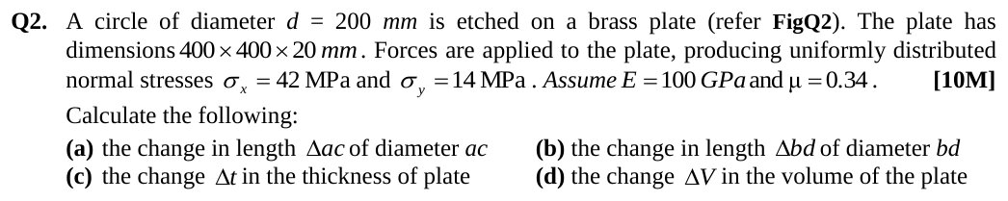
Original question: PYQ 2024-25 Compre A Q2
Given: $d=200$ mm. Plate 400 × 400 × 20 mm. $σ_{x}=42$, $σ_{y}=14$ MPa. $E=100$ GPa, ν = 0.34. Diameter ac is along x and bd along y.
$$ϵ_{x}=\frac{42−0.34\left(14\right)}{100 000}=372.4μ, ϵ_{y}=\frac{14−0.34\left(42\right)}{100 000}=−2.8μ, ϵ_{z}=−\frac{0.34\left(56\right)}{100 000}=−190.4μ$$
$$\boxed{Δ_{ac}=200ϵ_{x}=0.0745 \text{mm}}, \boxed{Δ_{bd}=200ϵ_{y}=−5.6×{10}^{−4} \text{mm}}, \boxed{Δt=20ϵ_{z}=−3.81×{10}^{−3} \text{mm}}$$
$$\boxed{ΔV=\left(3.2×{10}^{6}\right)\left(372.4−2.8−190.4\right)×{10}^{−6}=573 {\text{mm}}^{3}}$$
Takeaway: bd shrinks even though $σ_{y}$ is tensile, because $νσ_{x}>σ_{y}$. Examiners set the numbers up for exactly this surprise.

Q4 (Slides Ch5, Crandall §5.6) — Thin plate between rigid walls (medium)
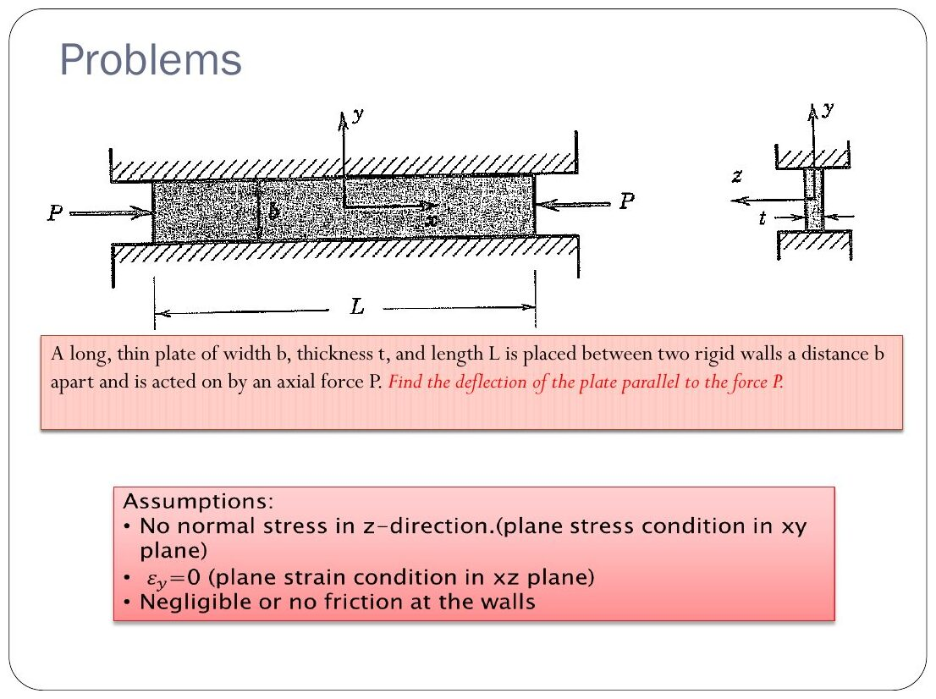
Original: Slides Ch 5, slide 29
Given: plate of width b, thickness t, length L, fitted between rigid smooth walls a distance b apart (y direction). Axial compressive force P along x. Find: the deflection along P. Assumptions (slide): $σ_{z}=0$ (plane stress in thickness), $ϵ_{y}=0$ (walls), no friction. $ϵ_{y}=0=\frac{1}{E}\left(σ_{y}−νσ_{x}\right)⇒σ_{y}=νσ_{x}$. $ϵ_{x}=\frac{1}{E}\left(σ_{x}−νσ_{y}\right)=\frac{σ_{x}\left(1−ν^{2}\right)}{E}$, with $σ_{x}=−P/\left(bt\right)$:
$$\boxed{δ=\frac{PL\left(1−ν^{2}\right)}{Ebt} \text{(shortening)}}$$
Interpretation: the walls make the plate stiffer by a factor $1/\left(1−ν^{2}\right)≈1.1$. They also push back with $σ_{y}=−νP/\left(bt\right)$.

Concept 5.3 — Relation between E, G and ν

A. Concept explanation
1. Intuition. Shear and stretch are not independent. A square under pure shear is, viewed at 45°, a square stretched in one diagonal and squashed in the other. So the shear stiffness G must be fixed by E and ν.
4. Derivation (slides, Crandall §5.4). Pure shear τ on the x–y element ⇔ principal stresses $σ_{1}=+τ$ and $σ_{2}=−τ$ on the 45° element.
- Strain along the 1-direction (Hooke): $ϵ_{1}=\frac{τ}{E}−ν\frac{−τ}{E}=\frac{τ\left(1+ν\right)}{E}$
- Strain along 45° from the shear strain (Ch. 4 transformation with $ϵ_{x}=ϵ_{y}=0$): $ϵ_{45}=\frac{γ}{2}=\frac{τ}{2G}$
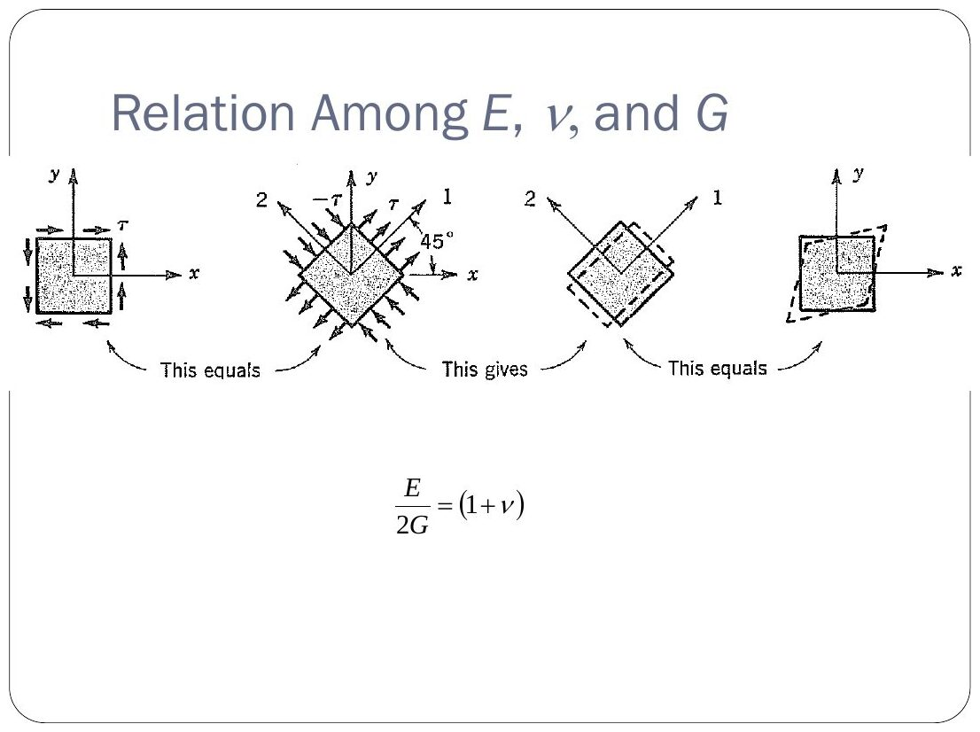
Original: Slides Ch 5, slide 25
These are the same strain, so
$$\frac{τ}{2G}=\frac{τ\left(1+ν\right)}{E} ⇒ \boxed{G=\frac{E}{2\left(1+ν\right)}}$$
Only two of E, G, ν (and K) are independent for an isotropic material.
Summary: $E=2G\left(1+ν\right)=3K\left(1−2ν\right)$.

Concept 5.4 — Thermal strain and thermal stresses

A. Concept explanation
1. Intuition. Heat a rail and it wants to grow. If it is free, it grows and no stress develops. If it is clamped between walls, the walls must push it back to its original length, and that push is the thermal stress. A rail can buckle on a hot day for exactly this reason.
2. Why it matters. Rails, pipelines, bimetal strips, bolts in sleeves, thermostats. PYQ 2014 A-Q1 and Test-2 Q3.
3. Formal treatment (slides).
$$ϵ_{T}=α\left(T−T_{0}\right)=αΔT, \text{total strain }ϵ=\frac{σ}{E}+αΔT$$
For isotropic materials, thermal strain is the same in all directions and produces no shear strain.
4. Derivation — bar fixed at both ends (slides, superposition).
- Release B and let it expand freely: $δ_{T}=αΔTL$.
- Apply the redundant P to push it back: $δ_{P}=PL/AE$.
- Compatibility: $δ_{T}+δ_{P}=0⇒P=−AEαΔT$
$$\boxed{σ=−EαΔT} \text{(compressive for heating; independent of L and A)}$$
- With a gap Δ: $αΔTL−Δ=\frac{\left|P\right|L}{AE}$ if the expansion exceeds the gap. Otherwise there is no stress.
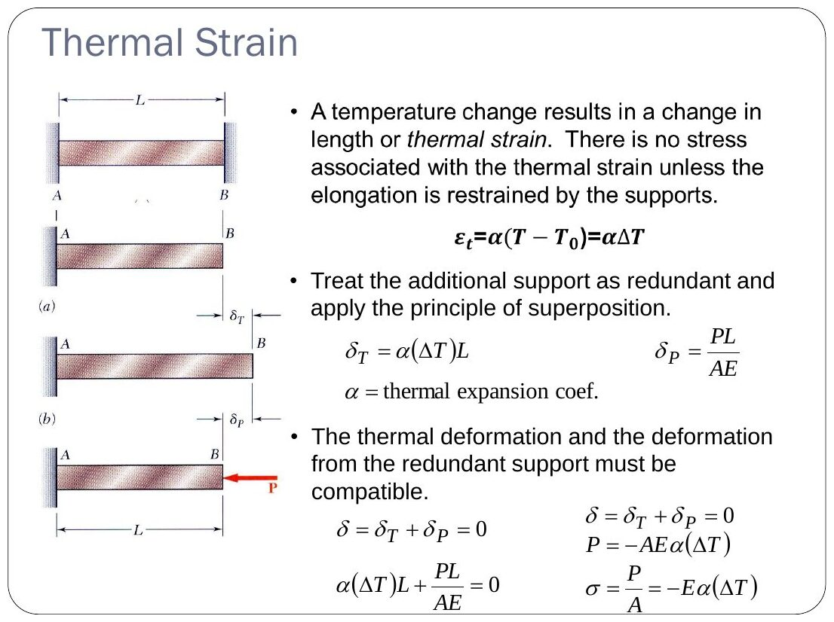
Original: Slides Ch 5, slide 26
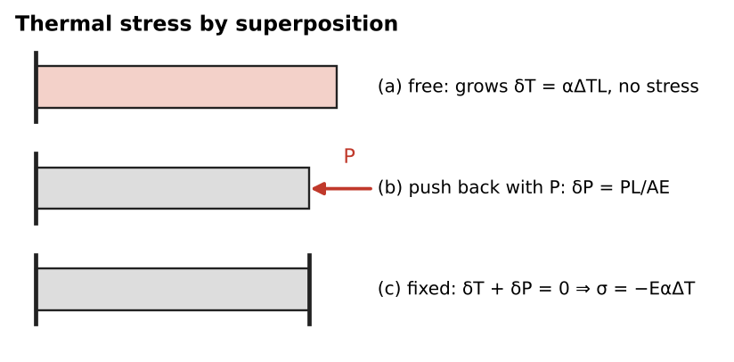
Thermal stress by superposition
General recipe for thermal indeterminate problems (the three steps of Ch. 2):
- Equilibrium of the members’ forces.
- Compatibility of total deformations, $δ_{i}=\frac{F_{i}L_{i}}{A_{i}E_{i}}+α_{i}ΔTL_{i}$.
- Solve.
7. Traps.
- Using $ΔT$ in °F with α in /°C.
- Forgetting that a temperature drop adds tension to a pre-stressed wire.
- Sign of the gap. Close the gap first, then stress builds up.
- In composite systems (bolt + sleeve), the member with the larger α ends up in compression.

B. Solved questions

Q5 (PYQ 2014-15 Compre A Q1) — Rod fixed at both ends, heated (easy)
Given: d = 20 mm, L = 1.5 m, ΔT = 60°C, E = 110 GPa, α = 1.2 × 10⁻⁵/°C.
$$σ=EαΔT=110 000\left(1.2×{10}^{−5}\right)\left(60\right)=79.2 \text{MPa}, P=79.2×π{\left(10\right)}^{2}⇒\boxed{R=24.9 \text{kN}}$$
(L doesn’t matter. That is the classic trap.)

Q6 (Slides Ch5, Gere) — Copper bar with a gap (easy)
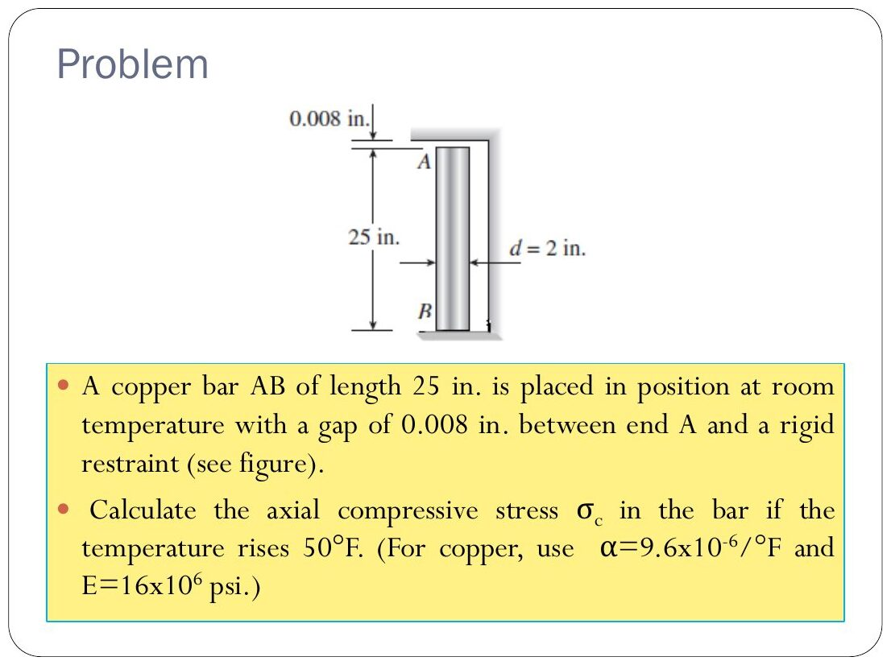
Original: Slides Ch 5, slide 48
Given: L = 25 in, gap 0.008 in, ΔT = 50°F, α = 9.6 × 10⁻⁶/°F, E = 16 × 10⁶ psi. Free expansion $=9.6×{10}^{−6}\left(50\right)\left(25\right)=0.012$ in, which is greater than the gap. Excess $=0.004$ in.
$$σ_{c}=E\frac{0.004}{25}=\boxed{2560 \text{psi (compression)}}$$

Q7 (Slides Ch5, Gere) — Pre-stressed steel wire (easy)
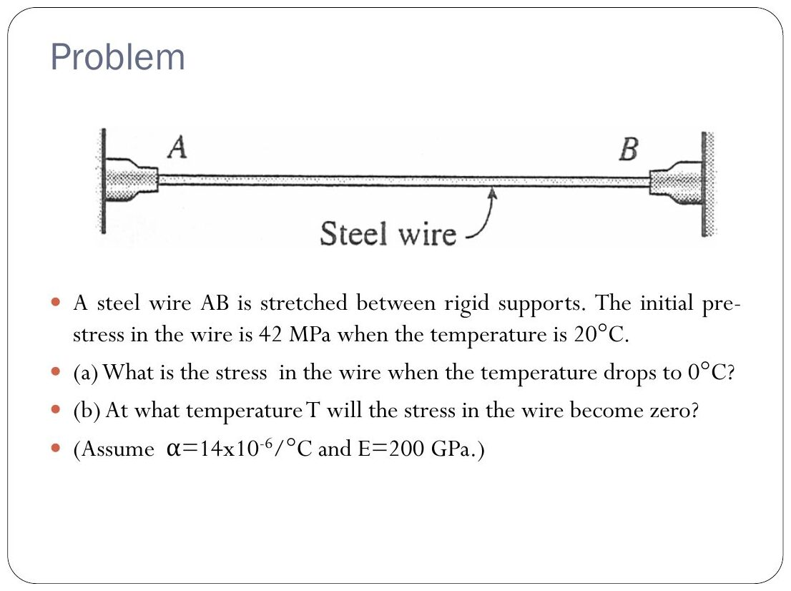
Original: Slides Ch 5, slide 49
Given: pre-stress 42 MPa at 20°C, α = 14 × 10⁻⁶/°C, E = 200 GPa.

  - Cooling to 0°C adds tension: $Δσ=EαΔT=200 000\left(14×{10}^{−6}\right)\left(20\right)=56$ MPa, so $\boxed{σ=98 \text{MPa}}$

  - Zero stress when $Eα\left(T−20\right)=42⇒T−20=15$, so $\boxed{T={35}^{∘}\text{C}}$

Q8 (Slides Ch5, Gere) — Three wires: when does steel carry everything? (medium)
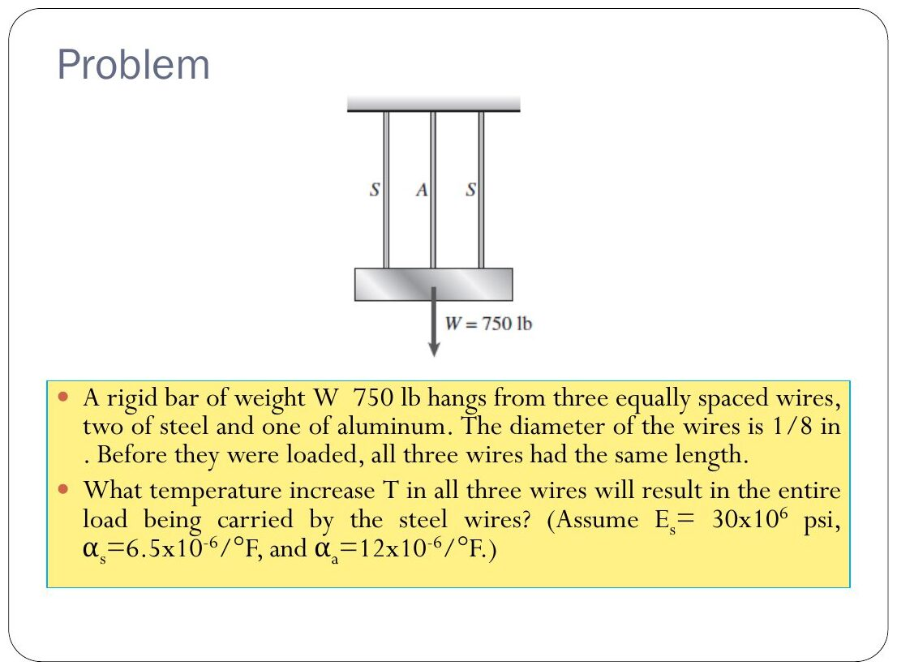
Original: Slides Ch 5, slide 47
Given: rigid bar, W = 750 lb, two steel wires and one aluminium wire (centre), each 1/8 in diameter, same initial length. $E_{s}=30×{10}^{6}$ psi, $α_{s}=6.5×{10}^{−6}$/°F, $α_{a}=12×{10}^{−6}$/°F. Idea: aluminium expands more. When its force drops to zero it is just slack, so the bar is held by steel alone. The bar stays level (symmetry), so all three wires have the same length change.
$$α_{s}ΔTL+\frac{\left(W/2\right)L}{A_{s}E_{s}}=α_{a}ΔTL ⇒ ΔT=\frac{W/2}{A_{s}E_{s}\left(α_{a}−α_{s}\right)}$$
$A_{s}=\frac{π}{4}{\left(0.125\right)}^{2}=0.01227$ in².
$$ΔT=\frac{375}{0.01227\left(30×{10}^{6}\right)\left(5.5×{10}^{−6}\right)}=\boxed{{185}^{∘}\text{F}}$$
(The aluminium modulus isn’t needed, because its force is zero at this instant.)

Q9 (Slides Ch5, Gere) — Brass sleeve on a steel bolt (medium)
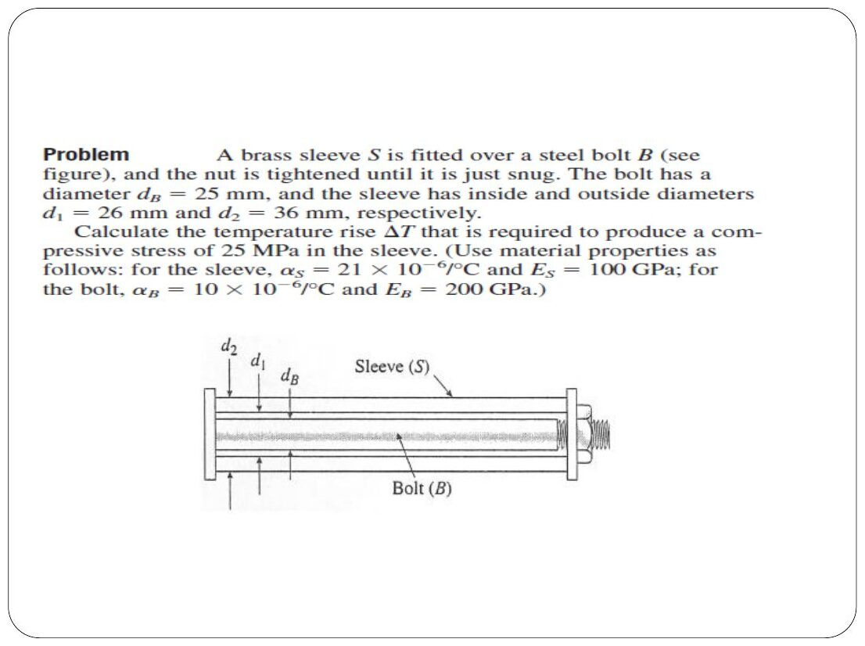
Original: Slides Ch 5, slide 50
Given: bolt $d_{B}=25$ mm, $E_{B}=200$ GPa, $α_{B}=10×{10}^{−6}$/°C. Sleeve $d_{1}=26$ mm, $d_{2}=36$ mm, $E_{S}=100$ GPa, $α_{S}=21×{10}^{−6}$/°C. Find: ΔT that gives 25 MPa compression in the sleeve.
- Equilibrium: $P_{S}=P_{B}$ (sleeve compressed, bolt stretched).
- Compatibility: equal final lengths, so $α_{S}ΔT−\frac{P}{E_{S}A_{S}}=α_{B}ΔT+\frac{P}{E_{B}A_{B}}$
$$⇒ σ_{S}=\frac{\left(α_{S}−α_{B}\right)ΔT E_{S}E_{B}A_{B}}{E_{S}A_{S}+E_{B}A_{B}} ⇒ ΔT=\frac{σ_{S}}{E_{S}\left(α_{S}−α_{B}\right)}\left(1+\frac{E_{S}A_{S}}{E_{B}A_{B}}\right)$$
- $A_{S}=\frac{π}{4}\left(620\right)=487$ mm², $A_{B}=\frac{π}{4}\left(625\right)=491$ mm², ratio factor $=1.496$.
$$ΔT=\frac{25\left(1.496\right)}{100 000\left(11×{10}^{−6}\right)}=\boxed{{34}^{∘}\text{C}}$$

Q10 (Slides Ch5, Gere) — Rigid bar on two cables + temperature rise: allowable P (hard)
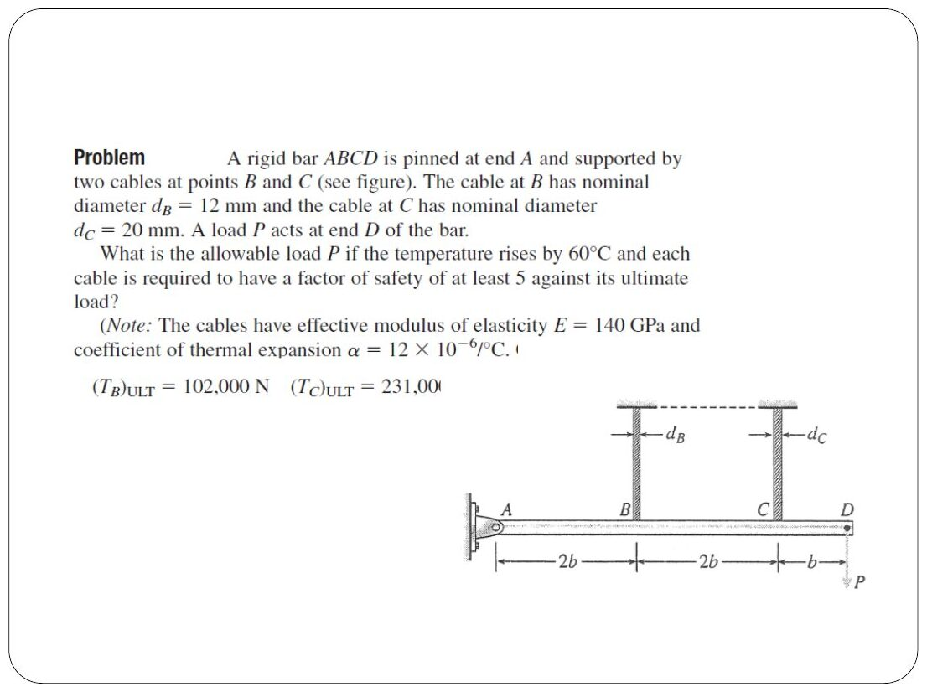
Original: Slides Ch 5, slide 53
Given: rigid bar ABCD pinned at A. Cables at B (2b, $d_{B}=12$ mm) and C (4b, $d_{C}=20$ mm). P at D (5b). ΔT = 60°C. E = 140 GPa, α = 12 × 10⁻⁶/°C. FS = 5 on ultimate: ${\left(T_{B}\right)}_{ult}=102$ kN and ${\left(T_{C}\right)}_{ult}=231$ kN.
- Equilibrium: $∑M_{A}$: $2T_{B}+4T_{C}=5P$.
- Compatibility (rigid bar): $δ_{C}=2δ_{B}$.
- Force–displacement–temperature: $δ_{i}=\frac{T_{i}L}{EA_{i}}+αΔTL$.
$$\frac{T_{C}}{EA_{C}}+αΔT=\frac{2T_{B}}{EA_{B}}+2αΔT⇒2T_{B}A_{C}−T_{C}A_{B}=−EαΔTA_{B}A_{C}$$
With the effective areas $A_{B}=76.7$ mm² and $A_{C}=173$ mm² (the slide’s values): $T_{B}=0.2494P−3480$ and $T_{C}=1.1253P+1740$ (N). Allowables: $T_{B}≤20.4$ kN gives $P≤95.7$ kN. $T_{C}≤46.2$ kN gives $P≤39.5$ kN.
$$\boxed{P_{allow}=39.5 \text{kN (cable C governs)}}$$
Takeaway: heating relieves cable B (the −3480 term) and loads cable C, because the compatibility condition forces C to stretch twice as much as B.

Q11 (PYQ 2014-15 Test-2 Q3) — Thermo-gate: Al + Mg plates closing a gap (medium, 20 marks)
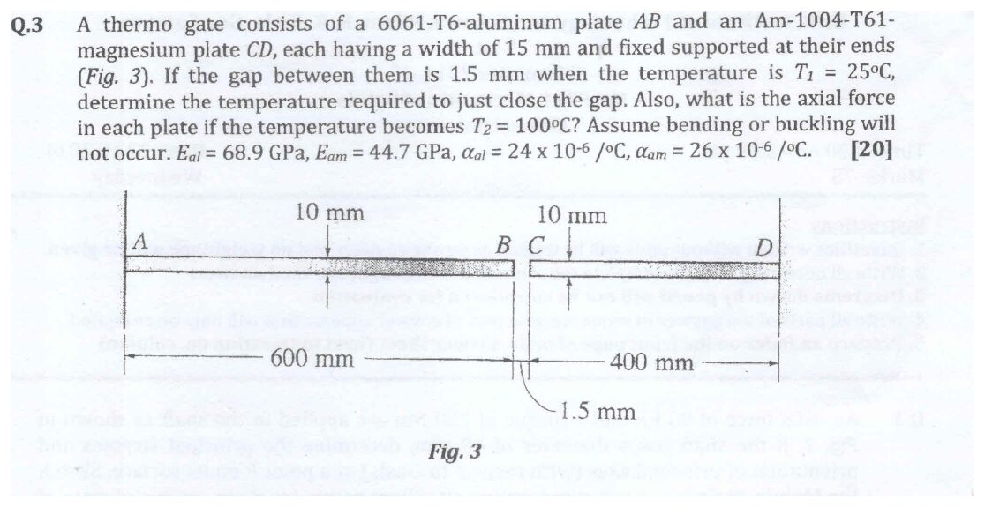
Original question: PYQ 2014-15 Test-2 Q3
Given: Al plate AB, 600 mm, $E_{al}=68.9$ GPa, $α_{al}=24×{10}^{−6}$/°C. Mg plate CD, 400 mm, $E_{am}=44.7$ GPa, $α_{am}=26×{10}^{−6}$/°C. Both 15 mm wide × 10 mm thick, fixed at the outer ends. Gap 1.5 mm at $T_{1}=25$°C. Find: (a) T to close the gap, (b) the force at $T_{2}=100$°C. (a) Free expansions must add up to the gap:
$$\left(24×{10}^{−6}⋅600+26×{10}^{−6}⋅400\right)ΔT=1.5⇒0.0248 ΔT=1.5⇒ΔT={60.5}^{∘}\text{C}⇒\boxed{T={85.5}^{∘}\text{C}}$$
(b) At ΔT = 75°C the free expansion is $0.0248\left(75\right)=1.86$ mm. The excess of 0.36 mm must be suppressed by a common compressive force F (equilibrium: the same F in both plates). With A = 150 mm²:
$$0.36=F\left(\frac{600}{150\left(68 900\right)}+\frac{400}{150\left(44 700\right)}\right)=F\left(5.806+5.966\right)×{10}^{−5}$$
$$\boxed{F=3.06 \text{kN (compression in both plates)}, σ=20.4 \text{MPa}}$$

Concept 5.5 — Complete equations of elasticity and strain energy

A. Concept explanation
3. Formal treatment (slides, Crandall §5.6). In 3-D, any elasticity problem combines:
- Equilibrium: $\frac{∂σ_{x}}{∂x}+\frac{∂τ_{xy}}{∂y}+\frac{∂τ_{zx}}{∂z}+X=0$ (and similarly for y and z; X, Y, Z are body forces per unit volume)
- Geometric compatibility: $ϵ_{x}=∂u/∂x$, $γ_{xy}=∂v/∂x+∂u/∂y$, …
- Stress–strain–temperature: generalized Hooke’s law with $α\left(T−T_{0}\right)$
That is 15 equations for 15 unknowns (6 stresses, 6 strains, 3 displacements). It is the continuum version of the three steps of Ch. 2.
Strain energy density (Crandall §5.8, slides). Work stored per unit volume:
$$u=1/2\left(σ_{x}ϵ_{x}+σ_{y}ϵ_{y}+σ_{z}ϵ_{z}+τ_{xy}γ_{xy}+τ_{yz}γ_{yz}+τ_{zx}γ_{zx}\right)$$
In principal stresses:
$$u=\frac{1}{2E}\left[σ_{1}^{2}+σ_{2}^{2}+σ_{3}^{2}−2ν\left(σ_{1}σ_{2}+σ_{2}σ_{3}+σ_{3}σ_{1}\right)\right]$$
Uniaxial: $u=σ^{2}/2E$. Pure shear: $u=τ^{2}/2G$. Integrating over a bar gives Ch. 2’s $U=P^{2}L/2AE$, and over a shaft Ch. 6’s $U=T^{2}L/2GJ$.
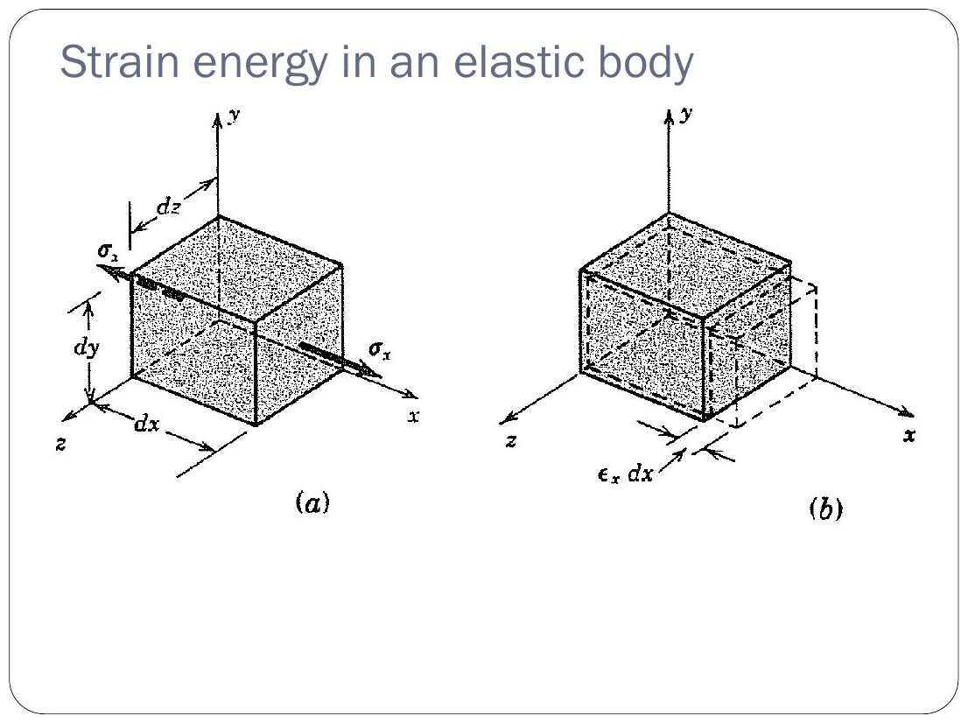
Original: Slides Ch 5, slide 30

Concept 5.6 — Yield criteria: Tresca (maximum shear stress) and von Mises (distortion energy)

A. Concept explanation
1. Intuition. A tensile test tells you when a material yields under one stress. Real parts feel combined stresses. A yield criterion is a rule that turns any combination into one “equivalent” number that you can compare with the tensile yield strength. Ductile metals yield by slip (shear), so both criteria are built on shear-related quantities. Hydrostatic pressure causes no slip, so it must not cause yield either.
2. Why it matters. Almost every compre has a “factor of safety by Tresca/von Mises” part (2019, 2021, 2024, 2014).
3. Formal treatment (slides). Fracture vs yield: fracture is driven by normal stress (bonds break and can’t reform). Yield is driven by shear stress (planes slide and bonds reform).
Tresca (maximum shear stress): yield starts when $τ_{max}$ reaches the value at yield in a tension test, $τ_{Y}=σ_{Y}/2$.
$$\boxed{σ_{max}−σ_{min}=σ_{Y}} \left(\text{using all three principal stresses, including }σ_{3}=0\text{ in plane stress}\right)$$
Plane stress cases (slides):
- $σ_{1},σ_{2}$ of opposite sign: $\left|σ_{1}−σ_{2}\right|=σ_{Y}$
- Same sign: $max\left(\left|σ_{1}\right|,\left|σ_{2}\right|\right)=σ_{Y}$
The yield surface in the $σ_{1}$–$σ_{2}$ plane is a hexagon.
von Mises (distortion energy): yield starts when the distortion part of the strain energy density reaches its value at yield in simple tension.
$$\boxed{σ_{vm}=\sqrt{\frac{{\left(σ_{1}−σ_{2}\right)}^{2}+{\left(σ_{2}−σ_{3}\right)}^{2}+{\left(σ_{3}−σ_{1}\right)}^{2}}{2}}≥σ_{Y}}$$
Plane stress: $σ_{vm}=\sqrt{σ_{1}^{2}−σ_{1}σ_{2}+σ_{2}^{2}}$. This is an ellipse that circumscribes the Tresca hexagon. In terms of x–y components (no need for principal stresses):
$$σ_{vm}=\sqrt{σ_{x}^{2}−σ_{x}σ_{y}+σ_{y}^{2}+3τ_{xy}^{2}}$$
Shaft or beam point with only σ and τ:
$$σ_{vm}=\sqrt{σ^{2}+3τ^{2}}, σ_{Tresca}=\sqrt{σ^{2}+4τ^{2}}$$
Factor of safety: $n=σ_{Y}/σ_{eq}$.
4. Derivation of von Mises (slides). Split each principal stress into a hydrostatic part $σ_{av}=\left(σ_{1}+σ_{2}+σ_{3}\right)/3$ and a distortional part $\left(σ_{i}−σ_{av}\right)$.
- Total energy: $u=\frac{1}{2E}\left[∑σ_{i}^{2}−2ν∑σ_{i}σ_{j}\right]$
- Volume-change energy: replace each $σ_{i}$ with $σ_{av}$, giving $u_{v}=\frac{3σ_{av}^{2}}{2E}\left(1−2ν\right)=\frac{1−2ν}{6E}{\left(σ_{1}+σ_{2}+σ_{3}\right)}^{2}$
- Distortion energy:
$$u_{d}=u−u_{v}=\frac{1+ν}{3E}\left[\frac{{\left(σ_{1}−σ_{2}\right)}^{2}+{\left(σ_{2}−σ_{3}\right)}^{2}+{\left(σ_{3}−σ_{1}\right)}^{2}}{2}\right] \left(1\right)$$
- In simple tension at yield ($σ_{1}=σ_{Y}$, $σ_{2}=σ_{3}=0$): $u_{d,Y}=\frac{1+ν}{3E}σ_{Y}^{2}$ … (2)
- Setting (1) = (2) gives the criterion. ∎
Tresca from Mohr’s circle: the tension test at yield has a circle of diameter $σ_{Y}$, so $τ_{Y}=σ_{Y}/2$.
5. Picture. In the $σ_{1}$–$σ_{2}$ plane the hexagon (Tresca) sits inside the ellipse (von Mises). They touch at the six points of uniaxial and equal-biaxial stress. The largest gap is in pure shear: Tresca predicts $τ_{Y}=0.5σ_{Y}$ and von Mises predicts $τ_{Y}=σ_{Y}/\sqrt{3}=0.577σ_{Y}$. Test data for steel, copper and nickel (Crandall Fig. 5.x, slide) fall closer to von Mises.
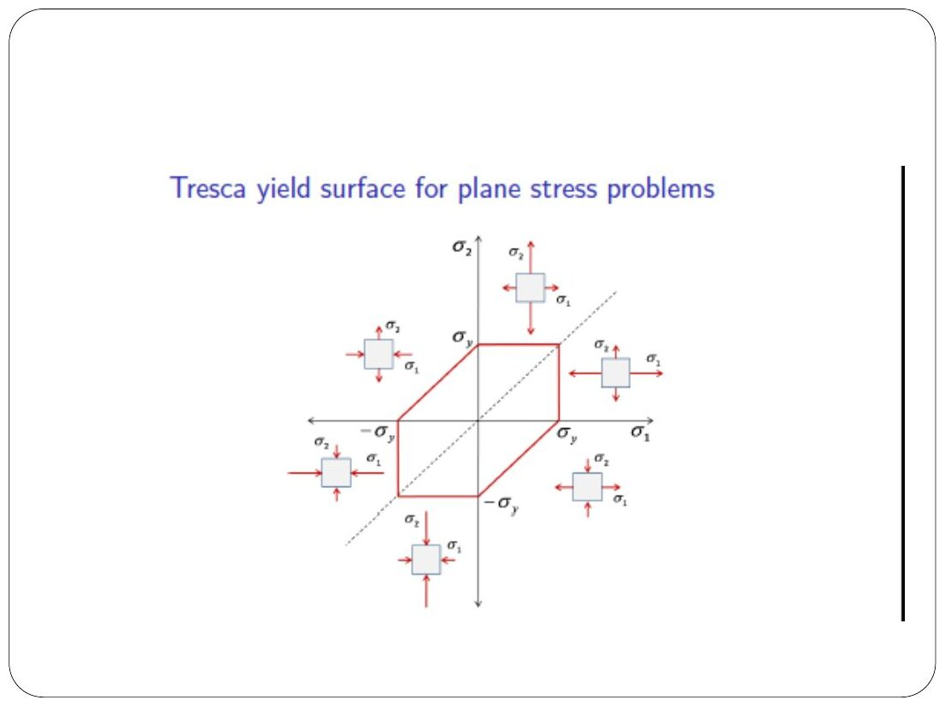
Original: Slides Ch 5, slide 39
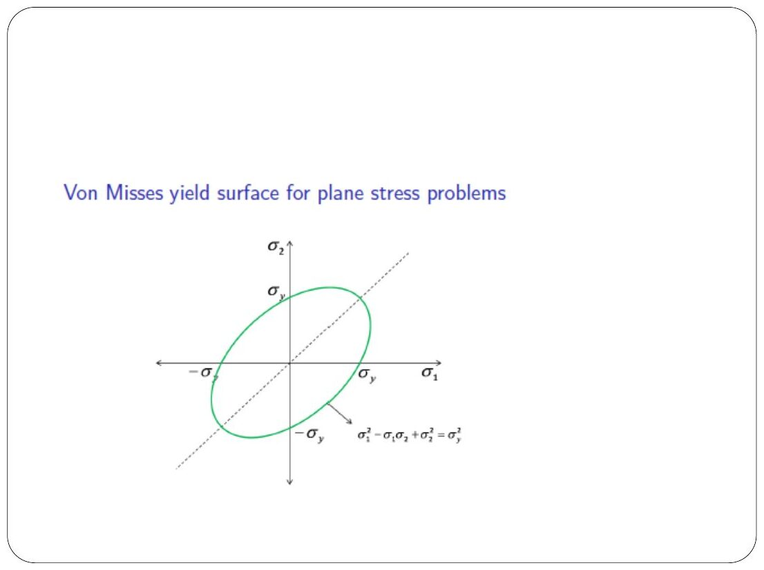
Original: Slides Ch 5, slide 45
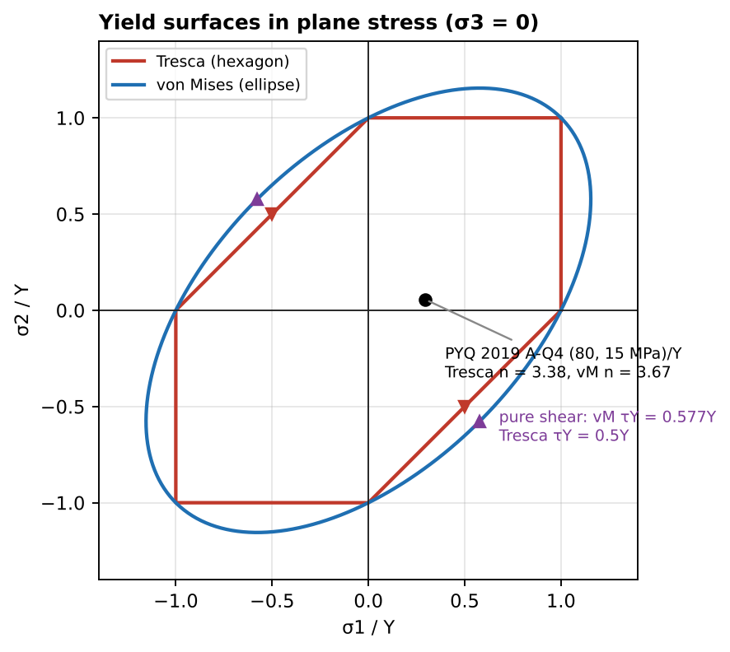
Tresca hexagon inside the von Mises ellipse
6. Special cases. Tresca is always conservative (it predicts yield earlier or equal), so it gives FS ≤ the von Mises FS. If the question asks “will it yield” and Tresca says no, von Mises says no too.
7. Common traps.
- Using in-plane $\left(σ_{1}−σ_{2}\right)/2$ for Tresca when both principal stresses have the same sign. You must include $σ_{3}=0$.
- Plugging x–y stresses into $\sqrt{σ_{1}^{2}−σ_{1}σ_{2}+σ_{2}^{2}}$ without first computing principal stresses (or use the $3τ^{2}$ form).
- Using $σ_{u}$ instead of $σ_{Y}$.
8. Summary box
Criterion | Equivalent stress | Pure-shear yield
Tresca | $σ_{max}−σ_{min}$ (incl. σ₃) = $\sqrt{σ^{2}+4τ^{2}}$ for σ–τ | $0.5σ_{Y}$
von Mises | $\sqrt{σ_{x}^{2}−σ_{x}σ_{y}+σ_{y}^{2}+3τ_{xy}^{2}}$ = $\sqrt{σ^{2}+3τ^{2}}$ for σ–τ | $0.577σ_{Y}$

B. Solved questions

Q12 (PYQ 2014-15 Compre A Q3) — Tresca with $σ_{2}=−0.5σ_{1}$ (easy)
$σ_{Y}=120$ MPa. Opposite signs, so $σ_{1}−σ_{2}=1.5σ_{1}=120$.
$$\boxed{σ_{1}=80 \text{MPa}}$$

Q13 (PYQ 2014-15 Compre A Q4) — Does it yield by von Mises? (easy)
$σ_{x}=140$, $σ_{y}=−80$, $τ_{xy}=125$ MPa, $σ_{Y}=250$ MPa.
$$σ_{vm}=\sqrt{{140}^{2}−\left(140\right)\left(−80\right)+{80}^{2}+3{\left(125\right)}^{2}}=\sqrt{84 075}=290 \text{MPa}>250 ⇒ \boxed{\text{Yields (FS = 0.86)}}$$

Q14 (PYQ 2019-20 A Q4) — FS by Tresca and von Mises (medium, 7 marks)
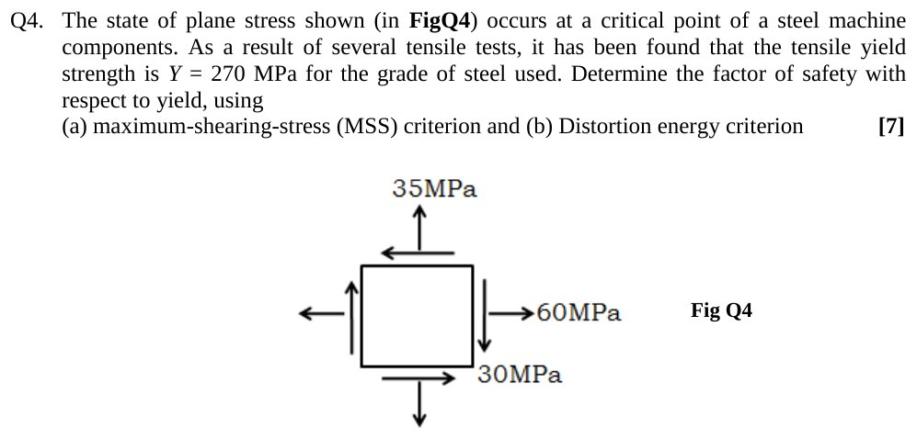
Original question: PYQ 2019-20 Compre A Q4
Given (from Fig Q4): $σ_{x}=60$ MPa (T), $σ_{y}=35$ MPa (T), $τ_{xy}=−30$ MPa (on the right face the shear points down). $σ_{Y}=270$ MPa. Principal: centre 47.5, $R=\sqrt{{12.5}^{2}+{30}^{2}}=32.5$, so σ₁ = 80, σ₂ = 15 and σ₃ = 0 MPa.
- (a) Tresca: same sign, so $σ_{max}−σ_{min}=80−0=80$. $\boxed{n=270/80=3.38}$
- (b) von Mises: $\sqrt{{80}^{2}−80\left(15\right)+{15}^{2}}=73.7$ MPa. $\boxed{n=270/73.7=3.67}$
Trap check: using the in-plane value $σ_{1}−σ_{2}=65$ would give n = 4.15. That’s wrong (unsafe), because both principal stresses are tensile. Check: $n_{Tresca}<n_{vM}$ ✓ (Tresca is conservative).
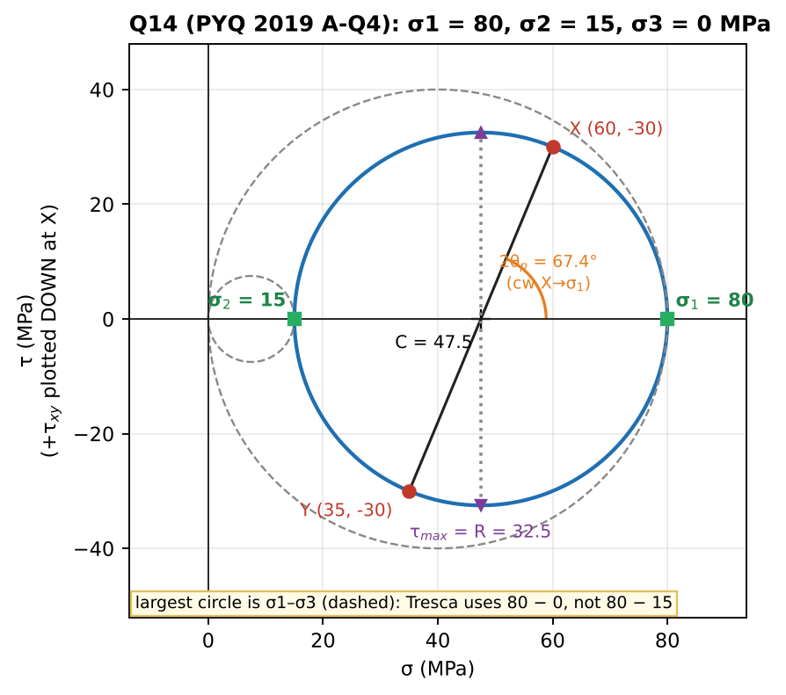
Mohr’s circles including σ3 = 0

Q15 (Slides Ch5) — Bolt diameter by Tresca and von Mises (easy–medium)
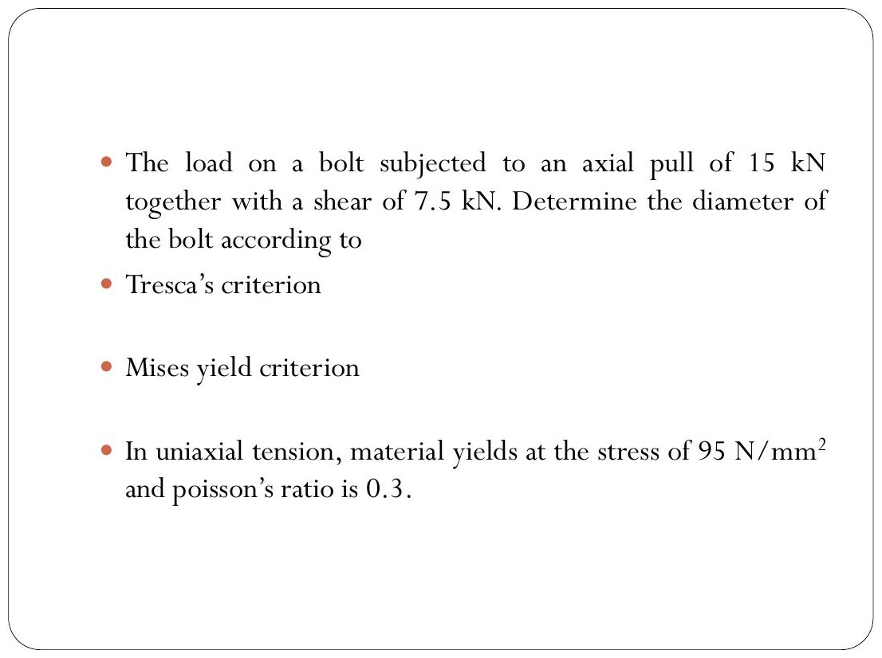
Original: Slides Ch 5, slide 58
Given: axial pull 15 kN with shear 7.5 kN. $σ_{Y}=95$ MPa (ν = 0.3 is given but not needed for these two criteria). With $σ=P/A$ and $τ=V/A$:
- Tresca: $\sqrt{σ^{2}+4τ^{2}}=\frac{\sqrt{{15}^{2}+4{\left(7.5\right)}^{2}}×{10}^{3}}{A}=\frac{21 213}{A}=95$, so $A=223.3$ mm². $\boxed{d=16.9 \text{mm}}$
- von Mises: $\frac{\sqrt{{15}^{2}+3{\left(7.5\right)}^{2}}×{10}^{3}}{A}=\frac{19 843}{A}=95$, so $A=208.9$ mm². $\boxed{d=16.3 \text{mm}}$
(Taking τ as the average V/A, as the slide intends. ν would be needed for the max-principal-strain theory, a common variation.)

PYQs on this concept that appear in later chapters
- 2021-22 A-Q2(c) — does the axle yield by von Mises (σ = 140 MPa, τ = 54.4 MPa, $σ_{Y}=350$ MPa)? See Ch. 6 Q10. $σ_{vm}=169$ MPa, so no (FS 2.07).
- 2024-25 B-Q2(d) — FS at point B of the post by von Mises. See Ch. 6 Q11.

Chapter 5 — Formula and convention sheet
Item | Formula
Engineering stress/strain | $σ=P/A_{0}$, $ϵ=δ/L_{0}$
Hooke + Poisson | $ϵ_{x}=\frac{1}{E}\left[σ_{x}−ν\left(σ_{y}+σ_{z}\right)\right]+αΔT$ (cyclic), $γ=τ/G$
Plane stress inverse | $σ_{x}=\frac{E}{1−ν^{2}}\left(ϵ_{x}+νϵ_{y}\right)$, $ϵ_{z}=−\frac{ν}{E}\left(σ_{x}+σ_{y}\right)$
Elastic constants | $G=\frac{E}{2\left(1+ν\right)}$, $K=\frac{E}{3\left(1−2ν\right)}$
Volume change | $ΔV/V=ϵ_{x}+ϵ_{y}+ϵ_{z}=\frac{1−2ν}{E}∑σ$
Dimension change | $ΔL=Lϵ$ (include Poisson terms)
Thermal (fixed ends) | $σ=−EαΔT$; with gap: stress only after the gap closes
Composite thermal | equilibrium + equal total deformation; larger α goes into compression
Energy density | $u=\frac{1}{2E}\left[∑σ_{i}^{2}−2ν∑σ_{i}σ_{j}\right]$; uniaxial $σ^{2}/2E$; shear $τ^{2}/2G$
Tresca | $σ_{max}−σ_{min}=σ_{Y}$ (include σ₃ = 0); σ–τ: $\sqrt{σ^{2}+4τ^{2}}$
von Mises | $\sqrt{σ_{1}^{2}−σ_{1}σ_{2}+σ_{2}^{2}}$; x–y: $\sqrt{σ_{x}^{2}−σ_{x}σ_{y}+σ_{y}^{2}+3τ^{2}}$; σ–τ: $\sqrt{σ^{2}+3τ^{2}}$
Factor of safety | $n=σ_{Y}/σ_{eq}$; Tresca n ≤ von Mises n
Other Crandall Ch. 5 problems worth practising: 5.1–5.10 (Hooke, Poisson), 5.15–5.25 (thermal, composite), 5.40+ (yield criteria).

Chapter 6 — Torsion
Circular shafts: geometry of deformation, $τ=Tr/J$, angle of twist, solid vs hollow, stepped shafts, power transmission, gears, statically indeterminate shafts, strain energy, combined torsion + axial/bending, yielding
Sources used: Slides “6.pdf” (Chapter 6, Torsion), Crandall Ch. 6 (§6.1–6.5, Figs 6.5–6.14), PYQs 2023-24 (A-Q1; B-Q2), 2024-25 (B-Q1; B-Q2), 2019-20 (B-Q4), 2021-22 (A-Q1; A-Q2), 2014-15 (Test-2 Q1, Q4; Compre A-Q5; Compre B-Q2).

Concept 6.1 — Geometry of deformation of a twisted circular shaft

A. Concept explanation
1. Intuition. Draw straight lines along a rubber hose, then twist it. The lines become helices, but each circular cross-section stays a flat circle and just rotates as a rigid disc, like a stack of coins each turned slightly more than the one below. Points far from the axis move farther, so the shear strain grows linearly with radius.
2. Why it matters. Drive shafts, axles, turbine–generator couplings, screwdrivers, torsion springs. Torsion appears in every compre (6 out of 6 papers in your set).
3. Formal treatment (Crandall §6.2, slide figs 6.5–6.7). Use cylindrical coordinates (r, θ, z). Crandall uses $M_{t}$ for torque, while the slides and Beer use T. Crandall proves by symmetry (not by assumption) that:
- Each cross-section originally normal to the axis remains plane and normal, and does not distort in its own plane. (Fig. 6.5: if the section warped, rotating the shaft 180° about a diameter X–X would give a different deformation under the same loading, which is impossible. Fig. 6.6: diameters must stay straight for the same reason.)
- Radial lines stay straight and radial.
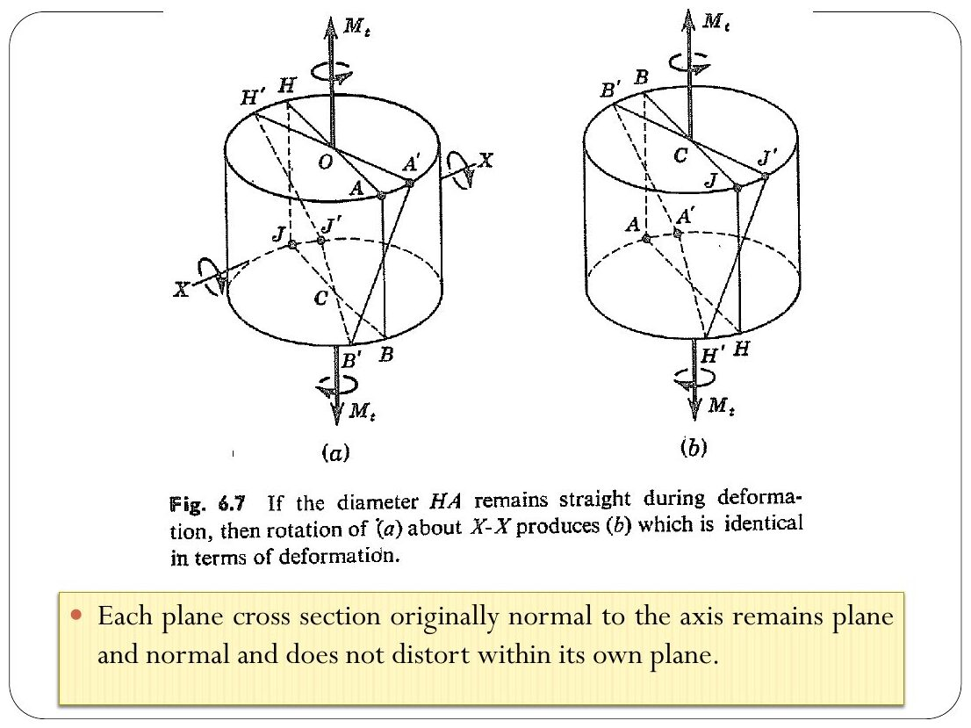
Original: Slides Ch 6, slide 7
No dilation (slide): $ϵ_{r}=ϵ_{θ}=ϵ_{z}=γ_{rθ}=γ_{rz}=0$. The only deformation is the rotation of sections relative to each other.
4. Derivation of shear strain (slides, Crandall Fig. 6.8). Take two sections $Δz$ apart that rotate relative to each other by $Δϕ$. A surface element at radius r: point E₀ moves to E₁, through an arc $rΔϕ$.
$$γ_{θz}=\lim_{Δz→0}\frac{E_{0}E_{1}}{H_{1}E_{0}}=lim\frac{rΔϕ}{Δz} ⇒ \boxed{γ_{θz}=r\frac{dϕ}{dz}}$$
$dϕ/dz$ is the rate of twist (rad per unit length), the same for all r. So γ varies linearly from 0 at the centre to its maximum at the surface.
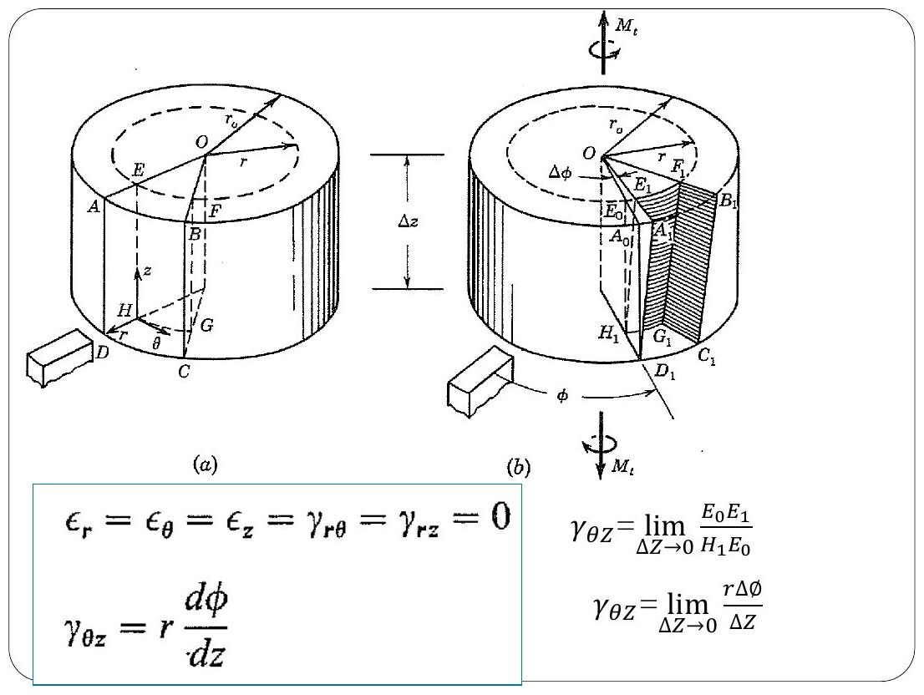
Original: Slides Ch 6, slide 9
5. Picture. Draw a lengthwise line on the surface. After twisting it tilts by the angle $γ_{max}=r_{o} dϕ/dz$. This is the “helix angle” in slide Fig. 6.x.
6. Special cases. These results hold for solid and hollow circular sections. They do not hold for non-circular sections, which warp.
7. Traps. Using $γ=ϕ$ (twist angle). It is $γ=rϕ/L$. γ is dimensionless (radians), φ is an angle of the whole bar.

Concept 6.2 — The torsion formula and the angle of twist

A. Concept explanation
1. Intuition. Material far from the axis is strained more and also has a longer lever arm, so it does most of the work. That is why hollow shafts are efficient: the material near the centre carries little and only adds weight.
3. Formal treatment / 4. Derivation (slides, Crandall §6.3). Step 1, stress–strain (Hooke in shear):
$$τ_{θz}=Gγ_{θz}=Gr\frac{dϕ}{dz}, \text{all other stresses zero}$$
Step 2, equilibrium: the shear stresses on a cross-section must add up to the internal torque.
Mt=A​r τθzdA=GdϕdzA​r2dA=GdϕdzIz
where $I_{z}=J=I_{P}$ is the polar moment of inertia:
$$\boxed{J_{solid}=\frac{πd^{4}}{32}=\frac{πr^{4}}{2}, J_{hollow}=\frac{π\left(d_{o}^{4}−d_{i}^{4}\right)}{32}}$$
Step 3, combine:
$$\frac{dϕ}{dz}=\frac{M_{t}}{GJ} \text{and} τ_{θz}=\frac{M_{t} r}{J}$$
Step 4, integrate along the length: $ϕ=\int_{0}^{L}{\frac{M_{t}}{GJ}}dz=\frac{M_{t}L}{GJ}$ (uniform shaft).
$$\boxed{\frac{T}{J}=\frac{τ}{r}=\frac{Gϕ}{L}}$$
Maximum (surface) stress for a solid shaft: $τ_{max}=\frac{Tc}{J}=\boxed{\frac{16T}{πd^{3}}}$. Hollow shaft: $τ_{max}=\frac{Td_{o}/2}{J}$ at the outer surface and $τ_{min}=\frac{Td_{i}/2}{J}$ at the inner surface ($τ_{min}=τ_{max} d_{i}/d_{o}$). Torsional stiffness: $k_{T}=T/ϕ=GJ/L$. GJ is the torsional rigidity.
Several segments or varying torque:
ϕA/B=i​TiLiGiJi (with Ti the internal torque in segment i, signed)
Sign convention (slides/Beer): use the right-hand rule. An internal torque is positive if its vector points away from the cut face (outward normal). This is the same “positive face, positive direction” rule as in Ch. 3.
5. Stress picture. τ is linear in r on the cross-section (zero at the centre). By $τ_{xy}=τ_{yx}$, an equal shear acts on longitudinal planes too. This is why wooden shafts split lengthwise.
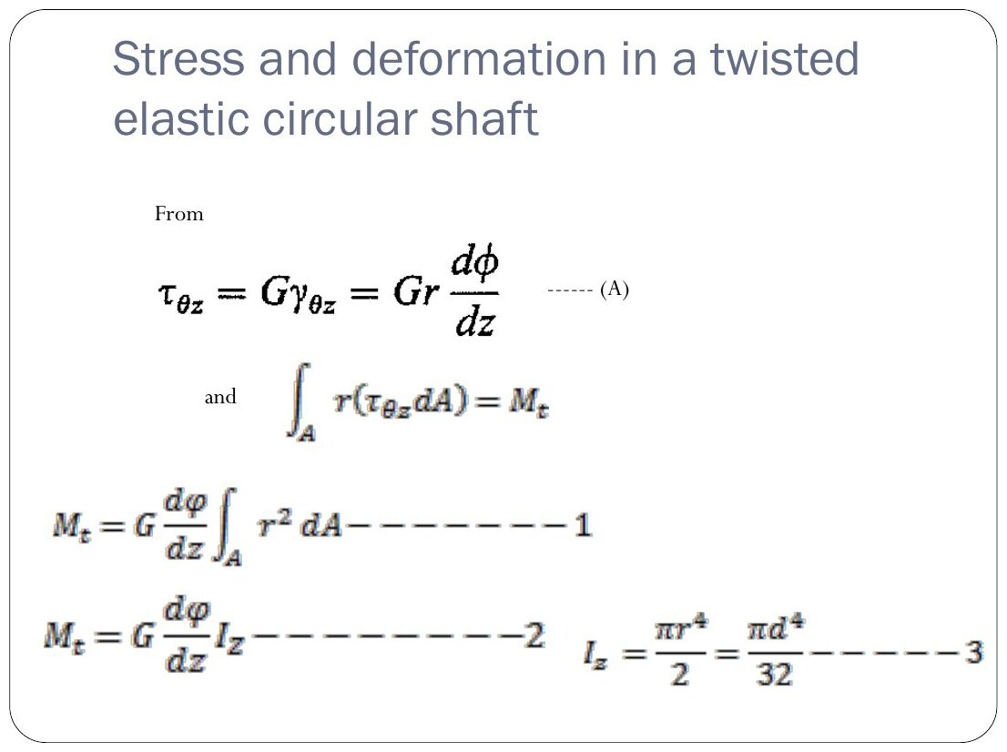
Original: Slides Ch 6, slide 12
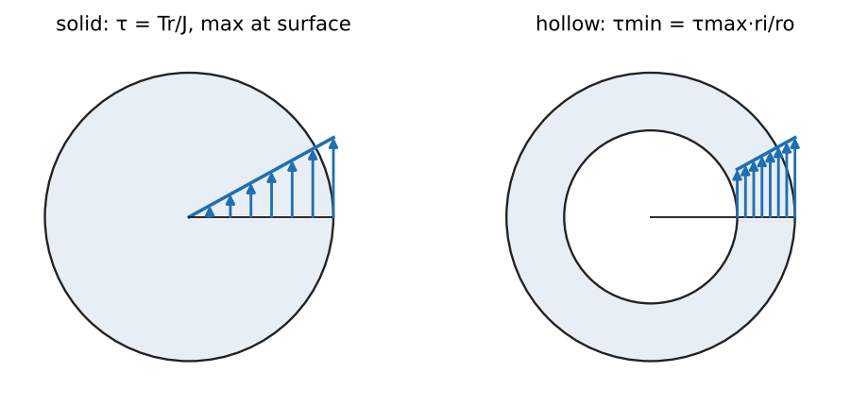
Shear stress varies linearly with radius
6. Special cases.
- Thin-walled tube (mean radius $r_{m}$, thickness t): $J≈2πr_{m}^{3}t$ and $τ≈T/\left(2πr_{m}^{2}t\right)$.
- Same weight: a hollow shaft carries more torque and is stiffer than a solid shaft of the same area (see Q4).
7. Common traps.
- Using the radius r = d where it should be d/2.
- Units: T in N·mm with r in mm and J in mm⁴ gives MPa. φ comes out in radians; convert to degrees only at the end.
- Using the external torque instead of the internal torque of the segment. Draw a torque diagram just like an axial force diagram.
- For a hollow shaft, using $πd_{o}^{4}/32−πd_{i}^{4}/32$ is right, but $π{\left(d_{o}−d_{i}\right)}^{4}/32$ is wrong.
8. Summary box
$$τ=\frac{Tr}{J}, τ_{max,solid}=\frac{16T}{πd^{3}}, ϕ=∑\frac{TL}{GJ}, J_{s}=\frac{πd^{4}}{32}, J_{h}=\frac{π\left(d_{o}^{4}−d_{i}^{4}\right)}{32}$$

B. Solved questions

Q1 (Slides Ch6, Gere 3.3-x) — Solid steel bar: τ_max, φ, and the allowable torque (easy)
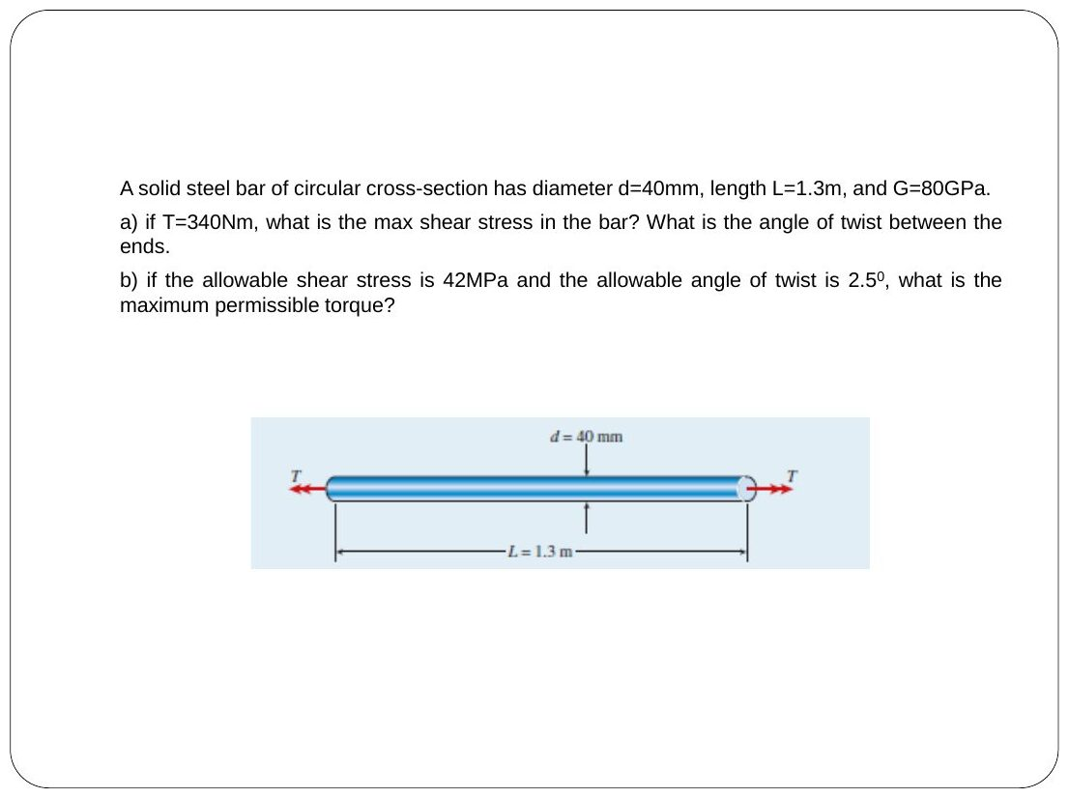
Original: Slides Ch 6, slide 15
Given: d = 40 mm, L = 1.3 m, G = 80 GPa. (a) T = 340 N·m. (b) $τ_{allow}=42$ MPa and $ϕ_{allow}={2.5}^{∘}$. (a) $τ_{max}=\frac{16\left(340 000\right)}{π{\left(40\right)}^{3}}=\boxed{27.1 \text{MPa}}$. $J=π{\left(40\right)}^{4}/32=251 327$ mm⁴.
$$ϕ=\frac{340 000\left(1300\right)}{80 000\left(251 327\right)}=0.0220 \text{rad}=\boxed{{1.26}^{∘}}$$
(b) Strength: $T=τπd^{3}/16=528$ N·m. Stiffness: $T=ϕGJ/L=0.04363\left(80 000\right)\left(251 327\right)/1300=675$ N·m.
$$\boxed{T_{max}=528 \text{N·m (stress governs)}}$$
Takeaway: always check both strength and stiffness, and report the smaller value.

Q2 (Slides Ch6, Beer 3.x) — Hollow shaft, 40/60 mm (easy)
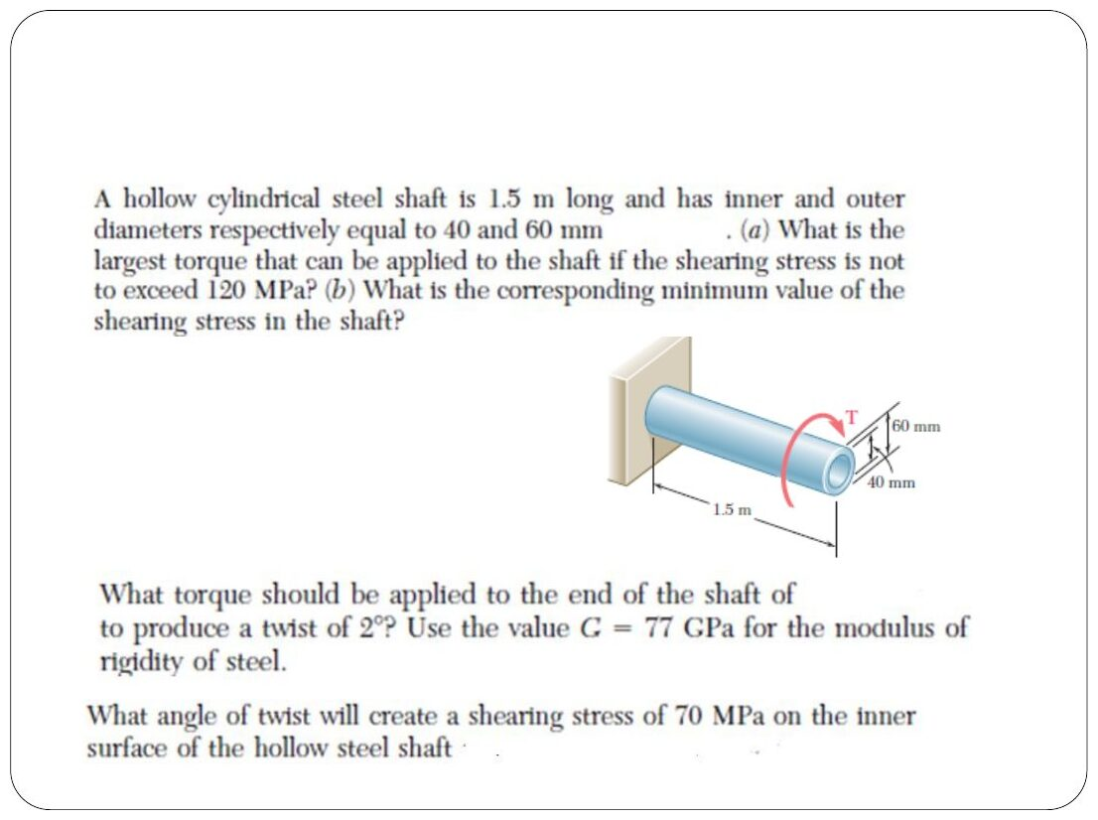
Original: Slides Ch 6, slide 18
Given: L = 1.5 m, $d_{i}=40$ mm, $d_{o}=60$ mm, $τ_{allow}=120$ MPa, G = 77 GPa. $J=\frac{π}{32}\left({60}^{4}−{40}^{4}\right)=1.021×{10}^{6}$ mm⁴.

  - $T=τJ/c=120\left(1.021×{10}^{6}\right)/30=\boxed{4.08 \text{kN·m}}$

  - $τ_{min}=120\left(20/30\right)=\boxed{80 \text{MPa}}$
- For φ = 2°: $T=ϕGJ/L=0.03491\left(77 000\right)\left(1.021×{10}^{6}\right)/1500=\boxed{1.83 \text{kN·m}}$
- For τ = 70 MPa on the inner surface: $ϕ=τL/\left(Gr_{i}\right)=70\left(1500\right)/\left(77 000⋅20\right)=0.0682$ rad $=\boxed{{3.91}^{∘}}$

Q3 (Slides Ch6, Gere) — Solid vs hollow tube (same outer R, inner 0.6R) (medium, conceptual)
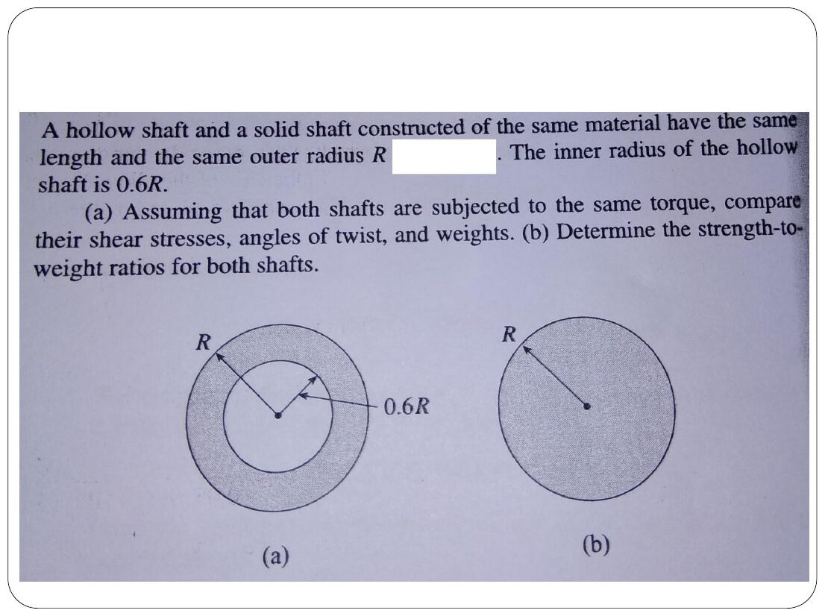
Original: Slides Ch 6, slide 16
Given: the same T, material and length. Compare τ, φ, weight, and strength-to-weight. $J_{h}/J_{s}=1−{0.6}^{4}=0.8704$ and $A_{h}/A_{s}=1−0.36=0.64$.
- $τ_{h}/τ_{s}=ϕ_{h}/ϕ_{s}=1/0.8704=\boxed{1.15}$
- $W_{h}/W_{s}=\boxed{0.64}$
- Strength-to-weight (the torque each can carry at the same $τ_{allow}$, divided by weight): hollow/solid $=0.8704/0.64=\boxed{1.36}$
The hollow shaft is 36% more efficient.

Q4 (Slides Ch6, Gere 3.x) — Design: solid vs hollow for 1200 N·m (medium)
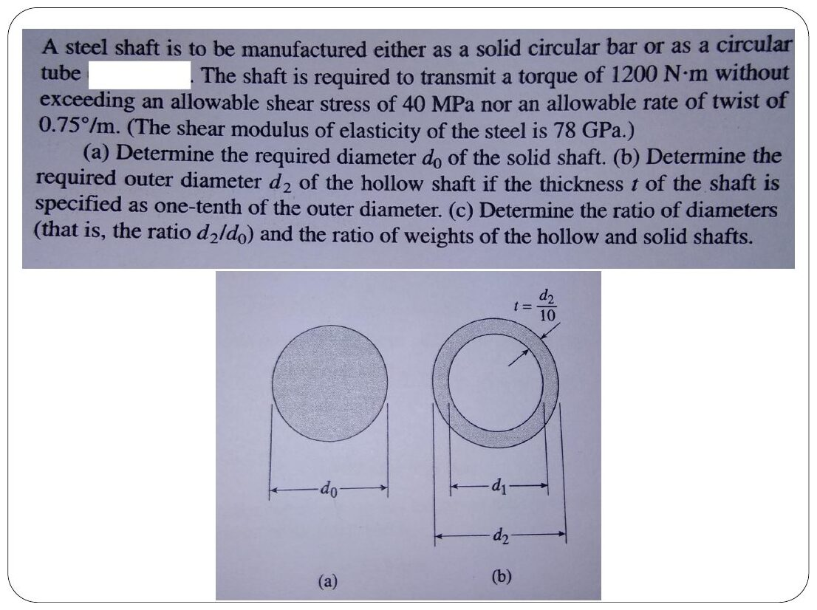
Original: Slides Ch 6, slide 17
Given: T = 1200 N·m, $τ_{allow}=40$ MPa, rate of twist ≤ 0.75°/m, G = 78 GPa. Hollow: $t=d_{2}/10$, so $d_{1}=0.8d_{2}$. Rate limit: $θ={0.75}^{∘}/\text{m}=1.309×{10}^{−5}$ rad/mm.
- (a) Solid. Strength: $d^{3}=16T/\left(πτ\right)$ gives $d=53.5$ mm. Stiffness: $d^{4}=32T/\left(πGθ\right)$ gives $d=58.8$ mm. So $\boxed{d_{0}=58.8 \text{mm}}$.
- (b) Hollow ($J=\frac{πd_{2}^{4}}{32}\left(0.5904\right)$). Strength gives 63.7 mm. Stiffness gives 67.1 mm. So $\boxed{d_{2}=67.1 \text{mm}}$.
- (c) $d_{2}/d_{0}=\boxed{1.14}$. Weight ratio $=\frac{d_{2}^{2}\left(1−0.64\right)}{d_{0}^{2}}=\boxed{0.47}$.

Q5 (Slides Ch6, Beer Sample 3.1) — Four-gear shaft: BC hollow, size AB and CD (medium)
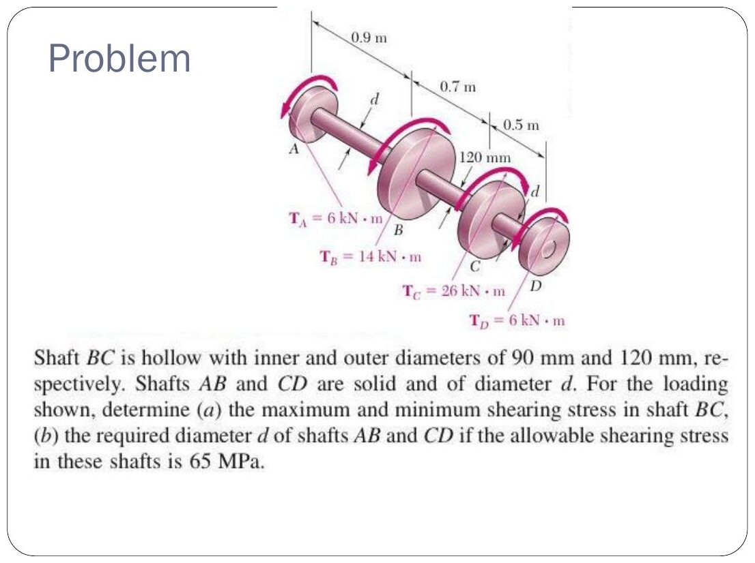
Original: Slides Ch 6, slide 25
Given: $T_{A}=6$, $T_{B}=14$, $T_{C}=26$, $T_{D}=6$ kN·m (balanced). BC: $d_{i}=90$ mm, $d_{o}=120$ mm. $τ_{allow}=65$ MPa in AB and CD. Internal torques: $T_{AB}=6$ kN·m and $T_{BC}=6+14=20$ kN·m. $T_{CD}=6$ kN·m (check: 20 − 26 = −6 ✓). $J_{BC}=\frac{π}{32}\left({120}^{4}−{90}^{4}\right)=13.92×{10}^{6}$ mm⁴.
$$\boxed{τ_{max,BC}=\frac{20×{10}^{6}\left(60\right)}{13.92×{10}^{6}}=86.2 \text{MPa}, τ_{min,BC}=64.7 \text{MPa}}$$
$$d={\left(\frac{16\left(6×{10}^{6}\right)}{π\left(65\right)}\right)}^{1/3}=\boxed{77.8 \text{mm}} ✓ \text{(slide)}$$
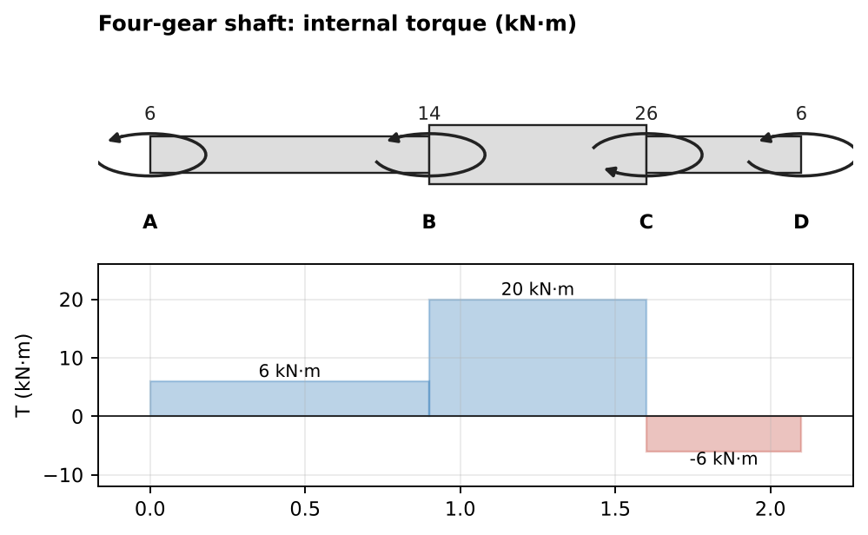
Internal torque diagram

Q6 (Slides Ch6, Beer 3.x) — Hollow 4 in/6 in, 12 ksi; equal-weight comparisons (medium)
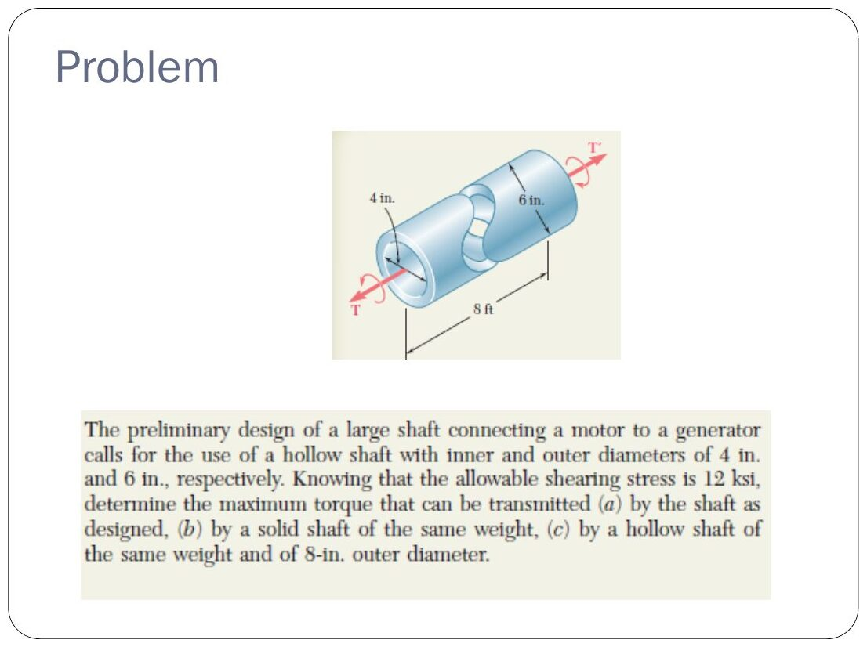
Original: Slides Ch 6, slide 28

  - As designed: $J=\frac{π}{32}\left(6^{4}−4^{4}\right)=102.1$ in⁴, so $T=12\left(102.1\right)/3=\boxed{408 \text{kip·in}}$

  - Solid shaft of the same weight (same area $5π$ in²): $d=4.47$ in, so $T=12πd^{3}/16=\boxed{211 \text{kip·in}}$

  - Hollow shaft of the same weight with $d_{o}=8$ in: $d_{i}^{2}=64−20=44$, so $d_{i}=6.63$ in. $T=12\frac{π\left(8^{4}−{6.63}^{4}\right)}{32}/4=\boxed{636 \text{kip·in}}$
Lesson: for the same material, moving it outward gives more torque capacity: 211 → 408 → 636.

Q7 (Slides Ch6, Beer 3.x) — Stepped hollow/solid shaft AD: twist at A (medium)
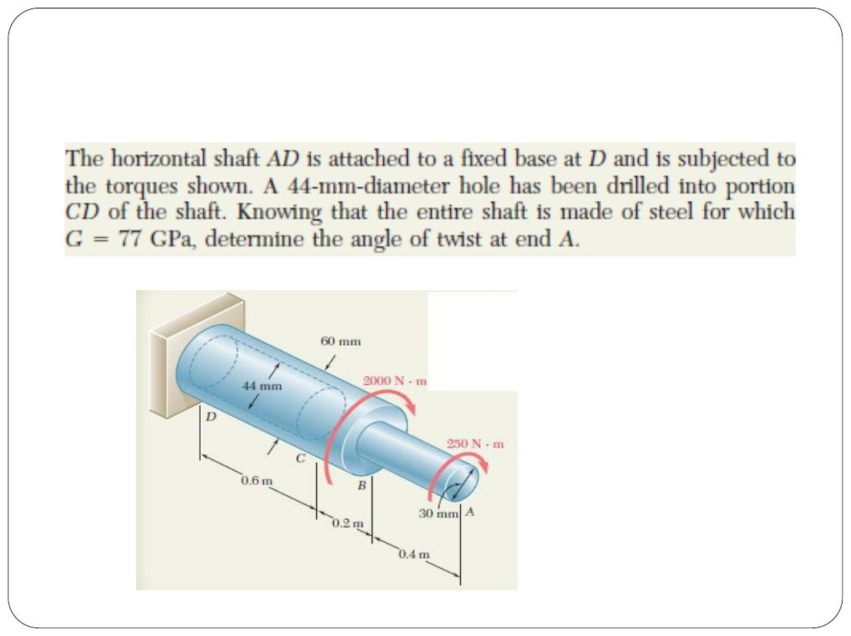
Original: Slides Ch 6, slide 19
Given: fixed at D. AB solid, 30 mm, 0.4 m, with 250 N·m at A. BC solid, 60 mm, 0.2 m. CD is 60 mm with a 44 mm bore, 0.6 m. 2000 N·m at B. G = 77 GPa. Internal: $T_{AB}=250$ N·m and $T_{BC}=T_{CD}=2250$ N·m (same sense).
$$ϕ_{A}=\frac{1}{G}\left[\frac{250e3\left(400\right)}{\frac{π}{32}{30}^{4}}+\frac{2250e3\left(200\right)}{\frac{π}{32}{60}^{4}}+\frac{2250e3\left(600\right)}{\frac{π}{32}\left({60}^{4}−{44}^{4}\right)}\right]=0.0403 \text{rad}=\boxed{{2.31}^{∘}}$$
(The three terms are 0.0163, 0.00459 and 0.0194 rad.)
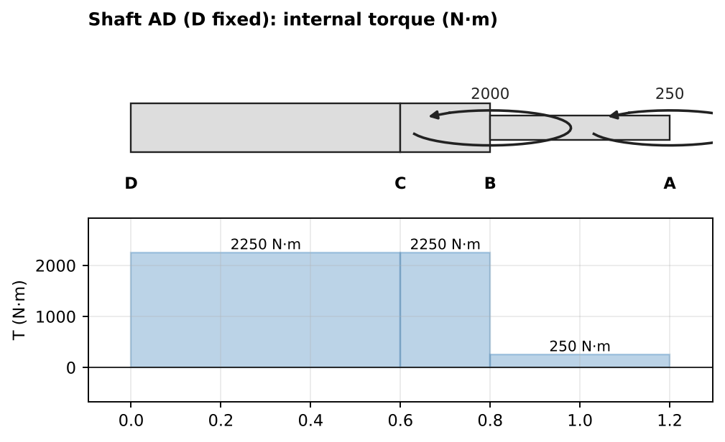
Internal torque diagram

Q8 (Slides Ch6, Gere) — Two-segment solid shaft vs equivalent hollow shaft (medium)
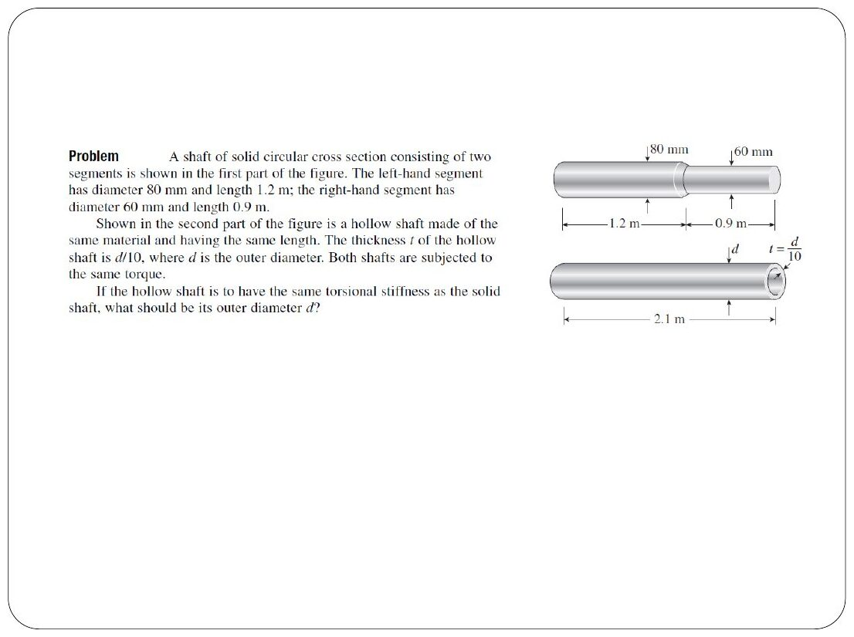
Original: Slides Ch 6, slide 45
Given: solid shaft with 80 mm × 1.2 m and 60 mm × 0.9 m. Hollow shaft 2.1 m long with $t=d/10$ ($d_{i}=0.8d$). Equal torsional stiffness.
$$ϕ_{1}=\frac{32T}{πG}\left[\frac{1.2}{{0.08}^{4}}+\frac{0.9}{{0.06}^{4}}\right]=\frac{32T}{πG}\left(98 741 {\text{m}}^{−3}\right), ϕ_{2}=\frac{32T}{πG}\frac{2.1}{0.5904 d^{4}}$$
Setting $ϕ_{1}=ϕ_{2}$ gives $d^{4}=3.5569/98 741$, so
$$\boxed{d=77.5 \text{mm}}$$

Q9 (Slides Ch6, Gere) — Truck drive shaft: power ↔ torque (easy)
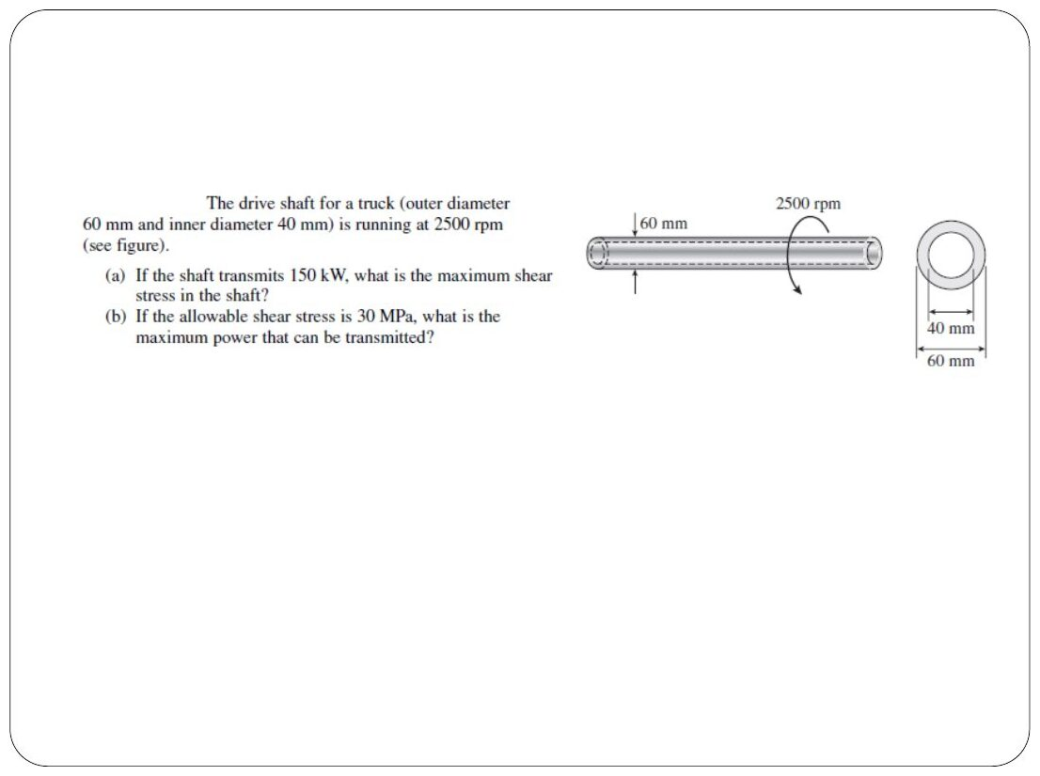
Original: Slides Ch 6, slide 42
$$\boxed{P=Tω=\frac{2πnT}{60}} \left(n \text{in rpm}, P \text{in W}, T \text{in N·m}\right)$$
Given: $d_{o}=60$ mm, $d_{i}=40$ mm, n = 2500 rpm.

  - 150 kW: $T=60\left(150 000\right)/\left(2π⋅2500\right)=573$ N·m, so $τ=573 000\left(30\right)/1.021×{10}^{6}=\boxed{16.8 \text{MPa}}$

  - $τ_{allow}=30$ MPa: $P=150\left(30/16.835\right)=\boxed{267 \text{kW}}$
Trap: P = Tω needs ω in rad/s, not rpm.

Q10 (Slides Ch6, Gere) — Aluminium tube, shear strain at the inner surface (easy)
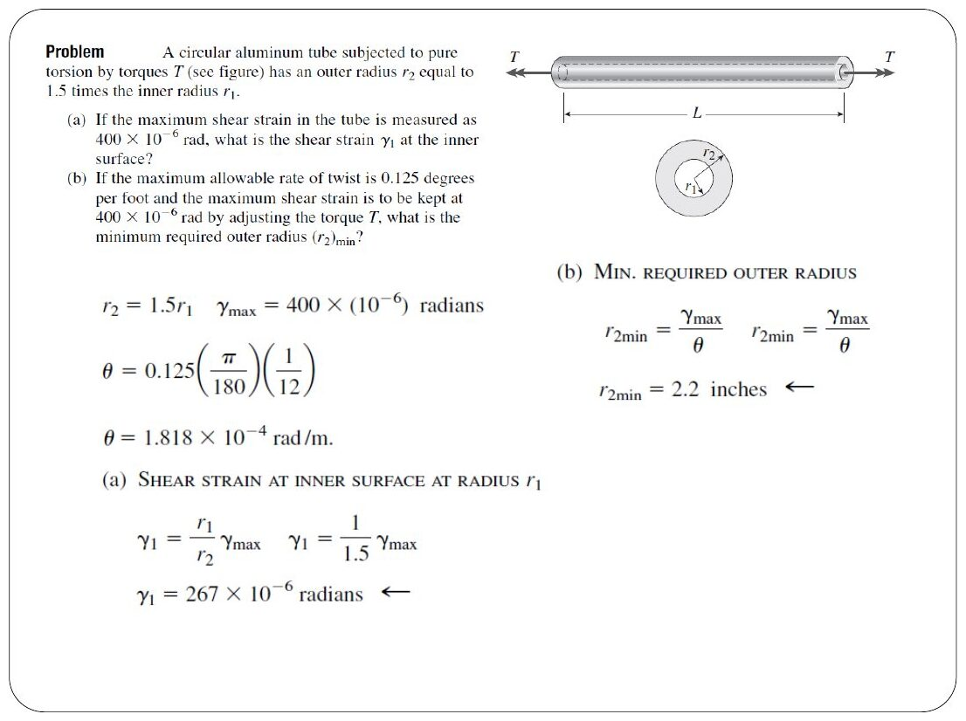
Original: Slides Ch 6, slide 44
Given: $r_{2}=1.5r_{1}$, $γ_{max}=400×{10}^{−6}$. Since γ ∝ r:
$$γ_{1}=γ_{max}\frac{r_{1}}{r_{2}}=\boxed{267×{10}^{−6}}$$
(b) Rate of twist ≤ 0.125°/ft $=1.818×{10}^{−4}$ rad/in (as on the slide) and $γ=rθ$, so $r_{2,min}=γ_{max}/θ=\boxed{2.2 \text{in}}$.

Q11 (Slides Ch6, Gere; also PYQ 2021-22 A Q1) — Strain gauge at 45° gives G (easy)
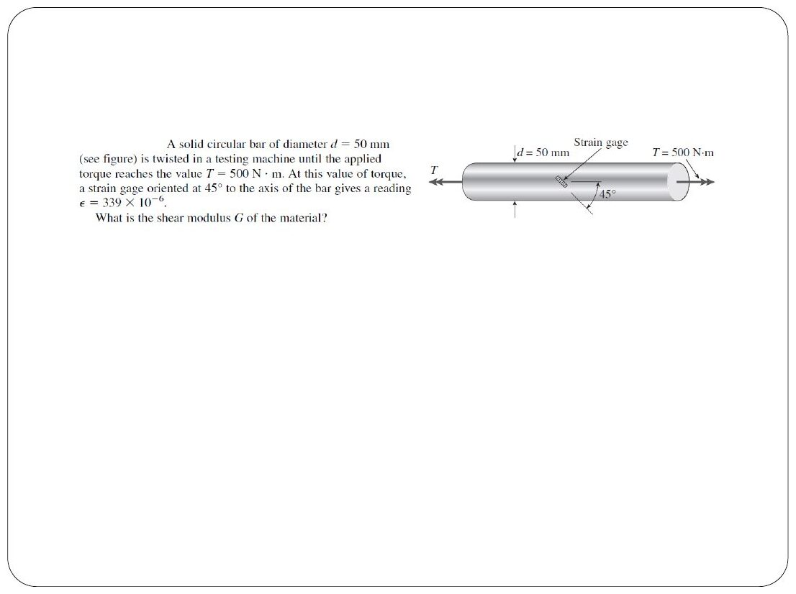
Original: Slides Ch 6, slide 49
Slide: d = 50 mm, T = 500 N·m, ε = 339μ. So $τ=20.37$ MPa, $γ=2ϵ=678μ$, and $G=\boxed{30.0 \text{GPa}}$. PYQ 2021 (same bar, ε = 350μ): $\boxed{G=29.1 \text{GPa}}$. Full solution in Ch. 4 Q13.

Q12 (PYQ 2014-15 Compre A Q5) — Size a shaft (easy)
Original question: PYQ 2014-15 Compre A Q5
T = 205 N·m and $τ_{allow}=100$ MPa:
$$d={\left(\frac{16\left(205 000\right)}{π\left(100\right)}\right)}^{1/3}=\boxed{21.9 \text{mm}}$$

Q13 (PYQ 2014-15 Test-2 Q4) — Axle of tubes + solid section (easy–medium, 20 marks)
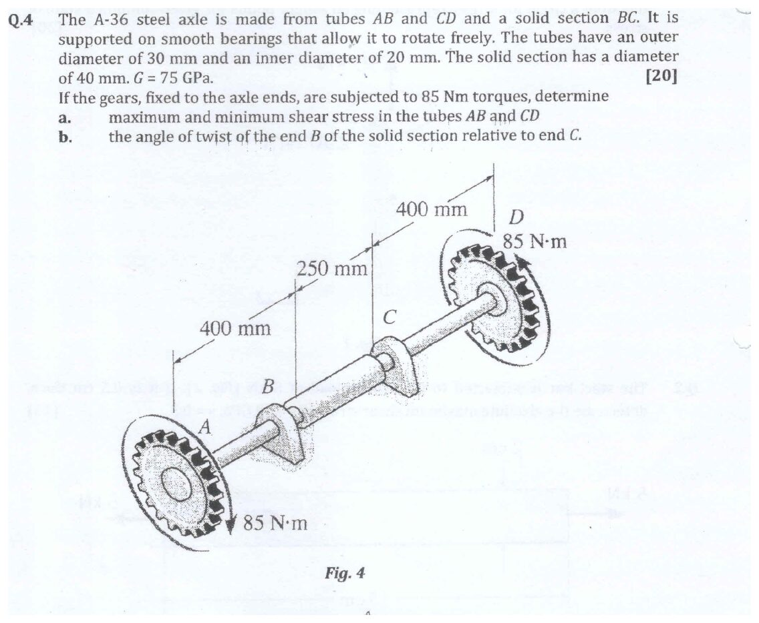
Original question: PYQ 2014-15 Test-2 Q4
Given: tubes AB and CD with $d_{o}=30$ mm and $d_{i}=20$ mm. Solid BC, 40 mm, 250 mm long. Gears at the ends carry 85 N·m. G = 75 GPa. Smooth bearings, so the internal torque is 85 N·m everywhere. $J_{tube}=\frac{π}{32}\left({30}^{4}−{20}^{4}\right)=63 814$ mm⁴.
$$\boxed{τ_{max,tube}=\frac{85 000\left(15\right)}{63 814}=20.0 \text{MPa}, τ_{min}=13.3 \text{MPa}}$$
$$ϕ_{B/C}=\frac{85 000\left(250\right)}{75 000⋅\frac{π}{32}{\left(40\right)}^{4}}=1.13×{10}^{−3} \text{rad}=\boxed{{0.0646}^{∘}}$$

Q14 (PYQ 2023-24 A Q1) — Shaft with three disks: allowable T and twist A relative to C (medium, 10 marks)
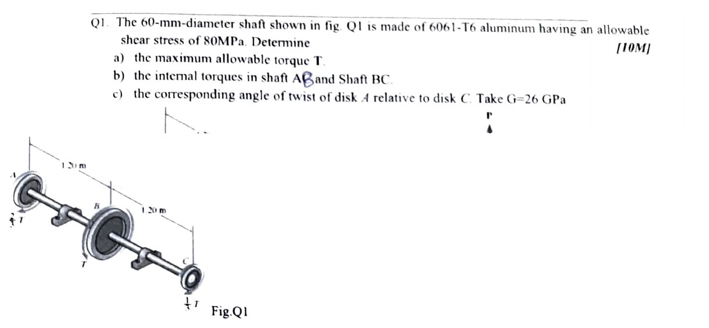
Original question: PYQ 2023-24 Compre A Q1
Given: 60 mm solid aluminium shaft, $τ_{allow}=80$ MPa, G = 26 GPa. Disks: A carries $2/3T$, B carries T (opposite sense), C carries $1/3T$. AB = BC = 1.20 m. Smooth bearings. Internal torques: $T_{AB}=2/3T$ and $T_{BC}=2/3T−T=−1/3T$. The maximum is in AB. (a) $2/3T=τπd^{3}/16=80π{\left(60\right)}^{3}/16=3.393$ kN·m, so $\boxed{T=5.09 \text{kN·m}}$. (b) $\boxed{T_{AB}=3.39 \text{kN·m}, T_{BC}=1.70 \text{kN·m (opposite sense)}}$ (c) $J=π{\left(60\right)}^{4}/32=1.272×{10}^{6}$ mm⁴, $GJ=3.308×{10}^{10}$ N·mm².
$$ϕ_{A/C}=\frac{\left(T_{AB}+T_{BC}\right)L}{GJ}=\frac{\left(3.393−1.696\right)×{10}^{6}\left(1200\right)}{3.308×{10}^{10}}=0.0615 \text{rad}=\boxed{{3.53}^{∘}}$$
Takeaway: opposite-signed segments partly cancel. Students who add magnitudes get 10.6°.
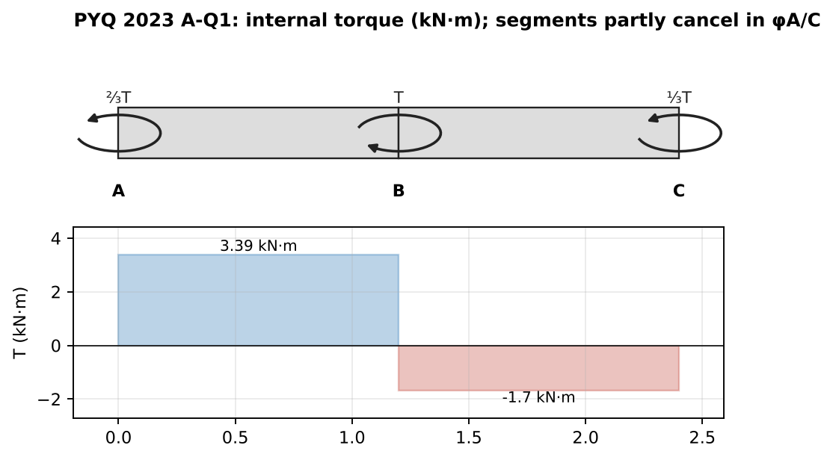
Internal torque diagram

Concept 6.3 — Gears and coupled shafts

A. Concept explanation
1. Intuition. Two meshing gears share one tooth force F. The bigger gear gets a bigger torque ($T=Fr$) but turns through a smaller angle. The contact point moves the same arc length on both: $r_{B}ϕ_{B}=r_{C}ϕ_{C}$.
3. Formal treatment (slides, Beer Sample 3.4).
- Statics: $F=T_{B}/r_{B}=T_{C}/r_{C}$, so $T_{C}=T_{B}\left(r_{C}/r_{B}\right)$.
- Kinematics: $r_{B}ϕ_{B}=r_{C}ϕ_{C}$ (equal arc at the contact).
- Twist of the free end: $ϕ_{A}=ϕ_{B}+ϕ_{A/B}$, where $ϕ_{B}$ comes from the other shaft’s twist through the gear ratio.
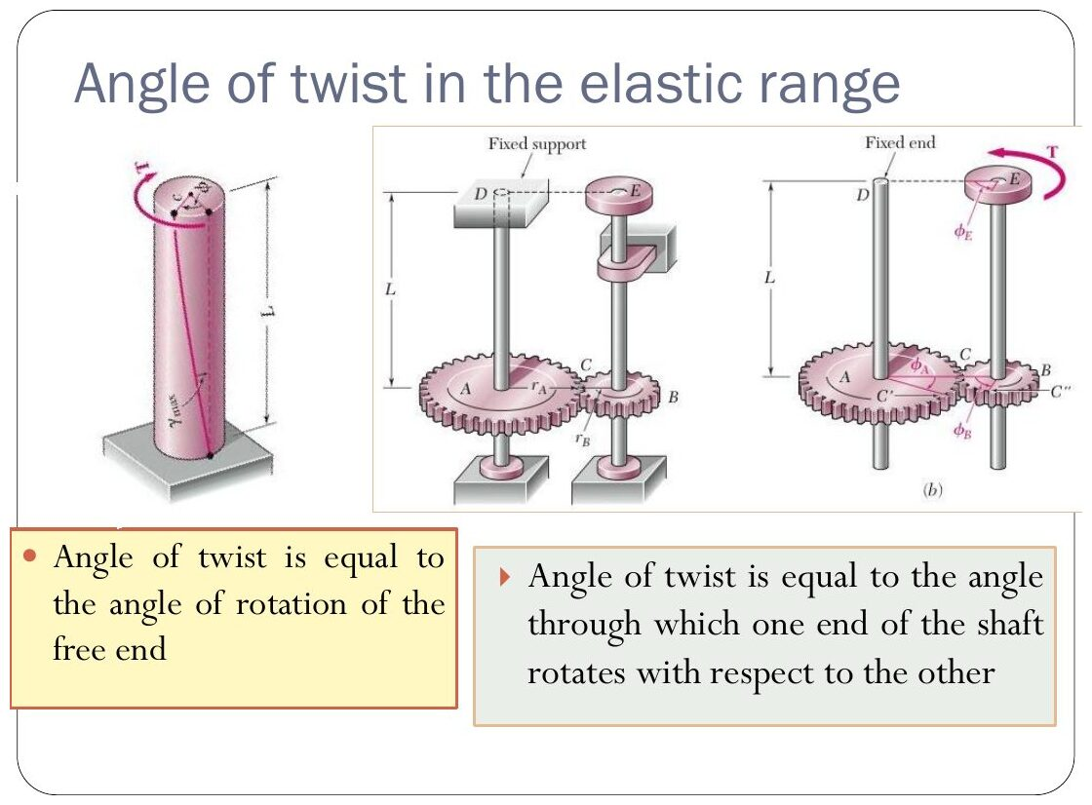
Original: Slides Ch 6, slide 30
7. Traps. Using the gear ratio the wrong way (torque scales with r, rotation with 1/r). Forgetting that the free shaft’s end rotation includes the gear’s rotation, not just its own twist.

B. Solved questions

Q15 (Slides Ch6, Beer Sample 3.4) — Two shafts with gears: largest $T_{0}$ and rotation of A (medium)
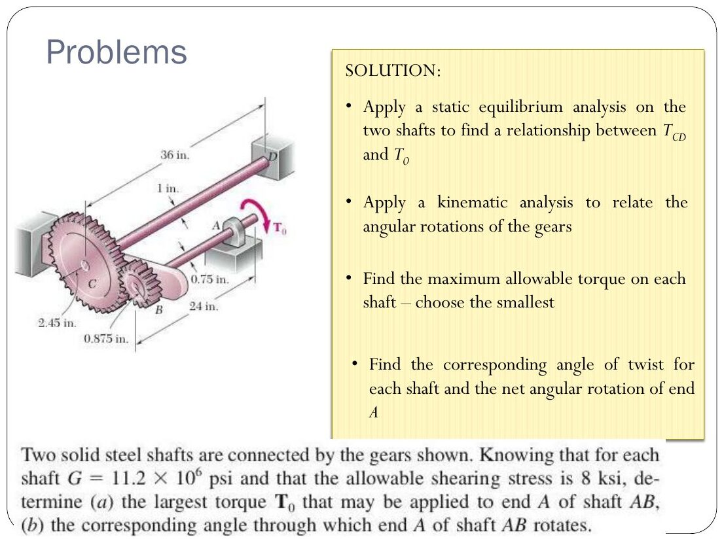
Original: Slides Ch 6, slide 32
Given: AB: 0.75 in diameter, 24 in long, gear B $r_{B}=0.875$ in. CD: 1 in diameter, 36 in long, fixed at D, gear C $r_{C}=2.45$ in. G = 11.2 × 10⁶ psi, $τ_{allow}=8$ ksi. Statics: $T_{CD}=2.8T_{0}$. Kinematics: $ϕ_{B}=2.8ϕ_{C}$.
- AB: $T_{0}=8000⋅\frac{π}{2}{\left(0.375\right)}^{3}=663$ lb·in
- CD: $2.8T_{0}=8000⋅\frac{π}{2}{\left(0.5\right)}^{3}$, so $T_{0}=561$ lb·in
$$\boxed{T_{0}=561 \text{lb·in}}$$
Twists: $ϕ_{A/B}={2.22}^{∘}$, $ϕ_{C}={2.95}^{∘}$, $ϕ_{B}=2.8\left(2.95\right)={8.26}^{∘}$.
$$\boxed{ϕ_{A}=8.26+2.22={10.48}^{∘}}$$

Q16 (Slides Ch6) — Find $ϕ_{E}$ (gear-coupled shafts, symbolic) (medium)
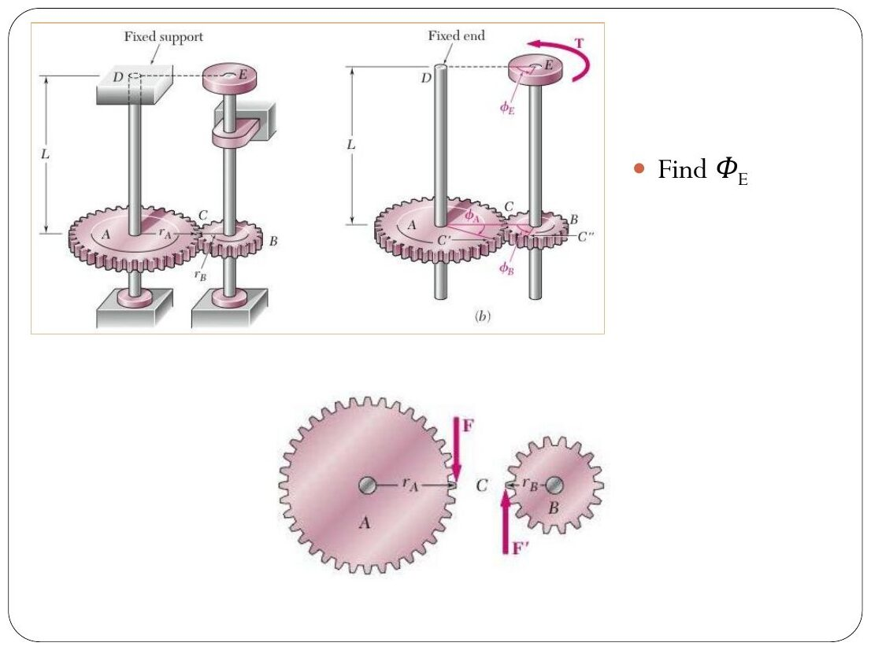
Original: Slides Ch 6, slide 31
Shaft AD is fixed at D and carries gear A ($r_{A}$). Shaft BE carries gear B ($r_{B}$) and torque T at E. Both have length L and rigidity GJ. Statics: $T_{AD}=T r_{A}/r_{B}$. $ϕ_{A}=\frac{Tr_{A}L}{r_{B}GJ}$, so $ϕ_{B}=\frac{r_{A}}{r_{B}}ϕ_{A}=\frac{r_{A}^{2}}{r_{B}^{2}}\frac{TL}{GJ}$.
$$\boxed{ϕ_{E}=\frac{TL}{GJ}\left(1+\frac{r_{A}^{2}}{r_{B}^{2}}\right)}$$

Q17 (PYQ 2014-15 Compre B Q2) — Coupled shafts: twist of A relative to D (medium, 15 marks)
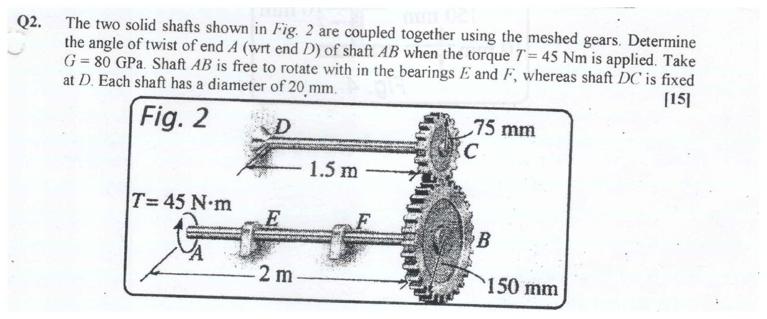
Original question: PYQ 2014-15 Compre B Q2
Given: T = 45 N·m at A. AB is 2 m long and free in bearings E, F, with gear B ($r_{B}=150$ mm). DC is 1.5 m long, fixed at D, with gear C ($r_{C}=75$ mm). Both shafts 20 mm diameter, G = 80 GPa. $J=π{\left(20\right)}^{4}/32=15 708$ mm⁴, $GJ=1.2566×{10}^{9}$ N·mm².
- Tooth force $F=45 000/150=300$ N, so $T_{DC}=300\left(75\right)=22.5$ N·m.
- $ϕ_{C}=\frac{22 500\left(1500\right)}{1.2566×{10}^{9}}=0.02686$ rad
- Kinematics: $ϕ_{B}=ϕ_{C}\frac{r_{C}}{r_{B}}=0.01343$ rad
- $ϕ_{A/B}=\frac{45 000\left(2000\right)}{1.2566×{10}^{9}}=0.07162$ rad
$$\boxed{ϕ_{A/D}=0.01343+0.07162=0.0850 \text{rad}={4.87}^{∘}}$$

Q18 (PYQ 2019-20 B Q4) — Gear-coupled shafts: find $T_{1}$, $T_{2}$ for 0.05 rad at A and C (hard, 12 marks)
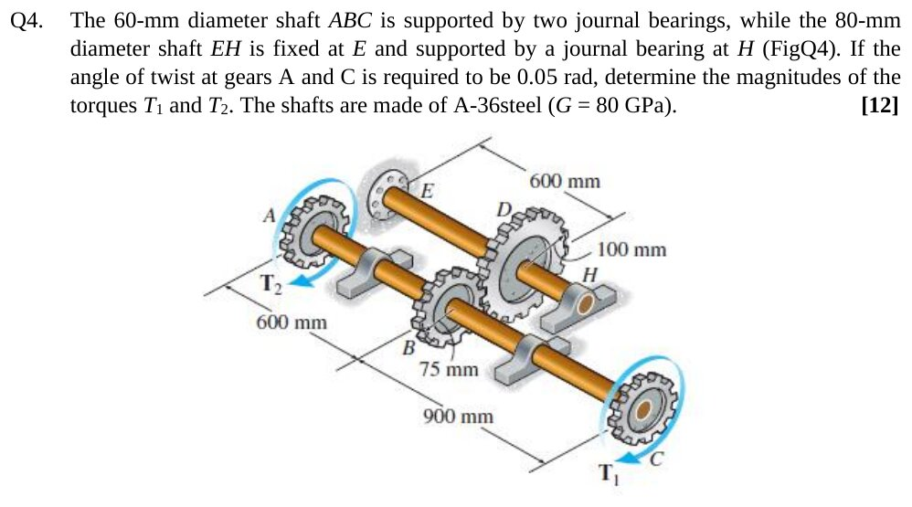
Original question: PYQ 2019-20 Compre B Q4
Given: ABC is 60 mm diameter on journal bearings, with gear B ($r_{B}=75$ mm). AB = 600 mm and BC = 900 mm, with $T_{2}$ at A and $T_{1}$ at C (same sense). EH is 80 mm, fixed at E, with gear D ($r_{D}=100$ mm) at 600 mm from E. G = 80 GPa. $ϕ_{A}=ϕ_{C}=0.05$ rad. $GJ_{1}=80 000⋅\frac{π}{32}{\left(60\right)}^{4}=1.018×{10}^{11}$ and $GJ_{2}=80 000⋅\frac{π}{32}{\left(80\right)}^{4}=3.217×{10}^{11}$ N·mm². Gear ratio $n=r_{D}/r_{B}=4/3$.
- Statics: shaft ABC is in equilibrium, so gear B carries $T_{B}=T_{1}+T_{2}$ and gear D gets $T_{D}=n\left(T_{1}+T_{2}\right)$.
- Shaft EH: $ϕ_{D}=\frac{n\left(T_{1}+T_{2}\right)\left(600\right)}{GJ_{2}}$. Gear kinematics: $ϕ_{B}=nϕ_{D}$.
- Shaft ABC: $ϕ_{A}=ϕ_{B}+\frac{T_{2}\left(600\right)}{GJ_{1}}$ and $ϕ_{C}=ϕ_{B}+\frac{T_{1}\left(900\right)}{GJ_{1}}$.
Setting $ϕ_{A}=ϕ_{C}$ gives $600T_{2}=900T_{1}$, so $T_{2}=1.5T_{1}$. Then
$$\frac{\left(16/9\right)\left(2.5T_{1}\right)\left(600\right)}{3.217×{10}^{11}}+\frac{1.5T_{1}\left(600\right)}{1.018×{10}^{11}}=0.05⇒T_{1}\left(8.29+8.84\right)×{10}^{−9}=0.05$$
$$\boxed{T_{1}=2.92 \text{kN·m}, T_{2}=4.38 \text{kN·m}}$$
Check: $ϕ_{B}=0.0242$ rad. $ϕ_{A}=0.0242+4.38e6\left(600\right)/1.018e11=0.0500$ ✓.

Concept 6.4 — Statically indeterminate shafts

A. Concept explanation
1. Intuition. A shaft clamped at both ends with a torque in the middle: both walls resist, and statics gives only $T_{A}+T_{D}=T$. The extra fact is that the total twist between the walls is zero. It is the exact twin of the axially loaded bar fixed at both ends (Ch. 2).
3–4. Method (the three steps of Ch. 2):
- Equilibrium: $T_{A}+T_{D}=∑T_{applied}$.
- Compatibility: $ϕ_{A/D}=∑\frac{T_{i}L_{i}}{GJ_{i}}=0$.
- Torque–twist: $ϕ=TL/GJ$.
Single torque $T_{0}$ at distance a from A (b from D), uniform GJ:
$$\boxed{T_{A}=T_{0}\frac{b}{L}, T_{D}=T_{0}\frac{a}{L}}$$
(The nearer wall carries more, as with axial bars.) Strain energy: $U=∑\frac{T_{i}^{2}L_{i}}{2GJ_{i}}$ (slide: $U=∫\frac{M_{t}^{2}}{2GI_{z}}dz$).

B. Solved questions

Q19 (Slides Ch6, Crandall Example 6.x) — Fixed–fixed shaft: rotation of point O (medium)
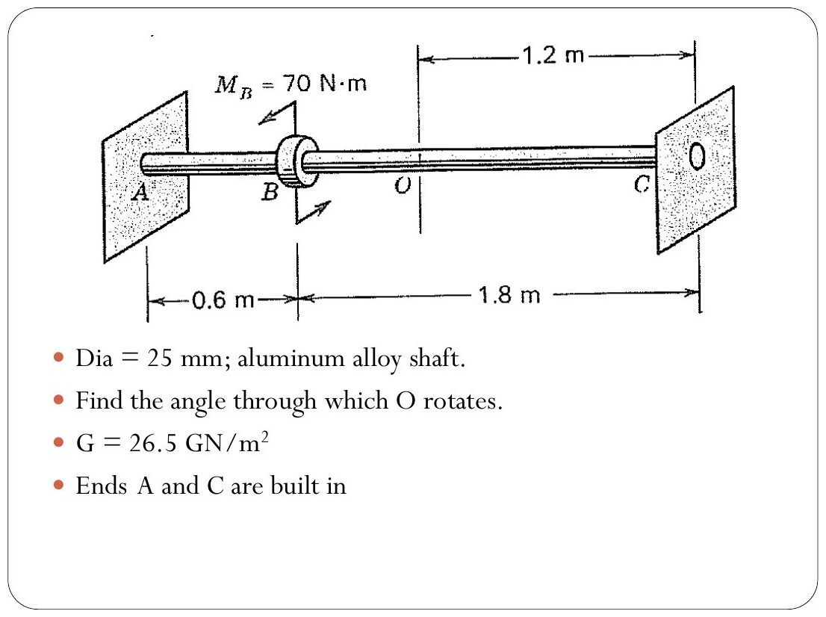
Original: Slides Ch 6, slide 21
Given: 25 mm aluminium, G = 26.5 GPa. A and C are built in. $M_{B}=70$ N·m at B, with AB = 0.6 m and BC = 1.8 m. O is 1.2 m from C. $T_{A}=70\left(1.8/2.4\right)=52.5$ N·m and $T_{C}=17.5$ N·m. Segment OC carries 17.5 N·m.
$$ϕ_{O}=\frac{17 500\left(1200\right)}{26 500⋅\frac{π}{32}{\left(25\right)}^{4}}=0.02066 \text{rad}=\boxed{{1.18}^{∘}}$$
Check from the A side: $ϕ_{B}=52 500\left(600\right)/GJ=0.0310$ rad. Then O, 0.6 m beyond B, is reduced by $17 500\left(600\right)/GJ=0.0103$, giving 0.0207 ✓.
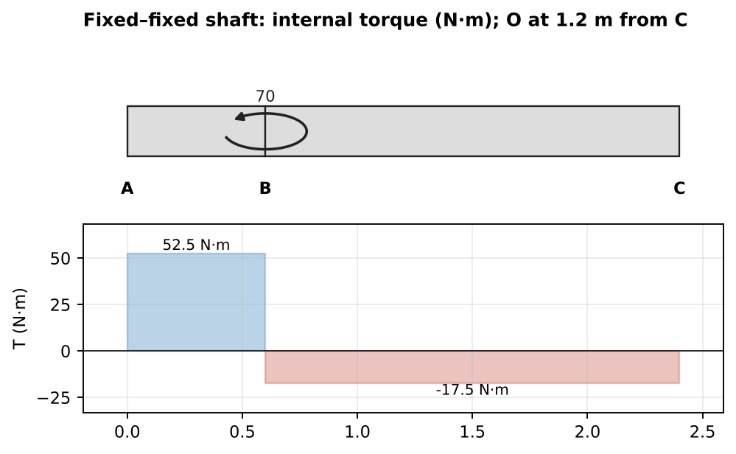
Internal torque diagram

Q20 (PYQ 2024-25 B Q1) — Fixed–fixed bar with two torques: reactions, max twist, strain energy (medium, 12 marks)
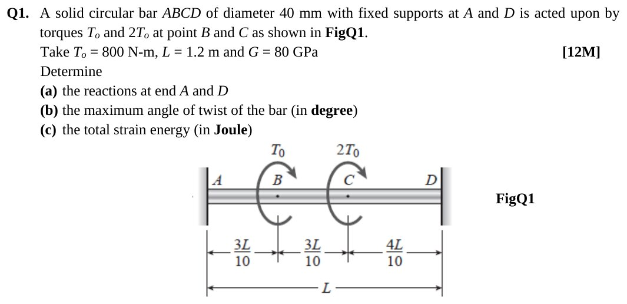
Original question: PYQ 2024-25 Compre B Q1
Given: d = 40 mm. A and D are fixed. $T_{0}=800$ N·m at B ($x=0.3L$) and $2T_{0}$ at C ($x=0.6L$), same sense. L = 1.2 m, G = 80 GPa. $J=251 327$ mm⁴, $GJ=2.0106×{10}^{10}$ N·mm². (a) Reactions (superposition of single-torque results):
$$T_{A}=T_{0}\frac{0.7L}{L}+2T_{0}\frac{0.4L}{L}=1.5T_{0}=\boxed{1200 \text{N·m}}, T_{D}=3T_{0}−1.5T_{0}=\boxed{1200 \text{N·m}}$$
(Both opposite to the applied torques.) Internal torques: $T_{AB}=1200$, $T_{BC}=1200−800=400$ and $T_{CD}=400−1600=−1200$ N·m. Compatibility check: $1200\left(360\right)+400\left(360\right)−1200\left(480\right)=0$ ✓. (b) Twist: $ϕ_{B}=\frac{1200e3\left(360\right)}{2.0106e10}=0.02149$ rad $={1.23}^{∘}$ and $ϕ_{C}=ϕ_{B}+\frac{400e3\left(360\right)}{2.0106e10}=0.02865$ rad.
$$\boxed{ϕ_{max}={1.64}^{∘} \text{at C}}$$
(c) Strain energy:
$$U=\frac{1}{2GJ}\left[{1200}^{2}\left(0.36\right)+{400}^{2}\left(0.36\right)+{1200}^{2}\left(0.48\right)\right]×{10}^{9} \text{N·mm}=\boxed{31.5 \text{J}}$$
Takeaway: the maximum twist is at a loading point where the internal torque changes sign, just as the maximum deflection in a beam occurs where the slope is zero.
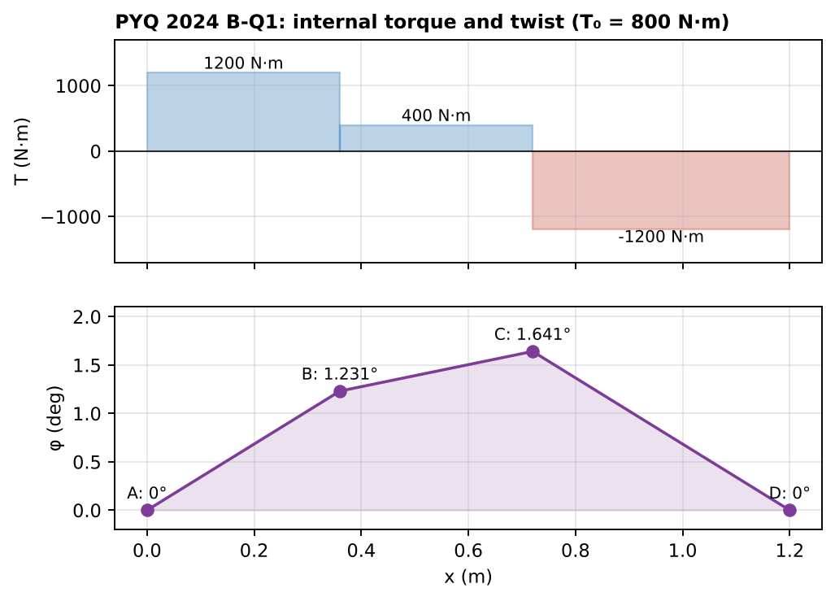
Internal torque and angle of twist along the bar

Concept 6.5 — Combined stresses: torsion + axial + bending; yielding of shafts

A. Concept explanation
1. Intuition. Real shafts are rarely just twisted. A propeller shaft is twisted and pushed, and a crank is twisted and bent. At a point on the surface you get a normal stress σ (from axial force and bending) plus a shear stress τ (from torque and transverse shear). Put them on one small square element, then use Mohr’s circle (Ch. 4) and a yield criterion (Ch. 5).
2. Why it matters. This is the single most-repeated long question in the compre papers (2019 B-Q2, 2021 A-Q2, 2023 B-Q2, 2024 B-Q2, 2021 B-Q4, 2014 Test-2 Q1), usually 15–20 marks.
3. Formal treatment (slides, Crandall §6.5, Fig. 6.14). Pure torsion: the surface element is in pure shear τ. The principal stresses are ±τ, acting at 45° to the axis. Brittle shafts (chalk!) break on a 45° helix (maximum tension), while ductile shafts shear off on a cross-section (maximum shear). Torsion + axial P: $σ=P/A$ and $τ=Tc/J$.
$$σ_{1,2}=\frac{σ}{2}±\sqrt{{\left(\frac{σ}{2}\right)}^{2}+τ^{2}}, τ_{max}=\sqrt{{\left(\frac{σ}{2}\right)}^{2}+τ^{2}}$$
Yield (slides): von Mises gives $\sqrt{σ^{2}+3τ^{2}}=Y$ and Tresca gives $\sqrt{σ^{2}+4τ^{2}}=Y$. Torsion + bending (solid shaft): $σ_{b}=\frac{32M}{πd^{3}}$ and $τ=\frac{16T}{πd^{3}}$.
$$τ_{max}=\frac{16}{πd^{3}}\sqrt{M^{2}+T^{2}}, σ_{1}=\frac{16}{πd^{3}}\left(M+\sqrt{M^{2}+T^{2}}\right)$$
These are the “equivalent torque” and “equivalent moment” formulas.
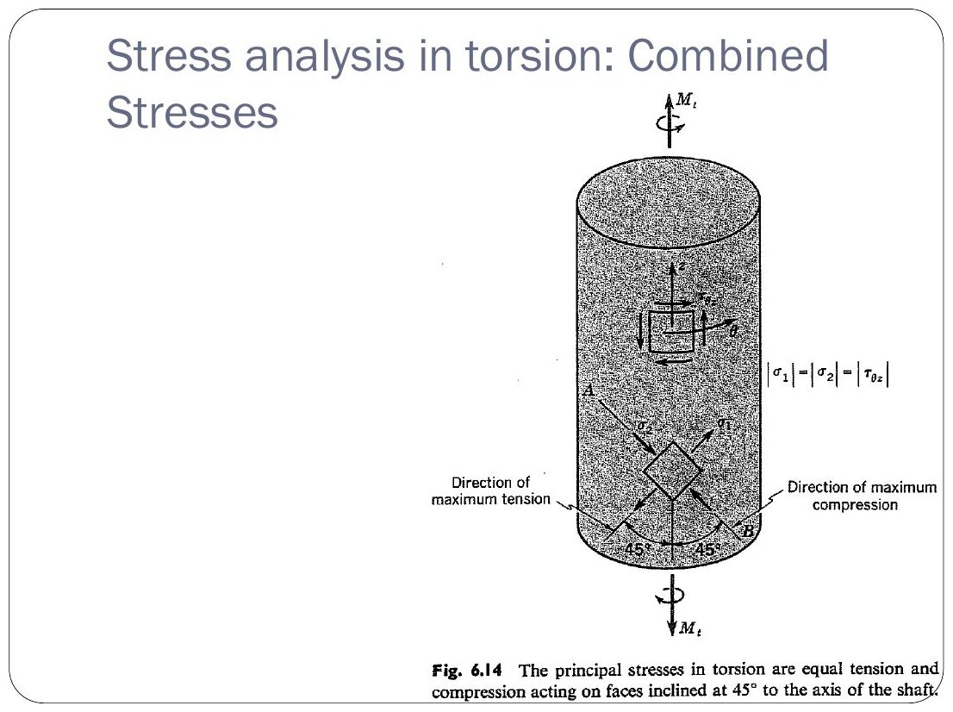
Original: Slides Ch 6, slide 22
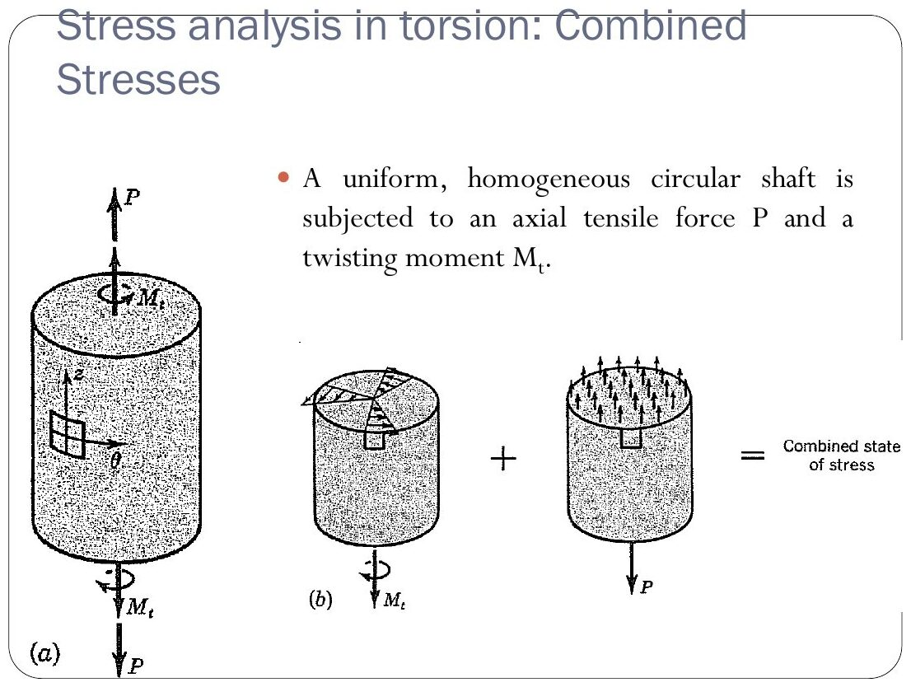
Original: Slides Ch 6, slide 23
General procedure for combined-loading PYQs:
- FBD of the whole member, then reactions (Ch. 1).
- Cut at the section and find $F$, $V$, $M_{b}$, $T$ (Ch. 3, 3-D vectors $M=r×F$).
- At the requested surface point:
  - $σ=F/A±M_{b}c/I$ (bending stress is zero at the neutral axis; I = πd⁴/64)
  - $τ=Tc/J±$ transverse shear ($τ_{V}=\frac{4V}{3A}$ at the neutral axis of a solid circle, 0 at the extreme fibre)
- Draw the 2-D element with correct directions.
- Mohr’s circle gives principal stresses and $τ_{max}$ (Ch. 4).
- Yield criterion gives the FS (Ch. 5).
7. Traps.
- Putting the maximum bending stress and the maximum transverse shear at the same point. They occur 90° apart.
- Using J where I is needed: $I=J/2$ for a circle.
- Forgetting that the transverse shear and torsion shear add on one side and subtract on the other.
- Using $τ_{max}=R$ for Tresca when both principal stresses have the same sign. That can’t happen here, because pure σ–τ states always have principal stresses of opposite sign. ✓

B. Solved questions

Q21 (Slides Ch6, Beer 7.x) — Torque for yield by Tresca with P = 240 kN (medium)
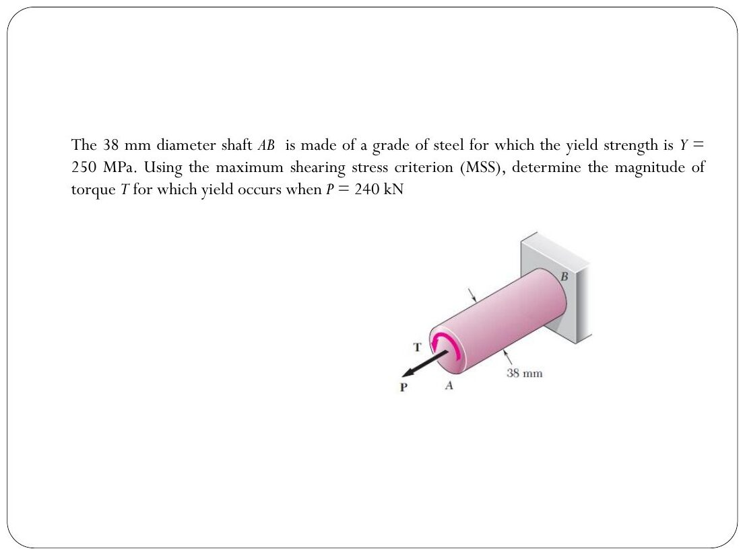
Original: Slides Ch 6, slide 37
Given: d = 38 mm, Y = 250 MPa, P = 240 kN. $σ=240 000/1134.1=211.6$ MPa. Tresca: $\sqrt{σ^{2}+4τ^{2}}=Y$, so $τ=1/2\sqrt{{250}^{2}−{211.6}^{2}}=66.6$ MPa.
$$T=\frac{τπd^{3}}{16}=\boxed{717 \text{N·m}}$$

Q22 (Slides Ch6, Hibbeler) — Helicopter rotor shaft (easy)
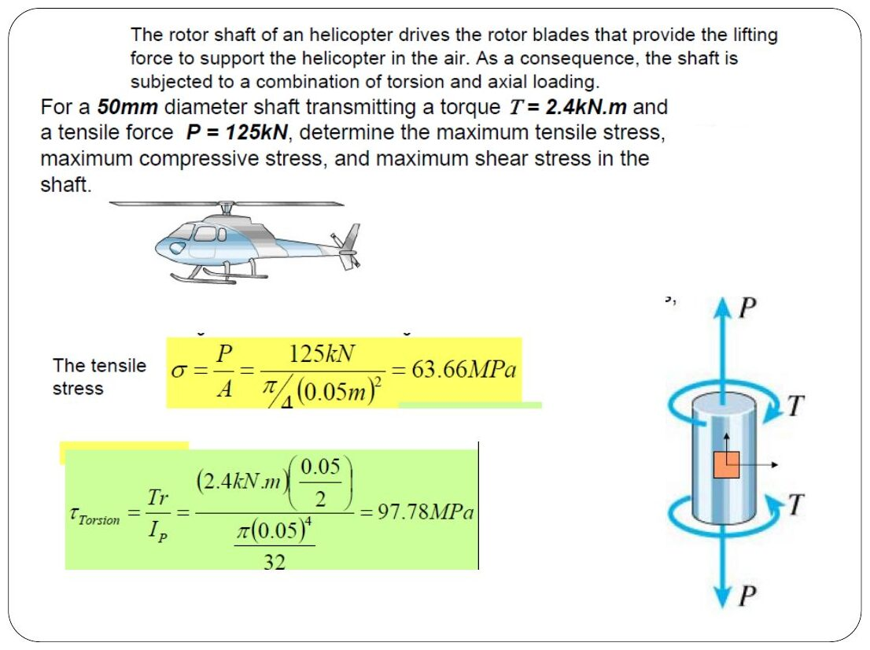
Original: Slides Ch 6, slide 40
Given: d = 50 mm, T = 2.4 kN·m, P = 125 kN. $σ=63.66$ MPa and $τ=16\left(2.4e6\right)/\left(π⋅{50}^{3}\right)=97.78$ MPa.
$$\boxed{σ_{1}=134.7 \text{MPa}, σ_{2}=−71.0 \text{MPa}, τ_{max}=102.8 \text{MPa}}$$
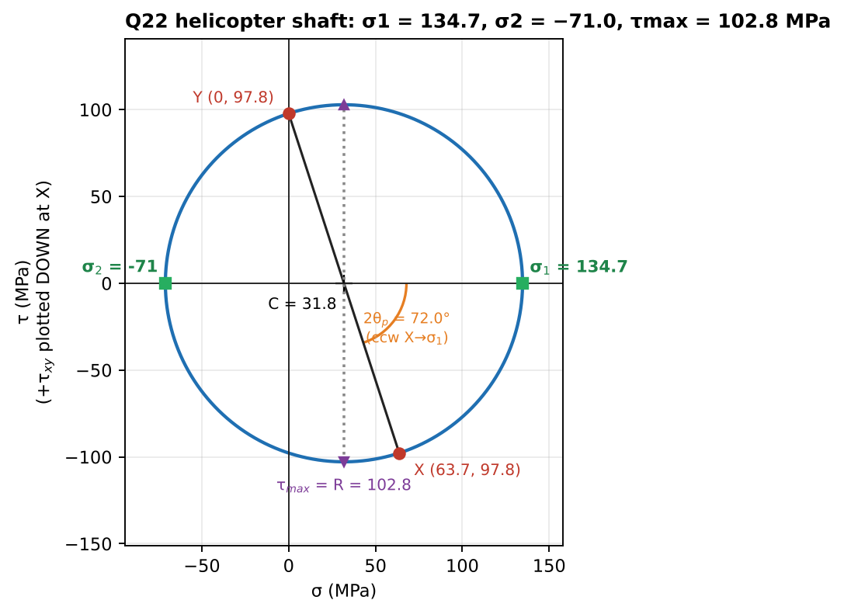
Mohr’s circle

Q23 (PYQ 2014-15 Test-2 Q1) — Axial + torque, principal stresses
Solved in Ch. 4 Q8: σ₁ = 76.8 MPa, σ₂ = −5.2 MPa, θₚ = 14.5° from the axis.

Q24 (PYQ 2021-22 A Q2) — Automobile axle: stress at H, principal stresses, von Mises (medium, 10 marks)
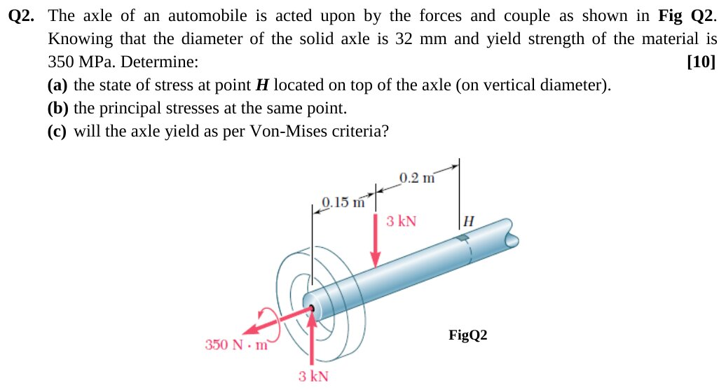
Original question: PYQ 2021-22 Compre A Q2
Given: solid axle d = 32 mm. At the wheel end: 3 kN ↑ and a 350 N·m torque. 3 kN ↓ at 0.15 m from the wheel. H is on top, 0.2 m beyond the 3 kN ↓ load. $σ_{Y}=350$ MPa. Internal forces at H (from the wheel side): $V=3−3=0$ (no transverse shear), $M=3\left(0.35\right)−3\left(0.20\right)=0.45$ kN·m (the two 3 kN forces form a constant couple beyond the second load), T = 350 N·m. (a) Stresses at H (top fibre):
$$σ=\frac{32M}{πd^{3}}=\frac{32\left(450 000\right)}{π{\left(32\right)}^{3}}=139.9 \text{MPa (compression at the top: sagging)}, τ=\frac{16\left(350 000\right)}{π{\left(32\right)}^{3}}=54.4 \text{MPa}$$
(b) Principal: centre −69.9 and R = 88.6, so
$$\boxed{σ_{1}=18.7 \text{MPa}, σ_{2}=−158.5 \text{MPa}, τ_{max}=88.6 \text{MPa}}$$
(c) von Mises:
$$σ_{vm}=\sqrt{{139.9}^{2}+3{\left(54.4\right)}^{2}}=168.7 \text{MPa}<350 ⇒ \boxed{\text{No yield (FS}=2.07)}$$
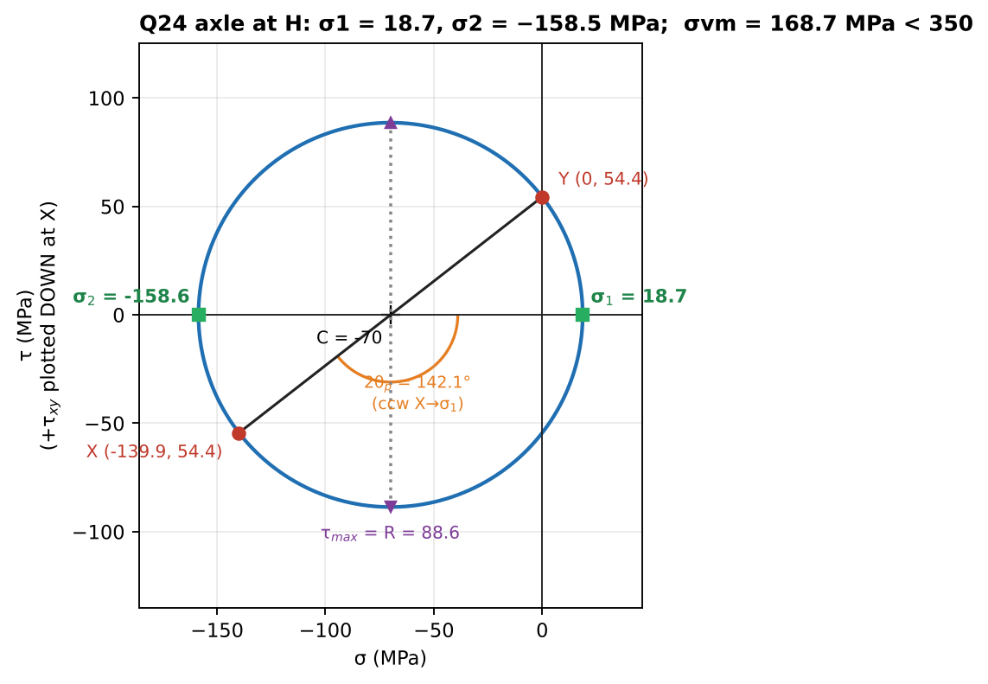
Mohr’s circle at H
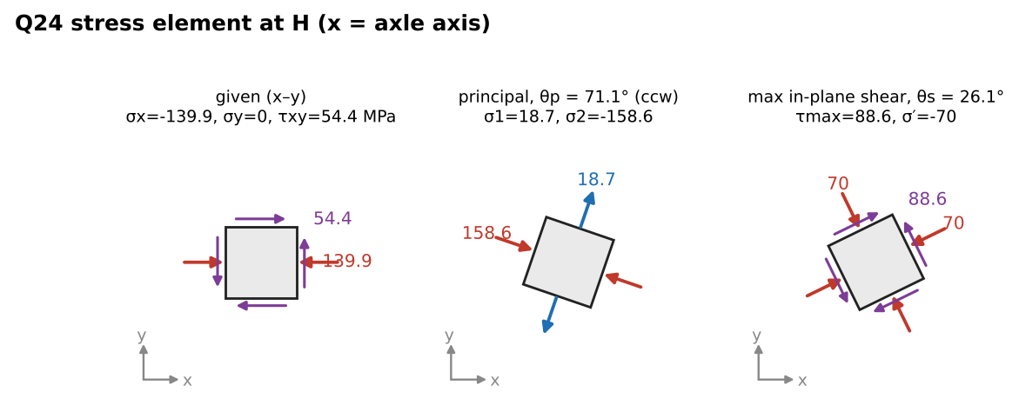
Stress elements at H

Q25 (PYQ 2023-24 B Q2) — Crank on a 20 mm shaft: reactions, elements E₁ and E₂ (hard, 20 marks)
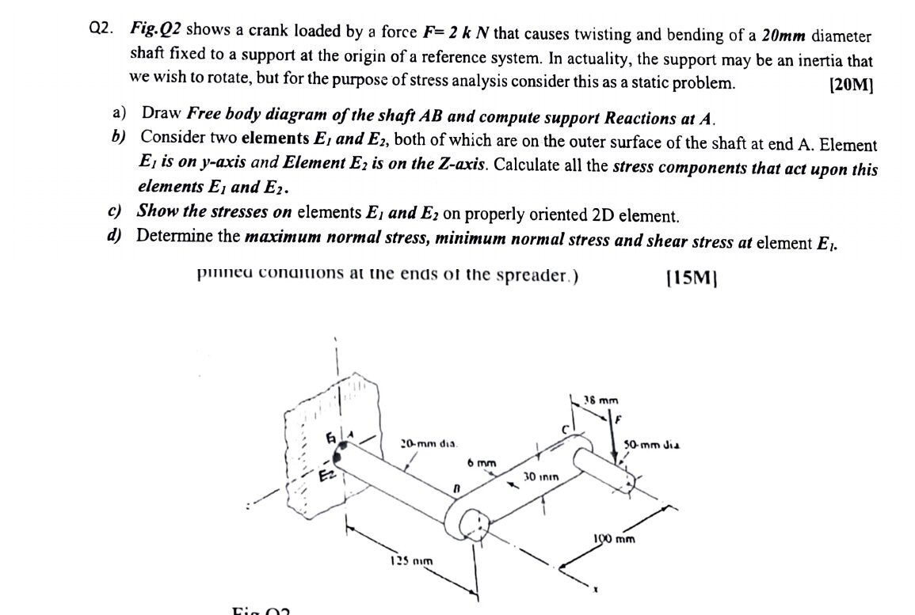
Original question: PYQ 2023-24 Compre B Q2
Given (from the figure): shaft AB, 20 mm diameter, 125 mm long along x from the wall at A. Crank arm BC is 100 mm long (6 mm × 30 mm section). The pin at C is parallel to x, and F = 2 kN acts downward (−y) at 38 mm along the pin. Assumption: the load point is at x = 125 + 38 = 163 mm from A and offset 100 mm in z. (a) Reactions at A: $R_{y}=+2$ kN. Twisting moment $T=F\left(100\right)=200$ N·m. Bending moment $M_{z}=F\left(163\right)=326$ N·m (hogging: top in tension). (b) Stresses at A:
- $σ_{b}=\frac{32\left(326 000\right)}{π{\left(20\right)}^{3}}=415$ MPa
- $τ_{T}=\frac{16\left(200 000\right)}{π{\left(20\right)}^{3}}=127.3$ MPa
- $τ_{V}=\frac{4\left(2000\right)}{3π\left(100\right)}=8.5$ MPa
Element | σ_x | τ
E₁ (top, on y-axis) | +415 MPa (tension) | 127.3 MPa (torsion only; transverse shear is 0 at the top)
E₂ (side, on z-axis = neutral axis) | 0 | 127.3 + 8.5 = 135.8 MPa (they add on this side; they subtract to 118.8 MPa on the opposite side)
(c) 2-D elements: E₁ is viewed from +y, with σ along x and τ on the x-faces in the z direction. E₂ is viewed from +z, with τ on the x-faces in the y direction. (d) At E₁: centre 207.5 and R = $\sqrt{{207.5}^{2}+{127.3}^{2}}=243.5$, so
$$\boxed{σ_{max}=451 \text{MPa}, σ_{min}=−35.9 \text{MPa}, τ_{max}=243.5 \text{MPa}}$$
Takeaway: the examiner tests that you know where each stress is maximum. Bending peaks at E₁, transverse shear peaks at E₂, and torsion is the same at both.
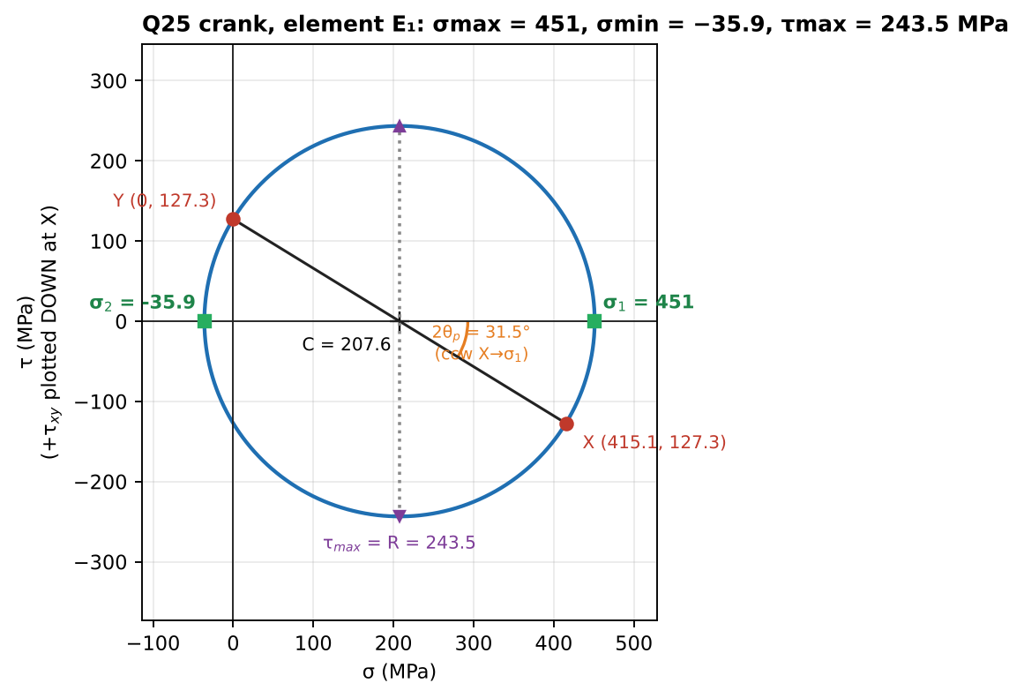
Mohr’s circle at element E₁

Q26 (PYQ 2024-25 B Q2) — L-shaped post: F, V, M_b, T at z–z; stresses at B; principal stresses; von Mises FS (hard, 18 marks)
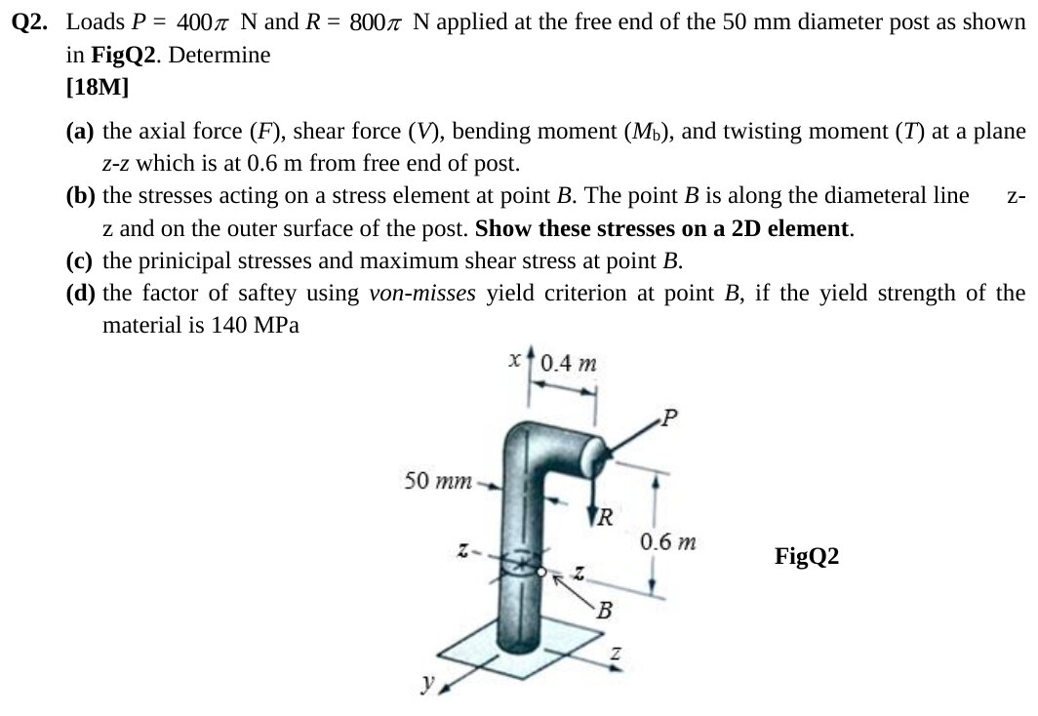
Original question: PYQ 2024-25 Compre B Q2
Given: 50 mm post, vertical axis x. A horizontal arm of 0.4 m (along z) is at the top. At the arm’s free end, $P=400π$ N (horizontal, along −y) and $R=800π$ N (downward). Section z–z is 0.6 m below the free end. B is on the surface where the diameter along z meets it. $σ_{Y}=140$ MPa. Interpretation: this reads the figure with the arm along z and P along −y. If your figure differs, rerun the same steps. (a) Section forces ($M=r×F$ with $r=\left(0.6,0,0.4\right)$ m and $F=\left(−800π,−400π,0\right)$ N):
- Axial $F=−800π=−2513$ N (compression)
- Shear $V=400π=1257$ N (y-direction)
- $M=\left(160π,−320π,−240π\right)$ N·m, so the twisting moment is $T=160π=502.7$ N·m, and the bending moments are $M_{y}=320π=1005$ N·m and $M_{z}=240π=754$ N·m (resultant $M_{b}=400π=1257$ N·m)
(b) Stresses at B (on the z-axis, so only $M_{y}$ bends B; B is on the neutral axis of $M_{z}$, where the y-shear peaks). $A=625π$ mm² and $\frac{πd^{3}}{32}=3906π$ mm³. The π’s cancel, which is why they’re in the data.
- $σ_{axial}=−\frac{800π}{625π}=−1.28$ MPa
- $σ_{bend}=−\frac{320π×{10}^{3}}{3906π}=−81.92$ MPa (the downward R on the +z arm compresses the +z side)
- $τ_{T}=\frac{160π×{10}^{3}}{7812π}=20.48$ MPa
- $τ_{V}=\frac{4V}{3A}=0.853$ MPa (adds to torsion at B)
$$\boxed{σ_{x}=−83.2 \text{MPa}, τ=21.3 \text{MPa}}$$
(c) Principal: centre −41.6 and R = 46.75, so
$$\boxed{σ_{1}=5.15 \text{MPa}, σ_{2}=−88.35 \text{MPa}, τ_{max}=46.75 \text{MPa}}$$
(d) von Mises:
$$σ_{vm}=\sqrt{{83.2}^{2}+3{\left(21.3\right)}^{2}}=91.0 \text{MPa} ⇒ \boxed{FS=140/91.0=1.54}$$
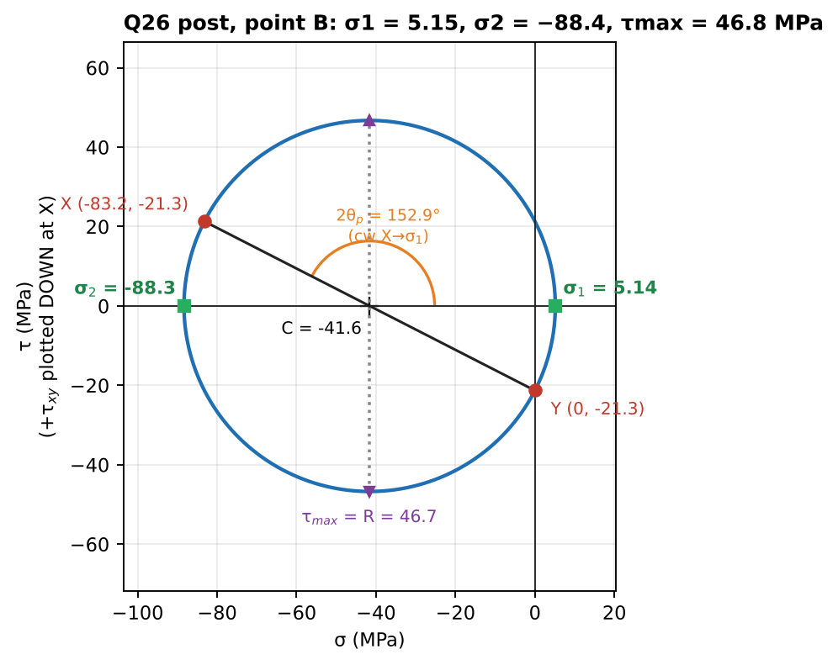
Mohr’s circle at B
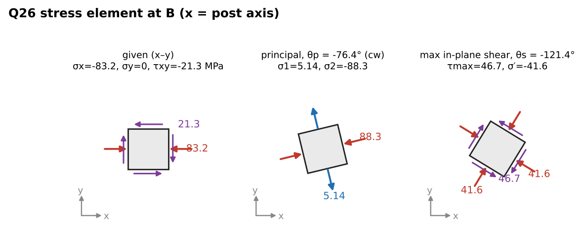
Stress elements at B

Chapter 6 — Formula and convention sheet
Item | Formula
Kinematics | sections stay plane and undistorted; $γ=r dϕ/dz$
Torsion formula | $T/J=τ/r=Gϕ/L$
Solid | $J=πd^{4}/32$; $τ_{max}=16T/πd^{3}$
Hollow | $J=π\left(d_{o}^{4}−d_{i}^{4}\right)/32$; $τ_{min}=τ_{max}d_{i}/d_{o}$
Thin tube | $J≈2πr_{m}^{3}t$
Twist | $ϕ=∑T_{i}L_{i}/\left(G_{i}J_{i}\right)$ with internal signed torques
Stiffness | $k_{T}=GJ/L$
Power | $P=Tω=2πnT/60$ (n in rpm)
Gears | $T_{C}/T_{B}=r_{C}/r_{B}$; $r_{B}ϕ_{B}=r_{C}ϕ_{C}$
Fixed–fixed, one torque | $T_{A}=T_{0}b/L$, $T_{D}=T_{0}a/L$
Energy | $U=∑T^{2}L/\left(2GJ\right)$
Pure torsion element | principal ±τ at 45°; gauge at 45° reads γ/2
Combined σ + τ | $σ_{1,2}=σ/2±\sqrt{{\left(σ/2\right)}^{2}+τ^{2}}$; vM $\sqrt{σ^{2}+3τ^{2}}$; Tresca $\sqrt{σ^{2}+4τ^{2}}$
Bending + torsion (solid) | $τ_{max}=\frac{16}{πd^{3}}\sqrt{M^{2}+T^{2}}$, $σ_{1}=\frac{16}{πd^{3}}\left(M+\sqrt{M^{2}+T^{2}}\right)$
Transverse shear (solid circle) | $τ_{V,max}=4V/3A$ at the neutral axis
Other Crandall Ch. 6 problems worth practising: 6.1–6.10 (basic shafts, power), 6.11–6.20 (indeterminate and composite shafts), 6.25+ (combined stresses, yield).

Course summary

Part 1 — One-page formula and convention sheet (Ch 1–6)

Conventions you must not mix up
Item | Convention used in the slides/Crandall
Stress/force sign | + on a positive face in a positive direction (or −face, −direction). Tension +.
Shear force V (Ch 3) | Crandall: $V=−Σ\left(\text{up-forces left of cut}\right)$, $dV/dx=−q$, $dM/dx=−V$. Opposite sign to Gere/Hibbeler. M is the same (sagging +).
Angle θ (Ch 4) | counter-clockwise from x to the normal of the face
Mohr’s circle | σ to the right; +τ_xy plotted downward at X, upward at Y; rotating 2θ on the circle = rotating θ on the element, same sense
Strain circle | vertical axis = γ/2
Torque | right-hand rule; internal torque + if its vector points out of the cut face

Ch 1 — Statics
$∑F_{x}=∑F_{y}=∑M=0$ · two-force member: forces collinear · three-force: concurrent · $f≤μN$ (= at impending) · incline: $T=W\left(sinα±μcosα\right)$ · belt: $T_{2}/T_{1}=e^{μβ}$ · truss: $m=2j−3$; sections: cut ≤ 3 members, moments about the intersection of two.

Ch 2 — Axial members and energy
$δ=∑\frac{P_{i}L_{i}}{A_{i}E_{i}}$ (internal P) · $k=AE/L$ · parallel: $k$ adds; series: $1/k$ adds · indeterminate: $δ_{load}+δ_{redundant}=0$ · displacement diagram: $δ_{bar}=u⋅e$ · $U=P^{2}L/2AE$ · Castigliano $δ_{i}=∂U/∂F_{i}$; truss $δ=∑F\frac{∂F}{∂P}\frac{L}{AE}$; beam $∫\frac{M}{EI}\frac{∂M}{∂P}ds$ · thin ring $σ=pr/t$, $δ_{R}=pr^{2}/Et$.

Ch 3 — Internal forces
Resultant of distributed load = area at the centroid (reactions only) · $V′=−q$, $M′=−V$ · $M_{max}$ where V = 0 · contraflexure where M changes sign · clockwise couple: M jumps up · singularity: $⟨x−a⟩^{n}$, point load $⟨⟩_{−1}$, couple $⟨⟩_{−2}$, no constants · standard: SS + W centre $WL/4$; SS + UDL $wL^{2}/8$; SS + W at a $Wab/L$; cantilever tip $PL$; cantilever UDL $wL^{2}/2$ · curved cantilever (tip P): $N=Pcosθ$, $V=Psinθ$, $M=PRcosθ$.

Ch 4 — Stress/strain transformation
$σ_{x′}=\frac{σ_{x}+σ_{y}}{2}+\frac{σ_{x}−σ_{y}}{2}cos2θ+τ_{xy}sin2θ$ · $τ_{x′y′}=−\frac{σ_{x}−σ_{y}}{2}sin2θ+τ_{xy}cos2θ$ · $σ_{x′}+σ_{y′}$ = const · $σ_{1,2}=\overset{‾}{σ}±R$, $R=\sqrt{{\left(\frac{σ_{x}−σ_{y}}{2}\right)}^{2}+τ_{xy}^{2}}$, $tan2θ_{p}=\frac{2τ_{xy}}{σ_{x}−σ_{y}}$ (substitute back to identify σ₁) · $τ_{max}=R$ at $θ_{p}±45°$, with $\overset{‾}{σ}$ on those faces · absolute $τ_{max}=\left(σ_{max}−σ_{min}\right)/2$ including $σ_{3}=0$ · strain: replace σ→ε, τ→γ/2 · $ϵ_{x}=∂u/∂x$, $γ_{xy}=∂u/∂y+∂v/∂x$ · 45° rosette $γ=2ϵ_{b}−ϵ_{a}−ϵ_{c}$ · 60° rosette $ϵ_{y}=\frac{1}{3}\left(2ϵ_{b}+2ϵ_{c}−ϵ_{a}\right)$, $γ=\frac{2}{\sqrt{3}}\left(ϵ_{b}−ϵ_{c}\right)$.

Ch 5 — Constitutive law and yield
$ϵ_{x}=\frac{1}{E}\left[σ_{x}−ν\left(σ_{y}+σ_{z}\right)\right]+αΔT$ · $γ=τ/G$ · plane stress: $σ_{x}=\frac{E}{1−ν^{2}}\left(ϵ_{x}+νϵ_{y}\right)$, $ϵ_{z}=−\frac{ν}{E}\left(σ_{x}+σ_{y}\right)$ · $G=\frac{E}{2\left(1+ν\right)}$, $K=\frac{E}{3\left(1−2ν\right)}$ · $ΔV/V=\frac{1−2ν}{E}∑σ$ · fixed bar heated: $σ=−EαΔT$ · $u=\frac{1}{2E}\left[∑σ_{i}^{2}−2ν∑σ_{i}σ_{j}\right]$ · Tresca $σ_{max}−σ_{min}=σ_{Y}$ (σ–τ: $\sqrt{σ^{2}+4τ^{2}}$) · von Mises $\sqrt{σ_{1}^{2}−σ_{1}σ_{2}+σ_{2}^{2}}$ = $\sqrt{σ_{x}^{2}−σ_{x}σ_{y}+σ_{y}^{2}+3τ_{xy}^{2}}$ (σ–τ: $\sqrt{σ^{2}+3τ^{2}}$) · FS = $σ_{Y}/σ_{eq}$; Tresca is always more conservative.

Ch 6 — Torsion
$γ=r dϕ/dz$ · $\frac{T}{J}=\frac{τ}{r}=\frac{Gϕ}{L}$ · $J=\frac{πd^{4}}{32}$, $J_{h}=\frac{π\left(d_{o}^{4}−d_{i}^{4}\right)}{32}$ · $τ_{max}=\frac{16T}{πd^{3}}$ · $ϕ=∑\frac{TL}{GJ}$ · $P=\frac{2πnT}{60}$ · gears: $T∝r$, $r_{B}ϕ_{B}=r_{C}ϕ_{C}$ · fixed–fixed: $T_{A}=T_{0}b/L$ · $U=∑\frac{T^{2}L}{2GJ}$ · pure shear: principal ±τ at 45° · combined: $σ=\frac{F}{A}±\frac{32M}{πd^{3}}$, $τ=\frac{16T}{πd^{3}}±\frac{4V}{3A}$ (at the neutral axis).

Units cheat
N, mm, MPa (= N/mm²) are consistent; GPa = 10³ MPa; kN·m = 10⁶ N·mm; angles in radians inside formulas; P = Tω needs ω in rad/s.

Part 2 — PYQ question types ranked by frequency
Counted across the 7 papers supplied (2014-15 Test-1, Test-2, Compre; 2019-20, 2021-22, 2023-24, 2024-25 Compre). “Appearances” counts distinct questions, including sub-parts embedded in bigger questions.
Rank | Question type | Appearances | Where | Solved in
1 | Euler buckling of columns (often combined with a beam that loads the column) | 8 | 19 B1, 21 A3, 21 B3, 23 B1, 24 A3, 24 B3, 14 C-A20, 14 C-B4 | not in Ch 1–6 slides
2 | Torsion of circular shafts (allowable T, twist, hollow vs solid, gears, fixed–fixed) | 7 | 14 T2-Q4, 14 C-A5, 14 C-B2, 19 B4, 21 A1, 23 A1, 24 B1 | Ch 6 Q12–Q14, Q17, Q18, Q20; Ch 4 Q13
3 | Beam deflection / statically indeterminate beams (integration, singularity functions, settlement, beam + rod) | 7 | 14 C-A9/10/15/16, 19 B3, 21 B2, 21 B3, 23 B3, 24 B3 | not in Ch 1–6 slides (SFD/BMD groundwork in Ch 3)
4 | Combined loading at a point (find F, V, M, T at a section → σ, τ on a 2-D element → principal stresses → FS) | 6 | 14 T2-Q1, 19 B2, 21 A2, 21 B4, 23 B2, 24 B2 | Ch 6 Q23–Q26; Ch 4 Q8
5 | Principal stresses / Mohr’s circle / transformation (stand-alone) | 5 | 14 C-A12, 14 C-A13, 14 C-B1, 19 A2, 14 T2-Q2 | Ch 4 Q6–Q9, Q14, Q16
5 | Yield criteria and factor of safety (Tresca, von Mises) | 5 | 14 C-A3, 14 C-A4, 19 A4, 21 A2c, 24 B2d | Ch 5 Q12–Q15; Ch 6 Q24, Q26
5 | Bending stress / curved beams / eccentric loads (σ = My/I, T-sections, chain link) | 5 | 14 C-A19, 14 C-B3, 19 A1b, 23 A2, 24 A1 | partly (Ch 3 Q18 uses σ = 32M/πd³); rest not in slides
8 | Generalized Hooke’s law: Δ-dimensions, Δt, ΔV, circle → ellipse | 4 | 14 C-A2, 21 B1, 23 A3, 24 A2 | Ch 5 Q1–Q3; Ch 4 Q15
8 | SFD/BMD, contraflexure, singularity functions | 4 papers (6 Qs) | 14 T1-Q4, 14 C-A6/7/14/17/18, 19 A1 | Ch 3 Q4, Q5, Q16–Q18
10 | Strain energy / Castigliano | 3 | 14 T1-Q2, 19 A3b, 24 B1c | Ch 2 Q11, Q12; Ch 6 Q20
11 | Thermal stresses | 2 | 14 T2-Q3, 14 C-A1 | Ch 5 Q5, Q11
12 | Trusses (sections) · friction + axial (rope on drum) · thin ring · strain gauge/rosette · axial stress ratio | 1 each | 14 T1-Q1, 14 T1-Q3, 14 C-A11, 21 A1, 14 C-A8 | Ch 1 Q20, Q11; Ch 2 Q16, PYQ A-Q8; Ch 4 Q13
What this tells you for the compre:
- Combined loading + Mohr + yield shows up in every recent Part B (2019, 2021, 2023, 2024), worth 18–20 marks each time. Practise the 6-step procedure in Ch 6 Concept 6.5 until it’s automatic.
- Torsion appears in nearly every paper, usually as one clean 10–12 mark question (fixed–fixed shaft, gear pair, or allowable T + twist).
- Hooke’s-law plate questions (Δt, ΔV, etched circle) are a near-certain 10 marks in Part A (2021, 2023, 2024).
- Buckling and beam deflection together are the biggest block, and they are outside these slides. Study them next.
- Test-1 style (2014) puts trusses, friction, Castigliano and singularity SFD/BMD together, so Ch 1–3 matter most for the mid-sem.

Part 3 — Errors found in the slides (double-check with your instructor)
Location | Slide says | Correct value | Why
Ch 1, Warren truss (2000 N/4000 N) table | BE = 500 N (C) | 577.4 N (C) | 500 N is the vertical component; member force = 500/sin 60°
Ch 1, A-frame truss table | member “AB” | AC | there is no member AB
Ch 2, brass bar 50/80/40/10 kN | δ = 0.2857 mm | 0.114 mm | 0.2857 is the AB segment alone; BC (−30 kN) and CD (+10 kN) were dropped
Ch 2, member ABCD | 0.4903 m | 0.491 mm | units typo
Ch 4 Part 2, rosette example | ε₂ = 246 − 119.2 | 153 − 119.2 = 33.8 μ | 153 is the circle centre; final value is right
2023-24 Compre A-Q3 | E = 200 MPa | E = 200 GPa | steel

Part 4 — PYQ questions not covered here (topics after Ch 6)
Paper | Question | Topic needed
2014-15 Compre A | Q9, Q10 (cantilever tip deflection/slope), Q15–16 (propped cantilever), Q19 (bending/shear ratio), Q20 (buckling) | Ch 7 (bending), Ch 8 (deflection), Ch 9 (buckling)
2014-15 Compre B | Q3 (inverted-T beam stresses), Q4 (buckling from deflection data) | Ch 7, Ch 9
2019-20 | A-Q1(b) (partly done in Ch 3 Q18), B-Q1 (two columns), B-Q2 (box-beam combined loading needs I and Q of a box section), B-Q3 (beam + rod, 4th-order ODE) | Ch 7–9
2021-22 | A-Q3, B-Q2, B-Q3, B-Q4 | Ch 7–9
2023-24 | A-Q2 (eccentric pull on a post), B-Q1 (spreader buckling), B-Q3 (singularity deflection with settlement) | Ch 7–9
2024-25 | A-Q1 (curved chain link), A-Q3, B-Q3 | Ch 7–9
Say the word and the next session can cover Ch 7–9 (bending stresses, beam deflection, buckling) in the same format, starting with these questions.

