-- Create the table

CREATE TABLE date_intervals (

interval_id INT AUTO_INCREMENT PRIMARY KEY,

start_date DATE,

end_date DATE,

days_difference INT

);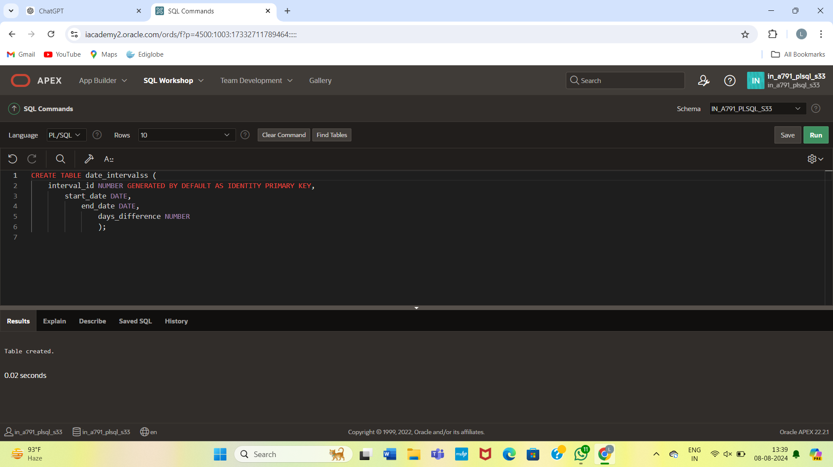

INSERT INTO date_intervals (start_date, end_date)

VALUES (TO_DATE('2024-07-08', 'YYYY-MM-DD'), TO_DATE('2024-08-08', 'YYYY-MM-DD'));

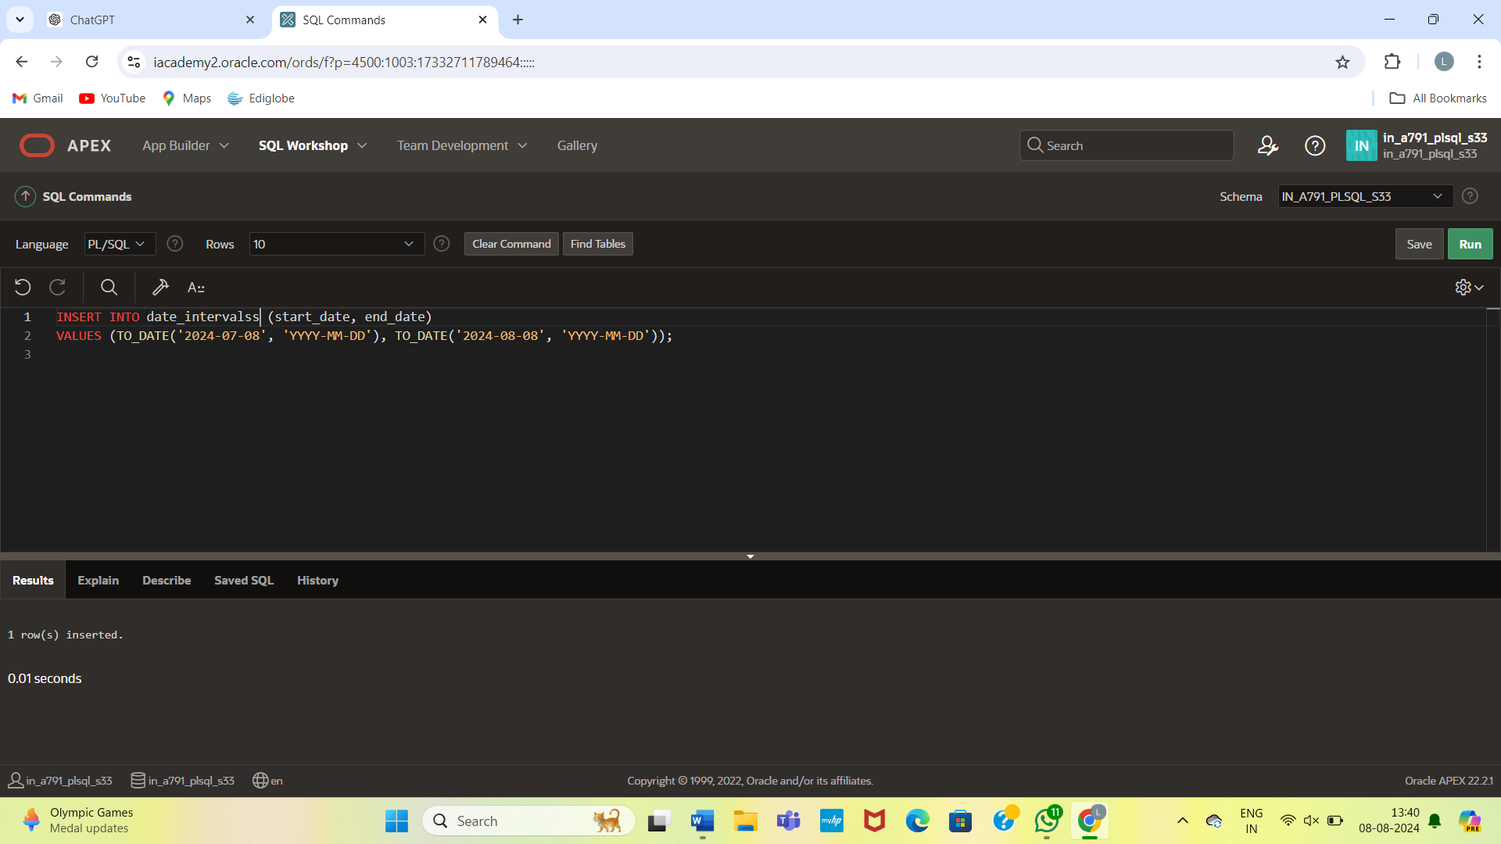

UPDATE date_intervals

SET days_difference = end_date - start_date;

