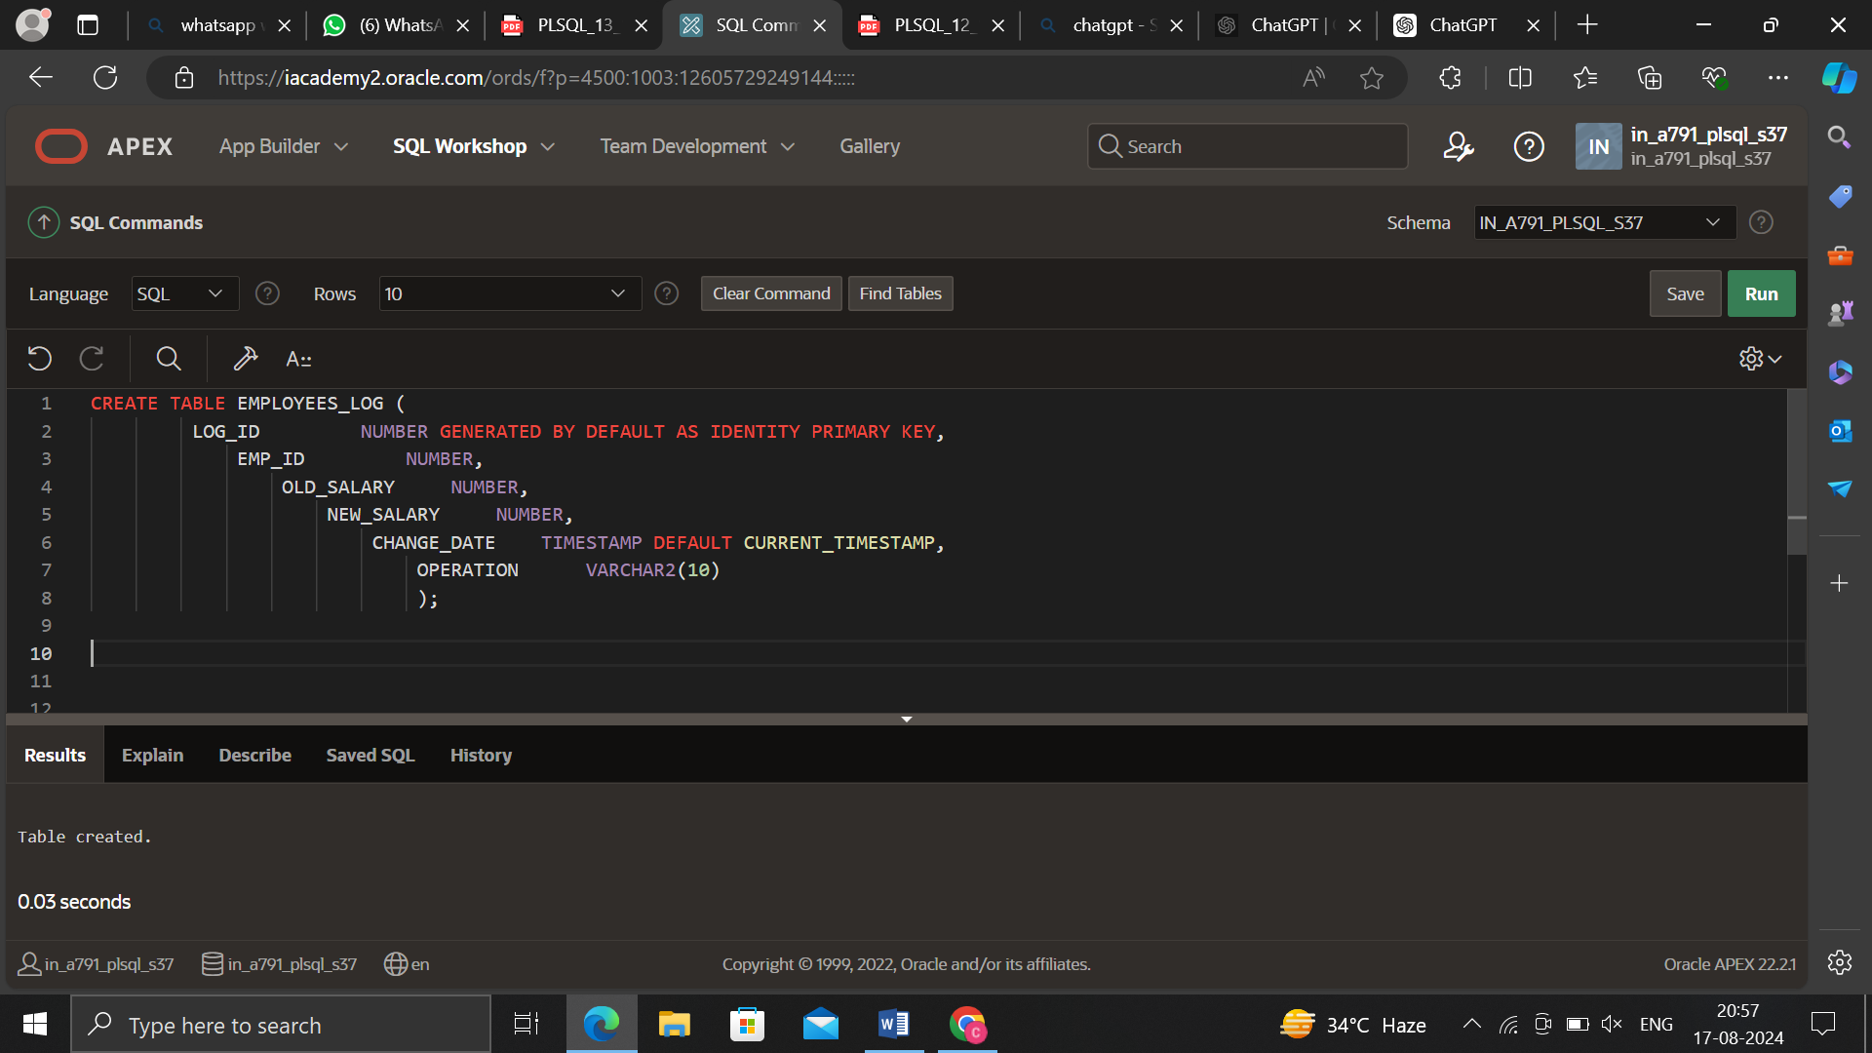

CREATE TABLE EMPLOYEES_LOG (

LOG_ID NUMBER GENERATED BY DEFAULT AS IDENTITY PRIMARY KEY,

EMP_ID NUMBER,

OLD_SALARY NUMBER,

NEW_SALARY NUMBER,

CHANGE_DATE TIMESTAMP DEFAULT CURRENT_TIMESTAMP,

OPERATION VARCHAR2(10)

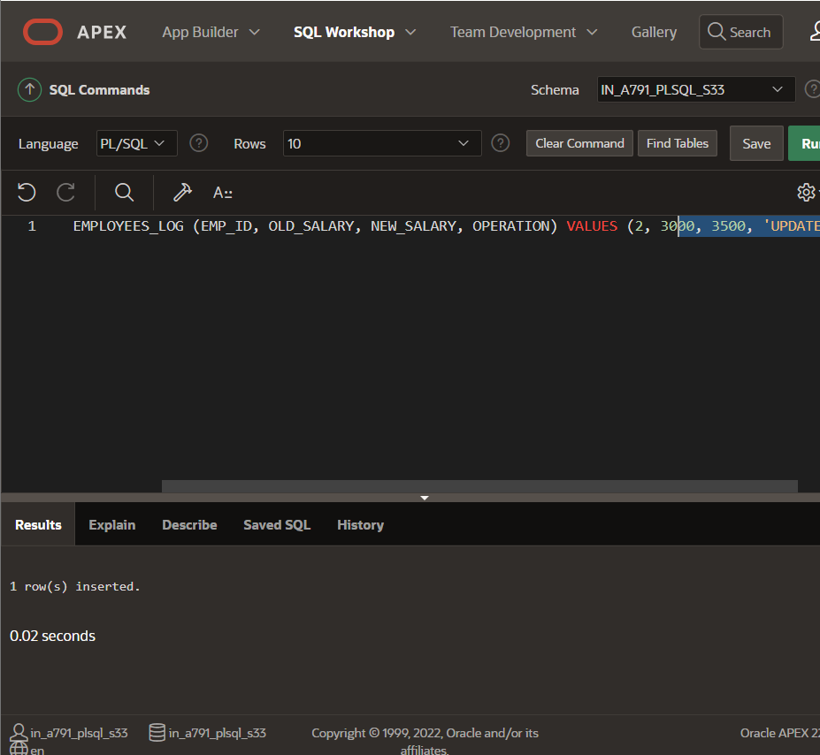

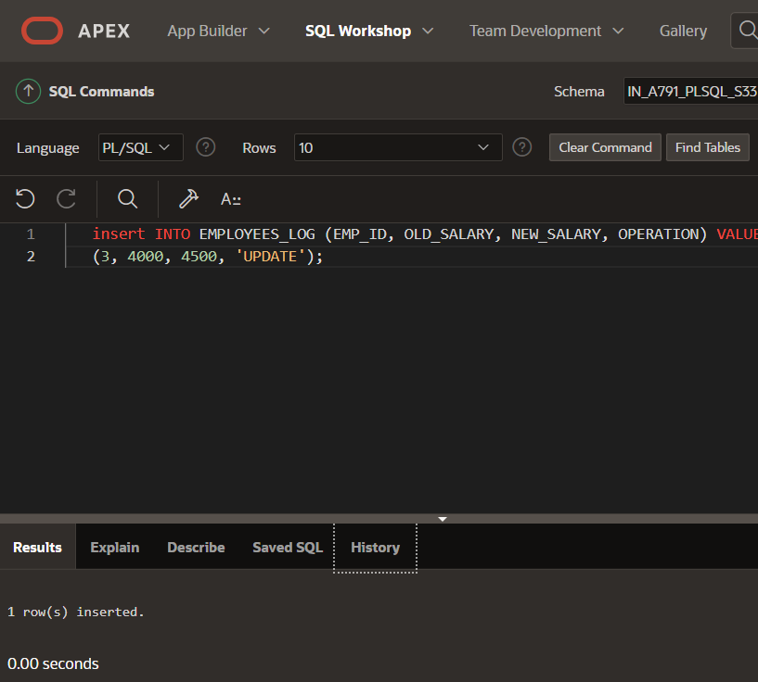

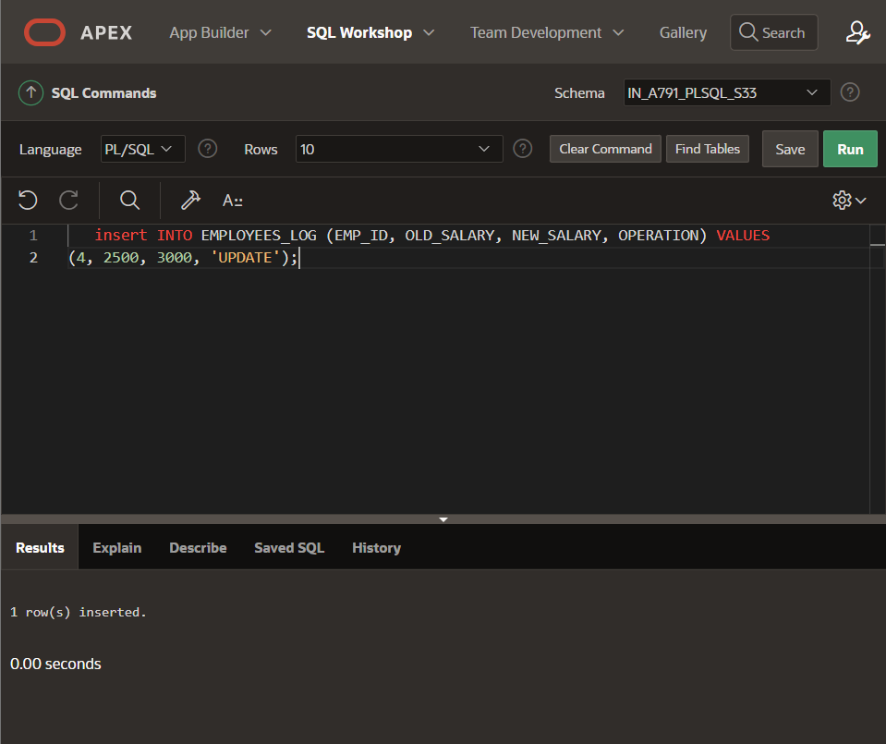

INSERT ALL

INTO EMPLOYEES_LOG (EMP_ID, OLD_SALARY, NEW_SALARY, OPERATION) VALUES (2, 3000, 3500, 'UPDATE')

INTO EMPLOYEES_LOG (EMP_ID, OLD_SALARY, NEW_SALARY, OPERATION) VALUES (3, 4000, 4500, 'UPDATE')

INTO EMPLOYEES_LOG (EMP_ID, OLD_SALARY, NEW_SALARY, OPERATION) VALUES (4, 2500, 3000, 'UPDATE')

SELECT * FROM dual;

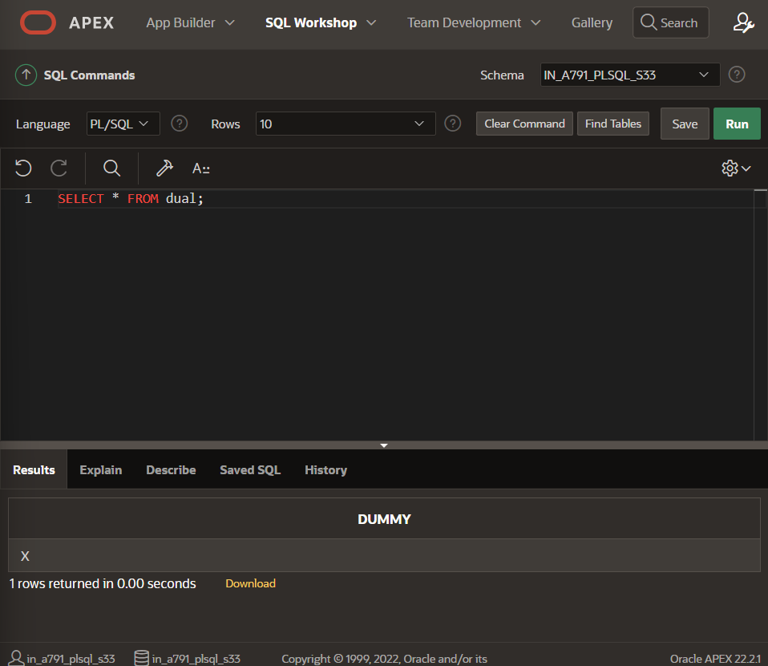

CREATE TABLE EMPLOYEES (

EMP_ID NUMBER PRIMARY KEY,

NAME VARCHAR2(100),

SALARY NUMBER,

HIRE_DATE DATE

);

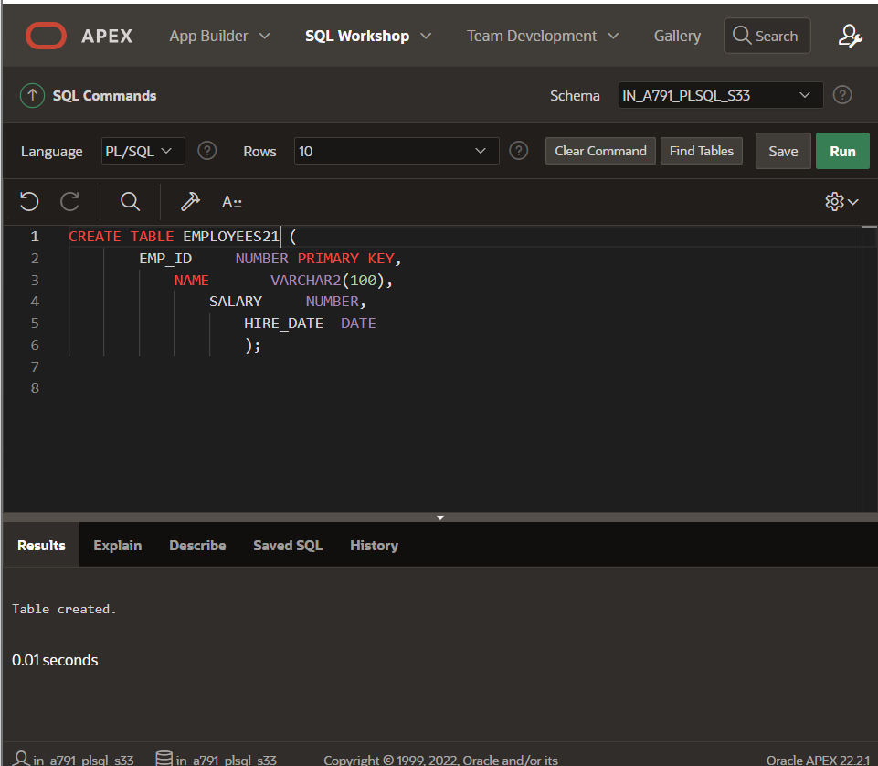

CREATE OR REPLACE TRIGGER trg_employees_update

BEFORE UPDATE ON EMPLOYEES

FOR EACH ROW

DECLARE

v_old_salary EMPLOYEES.SALARY%TYPE;

v_new_salary EMPLOYEES.SALARY%TYPE;

BEGIN

-- Store old and new salary values

v_old_salary := :OLD.SALARY;

v_new_salary := :NEW.SALARY;

-- Insert into log table

INSERT INTO EMPLOYEES_LOG (EMP_ID, OLD_SALARY, NEW_SALARY, OPERATION)

VALUES (:OLD.EMP_ID, v_old_salary, v_new_salary, 'UPDATE');

END;

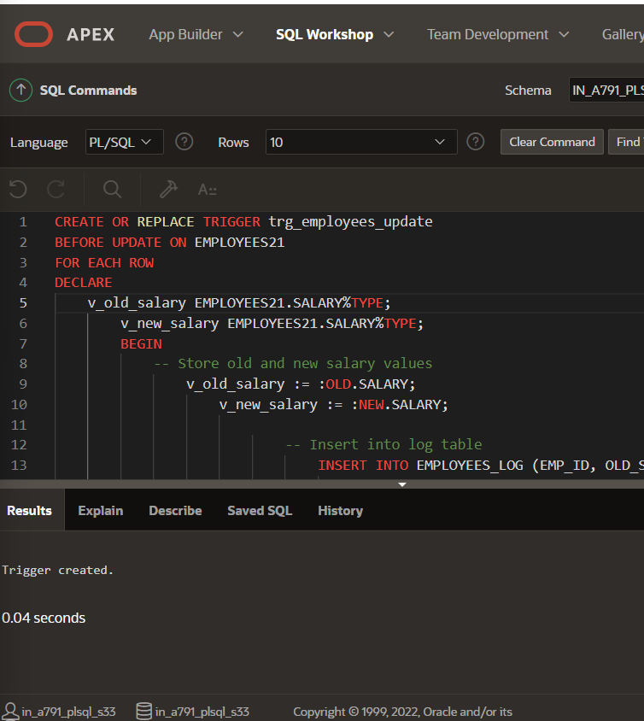

INSERT INTO EMPLOYEES (EMP_ID, NAME, SALARY, HIRE_DATE)

VALUES (1, 'Alice Johnson', 6000, TO_DATE('2024-08-01', 'YYYY-MM-DD'));

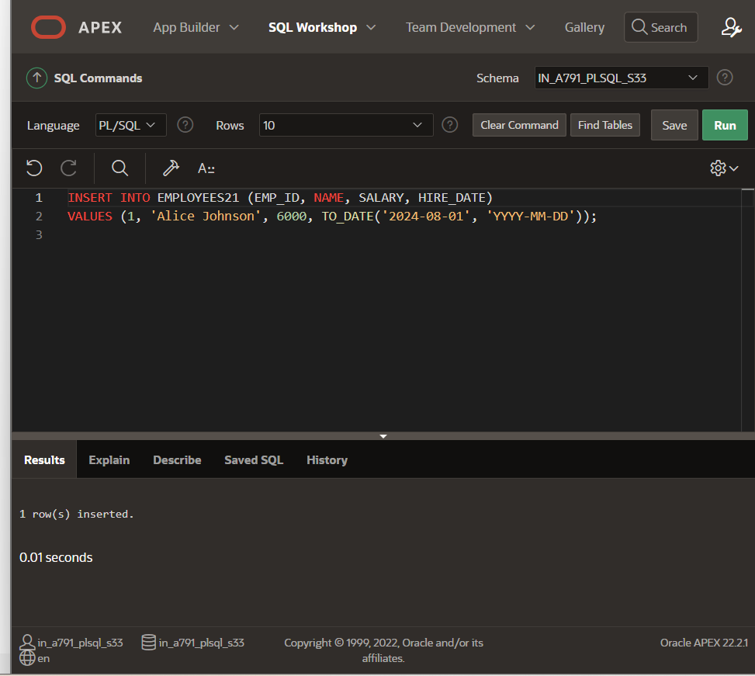

-- Example update

UPDATE EMPLOYEES

SET SALARY = SALARY + 1000

WHERE EMP_ID = 1;

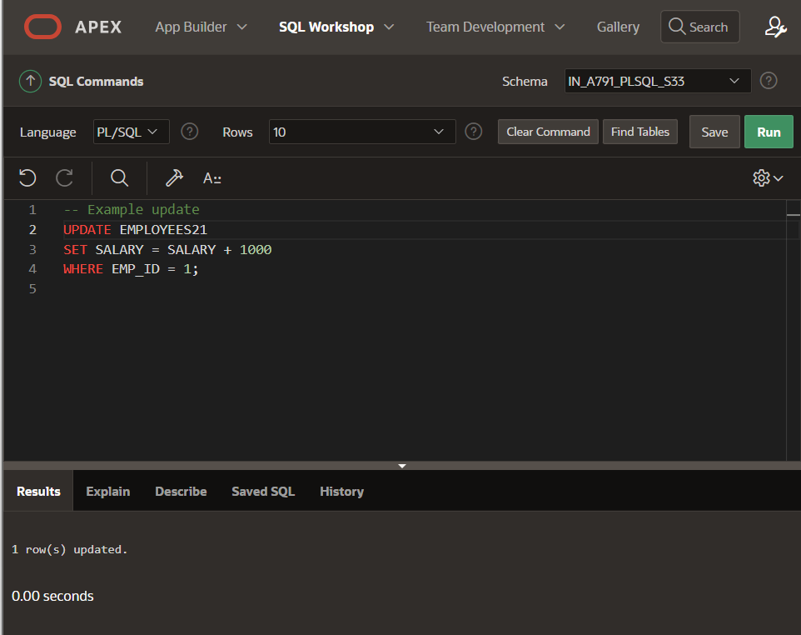

-- Check the log table

SELECT * FROM EMPLOYEES_LOG;

