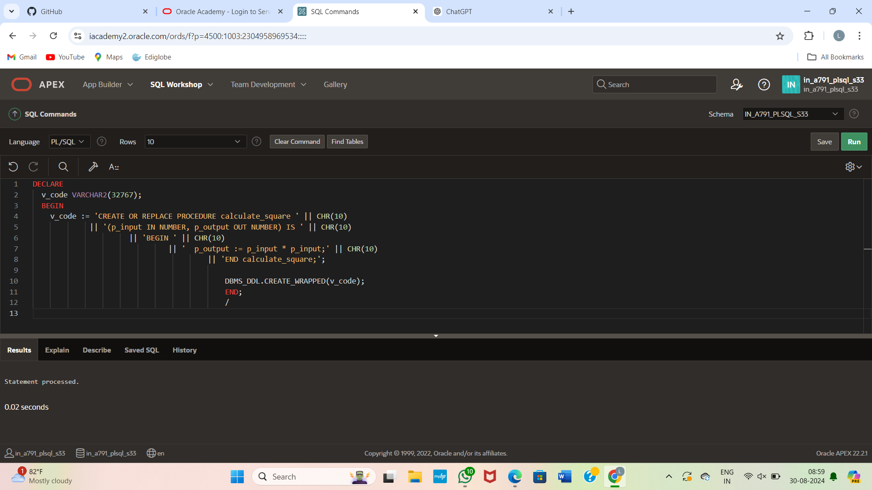

DECLARE v_code VARCHAR2(32767); BEGIN v_code:= 'CREATE OR REPLACE FUNCTION myclevererfunc ' || '(p_param1 IN NUMBER) ' || 'RETURN NUMBER IS BEGIN ' || '... /* some even cleverer but private code */ ' || ' END myclevererfunc;'; DBMS_DDL.CREATE_WRAPPED(v_code); END;