

**SIMATS SCHOOL OF ENGINEERING**

**SAVEETHA INSTITUTE OF MEDICAL AND TECHNICAL SCIENCES**

**CHENNAI-602105**

**Beauty Parlour Appointment**

**A CAPSTONE PROJECT REPORT**

*Submitted in the partial fulfillment for the award of the degree of*

**BACHELOR OF ENGINEERING**

**IN**

**Computer Science and Engineering**

**Submitted by**

**G. Harshitha (192211603)**

**Y. Sruthi(192211583)**

**A.Abhinaya Reddy(192210446)**

**Under the Supervision of**

**Dr. Moorthy**

**September 2024**

**DECLARATION**

We, **G. Harshitha, Y. Sruthi, A. Abhinaya Reddy** students of **Bachelor of Engineering in CSE**, Department of Computer Science and Engineering, Saveetha Institute of Medical and Technical Sciences, Saveetha University, Chennai, hereby declare that the work presented in this Capstone Project Work entitled Beauty Parlour Appointment is the outcome of our own bonafide work and is correct to the best of our knowledge and this work has been undertaken taking care of Engineering Ethics.

**G. Harshitha (192211603)**

**Y. Sruthi(192211583)**

**A. Abhinaya Reddy(192210446)**

Date:

Place:

**CERTIFICATE**

This is to certify that the project entitled **“Online Beauty parlour appointment booking system ”** submitted by **G.Harshitha, A. Abhinaya Reddy ,Y.Sruthi** has been carried out under my supervision. The project has been submitted as per the requirements in the current semester of B.E. Computer Science Engineering.

Dr. Moorthy

Teacher-in-charge

**Table of Contents**

|  |  |  |
| --- | --- | --- |
| **S.NO** | **TOPICS** | **Page No** |
| 1 | **Abstract** | **5** |
| 2 | **Introduction** | **5** |
| 3 | **Project Description** | **5-6** |
| 4 | **Problem Description** | **6** |
| 5 | **Tool Description** | **7** |
| 6 | **Operations** | **7-8** |
| 7 | **Module Description** | **8** |
| 8 | **Implementation** | **8-16** |
| 9 | **Result** | **17** |
| 10 | **Conclusion** | **17** |
| 11 | **Future Enhancements** | **17** |
|  | **Screenshots** | **18-20** |
|  | **References** | **20** |

**1. ABSTRACT**

" The Online Beauty Parlour Appointment Booking System is a web-based platform designed to streamline the process of scheduling and managing beauty services. This system allows clients to book appointments for various beauty treatments through an intuitive interface, providing real-time availability and confirmation. It integrates features such as service selection, stylist assignment, and payment processing, aiming to enhance user convenience and reduce administrative burdens for beauty parlours. The system also includes functionalities for appointment reminders, client feedback, and reporting, thereby improving overall operational efficiency and customer satisfaction.

**2. INTRODUCTION**

In today’s fast-paced world, convenience and efficiency have become paramount in every aspect of our lives, including personal grooming and beauty services. Traditional methods of booking beauty parlour appointments often involve cumbersome phone calls, in-person visits, or reliance on manual scheduling systems. These methods can lead to inefficiencies, scheduling conflicts, and an overall suboptimal customer experience. To address these issues, the Online Beauty Parlour Appointment Booking System emerges as a comprehensive solution designed to revolutionize how clients interact with beauty service providers.

This online system leverages digital technology to provide a seamless booking experience for both clients and beauty parlour staff. By offering a user-friendly interface accessible through web browsers or mobile applications, the system enables clients to schedule appointments at their convenience, view available time slots, and choose from a range of services and stylists. This self-service capability not only saves time for clients but also reduces the administrative workload for parlour staff, who can focus on delivering high-quality services rather than managing appointments manually.

The system is equipped with features such as real-time availability updates, automated appointment confirmations, and reminders, which help minimize no-shows and last-minute cancellations. Additionally, integrated payment gateways facilitate secure transactions, allowing clients to pay for services in advance or upon completion, depending on the parlour’s policy. This enhances financial management and streamlines the check-out process.

**3.PROJECT DESCRIPTION**

The Online Beauty Parlour Appointment Booking System is a web-based application designed to modernize and streamline the process of scheduling beauty services. This project aims to create a user-friendly platform that facilitates easy appointment booking for clients and efficient management for beauty parlours.:

#### Proposed Method

* **Frontend Development**: Utilizing Visual Studio for designing responsive and intuitive user interfaces.
* **Backend Development**: Using XAMPP stack (Apache, MySQL, PHP) to handle server-side scripting, database management via phpMyAdmin, and ensuring secure data storage and retrieval.

**4.PROBLEM DESCRIPTION**

**Existing System**

Managing beauty parlour appointments through traditional methods—such as phone calls, walk-ins, or manual scheduling systems—poses several challenges. These methods can lead to inefficiencies, errors, and a less-than-optimal customer experience. Key problems include.

Scheduling Conflicts: Manual booking processes are prone to errors, such as double bookings or missed appointments, due to the lack of real-time updates and synchronization.

Limited Accessibility: Clients often face difficulties scheduling appointments outside of business hours or finding available slots, leading to frustration and potential loss of business.

Administrative Burden: Beauty parlour staff spend considerable time managing bookings, handling cancellations, and processing payments manually, which reduces their focus on service quality.

Inconsistent Customer Experience: Without a centralized system, it is challenging to offer a personalized experience based on client preferences, service history, or special requests.

Inefficient Communication: Clients and staff may experience delays or miscommunications regarding appointment confirmations, changes, or reminders, leading to missed appointments and dissatisfaction.

Data Management Issues: Tracking client information, service histories, and feedback manually can be cumbersome and error-prone, limiting the ability to analyze trends and make informed business decisions.

**Proposed System**

The proposed system for an online beauty parlour appointment booking system is designed to streamline the process of scheduling and managing beauty services. This system will feature a user-friendly web interface where clients can view available services, select their preferred beautician, and choose convenient time slots. It will include real-time availability updates, allowing users to book, reschedule, or cancel appointments effortlessly. The backend will support secure payment processing, client data management, and automated reminders via email or SMS. For beauticians, there will be a dashboard to track their schedules, manage appointments, and view client details. Additionally, the system will offer reporting tools for the parlour to analyze appointment trends, revenue, and client preferences.

**5. TOOL DESCRIPTION**

#### Hardware and Software Tools

To develop and deploy the online beauty parlour web application, the following hardware and software tools were utilized:

**Hardware Specifications**

* **Laptop Model**: LENOVO LOQ
* **Graphics Card**: NVIDIA GeForce RTX 3050, 6GB
* **Storage**: 500GB SSD
* **RAM**: 16GB
* **Processor**: 12th Gen Intel(R) Core(TM) i5-12450H 2.00 GHz

**Software Tools**

* **Visual Studio Code**: An integrated development environment (IDE) used for writing and debugging code. Its extensions and integrated terminal enhanced the coding experience.
* **XAMPP**: A free and open-source cross-platform web server solution stack package developed by Apache Friends. It provided the necessary Apache, MySQL, PHP, and Perl support for local development and testing.
* **phpMyAdmin**: A free software tool written in PHP, intended to handle the administration of MySQL over the web. phpMyAdmin was used for database management, allowing for easy handling of the MySQL database used in the application.
* **Google Chrome**: The primary web browser used for testing and debugging the web application. Developer tools in Chrome facilitated real-time inspection and modification of the front-end code.

The combination of powerful hardware and a robust set of development tools provided a conducive environment for the efficient development, testing, and deployment of the recipe management web application.

**6.OPERATIONS**

Running a beauty parlour involves a range of operations to ensure the business functions smoothly and provides high-quality services to clients. Here's an overview of key operations typically involved in managing a beauty parlour:

* 1. **User Operations**

**Service Offerings**

* Hair Services: Haircuts, styling, coloring, treatments.
* Skincare Services: Facials, peels, treatments for acne, etc.
* Nail Services: Manicures, pedicures, nail art.
* Makeup Services: Daily, bridal, special occasion makeup.
* Spa Services: Massages, aromatherapy, body scrubs.
* Specialty Treatments: Hair removal (waxing, threading), eyelash extensions, etc**.**

**Inventory and Supplies Management**

* Product Inventory: Tracking and ordering beauty products and supplies.
* Equipment Maintenance: Regular upkeep of tools and equipment to ensure safety and efficiency.
* Supplier Relations: Building relationships with suppliers for quality products and favorable terms.

**7.MODULE DESCRIPTION**

In the context of a beauty parlour modules can refer to different areas or sections of the business operations or service offerings

**Function: Contact Form**

* **Description:** Allows users to send inquiries or feedback through a contact form.
* **Functionalities:**
  + Input fields for name, email, subject, and message.
  + Validate and submit the contact .

**Function: Search Beauty Parlour**

* **Description:** Allows users to enter keywords or phrases related to services, products, or general inquiries**.**
* **Functionalities:**
  + The beauty and wellness need of their clients.
  + Some key functionalities typically found in beauty parlours

**8.IMPLEMENTATION:**

### Home Page code:

<!DOCTYPE html>

<html lang="en">

<head>

    <meta charset="UTF-8">

    <meta name="viewport" content="width=device-width, initial-scale=1.0">

    <title>Home - Beauty Parlour</title>

    <link rel="stylesheet" href="style.css">

</head>

<body>

    <header>

        <div class="header-container">

            <img src="logo.png" alt="Beauty Parlour Logo" class="logo">

            <div class="header-title">

                <h1>Hi! BLOSSOM BEAUTIES</h1>

            </div>

            <nav>

                <ul>

                    <li><a href="index.html">Home</a></li>

                    <li><a href="services.html">Services</a></li>

                    <li><a href="about.html">About</a></li>

                    <li><a href="contact.html">Contact</a></li>

                    <li><a href="appointment.html">Appointment</a></li>

                </ul>

            </nav>

        </div>

    </header>

    <section id="home" class="hero">

        <div class="hero-text">

            <h1>Welcome to We shine Beauty Parlor</h1>

            <p>Your destination for the best beauty and wellness treatments.</p>

            <a href="services.html" class="cta-button">Explore Our Services</a>

        </div>

    </section>

    <footer>

        <p>&copy; 2024 Beauty Parlour. All rights reserved.</p>

    </footer>

</body>

</html>

**9.RESULT**

The provided HTML code creates an online beauty parlour appointment booking system. The DOCTYPE declaration specifies the document type as HTML5. The document contains a head section with metadata such as character set, viewport settings, and title. A style block within the head defines CSS styles to enhance the visual appearance, such as setting the font family, background color, and styling the container with padding and a box shadow.

**10.CONCLUSION**

A “BEAUTY PARLOUR” serves as a comprehensive destination for a range of personal care and beauty services. The operations of a beauty parlour encompass various modules, each focusing on specific aspects such as hair care, skincare, nail care, makeup, spa treatments, and more. Effective management of these modules, including staff training, customer relationship management, and adherence to health and safety standards, is crucial for ensuring high-quality services and client satisfaction.

**11.FUTURE ENHANCEMENTS**

To further enhance the Online Beauty Parlour Appointment Booking System, several future enhancements can be implemented to improve functionality, user experience, and operational efficiency. Firstly, integrating a user authentication system would allow clients to create accounts, manage their bookings, and view their appointment history. This feature would enable repeat customers to book appointments more conveniently and maintain a record of their service preferences.

**SCREENSHOTS**

**Fig. 1: Home Page**

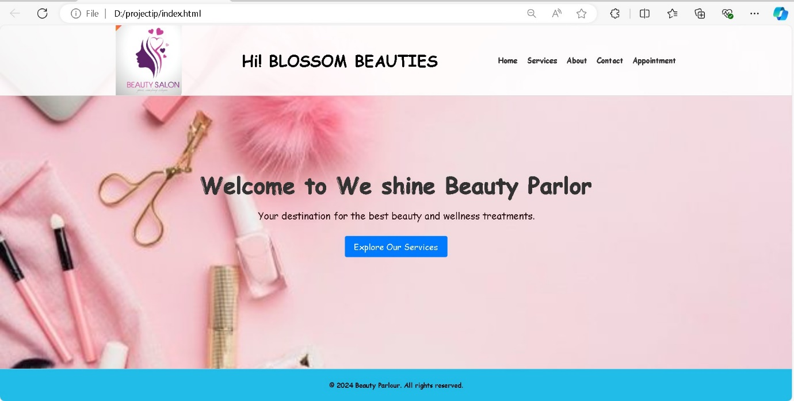

**Fig. 2: About Page**

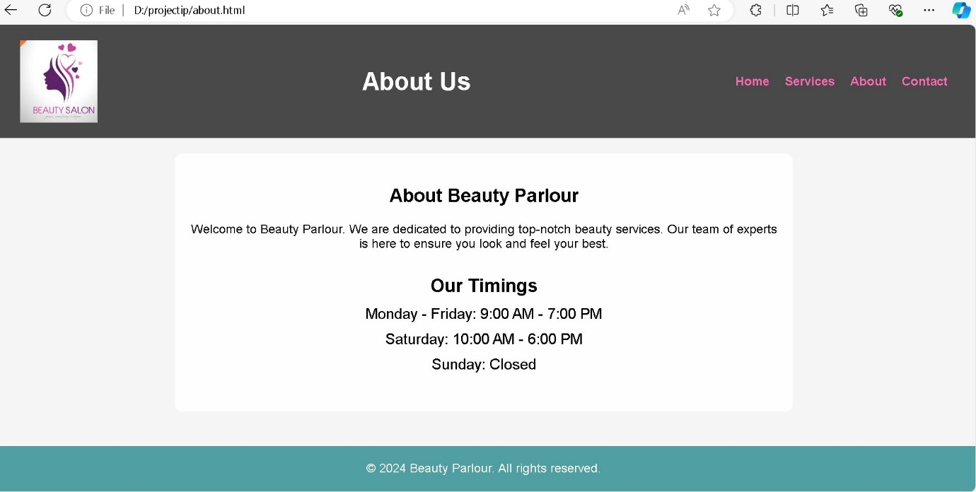

**Fig. 3: Appointment Page**

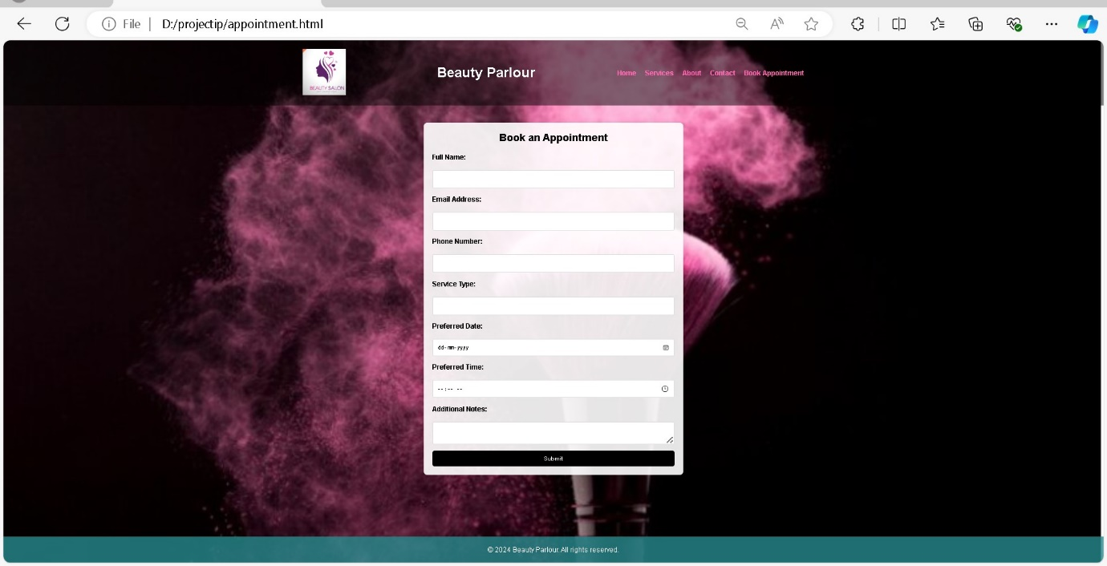

**Fig. 4: Contact Page**

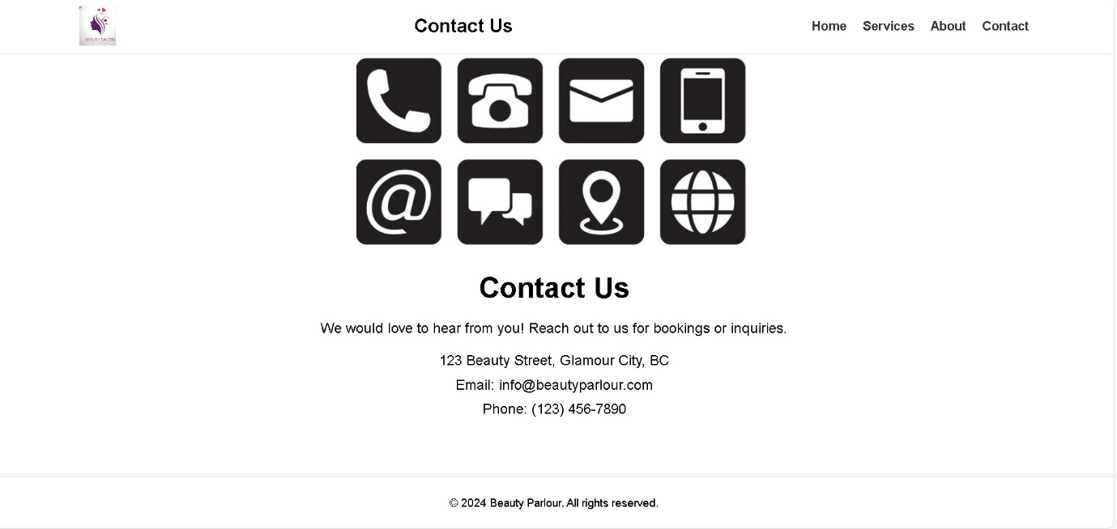

**Fig. 5: Report Page**

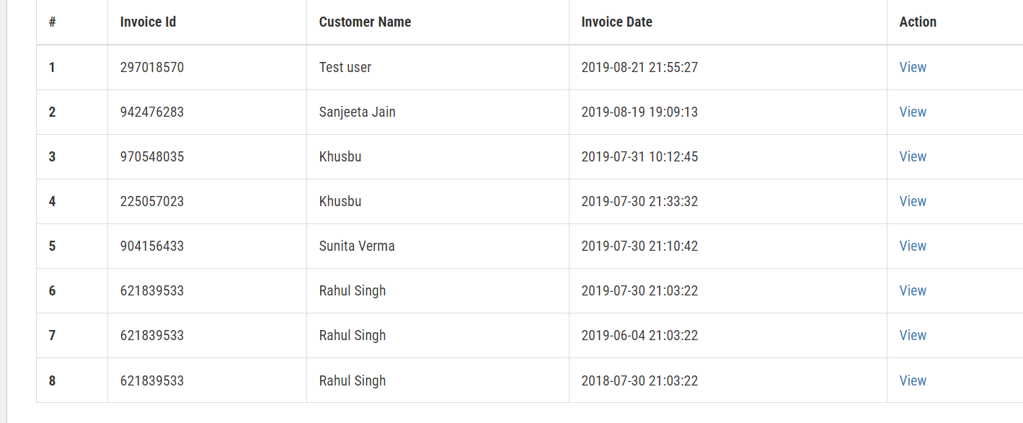

**REFERENCES:**

For creating an online beauty parlour appointment booking system, you can look at various examples of well-designed booking systems and appointment scheduling websites. These references can provide insights into user experience, design, and functionality. Here are some notable references:

* **Chatgpt**
* **Gemini AI**
* **GitHub**
* **Google Chrome**