**REPORT**

**BY**

**LAVANYA CHENNUPATI**

**BITALINO**

**04/28/2015**

**BITALINO BOARD AND HOW TO CONNECT TO IT:**

Bitalino board used to mark the start and end of a video based on the photo intensity. A bitalino board is a hardware tool kit designed to collect body signals. It can collect 3 body signals, ECG, EMG and EDA of the 6 signals on it. The other 2 are environmental- Accelerometer and luminous detector. The last one is the LED for the user. There is a power block that provides power to the entire unit. When on and in stand-by mode the LED will blink in white relatively slowly, if it’s collecting data, it blinks rapidly. Data collected through the board is transmitted to the computer with a software like MATLAB that gives readable values. All the 6 signals have an “A” value associated with it written correspondingly on the back of the board. These values are used in MATLAB, to collect the signals.

The placement of the electrodes on the body is important while collecting the ECG.

Place them like in the figure.

Electrode in the middle (I). The order of the other two electrodes is irrelevant (J and K).

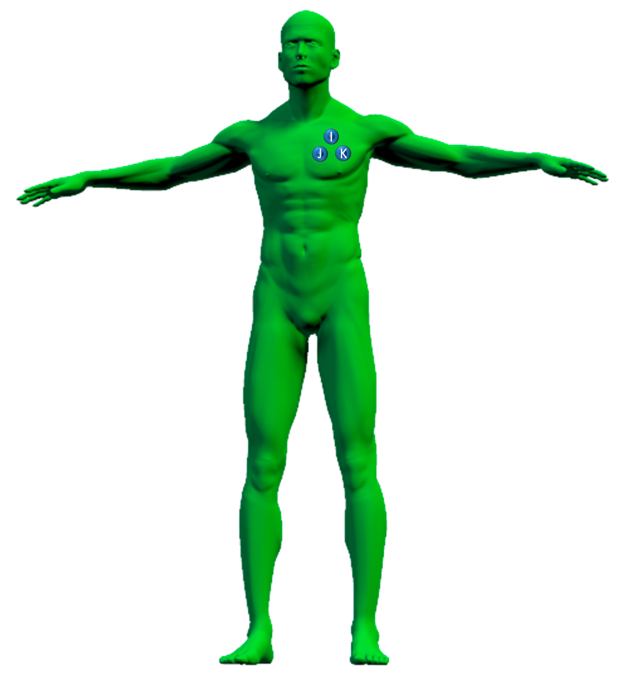

The EMG electrodes should be placed alongside the muscular fibers with a 2 cm spacing between them (G and H). They should be preferentially placed on the belly of the muscle.  The third electrode (F) is the referential and should be placed in an area of low muscular activity, usually a bony area.



The EDA electrodes are placed as in the figure below. The most frequently found are the AB (index - middle finger), AC (index - 3rd finger), and DE (thenar eminence).

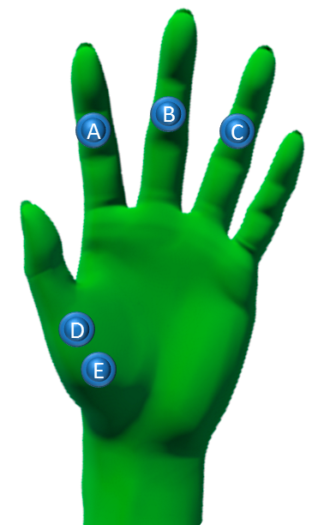

**MATLAB Code explained:**

Open MATLAB and open the files, testAPI.m and bitalino.m. In the testAPI.m we give the MAC Address of the bitalino board-“201307010810” that is used to connect the device to the computer via Bluetooth. To connect the board, search for the Bluetooth devices and pair it with the bitalino board when discoverable. To connect it use the pairing key “1234”.

The SamplingRate used in testAPI.m is the frequency at which the data has to be collected. For ECG atleast 100 Hertz is required.

nSamples is the total number of samples that are collected.

analogChannels is an array that stores the respective “A-1” values behind the board for the signals that we would like to capture.

plot is used to plot the collected data over the number of samples when the testAPI.m is run.

Now run testAPI.m and add it to the MATLAB path. The connection will be established and as the data is being collected the LED blinks rapidly. Once it stops collecting the data. The graph will be plotted based on the collected data.

**EXPERIMENT 1:**

Change in the Light Intensity Marked Using EMG and ACC.

**Requirements:**

1- Bitalino board

2- Power point presentation of 50 slides with varying light intensity from (0,0,0)-(255,255,255)

3- The intensity changes in binary (halves each time)

4- Each slide is for a duration of 3 seconds

**Procedure:**

* The change in light intensity in the power point from slide to slide is marked either using the EMG channel or Accelerometer channel.
* Each time the slide changes either there is a spike in the EMG signal (by tightening the fist) or Accelerometer(by giving a sudden movement to the bitalino board) marking that there is a change in the light intensity at that point.

**Findings:**

* Using EMG gives a better measurement of the LUX intensity.
* The sudden peak in the EMG value or ACC value indicates the change in LUX value.
* The peak of EMG and LUX coincide indicating a change in the power point slide.

All the corresponding graphs and results in the power point attached.

**EXPERIMENT-2:**

Marking the start and end of a video based on the LUX value.

**Requirements:**

1. Bitalino Board
2. A video divided into 5 equal parts.
3. Power point presentation of 11 slides with alternating gray screen( ) for 10 sec and one part of the video.

**Procedure:**

The average value of LUX for every10 seconds is calculated and if it’s equal to the LUX value of the gray slide, then at the end of this 10 seconds the next video starts. And except for the first 10 seconds, at the start of this 10 seconds the previous video ends.

**LOGIC USED:**

A linear average mechanism is used. The gray screen duration number of samples average is calculated each time. But if the video duration is not a proper multiple of the gray screen duration, then the extra samples are ignored. Whenever the average lux value is same as the lux value of the gray screen, then it’s the gray screen. At the end of gray screen starts a new video. And at the end of duration of video ends the video.

**FIGURE:**

----A*-----300samples---B*----------------500samples---------------C*---300samples---D*-----

According to the figure above, we say the ppt starts at A (1.59 sec—acc to results). First gray screen for 300 samples till B and so on.

We start calculating the average of 300 samples every time. But from B to C, we have 500 samples of which we calculate average for 300 and ignore the 200(as not a proper multiple of 300). Each average is checked with the lux of gray screen and if it is equal then it’s the gray screen. Hence time displayed accordingly.

**RESULTS:**

Experiment performed for 15 seconds, with 3 sec of gray screen and 5 sec of video in between. All the results are in accordance to this experiment.

From the graph in the experiment-2 folder, we can see the ppt starts at 1.59 seconds. So the first slide is for 3 seconds. Then the video for 5seconds. And gray for 3 seconds again and video again.

So the results displayed are accurate.