ETL/ELT
TITTLE: Meaning and difference between ETL/ELT
Explanation:
ETL: (Extract transform load)
Process:
- Extract: data is collected from various sources(database APIs ,flat files)
- Transform: data is cleaned, formatted and transformed before loading into the target system
- Load: the transformed data is loaded into the target system usually a data warehouse
ETL:(Extract load transform)
Process:
- Extract: data is collected from various sources
- Load: raw data is loaded into the target system (usually a cloud data warehouse or big data system)
- Transform: transformation happens inside the target system using its processing power
Differences between ELT/ETL:
ETL | ELT
Data transform before loading | Data transform after loading
Uses Separate ETL Server | Uses data warehouse power
Best for structured data/Used in tradition DW | Supports big/semi-structured data  /used in cloud DW
Slower for larger data /Higher infrastructure cost | Faster for larger data /low cost
Diagram:
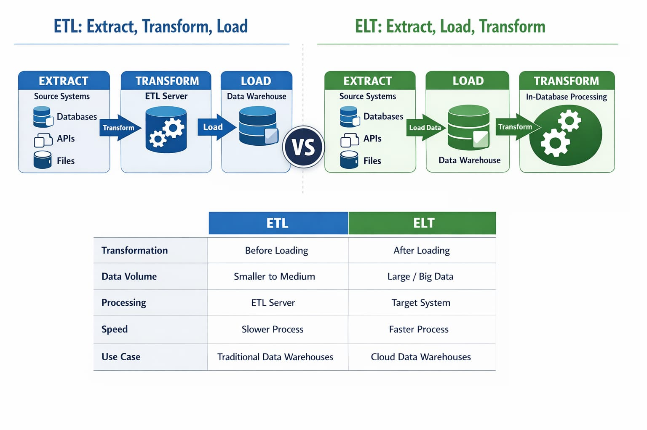
Interview questions:
- What is ELT/ETL?
  - ELT—Extract load transform
  - ETL---Extract transform load
- Main difference between ETL/ELT?
  - Transformation timing
- Where does transformation happen in ETL/ELT?
  - ETL—before loading
  - ELT--- after loading
- Which is faster for big data and cloud data warehouse and semi structure data?
  - ELT
- ETL/ELT tools
  - ETL— informatical, talend, SSIS
  - ELT----fivetran, stitch, matillion
- Explain ETL/ELT tools purpose
  - Informatical—data clean and transform to stored warehouse
  - Tlaned---data integration and data quality
  - SSIS----data integration and data loading
  - Fivetran----raw data automatically to stored cloud warehouse
  - Stitch---simple and fast data replication
  - Matillion---high performance data transformation

