
Master of Computer Applications
Semester – III
Data Analytics for Business
Experiment No.: 5
Title: Building Sales Performance
Dashboard

Submitted By:
Name: Lavanya E
Reg. No.: 2511022250083
Date: 05- Aug, 2026

Submitted To:
Faculty Name: Mr. Aman Kumar Sharma

Department of Computer Application
Alliance University
Chandapura - Anekal Main Road, Anekal
Bengaluru – 562106

Building Sales Performance Dashboard
Problem Statement
A retail company wants to monitor its overall sales performance using an interactive Power BI dashboard. Management requires a single dashboard to analyze weekly sales, compare store performance, monitor holiday and non-holiday sales, and understand the impact of business factors such as fuel price, temperature, Consumer Price Index (CPI), and unemployment. The objective is to design an interactive Sales Performance Dashboard using the Walmart Sales Dataset that supports effective business decision-making.
Dataset Used: Walmart Sales Dataset (Kaggle)

Methodology / Steps Followed
- Downloaded the Walmart Sales Dataset from Kaggle.
- Imported the dataset into Power BI Desktop using the Get Data option.
- Opened Power Query Editor and verified the data types of all columns.
- Removed duplicate records and checked for missing values.
- Converted the Date column into Date format for time-based analysis.
- Loaded the cleaned dataset into Power BI Desktop.
Created Card Visuals to display:
Total Sales
Average Weekly Sales
Maximum Weekly Sales
Minimum Weekly Sales
Total Number of Stores
Created a Clustered Bar Chart to compare total sales across different stores.
Created a Donut Chart to compare Holiday and Non-Holiday sales.
Created a Line Chart to visualize monthly sales trends.
Created Scatter Charts to analyze:
Fuel Price vs Weekly Sales
Temperature vs Weekly Sales
CPI vs Weekly Sales
Output
➤ Loading the Walmart Dataset
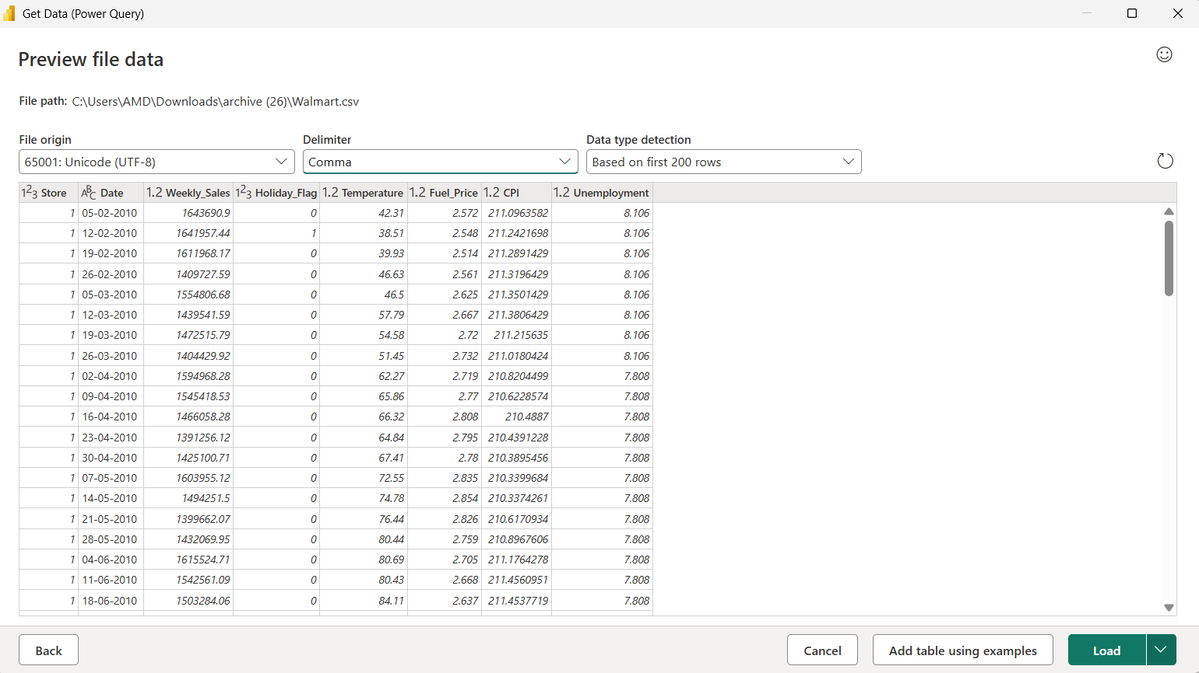
➤ Removing Duplicate Records
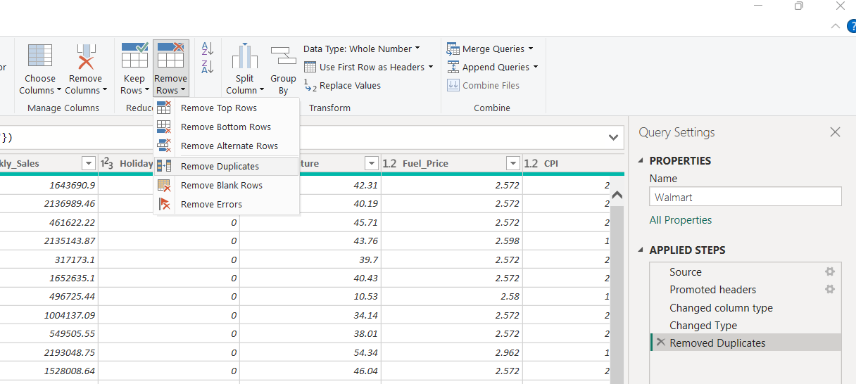
➤ Changing Data Type to Date Format
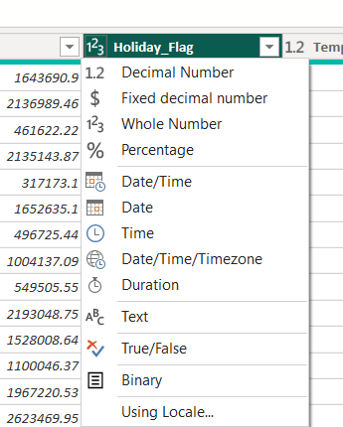
➤ Business Insights Dashboard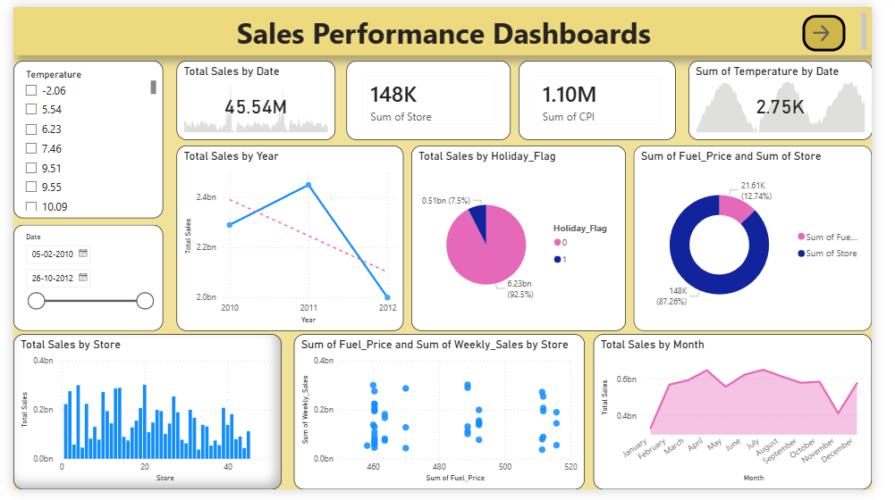
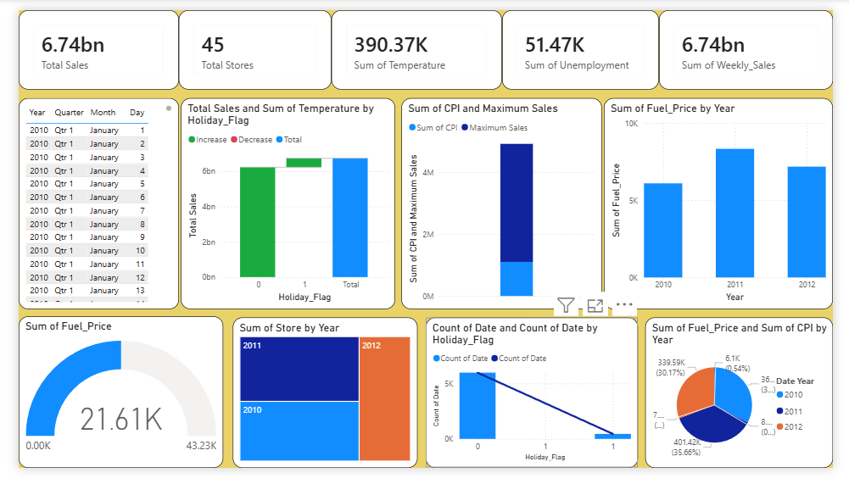
Results
- The Walmart Sales dataset was successfully imported, cleaned, and analyzed using Power BI.
- Data quality was verified by checking data types, duplicate records, and missing values.
- KPI cards provided an overview of total sales, average sales, maximum sales, minimum sales, and the total number of stores.
- The Clustered Bar Chart identified the highest-performing stores based on weekly sales.
- The Donut Chart compared sales generated during holiday and non-holiday periods.
- The Line Chart showed monthly sales trends and seasonal business patterns.
- Scatter Charts helped analyze the relationship between weekly sales and business factors such as fuel price, temperature, CPI, and unemployment.
- Interactive slicers enabled users to filter dashboard results by store, date, and holiday status.
- The dashboard presented business information in a clear and interactive format, supporting faster and more informed decision-making.

Conclusion
This experiment demonstrated how Power BI can be used to design an interactive Sales Performance Dashboard for business reporting. The dashboard combines multiple visualizations to monitor sales trends, compare store performance, evaluate holiday sales, and analyze the impact of economic factors on weekly sales. Interactive filters improve user experience by allowing customized analysis. The dashboard provides valuable insights that support effective business planning and strategic decision-making.

Learning Outcomes
✔ Understand the importance of interactive dashboards in business intelligence.
✔ Import and prepare the Walmart Sales Dataset in Power BI.
✔ Verify data quality by checking data types, duplicates, and missing values.
✔ Create KPI Cards to summarize business performance.
✔ Create Bar Charts to compare store-wise sales.
✔ Create Donut Charts to analyze holiday and non-holiday sales.
✔ Create Line Charts to monitor monthly sales trends.
✔ Create Scatter Charts to study the relationship between sales and external business factors.
✔ Use slicers to build interactive business reports.
✔ Apply formatting and visualization techniques to design professional Power BI dashboards.
✔ Gain practical experience in developing business intelligence dashboards for sales performance analysis.

