CLOUDFUZE • INTERNAL TOOL • USER GUIDE
Delta Migration Readiness Tracker
A plain-language guide to what the tool does and how work flows through it
This guide explains the tool as a process — no technical background needed. It walks through the problem it solves, who uses it, and the exact path every server takes from first setup to a finished migration.

1. What is this tool?
The Delta Migration Readiness Tracker is one central place for the Migration team to track and prove that a server is truly ready before its “Delta” migration is started. “Delta” simply means moving the actual data (mailboxes, drives, or messages) from a source system to a destination system.
Instead of chasing status across spreadsheets, chats, and emails, everyone looks at the same screen. A server can only move forward when the right checks are done and the right people have signed off. Nothing important can be skipped or forgotten.
2. The problem it solves
Before this tool | With this tool
Readiness checks, evidence, and approvals were scattered across spreadsheets and email. | Everything lives in one place, always up to date.
No trustworthy, shared view of what was actually ready. | A single dashboard shows readiness, approvals, and blockers at a glance.
Easy to start a migration before it was truly signed off. | The migration button stays locked until every required gate is green.
Hard to see who is waiting on whom. | Each step has a clear owner and an automatic email reminder.
3. How it helps the team
- One dashboard for server readiness, pending approvals, open tickets, and progress per project.
- A guaranteed process — a Delta cannot start until pre-checks are complete and every required role has approved.
- Evidence is captured for every check, so readiness can be proven later, not just claimed.
- Automatic email notifications keep the right person informed at every stage.
- Clear roles and permissions — people only see and do what fits their job.
4. Key words in plain English
Term | What it means
Project | A customer engagement or piece of work. It groups everything below it.
Server | A system being migrated. Each project can have several servers.
Workspace pair | One source account → one destination account (e.g., an old mailbox mapped to a new one). Imported from a CSV file.
Pre-check | A readiness checklist for a server. Every item needs a status, a note, and an attached evidence file.
Ticket | A logged blocker or issue linked to a project/server, marked Open or Resolved.
Sign-off / Approval | A required review by a specific role before the work can continue.
Delta | The actual data migration from source to destination.
Decommission-ready | Every server in a project has finished its Delta — the whole project is done.
5. Who uses it — the roles
Anyone signs in with their Microsoft account, but what they can do depends on their role:
Role | What they do
Admin | Manages people and access; can see and do everything.
Migration Manager | Owns the project; first to approve after a pre-check is submitted.
Dev Lead | Second approver; also decides whether a QA review is required.
QA Lead | Final approver on quality, when the Dev Lead requires it.
Migration Engineer | Does the hands-on work: imports pairs, completes pre-checks, and starts/finishes the Delta.

6. The journey of a server, step by step
Every server follows the same path. Each stage must be finished before the next one opens — this is what guarantees nothing is skipped.
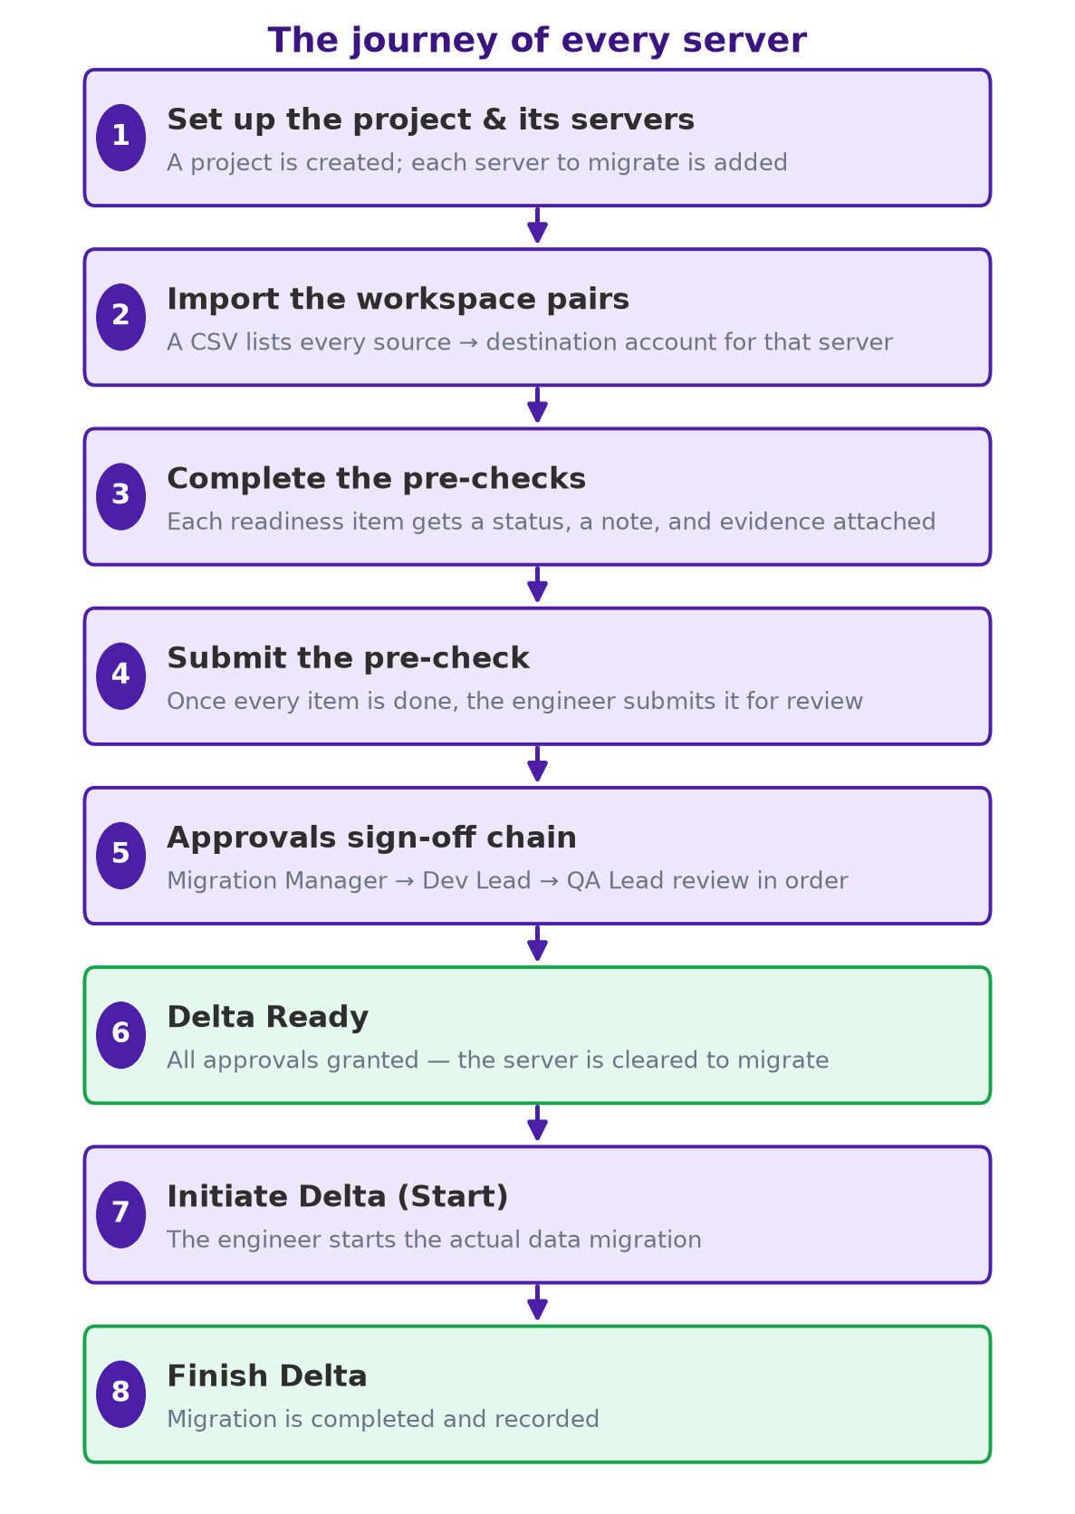
Step 1 — Set up the project & its servers: A Migration Manager or Admin creates the project and adds each server that needs migrating.
Step 2 — Import the workspace pairs: An engineer uploads a CSV listing every source → destination account. Duplicate rows are skipped automatically and reported.
Step 3 — Complete the pre-checks: The engineer works through the readiness checklist, adding a status, a short note, and an evidence file to each item.
Step 4 — Submit the pre-check: Once every item is complete, the engineer submits it. This is the trigger that starts the approval chain.
Step 5 — Approvals sign-off chain: The Migration Manager, Dev Lead, and (if needed) QA Lead review in a fixed order.
Step 6 — Delta Ready: When all required approvals are in, the server is officially cleared to migrate.
Step 7 — Initiate Delta (Start): The engineer starts the real migration. The Manager is notified that it has begun.
Step 8 — Finish Delta: When the migration completes, the engineer marks it finished and the Manager is notified.

7. The approval chain explained
Approvals happen strictly in order — only the person whose turn it is can act. This keeps accountability clear and prevents anyone from jumping ahead.
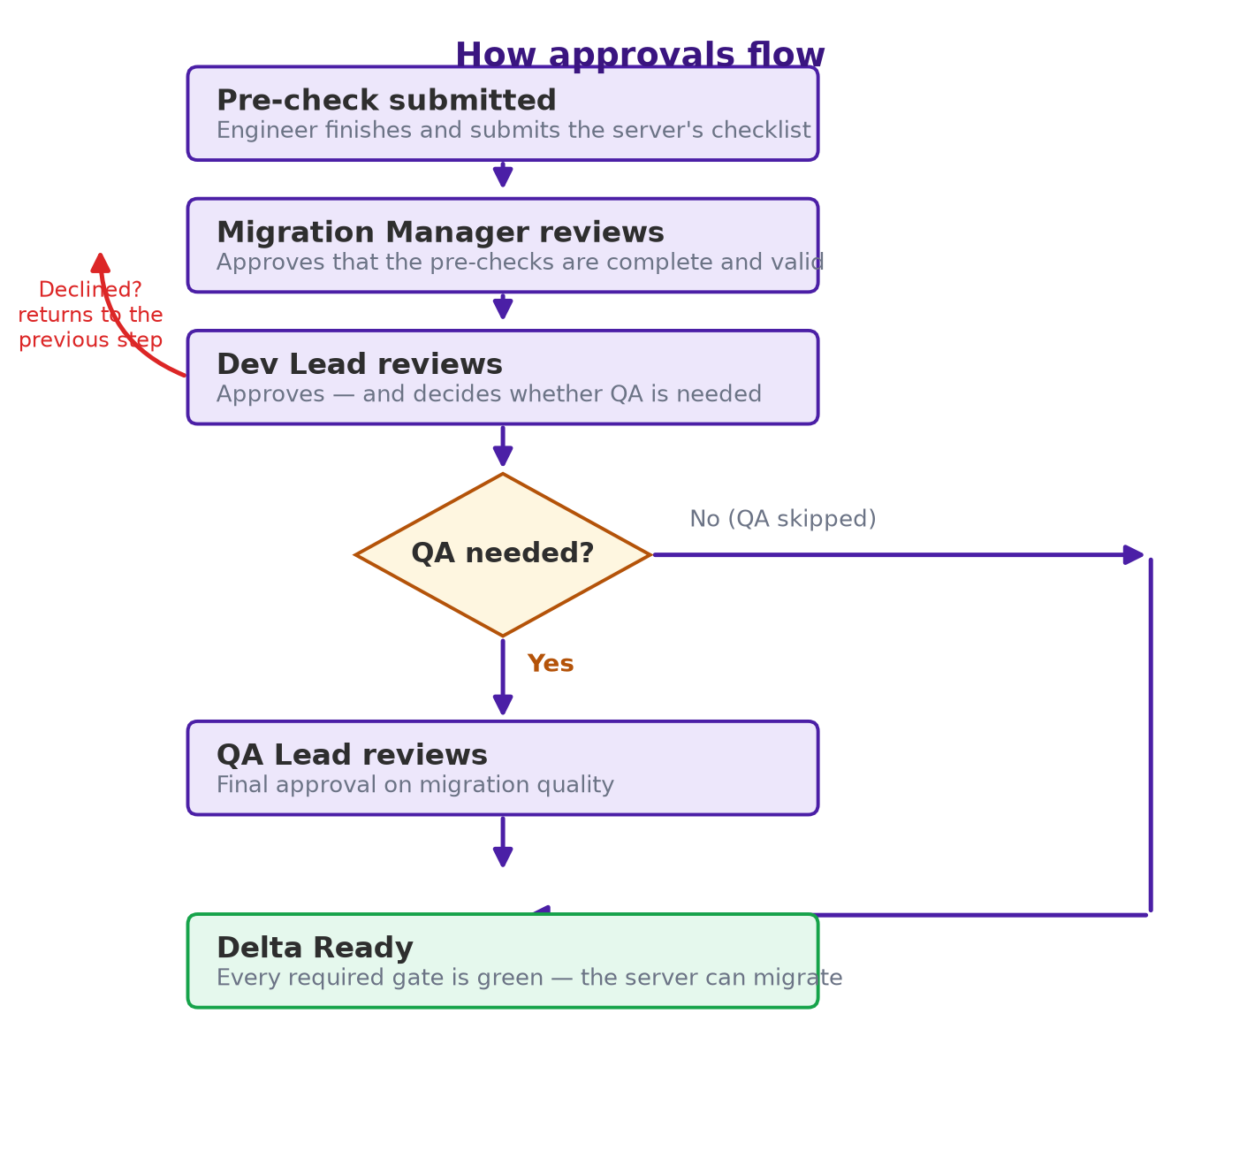
- First the Migration Manager approves that the pre-checks are complete and valid.
- Next the Dev Lead approves — and decides whether a QA review is needed for this server.
- If QA is required, the QA Lead gives the final approval. If not, QA is skipped and the server becomes Delta Ready right away.
- If anyone declines, the chain moves back one step so the issue can be fixed and re-submitted — nothing is lost.
- Only when every required approval is in does the server become Delta Ready and the Start button unlocks.
8. Tickets — handling blockers
When something is blocking readiness, the team logs a ticket against the project and server, with a link to the full details. Tickets are marked Open or Resolved, so blockers are visible on the dashboard and never quietly forgotten. Only the engineer who created a ticket (or an Admin) can edit, resolve, or remove it.

9. Staying informed — email notifications
The tool sends a clear, concise email each time the baton passes to the next person, so no one has to keep checking manually.
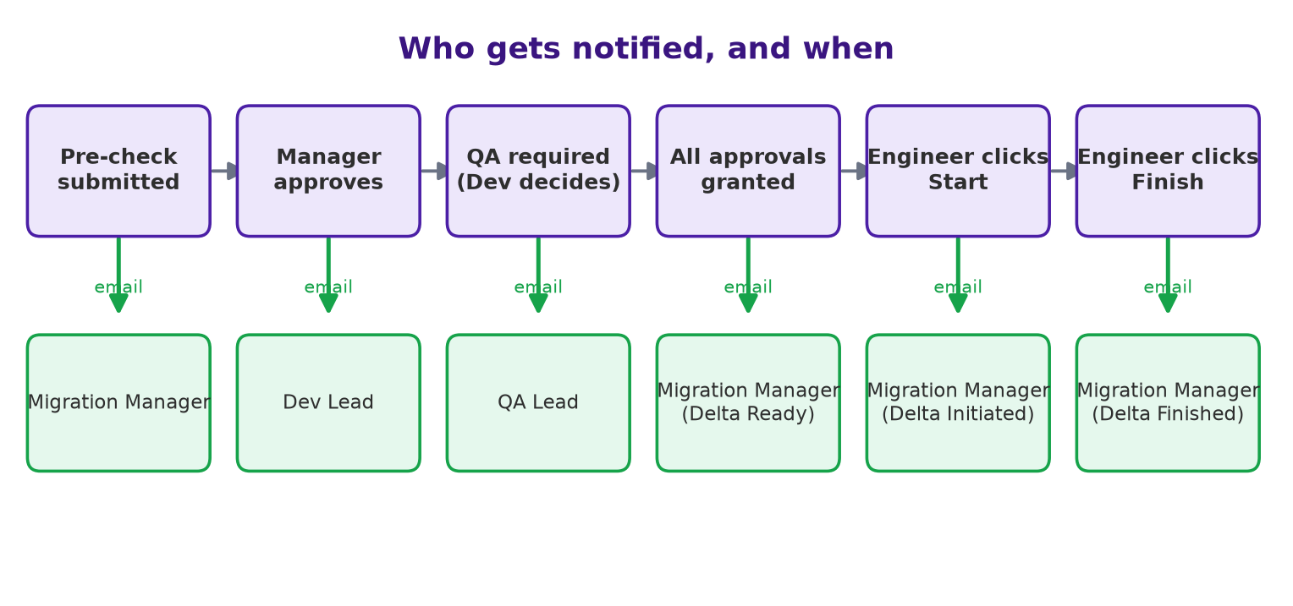
When this happens | Who receives an email
A pre-check is submitted | Migration Manager — asked to review and approve
The Manager approves | Dev Lead — asked to review and approve
The Dev Lead requires QA | QA Lead — asked to review and approve
All approvals are granted | Migration Manager — notified the server is Delta Ready
An engineer clicks Start | Migration Manager — notified the Delta has been initiated
An engineer clicks Finish | Migration Manager — notified the Delta has finished
10. The dashboard — everything at a glance
The home screen is designed to answer “what needs attention right now?” in seconds:
- Summary cards: total projects, servers, Delta-ready servers, pending approvals, open tickets, and projects ready to decommission.
- Three rings: server readiness, approvals approved-vs-pending, and overall project completion.
- Servers by product type: the mix of Content, Email, and Message work.
- Delta readiness by project: a progress bar per project, sorted so the most complete are on top.
- Needs Attention: a shortlist of projects with pending approvals or open tickets, each clickable to jump straight there.
11. Status labels you will see
Label | Meaning
Not started / Draft | The pre-check has not been submitted yet.
Submitted / Pending | Waiting for someone to review and approve.
Approved | That role has signed off; the baton moves on.
Delta Ready | All required gates are green — migration can begin.
Open (ticket) | A blocker that still needs resolving.
Resolved (ticket) | The blocker has been dealt with.

12. A day-in-the-life example
To see it all together: An engineer opens Project “Acme Email Move,” adds the server “Acme-EX01,” and imports 120 workspace pairs from a CSV. They work through the pre-check list — attaching a screenshot and a note to each item — then submit it.
The Migration Manager gets an email, opens Approvals, and approves. The Dev Lead is notified next, reviews, approves, and marks that QA is required. The QA Lead gets an email, checks the evidence, and gives the final approval. The server flips to Delta Ready and the Manager is notified.
The engineer clicks Start (the Manager is told the Delta has begun), runs the migration, and clicks Finish (the Manager is told it is done). Once every server in the project reaches this point, the project shows as ready to decommission.
13. Frequently asked questions
Q: Can a migration start before approvals are done?
A: No. The Start button stays locked until the server is Delta Ready — that is the whole point of the tool.
Q: What if I upload the same CSV twice?
A: Identical rows are detected and skipped, and the skipped rows are shown to you in a popup. Only new rows are added.
Q: What happens if an approver finds a problem?
A: They decline, which sends the server back one step. The issue is fixed and re-submitted — no data or history is lost.
Q: Is QA always required?
A: No. The Dev Lead decides per server. If QA is not needed, it is skipped and the server becomes Delta Ready immediately.
Q: Who can change or close a ticket?
A: Only the engineer who created it, or an Admin.

In one line
It turns “is this server ready for Delta?” from a question you chase across email into a single screen the whole team can trust — and the migration stays locked until every gate is green.

