Intelligent PDF Question Answering System
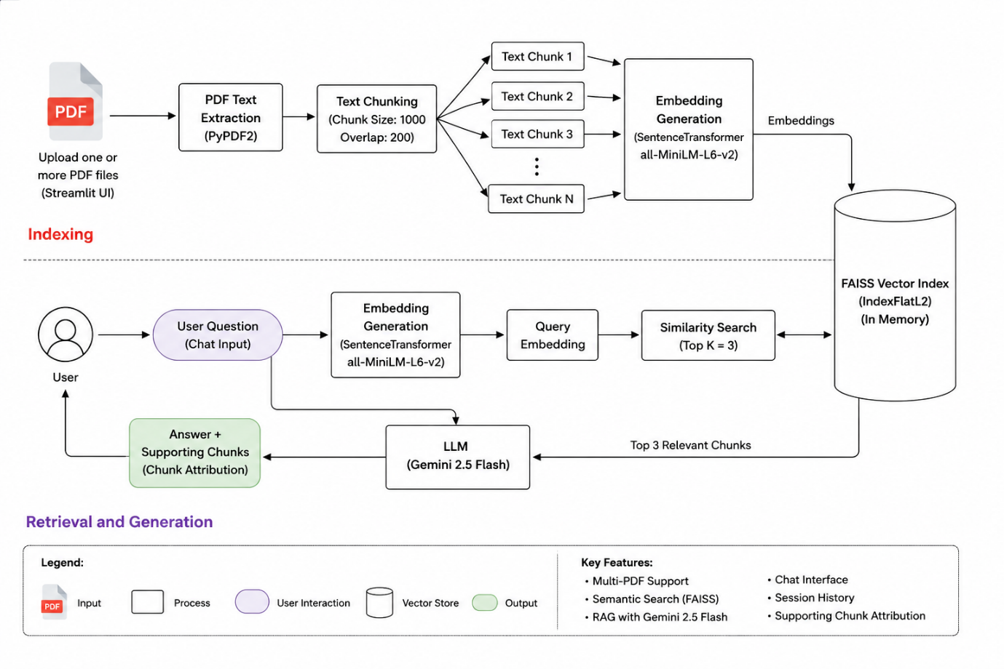

Overview
This project implements a Retrieval-Augmented Generation (RAG) pipeline that enables users to upload one or more PDF documents and ask natural language questions about their contents. The system retrieves the most relevant document sections using semantic search and generates context-aware answers using Gemini 2.5 Flash.

1. Indexing Phase
The indexing phase is executed whenever one or more PDF documents are uploaded.

Multi-PDF Upload
Users can upload one or multiple PDF documents through the Streamlit interface. All uploaded files are processed together to create a unified knowledge base.

PDF Text Extraction
The uploaded PDFs are processed using the PyPDF2 library. Text is extracted from every page and combined into a single text corpus.

Text Chunking
The extracted text is divided into smaller chunks using RecursiveCharacterTextSplitter.
Configuration:
- Chunk Size: 1000 characters
- Chunk Overlap: 200 characters
Chunk overlap helps preserve context between adjacent chunks and improves retrieval quality.

Embedding Generation
Each text chunk is converted into a dense vector representation using the Sentence Transformer model:
- all-MiniLM-L6-v2
These embeddings capture the semantic meaning of the text.

FAISS Vector Index
The generated embeddings are stored in a FAISS IndexFlatL2 vector index.
Purpose:
- Fast similarity search
- Efficient retrieval of relevant document chunks
- In-memory storage during application runtime

2. Retrieval and Generation Phase
The retrieval phase is executed whenever a user submits a question.

User Question
The user enters a natural language question through the chat interface.

Query Embedding
The question is converted into a vector embedding using the same Sentence Transformer model used during indexing.
Using the same embedding model ensures that document chunks and user queries exist in the same vector space.

Similarity Search
FAISS performs semantic similarity search between the query embedding and stored document embeddings.
Configuration:
- Top-K Retrieval: 3
The three most relevant chunks are selected and returned.

Large Language Model
The retrieved chunks are combined into a context prompt and sent to:
- Gemini 2.5 Flash
The model is instructed to answer the question using only the retrieved context.
This Retrieval-Augmented Generation (RAG) approach helps reduce hallucinations and improves answer accuracy.

Answer Generation
Gemini generates a final answer based on the retrieved document context.
The system also displays supporting chunks so users can verify the source of the generated response.

3. Key Features Implemented
- Multi-PDF Upload Support
- PDF Text Extraction
- Text Chunking with Overlap Preservation
- Sentence Transformer Embeddings
- FAISS Semantic Search
- Retrieval-Augmented Generation (RAG)
- Gemini 2.5 Flash Integration
- Chat-Based User Interface
- Session-Based Conversation History
- Supporting Chunk Attribution
- PDF Statistics Display
- Clear Chat Functionality
- Error Handling and Validation
- Streamlit Caching for Performance Optimization

Technology Stack
- Frontend Streamlit
- PDF Processing PyPDF2
- Text Chunking LangChain Text Splitter
- Embedding Model SentenceTransformers (all-MiniLM-L6-v2)
- Vector Search FAISS
- Large Language Model Gemini 2.5 Flash
- Programming Language Python

