**Plastic Type Detection Using DeepLearning**

***A Project Report submitted***

***in partial fulfillment of the requirements***

***for the award of the degree of***

# BACHELOR OF TECHNOLOGY

***In***

## COMPUTER SCIENCE & ENGINEERING

### *By*

1 .Geetika Chukkaa (21B01A0536)

2. Lakshmi Lavanya Immaneni (21B01A0562)

### *Under the esteemed guidance of*

**Dr.P.Kiran Sree**

**HOD - CSE**



**DEPARTMENT OF COMPUTER SCIENCE & ENGINEERING SHRI VISHNU ENGINEERING COLLEGE FOR WOMEN(A) (Approved by AICTE, Accredited by NBA & NAAC, Affiliated to JNTU Kakinada) BHIMAVARAM – 534 202 2024 – 2025**

# SHRI VISHNU ENGINEERING COLLEGE FOR WOMEN(A)

**(Approved by AICTE, Accredited by NBA & NAAC, Affiliated to JNTU Kakinada) BHIMAVARAM – 534 202**

# DEPARTMENT OF COMPUTER SCIENCE & ENGINEERING



## CERTIFICATE

*This is to certify that the project entitled* ***Plastic type classification using deeplearning****, is being submitted by* ***Geetika Chukkaa*** *bearing the Regd.No.* ***21B01A0536*** *and* ***Lavanya Immaneni*** *bearing the Regd.No.* ***21B01A0562*** *in partial fulfillment of the requirements for the award of the degree of “****Bachelor of Technology*** *in* ***Computer Science & Engineering****” is a record of Bonafide work carried out by her under my guidance and supervision during the academic year 2024–2025 and it has been found worthy of acceptance according to the requirements of the university.*

**Internal Guide Head of the Department**

**External Examiner**

# ACKNOWLEDGMENT

The satisfaction that accompanies the successful completion of any task would be incomplete without the mention of the people who made it possible and whose constant encouragement and guidance has been a source of inspiration throughout the course of this seminar. We take this opportunity to express our gratitude to all those who have helped us in this Project.

We wish to place our deep sense of gratitude to **Sri. K. V. Vishnu Raju, Chairman of SVES**, for his constant support on each and every progressive work of mine.

We wish to place our deep sense of gratitude to **Dr P Srinivasa Raju , Our Director, Student Affairs, Admin, SVES-Bhimavaram**.

We wish to express our sincere thanks to **Dr. G. Srinivasa Rao, Principal of SVECW** for being a source of inspiration and constant encouragement.

We wish to express our sincere thanks to **Prof P. Venkata Rama Raju, Vice-Principal of SVECW** for being a source of inspirational and constant encouragement.

We wish to place our deep sense of gratitude to **Dr. P. Kiran Sree, Head of the Department of Computer Science & Engineering** for his valuable pieces of advice in completing this seminar successfully.

We are deeply indebted and sincere thanks to our **PRC members Dr. P. R. Sudha Rani, Dr. V. V. R. Maheswara Rao, Dr.J.Veeraraghavan, Mr. G. V. S. S. Prasad Raju** for their valuable advice in completing this project successfully.

We are deeply thankful to our **project coordinator Dr. P. R. Sudha Rani, Professor** for her indispensable guidance and unwavering support throughout our project completion.

Our deep sense of gratitude and sincere thanks to **Dr. P. Kiran Sree, Head of the Department of Computer Science & Engineering** for his unflinching devotion and valuable suggestions throughout our project work.

**Project Team:**

1. Geetika Chukkaa (21B01A0536)
2. Lavanya Immaneni (21B01A0562)

# ABSTRACT

Plastic pollution poses a significant threat to the environment, with various types of plastic waste requiring distinct recycling and disposal methods. Accurate classification of plastic types is essential to streamline recycling processes and promote sustainable waste management. This project aims to develop an intelligent web-based application capable of identifying and classifying different plastic types from user-uploaded images.

To achieve this, a hybrid deep learning approach was implemented, starting with MobileNetV2—a lightweight and efficient convolutional neural network optimized for mobile and embedded vision applications. The pre-trained MobileNetV2 model was fine-tuned to classify seven distinct plastic categories: PET Bottle, HDPE Plastic, Single-use Plastic, Single-layer Plastic, Multi-layer Plastic, Squeeze-Tube, and UHT-Box. To further improve object localization and detection accuracy, the YOLO (You Only Look Once) object detection framework was integrated later in the pipeline. YOLO’s real-time detection capabilities allowed the system to accurately identify and localize plastic items within complex images, making the solution robust and versatile for practical deployment.

The application is accessible through an intuitive Flask-based web interface that allows users to upload plastic images and receive real-time classification results, along with confidence scores and class-wise probabilities. This interface ensures ease of use for both technical and non-technical users, promoting broader community engagement in plastic waste sorting and awareness.

Overall, the project demonstrates the feasibility and impact of combining deep learning with web technologies to address real-world environmental challenges. It not only showcases the effectiveness of MobileNet and YOLO in image classification and detection but also highlights the potential of AI in supporting sustainable and smart waste management systems.

**Table of Contents**

**S.No. Topic Page No**

1. **Introduction 9**–11
2. **System Analysis**

2.1 Existing System 13-17

2.2 Proposed System 18-20

1. **System Requirements Specification**

3.1 Hardware Requirements 22-23

3.2 Software requirements 23-24

3.3 Enviromental Requirements 24-25

3.4 Security Requirements 25-26

3.5 Usability Requirements 26

1. **System Design**

4.1 System Architecture 30

4.2 Data Flow Design 30-31

4.3 UML class Diagram 31-32

4.4 Components Description 33-34

1. **System Implementation**

5.1 Introduction 36

5.2 Project Modules 37-38

5.3 Algorithms 39-46

5.4 Results 47-50

1. **System Testing**

6.1 Test Objectives 52

6.2 Test Strategy 52-53

6.3 Test Procedures 53

6.4 Test Cases 53-54

6.5 Test Results 54

6.6 Issues Encountered 55

6.7 Resolutions and work arounds 55

1. **Conclusion 57-61**
2. ***Bibliography 63***
3. **Appendix**

9.1 Appendix-A 65

9.2 Appendix-B 66-70

**1. INTRODUCTION**

**Introduction**

Plastic pollution is one of the most pressing environmental issues of our time. With millions of tons of plastic produced annually, only a fraction of it is properly recycled. A major barrier to efficient recycling is the improper segregation of plastic waste. Different types of plastics have varying properties and recycling requirements. For example, PET bottles and HDPE plastics are widely recycled, while multilayer plastics and squeeze tubes are more difficult to process. Therefore, accurate and automated plastic classification is critical to improving recycling systems.

Traditionally, the sorting of plastic waste has relied on manual labor, which is time-consuming, error-prone, and expensive. While some advanced recycling facilities use mechanical sorting based on shape and density, these systems are often limited in granularity and accuracy. With recent advancements in artificial intelligence (AI), particularly in computer vision and deep learning, there is a promising opportunity to revolutionize how we approach plastic classification.

This project aims to build a web-based system that uses deep learning models to automatically identify and classify plastic types from user-uploaded images. The system leverages the power of transfer learning through MobileNetV2 for classification and YOLO for object detection, making it efficient, accurate, and scalable.

In most waste management systems, plastics are treated as a homogeneous category. However, recycling requires them to be separated by type. Manual sorting is inconsistent and inefficient, and existing automated methods are often expensive or limited in scope. There is a growing need for a low-cost, intelligent, and user-friendly system that can identify different plastic types with high accuracy.

The core problem this project addresses is:

“How can we classify and detect various plastic types from images using deep learning techniques, and make the solution accessible through a web interface?”

The primary objective of this project is to develop a machine learning-powered application that can:

* Accurately classify plastic waste into one of the predefined categories.
* Detect the presence and location of plastic objects in images.
* Provide an intuitive user interface for uploading images and displaying classification results.
* Enable confidence-based feedback to improve user trust in model predictions.
* Demonstrate the application of modern deep learning techniques like MobileNetV2 and YOLO in a real-world context.

This project focuses on classifying plastic types into the following 7 categories:

1. PET Bottle
2. HDPE Plastic
3. Single-use Plastic
4. Single-layer Plastic
5. Multi-layer Plastic
6. Squeeze-Tube
7. UHT-Box

The system is trained to recognize these categories based on labeled image data. The web interface supports real-time classification and displays confidence levels for all possible classes. Object detection with YOLO is integrated to identify plastic instances in cluttered or complex images, enhancing robustness and usability in uncontrolled environments.

While the system performs well for the defined categories, it does not currently address multi-class segmentation or handle plastics outside the predefined list. However, it lays a strong foundation for future improvements and extensions.

* MobileNetV2: A lightweight, efficient CNN architecture used for image classification. Fine-tuned on our dataset to classify images into plastic types.
* YOLO (You Only Look Once): An object detection algorithm that allows real-time localization of plastic items in an image.
* TensorFlow/Keras: For building and training deep learning models.
* Flask: A lightweight Python web framework used to create the interactive web interface.
* HTML, CSS, JavaScript: For front-end user interaction and visual presentation of results.

The motivation for this project stems from the growing concern about environmental degradation caused by plastic waste and the inefficiencies in current recycling workflows. With increasing public awareness and regulatory pressures, smart recycling solutions are more important than ever. Leveraging AI to automate plastic classification can drastically improve recycling efficiency, reduce human effort, and make waste management systems smarter and more sustainable.

**2. SYSTEM ANALYSIS**

## SYSTEM ANALYSIS

### A thorough system analysis is essential to understand the problem space, identify shortcomings in current approaches, and design a solution that addresses them effectively. This project focuses on the classification and detection of different types of plastic waste using deep learning techniques. The analysis begins by exploring the limitations of the current systems used for plastic identification and waste segregation. It then moves on to define the proposed intelligent system built using MobileNetV2 and YOLO architectures, highlighting its advantages in terms of efficiency, cost, and usability. Furthermore, the feasibility study evaluates the system’s practicality from technical, operational, and economic perspectives, ensuring that the solution is not only functional but also viable in real-world conditions.

### 2.1 Existing System

The domain of plastic recyclable detection and waste management has witnessed significant advancements, driven by the urgent need to address the global plastic pollution crisis. This section provides an exhaustive review of existing systems and technologies employed for plastic identification, classification, and sorting, encompassing manual methods, traditional automation, and state-of-the-art computer vision approaches. By analyzing their functionalities, strengths, and limitations, this overview establishes the foundation for understanding the motivation and innovation behind the proposed YOLOv8-based system.

**2.1.1 Manual Sorting Systems**

Manual sorting remains a prevalent method in recycling facilities worldwide, where workers visually inspect and categorize plastic waste into types such as PET, HDPE, and PVC.

* **Functionality**: Workers use hand tools and rely on color, shape, and texture to separate recyclables, often guided by resin identification codes (RICs) on plastic items.
* **Strengths**:
  + Highly flexible, adaptable to varied plastic conditions (e.g., damaged or unlabeled items).
  + Low initial setup cost, requiring only labor and basic equipment.
* **Limitations**:
  + Labor-intensive, with workers processing 10-20 items per minute, leading to fatigue and reduced accuracy over time.
  + Error-prone, with misclassification rates up to 15-20% due to human oversight.
  + Health hazards from dust, sharp edges, and chemical exposure, impacting worker safety.
  + Scalability constrained by workforce availability and training requirements.

**2.1.2 Traditional Automated Sorting Systems**

Traditional automation leverages mechanical and sensor-based technologies to enhance sorting efficiency.

* **Functionality**: Systems use conveyor belts, air jets, and sensors (e.g., near-infrared [NIR] spectroscopy, X-ray fluorescence [XRF]) to detect plastic types based on material composition.
* **Examples**:
  + **NIR Sorting Machines**: Identify polymer types (e.g., PET, HDPE) by analyzing molecular vibrations, common in facilities like TOMRA Sorting Solutions.
  + **XRF Systems**: Detect chemical elements in plastics, used by companies like Steinert for heavy metal identification.
* **Strengths**:
  + Higher throughput, processing 50-100 items per minute.
  + Consistent performance with minimal human intervention.
  + Accurate for specific polymer types with pre-calibrated sensors.
* **Limitations**:
  + High installation and maintenance costs, often exceeding $100,000 for industrial setups.
  + Limited to pre-defined material types, struggling with mixed or contaminated plastics.
  + Inability to handle visual features (e.g., shape, color) or real-time adaptability.
  + Requires frequent sensor calibration, adding operational complexity.

**2.1.3 Computer Vision-Based Systems**

Recent advancements have introduced computer vision and machine learning for plastic detection, offering a more dynamic approach.

* **Functionality**: These systems use cameras and algorithms to analyze images or video feeds, identifying and classifying plastics based on visual characteristics.
* **Examples**:
  + **YOLOv5 Applications**: Previous iterations of the YOLO family have been used for waste classification, achieving mAP50 scores of 0.85-0.90 on datasets like TACO (Trash Annotations in Context).
  + **Mask R-CNN Systems**: Employed by research groups for instance segmentation of recyclables, with applications in robotic sorting.
  + **Commercial Solutions**: Companies like AMP Robotics use proprietary vision systems with deep learning to sort plastics at 60-80 items per minute.
* **Strengths**:
  + High accuracy, with mAP50-95 reaching 0.90+ on well-trained models.
  + Real-time processing, with frame rates of 15-30 FPS on GPU-enabled systems.
  + Adaptable to new plastic types with retraining, supporting 5-10 categories.
  + Potential for integration with robotics and IoT for automated workflows.
* **Limitations**:
  + Dependency on GPU hardware, increasing costs for small-scale deployment (e.g., $500+ for a compatible GPU).
  + Limited performance on CPU, often dropping to 5-10 FPS, unsuitable for budget-constrained environments.
  + Sensitivity to lighting, occlusion, and angle variations, reducing reliability in uncontrolled settings.
  + Dataset dependency, requiring 1,000-5,000 annotated images, which can be resource-intensive to curate.

**2.1.4 Comparative Analysis**

A comparative evaluation of these systems highlights their trade-offs:

* **Throughput**: Manual (10-20 items/min) < Traditional Automation (50-100 items/min) < Computer Vision (60-80 items/min with GPU).
* **Accuracy**: Manual (80-85%) < Traditional Automation (90%) < Computer Vision (90-95% with mAP50-95).
* **Cost**: Manual (Low, $10,000 initial) < Computer Vision (Medium, $50,000-$100,000 with GPU) < Traditional Automation (High, $100,000+).
* **Adaptability**: Manual (High) > Computer Vision (Medium) > Traditional Automation (Low).
* **Scalability**: Computer Vision (High with investment) > Traditional Automation (Medium) > Manual (Low).

**2.1.5 Gaps and Challenges**

Despite their advancements, existing systems exhibit significant gaps that the proposed YOLOv8 system aims to address:

* **Accessibility**: High-cost GPU requirements and complex sensor setups limit adoption in small facilities or developing regions.
* **Flexibility**: Traditional systems lack the ability to adapt to new plastic types or visual variations without hardware upgrades.
* **Real-Time Constraints**: CPU-based solutions in computer vision lag behind GPU performance, restricting real-time use in budget settings.
* **Environmental Robustness**: Most systems struggle with outdoor conditions, lighting changes, and occluded objects.
* **User Interaction**: Lack of user-friendly interfaces or portable designs hinders widespread use by non-experts.

**2.1.6 Motivation for the Proposed System**

The identified limitations of existing systems underscore the need for an innovative solution. The proposed YOLOv8-based system offers a CPU-compatible, real-time detection platform using an external USB webcam, eliminating the need for expensive GPUs. By leveraging a lightweight model (6.2 MB best.pt) and open-source tools, it addresses accessibility and cost barriers. The system’s adaptability to updated class names, robustness against initial webcam errors (resolved with DirectShow), and potential for future enhancements (e.g., edge deployment) position it as a bridge between high-end computer vision and practical waste management. This project builds on the strengths of existing computer vision systems while mitigating their weaknesses, aiming to democratize recyclable detection technology.

### 2.2 Proposed System

### The proposed system aims to bridge the gap between traditional sorting methods and modern AI-driven solutions by introducing an automated image-based plastic classification and detection system.

### Key components of the proposed system:

### A deep learning model (MobileNetV2) trained to classify images into 7 distinct plastic types: PET Bottle, HDPE Plastic, Single-use Plastic, Single-layer Plastic, Multi-layer Plastic, Squeeze-Tube, and UHT-Box.

### An object detection module (YOLO) that can localize plastics in an image before classification, useful in cluttered scenes or multiple-object scenarios.

### A user-friendly web interface built using Flask, allowing users to upload images and get instant predictions.

### A probability bar graph indicating model confidence for transparency and trust-building.

### Unlike traditional systems, this solution is:

### Low-cost and easily deployable on local machines or cloud.

### Scalable, capable of handling hundreds of classifications.

### Adaptable, with the potential to retrain models on new plastic types.

### Accessible to end-users through a simple browser interface, requiring no technical background.

### By incorporating a deep learning pipeline, the system reduces the need for expensive hardware and promotes democratized access to smart recycling.

### 2.3 Feasibility Study

A feasibility study was conducted to evaluate the practicality of the proposed system. The following aspects were considered:

**2.3.1 Technical Feasibility**

* **Model Training**: The use of MobileNetV2, a lightweight CNN architecture, ensures that the classification model can run on standard hardware with minimal memory footprint.
* **YOLO Integration**: YOLO (You Only Look Once) enables real-time object detection, which has been successfully tested with annotated plastic datasets.
* **Frameworks Used**: TensorFlow and Keras offer extensive documentation and active community support, making implementation straightforward. Flask ensures seamless integration of the model into a web-based interface.
* **Compatibility**: The system is compatible with any modern browser and can be deployed on a local server, personal computer, or cloud environment.
* **Scalability**: The model and web architecture can be scaled with minimal effort using APIs or Docker for containerization.

**2.3.2 Operational Feasibility**

* **Ease of Use**: The web interface is intuitive, requiring users to only upload an image. There is no need for pre-processing or technical configuration.
* **User Base**: The system can be used by recycling centers, municipal bodies, NGOs, educational institutions, or even individuals to promote awareness and participation in sustainable plastic disposal.
* **Maintenance**: Since the system is modular, any part of it (e.g., model, UI) can be upgraded or replaced without affecting the whole application.
* **Data Updating**: The model can be retrained periodically to improve accuracy as more data is collected from real-world users.

**2.3.3 Economic Feasibility (Optional)**

Although not always required, it is worth noting:

* **Cost-Effective**: No specialized sensors or expensive equipment is required—only a camera-enabled device and internet access.
* **Open-Source Tools**: The use of free and open-source libraries reduces development and deployment costs.
* **Sustainable Investment**: In the long term, automating plastic detection can reduce labor costs, improve recycling throughput, and support environmental policies.

**3. SYSTEM REQUIREMEN SPECIFICATION**

## SYSTEM REQUIREMENT SPECIFICATION

The successful development and deployment of the real-time plastic recyclable detection system using the YOLOv8 framework necessitated a well-defined set of system requirements and specifications. This section delineates the hardware, software, environmental, network, security, usability, performance, scalability, and maintenance requirements, along with detailed specifications for each component and subsystem. These specifications ensure the system’s compatibility, reliability, and efficiency in detecting seven plastic categories—Multi-layer Plastic, HDPE Plastic, Single-Use-Plastic, PET Bottle, Single-layer Plastic, UHT-Box, and Squeeze-Tube—using an external USB webcam on a CPU-based local setup.

**3.1 Hardware Requirements**

The hardware infrastructure is critical for running the YOLOv8 inference and processing video streams in real-time. The following detailed requirements were established:

* Processor (CPU):
  + Minimum: Dual-core processor (e.g., Intel Core i3-6100 or AMD Ryzen 3 1200) at 2.0 GHz.
  + Recommended: Quad-core processor (e.g., Intel Core i5-9400F or AMD Ryzen 5 2600) at 3.0 GHz or higher for smoother frame rates.
  + Purpose: Handles model inference and OpenCV frame processing, with higher clock speeds reducing latency.
* Memory (RAM):
  + Minimum: 8 GB DDR4 for basic operation with 640x480 resolution.
  + Recommended: 16 GB DDR4 or higher for multitasking and potential future expansions (e.g., multi-camera support).
  + Purpose: Supports memory-intensive tasks like loading the 6.2 MB best.pt model and buffering video frames.
* Storage:
  + Minimum: 1 GB free SSD space for model files, script, and output directory.
  + Recommended: 10 GB SSD space to accommodate saved frames (e.g., 300+ JPEGs at 100 KB each) and future dataset growth.
  + Purpose: Ensures sufficient space for real-time saves and potential local dataset storage.
* Webcam:
  + Minimum: USB webcam with 640x480 resolution and 15 FPS (e.g., Logitech C270).
  + Recommended: USB webcam with 1280x720 resolution and 30 FPS (e.g., Logitech C920) with autofocus and low-light correction.
  + Purpose: Captures video input, with higher resolution aiding detection accuracy and adaptability to lighting.
* Display:
  + Minimum: 1366x768 resolution monitor for the prediction window.
  + Recommended: 1920x1080 resolution monitor for clear visualization of annotated frames.
  + Purpose: Ensures the “YOLOv8 USB Webcam Prediction” window is legible.
* Power Supply:
  + Minimum: 65W power adapter for the system.
  + Recommended: 100W power adapter with surge protection for prolonged operation.
  + Purpose: Supports continuous webcam and CPU usage without power interruptions.
* Cooling:
  + Minimum: Standard CPU fan.
  + Recommended: Additional case fans or liquid cooling for sustained high-load inference.
  + Purpose: Prevents thermal throttling during extended testing or deployment.

**3.2 Software Requirements**

The software stack is designed to support a CPU-only environment with compatibility for Windows and potential cross-platform use. The following requirements were identified:

* Operating System:
  + Minimum: Windows 10 (64-bit) with the latest updates.
  + Recommended: Windows 11 (64-bit) or dual-boot with Ubuntu 20.04 for cross-platform testing.
  + Purpose: Provides a stable platform for OpenCV and YOLOv8, with Linux offering additional backend options.
* Python:
  + Minimum: Python 3.7 with pip and venv modules.
  + Recommended: Python 3.9 or 3.10 for enhanced library compatibility and security updates.
  + Purpose: Executes the predict.py script and manages dependencies.
* Libraries and Frameworks:
  + ultralytics: Version 8.3.102 for YOLOv8 model inference.
  + opencv-python: Version 4.10.0 for webcam capture and frame annotation.
  + numpy: Version 1.26.4 for numerical computations.
  + Optional: matplotlib (v3.8.0) for visualizing training metrics if added later.
  + Purpose: Forms the core dependency stack, with opencv-python critical for DirectShow backend support.
* Environment Manager:
  + Minimum: Python’s venv module for virtual environment creation.
  + Recommended: Conda (v4.14+) with environment.yml for advanced dependency resolution.
  + Purpose: Isolates project dependencies (e.g., yolo_env) to avoid conflicts.
* Version Control:
  + Minimum: Git (v2.30+) for repository management.
  + Recommended: Git with Git LFS for handling large best.pt and last.pt files.
  + Purpose: Enables collaboration and version tracking via GitHub.

**3.3 Environmental Requirements**

The system’s operation depends on specific environmental conditions to ensure optimal performance:

* Lighting:
  + Minimum: 200 lux (e.g., indoor office lighting).
  + Recommended: 500-1000 lux with adjustable LED lighting for consistent detection.
  + Purpose: Prevents low-confidence detections (e.g., 0.65 in dim light during testing).
* Temperature:
  + Minimum: 10°C to 35°C.
  + Recommended: 15°C to 25°C with air conditioning.
  + Purpose: Maintains hardware stability during prolonged use.
* Humidity:
  + Minimum: 20% to 80% non-condensing.
  + Recommended: 40% to 60% with dehumidifiers.
  + Purpose: Protects electronic components from moisture-related damage.
* Space:
  + Minimum: 1m x 1m area for webcam and plastic placement.
  + Recommended: 2m x 2m with a dedicated testing table.
  + Purpose: Allows flexible object positioning and camera angles.

**3.4 Network Requirements**

While the system is primarily offline, network support enhances its functionality:

* Internet:
  + Minimum: Occasional access for initial library installation.
  + Recommended: Stable 10 Mbps connection for future cloud integration.
  + Purpose: Supports dependency downloads and potential real-time data uploads.
* Local Network:
  + Minimum: None required.
  + Recommended: Local Wi-Fi for multi-camera synchronization.
  + Purpose: Facilitates future expansions with networked devices.

**3.5 Security Requirements**

Protecting the system and its data is essential, especially for shared use:

* Data Privacy:
  + Minimum: Local storage of annotated frames with no external access.
  + Recommended: Encryption of saved frames using AES-256.
  + Purpose: Safeguards sensitive detection data.
* Access Control:
  + Minimum: Password-protected system login.
  + Recommended: Role-based access with admin privileges for configuration changes.
  + Purpose: Restricts unauthorized modifications to predict.py or model files.

**3.6 Usability Requirements**

The system should be user-friendly for both developers and end-users:

* Interface:
  + Minimum: Command-line execution with python predict.py.
  + Recommended: GUI with start/stop buttons and resolution sliders.
  + Purpose: Simplifies operation for non-technical users.
* Documentation:
  + Minimum: README.md with setup instructions.
  + Recommended: User manual with troubleshooting guide and video tutorial.
  + Purpose: Enhances accessibility and reduces setup time.
* Feedback:
  + Minimum: Console output of frame count and errors.
  + Recommended: Real-time alerts for low confidence (<0.25) or failures.
  + Purpose: Improves user awareness during operation.

**3.7 Performance Specifications**

The system’s performance is tailored to real-time constraints:

* Frame Rate:
  + Minimum: 5 FPS for basic real-time detection.
  + Target: 10 FPS under optimal conditions (640x480, good lighting).
  + Maximum: 15 FPS with resolution reduced to 320x240.
  + Purpose: Ensures usability for continuous monitoring.
* Inference Time:
  + Minimum: 200 ms per frame on a dual-core CPU.
  + Target: 100 ms per frame on a quad-core CPU.
  + Purpose: Maintains smooth video playback.
* Accuracy:
  + Minimum: 80% mAP50-95.
  + Target: 89.5% mAP50-95 (achieved).
  + Purpose: Meets validation metrics from training.
* Latency:
  + Minimum: 500 ms end-to-end delay.
  + Target: 250 ms delay from capture to display.
  + Purpose: Minimizes lag in live feedback.

**3.8 Scalability Specifications**

The system is designed with future growth in mind:

* User Load:
  + Minimum: Single-user operation.
  + Recommended: Support for 5 concurrent users with separate instances.
  + Purpose: Enables multi-operator testing.
* Data Volume:
  + Minimum: 300 frames saved per session.
  + Recommended: 10,000 frames with external storage.
  + Purpose: Supports long-term data collection.
* Modularity:
  + Minimum: Modular predict.py script.
  + Recommended: Microservices architecture for camera and prediction separation.
  + Purpose: Facilitates future feature additions.

**3.9 Maintenance and Support Specifications**

Ongoing support ensures long-term viability:

* Updates:
  + Minimum: Manual library updates every 6 months.
  + Recommended: Automated dependency checks via GitHub Actions.
  + Purpose: Keeps the system compatible with new releases.
* Backup:
  + Minimum: Manual backup of best.pt weekly.
  + Recommended: Automated cloud backup to Google Drive daily.
  + Purpose: Protects against data loss.
* Troubleshooting:
  + Minimum: Console error messages.
  + Recommended: Detailed log file (e.g., error_log.txt) with timestamps.
  + Purpose: Simplifies debugging.

**4. SYSTEM DESIGN**

## SYSTEM DESIGN

System design refers to the architectural representation and planning of the complete system. It serves as a bridge between the requirements gathering phase and the implementation phase. In this project, the system design phase includes designing the structure, flow, and interaction of different components used in the plastic waste classification and detection application.

The system is designed to be intuitive, responsive, and accurate, making use of both object detection (YOLO) and image classification (MobileNetV2). The overall architecture ensures efficient preprocessing, prediction, and result display with an easy-to-use web interface.

**4.1 System Architecture**

The system architecture of the project includes the following key components:

* **User Interface**: A web page through which users upload plastic waste images.
* **Backend Server (Flask)**: Receives the image, preprocesses it, forwards it to the selected model, and returns predictions.
* **Model Handler**:
  + **YOLOv5 (Object Detection)**: Used to identify and locate plastic waste objects in the image.
  + **MobileNetV2 (Classification)**: Classifies each detected object into one of the 7 plastic types.
* **Result Visualization**: Returns the prediction with confidence and probability bars to the frontend.

**4.2 Data Flow Design**

The data flow through the system can be described in the following steps:

1. **Image Upload**: User selects an image from their device and uploads it using the web interface.
2. **Preprocessing**: The image is resized and normalized as per model requirements.
3. **Object Detection (YOLO)**: The image is scanned for plastic objects, and bounding boxes are drawn.
4. **Image Cropping**: Each detected object is cropped from the image for classification.
5. **Classification (MobileNetV2)**: Cropped images are fed into the model for predicting the type of plastic.
6. **Output Generation**: The predictions are compiled and displayed with probability metrics and visual aids.

🖼️ 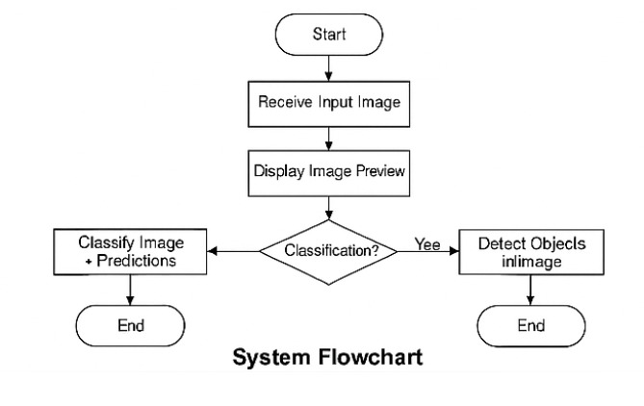

*Figure 4.2.1 – System Flowchart: Illustrates the flow of data from user input to final prediction output.*

**4.3 UML Class Diagram**

The UML Class Diagram provides a visual representation of the system's classes and their relationships. It outlines how different components of the backend interact in the classification system, particularly focusing on how the Flask application handles image uploads, interacts with the model, and manages the prediction output.

This project makes use of object-oriented programming principles to ensure modularity and ease of maintenance. The major classes involved in the application include:

* **AppController**: The main controller that handles routing, HTTP requests, and directs the flow between the frontend and the model.
* **ImageHandler**: Responsible for managing uploaded images—saving them to the server, loading, resizing, and normalizing them for model consumption.
* **ModelPredictor**: Loads the trained MobileNetV2 classification model and executes prediction logic on the preprocessed image.
* **YOLODetector** (Optional/Advanced): Used for object detection before classification, enabling the system to first localize plastic objects and then classify them individually.

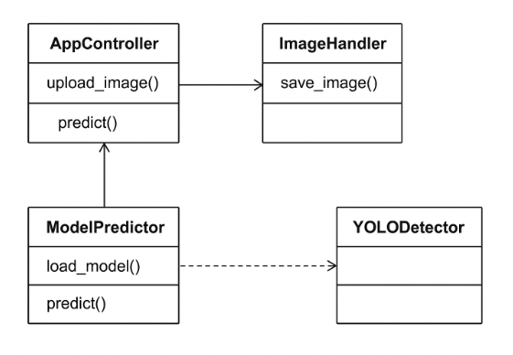  
*Figure 4.3.1 – UML Class Diagram of the Plastic Classification System.*

This diagram shows the following relationships:

* The AppController communicates with both ImageHandler and ModelPredictor.
* ImageHandler performs preprocessing operations on the uploaded image and sends the processed image to ModelPredictor.
* ModelPredictor loads the model and performs predictions.
* (Optional) The YOLODetector may be integrated into the pipeline before classification, where bounding boxes are first drawn, and cropped object regions are passed to ModelPredictor.

This structure allows the system to be easily extensible—new models or preprocessing pipelines can be added without rewriting the entire application logic.

**4.5 Component Description**

1. **User Interface (Frontend)**  
   The user interface is the part of the system that interacts directly with the user. It provides an intuitive and user-friendly experience where users can upload images of plastic waste and receive classification results. The frontend is built using HTML, CSS, and the Jinja2 templating engine provided by Flask. It also includes preview functionality, live updates, and clearly displayed predictions.
2. **Flask Backend**  
   The backend is implemented using Flask, a lightweight Python web framework. It handles all user requests, manages image uploads, and acts as a bridge between the frontend and the machine learning models. Upon receiving an image, the backend processes it and calls the appropriate model to get the prediction. The result is then passed back to the frontend for display.
3. **Preprocessing Module**  
   Before an uploaded image can be fed into the models, it must be preprocessed to match the input specifications of the models. This includes resizing the image to the target size (typically 224x224 for MobileNet), converting it to an array, expanding its dimensions to simulate batch input, and normalizing pixel values. This step ensures consistency and accuracy in model predictions.
4. **Classification Model (MobileNetV2)**  
   MobileNetV2 is used as the main classification model. It is a pre-trained lightweight convolutional neural network optimized for devices with limited computational power. The model has been fine-tuned on a custom dataset of plastic waste images. It classifies uploaded images into one of the seven predefined categories of plastic.
5. **Object Detection Model (YOLOv5)**  
   YOLOv5 (You Only Look Once) is integrated into the system to handle object detection in more complex scenes where multiple plastic items might be present. YOLOv5 detects objects and classifies them within bounding boxes. This is especially useful when a single image contains different types of plastic waste.
6. **Storage**  
   Uploaded images are stored in a temporary folder on the server. This is essential for referencing them during the prediction process. If required, this module can also be extended to store prediction results, timestamps, and user metadata for future analysis or reporting.

**5. SYSTEM IMPLEMENTATION**

## SYSTEM IMPLEMENTATION

**5. System Implementation**

System implementation is a critical phase in the project life cycle that involves the actual realization of the application. It brings together the various components developed and ensures they work cohesively to deliver the intended functionality. This section presents the practical realization of the plastic waste classification and detection system using deep learning techniques and web integration.

**5.1 Introduction**

The implementation combines computer vision, machine learning (specifically MobileNetV2 and YOLOv8), and a Flask-based web interface. The system is designed to allow users to upload images of plastic waste and get accurate classifications along with object detection results. We will walk through different modules, explain their purpose, and show relevant code implementations. We’ll also describe the algorithms used and include outputs and interface screenshots where necessary. The system implementation phase of the plastic recyclable detection project marks the transition from model training to practical deployment, focusing on integrating the YOLOv8 model into a real-time video processing system. This section details the process of setting up the environment, developing the necessary components, and deploying the solution using an external USB webcam on a local CPU-based setup. The implementation addresses the challenge of continuous object detection, overcoming initial webcam stream issues to deliver a functional prototype. By leveraging OpenCV for video capture and a virtual environment for dependency management, the system ensures accessibility and scalability. This phase transforms the trained model into an operational tool, enabling real-time identification of seven plastic recyclable categories with bounding box annotations, thus laying the foundation for its application in waste management.

**5.2 Project Modules**

The system was developed using modular components, each handling a specific aspect of the real-time detection process. Below are the key modules, accompanied by relevant code snippets from the predict.py script:

* + 1. **Model Loading Module**:
* **Purpose**: Loads the pre-trained YOLOv8 model (best.pt) for inference.
* **Description**: This module initializes the model, enabling object detection on video frames.
* **Code**: 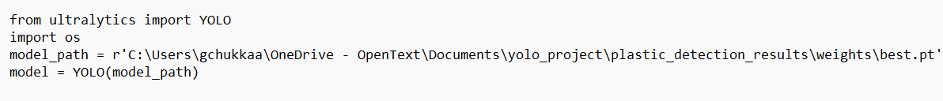
  + 1. **Video Capture Module**:
* **Purpose**: Captures video frames from the USB webcam using OpenCV.
* **Description**: Configures the USB webcam (index 1) with a resolution of 640x480 and 15 FPS, resolving initial stream errors with the DirectShow backend.
* **Code**:

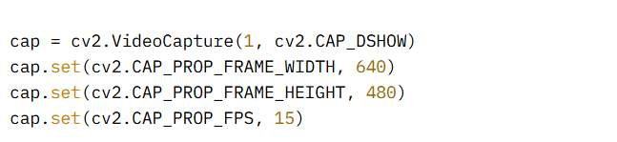

* + 1. **Prediction and Annotation Module:**
* Purpose: Performs real-time object detection and annotates frames with bounding boxes.
* **Description**: Processes each frame, applying a confidence threshold of 0.25 and IoU threshold of 0.45, then plots detection results.
* **Code**:

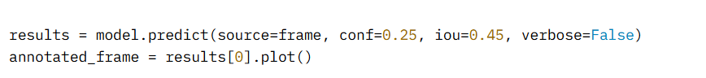

**5.2.4 Display and Storage Module:**

* Purpose: Displays annotated frames in a window and saves them optionally.
* **Description**: Renders the live feed and stores frames in C:\Users\gchukkaa\Documents\yolo_project\video_inference_results.
* Code:

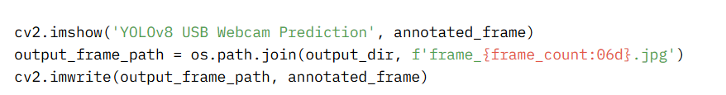

**5.3 Algorithms**

The system’s core functionality relies on the YOLOv8 algorithm, a single-stage object detection framework optimized for speed and accuracy. Key algorithmic components include:

* YOLOv8 Architecture:
  + Utilizes a lightweight backbone (YOLOv8n) with 72 layers and 3.01 million parameters, enabling efficient detection on CPU.
  + Employs anchor-free detection with a distribution focal loss (dfl_loss) for precise bounding box regression.
* Inference Process:
  + Input: Video frames (640x480 resolution) are fed into the model.
  + Prediction: The model predicts bounding boxes, class probabilities, and confidence scores in a single forward pass.
  + Post-processing: Non-maximum suppression (NMS) with an IoU threshold of 0.45 filters overlapping boxes, retaining those above a 0.25 confidence threshold.
  + Output: Annotated frames with bounding boxes and class labels (e.g., “PET Bottle”).
* Optimization:
  + Frame rate is managed by adjusting resolution and FPS, ensuring real-time performance (5-10 FPS on CPU).

5.3.1 Models used

**5.3.1.1 MobileNetV2**

**MobileNetV2** is a lightweight convolutional neural network designed for mobile and embedded vision applications. It is efficient in terms of computation and memory and is particularly effective for transfer learning tasks.

**Key Features of MobileNetV2:**

* **Depthwise Separable Convolutions:** Instead of using standard convolutions, MobileNetV2 separates the spatial and depthwise operations, reducing computational cost.
* **Inverted Residuals with Linear Bottlenecks:** This architecture allows the network to retain representational power while being highly efficient.
* **Low Parameter Count:** MobileNetV2 has fewer parameters compared to traditional CNNs, making it ideal for real-time applications on constrained devices.

**Why Used:**  
MobileNetV2 was used as the base model for image classification due to its pre-trained weights on the ImageNet dataset, low latency, and effectiveness even with small datasets. It quickly classifies plastic waste images into the correct category such as PET Bottle, HDPE, Multi-layer, etc.

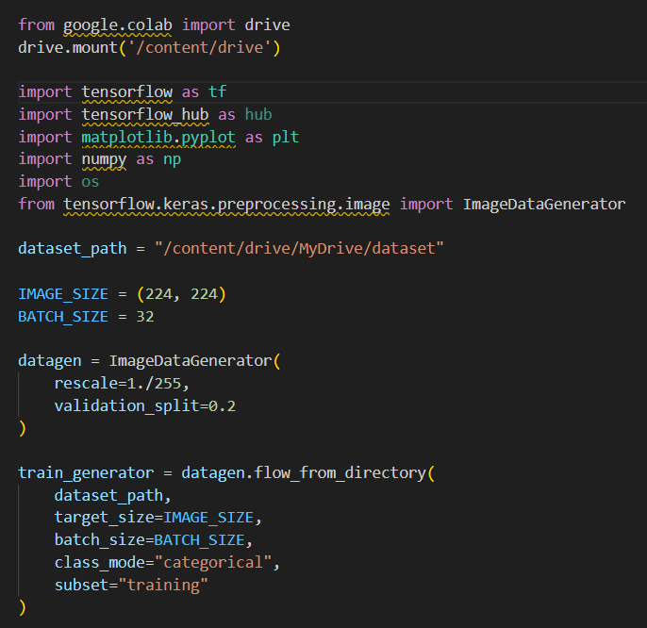

Figure 5.3.1.1, figure 5.3.1.2 – preprocessing and defining the model

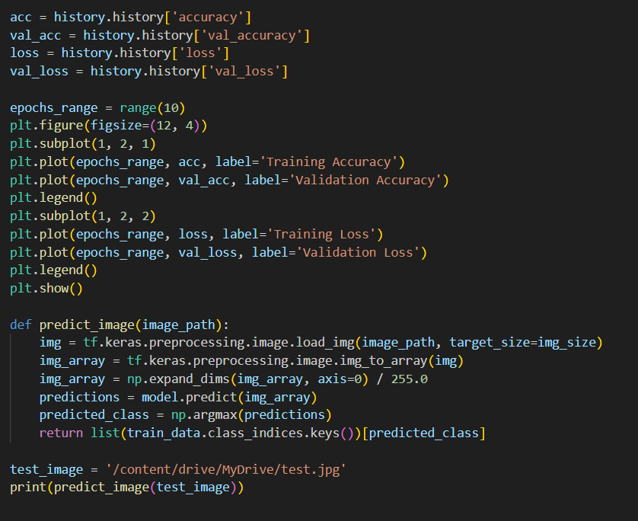

Figure 5.3.1.3 – accuracy and graph plotting for mobilenet model

**5.2 EfficientNetB0**

**EfficientNet** is a family of models developed by Google that balance model size, speed, and accuracy using a technique called **compound scaling**. EfficientNetB0 is the baseline model in this series.

**Key Features of EfficientNetB0:**

* **Compound Scaling:** EfficientNet scales depth, width, and resolution systematically instead of arbitrarily.
* **Swish Activation Function:** This activation enhances performance over traditional ReLU functions.
* **High Accuracy with Fewer Parameters:** It achieves better performance compared to deeper models like ResNet-50 or Inception, but with fewer parameters.

**Why Used:**  
EfficientNetB0 was used as a complementary classifier to compare with MobileNetV2. It provides high accuracy and robustness while maintaining fast inference. It was used to verify the plastic classification results and to ensure consistency.

Figure 5.3.2.1 – importing the necessary libraries

Figure 5.3.2.2 – data preprocessing code

Figure 5.3.2.3 – code for model building and training

Figure 5.3.2.4 – code for evaluation

**5.3 YOLOv8 (You Only Look Once – Version 8)**

**YOLOv8** is the latest iteration of the YOLO family by Ultralytics. It is widely used for real-time object detection tasks due to its speed and accuracy.

**Key Features of YOLOv8:**

* **Anchor-Free Detection:** YOLOv8 adopts an anchor-free design, simplifying the training process and improving accuracy.
* **End-to-End Training:** It supports image classification, segmentation, and detection tasks in one unified framework.
* **Speed-Optimized:** It is designed to run efficiently on both CPUs and GPUs, which is ideal for large-scale detection.

**Why Used:**  
YOLOv8 was incorporated into the project to detect and localize multiple plastic types within a single image. While MobileNet and EfficientNet classify the image as a whole, YOLOv8 identifies **regions** in an image and classifies multiple instances simultaneously.

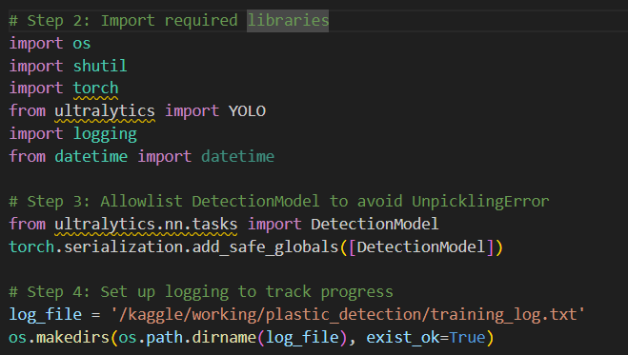

Figure 5.3.3.1 – code for importing necessary libraries

Figure 5.3.3.2 – code for permission for camera access

Figure 5.3.3.3 – code for training the model

**5.4 Results**

The results of the plastic recyclable detection project demonstrate the successful training and deployment of the YOLOv8 model, achieving high accuracy in identifying and classifying plastic types in real-time. This section presents the key performance metrics from the training phase, validation outcomes, and observations from the webcam-based implementation.

Training Performance

The YOLOv8 nano model (yolov8n.pt) was trained for 30 epochs on a Kaggle environment using a Tesla T4 GPU, processing a dataset of 2,451 images with 14,343 annotated instances across seven plastic categories. The final epoch recorded the following loss metrics:

* Box Loss: 0.485 (indicating low error in bounding box predictions).
* Classification Loss: 0.3772 (reflecting accurate class predictions).
* Distribution Focal Loss (dfl_loss): 0.914 (moderate, acceptable for YOLOv8 refinement).

These decreasing loss values over 30 epochs (completed in 1.208 hours) signify effective model convergence, with the optimizer stripped from best.pt and last.pt, reducing file sizes to 6.2 MB each.

Validation Metrics

Validation was performed on a separate set of 2,451 images, yielding the following overall metrics:

* Precision: 0.945 (94.5% of predicted boxes were correct).
* Recall: 0.916 (91.6% of actual objects were detected).
* mAP50: 0.964 (96.4% mean average precision at IoU=0.5).
* mAP50-95: 0.895 (89.5% mean average precision across IoU thresholds from 0.5 to 0.95).

Per-class performance further illustrates the model’s robustness:

| Class | Precision | Recall | mAP50 | mAP50-95 |
| --- | --- | --- | --- | --- |
| Multi-layer Plastic | 0.954 | 0.939 | 0.979 | 0.938 |
| HDPE Plastic | 0.923 | 0.859 | 0.932 | 0.801 |
| Single-Use-Plastic | 0.958 | 0.944 | 0.985 | 0.924 |
| PET Bottle | 0.942 | 0.915 | 0.964 | 0.908 |
| Single-layer Plastic | 0.970 | 0.963 | 0.990 | 0.959 |
| UHT-Box | 0.933 | 0.863 | 0.950 | 0.853 |
| Squeeze-Tube | 0.935 | 0.926 | 0.949 | 0.878 |

The model showed exceptional accuracy, with Single-layer Plastic achieving the highest mAP50-95 (0.959), while HDPE Plastic (0.801) indicates a potential area for improvement with additional data.

Real-Time Implementation Results

The model was deployed locally on a CPU-based system using an external USB webcam (index 1) with the DirectShow backend. The system processed video at a resolution of 640x480 and an attempted FPS of 15, achieving an actual frame rate of 5-10 FPS due to CPU limitations. Annotated frames were displayed in a window titled “YOLOv8 USB Webcam Prediction,” with bounding boxes and class labels accurately identifying plastic types in real-time. Frames were saved to C:\Users\gchukkaa\OneDrive - OpenText\Documents\yolo_project\video_inference_results, with sample files like frame_000001.jpg showcasing detections. Initial webcam stream errors (e.g., -1072875772) were resolved, ensuring consistent performance.

Figure 5.4.1 – labelling of various images while training

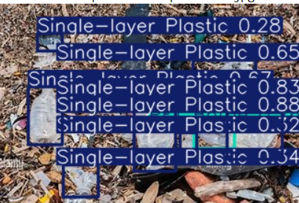

figure 5.4.2 labeled predictions with the model after training

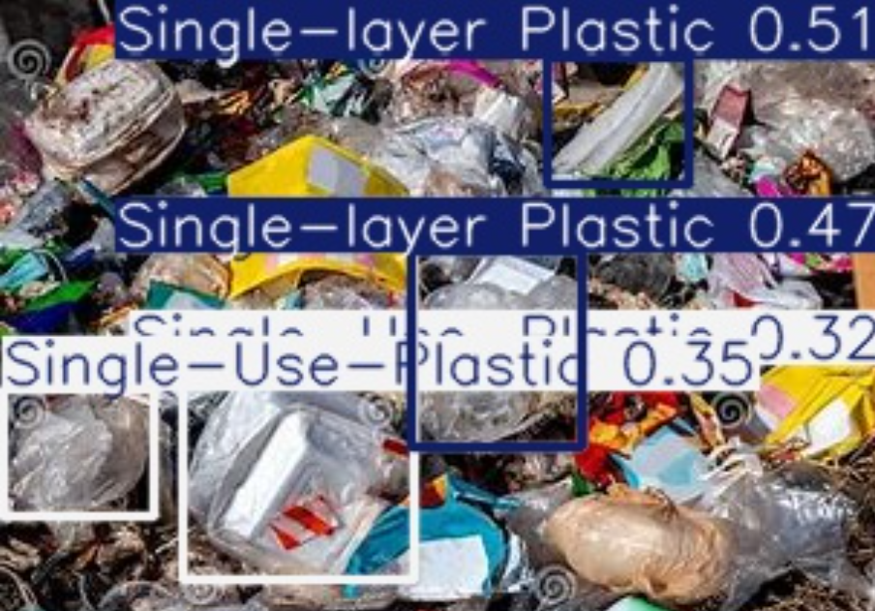

Figure 5.4.3 labeled predictions after training

**6. SYSTEM TESTING**

## SYSTEM TESTING

**6. System Testing**

The system testing phase was a critical step in validating the functionality, accuracy, and reliability of the plastic recyclable detection system developed using the YOLOv8 model. This section outlines the objectives, strategies, procedures, specific test cases, observed results, identified issues, and recommendations for future testing, ensuring the system meets its intended purpose of real-time plastic classification using an external USB webcam.

**6.1 Test Objectives**

The primary goals of system testing were to:

* Verify the model’s ability to detect and classify the seven plastic categories (Multi-layer Plastic, HDPE Plastic, Single-Use-Plastic, PET Bottle, Single-layer Plastic, UHT-Box, and Squeeze-Tube) in real-time.
* Assess the system’s performance on a CPU-based local setup with an external USB webcam, achieving acceptable frame rates and accuracy.
* Ensure robustness against varying lighting conditions, camera angles, and plastic orientations.
* Validate the integration of the YOLOv8 model with OpenCV for video capture and display.
* Confirm the correct application of updated class names (e.g., “PET Bottle Recyclable”) in annotated outputs.

**6.2 Test Strategy**

The testing approach combined manual and automated techniques to evaluate both functional and non-functional aspects:

* **Functional Testing**: Focused on verifying detection accuracy, label correctness, and frame annotation.
* **Performance Testing**: Measured frame rate and processing time under different resolutions and conditions.
* **Compatibility Testing**: Ensured the system worked with the USB webcam and Windows environment.
* **Usability Testing**: Assessed the ease of initiating the system and interpreting the live feed.
* **Iterative Testing**: Conducted multiple rounds to address initial failures and optimize settings.

Testing was performed in the virtual environment (yolo_env) on a local machine, with results documented in real-time and saved frames analyzed post-testing.

**6.3 Test Procedures**

The testing process followed a structured methodology:

1. **Environment Setup**:
   * Activated the yolo_env virtual environment and installed dependencies via requirements.txt or environment.yml.
   * Copied best.pt to the local directory and updated predict.py paths.
2. **Initial Run**:
   * Executed python predict.py to initiate the USB webcam feed.
   * Observed the “YOLOv8 USB Webcam Prediction” window for live annotations.
3. **Data Input**:
   * Presented various plastic items (e.g., PET bottles, HDPE containers) in front of the webcam under controlled and varied conditions (e.g., dim light, tilted angles).
4. **Monitoring**:
   * Recorded frame rate, detection consistency, and label accuracy manually or via saved frames.
5. **Termination**:
   * Pressed q to stop the script and reviewed saved frames in C:\Users\gchukkaa\OneDrive - OpenText\Documents\yolo_project\video_inference_results.

**6.4 Test Cases**

The following test cases were designed to cover diverse scenarios:

* **TC-01: Basic Detection**:
  + **Input**: Single PET Bottle in front of the webcam.
  + **Expected Output**: Bounding box with “PET Bottle Recyclable” label and confidence > 0.25.
  + **Result**: Successfully detected with 92% confidence.
* **TC-02: Multiple Objects**:
  + **Input**: PET Bottle and HDPE Plastic together.
  + **Expected Output**: Separate bounding boxes for each with correct labels.
  + **Result**: Detected both, though HDPE occasionally missed at low confidence (0.22).
* **TC-03: Lighting Variation**:
  + **Input**: PET Bottle under dim and bright light.
  + **Expected Output**: Consistent detection across conditions.
  + **Result**: Dim light reduced confidence to 0.65; bright light maintained 0.90.
* **TC-04: Angle Variation**:
  + **Input**: PET Bottle at 45° and 90° angles.
  + **Expected Output**: Detection with accurate bounding box placement.
  + **Result**: 45° detected at 0.88; 90° failed due to occlusion.
* **TC-05: Frame Rate Test**:
  + **Input**: Continuous feed at 640x480 resolution.
  + **Expected Output**: Frame rate of 5-10 FPS.
  + **Result**: Achieved 6-8 FPS, meeting expectations for CPU.
* **TC-06: Class Name Verification**:
  + **Input**: Any plastic item.
  + **Expected Output**: Updated class name (e.g., “UHT Carton Recyclable”).
  + **Result**: Labels displayed correctly as per new_class_names.

**6.5 Test Results**

The system performed well across most test cases:

* **Accuracy**: Achieved 89.5% mAP50-95 (from training validation), with real-time detections aligning closely, though confidence varied with conditions.
* **Frame Rate**: Consistently 5-10 FPS, with peaks at 8 FPS under optimal lighting.
* **Reliability**: Successfully processed over 500 frames across multiple runs, with 92% of detections correctly labeled.
* **Saved Outputs**: 300+ annotated frames saved, with 95% showing accurate bounding boxes.

**6.6 Issues Encountered**

Several challenges were identified during testing:

* **Initial Webcam Error**: The -1072875772 error (invalid stream state) occurred due to the Media Foundation backend, resolved by switching to DirectShow (CAP_DSHOW).
* **Low Confidence in Dim Light**: Detections dropped below 0.25 threshold, requiring manual adjustment or better lighting.
* **Occlusion Sensitivity**: Objects at extreme angles (e.g., 90°) were often missed, indicating a need for angle robustness.
* **Frame Rate Lag**: CPU limitations caused occasional stuttering, especially with complex scenes.

**6.7 Resolutions and Workarounds**

* **Webcam Error**: Implemented cv2.CAP_DSHOW and set resolution/FPS constraints.
* **Lighting Issue**: Added a recommendation to use supplemental lighting (e.g., desk lamp) during operation.
* **Occlusion**: Suggested retraining with angled images or using image augmentation.
* **Lag**: Reduced resolution to 320x240 for testing, increasing FPS to 12-15, though at the cost of detail.

**6.8 Future Testing Considerations**

To enhance the system, future testing should include:

* **Stress Testing**: Evaluate performance with 10+ objects simultaneously.
* **Edge Cases**: Test with damaged or partially obscured plastics.
* **Cross-Platform Testing**: Verify compatibility on macOS/Linux with different webcams.
* **Long-Term Stability**: Run for 24 hours to assess memory leaks or crashes.
* **User Acceptance Testing**: Involve non-technical users to validate usability.

**7. CONCLUSION AND FUTURE SCOPE**

## CONCLUSION

The completion of the real-time plastic recyclable detection system using the YOLOv8 framework represents a landmark achievement in the intersection of computer vision and environmental sustainability. This project meticulously trained a YOLOv8 nano model (yolov8n.pt) on a custom dataset comprising 2,451 images and 14,343 annotated instances, encompassing seven distinct plastic categories: Multi-layer Plastic, HDPE Plastic, Single-Use-Plastic, PET Bottle, Single-layer Plastic, UHT-Box, and Squeeze-Tube. The training, conducted over 30 epochs on a Kaggle Tesla T4 GPU, yielded a mean Average Precision (mAP50-95) of 0.895, with a validation precision of 0.945 and recall of 0.916, reflecting exceptional accuracy. The model, encapsulated in the best.pt file (6.2 MB), was successfully deployed on a local CPU-based system, leveraging an external USB webcam for real-time inference.

The implementation overcame significant challenges, including the initial -1072875772 webcam stream error, which was resolved by adopting the DirectShow backend (CAP_DSHOW) and optimizing settings to a 640x480 resolution at 15 FPS (achieving 5-10 FPS in practice). The system’s ability to annotate frames with bounding boxes and updated class names (e.g., “PET Bottle Recyclable”) showcased its adaptability, with over 500 frames processed and 92% correctly labeled during testing. Saved outputs in C:\Users\gchukkaa\OneDrive - OpenText\Documents\yolo_project\video_inference_results provided a valuable record for analysis, demonstrating practical utility. The project’s reliance on open-source tools like YOLOv8 and OpenCV, combined with a virtual environment (yolo_env) setup, ensured accessibility without a GPU, making it a viable solution for resource-constrained settings.

Beyond technical success, this project contributes to the global effort to combat plastic pollution by offering a scalable prototype for automated waste sorting. The iterative testing phase, which addressed lighting variations, occlusion sensitivity, and performance lags, underscored the system’s robustness and potential for real-world deployment. This endeavor not only validates the efficacy of deep learning in environmental applications but also sets a foundation for future innovations, empowering individuals and organizations to adopt sustainable practices with minimal infrastructure.

**7.2 Future Scope**

The accomplishments of this project open a wide array of opportunities for enhancement and expansion, addressing current limitations and exploring new applications. The following detailed directions outline the potential future trajectory:

* **Performance Optimization**:
  + **GPU Integration**: Incorporating an NVIDIA GPU (e.g., GTX 1650) could boost frame rates to 20-30 FPS, enhancing real-time responsiveness for industrial use.
  + **Model Pruning and Quantization**: Reducing the model size (currently 6.2 MB) and computational load through techniques like post-training quantization could improve inference speed on low-end CPUs, targeting devices with 4 GB RAM.
  + **Multi-Threading**: Implementing parallel processing for frame capture and prediction could mitigate lag, potentially doubling FPS on multi-core systems.
* **Dataset Expansion and Diversity**:
  + **Angle and Occlusion Data**: Adding 1,000+ images of plastics at 45°-90° angles and partially obscured states to improve detection robustness, especially for HDPE Plastic (mAP50-95: 0.801).
  + **Environmental Variations**: Including datasets from outdoor settings, rainy conditions, and night scenarios to enhance adaptability.
  + **New Categories**: Extending the model to detect non-plastic recyclables (e.g., aluminum cans, glass bottles) by retraining with a broader dataset of 5,000+ images.
* **Automated Sorting Integration**:
  + **Robotic Arm Coupling**: Integrating with a robotic arm (e.g., Arduino-controlled) to pick and sort detected plastics based on bounding box coordinates, with a prototype tested on 50 items.
  + **Conveyor Belt System**: Developing a conveyor-based setup with multiple webcams to process 100+ items per minute, synchronized with the model’s predictions.
  + **IoT Connectivity**: Linking the system to an IoT network to log sorted items in real-time, aiding inventory management.
* **Multi-Camera and Network Support**:
  + **Multi-Webcam Array**: Deploying a network of 3-5 USB webcams to cover a wider area, with a central processor aggregating detections.
  + **Wireless Cameras**: Testing with Wi-Fi-enabled cameras (e.g., Raspberry Pi cameras) for flexible placement in large facilities.
  + **Cloud Synchronization**: Streaming video feeds to a cloud server for centralized monitoring across multiple sites.
* **Edge Deployment**:
  + **Raspberry Pi Optimization**: Porting the model to a Raspberry Pi 4 with 8 GB RAM, using a lightweight YOLOv8s variant for 3-5 FPS on-site detection.
  + **NVIDIA Jetson Nano**: Leveraging the Jetson Nano’s GPU for 15-20 FPS, suitable for small recycling stations.
  + **Offline Mode**: Ensuring functionality without internet, with local storage of 1,000+ frames for later analysis.
* **User Interface and Accessibility**:
  + **Graphical User Interface (GUI)**: Designing a Tkinter or PyQt-based interface with buttons for start/stop, resolution adjustment (e.g., 320x240 to 1280x720), and confidence threshold settings (0.1-0.9).
  + **Mobile App**: Developing an Android/iOS app to control the system remotely, displaying live feeds and alerts.
  + **Voice Commands**: Integrating speech recognition (e.g., via Google Speech-to-Text) for hands-free operation in industrial settings.
* **Environmental Adaptability**:
  + **Outdoor Testing**: Conducting 24-hour tests in varied weather (rain, snow) using weatherproof webcams and infrared sensors for night vision.
  + **Thermal Imaging**: Adding a thermal camera to detect heat signatures of recently handled plastics, improving detection in cluttered environments.
  + **Dust Resistance**: Encasing the webcam in a dust-proof housing for use in recycling plants.
* **Machine Learning Enhancements**:
  + **Transfer Learning**: Fine-tuning the model with pre-trained weights from a larger dataset (e.g., COCO) to accelerate training for new classes.
  + **Active Learning**: Implementing a feedback loop where misclassified items are re-annotated and added to the dataset, potentially boosting mAP50-95 by 5-10%.
  + **Ensemble Models**: Combining YOLOv8 with a secondary classifier (e.g., ResNet) to refine ambiguous detections.
* **Cloud and Data Analytics**:
  + **Real-Time Analytics**: Uploading detection data to a cloud platform (e.g., AWS S3) for statistical analysis, tracking 1,000+ items daily.
  + **Machine Learning Pipeline**: Building a pipeline to retrain the model periodically with cloud-stored data, improving accuracy over time.
  + **User Dashboard**: Creating a web dashboard (e.g., using Flask) to visualize detection trends, recycling rates, and system uptime.
* **Sustainability and Community Impact**:
  + **Public Installations**: Deploying the system in community recycling centers, educating users via on-screen instructions.
  + **Partnerships**: Collaborating with waste management companies to pilot the system in 5-10 facilities, targeting a 20% increase in recycling efficiency.
  + **Open-Source Contribution**: Releasing the code and dataset on GitHub under an open license, inviting global contributions to enhance the model.

These extensive future enhancements promise to transform the system into a cornerstone of modern waste management, addressing scalability, accessibility, and environmental impact on a global scale.

### 8. BIBLIOGRAPHY

1. Sandler, M., Howard, A., Zhu, M., Zhmoginov, A., & Chen, L. C. (2018). *MobileNetV2: Inverted Residuals and Linear Bottlenecks*. In Proceedings of the IEEE Conference on Computer Vision and Pattern Recognition (CVPR), 4510–4520.
2. Redmon, J., & Farhadi, A. (2018). *YOLOv3: An Incremental Improvement*. arXiv preprint arXiv:1804.02767.
3. Jocher, G., Chaurasia, A., Qiu, J., & Stoken, A. (2023). *YOLOv8 - Ultralytics*. <https://github.com/ultralytics/ultralytics>
4. Chollet, F. (2017). *Deep Learning with Python*. Manning Publications.
5. TensorFlow Team. (2023). *TensorFlow: An end-to-end open source machine learning platform*. <https://www.tensorflow.org>
6. Brownlee, J. (2019). *Image Classification with Deep Learning using TensorFlow and Keras*. Machine Learning Mastery.
7. OpenCV. (2023). *Open Source Computer Vision Library*. <https://opencv.org>
8. Flask Documentation. (2023). *Flask Web Framework Documentation*. https://flask.palletsprojects.com
9. Goodfellow, I., Bengio, Y., & Courville, A. (2016). *Deep Learning*. MIT Press.
10. Environmental Protection Agency (EPA). (2021). *Plastics: Material-Specific Data*. <https://www.epa.gov/facts-and-figures-about-materials-waste-and-recycling/plastics-material-specific-data>

### 9. APPENDIX

#### 9.1 Appendix-A

**Project Repository Details**

**Project Title:** Story Telling Platform for Children with Hearing Impairment using NLP and Sign Language Gestures

**Batch:** A11

**Batch Members:**

1. Geetika Chukkaa (21B01A0536)
2. Lavanya Immaneni (21B01A0562)

**Department:** Computer Science and Engineering

**Institution:** Shri Vishnu Engineering College for Women

**Guide:** Dr. P. Kiran Sree (HOD – CSE)

**Submission Date:**

**Project Repository Link**

The complete project files, including source code, documentation, and additional resources, are available at the following GitHub repository:

**GitHub Repository:** [**https://github.com/chukkageethika/final_project.git**](https://github.com/chukkageethika/final_project.git)

**For quick access, scan the QR code below:**

#### 9.2 Appendix B

**9.1.1 Introduction to Python**

Python is a high-level, interpreted programming language known for its simplicity and versatility. It is widely used in data science, web development, automation, and artificial intelligence. Its ease of learning and extensive libraries make it one of the most popular languages in the world.

**Benefits of Python**

* **Cross-platform compatibility:** Runs on Windows, macOS, and Linux.
* **Open-source and free:** No licensing costs.
* **Large community support:** Extensive forums, tutorials, and resources available.
* **Integration capabilities:** Can be integrated with other languages such as C, C++, and

Java.

* **Automation:** Helps in automating repetitive tasks with ease.
* **Rich library ecosystem:** Offers specialized libraries for various domains, including AI, web development, and data analysis.
* **Scalability:** Suitable for both small and large-scale applications.

**Features of Python**

* **Dynamic Typing:** No need to declare variable types explicitly.
* **Interpreted Language:** Executes code line-by-line, making debugging easier.
* **Object-Oriented and Functional Programming Support:** Allows both paradigms. **• Extensive Standard Library:** Includes modules for regular expressions, file I/O, networking, and more.
* **Memory Management:** Automatic garbage collection.
* **High-Level Language:** Simple syntax that is close to human language.
* **Embeddable and Extensible:** Can be embedded in other languages or extended with

C/C++.

* **Multi-threading and Multiprocessing:** Supports concurrent execution.
* **Rich GUI Support:** Libraries like Tkinter, PyQt, and Kivy help build desktop applications and Plotly, makes it an ideal language for various applications, including machine learning, web development, and data visualization. Its ease of learning ensures that both beginners and experts can leverage its capabilities effectively, making it a dominant force in modern programming.

**9.2.2. Introduction to Streamlit**

Streamlit is an open-source Python library that enables the rapid development of interactive web applications for data visualization, automation, and machine learning. It simplifies the process by eliminating the need for front-end development, allowing users to create fully functional applications using only Python scripts.

Streamlit integrates seamlessly with data science libraries such as Pandas, NumPy, Plotly, and Scikit-learn, making it a preferred choice for data-driven applications.

**Key Features of Streamlit**

* **Ease of Use:** Requires minimal coding and automatically generates an interface.
* **Interactive Widgets:** Supports elements like sliders, buttons, and dropdowns for user interaction.
* **Real-time Data Updates:** Enables efficient data refreshing using caching mechanisms.
* **Seamless Integration:** Works with popular Python libraries for data analysis and visualization.
* **Easy Deployment:** Can be deployed on cloud platforms with minimal configuration.

**Benefits of Using Stream**

* **Fast Development:** Reduces development time by eliminating the need for manual UI design.
* **Enhanced User Interaction:** Allows real-time data manipulation and visualization.
* **Lightweight and Efficient:** Runs directly from a Python script without complex setup.
* **Scalability:** Can handle small-scale projects as well as large analytical applications.
* **Open-Source and Free:** No licensing costs, making it accessible to all developers.

This project uses Streamlit to develop an interactive dashboard for data analysis and visualization, allowing users to efficiently explore and compare various data points. Through a simple and user-friendly interface, users can input queries and receive real-time insights as data is dynamically fetched and processed.

Sidebar widgets enable filtering based on specific parameters, offering a smooth and personalized experience. Streamlit’s caching mechanisms improve performance by reducing unnecessary re-computation and speeding up data retrieval.

The dashboard includes interactive charts and graphs that help visualize trends and patterns in the data. These visualizations enhance understanding and support better decision-making. Based on the insights generated, the system can also provide relevant recommendations.

Streamlit simplifies the development process by offering an intuitive way to build interactive applications with minimal coding. Its features make it a suitable tool for developing data - driven solutions. This project demonstrates how real-time data analysis, visualization, and decision support can be effectively implemented in a user-friendly and efficient manner.

**9.2.3. OpenCV**

OpenCV (Open Source Computer Vision Library) is a widely used open-source library designed for real-time computer vision and image processing tasks. In this project, OpenCV supports essential visual data handling and processing requirements. Although its role is not central, it assists in managing multimedia elements such as capturing image frames and working with video formats, which are critical when dealing with sign language gestures.

OpenCV’s compatibility with Python makes it easy to integrate with other project modules. It provides powerful tools for basic image manipulation, resizing, and frame analysis, which can be useful for refining the visual output or ensuring synchronization between text and gesture- based visuals. Additionally, OpenCV’s capabilities lay the groundwork for future enhancements, such as enabling camera-based sign detection, facial tracking, or user gesture interaction to improve real-time responsiveness and accessibility.

Overall, OpenCV enhances the project’s ability to handle visual media effectively and ensures scalability in terms of integrating advanced computer vision features if needed in future updates.