**-**

**1. Introduction**

Regional Transport Office (RTO) is an Indian government bureau which is responsible for the registration of vehicles and issue of Driver’s License in India. RTO management will be having lot of work regarding registration of vehicles and issue of driver’s license. Similarly the vehicle owner sometimes forgets to carry the license, and forgets the insurance at the time of enquiry. This paper proposed an approach to solve such problems that is by storing all the information related to vehicle and driver at database by RTO administrator.

**1.1 Purpose**

Now a day’s population has become a major factor to be considered as a result the number of vehicle’s are growing by increasing problems of vehicle registration, license registration, emission testing and insurance validity for RTO departments and vehicle related documents verification by traffic police. RTO employees having lot of work burden of making registration, license issue, transfer etc., which requires lot of paper work. As a result people can’t get the things done in right time, which is the waste of time and energy. Similarly the vehicle owner sometimes forgets to carry the license, and forgets the insurance at the time of enquiry.

**1.2 Scope**

This application is a service oriented Android application specifically designed for transport department which allows efficiently managing and verifying the documents related to vehicle and license. This project targets to store the information related to vehicle such as insurance, license, emission testing details, personal details of the applier and registration date. This application would be installed in Android phones of traffic police. And it will provide input fields to traffic police to enter the vehicle number as well as license number in order to retrieve the information related to vehicle and license from database. In case of civil police, a web page will be provided where he can update the stolen status of the vehicle to database in order to catch the thief. This application also generates fine and stolen status of vehicle. Hence it is completely service oriented application.

**2. Software Requirement Specification**

**2.1 Overall Description**

Describes the general factors that affect the product and its requirements:

* Performance: Since there is is organized storage of data, accessing is faster.
* Availability: Application can be accessed in any device anywhere through internet.
* Reliability: User can rely upon the data since database is structurely organized and authority for manipulation is provided only to the admin.
* Maintainability: No maintainability overheads are associated since this is webpage

**2.2Specific Requirements**

**2.2.1Software Requirements**

* Web Presentation : HTML, CSS
* Client – side Scripting : JavaScript,php
* Backend Database : My SQL.
* Operating System : Windows.
* Web Server : xampp
* Browser : Chrome/Mozilla

**2.2.2Hardware requirements**

* Pentium processor : 1.1 GHZ
* RAM Capacity : 256 MB (min)
* Hard Disk : 20GB
* Keyboard : Standard keyboard.
* Mouse : Optical
* Monitor : 15’’ Color Monitor

**2.2.3 Functionality**

* The server must respond to the requests immediately.
* Should provide user friendly interface.
* Should verify usernames, passwords

**3. Detailed Design**

The system designed aimed at developing an RTO management system that can be used to keep track of user’s information. Security of the database used in the design was highly taken care. The objective of the design includes:

* Design software that can be used to store different types of user’s information on database.
* Structure a database system that will store all users information.
* Design a query system to retrieve specified user information.
* Design a well formatted output that will present information in a meaningful format.
* Ensure accuracy in the handling of data.

**Data flow diagrams -:** Data Flow Diagram is the logical representation of the data flow of the project. The DFD is drawn using various symbols. It has a source and a destination. The process is represented using circlesand source and destination are represented using squares. The data flow is represented using arrows.One reader can easily get the idea about the project through Data Flow Diagram.

**Symbols used in data flow diagrams:**

3.1 Rectangle:

- Source rectangle, which defines or destination

3.2 Arrow:

-Arrow, which shows dataflow.

3.3 Circle:

-Circle, which represent a process that transforms incoming data

into outgoing flow.

3.4 Open rectangle:

-Open rectangle, which shows a data store.

**3.1 DFD Level 0:**

Below figure 3.1 represents first level DFD shows the main processes within the system.

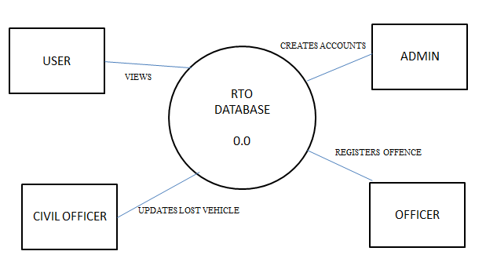

Fig-3.1 DFD level 0

**3.2 DFD Level 1:**

Below figure 3.2 represents the **Level 1 DFD** shows how the system is divided into subsystems

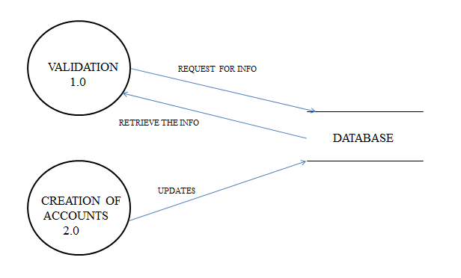

Fig-3.2 DFD level 1

**3.3 DFD Level 2:**

Below figures from 3.1.3 represents Level **2 Data Flow Diagram** of each sub-processes shown in Level 1 **DFD** .

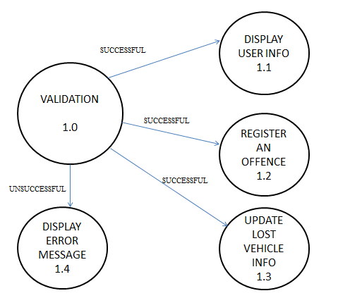

Fig-3.3alevel 2

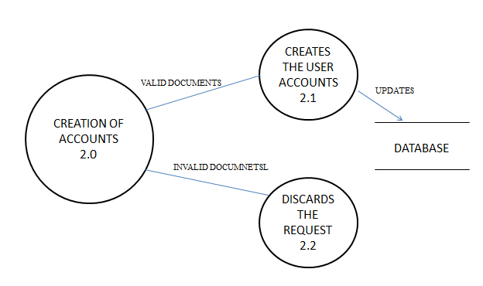

Fig-3.4level 2

**4. ER Diagram**

Any object, for example, entities, attributes of an entity, relationship sets, and attributes of relationship sets, can be represented with the help of an ER diagram.

**4.1 Entity**

Entities are represented by means of rectangles. Rectangles are named with the entity set they represent.

User Admin

Fig-4.1 Entity

**4.2 Attributes**

Attributes are the properties of entities. Attributes are represented by means of ellipses. Every ellipse represents one attribute and is directly connected to its entity (rectangle).

Age

Name

Fig-4.2 Attributes

**Relationship**

Relationships are represented by diamond-shaped box. Name of the relationship is written inside the diamond-box. All the entities (rectangles) participating in a relationship, are connected to it by a line.

Entity

Entity

Relationship

Fig-4.3 Relationship

Figure 4.4 shows an ER model a commonly formed to represent things that a business needs

to remember in order to perform business processes. Consequently, the ER model becomes

an abstract data model that defines a data or information structure that can be implemented in

a database, typically a relational database.

USER_PHONE_INFO

ADMIN

HAS

OFFENCE_LIST

UPDATES

REGISTERS

NOTIFY

VIEWS

LOST_VEH_INFO

ACCOUNTS

USER_INFO

CREATES

PROVIDES

USER

OFFICER

CIVIL_OFFICER

Fig 4.4 ER DIAGRAM

**5. Relational Schema and Normalization**

Splitting data into a number of related tables brings many advantages over a flat file database. These include:

 Data is only stored once.In the previous example, the city data was gathered into one table so now there is only one record per city. The advantages of this are

* No multiple record changes needed
* More efficient storage
* Simple to delete or modify details.
* All records in other tables having a link to that entry will show the change.

 Advantages of a relational database over flat file

* Avoids data duplication
* Avoids inconsistent records
* Easier to change data
* Easier to change data format
* Data can be added and removed easily
* Easier to maintain security.

RELATIONAL SCHEMA: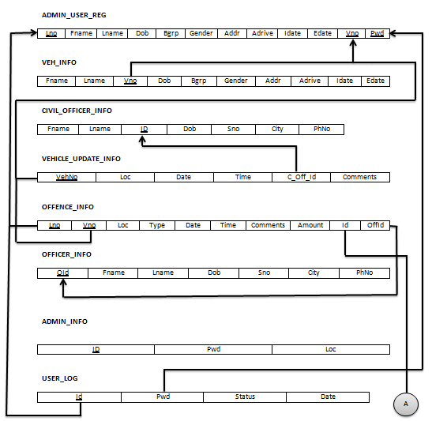

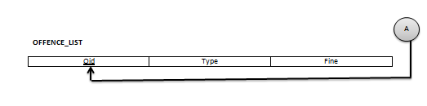

Fig 5.1 .Relational schema

**Normalization of Database**

Database Normalization is a technique of organizing the data in the database. Normalization is a systematic approach of decomposing tables to eliminate data redundancy and undesirable characteristics like Insertion, Update and Deletion Anomalies. It is a multi-step process that puts data into tabular form by removing duplicated data from the relation tables.

Normalization is used for mainly two purpose :

* Eliminating redundant(useless) data.
* Ensuring data dependencies make sense i .e data is logically stored.

**First Normal Form (1NF)**

As per First Normal Form, no two Rows of data must contain repeating group of information i .e each set of column must have a unique value, such that multiple columns cannot be used to fetch the same row. Each table should be organized into rows, and each row should have a primary key that distinguishes it as unique.

The Primary key is usually a single column, but sometimes more than one column can be combined to create a single primary key. For example consider a table which is not in First normal form

**Second Normal Form (2NF)**

As per the Second Normal Form there must not be any partial dependency of any column on primary key. It means that for a table that has concatenated primary key, each column in the table that is not part of the primary key must depend upon the entire concatenated key for its existence. If any column depends only on one part of the concatenated key, then the table fails Second normal form.

**Third Normal Form (3NF)**

Third Normal form applies that every non-prime attribute of table must be dependent on primary key, or we can say that, there should not be the case that a non-prime attribute is determined by another non-prime attribute. So this transitive functional dependency should be removed from the table and also the table must be in Second Normal form.

**Functional Dependency**

Functional dependency (FD) is a set of constraints between two attributes in a relation. Functional dependency says that if two tuples have same values for attributes A1, A2,..., An, then those two tuples must have to have same values for attributes B1, B2, ..., Bn.

Functional dependency is represented by an arrow sign (→) that is, X→Y, where X functionally determines Y. The left-hand side attributes determine the values of attributes on the right-hand side.

**2NF AND 3NF**

**ADMIN_INFO**

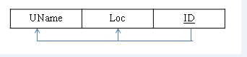

**CIVIL_OFFICER_INFO**

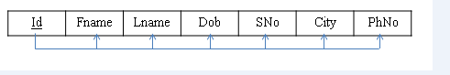

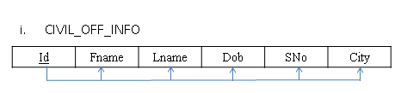

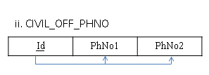

**OFFENCE_INFO**

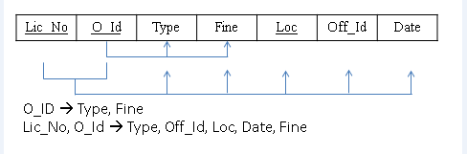

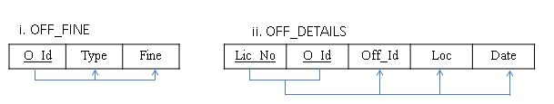

**OFFICER_INFO**

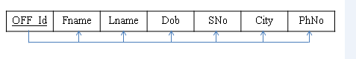

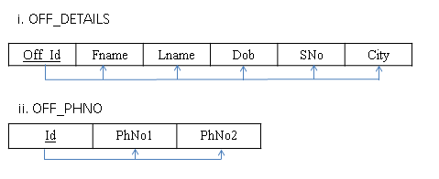

**ADMIN_USER_REG**

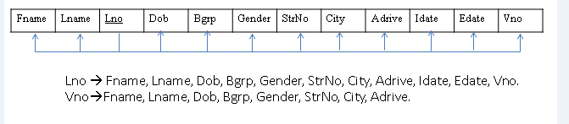

**VEHICLE_UPDATE_INFO**

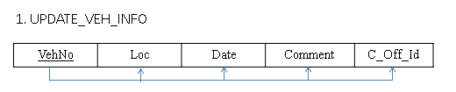

**VEHICLE_INFO**

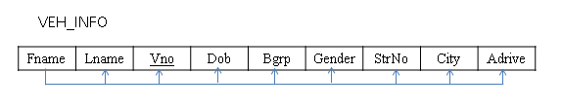

Fig 5.2 .Second and Third normal form

**6. Implementation**

Implementation is the stage in the project where the theoretical design is turned into a working system and is giving confidence on the new system for the users that it will work efficiently and effectively. It involves careful planning, investigation of the current system and its constraints on implementation, design of methods to achieve the changeover, an evaluation of change over methods. Apart from planning major task of preparing the implementation are education and training of users. The implementation process begins with preparing a plan for the implementation of the system. According to this plan, the activities are to be carried out, discussions made regarding the equipment and resources and the additional equipment has to be acquired to implement the new system. In network backup system no additional resources are needed. Implementation is the final and the most important phase. The most critical stage in achieving a successful new system is giving the users confidence that the new system will work and be effective. The system can be implemented only after thorough testing is done and if it is found to be working according to the specification. This method also offers the greatest security since the old system can take over if the errors are found or inability to handle certain type of transactions while using the new system.

**6.1 RDBMS Tables and theirs description**

**6.1 Civil_Officer Table:**It gives the information about the civil officers which are registered by the administrator.

|  |  |
| --- | --- |
| **Name** | **Type** |
| Id | Varchar |
| Fname | Char |
| Lname | Char |
| Dob | Date |
| Addr | Varchar |
| PhNo | Int |

**6.1 Civil_Officer Table**

**6.2 Offence_Info Table**: It gives information about all the offences registered by the admin.

|  |  |
| --- | --- |
| **Name** | **Type** |
| Lno | Varchar |
| Vino | Varchar |
| Loc | Char |
| Type | Varchar |
| Date | Date |
| Time | Int |
| Comments | Varchar |
| Amount | Int |

**6.2 Offence_Info Table**

**6.3 Officer_Info Table:** It gives the information about the officer registered by the administrator.

|  |  |
| --- | --- |
| **Name** | **Type** |
| Oid | Varchar |
| Fname | Char |
| Lname | Char |
| Dob | Date |
| Addr | Varchar |
| PhNo | Int |

**6.3 Officer_Info Table**

**6.4 Admin_User_Reg Table:** This is the table which gives information about all the users who have been registered by the administrator and acts as one of the base table.

|  |  |
| --- | --- |
| **Name** | **Type** |
| Fname | Char |
| Lname | Char |
| Address | Varchar |
| Phone no | Int |
| Bgrp | Char |
| Gender | Char |
| StrNo | Varchar |
| City | Varchar |
| Adrive | Char |
| Idate | Date |
| Edate | Date |
| Vino | Varchar |

**6.4 Admin_User_Reg Table**

**6.5 Vehicle_Update_Info Table:** This is the table which gives information about the lost vehicles and been updated by the civil officer**.**

|  |  |
| --- | --- |
| **Name** | **Type** |
| VehNo | Varchar |
| Loc | Char |
| Date | Date |
| Comment | Varchar |
| C_Off_Id | Varchar |
| Time | Int |

**6.5 Vehicle_Update_Info Table**

**6.6 Vehicle_Info Table:** This is the information of all the vehicles being registered by the administrator.

|  |  |
| --- | --- |
| **Name** | **Type** |
| Fname | Char |
| Lname | Char |
| Vino | Varchar |
| Dob | Date |
| Bgrp | Char |
| Gender | Char |
| StrNo | Varchar |
| City | Varchar |
| Adrive | Char |

6.6 **Vehicle_Info Table**

**6.2 Code Snipets**

**Admin with database connectivity**

|  |  |
| --- | --- |
|  |  |
|  | <!DOCTYPE HTML> |
|  | <html> |
|  |  |
|  | <head> |
|  | <meta http-equiv="Content-Type" content="text/html; charset=UTF-8"> |
|  | <script type="text/javascript" src="common/js/form_init.js" id="form_init_script" |
|  | data-name=""> |
|  | </script> |
|  |  |
|  | <script type="text/javascript"> |
|  | function fun() |
|  | { |
|  |  |
|  | var x=0; |
|  | var res=document.getElementById('fname').value; |
|  | if(res=="") |
|  | { |
|  | document.getElementById('fname').style.borderColor="red"; |
|  | x++; |
|  | //return false; |
|  | } |
|  |  |
|  | res=document.getElementById('lname').value; |
|  | if(res=="") |
|  | { |
|  | document.getElementById('lname').style.borderColor="red"; |
|  | x++; |
|  | //return false; |
|  | } |
|  |  |
|  | res=document.getElementById('avno').value; |
|  | if(res=="") |
|  | { |
|  | document.getElementById('avno').style.borderColor="red"; |
|  | x++; |
|  | //return false; |
|  | } |
|  |  |
|  |  |
|  | res=document.getElementById('lno').value; |
|  | if(res=="") |
|  | { |
|  | document.getElementById('lno').style.borderColor="red"; |
|  | x++; |
|  | //return false; |
|  | } |
|  | res=document.getElementById('dob').value; |
|  | if(res=="") |
|  | { |
|  | document.getElementById('dob').style.borderColor="red"; |
|  | x++; |
|  | //return false; |
|  | } |
|  |  |
|  | res=document.getElementById('bgrp').value; |
|  | if(res=="") |
|  | { |
|  | document.getElementById('bgrp').style.borderColor="red"; |
|  | x++; |
|  | //return false; |
|  | } |
|  |  |
|  | res=document.getElementById('phno').value; |
|  | if(res=="") |
|  | { |
|  | document.getElementById('phno').style.borderColor="red"; |
|  | x++; |
|  | //return false; |
|  | } |
|  |  |
|  | res=document.getElementById('addr').value; |
|  | if(res=="") |
|  | { |
|  | document.getElementById('addr').style.borderColor="red"; |
|  | x++; |
|  | //return false; |
|  | } |
|  | res=document.getElementById('pwd').value; |
|  | if(res=="") |
|  | { |
|  | document.getElementById('pwd').style.borderColor="red"; |
|  | x++; |
|  | //return false; |
|  | } |
|  | res=document.getElementById('photo').value; |
|  | if(res=="") |
|  | { |
|  | document.getElementById('photo').style.borderColor="red"; |
|  | x++; |
|  | } |
|  | res=document.getElementById('tphno').value; |
|  | if(res=="") |
|  | { |
|  | document.getElementById('tphno').style.borderColor="red"; |
|  | x++; |
|  | //return false; |
|  | } |
|  | res=document.getElementById('edate').value; |
|  | if(res=="") |
|  | { |
|  | document.getElementById('edate').style.borderColor="red"; |
|  | x++; |
|  | //return false; |
|  | } |
|  | res=document.getElementById('idate').value; |
|  | if(res=="") |
|  | { |
|  | document.getElementById('idate').style.borderColor="red"; |
|  | x++; |
|  | //return false; |
|  | } |
|  |  |
|  | if(x==0) |
|  | return true; |
|  | return false; |
|  |  |
|  | } |
|  | </script> |
|  |  |
|  |  |
|  |  |
|  |  |
|  |  |
|  | <link rel="stylesheet" type="text/css" href="css/default.css" |
|  | id="theme" /> |
|  | <title> |
|  | </title> |
|  | </head> |
|  |  |
|  | <body><style>#docContainer .fb_cond_applied{ display:none; }</style><noscript><style>#docContainer .fb_cond_applied{ display:inline-block; }</style></noscript><form class="fb-toplabel fb-100-item-column selected-object" id="docContainer" |
|  | action="admin_reg.php" onsubmit="return fun();" enctype="multipart/form-data" method="POST" novalidate="novalidate" |
|  | data-form="preview"> |
|  | <div class="fb-form-header" id="fb-form-header1" style="min-height: 0px;"> |
|  | <a class="fb-link-logo" id="fb-link-logo1" target="_blank"><img title="Alternative text" class="fb-logo" id="fb-logo1" style="display: none;" alt="Alternative text" src="common/images/image_default.png"/></a> |
|  | </div> |
|  | <div class="section" id="section1"> |
|  | <div class="column ui-sortable" id="column1"> |
|  | <div class="fb-item fb-100-item-column" id="item1"> |
|  | <div class="fb-header"> |
|  | <h2 style="display: inline;"> |
|  | User Registration Form |
|  | </h2> |
|  | </div> |
|  | </div> |
|  | <h4 align="right"><a href="<http://localhost/RTO_NEW/Login_form/index.php>">LOGOUT</a></h4><br/><br/> |
|  |  |
|  | <div class="fb-item fb-50-item-column" id="item2"> |
|  | <div class="fb-grouplabel"> |
|  | <label id="item2_label_0" style="display: inline;">First Name</label> |
|  | </div> |
|  | <div class="fb-input-box"> |
|  | <input name="fname" id="fname" requiredtype="text" maxlength="254" |
|  | placeholder="" autocomplete="off" data-hint="" /> |
|  | </div> |
|  | </div> |
|  | <div class="fb-item fb-50-item-column" id="item3"> |
|  | <div class="fb-grouplabel"> |
|  | <label id="item3_label_0" style="display: inline;">Last Name</label> |
|  | </div> |
|  | <div class="fb-input-box"> |
|  | <input name="lname" id="lname" requiredtype="text" maxlength="254" |
|  | placeholder="" autocomplete="off" data-hint="" /> |
|  | </div> |
|  | </div> |
|  | <div class="fb-item fb-66-item-column" id="item4"> |
|  | <div class="fb-grouplabel"> |
|  | <label id="item4_label_0" style="display: inline;">Licence Number</label> |
|  | </div> |
|  | <div class="fb-input-box"> |
|  | <input name="lno" id="lno" requiredtype="text" maxlength="13" |
|  | placeholder="" autocomplete="off" data-hint="" /> |
|  | </div> |
|  | </div> |
|  | <div class="fb-item fb-66-item-column" id="item7" style="opacity: 1;"> |
|  | <div class="fb-grouplabel"> |
|  | <label id="item7_label_0" style="display: inline;">Date of Birth</label> |
|  | </div> |
|  | <div class="fb-input-date"> |
|  | <input name="dob" class="datepicker" id="dob" requiredtype="date" |
|  | data-hint="" /> |
|  | </div> |
|  | </div> |
|  | <div class="fb-item fb-25-item-column" id="item6"> |
|  | <div class="fb-grouplabel"> |
|  | <label id="item6_label_0" style="display: inline;">Blood Group</label> |
|  | </div> |
|  | <div class="fb-input-box"> |
|  | <input name="bgrp" id="bgrp" requiredtype="text" maxlength="3" |
|  | placeholder="" autocomplete="off" data-hint="" /> |
|  | </div> |
|  | </div> |
|  | <div class="fb-item fb-100-item-column fb-two-column" id="item8"> |
|  | <div class="fb-grouplabel"> |
|  | <label id="item8_label_0" style="display: inline;">Gender</label> |
|  | </div> |
|  | <div class="fb-radio"> |
|  | <label id="item8_0_label"><input name="gender" id="gender" requiredtype="radio" data-hint="" value="Female" /><span class="fb-fieldlabel" id="item8_0_span">Female</span></label> |
|  | <label id="item8_1_label"><input name="gender" id="gender" type="radio" value="Male" /><span class="fb-fieldlabel" id="item8_1_span">Male</span></label> |
|  | </div> |
|  | </div> |
|  | <div class="fb-item fb-50-item-column" id="item9"> |
|  | <div class="fb-grouplabel"> |
|  | <label id="item9_label_0">Phone Number</label> |
|  | </div> |
|  | <div class="fb-phone"> |
|  | <input name="phno" id="phno" type="tel" data-hint="" /> |
|  | </div> |
|  | </div> |
|  | <div class="fb-item fb-50-item-column" id="item10"> |
|  | <div class="fb-grouplabel"> |
|  | <label id="item10_label_0" style="display: inline;">Telephone Number</label> |
|  | </div> |
|  | <div class="fb-phone"> |
|  | <input name="tphno" id="tphno" type="varchar" data-hint="" size="10"/> |
|  | </div> |
|  | </div> |
|  | <div class="fb-item fb-100-item-column" id="item11"> |
|  | <div class="fb-grouplabel"> |
|  | <label id="item11_label_0" style="display: inline;">Address</label> |
|  | </div> |
|  | <div class="fb-input-box"> |
|  | <input name="addr" id="addr" requiredtype="text" maxlength="254" |
|  | placeholder="" autocomplete="off" data-hint="" /> |
|  | </div> |
|  | </div> |
|  | <div class="fb-item fb-100-item-column" id="item13"> |
|  | <div class="fb-grouplabel"> |
|  | <label id="item13_label_0" style="display: inline;">Authorised to Drive</label> |
|  | </div> |
|  | <div class="fb-dropdown"> |
|  | <select name="adrive" id="adrive" requireddata-hint=""> |
|  | <option id="item13_0_option" selectedvalue=""> |
|  | Choose one |
|  | </option> |
|  | <option id="adrive" value="Motorcycles with engine capacity of 50 cc or less than 50 cc" type="text"> |
|  | Motorcycles with engine capacity of 50 cc or less than 50 cc |
|  | </option> |
|  | <option id="adrive" value="MC EX50CC (Motorcycle more than 50 cc)" type="text"> |
|  | MC EX50CC (Motorcycle more than 50 cc) |
|  | </option> |
|  | <option id="adrive" value="All Motorcycles types including Motorcycle with gear" type="text"> |
|  | All Motorcycles types including Motorcycle with gear |
|  | </option> |
|  | <option id="adrive" value="Motorcycles of any cc but with no gears - including scooters and mopeds" type="text"> |
|  | Motorcycles of any cc but with no gears - including scooters and mopeds |
|  | </option> |
|  | <option id="adrive" value="Light Motor Vehicle for non transport purposes" type="text"> |
|  | Light Motor Vehicle for non transport purposes |
|  | </option> |
|  | <option id="adrive" value="Light Motor Vehicle intended for commercial purposes " type="text"> |
|  | Light Motor Vehicle intended for commercial purposes |
|  | </option> |
|  | <option id="adrive" value="Heavy Passenger Motor Vehicle" type="text"> |
|  | Heavy Passenger Motor Vehicle |
|  | </option> |
|  | <option id="adrive" value="Heavy Goods Motor Vehicle" type="text"> |
|  | Heavy Goods Motor Vehicle |
|  | </option> |
|  | <option id="adrive" value="Motorcycles of any cc but with no gears - including scooters and mopeds" type="text"> |
|  | Motorcycles of any cc but with no gears - including scooters and mopeds |
|  | </option> |
|  |  |
|  |  |
|  |  |
|  |  |
|  |  |
|  |  |
|  |  |
|  |  |
|  |  |
|  |  |
|  |  |
|  |  |
|  | </select> |
|  | </div> |
|  | </div> |
|  |  |
|  | <div class="fb-item fb-50-item-column" id="item14" style="opacity: 1;"> |
|  | <div class="fb-grouplabel"> |
|  | <label id="item14_label_0" style="display: inline;">Issue Date</label> |
|  | </div> |
|  | <div class="fb-input-date"> |
|  | <input name="idate" class="datepicker" id="idate" type="date" |
|  | data-hint="" /> |
|  | </div> |
|  | </div> |
|  | <div class="fb-item fb-50-item-column" id="item15"> |
|  | <div class="fb-grouplabel"> |
|  | <label id="item15_label_0" style="display: inline;">Expiry Date</label> |
|  | </div> |
|  | <div class="fb-input-date"> |
|  | <input name="edate" class="datepicker" id="edate" type="date" |
|  | data-hint="" /> |
|  | </div> |
|  | </div> |
|  | <div class="fb-item fb-66-item-column" id="item16"> |
|  | <div class="fb-grouplabel"> |
|  | <label id="item16_label_0">Password</label> |
|  | </div> |
|  | <div class="fb-input-box"> |
|  | <input name="pwd" id="pwd" requiredtype="password" |
|  | maxlength="254" placeholder="" autocomplete="off" data-hint="" /> |
|  | </div> |
|  | </div> |
|  | <div class="fb-item fb-66-item-column" id="item17"> |
|  | <div class="fb-grouplabel"> |
|  | <label id="item17_label_0" style="display: inline;">Associated Vehicle Number</label> |
|  | </div> |
|  | <div class="fb-input-box"> |
|  | <input name="avno" id="avno" type="text" maxlength="13" placeholder="" |
|  | autocomplete="off" data-hint="" /> |
|  | </div> |
|  | </div> |
|  | </div> |
|  | </div> |
|  |  |
|  |  |
|  | <div class="fb-captcha fb-item-alignment-center" id="fb-captcha_control" |
|  | style="display: none; cursor: default;"> |
|  |  |
|  | <img src="editordata/images/recaptchawhite.png" /> |
|  | </div> |
|  | <div class="fb-item-alignment-left fb-footer" id="fb-submit-button-div" |
|  | style="min-height: 0px;"> |
|  | <input class="fb-button-special" id="fb-submit-button" type="submit" data-regular="url('images/btn_submit.png')" |
|  | value="Submit" /> |
|  | </div> |
|  | </form> |
|  | </body> |
|  | </html> |

**7. Report**

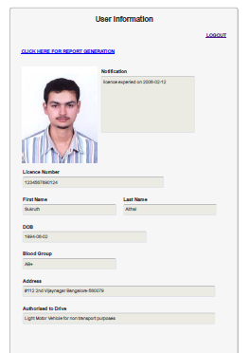

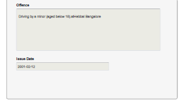

Fig .7.1 Report generation

**Introduction to PHP**

PHP is a [server-side scripting](http://en.wikipedia.org/wiki/Server-side_scripting) language designed for [web development](http://en.wikipedia.org/wiki/Web_development) but also used as a [general-purpose programming language](http://en.wikipedia.org/wiki/General-purpose_programming_language). As of January 2013, PHP was installed on more than 240 million [websites](http://en.wikipedia.org/wiki/Website) (39% of those sampled) and 2.1 million [web servers](http://en.wikipedia.org/wiki/Web_server). Originally created by [RasmusLerdorf](http://en.wikipedia.org/wiki/Rasmus_Lerdorf) in 1995, the [reference implementation](http://en.wikipedia.org/wiki/Reference_implementation) of PHP is now produced by The PHP Group. While PHP originally stood for Personal Home Page, it now stands for PHP: Hypertext Preprocessor, a recursive [backronym](http://en.wikipedia.org/wiki/Backronym).

PHP code is [interpreted](http://en.wikipedia.org/wiki/Interpreter_(computing)) by a web server with a PHP processor module, which generates the resulting web page: PHP commands can be embedded directly into an [HTML](http://en.wikipedia.org/wiki/HTML) source document rather than calling an external file to process data. It has also evolved to include a [command-line interface](http://en.wikipedia.org/wiki/Command-line_interface)capability and can be used in [standalone](http://en.wikipedia.org/wiki/Computer_software) [graphical applications](http://en.wikipedia.org/wiki/Graphical_user_interface).

PHP is [free software](http://en.wikipedia.org/wiki/Free_software) released under the [PHP License](http://en.wikipedia.org/wiki/PHP_License). PHP can be deployed on most web servers and also as a standalone [shell](http://en.wikipedia.org/wiki/Shell_(computing)) on almost every[operating system](http://en.wikipedia.org/wiki/Operating_system) and [platform](http://en.wikipedia.org/wiki/Computing_platform), free of charge

However, as PHP does not need to be embedded in HTML or used with a web server, the simplest version of a Hello World program can be written like this, with the closing tag omitted as preferred in files containing pure PHP code (prior to PHP 5.4.0, this short syntax for echo() only works with the short_open_tag configuration setting enabled):

< ? = 'Hello world';

The PHP interpreter only executes PHP code within its [delimiters](http://en.wikipedia.org/wiki/Delimiter). Anything outside its delimiters is not processed by PHP (although non-PHP text is still subject to [control structures](http://en.wikipedia.org/wiki/Control_structure) described in PHP code). The most common delimiters are <? php to open and ?> to close PHP sections. <script language="php"> and </script> delimiters are also

available as are the shortened forms <? or <?= (which is used to echo back a [string](http://en.wikipedia.org/wiki/String_(computer_science)) or [variable](http://en.wikipedia.org/wiki/Variable_(programming))) and ?> as well as [ASP](http://en.wikipedia.org/wiki/Active_Server_Pages)-style short forms <% or <%= and %>. While short delimiters are used, they make script files less portable as support for them can be disabled in the [PHP configuration](http://wiki.php.net/rfc/shortags), and they are therefore discouraged. The purpose of all these delimiters is to separate PHP code from non-PHP code, including HTML.

The first form of delimiters, <?php and ?>, in [XHTML](http://en.wikipedia.org/wiki/XHTML) and other [XML](http://en.wikipedia.org/wiki/XML) documents, creates correctly formed XML "processing instructions". This means that the resulting mixture of PHP code and other markup in the server-side file is itself well-formed XML.

Variables are prefixed with a [dollar symbol](http://en.wikipedia.org/wiki/Dollar_sign), and a [type](http://en.wikipedia.org/wiki/Primitive_type) does not need to be specified in advance. Unlike function and class names, variable names are case sensitive. Both double-quoted ("") and[heredoc](http://en.wikipedia.org/wiki/Heredoc) strings provide the ability to interpolate a variable's value into the string. PHP treats [newlines](http://en.wikipedia.org/wiki/Newline) as [whitespace](http://en.wikipedia.org/wiki/Whitespace_character) in the manner of a [free-form language](http://en.wikipedia.org/wiki/Free-form_language) (except when inside string quotes), and statements are terminated by a semicolon. PHP has three types of [comment syntax](http://en.wikipedia.org/wiki/Comparison_of_programming_languages_(syntax)#Comments): /* */ marks block and inline comments; // as well as # are used for one-line comments. Theecho statement is one of several facilities PHP provides to output text, e.g., to a web browser.

In terms of keywords and language syntax, PHP is similar to most high level languages that follow the C style syntax. if conditions, for and while loops, and function returns are similar in syntax to languages such as C, C++, C#, Java and Perl.

**phpMAdmin**

phpMyAdmin is an open source tool written in PHP intended to handle the administration of MySQLover the World Wide Web. phpMyAdmin supports a wide range of operations with MySQL.Currently it cancreate and drop databases, create/drop/alter tables, delete/edit/add fields, execute any SQL statement, manageusers and permissions, and manage keys on fields. while you still have the ability to directly execute any SQLstatement. phpMyAdmin can manage a whole MySQL server (needs a super-user) as well as a single database.

To accomplish the latter you’ll need a properly set up MySQL user who can read/write only the desireddatabase. It’s up to you to look up the appropriate part in the MySQL manual.

Hostel Mangement System

Division of computer Engineering, SOE 20

**phpMyAdmin can:**

· browse and drop databases, tables, views, fields and indexes

· create, copy, drop, rename and alter databases, tables, fields and indexes

· maintenance server, databases and tables, with proposals on server configuration

· execute, edit and bookmark any SQL-statement, even batch-queries

· load text files into tables

· create and read dumps of tables

· export data to various formats: CSV, XML, PDF, ISO/IEC 26300 - OpenDocument Text and

Spreadsheet, Word, Excel and LATEX formats

· administer multiple servers

· manage MySQL users and privileges

· check referential integrity in MyISAM tables

· using Query-by-example (QBE), create complex queries automatically connecting required tables

· create PDF graphics of your Database layout

· search globally in a database or a subset of it

· transform stored data into any format using a set of predefined functions, like displaying BLOB

data as image or download-link

· support InnoDB tables and foreign keys

**Introduction to HTML**

HTML or HyperText Markup Language is the main [markup language](http://en.wikipedia.org/wiki/Markup_language) for creating [web pages](http://en.wikipedia.org/wiki/Web_page) and other information that can be displayed in a [web browser](http://en.wikipedia.org/wiki/Web_browser).

HTML is written in the form of [HTML elements](http://en.wikipedia.org/wiki/HTML_element) consisting of tags enclosed in [angle brackets](http://en.wikipedia.org/wiki/Angle_brackets) (like <html>), within the web page content. HTML tags most commonly come in pairs like <h1> and </h1>, although some tags represent empty elements and so are unpaired, for example <img>. The first tag in a pair is the start tag,

and the second tag is the end tag (they are also called opening tags and closing tags). In between these tags web designers can add text, further tags, [comments](http://en.wikipedia.org/wiki/Comment_(computer_programming)) and other types of text-based content.

The purpose of a [web browser](http://en.wikipedia.org/wiki/Web_browser) is to read HTML documents and compose them into visible or audible web pages. The browser does not display the HTML tags, but uses the tags to interpret the content of the page.

HTML elements form the building blocks of all [websites](http://en.wikipedia.org/wiki/Website). HTML allows [images and objects](http://en.wikipedia.org/wiki/Img_(HTML_element)) to be embedded and can be used to create [interactive forms](http://en.wikipedia.org/wiki/Fieldset). It provides a means to create [structured documents](http://en.wikipedia.org/wiki/Structured_document) by denoting structural [semantics](http://en.wikipedia.org/wiki/Semantic) for text such as headings, paragraphs, lists, [links](http://en.wikipedia.org/wiki/Hyperlink), quotes and other items. It can embed [scripts](http://en.wikipedia.org/wiki/Scripting_language) written in languages such as [JavaScript](http://en.wikipedia.org/wiki/JavaScript) which affect the behavior of HTML web pages.

Web browsers can also refer to [Cascading Style Sheets](http://en.wikipedia.org/wiki/Cascading_Style_Sheets) (CSS) to define the look and layout of text and other material. The [W3C](http://en.wikipedia.org/wiki/W3C), maintainer of both the HTML and the CSS standards, encourages the use of CSS over explicit presentational HTML.

Elements

HTML documents imply a structure of nested [HTML elements](http://en.wikipedia.org/wiki/HTML_element). These are indicated in the document by HTML tags, enclosed in angle brackets thus: <p>

In the simple, general case, the extent of an element is indicated by a pair of tags: a 'start tag' <p> and 'end tag' . The text content of the element, if any, is placed between these tags.

Tags may also enclose further tag markup between the start and end, including a mixture of tags and text. This indicates further, nested, elements, as children of the parent element.

The start tag may also include attributes within the tag. These indicate other information, such as identifiers for sections within the document, identifiers used to bind style information to the presentation of the document, and for some tags such as the <img> used to embed images, the reference to the image resource.

Some elements, such as the [line break](http://en.wikipedia.org/wiki/Line_breaking_character) <br>, do not permit any embedded content, either text or further tags. These require only a single empty tag (akin to a start tag) and do not use an end tag.

Many tags, particularly the closing end tag for the very commonly-used paragraph element <p>, are optional. An HTML browser or other agent can infer the closure for the end of an element from the context and the structural rules defined by the HTML standard. These rules are complex and not widely understood by most HTML coders.

The general form of an HTML element is therefore: <tag attribute1="value1" attribute2="value2">content</tag>. Some HTML elements are defined as empty elements and take the form <tag attribute1="value1" attribute2="value2" >. Empty elements may enclose no content, for instance, the BR tag or the inline IMG tag. The name of an HTML element is the name used in the tags. Note that the end tag's name is preceded by a slash character, "/", and that in empty elements the end tag is neither required nor allowed. If attributes are not mentioned, default values are used in each case

**Introduction to MySQL**

MySQL is the world's most popular open source database software, with over 100 million copies of its software downloaded or distributed throughout it's history. With its superior speed, reliability, and ease of use, MySQL has become the preferred choice for Web, Web 2.0, SaaS, ISV, Telecom companies and forward-thinking corporate IT Managers because it eliminates the major problems associated with downtime, maintenance and administration for modern, online applications.

Many of the world's largest and fastest-growing organizations use MySQL to save time and money powering their high-volume Web sites, critical business systems, and packaged software — including industry leaders such as Yahoo!, Alcatel-Lucent, Google, Nokia, YouTube, Wikipedia, and Booking.com.

The flagship MySQL offering is MySQL Enterprise, a comprehensive set of production-tested software, proactive monitoring tools, and premium support services available in an affordable annual subscription.

MySQL is a key part of LAMP (Linux, Apache, MySQL, PHP / Perl / Python), the fast-growing open source enterprise software stack. More and more companies are using LAMP as an alternative to expensive proprietary software stacks because of its lower cost and freedom from platform lock-in.MySQL was originally founded and developed in Sweden by two Swedes and a Finn: David Axmark, Allan Larsson and Michael "Monty" Widenius, who had worked together since the 1980's.

**Interfaces**

MySQL is a [relational database management system](http://en.wikipedia.org/wiki/Relational_database_management_system) (RDBMS), and ships with no [GUI](http://en.wikipedia.org/wiki/Graphical_user_interface) tools to administer MySQL databases or manage data contained within the databases. Users may use the included [command line](http://en.wikipedia.org/wiki/Command_line) tools, or use MySQL "front-ends", desktop software and web applications that create and manage MySQL databases, build database structures, back up data, inspect status, and work with data records. The official set of MySQL front-end tools, [MySQL Workbench](http://en.wikipedia.org/wiki/MySQL_Workbench) is actively developed by Oracle, and is freely available for use.

**Programming**

MySQL works on many [system platforms](http://en.wikipedia.org/wiki/System_platform), including [AIX](http://en.wikipedia.org/wiki/AIX_operating_system), [BSDi](http://en.wikipedia.org/wiki/BSD/OS), [FreeBSD](http://en.wikipedia.org/wiki/FreeBSD), [HP-UX](http://en.wikipedia.org/wiki/HP-UX), [eComStation](http://en.wikipedia.org/wiki/EComStation), [i5/OS](http://en.wikipedia.org/wiki/IBM_i5/OS), [IRIX](http://en.wikipedia.org/wiki/IRIX), [Linux](http://en.wikipedia.org/wiki/Linux), [OS X](http://en.wikipedia.org/wiki/OS_X), [Microsoft Windows](http://en.wikipedia.org/wiki/Microsoft_Windows), [NetBSD](http://en.wikipedia.org/wiki/NetBSD), [Novell NetWare](http://en.wikipedia.org/wiki/Novell_NetWare), [OpenBSD](http://en.wikipedia.org/wiki/OpenBSD),[OpenSolaris](http://en.wikipedia.org/wiki/OpenSolaris), [OS/2](http://en.wikipedia.org/wiki/OS/2) Warp, [QNX](http://en.wikipedia.org/wiki/QNX), [Solaris](http://en.wikipedia.org/wiki/Solaris_(operating_system)), [Symbian](http://en.wikipedia.org/wiki/Symbian), [SunOS](http://en.wikipedia.org/wiki/SunOS), [SCO OpenServer](http://en.wikipedia.org/wiki/SCO_OpenServer), SCO [UnixWare](http://en.wikipedia.org/wiki/UnixWare), [Sanos](http://en.wikipedia.org/wiki/Sanos) and [Tru64](http://en.wikipedia.org/wiki/Tru64). A port of MySQL to [OpenVMS](http://en.wikipedia.org/wiki/OpenVMS) also exists.[[33]](http://en.wikipedia.org/wiki/MySQL#cite_note-34)

MySQL is written in [C](http://en.wikipedia.org/wiki/C_(programming_language)) and [C++](http://en.wikipedia.org/wiki/C%2B%2B). Its SQL parser is written in [yacc](http://en.wikipedia.org/wiki/Yacc), but it uses a home-brewed [lexical analyzer](http://en.wikipedia.org/wiki/Lexical_analysis).[[34]](http://en.wikipedia.org/wiki/MySQL#cite_note-35) Many [programming languages](http://en.wikipedia.org/wiki/Programming_language) with language-specific [APIs](http://en.wikipedia.org/wiki/Application_programming_interface) include[libraries](http://en.wikipedia.org/wiki/Library_(computing)) for accessing MySQL databases. These include MySQL Connector/Net for integration with Microsoft's [Visual Studio](http://en.wikipedia.org/wiki/Visual_Studio) (languages such as [C#](http://en.wikipedia.org/wiki/C_Sharp_(programming_language)) and [VB](http://en.wikipedia.org/wiki/Visual_Basic) are most commonly used) and the JDBC driver for Java. In addition, an [ODBC](http://en.wikipedia.org/wiki/ODBC) interface called [MyODBC](http://en.wikipedia.org/wiki/MyODBC) allows additional programming languages that support the ODBC interface to communicate with a MySQL database, such as [ASP](http://en.wikipedia.org/wiki/Active_Server_Pages) or [ColdFusion](http://en.wikipedia.org/wiki/Adobe_ColdFusion). The [HTSQL](http://en.wikipedia.org/wiki/HTSQL) – [URL](http://en.wikipedia.org/wiki/Uniform_resource_locator)-based query method also ships with a MySQL adapter, allowing direct interaction between a MySQL database and any web client via structured URLs.

**Features**

As of April 2009, MySQL offered MySQL 5.1 in two different variants: the open source MySQL Community Server and the commercial [Enterprise Server](http://en.wikipedia.org/wiki/MySQL_Enterprise). MySQL 5.5 is offered under the same licenses. They have a common code base and include the following features:

A broad subset of [ANSI SQL 99](http://en.wikipedia.org/wiki/SQL:1999), as well as extensionsCross-platform support

[Stored procedures](http://en.wikipedia.org/wiki/Stored_procedure), using a procedural language that closely adheres to [SQL/PSM](http://en.wikipedia.org/wiki/SQL/PSM)

[Triggers](http://en.wikipedia.org/wiki/Database_trigger)[Cursors](http://en.wikipedia.org/wiki/Cursor_(databases))Updatable [views](http://en.wikipedia.org/wiki/View_(SQL))[Information schema](http://en.wikipedia.org/wiki/Information_schema)

Strict mode (ensures MySQL does not truncate or otherwise modify data to conform to an underlying data type, when an incompatible value is inserted into that type)

[X/Open XA](http://en.wikipedia.org/wiki/X/Open_XA) [distributed transaction processing](http://en.wikipedia.org/wiki/Distributed_transaction_processing) (DTP) support; [two phase commit](http://en.wikipedia.org/wiki/Two-phase-commit_protocol) as part of this, using Oracle's [Inno DB](http://en.wikipedia.org/wiki/InnoDB) engine Independent [storage engines](http://en.wikipedia.org/wiki/Storage_engine) ([MyISAM](http://en.wikipedia.org/wiki/MyISAM) for read speed, InnoDB for transactions and [referential integrity](http://en.wikipedia.org/wiki/Referential_integrity), [MySQL Archive](http://en.wikipedia.org/wiki/MySQL_Archive) for storing historical data in little space) Transactions with the InnoDB and [NDB Cluster](http://en.wikipedia.org/wiki/NDB_Cluster) storage engines; [savepoints](http://en.wikipedia.org/wiki/Savepoint) with InnoDB

[SSL](http://en.wikipedia.org/wiki/Secure_Sockets_Layer) support ,Query [caching](http://en.wikipedia.org/wiki/Cache_(computing)) Sub-[SELECTs](http://en.wikipedia.org/wiki/Select_(SQL)) (i.e. nested SELECTs) [Replication](http://en.wikipedia.org/wiki/Database_replication) support (i.e. Master-Master Replication & Master-Slave Replication) with one master per slave, many slaves per master. [Multi-master replication](http://en.wikipedia.org/wiki/Multi-master_replication) is provided in [MySQL Cluster](http://en.wikipedia.org/wiki/MySQL_Cluster), and multi-master support can be added to unclustered configurations using Galera Cluster.

Full-text [indexing](http://en.wikipedia.org/wiki/Index_(database)) and searching (initially a My ISAM-only feature; supported by Inno DB since the release of MySQL 5.6) Embedded database library [Unicode](http://en.wikipedia.org/wiki/Unicode) support (however prior to 5.5.3 [UTF-8](http://en.wikipedia.org/wiki/UTF-8) and [UCS-2](http://en.wikipedia.org/wiki/UTF-16/UCS-2) encoded strings are limited to the [BMP](http://en.wikipedia.org/wiki/Basic_Multilingual_Plane), in 5.5.3 and later use utf8mb4 for full unicode support) [ACID](http://en.wikipedia.org/wiki/Atomicity,_consistency,_isolation,_durability) compliance when using transaction capable storage engines (InnoDB and Cluster) Partitioned tables with pruning of partitions in optimizer [Shared-nothing](http://en.wikipedia.org/wiki/Shared-nothing) clustering through [MySQL Cluster](http://en.wikipedia.org/wiki/MySQL_Cluster) ,Multiple storage engines, allowing one to choose the one that is most effective for each table in the application (in MySQL 5.0, storage engines must be compiled in MySQL

.

**8. Conclusion and Future Enhancement**

To conclude the description about the project : The project, developed using PHP and MySQL isbased on the requirement specification of the user and the analysis of the existing system, with flexibility forfuture enhancement.

The expanded functionality of today’s software requires an appropriate approach towards softwaredevelopment.

It can be concluded that “Cross Verification of Driver and License for RTO”, effectively verifies documents related to vehicle and license. This system introduces facility for RTO officers to perform verification of license and vehicle documents. It also helps the RTO officials to maintain records systematically and reduces a lot of paper work and manual efforts. Hence drivers are totally independent of vehicle related documents. The driver’s data will be fetched from RTO server.

* The application can be enhanced with the concept of Face Recognition and Number Plate Recognition through image/camera.
* The application can be enhanced to send message to the drivers about the expiry dates of documents.
* It is a practical project, later it can dispatch the project in Real-time Environment.
* This paper can enhance the application by linking it to the Adhar Card database in order to retrieve more details of the license/vehicle owner.
* Identification of the drawbacks of the existing system leads to the designing of computerized systemthat will be compatible to the existing system with the system which is more user friendly and more GUIoriented.

**9. References**

[1] http://www.kassoftindia.com/Product/GeniusAcademic/poultrymgnt.htm [accessed September 24, 2012]

[2] Hampton, David R. 1977. Contemporary Management, McGraw-Hill Series in Management.

[3] http://www.educationmanagementsoftware.com [accessed June 15, 2011]

[4]<http://nptel.iitm.ac.in/courses/Webcourse>contents/IIScBANG/System%20Analysis%20and%20Design/pdf/Lecture_Notes/L Nm5.pdf [accessed June 20, 2012]

[5] http://www.bbnisys.com/images/eschool.pdf [accessed October 10, 2012].

[6] Poultry Farm Management Software by Initio (2010).

[7] Loventis Booking System by Loventis Systems (2005).

[8] Indocon Poultry Management Software by Indocon Micro Engineers Limited**.**

**10. Appendix**

**Home page:**

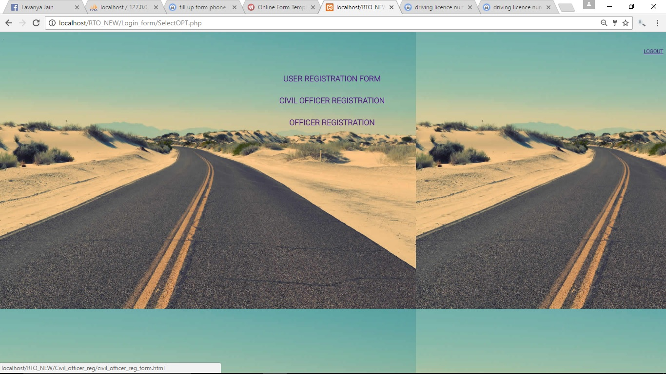

**Fig A1: Home page**

**Login page:**

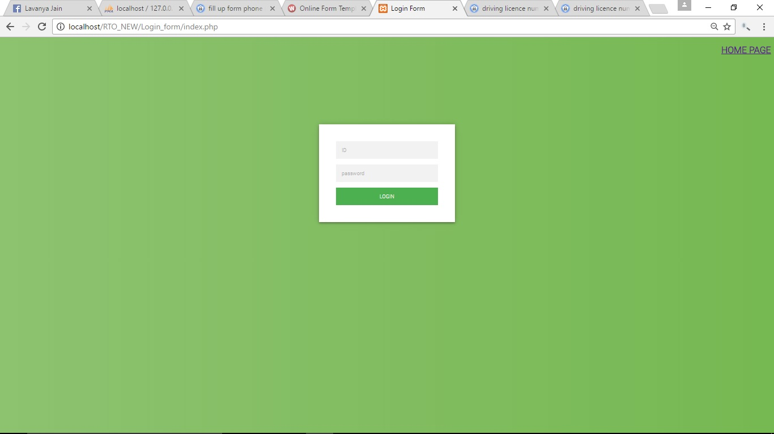

**Fig A2: Login page**

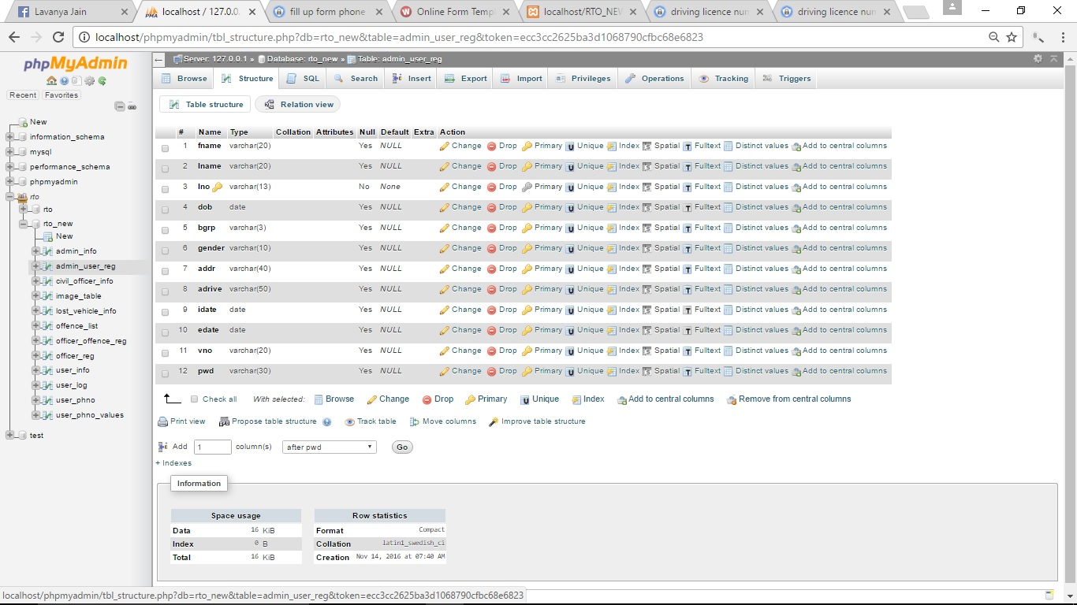

**Fig A3**: **Admin_user_reg**

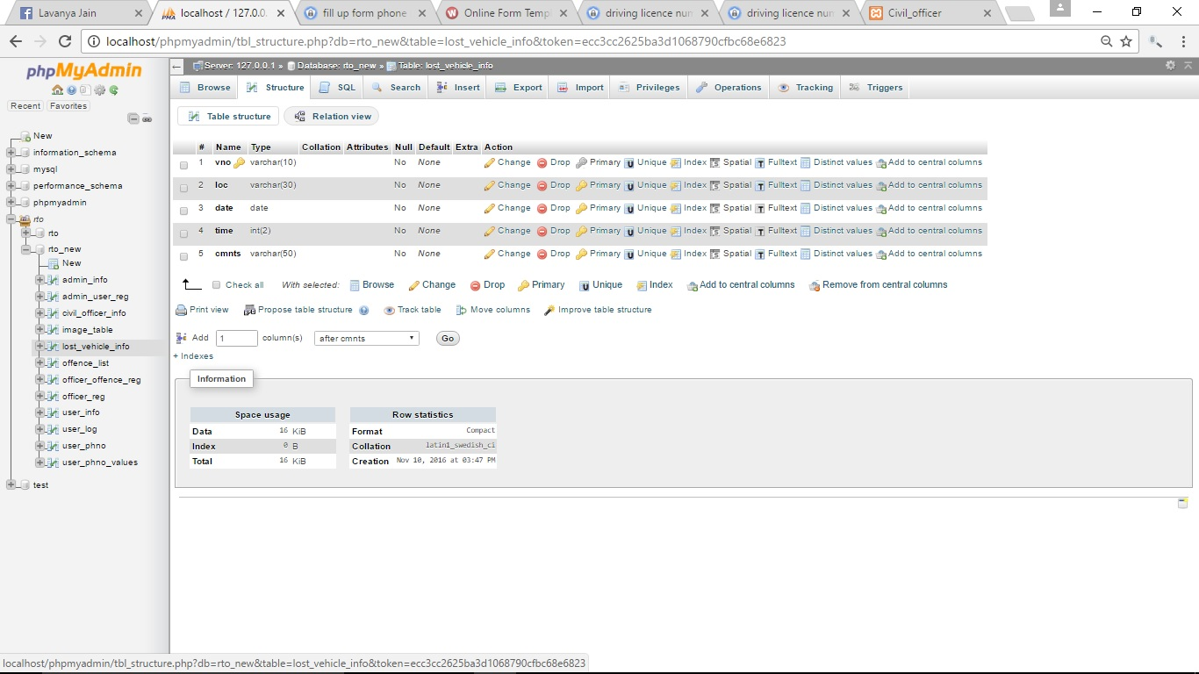

**Fig A4: Lost_vehicle**

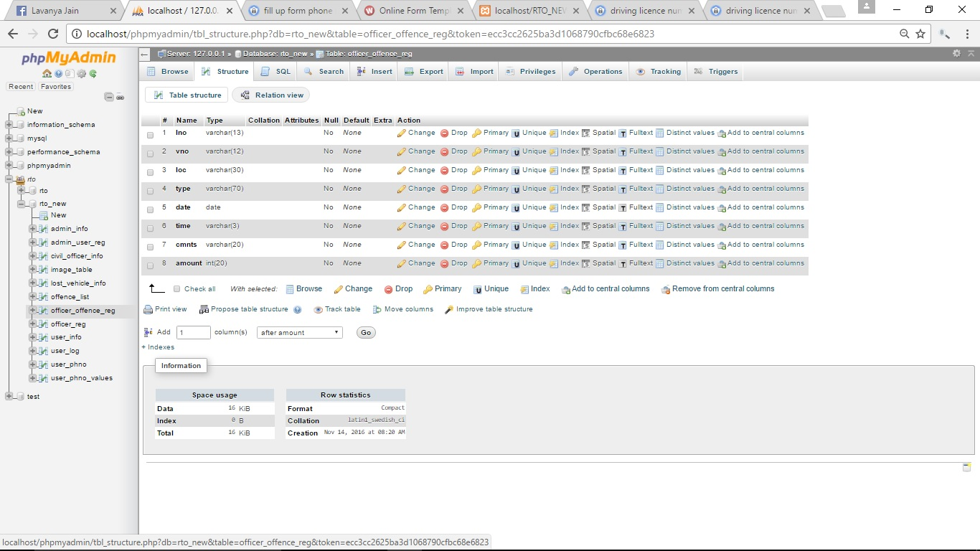

**Fig A5: Offence_reg**

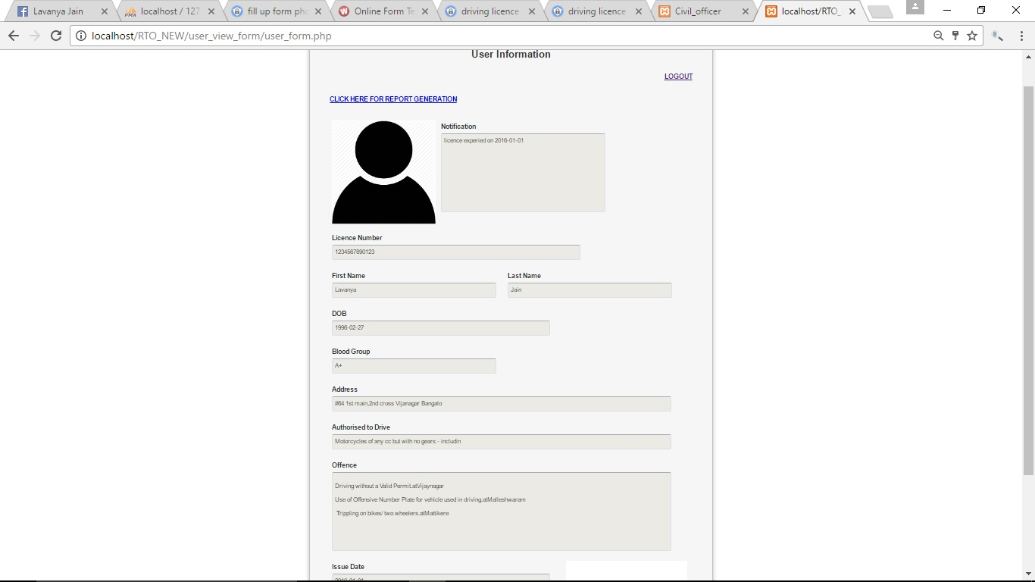

**Fig A6: User_report**