SKILL 5
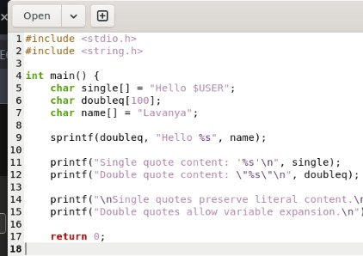
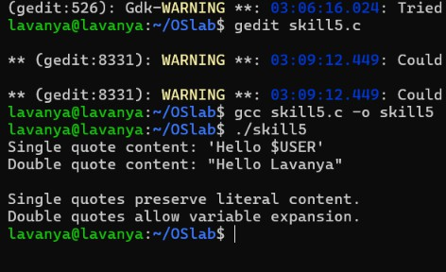
#include <stdio.h> #include <string.h>

int main() {
char single[] = "Hello $USER"; char doubleq[100];
char name[] = "Lavanya";

sprintf(doubleq, "Hello %s", name);

printf("Single quote content: '%s'\n", single); printf("Double quote content: \"%s\"\n", doubleq);

printf("\nSingle quotes preserve literal content.\n"); printf("Double quotes allow variable expansion.\n");

return 0;
}

