Skill6
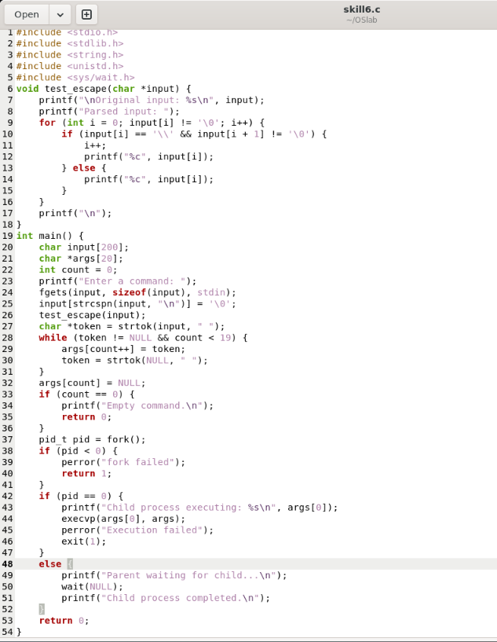

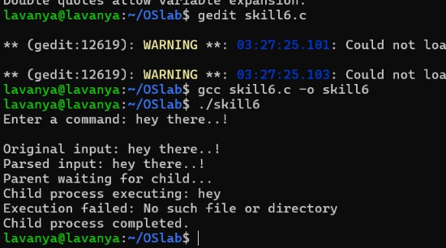

#include <stdio.h> #include <stdlib.h> #include <string.h> #include <unistd.h> #include
<sys/wait.h>

void test_escape(char *input) { printf("\nOriginal input: %s\n", input);

printf("Parsed input: ");

for (int i = 0; input[i] != '\0'; i++) {
if (input[i] == '\\' && input[i + 1] != '\0') { i++;
printf("%c", input[i]);
} else {
printf("%c", input[i]);
}
}

printf("\n");

}

int main() { char input[200]; char *args[20]; int count = 0;

printf("Enter a command: "); fgets(input, sizeof(input), stdin);

input[strcspn(input, "\n")] = '\0';

/* Test escape sequences */ test_escape(input);

/* Tokenize command */
char *token = strtok(input, " "); while (token != NULL && count < 19) {
args[count++] = token; token = strtok(NULL, " ");
}
args[count] = NULL; if (count == 0) {
printf("Empty command.\n"); return 0;
}

/* Create child process */ pid_t pid = fork();

if (pid < 0) { perror("fork failed"); return 1;
}

if (pid == 0) {
/* Child process */
printf("Child process executing: %s\n", args[0]); execvp(args[0], args);
/* If execvp fails */ perror("Execution failed"); exit(1);
}
else {
/* Parent process */
printf("Parent waiting for child...\n");

wait(NULL);

printf("Child process completed.\n");
}

return 0;

}

