Practical-9
1.
Code:-
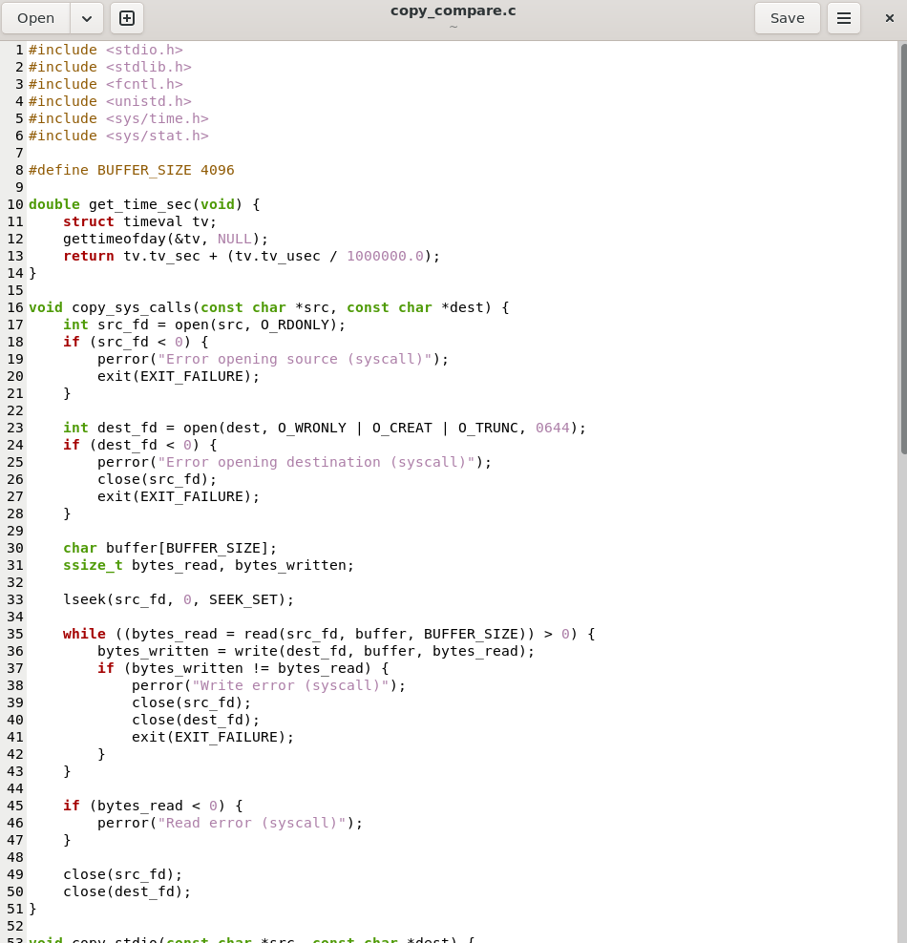

Output:-
- Compile with optimization:
- Create a test file (100 MB dummy binary):
- Execute the compiled binary:
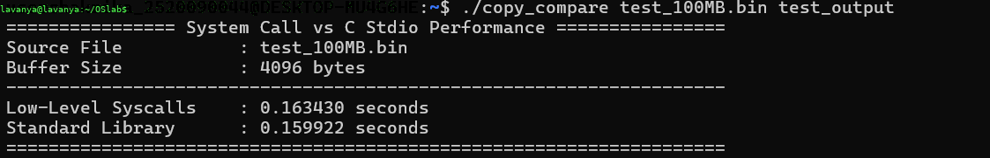
- Verify both outputs match the source exactly:

2.
Code:-
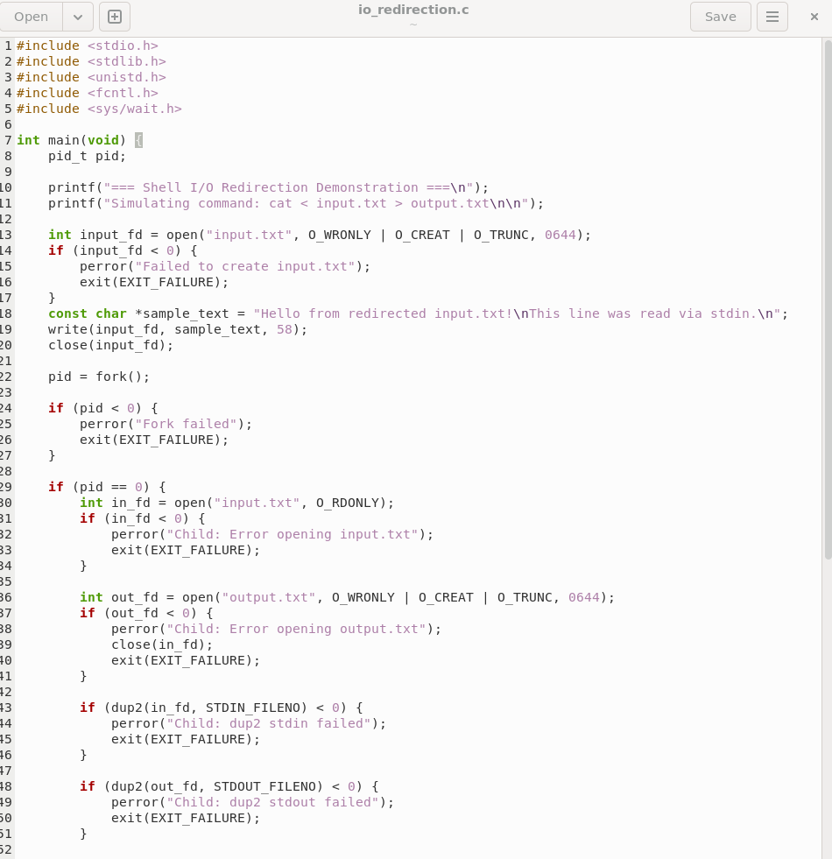

Output:-
