SKILL(Week-4):-
Name: Lavanya
Roll No: 2520090009
- CREATE CUSTOMER TABLE
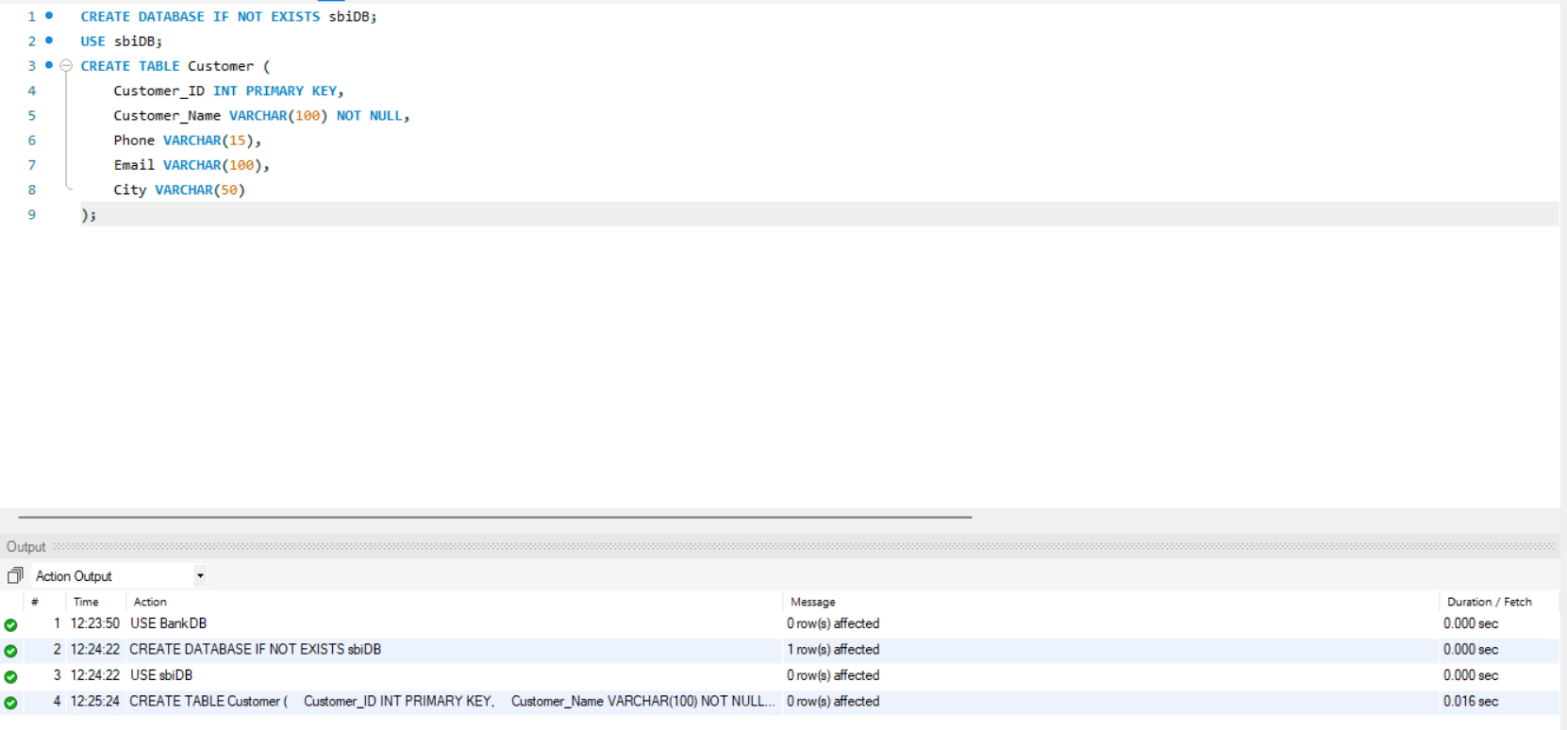
- CREATE ACCOUNT TABLE
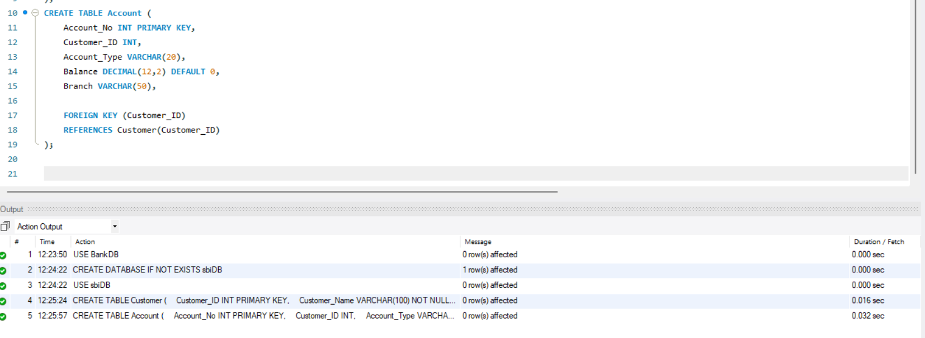
- CREATE TRANSACTION TABLE
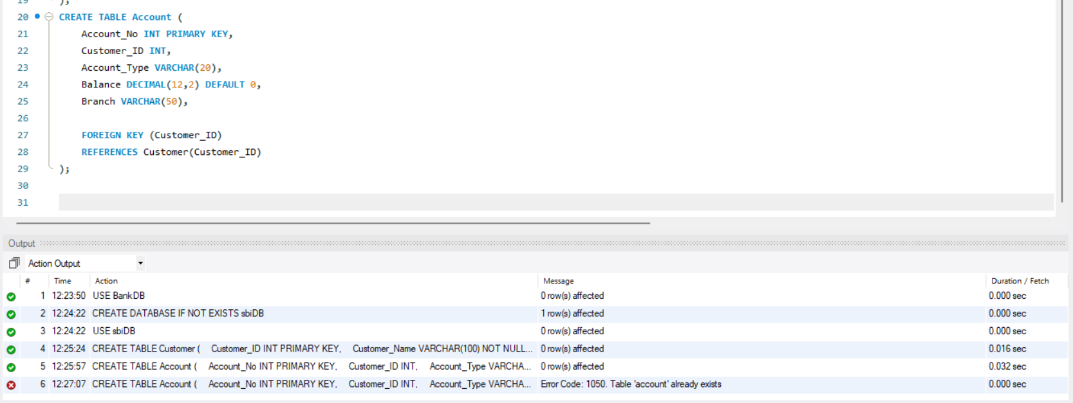
- CREATE TRANSACTION TABLE
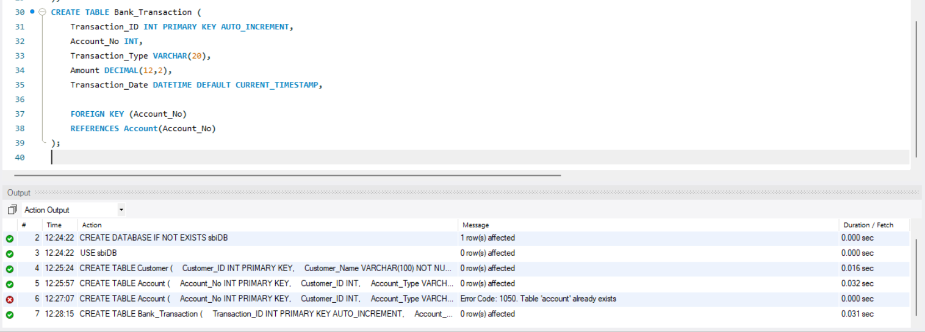
- CREATE LOAN TABLE
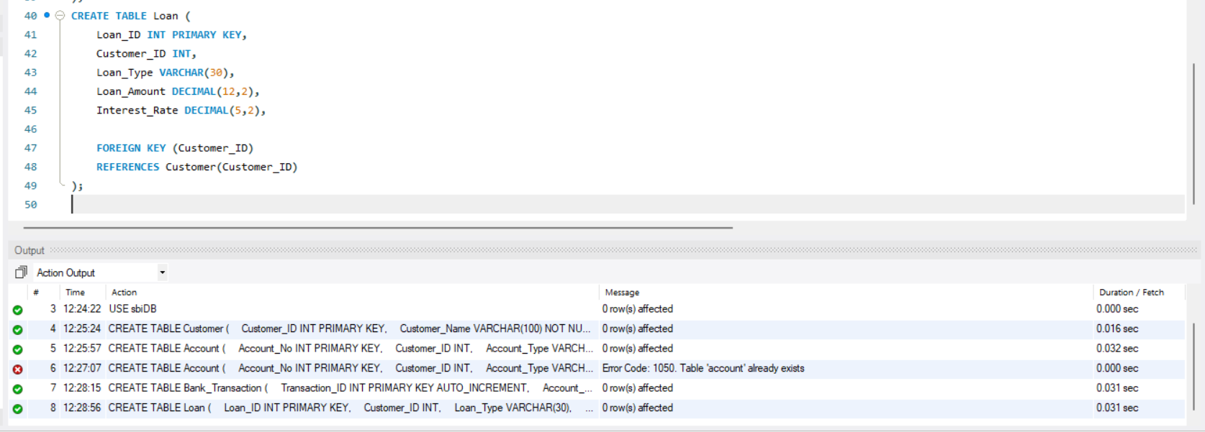
- INSERT CUSTOMER DATA

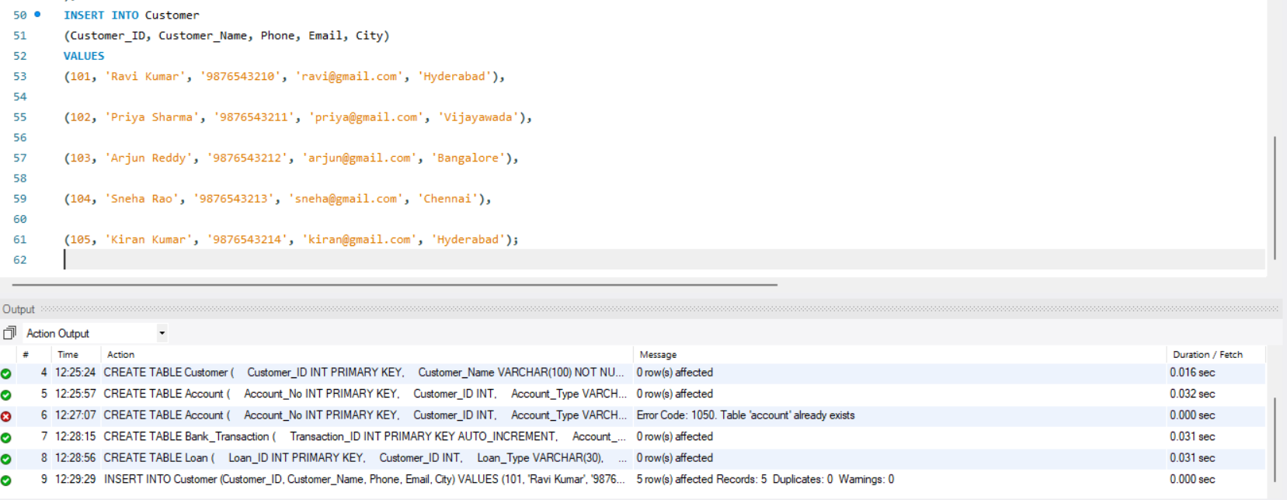
- INSERT ACCOUNT DATA
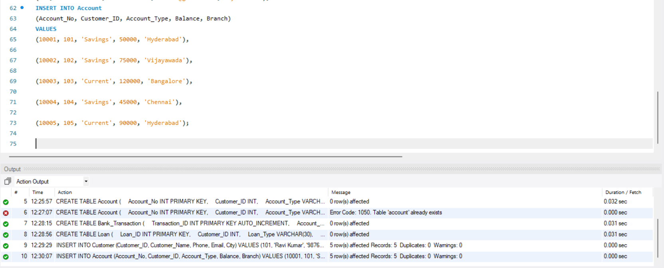
- INSERT TRANSACTION DATA
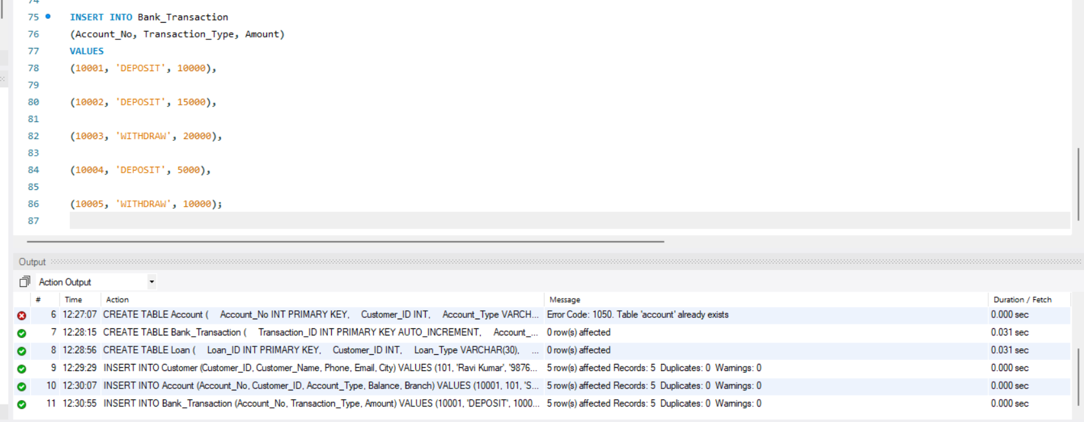
- INSERT LOAN DATA
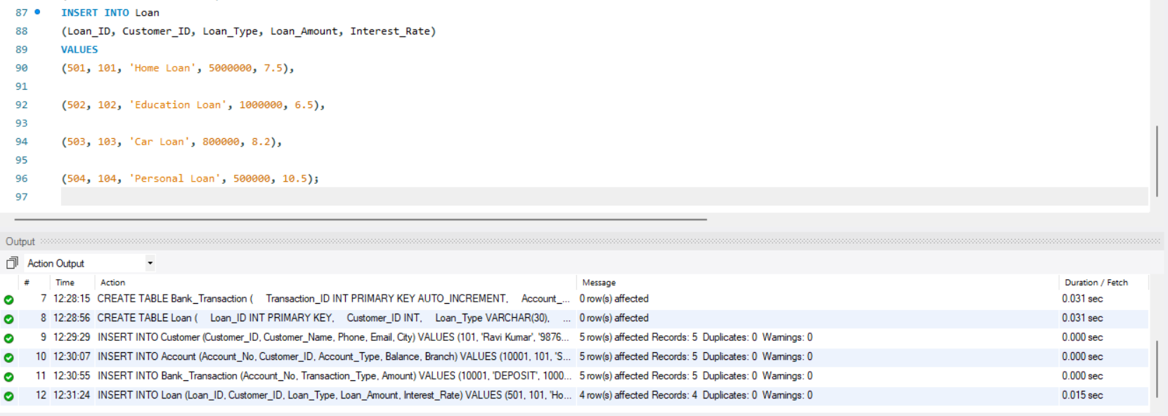
- DISPLAY TABLE DATA
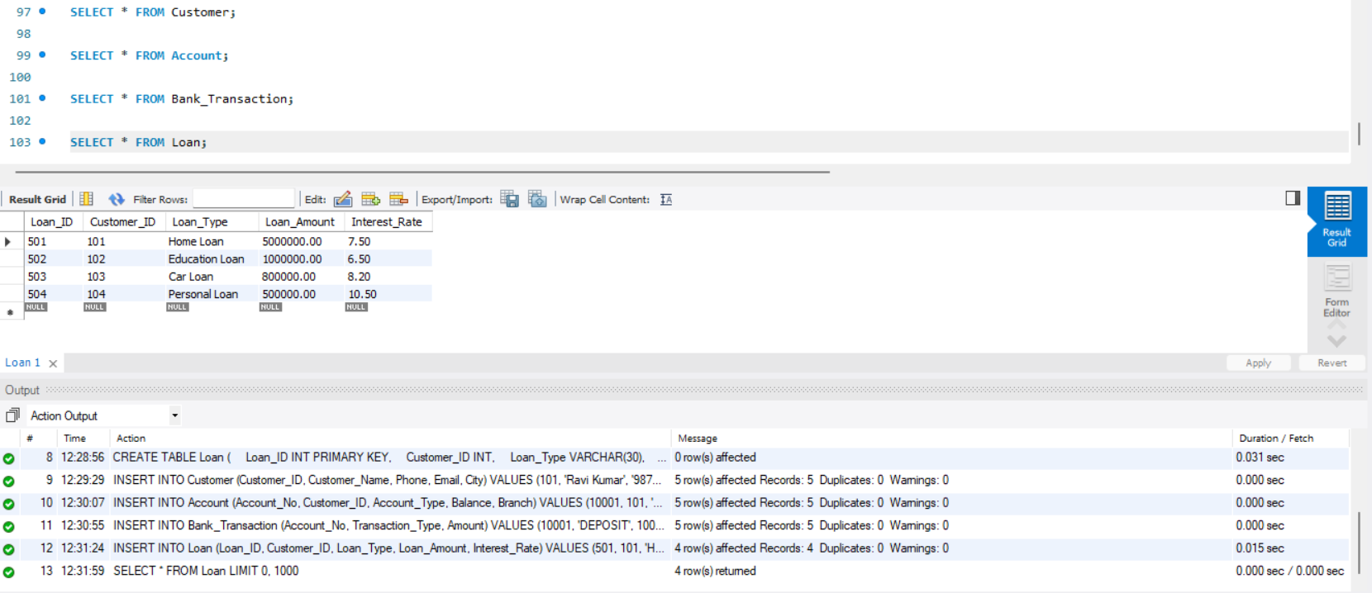
- PROCEDURE TO DISPLAY ALL CUSTOMERS
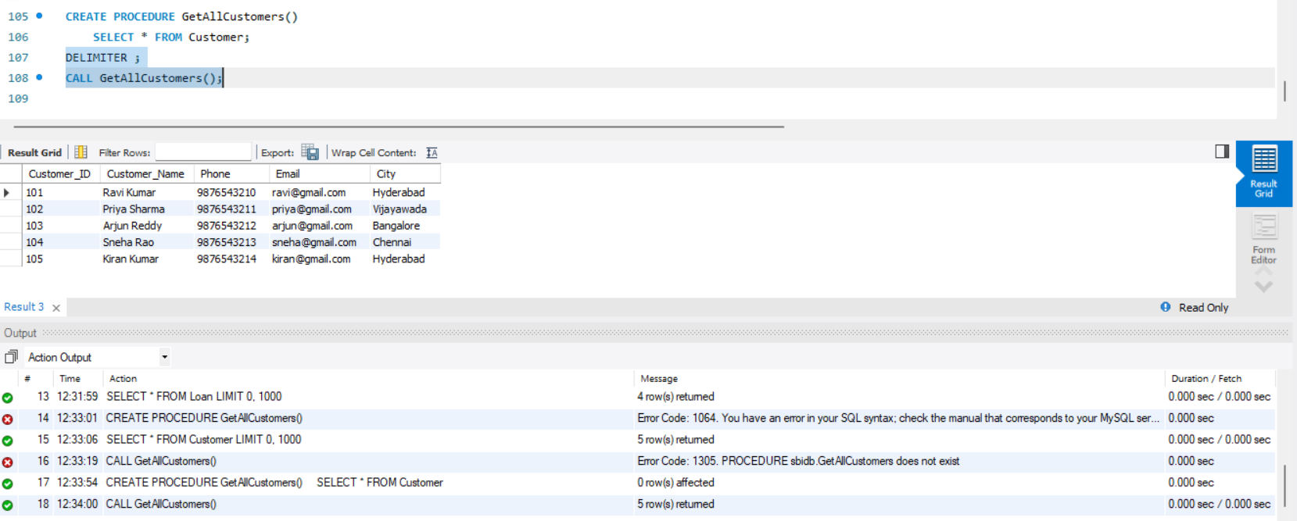
- PROCEDURE TO DISPLAY ACCOUNT DETAILS FOR A GIVEN ACCOUNT NUMBER
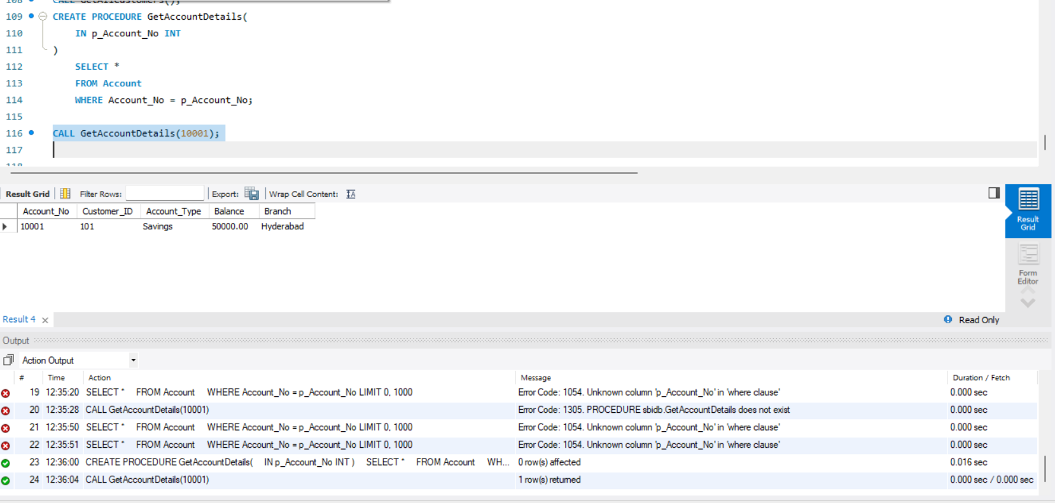
- PROCEDURE TO FIND CUSTOMER ACCOUNTS
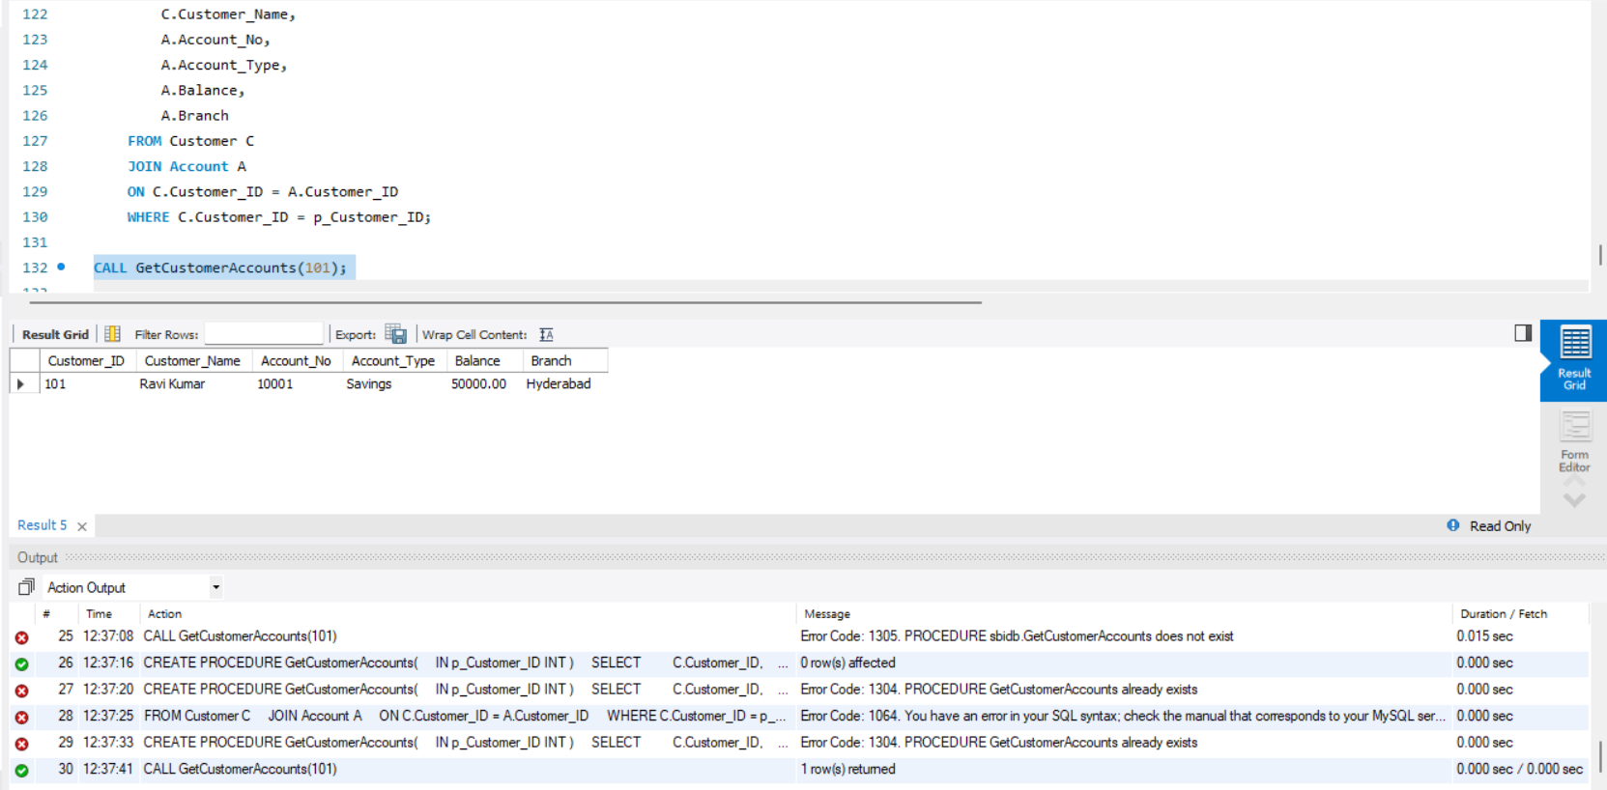
- PROCEDURE TO DEPOSIT MONEY
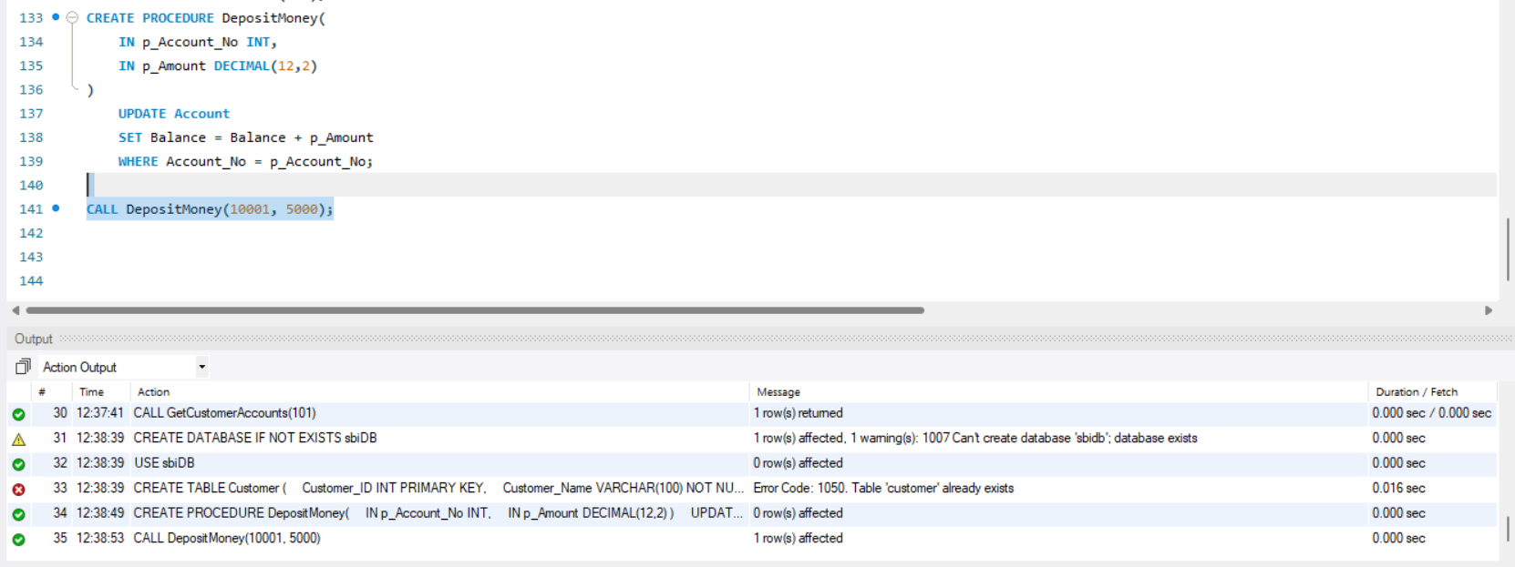
- PROCEDURE TO WITHDRAW MONEY
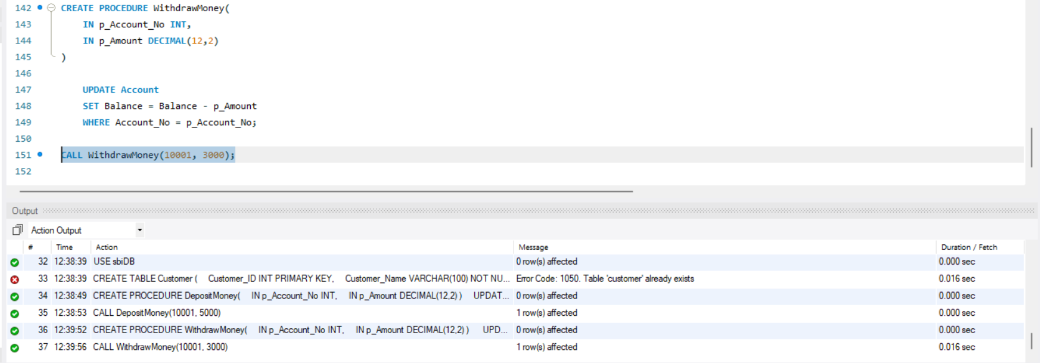
- TRIGGER – PREVENT NEGATIVE BALANCE
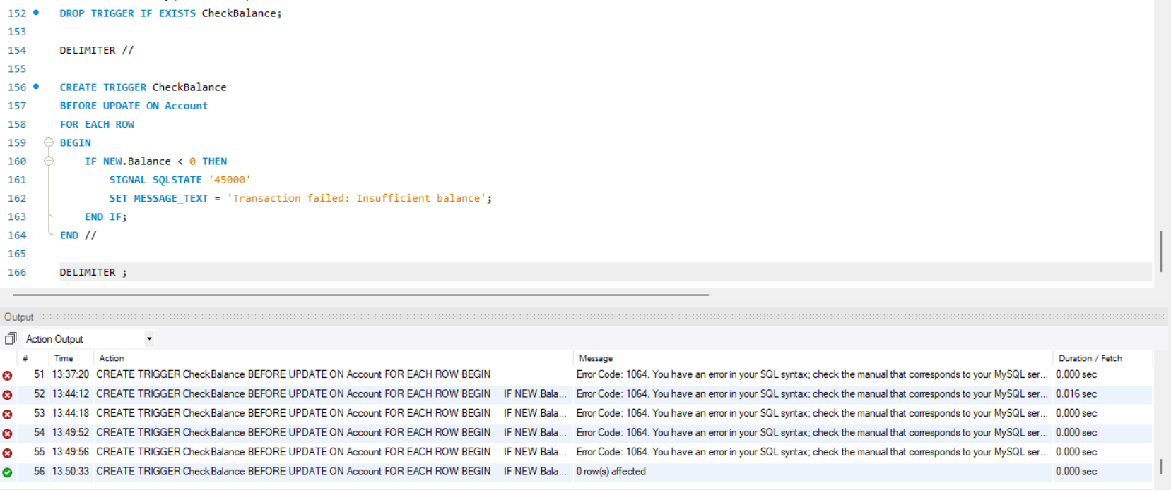
- TRIGGER – PREVENT NEGATIVE DEPOSIT
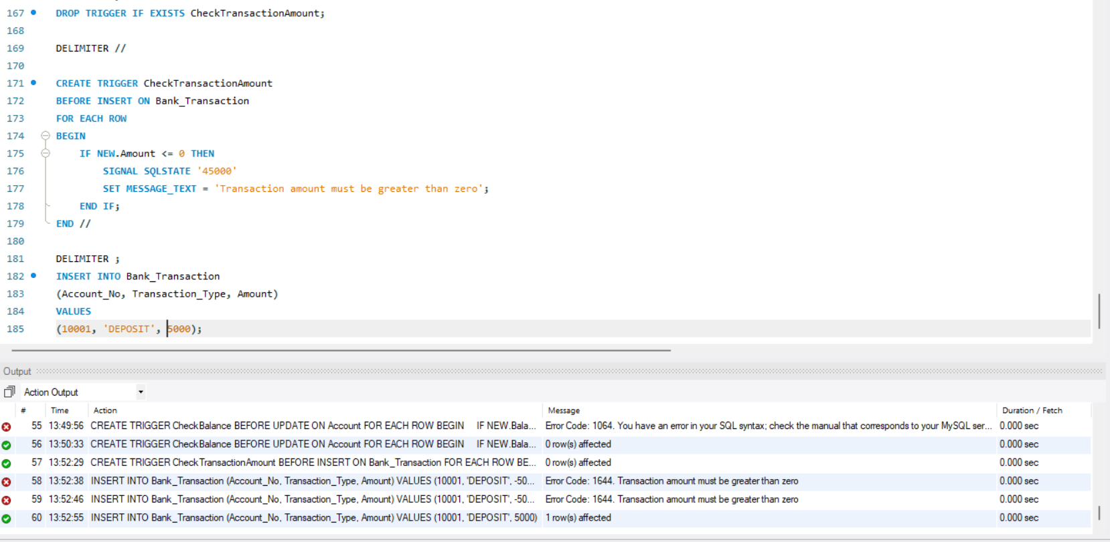
- CREATE TRANSACTION AUDIT TABLE
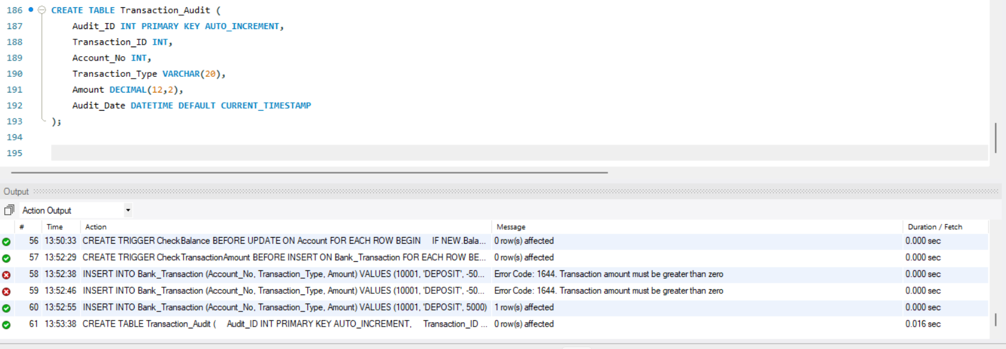
- TRIGGER – TRANSACTION AUDIT
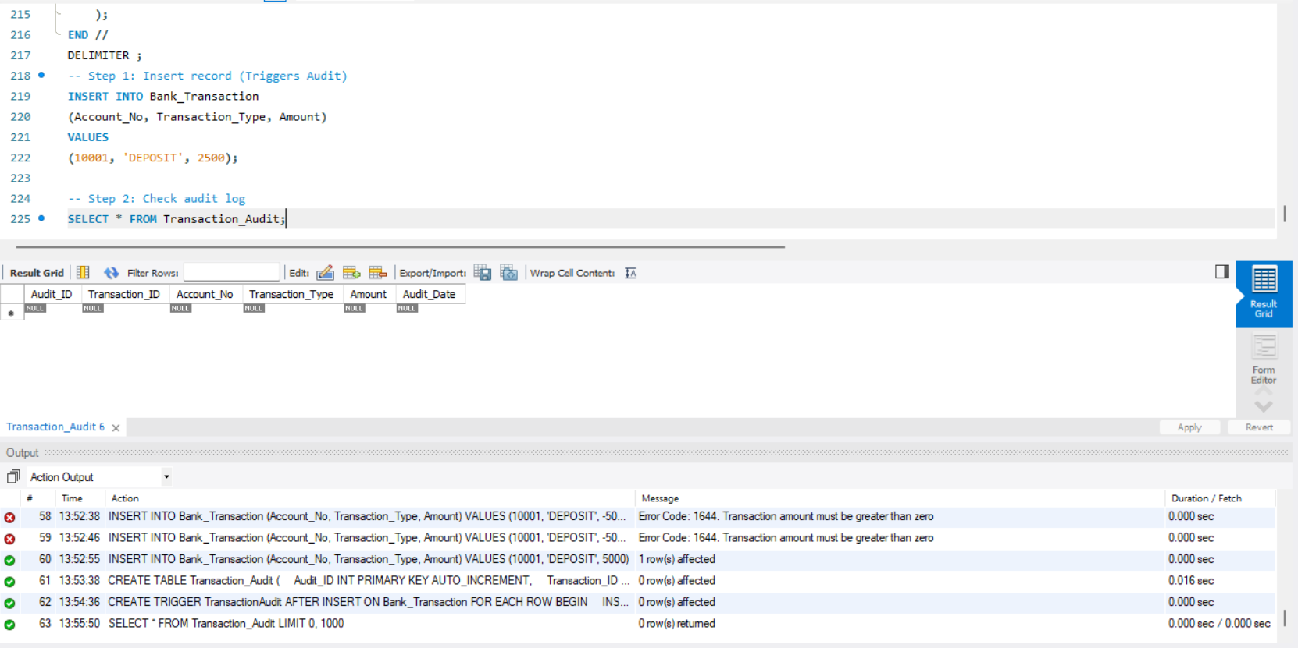
- TRIGGER – AUTOMATICALLY UPDATE ACCOUNT BALANCE
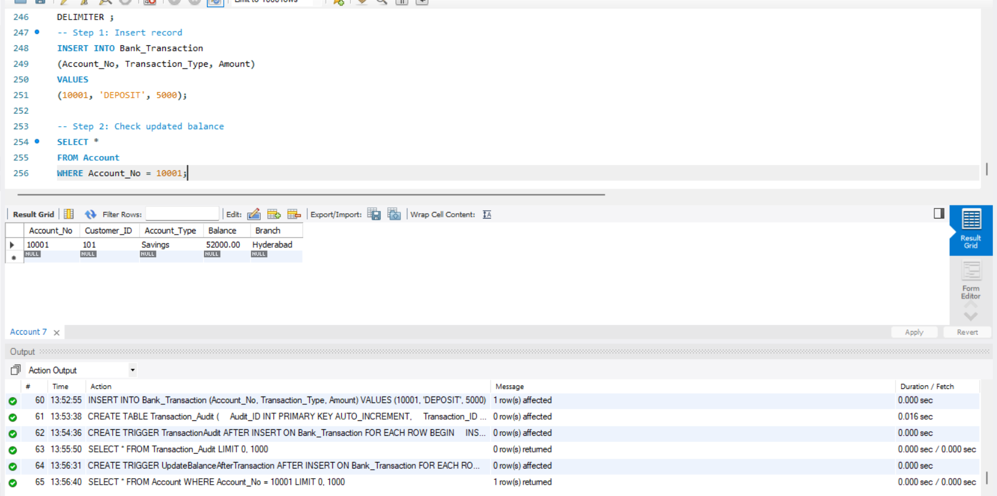
- TRIGGER – PREVENT WITHDRAWAL ABOVE BALANCE
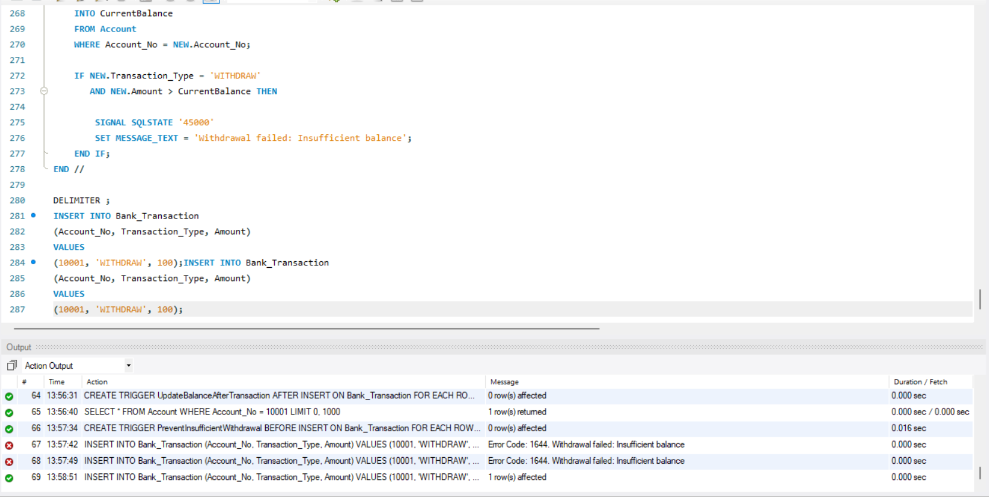
- PROCEDURE – ACCOUNT TRANSFER
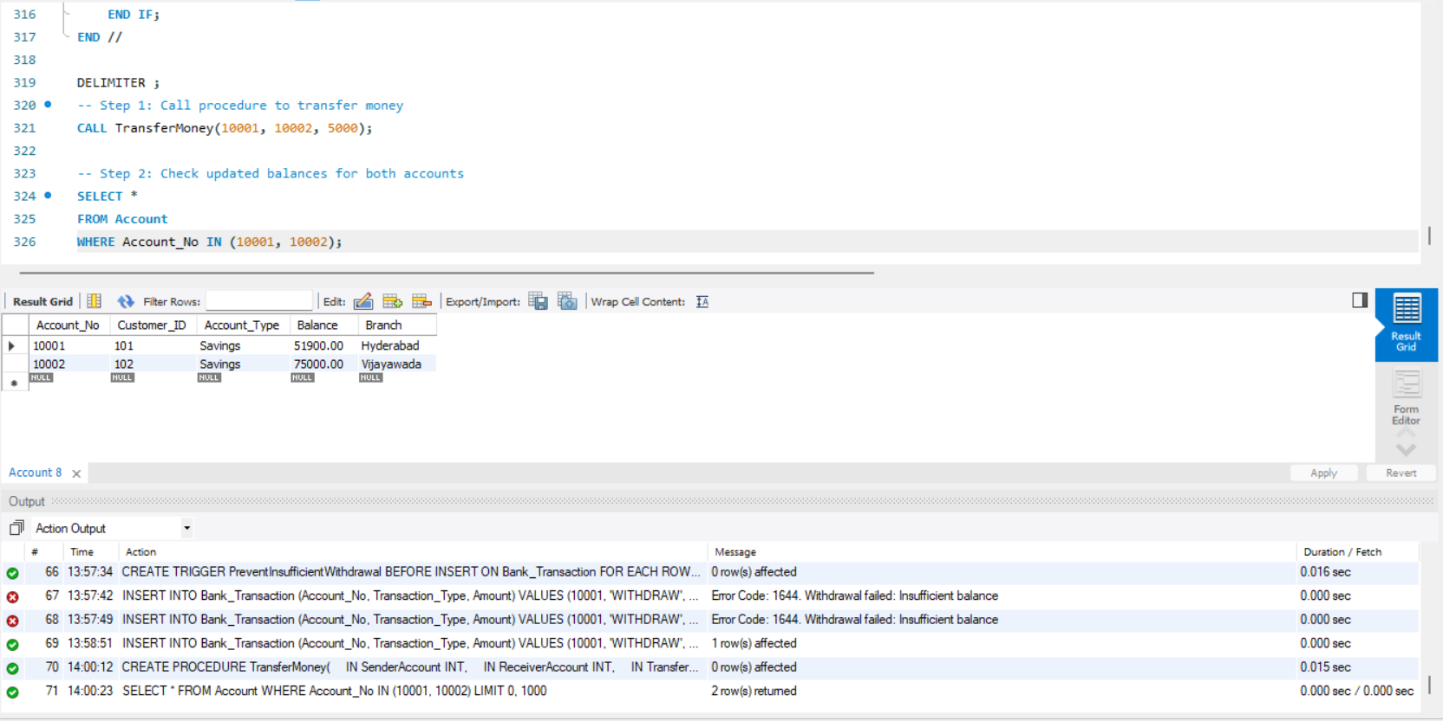
- PROCEDURE – CUSTOMER LOAN DETAILS
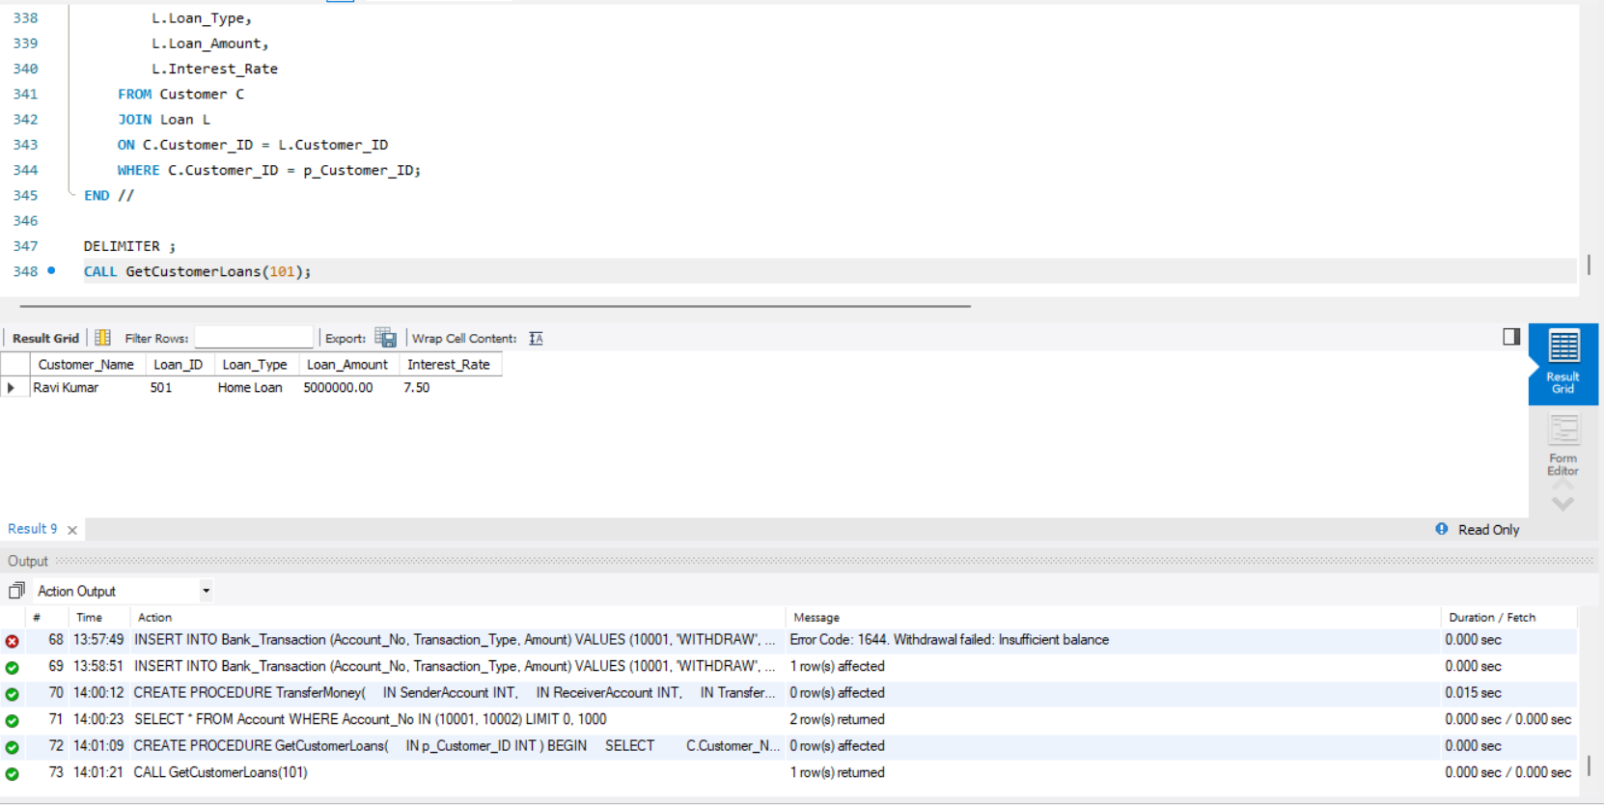
- PROCEDURE – HIGH BALANCE ACCOUNTS
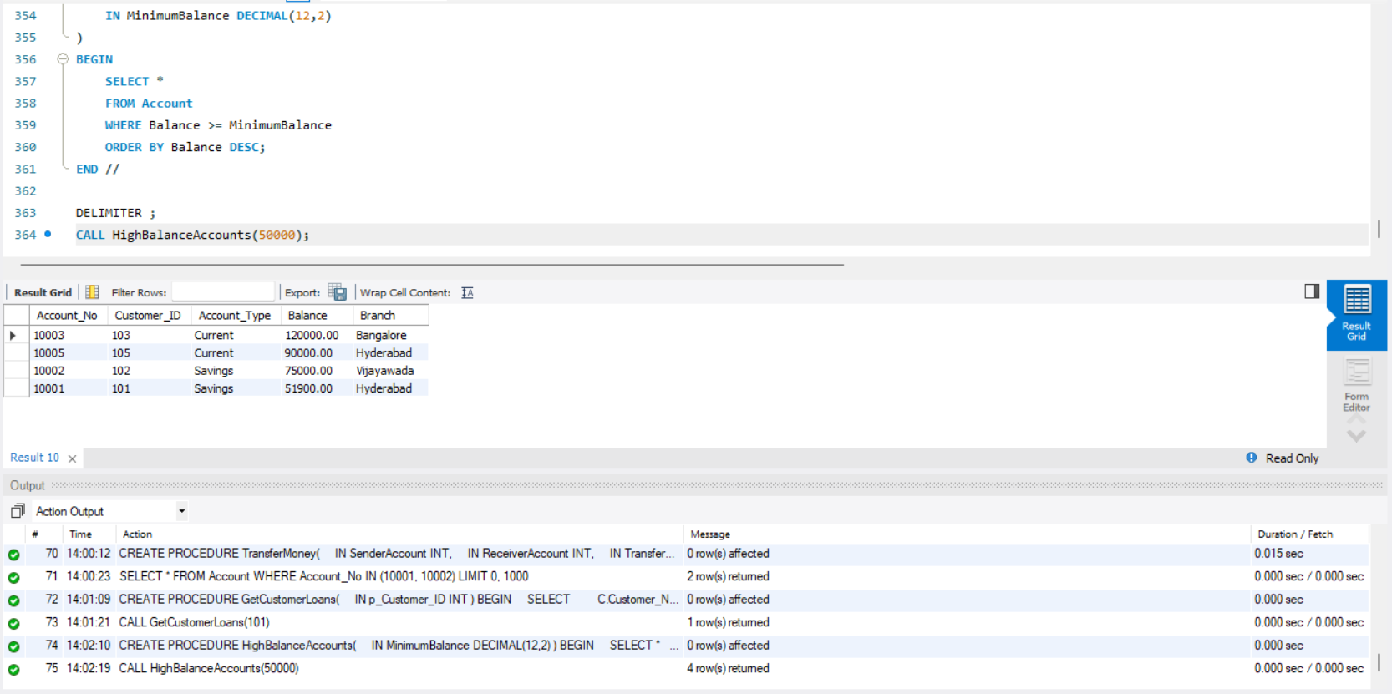
- PROCEDURE WITH IN, OUT PARAMETERS
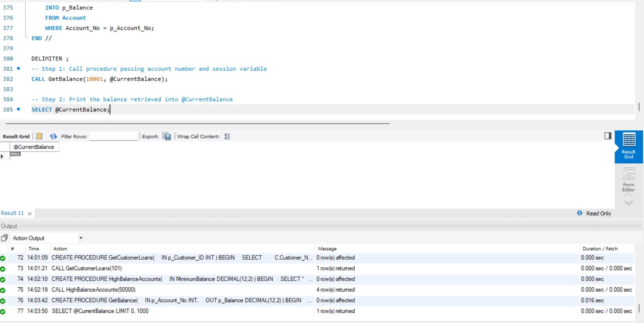
- TRIGGER MANAGEMENT COMMANDS
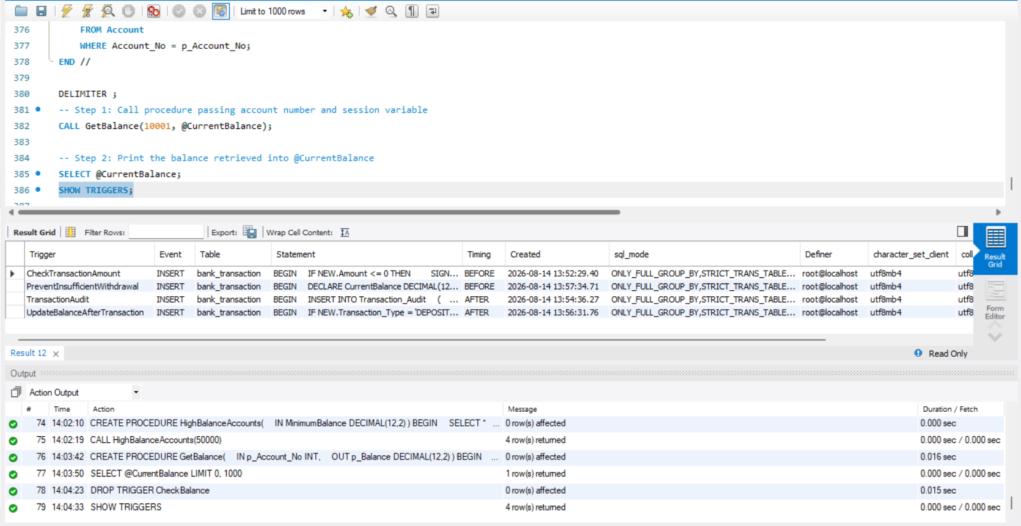
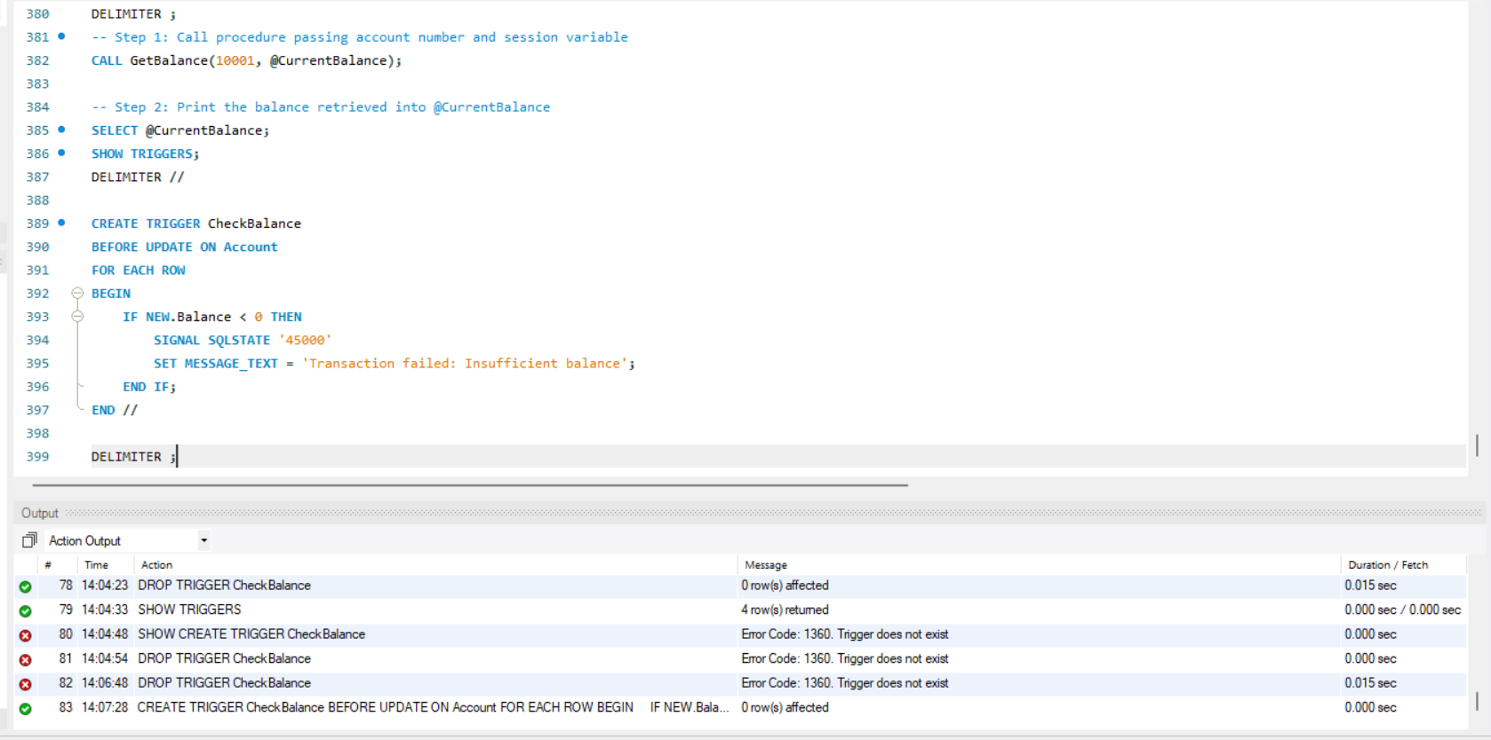
- PROCEDURE MANAGEMENT COMMANDS
