TEAM DETAILS
PHASE-WISE PROJECT DOCUMENTATION
Streamlining IT Procurement:
Automating Standard Laptop Orders
with Flow Designer
PROJECT PRESENTATION

Team ID SWTID-2026-6103

Team Size 4
Team Leader LAVANYA K

Team Member NASIMA J
Team Member DIVYADHARSHINI M
Team Member DEVADHARSHINI S

Phase 1: Brainstorming and Ideation
The IT procurement team observed that standard laptop requests were repeatedly delayed because the configuration step depended on manual coordination between the procurement and hardware teams. Team discussions centred on how to remove this manual dependency for a routine, repeatable request type.
Ideas considered during brainstorming:
- Manually reminding the hardware team through email or chat for every approved request — rejected, as it does not scale and relies on individual follow-up.
- Building a custom script outside ServiceNow to poll approved requests — rejected, as it duplicates platform capability and adds maintenance overhead.
- Using ServiceNow's native Flow Designer to automatically generate and assign a Catalog Task the moment a Standard Laptop request is approved — selected as the most efficient, low-code, and maintainable option.
The finalised idea: automate the standard laptop procurement workflow using Flow Designer so that a Catalog Task is created and routed to the Hardware assignment group automatically after approval, with no manual intervention.

Phase 2: Requirement Analysis

Problem Statement
The current IT procurement process lacks efficiency and automation, resulting in delays and manual overhead, particularly in handling standard laptop orders. Requests for standard laptops often require configuration, but this step is prone to oversight or delay, leading to frustration among users and inefficient resource allocation within the IT department.

User Story
As a member of the IT procurement team, I want a streamlined process for ordering standard laptops so that tasks are automatically generated and assigned to the hardware team for configuration. This will ensure that laptops are promptly configured upon arrival, reducing user wait times and minimising manual intervention.

Functional Requirements
- A Flow must trigger automatically when a Service Catalog request is raised.
- On approval of the request, a Catalog Task must be created automatically.
- The Catalog Task must carry a fixed short description and description (“Laptop needs to be Configured”).
- The Catalog Task must be routed to the Hardware assignment group.
- The Flow must be linked to the Standard Laptop catalog item via its Process Engine.

Non-Functional Requirements
- The workflow must run using the System User so it does not depend on a specific human account.
- The solution must be built using low-code configuration (Flow Designer) rather than custom scripting.
- The Flow must be reusable for every Standard Laptop order raised through the catalog.

Phase 3: Project Design
The solution is designed as a single ServiceNow Flow, “Standard Laptop task”, built in Flow Designer, wired to the Standard Laptop catalog item's Process Engine.

Workflow Design
- Trigger: Service Catalog — fires when a request tied to the Standard Laptop catalog item is submitted.
- Action: Create Catalog Task — executes once the Requested Item is approved.
- Field mapping: Requested Item is bound from the trigger record; Short Description, Description, Assignment Group, and Approval fields are pre-filled.
- Assignment logic: every generated task is routed to the Hardware group, since standard laptops always need hardware configuration.

Project Objective
The objective of this project is to implement an automated workflow using Flow Designer to facilitate the procurement and configuration of standard laptops. By integrating automation into the process, the project aims to:
- Create a seamless experience for users requesting standard laptops by ensuring timely configuration.
- Reduce manual intervention and potential errors in the procurement process.
- Improve resource utilisation within the IT department by optimising task allocation.
- Enhance overall efficiency and productivity in IT procurement operations.

Phase 4: Project Planning
The implementation was planned across three milestones, each building on the previous one:
- Milestone 1 – Flow: Build and activate the “Standard Laptop task” Flow in Flow Designer.
- Milestone 2 – Flow Assignment: Link the Flow to the Standard Laptop catalog item's Process Engine.
- Milestone 3 – Service Catalog: Raise a test request through the Service Catalog, approve it, and verify the Catalog Task is generated correctly.
Tools used: ServiceNow platform (Flow Designer, Service Catalog, Maintain Items). Role involved: IT Procurement / Platform configurator, working as System User for the Flow's runtime context.

Phase 5: Project Development

Milestone 1: Flow
Activity 1: Create a Flow to create a Catalog Task that updates the short description after Approval of the Service Request, and assigns it to the Hardware group.
- Open ServiceNow.
- Click on All >> search for Flow Designer.
- Click on Flow Designer under Process Automation.
- After opening Flow Designer, click on New and select Flow.
- Under Flow properties, give the Flow Name as “Standard Laptop task”.
- Set Application as Global.
- Select Run As “System User”.
- Click on Submit.
- Click on Add a trigger.
- Search for “Service Catalog” and select it as the trigger.
- Click on Done.
- Under Actions, click on Add an action.
- Search for “Create Catalog Task” and select it.
- Set Action as Create Catalog Task.
- Drag and drop the Requested Item record into the Request Item field.
- The table auto-populates as Catalog Task.
- Set the Short Description as “Laptop needs to be Configured”.
- Click on Add field value.
- Set the Description field value as “Laptop needs to be Configured”.
- Set the Assignment Group field value as “Hardware”.
- Set the Approval field value as “Approved”.
- Leave the remaining fields as default and click Done.
- Click Save on the Flow.
- Click Activate, then confirm by clicking Activate again.

Milestone 2: Flow Assignment
Activity 1: Assign the Flow to the Standard Laptop Service Catalog item.
- Open ServiceNow.
- Click on All and search for Maintain Items.
- Select Maintain Items.
- Under the Name field, search for “Standard Laptop” and select that record.
- Under that record, select the Process Engine tab.
- Remove any existing automation and add Flow instead.
- Add the flow created earlier, named “Standard Laptop Task”.
- Save the record.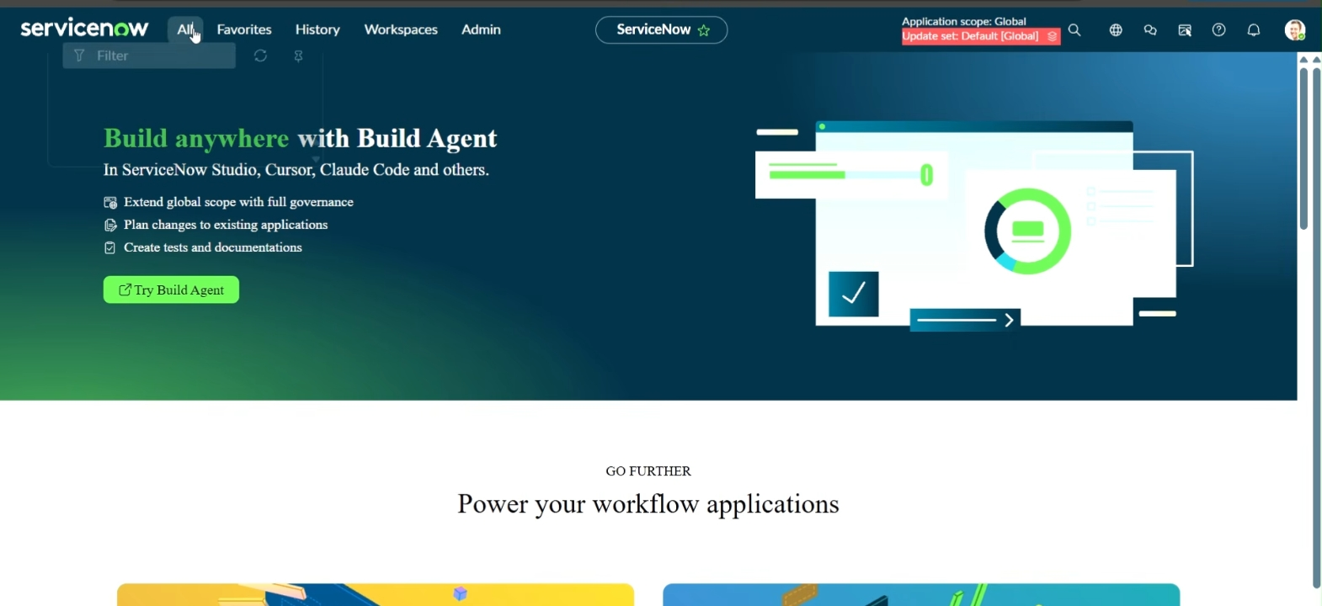

Phase 6: Project Testing
Testing was carried out by simulating an actual end user raising a Standard Laptop request through the Service Catalog, then tracing the request through approval to confirm the Flow behaves as designed.

Test Activity: Service Catalog Order and Approval
- Click on All >> search for “Service Catalog”.
- Click on Service Catalog >> click on Hardware.
- Scroll to find “Standard Laptop” and click on it.
- Click on “Order Now” to place the request.
- View the Order Status and click on the Request Number.
- This opens the Requested Number record.
- Scroll down and click on the Approvers section.
- Right-click on the record to view configuration options, then click Approve.
- Click on the Requested Item section.
- Open the Requested Item record.
- Scroll down to the Catalog Tasks section.
- Open the record to verify the updated Short Description and Assignment Group.
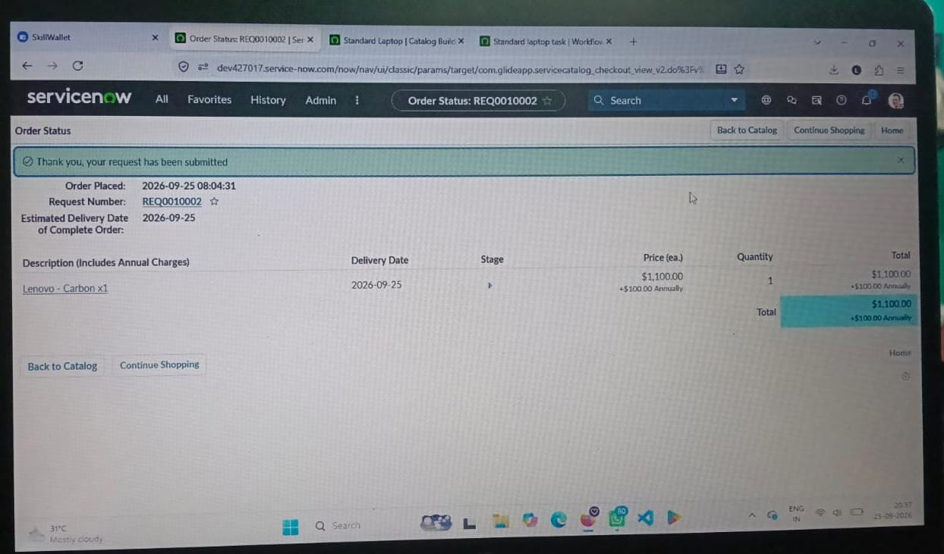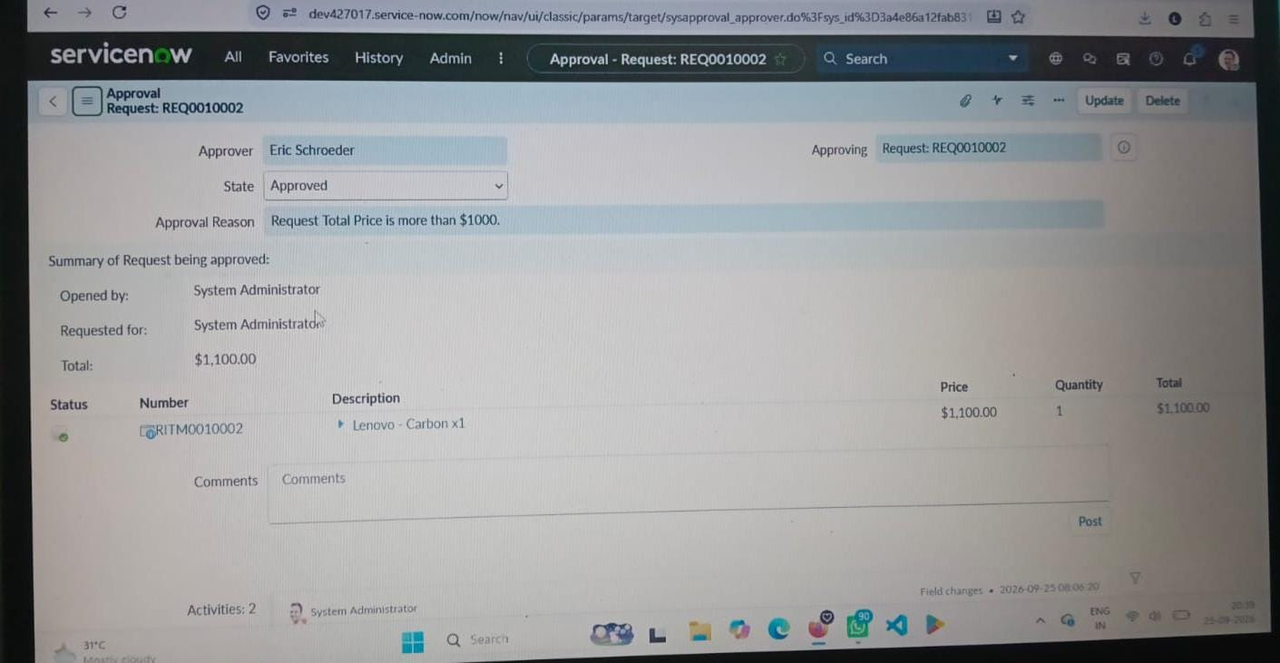

Test Result
On approval, the Flow triggered successfully and a Catalog Task (e.g. SCTASK0010001) was auto-generated with Short Description “Laptop needs to be Configured”, Approval status “Approved”, and Assignment Group “Hardware” — confirming the workflow met all functional requirements defined in Phase 2.

Phase 7: Project Documentation
This document itself constitutes the documentation phase, consolidating the problem statement, requirements, design, planning, build steps, and test evidence into a single phase-wise record for review, handover, and future reference. Supporting screenshots of each configuration step (Flow properties, trigger setup, action configuration, catalog item Process Engine, and the completed Catalog Task) were captured during development and are maintained alongside this document.

Phase 8: Project Demonstration
The completed solution was demonstrated end-to-end: a Standard Laptop request was raised from the Service Catalog, approved by the designated approver, and the system was shown to automatically generate and route the Catalog Task to the Hardware team — with no manual task creation required at any step.

Conclusion
By automating the standard laptop procurement process with ServiceNow's Flow Designer, the project effectively addresses inefficiencies and reduces manual overhead. This streamlined workflow ensures timely configuration of laptops, minimizes user wait times, and enhances overall productivity within the IT department. The implementation of this automated solution not only optimizes resource allocation but also significantly improves the user experience by providing a seamless and efficient procurement process.
ServiceNow • Flow Designer • IT Procurement Automation

