7. RESULTS

7.1 Output Screenshots
The results of the Heritage Treasures: An In-Depth Analysis of UNESCO World Heritage Sites (2019) project are presented through interactive dashboards and story scenes developed in Tableau.
The dataset used is based on World Heritage Sites designated by UNESCO under its World Heritage Programme.

Dashboard 1 – UNESCO Overview
🔹 Description
This dashboard provides a global overview of UNESCO World Heritage Sites.
🔹 Key Components
- World Map showing site distribution by country
- Site Count per Region
- Category Distribution (Cultural / Natural / Mixed)
- Country-wise Site Contribution (Treemap or Bar Chart)
- Interactive Filters:
  - Region
  - Country
  - Category
🔹 Insights Observed
- Certain countries dominate in heritage site count.
- Cultural sites form the majority category.
- Europe & North America region has a high concentration of sites.
Dashboard 1
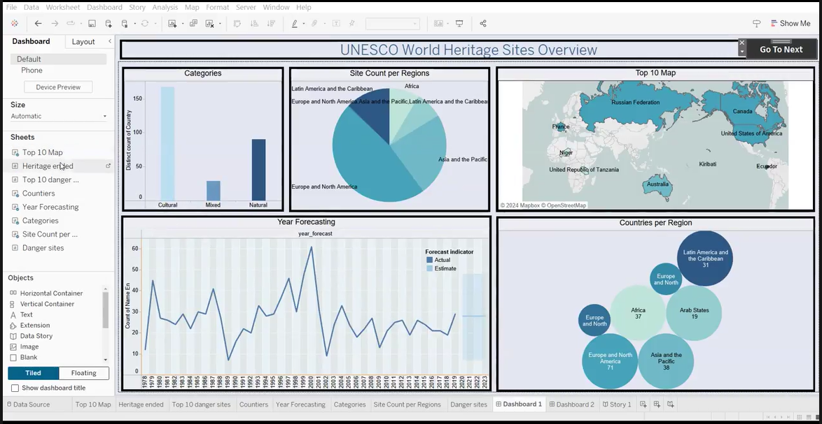

Dashboard 2 – Risk & Trends Analysis
🔹 Description
This dashboard focuses on endangered sites and historical trends.
🔹 Key Components
- Pie Chart showing “In Danger” vs “Not in Danger”
- Top 10 Endangered Sites
- Line Chart showing inscription trends over time
- Forecasting model for future growth
- Interactive Filters:
  - Region
  - Danger Status
  - Year
🔹 Insights Observed
- Only a small percentage of sites are officially marked “In Danger”.
- Certain regions show consistent inscription growth.
- Forecasting indicates steady increase in future inscriptions.
Dashboard 2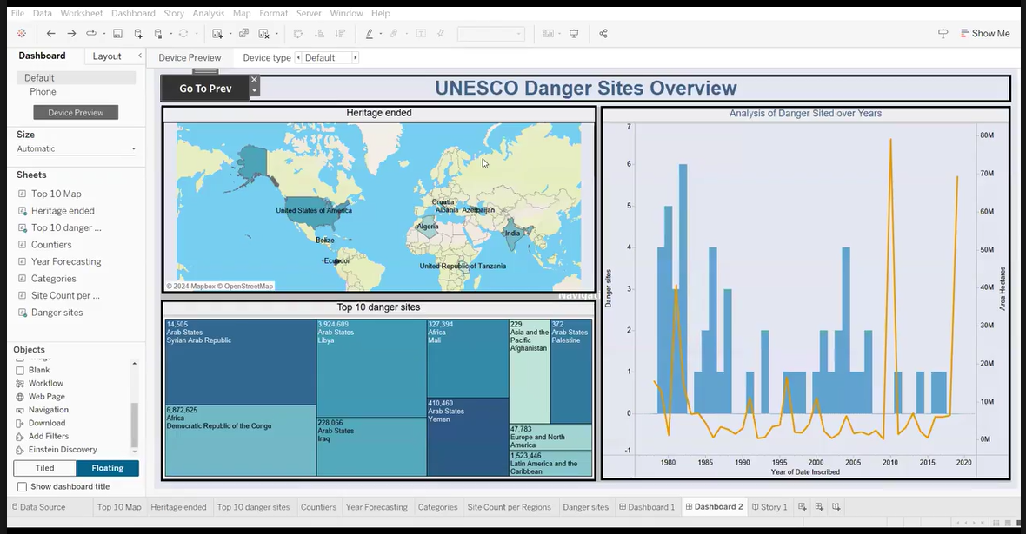
Story Scenes
The Tableau Story presents insights in a structured narrative format.
Scene 1 – Global Heritage Overview
- Displays worldwide distribution map
- Highlights leading countries
Scene 2 – Regional Comparison
- Compares site count by region
Scene 3 – Endangered Sites Analysis
- Focus on risk distribution
Scene 4 – Category Analysis
- Cultural vs Natural vs Mixed comparison
Scene 5 – Inscription Trends
- Historical growth pattern
Scene 6 – Forecasting Insights
- Predicted future inscription trends
Story Screenshots:
