SMART AGRICULTURE USING IOT

# S.LAVANYA SREE

a Department of Information Technology, Velammal Engineering College, Chennai – 66

lavanyasekar0108@gmail.com

# ABSTRACT

IOT has the ability to transfer a data over a network without requiring human to human and human to machine interactions, Internet of Things (IOT) plays a crucial role in smart agriculture. Smart farming is an emerging concept, because IOT sensors capable of providing information about their fields. The Agriculture is the largest provider of livelihood in rural India. The growth in agricultural production has been stagnant for the past several years. Our project aims at improving the yield of crops through IOT. The purpose of SMART AGRICULTURE is to detect various problems of farmers and provide a solution by using 3 Way Soil Meter sensor, soil moisture sensor and passive infrared sensor. The world’s population is growing by large percentages. Agriculture needs reforms to feed the world in large quantities. The internet of things allows the integration of technology with agriculture to provide better quality food, management, monitoring and control. Though it is implemented in the research level it is not given to the farmers as a product to get benefitted from the resources. Hence this paper deals about developing smart agriculture using IOT and given to the farmers.

**Keywords:** Sensors, Humidity, Moisture, Predators, IOT, Relay.

# Introduction

Farming and agriculture is basis of human life and technology holds a tremendous role in increased production and decreased extra man power. IOT has opened a suitable solution for smart agriculture but remains a dream till the agriculture and farming bases situated in rural areas are not connected to the main stream efficiently. The main aim of this project is to turn on and off water pump from anywhere using mobile phone. Now a day’s most of the farmers use water from the wells and underground water resources for their farms and for this they need water pumps. Using Arduino

and GSM shield we can implement this project. The purpose of this system is to help the farmers for knowing the update of the field frequently.

# Literature Survey

The existing method and one of the oldest ways in agriculture is the manual method of checking the parameters. In this method the farmers they themselves verify all the parameters and calculate the readings. It focuses on developing devices and tools to manage, display and alert the users using the advantages of a wireless sensor network system. It aims at making agriculture smart using automation and IOT technologies. The highlighting features are smart GPS based remote controlled robot to perform tasks like weeding, spraying, moisture sensing, human detection and keeping vigilance. This idea proposes a novel methodology for smart farming by linking a smart sensing system and smart irrigator system through wireless communication technology. It proposes a low cost and efficient wireless sensor network technique to acquire the soil moisture and temperature from various location of farm and as per the need of crop controller to take the decision whether the irrigation is enabled or not.

# Software Requirements: C

**Hardware Requirements**: Arduino, 3 way soil meter, Soil moisture sensor, Passive infrared sensor, Relay, DC motor, GSM, Breadboard, Laptop.

# Project Implementation

Three different soil test meters in one device: It measures moisture content in soil, pH/Acidity/Alkalinity, and light intensity (sun rays) .Water wasted through irrigation can be conserved by soil moisture sensor .PIR (Passive Infrared) Sensors can be used to prevent harm caused by predators by detecting the motion of animals and scars the animal away from the field by using buzzers and creating alarm.. GSM Keeps the farmer updated frequently about their field status, especially when an inconvenience occurs. Data is the center of any IOT based technology. In order to ensure optimization, smart farms must form a continuous and constant cycle that collects and analyzes data to perform the next set of actions.

* **Observation:** sensors are used to sense the surroundings and collect information about the soil, temperature, humidity and so on.
* **Diagnostics:** the information collected from sensors are sent to IOT based cloud platforms for data analytics.
* **Decisions:** based on the analysis done the farmers make relevant decisions to generate better outputs.
* **Actions:** when the tasks are operated the cycle repeats itself from the beginning.

# Proposed Solution

It control pH level in soil, acidic or alkaline is suitable for your plants, tests whether plants are getting adequate sunlight or not. The moisture in the soil is measured by using soil moisture sensor, the sensor measures the moisture content and based on the moisture content, it turns on or off the motor. Passive infrared sensor detects infrared light radiated by a warm object. The hardware is interfaced with all the sensors in the board. The hardware components include the microcontroller, buzzer, relay, and all the sensors interfaced. The arduino has a display in it which displays the respective value of all the parameters.

# Methodology

Passive Infrared (PIR) sensor detects infrared light radiated by a warm object. The moisture in the soil is measured by using soil moisture sensor. The sensor measures the moisture content and based on the moisture content ,it turns on or off the motor.3 Way Soil Meter : Lets you know that soil is dry or not. It control pH level in soil, acidic or alkaline is suitable for your plants. Tests whether plants are getting adequate sunlight or not. IOT connects all the sensors and sends their values and messages to the system for display. It is designed for IOT based monitoring system to analyze crop environment and the method to improve the efficiency of decision making by analyzing harvest statistics

# Block Diagram

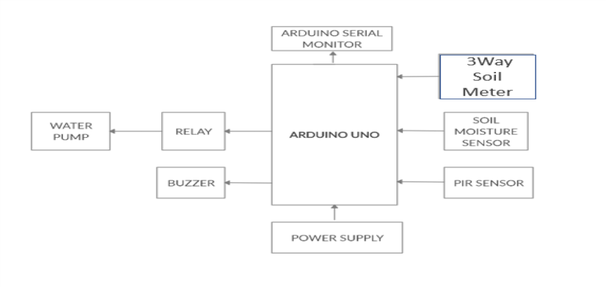

**Sample Source Code**

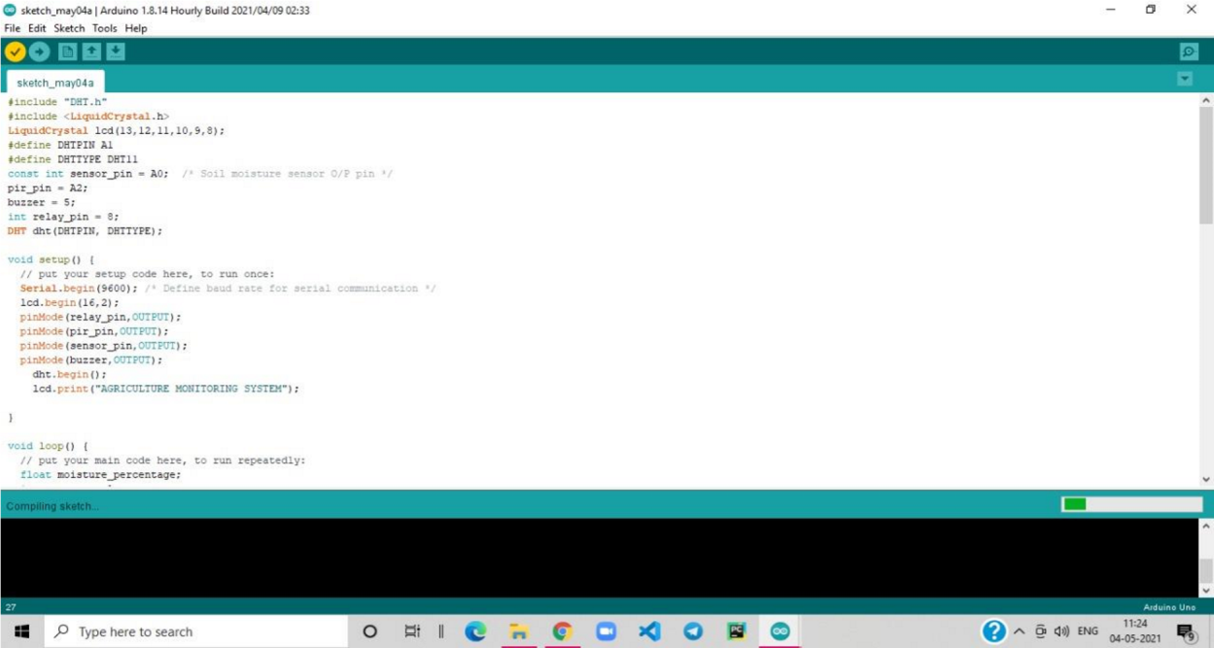

# Advantages of This Method

**Economic feasibility-** The SMART AGRICULTURE being developed is economic because it conserve water by using soil moisture sensor. The sunlight, moisture, pH of the soil is measured by using 3 Way Soil Meter. The destruction of crops by predators are prevented by using Passive Infrared sensor (PIR). Global System for Mobile Communication (GSM) keeps them updated about their field either through image or voice note.

**Technical feasibility-** The technical requirement for the system is economic and it does not use any other additional Hardware and software**.**

**Behavioral feasibility-** The system working is quite easy to use and learn due to its simple but attractive interface. Users require no special training for operating the system.

# Future Scope

For future developments it can be enhanced by developing this system for large acres of land. Also the system can be integrated to check the quality of the soil and the growth of crop in each soil. The sensors and microcontroller are successfully interfaced and wireless communication is achieved between various nodes. All observations and experimental tests prove that this project is a complete solution to field activities and irrigation problems. Implementation of such a system in the field can definitely help to improve the yield of the crops and overall production Instead of using GSM making use of GPRS and controlling those applications through the internet. Instead of switching of the water pump when single phase is present, convert the single phase power supply to three phase power supply.

# Working Model

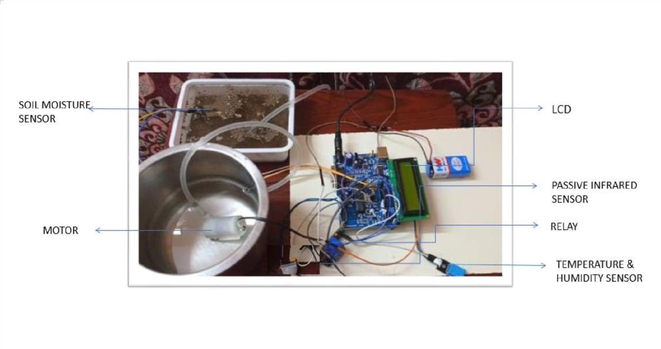

**Acknowledgement**

We express our sincere thankfulness to our Project Guide Mrs. NALAYANI for her successful guidance to our project. Without the help it would be a tough job for us to accomplish this task. We also thank our Head of the Department (IT) Dr. JEEVA KATHIRAVAN for providing us all the necessary facilities.

# Conclusion

The goal of smart agriculture research is to ground a decision making support system for farm management. A system that optimises and examines how high-tech farming can aid the production output as well as focuses on the preservation of resources. Smart farming can make agriculture more profitable for the farmer. Decreasing resource inputs will save the farmer money and labor, and increased reliability of spatially explicit data will reduce risks.

# References

1. Gondchawar, N. and Kawitkar, R.S., 2016. IoT based smart Agriculture. International
2. Journal of advanced research in Computer and Communication Engineering, 5(6).
3. 3.IoT in agriculture: 5 technology use cases for smart farming
4. 4.https://[www.geeksforgeeks.org/crop-monitoring-smart-farming-using-iot](http://www.geeksforgeeks.org/crop-monitoring-smart-farming-using-iot)
5. H. Kothiya ,Rathinkumar. and L. Patel ,Karan. and Prof. Jayswal., Hardik .S., 2018