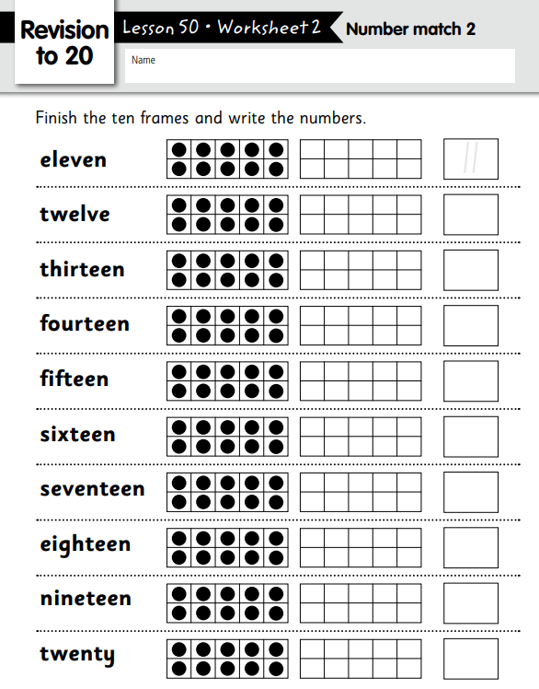

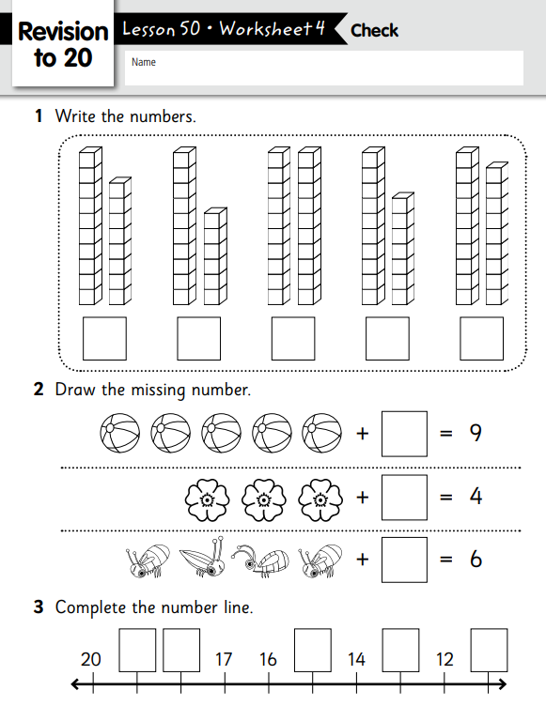

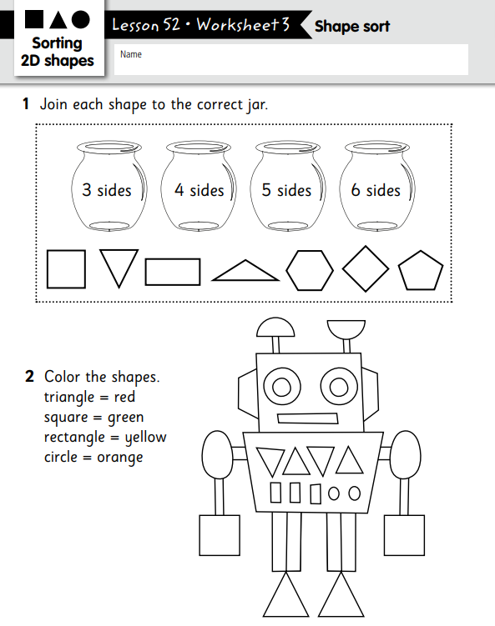

|  |  |  |  |  |
| --- | --- | --- | --- | --- |
| **Lesson** | **Lesson Name** | **Strand** | **Content** | **Outcome** |
| **1** | Length - Long and Short | Measurement | Length | Compare an order which is longer or shorter using everyday language. Use comparative language: big, small, short, tall, tallest, longest, shortest. |
| **2** | Patterns | Patterns & Algebra | Patterns | Copy, continue and create patterns. Identify colours. Match objects to colour names. |
| **3** | Number Lines (2) | Number | Counting | Count to 10. Read number words to ten. Connect counting to cardinality. Sequence numbers, counting forwards and backwards. Count to answer 'How many?' questions. Subitise small groups of objects in different formations. |
| **4** | Mass - Heavy and Light (1) | Measurement | Mass | Compare and order which is heavier or lighter using everyday language. Use comparative language: big, small, heavy, light, heavier, lighter. |
| **5** | Adding to 6 | Operations | Addition | Connect counting to addition. Model addition with objects. Write equations for addends to 6. Subitise small groups of objects in different formations. Subitise small groups of objects in different formations. |
| **6** | Counting to 10 | Number | Counting | Sequence numbers, counting forwards and backwards. Estimate the quantity of items in a group. Compare groups of objects. Use comparative language: more, less, the same. Count to answer 'How many?' questions. Find pairs of numbers that make 10. |
| **7** | Add to 7 | Operations | Addition | Connect counting to addition. Model addition with objects. Write equations for addends to 7. Compare groups of objects. Subitise small groups of objects in different formations. |
| **8** | Number Words to 10 | Number | Counting | Read the words: zero, one, two, three, four, five, six, seven, eight, nine, ten. |
| **9** | Add to 10 (1) | Operations | Addition | Connect counting to addition. Model addition with objects. Write equations for addends to 10. Find pairs of numbers that make 10. Subitise small groups of objects in different formations. |
| **10** | 3D Objects - Cube & Sphere | Geometry | 3D Shape | Name cubes and spheres in the environment. Match and sort cubes and spheres. Name cubes and spheres in different sizes. Identify objects that can be stacked and those that roll. |
| **11** | Add to 10 (2) | Operations | Addition | Connect counting to addition. Model addition with objects. Write equations for addends to 10. Find pairs of numbers that make 10. |
| **12** | Patterns 2 | Patterns | Patterns | Copy, continue and create patterns. |
| **13** | Capacity | Measurement | Capacity | Use comparisons to decide which holds more or less. Use comparative language: full, empty, big, small, short, tall. |
| **14** | Time | Measurement | Time | Compare and order events using the everyday language of time. |
| **15** | Add to 10 on a Number Line | Operations | Addition | Connect counting to addition. Add on a number line. Model addition with objects. Write equations for addends to 10. Find pairs of numbers that make 10. |
| **16** | Numbers 11 & 12 | Number | Counting | Count to 12. Know, read and write the numerals 11 & 12. Read number words to twelve. Represent a number of objects with a written number. Compare numbers. Connect counting to cardinality. Subitise small groups of objects in different formations. |
| **17** | Days of the Week | Measurement | Time | Connect days of the week to familiar events and actions. |
| **18** | Numbers 13, 14 & 15 | Number | Counting | Count to 15. Know, read and write the numerals 13, 14, 15. Read number words to fifteen. Represent a number of objects with a written number. Compare numbers. Connect counting to cardinality. |
| **19** | 3D - Cone and Cylinder | Geometry | 3D Shape | Name cones and cylinders in the environment. Match and sort cones and cylinders. Name cones and cylinders in different sizes. |
| **20** | Numbers 16 & 17 | Number | Counting | Count to 17. Know, read and write the numerals 16 & 17. Read number words to seventeen. Represent a number of objects with a written number. Compose and decompose the numbers 11, 12, 13, 15 into tens and ones. Compare groups of objects. Use comparative language: more, less, the same. |
| **21** | Numbers 18, 19 & 20 | Number | Counting | Count to 20. Know, read and write numbers to 20. Read number words to twenty. Represent a number of objects with a written number. Compose and decompose the numbers 12, 14, 16, 19 into tens and ones. Compare groups of objects. Use comparative language: more, less, the same. |
| **22** | Subtraction | Operations | Subtraction | Solve subtraction problems using objects and equations. Represent objects with a written numeral to solve subtraction problems. Represent a written numeral with objects to solve subtraction problems. |
| **23** | Number Words 11-20 | Number | Counting | Count to 20. Read number words to twenty. |
| **24** | Doubles (to double 5) | Operations | Counting | Connect counting to addition. Model addition. Write equations for addends to 10. Find pairs of numbers that make 10. Subitise small groups of objects in different formations. |
| **25** | Revision 0-20 | Number | Counting | Count to 20. Know, read and write numbers to 20. Read number words to twenty. Compose and decompose the numbers 15, 17, 18, 20 into tens and ones. Use comparative language: smaller, larger. Sequence numbers, counting forwards and backwards. |