B.M.S COLLEGE OF ENGINEERING BENGALURU
Autonomous Institute, Affiliated to VTU

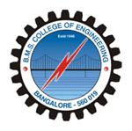

SPC AAT Report on

TITLE

Submitted in partial fulfillment of the requirements for AAT

Bachelor of Engineering
in
Computer Science and Engineering

Submitted by:

NAME OF THE CANDIDATE

Department of Computer Science and Engineering
B.M.S College of Engineering
Bull Temple Road, Basavanagudi, Bangalore 560 019
2025-2026

B.M.S COLLEGE OF ENGINEERING
DEPARTMENT OF COMPUTER SCIENCE AND ENGINEERING

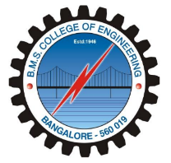

DECLARATION

We, AAAA students of 1st Semester, B.E, Department of -------------------, BMS College of Engineering, Bangalore, hereby declare that, this AAT Project entitled "TITLE HERE" has been carried out in Department of CSE, BMS College of Engineering, Bangalore during the academic semester Oct 2024 – Jan 2025. We also declare that to the best of our knowledge and belief, the AAT Project report is not from part of any other report by any other students.

Student Name Student Signature
1.
2.

BMS COLLEGE OF ENGINEERING
DEPARTMENT OF COMPUTER SCIENCE AND ENGINEERING

CERTIFICATE

This is to certify that the AAT Project titled “TITLE” has been carried out by AAAA (1BM22CSXXX) during the academic year 2025-2026.

Signature of the Faculty in Charge

Table of Contents
Sl. No. | Title | Page no.
1 | Introduction
2 | Algorithm
3 | Flowchart
4 | Source code
5 | Results (screenshots)
6 | References

1. INTRODUCTION

2. ALGORITHM

3. FLOWCHART

4. SOURCE CODE

5. RESULTS

REFERENCES

