DevOps Home Work
- Build local Dev/QA environment
- Environment desc
nodejs01.lavender.info (static resource service)
tomcat01.lavender.info:8080 (java service)
jenkins.lavender.info (Jenkins server)
- Tools
Docker container
- Requirement
Docker
- Download git project to build docker images
git clone https://github.com/lavender2020/DevOps.git
- Run shell script to deploy environment

Directory structure:
.DevOps
├── README.md
├── jenkins
│ └── run.sh
├── nginx
│ ├── Dockerfile
│ ├── nginx-default.conf
│ ├── nginx.conf
│ ├── run.sh
│ ├── ssh.conf
│ └── supervisord.conf
└── tomcat
├── Dockerfile
├── nginx-default.conf
├── run.sh
├── ssh.conf
├── supervisord.conf
└── tomcat.conf

Build QA/Dev environment:
bash Devops/nginx/run.sh
bash Devops/tomcat/run.sh
bash Devops/jenkins/run.sh

Env introduction:
Nginx container running service sshd、nginx、supervisor. Ssh service used for Jenkins deployment over ssh. nginx service for static resource. Supervisor service used for managing nginx and sshd service in case of service down and also provide a web consule to manage services. Supervisor will restart service after deployment.
Tomcat container running services sshd、tomcat、supervisor. Tomcat service used for non static resource.
Jenkins container running service Jenkins used for CI/CD. Create deployment ssh public key and add into container ‘s file /root/.ssh/authorized_keys.

- Design CI/CD environment

- CI/CD work flow using Jenkins+Docker+ssh plugin

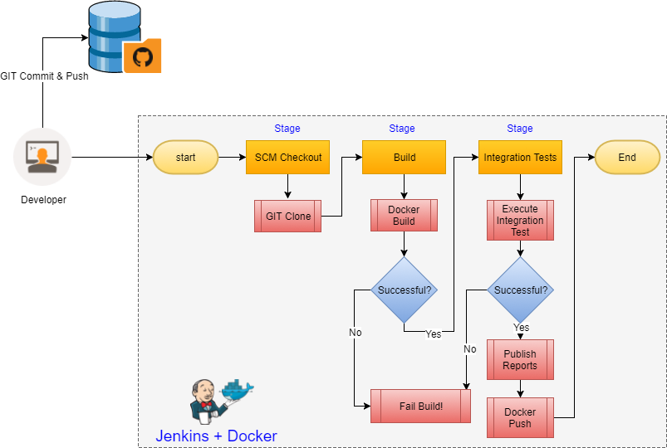

- Build up Jenkins pipeline for deploying code

Running Jenkins service: bash Devops/jenkins/run.sh
Jenkins plugins: ssh plugin、pipeline、Pipeline Maven Integration、SSH Credential、Nodejs
Jenkins Tools: Maven、git、nodejs
Create pipeline for static resource:
Define build trigger(Build when a change is pushed to GitLab)
Write pipeline script(Jenkinsfile_java)
Create pipeline for java application:
Define build trigger(Build when a change is pushed to GitLab)
Write pipeline script(Jenkinsfile_node)
Create gitlan webhook for java and nodejs project:

- Deployment
Developers commit changes to gitlab and trigger automatic deployment

- Design publish strategy integrating with CI/CD

CI: gitlab/github webhook -> Jenkins -> Auto deploy
CD: Jenkins trigger api -> Manual deployment

- HA、monitor、log
HA: kubernetes+ingress+kubeproxy
Monitor: heapster/cadvisor/node exporter+influxdb/prometheus+Grafana
Log: filebeat/log driver+elasticsearch+kibana

